FuseTwo — Bug Report (Today)
Bugs found on 28 August 2026 during QA automation of the advertiser platform. Each has steps to reproduce, expected vs actual, evidence and screenshots. Prepared by Syed Shah, QA. Environment: dev.

ID | Severity | Title | Area
BUG-1 | High | Programs API returns HTTP 500 across the whole app | Advertiser platform — Programs API (GET /api/{advertiserId}/programs)

BUG-1: Programs API returns HTTP 500 across the whole app
Severity: High | Area: Advertiser platform — Programs API (GET /api/{advertiserId}/programs) | Environment: dev (advertiser 1062551 / playwright@fusetwo.com)
Steps to reproduce
- Sign in to the advertiser platform (advertiser.dev.fusetwo.com).
- Open the Programs page (or Dashboard, Campaigns, Creatives, Coupons & Offers, Products, Reports > Sales Detailed, Reports > Clicks Detailed).
- Open the browser DevTools > Network (or Console) and watch the request to /api/1062551/programs.
Expected: GET /api/{advertiserId}/programs returns HTTP 200 with the program list (or an empty list for a new account), and the page renders without an error.
Actual: GET /api/1062551/programs returns HTTP 500 with body {"result":null,"errorMessage":"Oops! Something went wrong. Please try again in a few moments."}. It fails on every page that calls it, and the browser console logs an error each time. Reproduced consistently on repeated loads (verified twice).
Evidence: The request is authenticated (a valid Bearer JWT is sent), so this is a server-side crash, not an auth failure. The same generic error surfaces to the user as an 'Oops! Something went wrong' toast (seen on Message Center). Note: the test account is currently in 'Initial Setup' status (not Approved); the 500 may correlate with that state, but the API should degrade gracefully (empty list / proper status), not return a 500.
Affected pages
- /app/dashboard
- /app/programs
- /app/campaigns
- /app/creatives
- /app/couponsandoffers
- /app/products
- /app/reports/salesdetailed
- /app/reports/clicksdetailed
Screenshot: programs.png
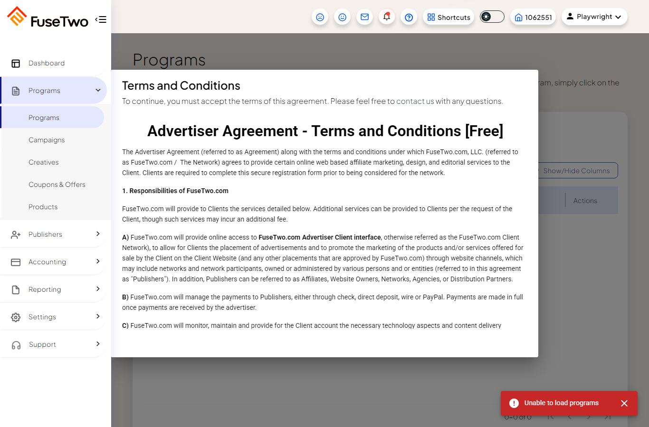
Screenshot: messagecenter.png
