Advertiser Onboarding — Scenario Reference
What an advertiser experiences from registration through every management status. Captured live on the dev environment on 24 August 2026. Prepared by Syed Shah, QA.
Every scenario in this document is backed by an automated Playwright test in e2e/Onboarding/. The journey spans both the advertiser app and the management portal, where staff move an account between statuses.

Bugs and issues found during this work
Everything below was reproduced with an automated test or a scripted probe on dev while building the onboarding coverage. New items are not yet on the board.
# | Severity | Bug | Where | Evidence | State
B-1 | High | Status notification e-mails do not send — Send reports success and closes, but nothing is delivered. | Management → status change | Many status changes + explicit Send: 0 mails in 3 min, while “Verify Your Email” arrives in ~1 min. | New
B-2 | High (Security) | Wrong CAPTCHA accepted — a deliberately wrong CAPTCHA advances registration to step 2. | Signup step 1 | testSignup.spec.ts “a wrong CAPTCHA is rejected” fails. | #681 — board says Done, still reproduces
B-3 | Medium | $50 vs $100 monthly minimum — Collect Payment page shows $50; management Pricing Schedule shows $100. Customer-facing. | Advertiser Collect Payment page | Screenshot 2-CollectPayment.png. | #762 (open)
B-4 | Low | “Required field*” helper appears after valid input and does not hide. | Signup step 1 | Helper count goes 0 → 1 after a valid value. | #686 (open)
B-5 | Low | Confirmation page lies on an invalid token — a forged link shows “Your email has been verified!”, though sign-in stays blocked. | Advertiser e-mail confirmation | Scripted forge probe. | New (minor UX; not an auth bypass)
B-6 | Question | Follow Up is identical to Pending for the advertiser — same URL, same copy. May be intended. | Advertiser account gate | Stage capture: both land on /account/pending-account. | Needs product confirmation
Positive findings worth recording:
- #684 is fixed on dev — the management Advertiser Detail page renders in full (no “Coming Soon”).
- Unverified sign-in is correctly blocked, and only Approved reaches the dashboard; Declined / Deactivated are kept out.
- The forged-token check (B-5) shows the token cannot actually verify an account — the concern is only the misleading message.

The journey at a glance
- Register on the advertiser app — account created, but sign-in is blocked.
- Verify e-mail via the link from the real inbox — the account can now sign in.
- Management moves the account through statuses, each with its own advertiser view.
- Only “Approved” grants the dashboard; every other status routes to a gate page.

Registration (advertiser app)
Three steps, then a thank-you screen. Covered by testSignup.spec.ts.
Step | Fields | Notes
1. Your Information | name, email + confirm, password + confirm, security Q + A, CAPTCHA | CAPTCHA drawn on a canvas, regenerated every load
2. Company Information | company, website, address, country, city, state, zip, phone, agency?, platform | native combobox dropdowns
3. Program Information | in another affiliate network?, network, active publishers | answering “No” is enough to submit

Registration scenarios
Scenario | Tag | Result
A new advertiser can register end to end | @blocker @write @crud | PASS
The CAPTCHA answer is regenerated on every load | @security | PASS
An empty step 1 cannot be submitted | @blocker | PASS
An already-registered email cannot proceed | @write | PASS
A wrong CAPTCHA is rejected | @security @known-bug | FAILS — reproduces #681
“Required field*” hides after valid input | @known-bug | FAILS — reproduces #686
The registration e-mail is sent through HubSpot; the verification link is a HubSpot tracking redirect, not a link on the advertiser host. It resolves to /emailconfirmation?userref=<base64(email)>.

Per-status experience (verified advertiser)
Each status is set from the management portal, then the advertiser signs in and the landing page is asserted. Covered by testEmailVerification.spec.ts.
Status | Landing path | What the advertiser sees | Dashboard?
Unverified | /signin | “This account needs to be verified…” | No
Pending | /account/pending-account | “Your application is currently being reviewed.” | No
Collect Payment | /account/collect-payment | “You Have Been Approved” + Agreement, Pricing Schedule, signature form | No
Initial Setup | /app/settings/advertisersetup | Dashboard shell behind a Terms & Conditions modal | Gated
Follow Up | /account/pending-account | Same as Pending | No
Approved | /app/dashboard | Full dashboard (T&C modal on first entry) | Yes
Deactivated | /account/deactivated-account | “…your FuseTwo account has been deactivated.” | No
Declined | /account/declined-account | “…application declined.” | No

Notes worth raising
- Only “Approved” grants the dashboard. Every other status routes to a dedicated gate page — the suite asserts this.
- “Follow Up” is indistinguishable from “Pending” — same URL, same copy. If they should differ for the advertiser, that is a gap.
- “Collect Payment” shows the Pricing Schedule with a $50 monthly minimum — the advertiser-facing side of bug #762 ($50 vs $100 in management).
- “Initial Setup” and “Approved” both surface a Terms & Conditions modal before the dashboard is usable.

Screenshots
Unverified — sign-in blocked
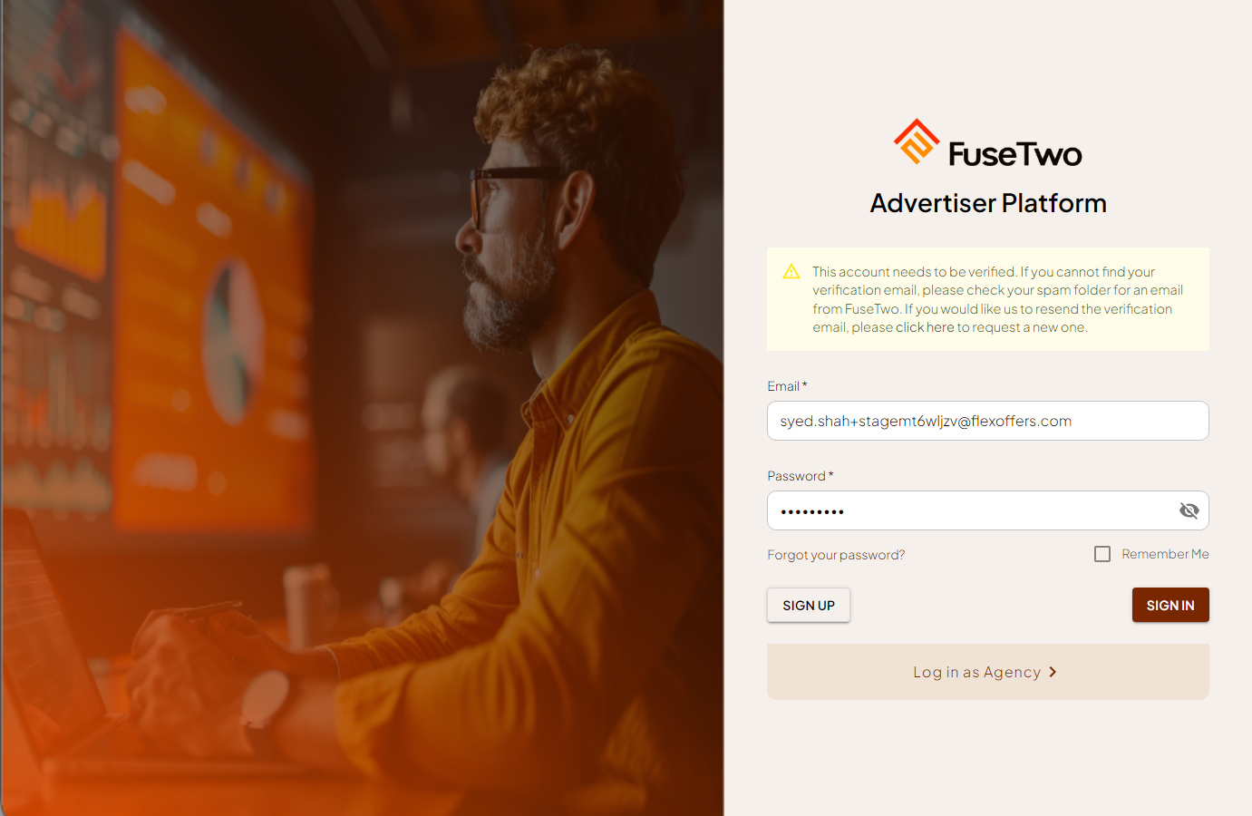
Pending — application under review
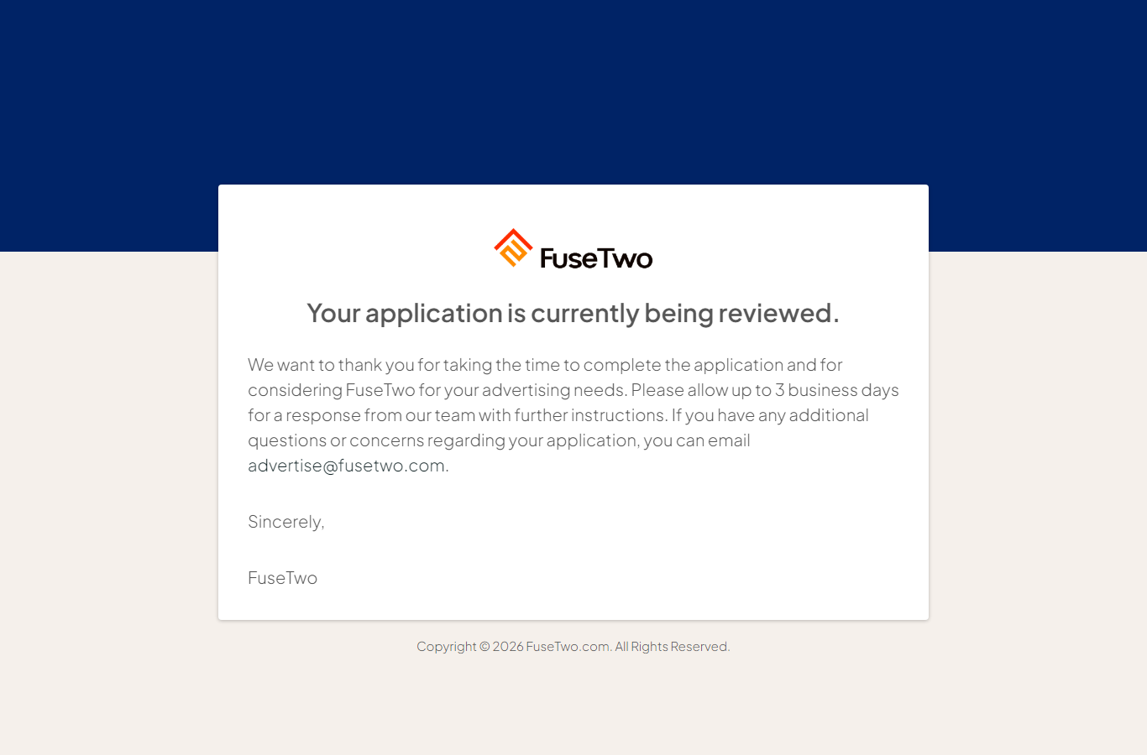
Collect Payment — approved, agreement & pricing
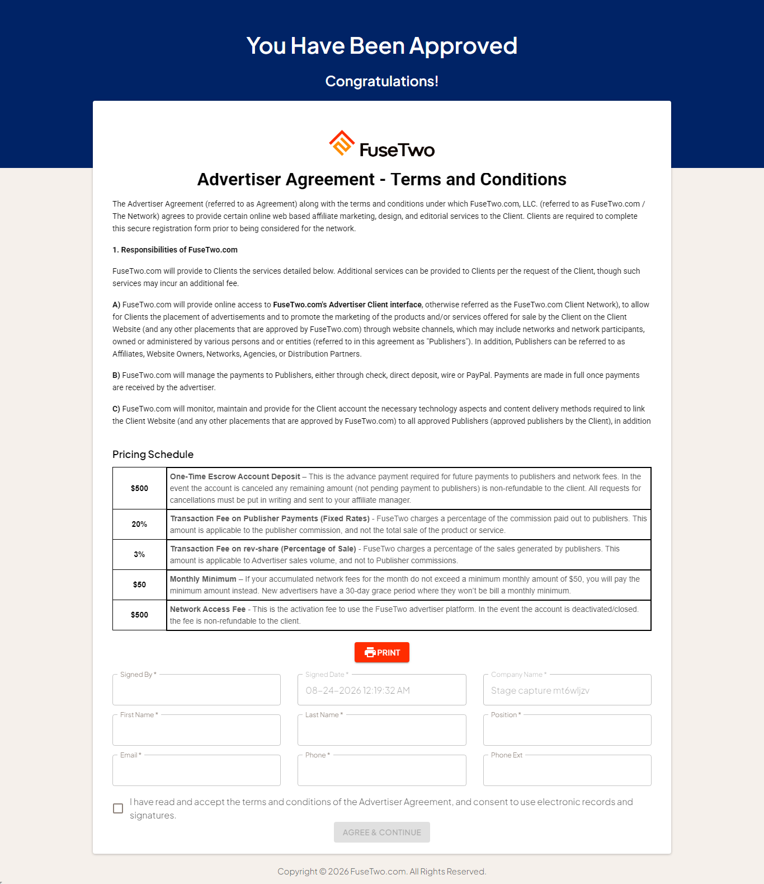
Initial Setup — dashboard gated by T&C modal
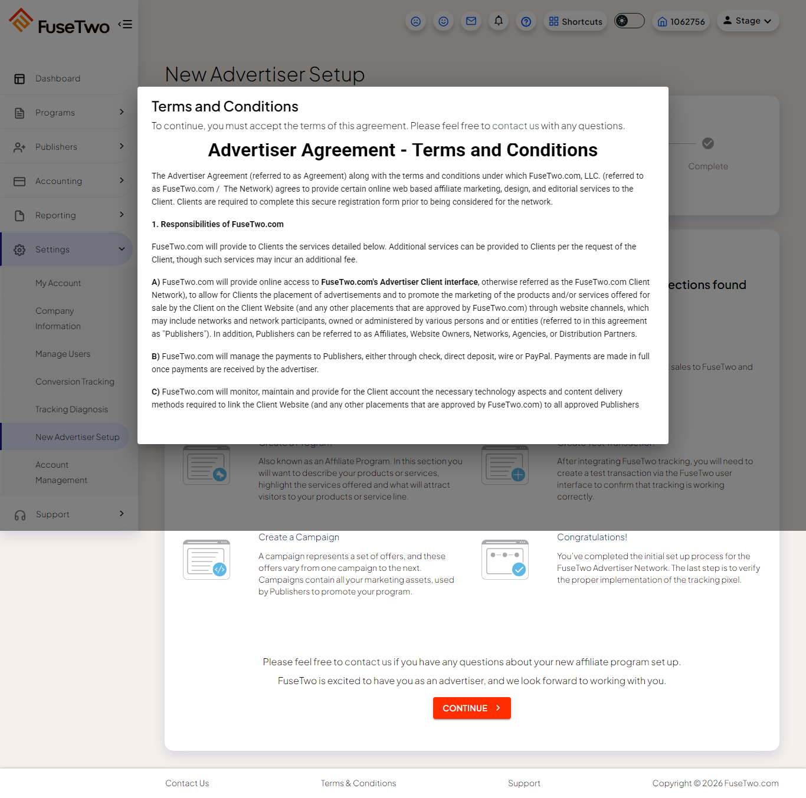
Follow Up — same as Pending

Approved — full dashboard
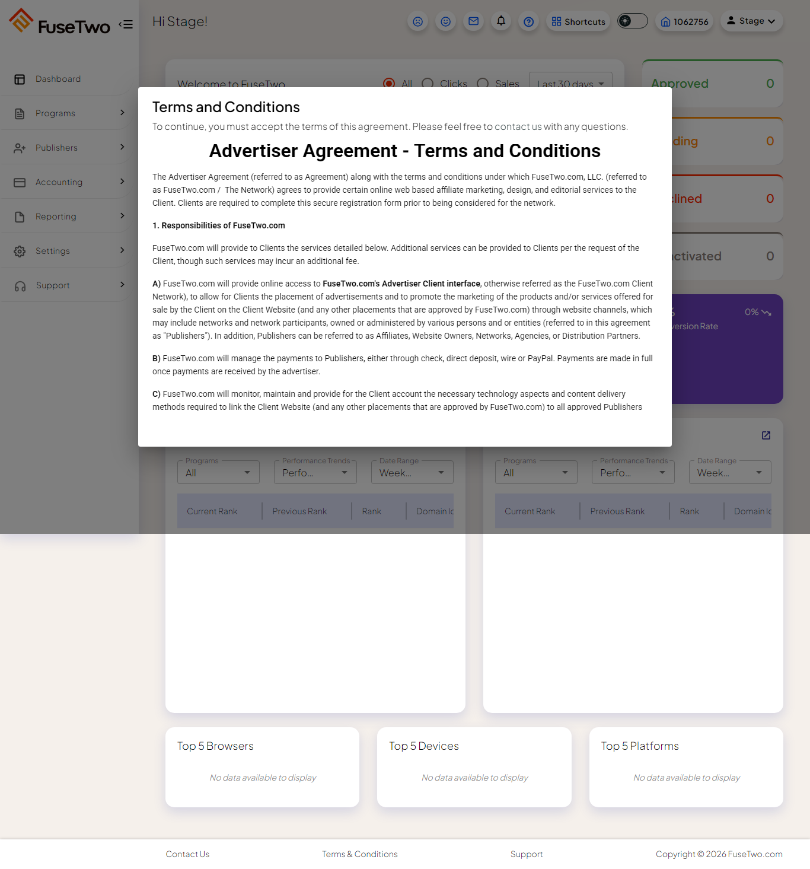
Deactivated — account deactivated
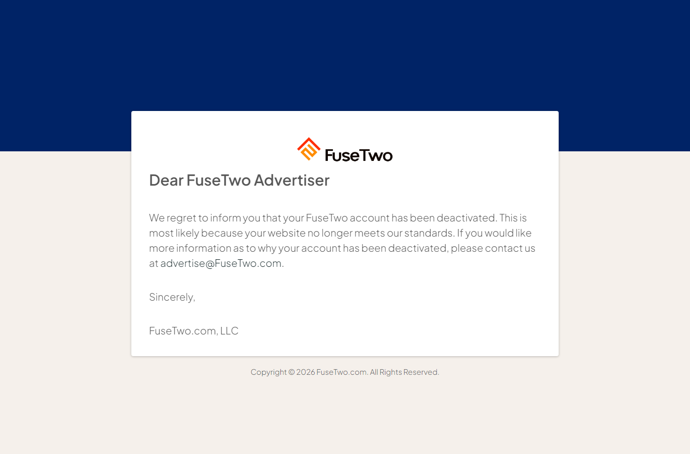
Declined — application declined
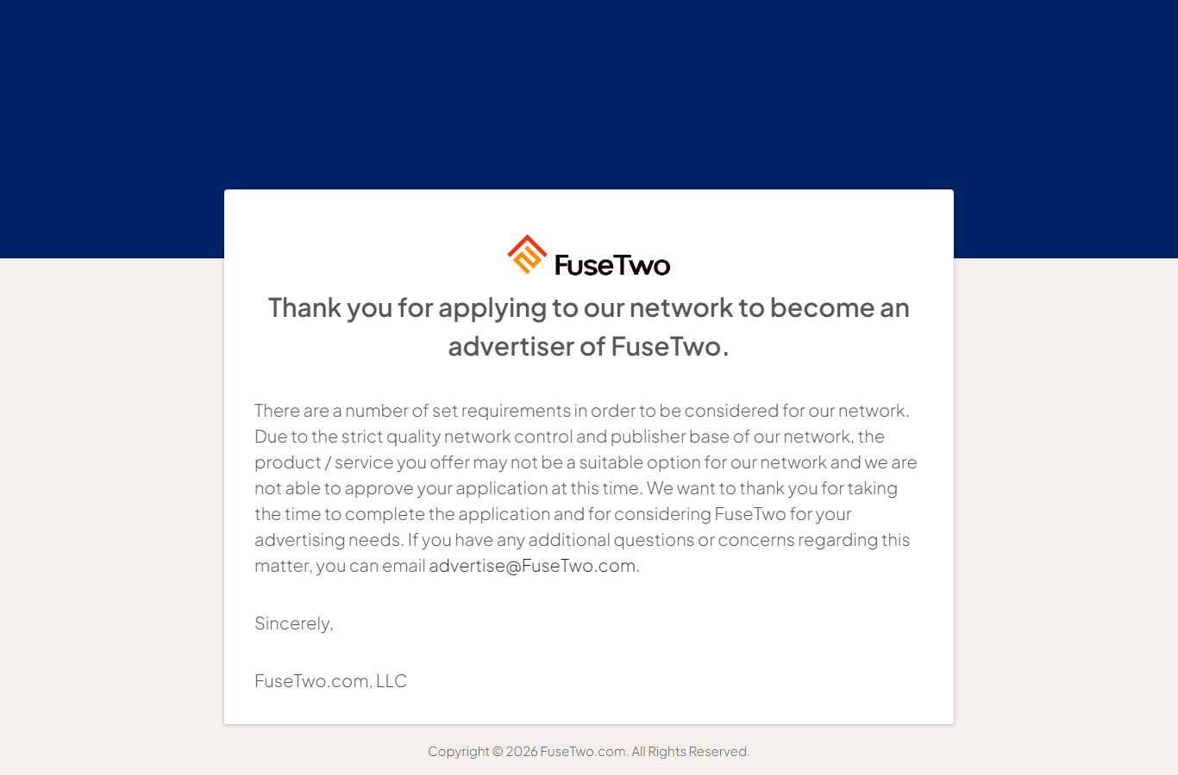

Status-change email notifications
Changing a status does NOT send an e-mail by itself. Submitting a status change opens an “Advertiser Email Notification” dialog where staff optionally choose a template and press Send. Covered by testStatusEmail.spec.ts.
Templates offered (dev and staging):
- Advertiser or Publisher
- Approval Login Information
- Collect Payment - Application Accepted
- Collect Payment - Free
- Deactivated - Letter
- Declined - Advertiser Application
- Follow Up - Free
- Initial Setup - Payment Confirmation & Instruction
Scenario | Tag | Result
Dialog opens, pre-addressed, with the templates above | @blocker | PASS
Sending a template delivers an e-mail | @known-bug | FAILS — no e-mail delivered
Finding: status notification e-mails do not dispatch. On Send the dialog accepts the template and closes cleanly, but no e-mail arrives. Confirmed on dev — across many status changes plus an explicit Send, zero notifications reached the inbox within 3 minutes, while “Verify Your Email” consistently arrives within a minute. The mail path works; status notifications silently fail to send.
The Advertiser Email Notification dialog after a status change
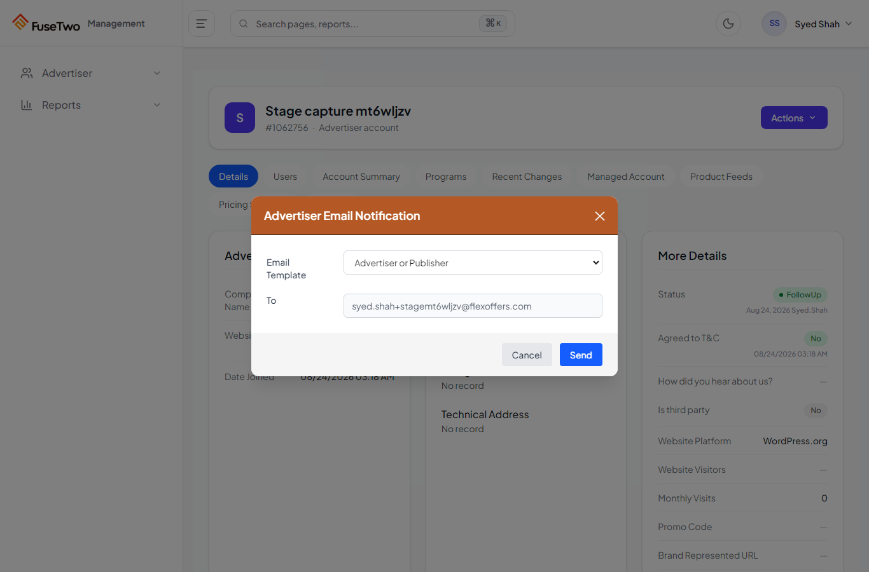

Management status control
- Advertiser detail is reached from the overview search (“Search by Advertiser ID | Name”); the result row's link carries the advertiser id.
- Actions → Change Status opens a dialog with a native dropdown: Pending, Collect Payment, Initial Setup, Follow Up, Approved, Declined, Deactivated, Fraud, Removed due to Audit, Collect Payment - Free, Follow Up - Free.
- The detail panel renders statuses without spaces (“CollectPayment”) while the dropdown uses spaces (“Collect Payment”) — comparisons are normalised.
- Bug #684 (“Advertiser Detail — Coming Soon”) is fixed on dev: the detail page renders in full.

How the mailbox is read
Verification needs the real e-mail, so tests read the actual QA inbox — no fake mail domain. Two backends, chosen automatically:
- Outlook COM (local, default here) — reuses the signed-in Outlook profile. No credentials, no app registration.
- Microsoft Graph (for CI) — an Azure AD app registration with Mail.Read. Set GRAPH_TENANT_ID / GRAPH_CLIENT_ID / GRAPH_CLIENT_SECRET.
Where neither is available, the mailbox-backed tests skip with a clear reason rather than passing as if covered. Every signup is plus-addressed (syed.shah+auto…@flexoffers.com), so one inbox receives them all.
Security note: the confirmation token is just base64(email) — no signature or expiry. A forged link shows “Your email has been verified!” but sign-in stays blocked, so it does not actually verify the account. The misleading success message on an invalid token is a minor UX issue.

Open questions for the team
- Status notification e-mails do not send — the Send button reports success but nothing is delivered. Needs a fix, then the known-bug tag comes off the delivery test.
- Should Follow Up look different from Pending to the advertiser? They are identical today.
- Confirm the intended landing page for each status, so the assertions can be locked as the contract.
- #762 ($50 vs $100 minimum) is visible on the Collect Payment page — worth prioritising, since it is customer-facing.

Full scenario checklist
Area | Scenario | Tag | Status
Registration | Register end to end | @blocker @write @crud | PASS
Registration | CAPTCHA regenerates every load | @security | PASS
Registration | Empty step 1 cannot submit | @blocker | PASS
Registration | Duplicate email cannot proceed | @write | PASS
Registration | Wrong CAPTCHA rejected | @known-bug | FAIL #681
Registration | “Required field*” hides after valid input | @known-bug | FAIL #686
Verification | E-mail arrives with a link | @blocker | PASS
Verification | Link enables sign-in | @blocker @crud | PASS
Lifecycle | New account blocked until verified | @blocker @security | PASS
Lifecycle | Advertiser appears in management | @blocker | PASS
Lifecycle | Moves through onboarding stages | @crud | PASS
Lifecycle | Declined kept out | @security | PASS
Per-stage | Each status lands on its correct page | @crud | PASS
Per-stage | Deactivated cannot sign in | @security | PASS
Status e-mail | Dialog opens, pre-addressed, templates present | @blocker | PASS
Status e-mail | Sending delivers an e-mail | @known-bug | FAIL — not delivered
Runs identically on dev, staging and live via TEST_ENV. All @write, so excluded from live runs unless explicitly enabled. Verified headed on dev (21 tests) on 24 August 2026.
Capture reference: advertiser id 1062756, syed.shah+stagemt6wljzv@flexoffers.com.

