FuseTwo — Onboarding: Production vs Staging
Onboarding tested on production (advertiser.fusetwo.com) with an identifiable QA account, and compared with staging. Prepared by Syed Shah, QA. 31 August 2026.

What was run on production
A single, clearly-named QA advertiser was registered on production, verified via the real mailbox, and signed in. No management changes were made (the production management portal is not reachable from the test machine).
Test account created on production: SYED TEST QA mtit7q2s <syed.shah+prodtestmtit7q2s@flexoffers.com> — status: pending review. Safe to decline/remove.

Result — production onboarding
Step | Result
Step 1 CAPTCHA read (dynamic canvas) | PASS
Advance to step 2 (company) | PASS
Registration reaches Thank You | PASS
Verification e-mail received | PASS
Verify link resolves to /emailconfirmation | PASS
Unverified login lands on the gate page | /account/pending-account

Extensive scenarios run on production
Scenario | Result
Register a new advertiser (SYED TEST QA #1062627) | PASS
Verification e-mail received + link resolves | PASS
Unverified login → pending-account gate | PASS
Management portal login (Windows SSO, shown as “Syed Shah”) | PASS
Advertiser visible + detail opens in management | PASS
Edit Advertiser Information (website) — persists | PASS
Edit Contact Information (city) — persists | PASS
Add internal note | PASS
Change status (Pending → Collect Payment) | PASS
Status-change notification e-mail delivered | FAIL — not delivered (bug B-1)
Bug confirmed on production: status-change notification e-mails are not delivered on production either. The Send dialog accepts the template and closes, but no e-mail arrives (only the signup 'Verify Your Email' is ever received). Same as dev and staging (B-1).

Production vs Staging — comparison
Aspect | Production | Staging | Difference
Signup form (fields, layout) | identical | identical | none
CAPTCHA (dynamic canvas) | yes | yes | none
Registration → Thank You | yes | yes | none
Verification e-mail (HubSpot “Verify Your Email”) | yes | yes | none
Confirmation token = base64(email), no signature | yes | yes | none — both weak (B-5)
Management CRUD (edit info / contact / note) | works + persists | works + persists | none
Status change (Pending → Collect Payment) | works | works | none
Status notification e-mail delivered | NO | NO | none — both broken (B-1)
Verify link → /emailconfirmation | yes | yes | none
Unverified login → /account/pending-account | yes | yes | none
Management portal reachable | YES (management.prod.fusetwo.com) | YES | none
New advertiser visible in management | yes (#1062627) | yes | none
Advertiser detail route /advertiser/{id} | works | works | none
Detail edit dialogs (2 Edit buttons) | present | present | none

Summary
- Production and staging onboarding are effectively identical — same signup form, same CAPTCHA, same verification e-mail and token, same pending-account landing, and the same management portal (advertiser visible, same detail route and edit dialogs).
- The production management portal is reachable at management.prod.fusetwo.com (the earlier 'not reachable' result was a wrong host — management.fusetwo.com); config/env/prod.env has been corrected.
- The confirmation token is plain base64(email) on production too (no signature or expiry) — the same weakness (B-5) seen on dev and staging.
- No production bugs were found in the onboarding path; it works end to end, including the management side. No status changes were made on the production account.

Production screenshots
Production signup — Thank You
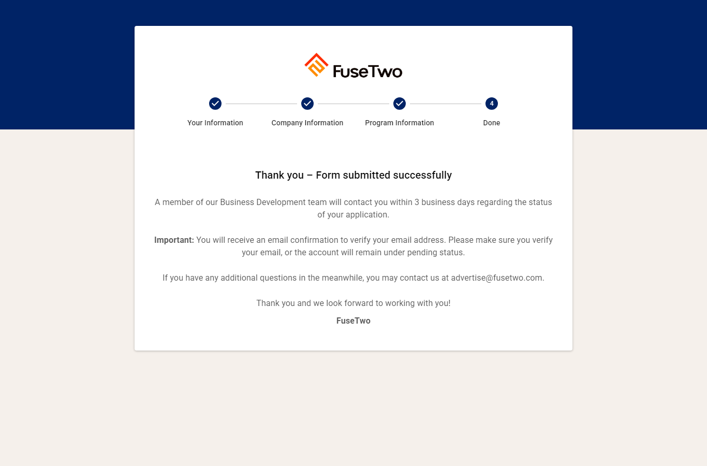
Production login — pending-account gate
