**Chandrayaan-2:**

The Indian Space Research Organisation (ISRO) developed Chandrayaan-2 as their second mission to explore the moon, following Chandrayaan-1. The mission includes an orbiter, lander, and rover called Pragyan, all of which were developed in India. The primary scientific goal is to analyze the differences in the lunar surface's composition, as well as identify the presence and amount of water on the moon.

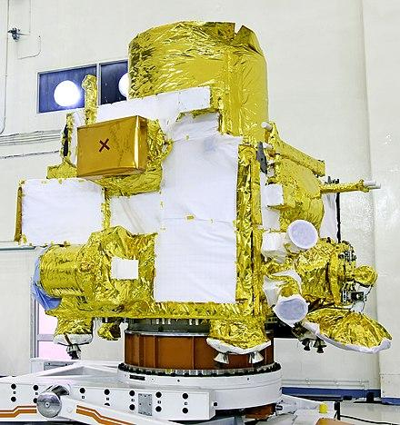

On 22 July 2019 at 09:13:12 UTC, a LVM3-M1 rocket launched the spacecraft from the Satish Dhawan Space Centre's second launch pad in Andhra Pradesh to commence its mission to the Moon. After reaching the Moon's orbit on 20 August 2019, the craft initiated orbital positioning manoeuvres for the Vikram lander's landing. The planned landing site was the near side of the Moon's south polar region, at a latitude of approximately 70° south. The lander and rover were expected to perform scientific experiments for one lunar day, equivalent to two weeks on Earth.

Unfortunately, on 6 September 2019, the lander deviated from its intended trajectory and crashed during its landing attempt. A software glitch caused the crash, according to a failure analysis report submitted to ISRO. In response, ISRO will make a new attempt to land with Chandrayaan-3 in 2023.

As of June 2019, the mission has an allocated cost of ₹ 9.78 billion (approximately US$141 million which includes ₹ 6 billion for the space segment and ₹ 3.75 billion as launch costs on GSLV Mk III M1.[49][50] Chandrayaan-2 stack was initially put in an Earth parking orbit of 170 km (110 mi) perigee and 40,400 km (25,100 mi) apogee by the launch vehicle.

**Goal**

* The primary objectives of the Chandrayaan-2 lander were to demonstrate the ability to soft-land and operate a robotic rover on the lunar surface.
* to study lunar topography, mineralogy, elemental abundance, the lunar exosphere, and signatures of hydroxyl and water ice.[43][44]
* to study the water ice in the south polar region and thickness of the lunar regolith on the surface.[45]
* to map the lunar surface and help to prepare 3D maps of it.