**GIT [By Linus Torvalds - 2005]**

1.What is GIT ?

GIT is a Distributed Version Control System (VCS).

2.USES :

* Easy File Recovery.
* Roll back to the previously working stage.
* Can easily find out what, when and who did the changes.

3. What is version control system?

1.**Local version control system** : [A server is maintained to keep track of files].

Project is deployed only in our local system.

Pros : Can track files and rollback easily.

Cons : If you lose your hard disk everything is lost.

Local Server

2. **Centralized Version Control System** : [A server is maintained where pulling of files and

modifying it and pushing back to the server].

File Pulled

Server

File Pushed

3. **Distributed Version Control System** : [A Complete backup of repository can be taken from

distributed server].

Commit/Replace

Local System

Server Repository

File Pushed

File Pulled

Server

4.What is GITHUB?

* GitHub is a hosting service(website).
* GITHUB is a website that hosts git repositories.

5.CHECKSUM : It is used to verify whether the downloaded file is authentic or not.

Using : SHA (eg : 3IUE32142).

How to make Author of Git Repository ?

Open folder 🡪 right click 🡪 open git bash terminal :

Commands :

$git config --global user.name “Syed” - [For creating author]

$git config --global user.email “[zrsyed03@gmail.com](mailto:zrsyed03@gmail.com)” - [For creating Email]

$git config --list - [To Print details of repository author name, email , date]

$git config user.name - [To Print only username]

$git config user.email - [To Print only email]

$git status - [To check the status of repository]

$git init - [To initialize the repository]

$git add --a / . - [To add the files in repository]

$git commit -m “initial commit” - [To commit the changes done along with msg]

$git commit - [A vim editor will open bttr to use above cmd]

$git log - [Displays history of changes done on your project]

$git add file_name.txt - [To add single file]

$git commit file_name.txt - [To commit singlr file]

$git rm -rf .git - [To delete whole repository]

$pwd (Present Working Directory) - [To check in which directory u r present]

Note : if the path contains /.git that means ur are in git repository.

$ls - [Displays list of files, folders]

$cd tensorflow/ - [Moves to the desired folder]

$touch file_name.ext - [To create blank file]

$touch .gitignore - [Create this file and add the file names to ignore those   
 files,those files will be untracked now].

$git diff -staging - [It shows the differences made in files.]

$git commit -a -m “Direct Commit” - [To commit the Files which are modified by skipping the  
 Staging Area].

$git rm file_name.ext - [To remove/delete file]

$git mv file_name.ext - [To move/rename file]

$git rm –cached file_name.ext - [To untrack file externally]  
(After adding filename in .gitignore file and still terminal shows that modification has been done, so to untrack that file and ignore it explicitly using above cmd).

$git log - [History of changes done in directories]

$git log -p - [What changes made before and after will be displayed]

$git log -p -3 - [Displays only 3 commit based on no. we enter]

$git log --stat - [Display’s summary of whole data of author]

$git log --pretty=oneline - [Display’s all the commit done in whole repository in   
 single line]

$git log --pretty=short - [Display’s author ,commit,message only].

$git log --pretty=full - [Display’s author,date ,commit,message only].

$git.log --since=2.days - [Display’s the 2 days history]

$git log --pretty=format:”%h -- %an” - [Apply filter to git log, only these details are displayed]

(%h-abbrivated hash commit %an- author name, %ae – author email).

$git commit --amend - [changes made are added to author’s commit]  
(While using this command a VIM editor will open 🡪 press I 🡪 type msg in 1st line 🡪 press ESC 🡪 press semicolon [:wq] to exit from VIM editor).

$git log -p -1 - [Display’s author name and msg will be printed]

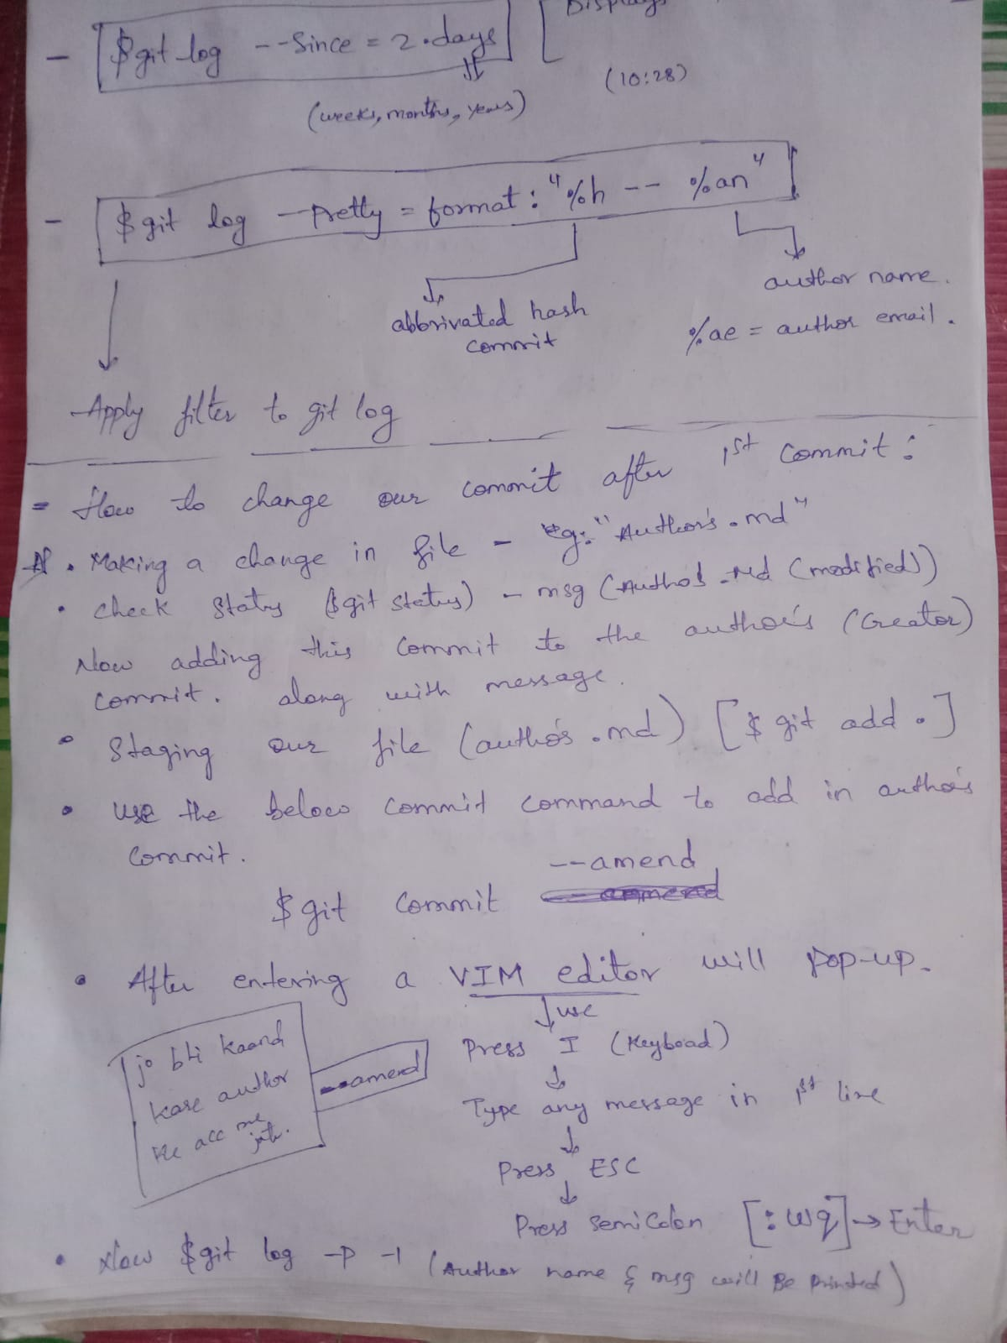

How to ignore , unsatge and unmodify git ?

$git checkout --file_name.ext - [To Unstage a file after modification to previous stage]  
  
$git restore --staged file_name.ext - [previous changes are retrived after using this command]

$git checkout -f - [To retrive the changes done for number of files].

**What is .gitignore?**

.gitignore is a file created using $tocuh .gitignore, it automatically creates a file in your local repository.

Features :  
1.what all the files you want to ignore in your repository write their names in .gitignore file.

2.If you want to ignore all the text files (write eg : *.txt,*.log), these all files will be ignored.

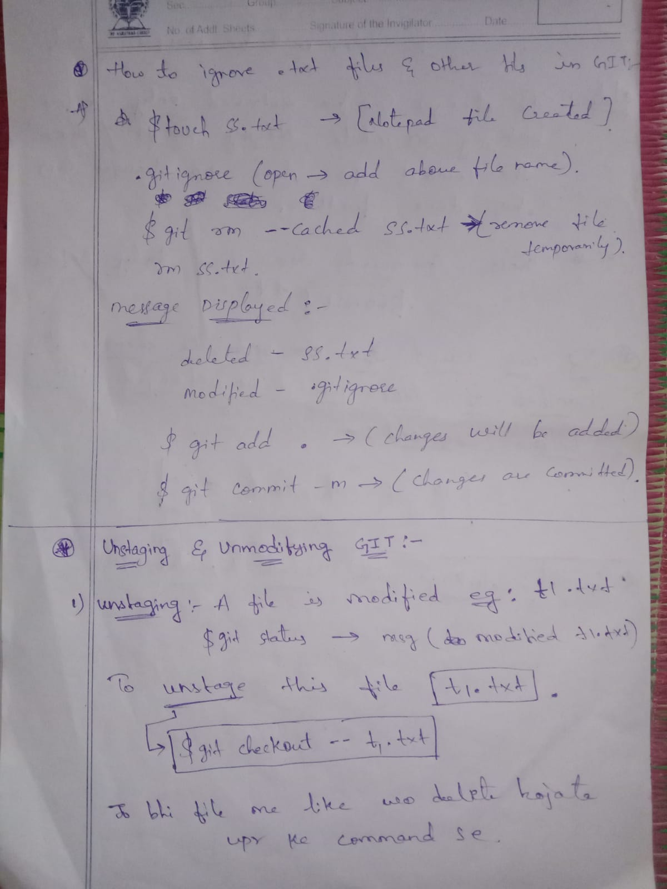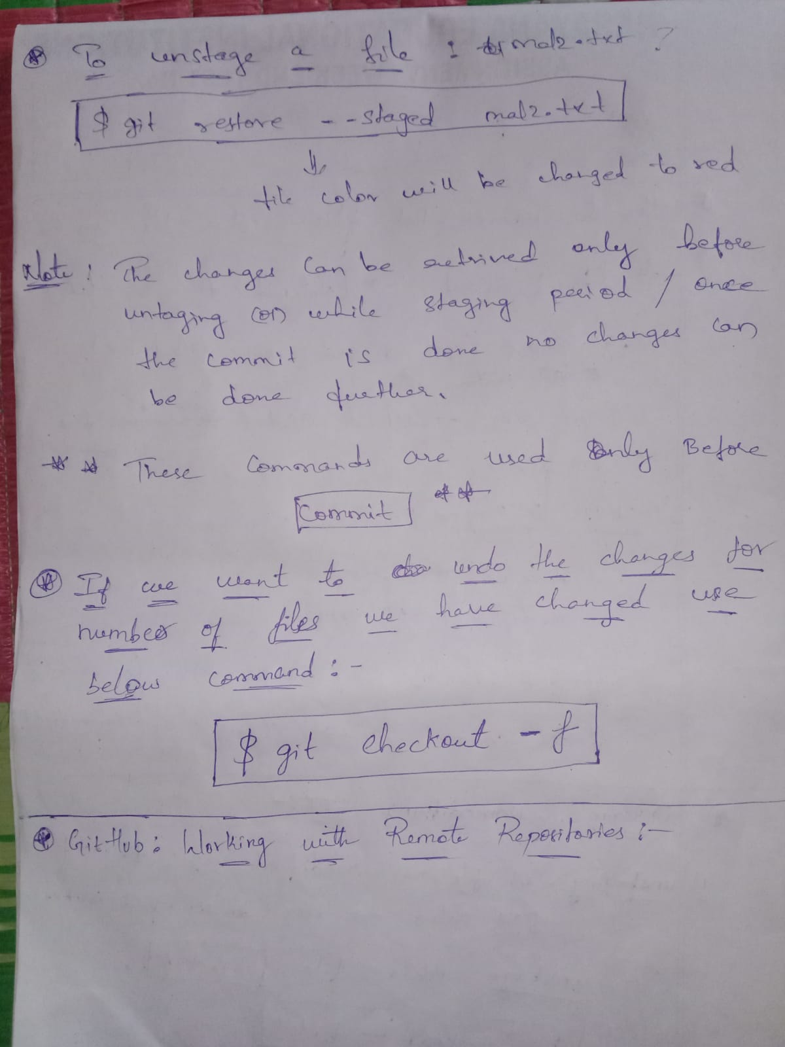

How to Clone remote GIT repository (from GITHUB)?

Copy link from GITHUB project [eg : tensorflow project]

Commands :

$git clone “<https://tensorflow/project>” ternsoflow_copy (given name)

[The above cmd will copy whole project repository in our local system].

If any changes done in above repository :

$git status - [To check the status of repository]

$git add --a / . - [To add the files in repository]

$git commit -m “initial commit” - [To commit the changes done along with msg]

$git log - [Displays history of changes done on your project ]