MamaBot: A System Based on ML and NLP for Supporting Women and Families during Pregnancy

In this project we are designing MAMABOT application which helps pregnant women’s to get answers for their queries or doubt. To build this project we used NLP (natural language processing toolkit) and Machine Learning Algorithm called LSTM (Long Short Term Memory).

LSTM will be trained with all possible questions and answers and whenever user ask any question then LSTM will predict answer for that question and handover that answer to MAMABOT to display to user. To train LSTM we have used some questions and answers related to pregnancy as no public dataset available so we gather some questions and answers from internet and all this questions are saved in dataset folder as JSON file. Below screen shots showing some questions from dataset.

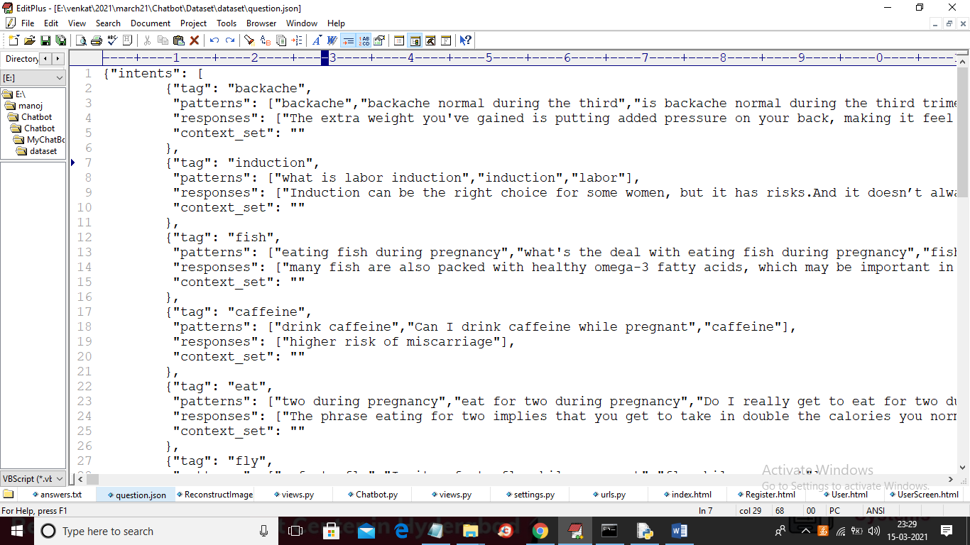

In above screen tag is the question id and patterns are the question and responses are the answer and we used above dataset to train ML algorithm. You can download below IEEE paper related to your project

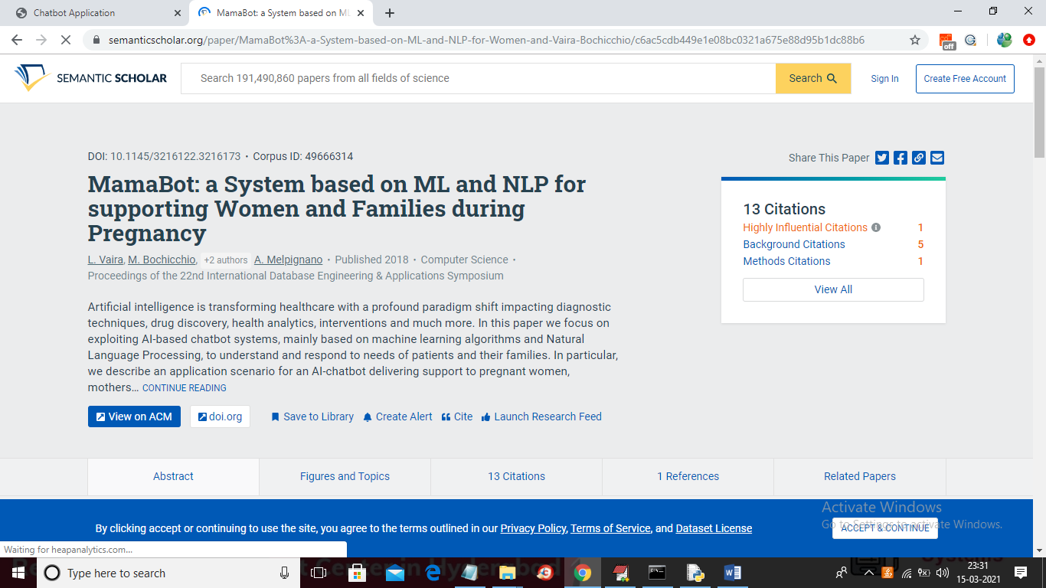

SCREEN SHOTS

To run project install DJANGO, MYSQL and put Chatbot folder in any directory of your system and then run below command to start server

Python manage.py runserver

After executing above command then open browser and enter URL as ‘http://127.0.0.1:8000/index.html’ and press enter key to get home page

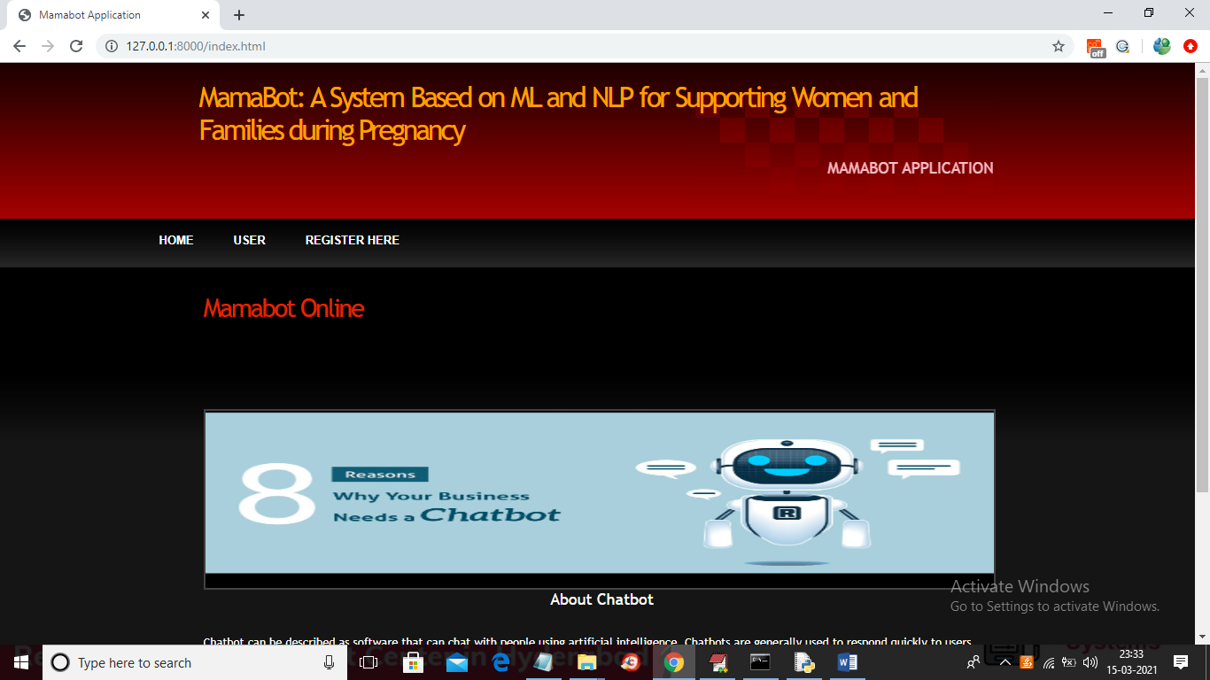

In above screen click on ‘Register Here’ link to get below signup page

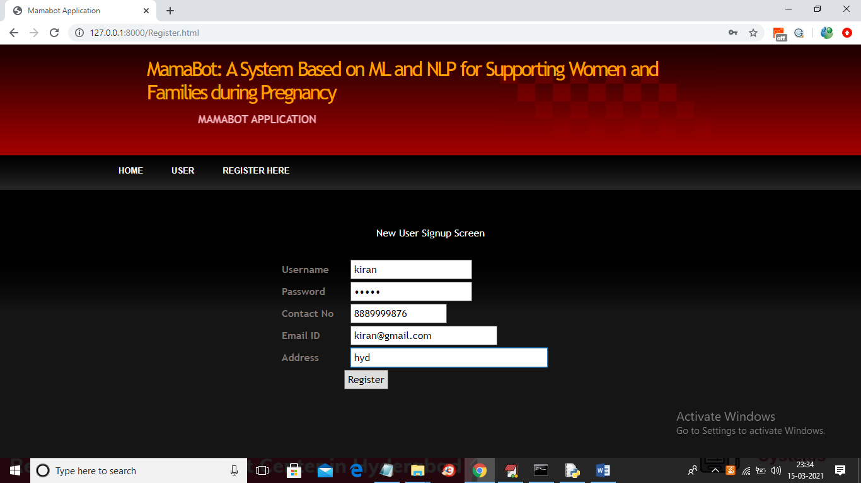

In above screen user can enter some signup details and then press ‘Register’ button to get below screen

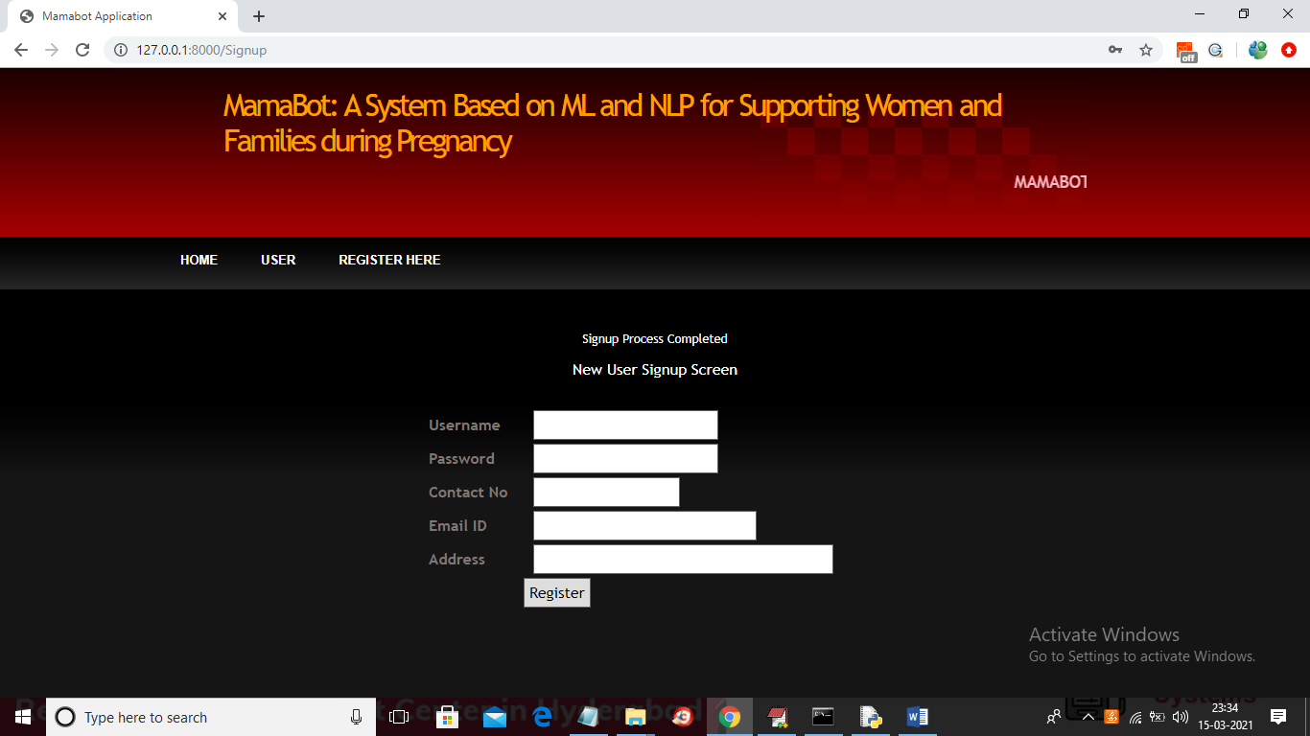

In above screen user signup process completed and now user can login by clicking on ‘User’ link

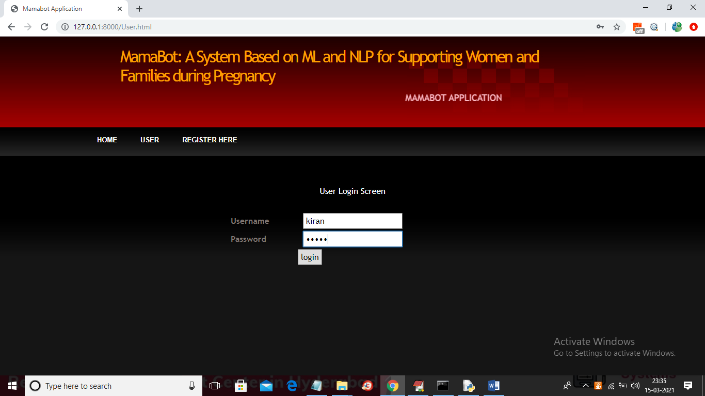

In above screen user is login and after successful login will get below page

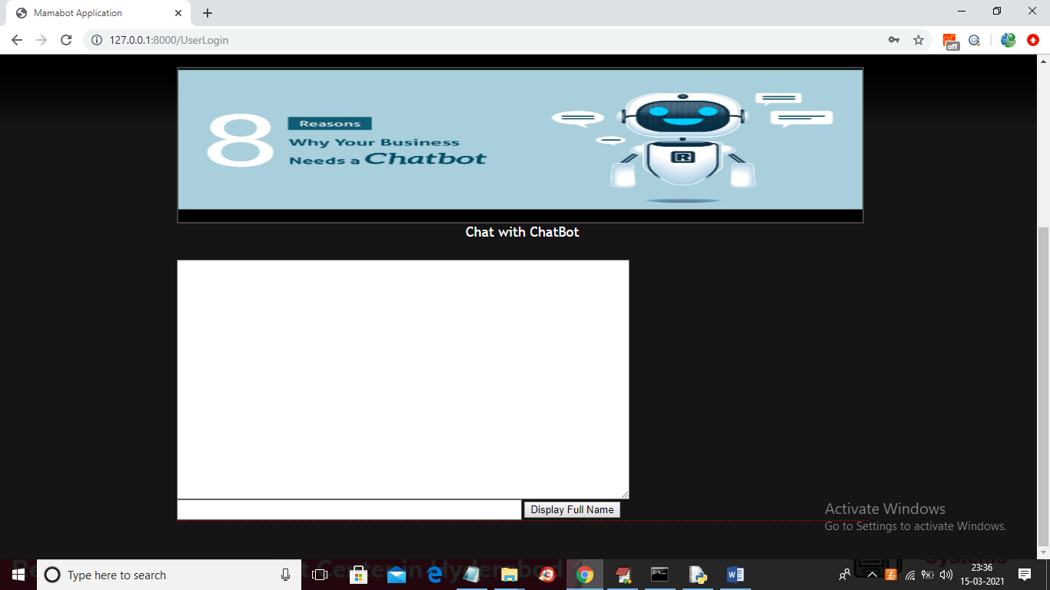

In above screen user can enter any query and then click on ‘Display Full Name’ button to get answer from MAMABOT and if question not available in MAMABOT train model then user will get SORRY message

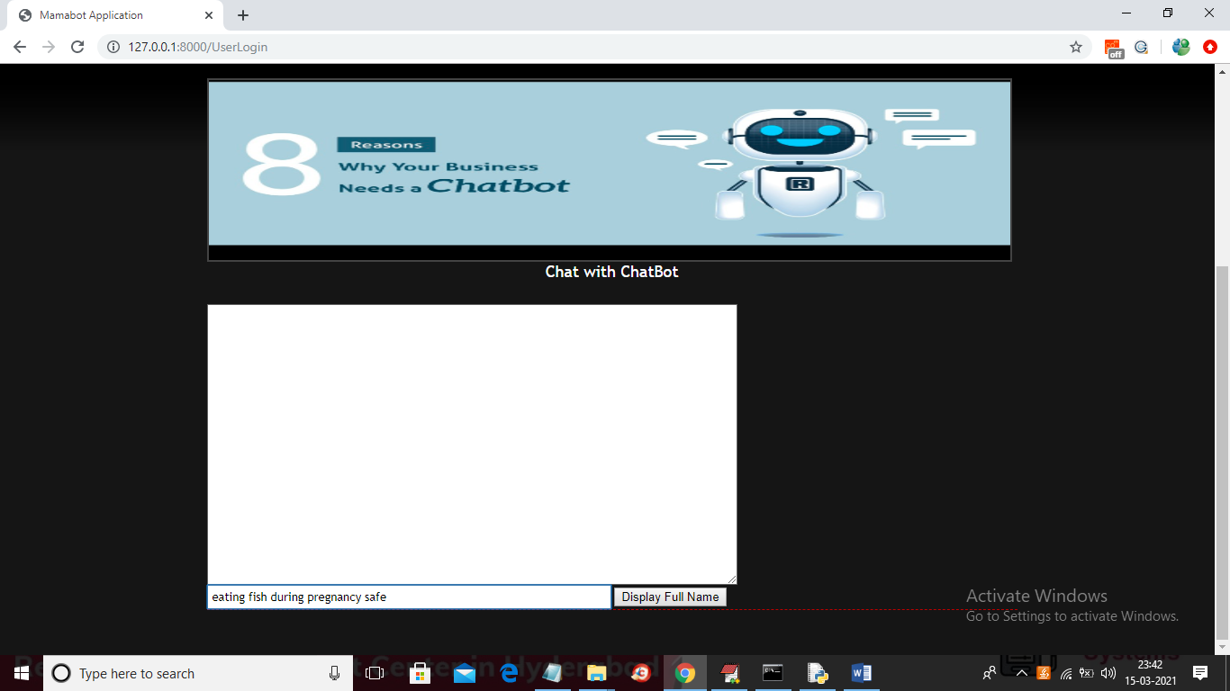

In above screen user type some question and then press button to get below output

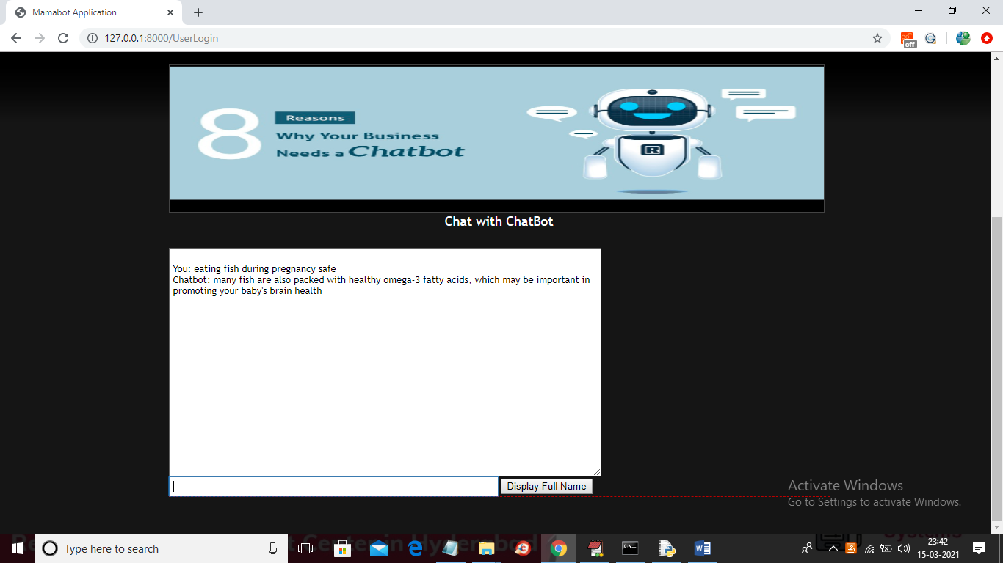

In above screen we got some answer from MAMABOT and try some other questions as

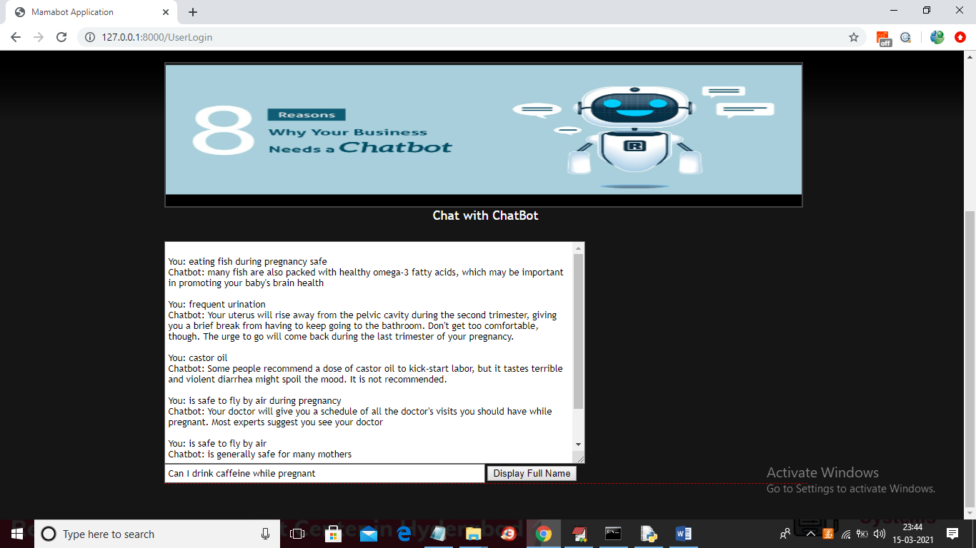

In above screen I ask some question and MAMABOT answer it well

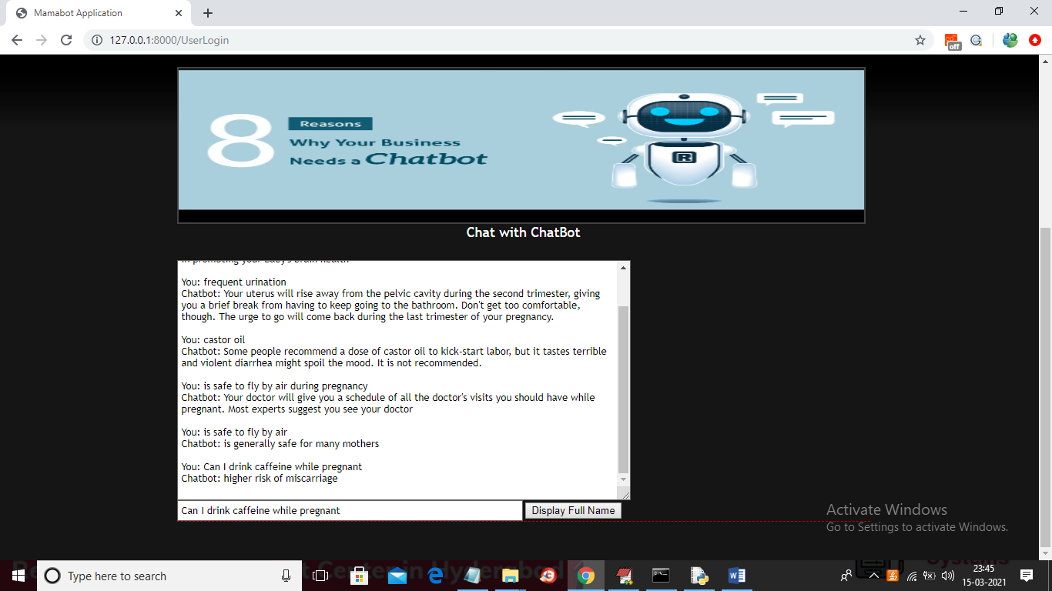

You can ask all questions available in dataset/question.json file and now give some query out of train model

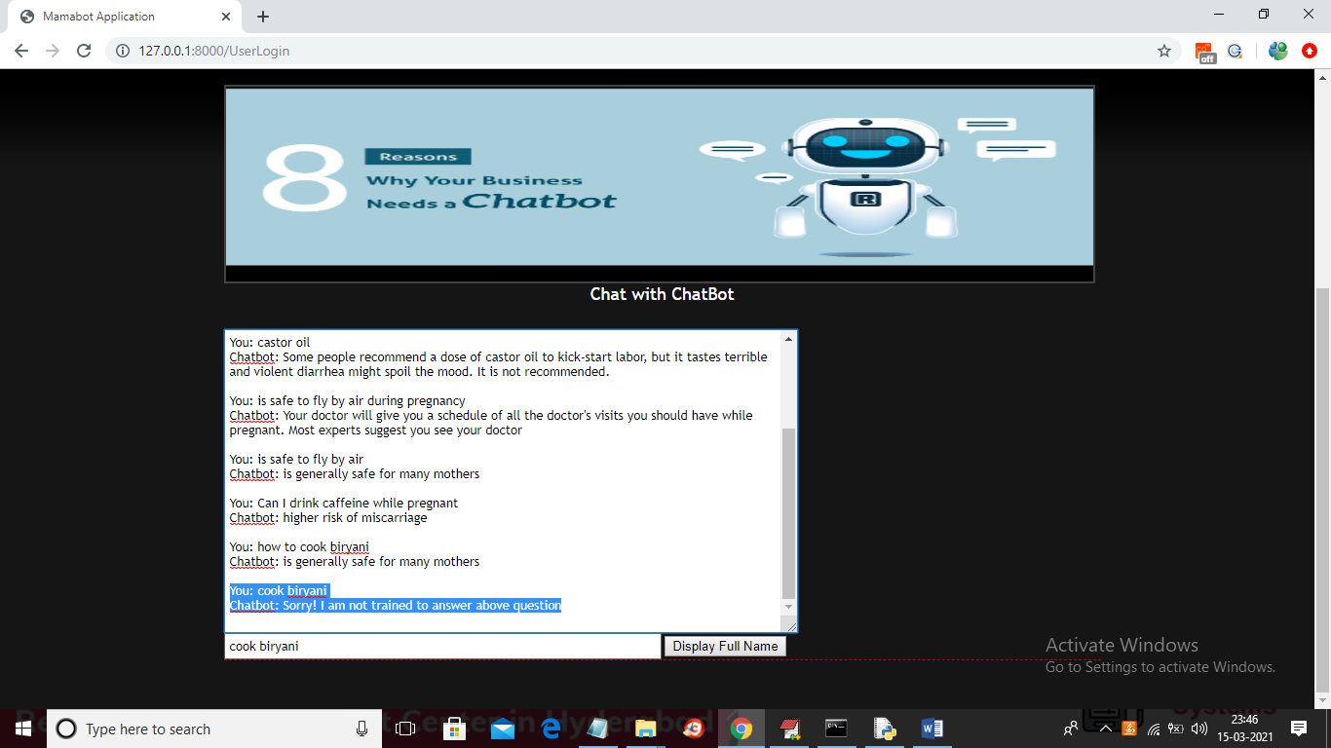

In above screen I ask question as ‘cook biryani’ and bot answer as SORRY