**PROJECT REPORT**

**Application description** : It is a basic sample application used to register a user and the user details will be added in the database php myadmin. details of user like username,email,password..etc

**Basic Components**

* Php:
* Tomcat Server
* Database

Application deployed as a Docker Container with the help of Docker Compose and the Cloud provider AWS

AWS services used EC2 and VPC

**Configuration of EC2:**

1. **Instance-Type** : t2.micro
2. **VPC**: I have created one VPC in N.Virginia region(us-east-1) name as myvpc.
   * 1. Vpc Id: vpc-09aa43ffcb73cb68a(myvpc)
     2. Vpc Ipv4 cidr block: 10.0.0.0/16

3.**Subnet**: I have created one subnet in VPC in N.Virginia region(us-east-1) name as mysubnet

1. Subnet id: subnet-0086ed7d5a2200fb8
2. Subnet Ipv4 cidr block 10.0.0.0/24

4.**Internet Gateway**: I have created one IGW in N.Virginia region(us-east-1) name as igw and attach with VPC.

5.**Route Table**: I have created one Route Table in N.Virginia region(us-east-1) name as routtable1 and associate with subnet mysubnet and define Routes inside the Routes.

6. **Tag Name**: I have given tag name to the ec2-machine is Linux-instance.

7. **Security Group**: I have created one Security group named as sg1. It is used to route traffic on this webserver. In this group I have opened some ports to route traffic.

I have opened ports are : Port no. 22,80,443,3306,8081

**Screenshots of EC2/SG:**

**EC2:**

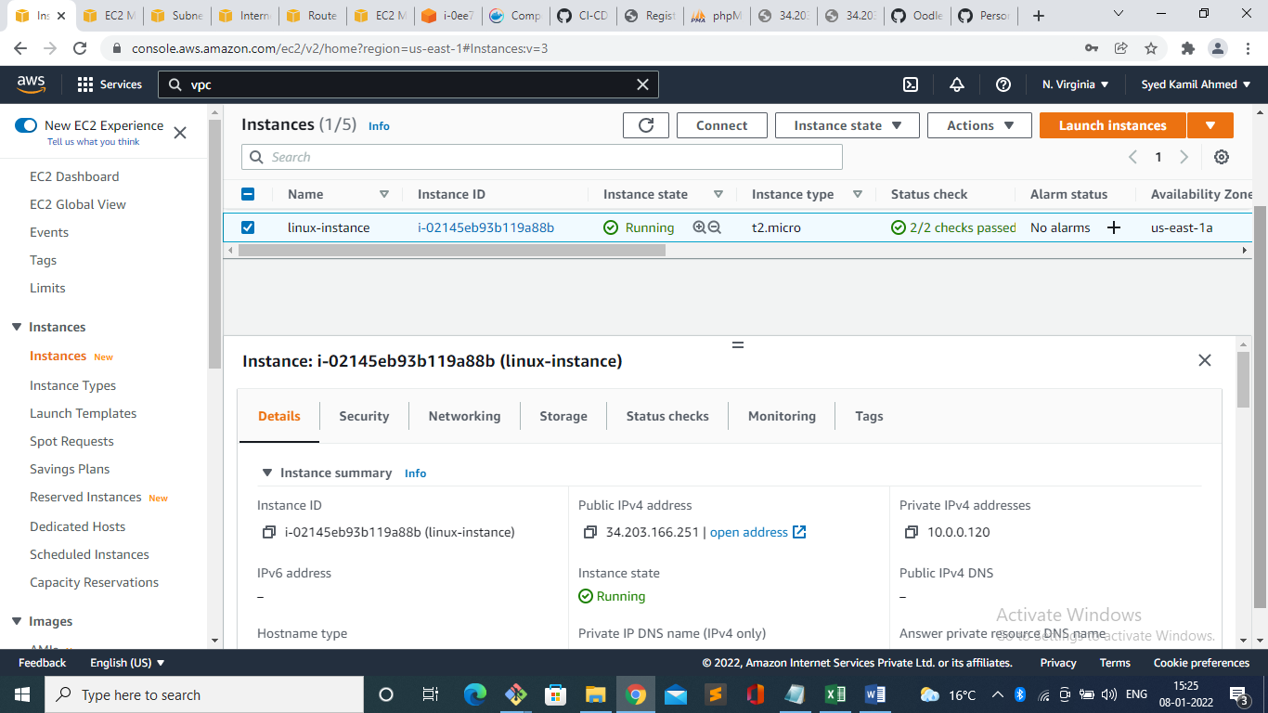

**SG:**

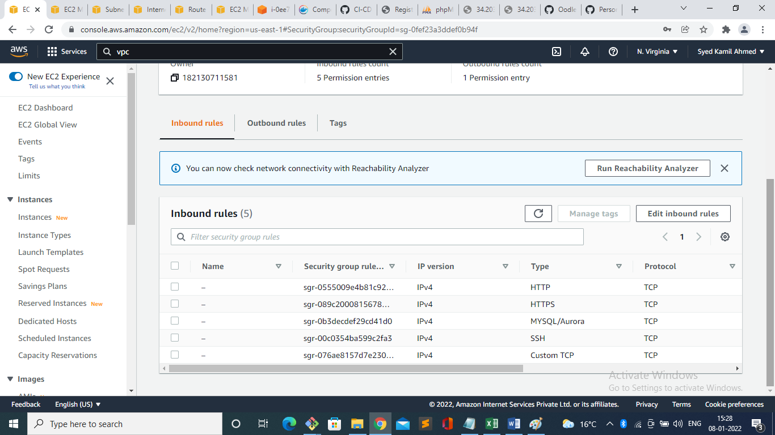

**Screenshots of VPC, Subnet, IG, and Route Table**

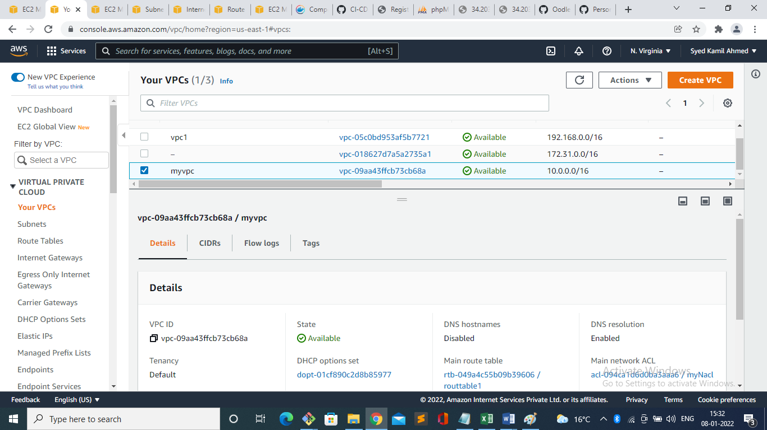

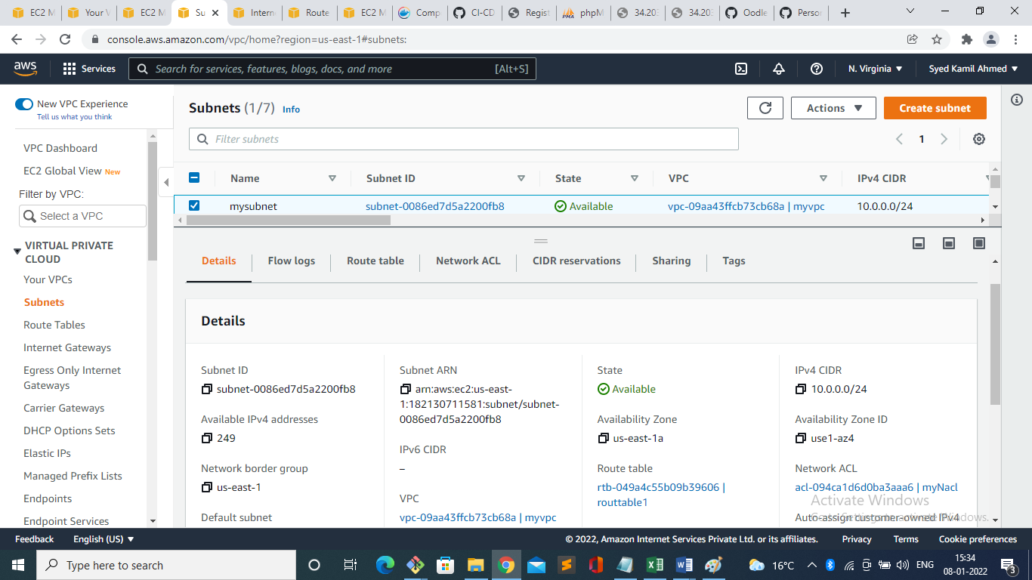

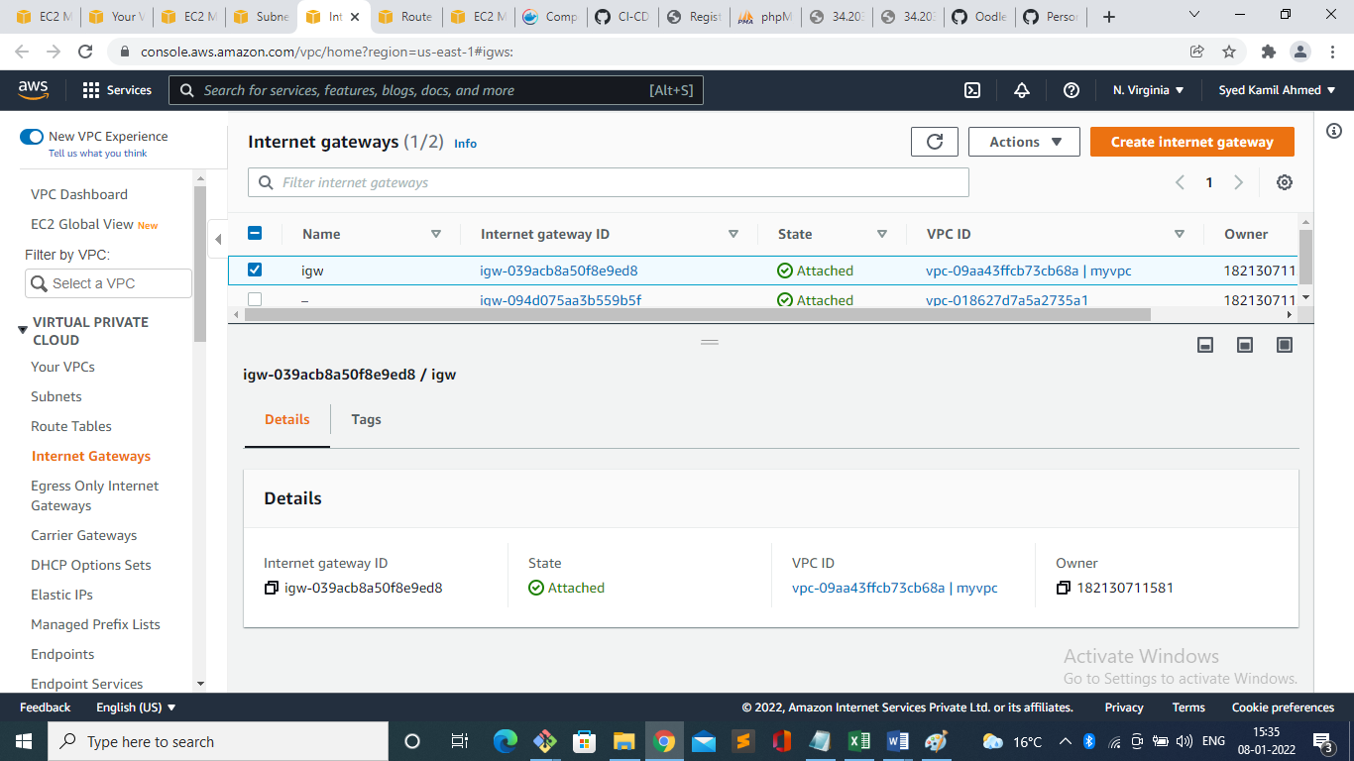

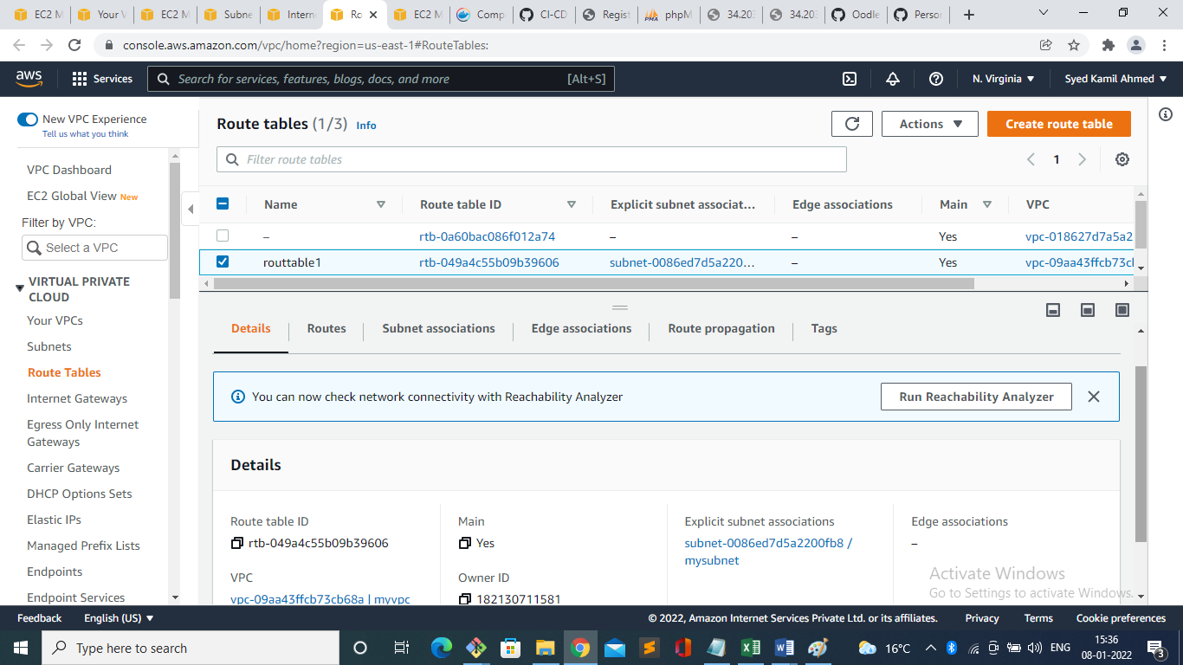

I have Created new user username name as Syed on same Linux Machine and enable ssh key based authentication

1. I have created user using command: **useradd syed**
2. I switched user to syed using command :

**su – syed**

1. I have created ssh based authentication using command : **ssh-keygen**
2. .ssh directory created using this command in this directory one private key and one public key is generated.
3. I have created one file using touch command : touch authorized_keys
4. I generated one .pem key from AWS key pairs and after that I retrived the public key from private keyusing command

ssh-keygen –y –f keyname.pem

1. After that I copied the code of .pem file to authorized_keys file
2. Then, change permission to this authorized_keys file : chmod 600 authorized_keys
3. Then, change permission to this authorized_keys file : chmod 400 keyname.pem
4. ssh –i keyname.pem syed@publicipofhost

now you can acess the linux machine as a user named syed

**Reference:** **https://github.com/devops4solutions/CI-CD-using-Docker.git**