nmap -v -sC -sV 10.10.10.250

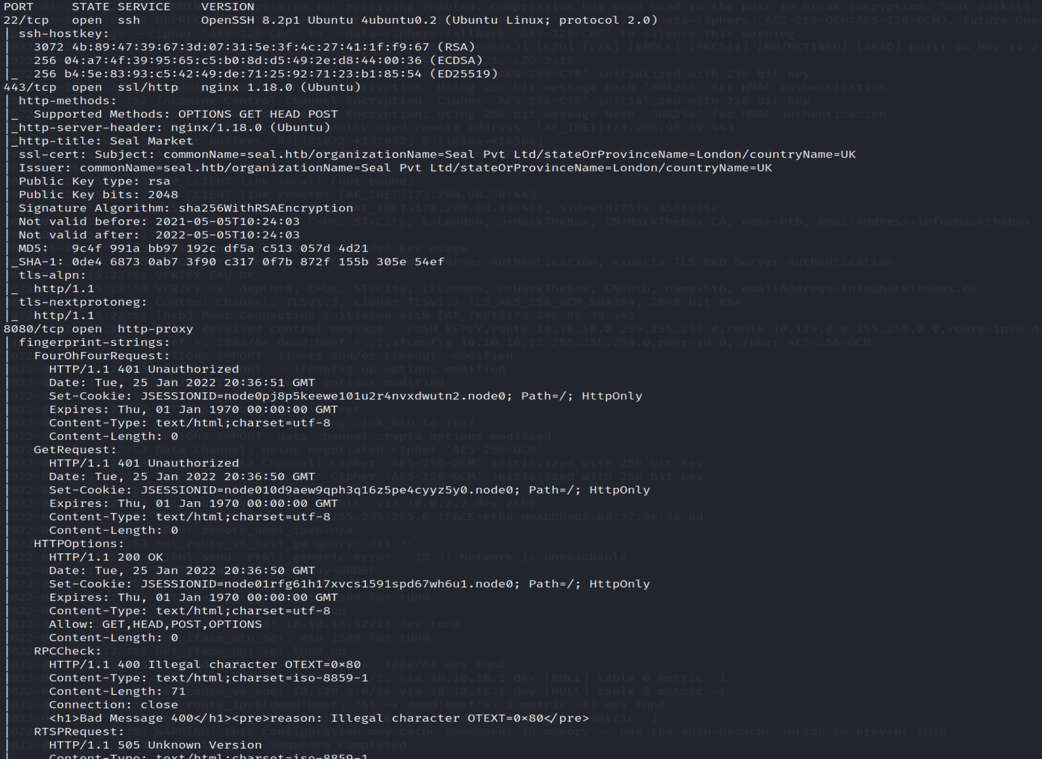

We have 3 open ports 22,443,8080 running openssh, nginx, http-proxy

Visitng the site

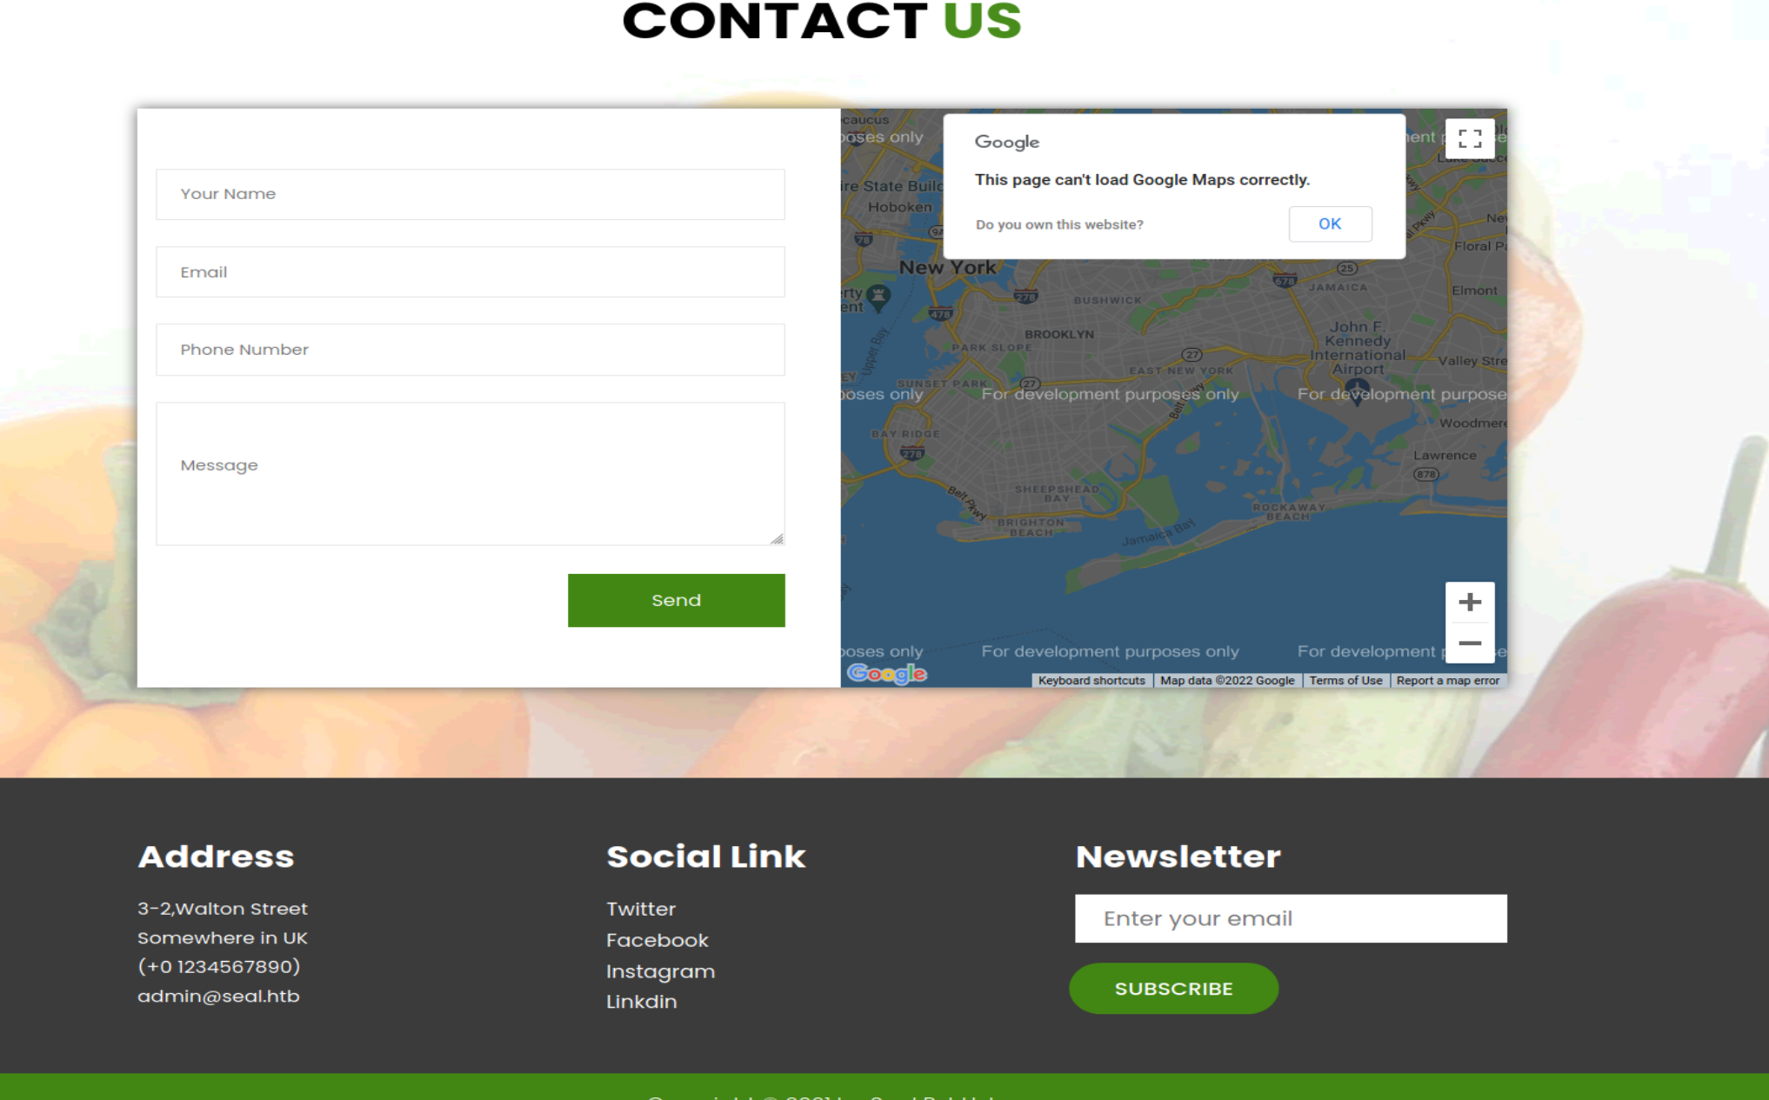

Dirbustering the seal

