Baby-RE

Strings useful as stripped used

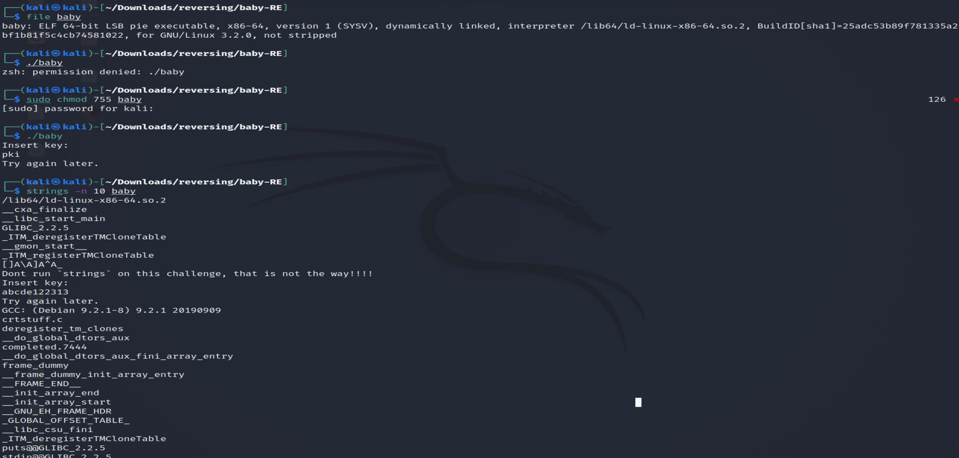

2.Use of ltrace

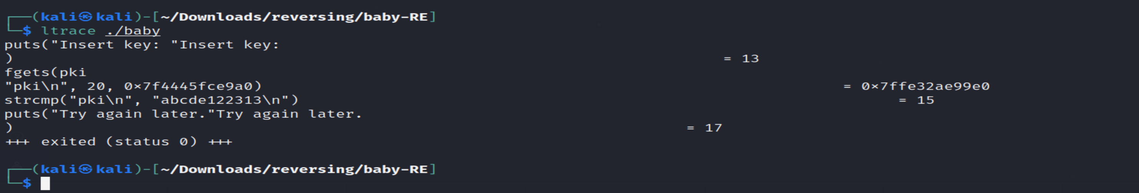

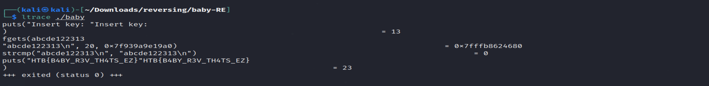

3.ghidra static analysis

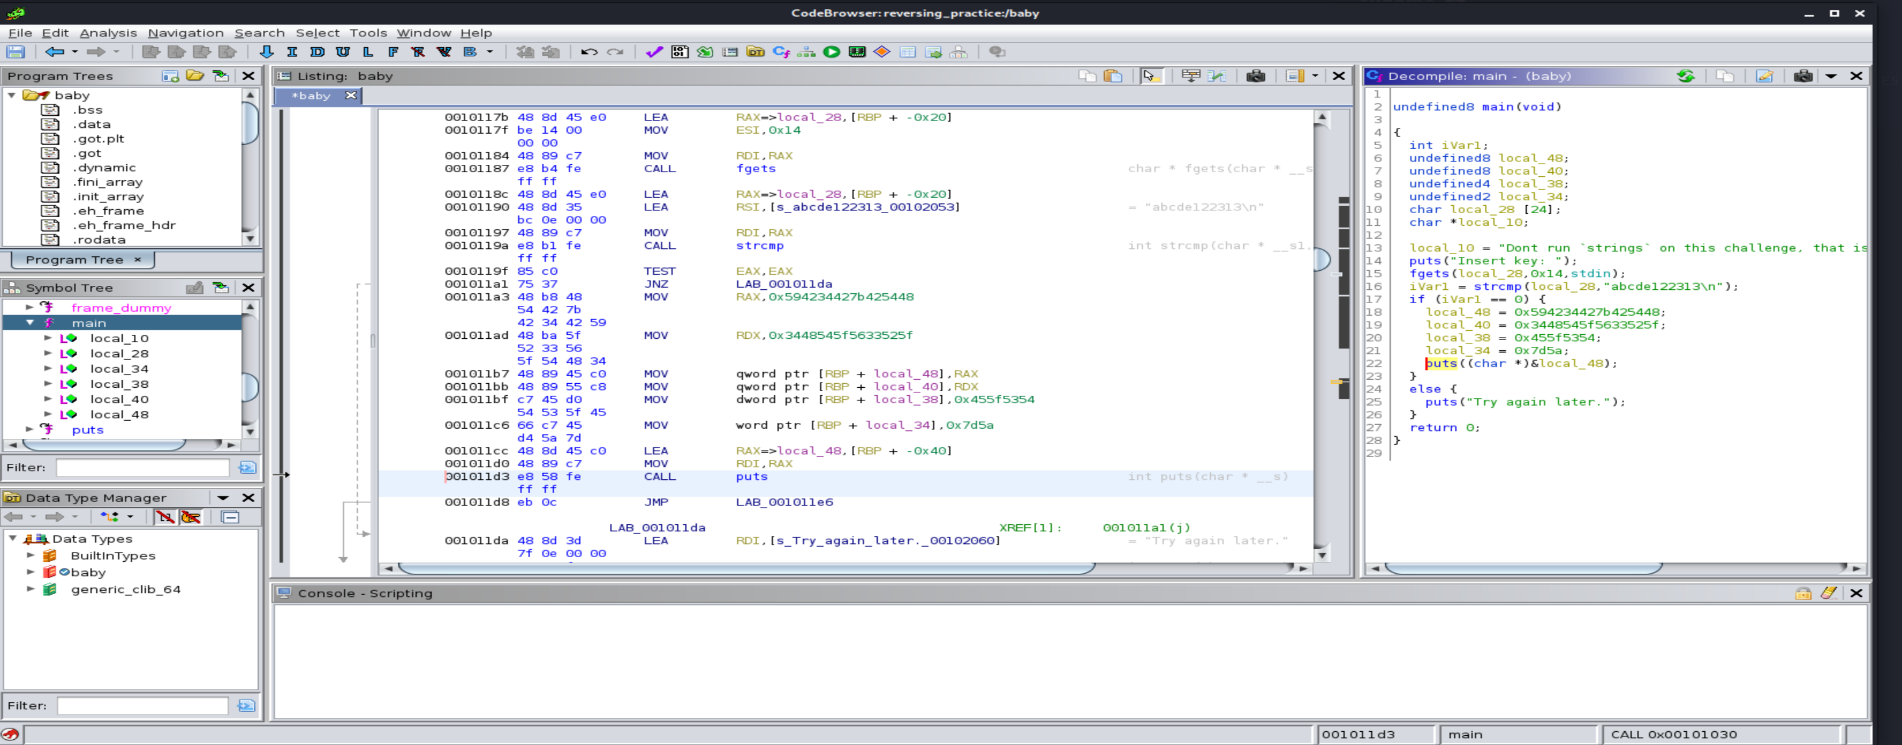

4.Dynamic analysis

IDA