

Software Engineering

Name : Syed Hamza Zulfiqar

ID : F2023266121

Section : V20

Assignment no : 3

Submitted to:

**Prof. Shabaz Qadeer**

DEPARTMENT OF COMPUTER SCIENCE

SCHOOL OF SYSTEM AND TECHNOLOGY

UNIVERSITY OF MANAGEMENT AND TECHNOLY

**ERD Diagram Explanation**

This document provides a comprehensive explanation of an Entity-Relationship Diagram (ERD) designed for a medical database system. The ERD illustrates the relationships between various entities such as Doctor, Patient, Appointment, Payment, Insurance, and Bill. The purpose of this database model is to ensure efficient hospital management by maintaining proper records of patients, doctors, appointments, payments, and insurance.

**Entities and Attributes**

1. Doctor

• **Attributes:**

• Name

• ID

• Specialization Field

• Schedule

2. Patient

• **Attributes:**

• Name

• ID

• Age

• Disease

• **Relationship:**

• Patients have appointments and may have insurance.

3. Appointment

• **Attributes:**

• Appointment Number

• Record of Patient

• **Relationship:**

• Appointments are managed by doctors and associated with patients.

4. Insurance

• **Attributes:**

• Insurance Company

• Insurance Type

• Patient Details

• **Relationship:**

• Patients may have insurance, which is applied during billing.

5. Payment

• **Attributes:**

• Payment Type

• **Relationship:**

• Payments are applied to generate bills for appointments.

6. Bill

• **Attributes:**

• Bill Number

• Bill Type

• **Relationship:**

• Payments generate bills for appointments.

**Relationships**

• Doctor-Patient:

• Doctors manage appointments for patients.

• Patient-Appointment:

• Patients book appointments that are scheduled by doctors.

• Patient-Insurance:

• Patients may have insurance provided by an insurance company, which is linked to their payment and billing details.

• Payment-Bill:

• Payments made by patients generate bills for their appointments

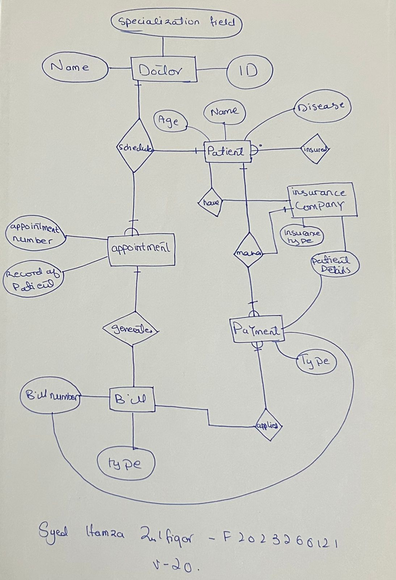

.

The ERD diagram provides a structured approach to designing a medical database system. It ensures the seamless flow of information between different entities, improving hospital management efficiency. By linking patients, doctors, appointments, payments, and insurance, this database model reduces errors, maintains accurate records, and streamlines   
the workflow of a healthcare organization.

**GitHub Upload Instructions**

**Step 1: Prepare Files**

1. The ERD diagram saved as an image file (e.g., .jpeg, .png).

2. The Word document (.docx) and its PDF version (.pdf) containing the explanation.

**Step 2: Create a GitHub Repository**

1. Go to GitHub.

2. Log in to your GitHub account.

3. Click on the “+” icon in the top-right corner and select New Repository.

4. Name your repository (e.g., Medical-Database-ERD).

5. Add a description for the repository.

6. Set the repository as Public (or Private if needed) and click Create Repository.

**Step 3: Upload Files**

1. On the repository page, click on Add File > Upload Files.

2. Drag and drop the image file of the ERD, the .docx Word file, and the .pdf file into the upload area.

3. Add a meaningful commit message, such as Uploaded ERD Diagram and Explanation Document.

4. Click Commit Changes to save your files in the repository.

**Step 4: Share Repository**

1. Copy the repository URL from the address bar (e.g., https://github.com/username/Medical-Database-ERD).

2. Share the URL with your anyone as needed.

**LINK:**

https://github.com/syedHamzaZulfiqar/software-engineering.git