Real Annual Report Analysis & AI-Assisted Structuring
Ismail Industries Limited | Supply Chain Analytics (MGT-353) | Fall 2026

Hand-Calculated Ratios
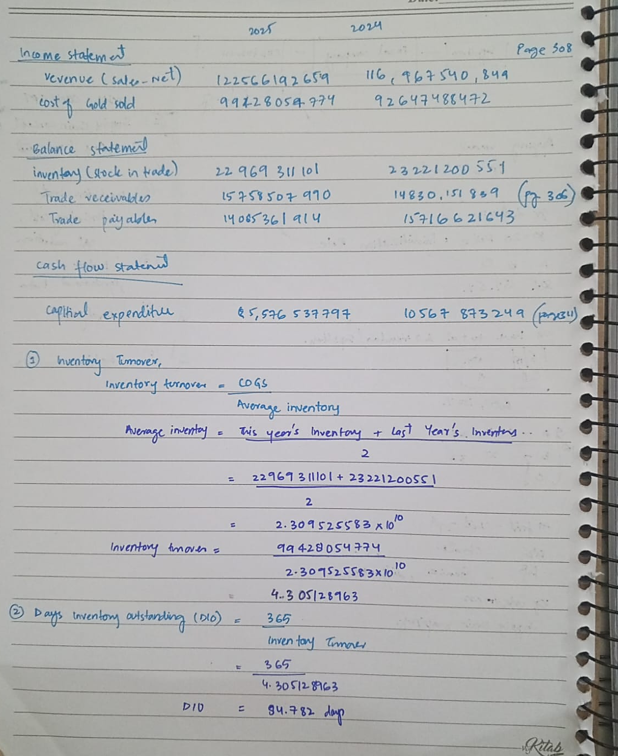

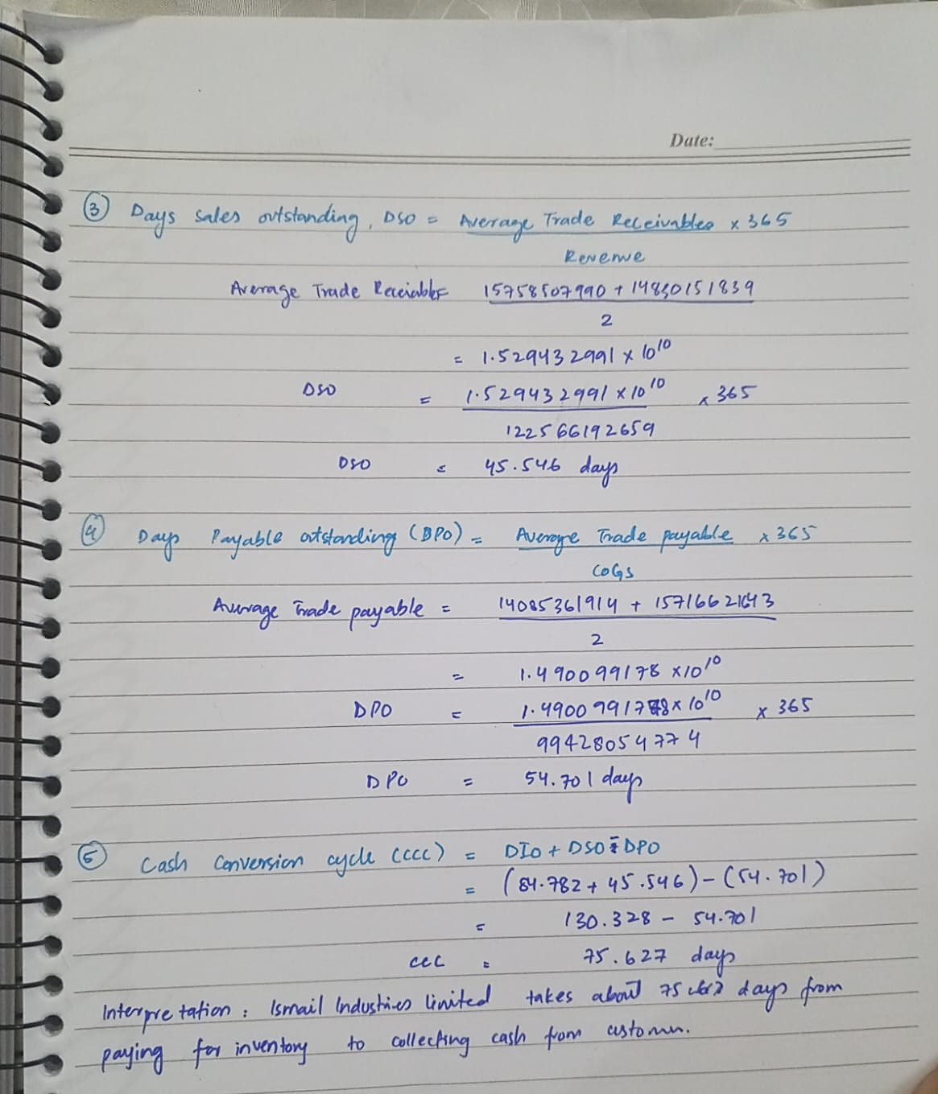

AI Prompt Log and Structured Output

Prompt submitted to AI
I am a BBA student in a Supply Chain Analytics course, working with REAL financial data from Ismail Industries Limited’s annual report (a company listed on the Pakistan Stock Exchange).
I am going to paste the actual text of their Income Statement, Balance Sheet, and Cash Flow Statement below. Your only job is to organize the numbers I give you into a clean table — DO NOT estimate, infer, calculate, or fill in any figure I have not explicitly provided.
If a figure I ask for is not present in what I pasted, write “Not provided” — never guess or approximate it.
Organize the output as a table with these columns:
Year | Statement | Line Item | Value (PKR) | Notes
Extract these line items specifically, where available: Revenue, Cost of Goods Sold, Gross Profit, Inventory, Trade Receivables, Trade Payables, Capital Expenditure, and Segment/Geographic Revenue breakdown if disclosed.
Here is the pasted financial statement text:
[The actual consolidated financial statement text from the annual report was pasted here.]
At the end, list any line item I asked about that was NOT found in what I pasted.

AI structured output
Year | Statement | Line Item | Value (PKR) | Notes
2025 | Income Statement | Revenue | 122,566,192,659 | Sales - net
2024 | Income Statement | Revenue | 116,967,540,849 | Sales - net
2025 | Income Statement | Cost of Goods Sold | (99,428,054,774) | Cost of sales
2024 | Income Statement | Cost of Goods Sold | (92,647,488,472) | Cost of sales
2025 | Income Statement | Gross Profit | 23,138,137,885 | Gross profit
2024 | Income Statement | Gross Profit | 24,320,052,377 | Gross profit
2025 | Balance Sheet | Inventory | 22,969,311,101 | Stock-in-trade
2024 | Balance Sheet | Inventory | 23,221,200,551 | Stock-in-trade
2025 | Balance Sheet | Trade Receivables | 15,758,507,990 | Trade debts
2024 | Balance Sheet | Trade Receivables | 14,830,151,839 | Trade debts
2025 | Balance Sheet | Trade Payables | 14,085,361,914 | Trade and other payables*
2024 | Balance Sheet | Trade Payables | 15,716,621,643 | Trade and other payables*
2025 | Cash Flow Statement | Capital Expenditure | (5,576,537,797) | Including CWIP
2024 | Cash Flow Statement | Capital Expenditure | (10,567,873,249) | Including CWIP
2025 | Income Statement / Notes | Segment/Geographic Revenue | Not provided | Not found in pasted text
2024 | Income Statement / Notes | Segment/Geographic Revenue | Not provided | Not found in pasted text

Verification Checklist

Check | Status | Verification / Action
Every number traces to a page | Verified
Units match | Verified | The pasted statements state “Rupees”; values were therefore treated as full PKR, not PKR '000 or PKR millions.
Year alignment | Verified | The annual-report text shows 2025 first and 2024 second; the structured table preserves this order.
No invented figures | Verified | No missing amount was estimated. Segment/geographic revenue was marked “Not provided”.
Payables label | FLAGGED / DISCLOSED | The source line is “Trade and other payables,” not a separately disclosed trade-payables amount.

Page-number verification table
Year | Line Item | Verified Value (PKR) | Annual Report Page
2025 | Revenue | 122,566,192,659 | 308
2024 | Revenue | 116,967,540,849 | 308
2025 | Cost of Goods Sold | (99,428,054,774) | 308
2024 | Cost of Goods Sold | (92,647,488,472) | 308
2025 | Gross Profit | 23,138,137,885 | 308
2024 | Gross Profit | 24,320,052,377 | 308
2025 | Inventory | 22,969,311,101 | 306
2024 | Inventory | 23,221,200,551 | 306
2025 | Trade Receivables | 15,758,507,990 | 306
2024 | Trade Receivables | 14,830,151,839 | 306
2025 | Trade Payables | 14,085,361,914 | 306
2024 | Trade Payables | 15,716,621,643 | 306
2025 | Capital Expenditure | (5,576,537,797) | 311
2024 | Capital Expenditure | (10,567,873,249) | 311

AI-Assisted Ratio Cross-Check
Metric | Step 2 Hand Result | Initial Ai Result | Corrected AI Result | Outcome
Inventory Turnover | 4.3051× | 4.3051× | 4.3051× | Matched after correction
DIO | 84.782 days | 84.783 days | 84.783 days | Matched subject to rounding
DSO | 45.546 days | 45.546 days | 45.546 days | Matched subject to rounding
DPO | 54.701 days | 51.71 days | 54.701 days | Matched after correction
CCC | 75.627 days | 79.54 days | 75.627 days | Matched after correction

Discrepancy and resolution
Initial discrepancy: The AI initially used year-end closing balances instead of average balances. This produced DPO of 51.71 days and CCC of 79.54 days, which did not match the hand calculations.
Resolution: The formulas were checked against the assignment instructions. Inventory, trade receivables and trade payables were recalculated using the average of the 2024 and 2025 closing balances. The corrected AI results then matched the Step 2 hand calculations subject to rounding. In particular, DPO changed from 51.71 to 54.701 days and CCC changed from 79.54 to 75.627 days.

Reflection — Cash Conversion Cycle
Ismail Industries Limited’s Cash Conversion Cycle in 2025 was around 75.63 days. This means that the company’s cash remains tied up in its operating cycle for about two and a half months before it comes back through customer payments. The biggest part of this is inventory, with a DIO of 84.78 days. This means that inventory stays with the company for almost 85 days on average before it is sold. After selling the products, the company takes around 45.55 days to collect the money from customers.
The company takes around 54.70 days to pay its suppliers, which helps reduce the amount of cash tied up in the cycle. However, it is still not enough to cover the time spent on inventory and receivables, resulting in a positive CCC of 75.63 days. This shows that managing inventory and cash flow is quite important for Ismail Industries. The company could improve this by reducing unnecessary inventory, forecasting demand more accurately, and collecting payments from customers faster. Better payment terms with suppliers could also help the company manage its cash more effectively.

