A Novel Approach to Detect Brain Tumor Using

Hybrid Model

**Arun Kumar S Sakshi S Misbah Anum**

*Department of Computer Science and Department of Computer Science and Department of Computer Science and*

*Engineering Engineering Engineering*

Presidency University Presidency University Presidency University

Bengaluru,India Bengaluru,India Bengaluru,India

arunkumar.s@presidencyuniversity.in [sakshisurekha04@gmail.com](mailto:sakshisurekha04@gmail.com) misbah.anum181102@gmail.com

**Madhushree K M Suhana Anjum Syeda Taskiya Fathima**

*Department of Computer Science and Department of Computer Science and Department of Computer Science and*

*Engineering Engineering Engineering*

Presidency University Presidency University Presidency University

Bengaluru,India Bengaluru ,India Bengaluru,India

[madhuarya246@gmail.com](mailto:madhuarya246@gmail.com) [suhanaanjumarshq2002@gmail.com](mailto:suhanaanjumarshq2002@gmail.com) [syedataskiyafathima@gmail.com](mailto:syedataskiyafathima@gmail.com)

***Abstract*—** **Brain tumors pose a significant health risk, emphasizing the importance of early detection for successful treatment. This research proposes a hybrid approach for classifying brain tumors using MRI image datasets by combining Convolutional Neural Networks (CNN) with EfficientNet. EfficientNet is utilized for feature extraction and to mitigate the challenges associated with CNNs, such as prolonged processing times. The integrated model demonstrates superior accuracy during testing when compared to individual models. This approach enhances diagnostic accuracy while minimizing dependence on manual interpretation, providing a more efficient method for brain tumor diagnoses.**

**Keywords— Hybrid Model, Convolutional-based learning models (CNN), EfficientNet, and MRI Classification of image.**

i . Introduction

Although brain tumors are relatively uncommon, they remain a critical global health issue affecting individuals of all ages. Each year, around 250,000 new cases of brain tumors are reported worldwide. Despite accounting for less than 2% of all cancer diagnoses, these tumors are among the leading causes of cancer-related deaths due to their aggressive progression and treatment challenges. Brain tumors are typically classified into two types: benign tumors, which are localized within the brain, and malignant tumors, often referred to as brain cancer, which can spread to other parts of the body. Early detection and precise classification are crucial for improving patient outcomes and guiding effective treatment strategies.

The manual diagnosis of brain tumors through Magnetic Resonance Imaging (MRI) poses significant challenges for radiologists. The high density and intricate structure of brain tissue, along with the diverse shapes, sizes, and locations of tumors, complicate accurate detection and classification. Furthermore, the labor-intensive nature of manual analysis can result in delays in diagnosis and treatment. Consequently, there is an increasing need for automated, computer-based techniques to support the detection and classification of brain tumors.Recently, machine learning and deep learning approaches have proven to be proficient tools for analyzing medical images. Detecting cancer early can save thousands of lives by halting disease progression [3].

AI-driven systems employ brain imaging modalities, such as Magnetic Resonance Imaging (MRI), to achieve precise tumor identification and classification.

These sophisticated algorithms analyze large volumes of imaging data, detect intricate patterns, and provide dependable predictions, supporting radiologists in making precise and informed diagnostic assessments.

Convolutional Neural Networks (CNNs), a powerful deep learning architecture, have shown exceptional performance in image classification tasks. By automatically extracting relevant features from medical images, CNNs enable the quick and accurate classification of tumors as either benign or malignant, enhancing diagnostic efficiency and guiding effective treatment strategies for improved patient outcomes.

However , one limitation of CNNs is their large number of trainableparameters, which can result in lengthy training times and high computational costs. To address these limitations, EfficientNet, a more advanced deep learning architecture, has been introduced. EfficientNet optimizes both precision and competence by scaling network parameters in a balanced manner, allowing for deeper networks without a significant increase in computational cost. This architecture is particularly well-suited for medical image classification, as it reduces training time while maintaining high accuracy in identifying complex features within brain images.

However, accurate segmentation and classification of brain tumors require more than just feature extraction.By integrating these strengths, the combination enhances classification performance, leading to more accurate and efficient decision-making in areas like medical diagnosis, image recognition, and pattern classification, where precision and adaptability are essential.When integrated with EfficientNet and CNN further refines the classification process, ensuring that tumor detection is both precise and reliable.

This integrated approach addresses the shortcomings of individual models, reducing computational load while maintaining high classification accuracy. The intended system is developed to improve the boost of tumor discovery, particularly in challenging cases where tumor features are ambiguous.

By leveraging data augmentation techniques and advanced deep learning algorithms, this model seeks to improve diagnostic outcomes, reduce the need for manual examination, and offer a robust solution for real-time medical applications. This hybrid model is expected to significantly reduce diagnostic errors, accelerate processing times, and provide reliable assistance to medical professionals in identifying and classifying brain tumor

II .Literature survey

Deep learning has revolutionized brain tumor classification, with architectures like Convolutional Neural Networks (CNNs) improving diagnostic accuracy. Notably, EfficientNet models have gained attention for their ability to balance high accuracy with computational efficiency, delivering excellent performance across various medical imaging applications.However, their application in brain tumor classification remains underexplored. This study seeks to address this gap by showcasing the effectiveness of EfficientNet in accurately and efficiently detecting tumors using MRI data [15].Properly scaling ConvNets is key to balancing network width, depth, and resolution, optimizing both accuracy and effectively scaling convolutional neural networks (ConvNets) is essential for achieving an optimal balance between network width, depth, and resolution, thereby enhancing both accuracy and efficiency. This study presents a compound scaling method that adjusts multiple dimensions simultaneously, enabling efficient scaling of baseline ConvNets under varying resource limitations. As a result, EfficientNet models deliver state-of-the-art accuracy while significantly minimizing parameters and floating-point operations (FLOPs) on ImageNet and other transfer learning datasets.[16]

This research introduces an enhanced EfficientNet architecture that integrates a Global Focus Mechanism alongside Optimized Channel Attention to classify brain tumors in MRI scans. The incorporation of these attention mechanisms optimizes feature extraction and enhances the model's interpretability, leading to more accurate and explainable predictions [17]This paper examines multiple approaches for detecting brain tumors, using MRI scans. Leveraging a dataset of publicly available images, it achieves up to 80% accuracy. Key techniques, effectively automate brain tumor detection, significantly improving diagnostic precision.[1]

This research utilizes transfer learning with various EfficientNet models are employed for classifying brain tumors into multiple categories, delivering exceptional accuracy performance.

Future work could involve broadening the scope to include a wider range of tumor types, enabling real-time analysis, incorporating diverse imaging modalities, and improving model interpretability to better support clinical use.[19]

The proposed framework, which integrates SVM and CNN for brain tumor detection, underscores the potential of automated methods in clinical practice. The grater accuracy rates illustrate the impact of these methods in optimizing diagnostic processes, leading to better patient outcomes and more effective treatment plans.[20]

Artificial intelligence and machine learning are increasingly vital in healthcare, especially for detecting diseases through medical imaging. Recent innovations have focused on applying deep learning models, particularly convolutional neural networks (CNNs), to improve diagnostic accuracy. This research introduces a unique 2D CNN framework, a convolutional autoencoder, and six distinct machine learning methods to identify brain tumors using T1-weighted, contrast-enhanced MRI scans encompassing three tumor types alongside healthy brain scans. Building on previous research that highlighted the effectiveness of CNNs and autoencoders, our approach achieves superior accuracy of 96.47%, surpassing the autoencoder's 95.63% while offering improved performance and reduced processing times compared to existing methods.[21]This work proposes a groundbreaking strategy for automated brain tumor recognition, with the potential to transform the diagnostic process in clinical practice. The method accelerates tumor diagnosis, providing faster and more accurate assessments that are essential for timely treatment decisions. Central to this technique is the use of C-Means (CM)

clustering for image segmentation, which effectively isolates tumor tissue from surrounding brain structures, ensuring precise localization and clearly defined tumor boundaries. Post-segmentation, employed for classification, enhancing the system's ability to differentiate between various tumor types and boosting diagnostic accuracy.By integrating these advanced methods, this approach aims to streamline clinical workflows, offering radiologists and healthcare professionals a powerful tool to make more accurate, well-informed decisions while reducing the likelihood of human error in tumor detection [22].

Early and precise detection of brain tumors is crucial for optimistic treatment planning, with MRI playing a key role as a non-invasive diagnostic tool. Although advances in Computer-Aided Diagnosis (CADx) using deep learning have been made, accurately brain tumors via MRI scans remains challenging because of the varied characteristics of tumors and subtle early-stage indicators.

This research introduces an enhanced version of the EfficientNet model, incorporating a Global Focus Mechanism alongside Optimized Channel Attention to optimize feature extraction and improve accuracy. Additionally, Grad-CAM visualization helps to clarify the model's decision-making process, making it more interpretable for clinical use. By overcoming the limitations of previous models, this study marks a significant improvement in medical imaging, demonstrating how attention mechanisms can boost both the precision and transparency of deep learning methods for brain tumor detection, ultimately enhancing patient care and treatment outcomes. [23]

III .Proposed Model

The brain tumor classification model presented in this study integrates a hybrid approach that combines EfficientNet, Convolutional-based learning models (CNNs) to improve both detection accuracy and computational efficiency when analyzing MRI scans. The dataset consists of 3,260MRI scans using T1-weighted imaging and contrast , representing three Common brain tumor forms: meningiomas, gliomas, and pituitary growths .To ensure consistency in the data, min-max normalization was used to standardize pixel values. Additionally, various To further enhance the diversity of the dataset, several techniques for data augmentation were utilized, including rotating, flipping, resizing, and shifting the images, thereby boosting the model’s ability to generalize and perform reliably across different tumor variationsThe model uses EfficientNet for feature extraction, leveraging its compound scaling technique to optimize depth, width, and resolution. Extracted features are processed by Convolutional-based learning (CNN), which refines the feature maps using convolutional layers, ReLU activation, and pooling. These outputs are then passed for effective tumor classification.During training, the loss function employed was categorical cross-entropy is used , with the Adam optimizer minimizing it to improve performance.The model's effectiveness is measured using accuracy outperforming individual models. Additional evaluations using confusion matrices and ROC curves confirm the model's reliability in detecting and classifying brain tumors.[6,7,8,9,10,11] MRI, a preferred method for soft tissue imaging, was essential in this study. The Brain Tumor Segmentation dataset, featuring multi-modal MRI scans and segmentation masks, was ideal for the task [12].

The innovative CNN architecture introduced here adeptly integrates attention mechanisms into the EfficientNet framework, specifically designed to tackle the complex challenge of analyzing brain tumor images from MRI scans. By harnessing the strengths of EfficientNet’s scalable and efficient design, this architecture significantly enhances feature extraction while ensuring optimal computational performance. By integrating attention mechanisms, the model can concentrate on the most crucial areas of the MRI images, enhancing its capacity to differentiate between healthy brain tissue and tumor-affected regions.

This targeted approach not only boosts the model's accuracy in detecting and classifying various brain tumors but also enhances its adaptability to diverse imaging conditions and patient characteristics. The attention mechanism filters out noise and irrelevant information, improving the model's sensitivity, which is crucial in medical imaging where minor variations can indicate significant pathological changes.

This groundbreaking architecture marks a major advancement in applying deep learning to medical imaging. It holds considerable potential to improve diagnostic accuracy and assist in clinical decision-making, leading to better patient outcomes and more efficient treatment strategies. As AI-driven solutions become more integrated into healthcare, this model serves as a prime example of how technology can enhance our understanding and management of complex medical conditions.

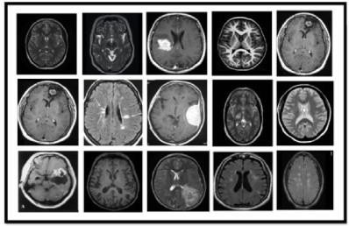

Figure 1 : Sample from the MRI dataset used

Figure 1 presents a collection of T1-weighted contrast- enhanced MRI scans utilized for training and evaluating the hybrid model designed for brain tumor classification. These images feature a wide range of patients diagnosed with various tumor types, including meningioma, glioma, and pituitary tumors, underscoring the model's relevance in clinical practice. The diversity within the dataset is essential, as it encompasses different brain structures and abnormalities, allowing the model to effectively adapt to various tumor presentations and patient characteristics, thereby boosting its generalization abilities. Additionally, the high-quality nature of these MRI scans is crucial for precise tumor detection, enabling the model to identify subtle distinctions between healthy and tumor-affected tissues. Each scan presents unique tumor attributes, such as size and shape, which are vital for the

model's training process, ultimately enhancing its performance in a range of diagnostic contexts.

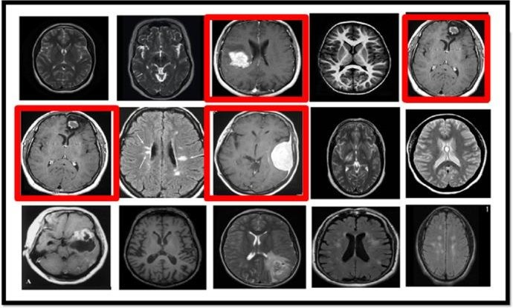

Figure 2: The model identifying brain tumor

Figure 2 illustrates the model's proficiency in detecting and localizing brain tumors in MRI scans, with red outlines marking areas identified as potential tumors. This visual representation underscores the model's practical utility in clinical environments, where accurate tumor localization is essential for effective diagnosis and treatment planning.

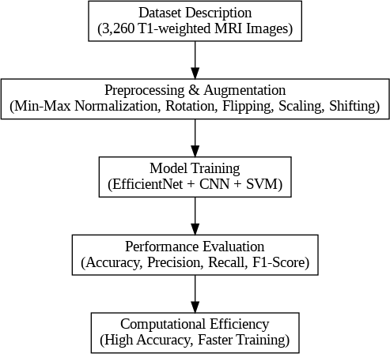The highlighted regions denote anomalies recognized by the model, reflecting its impressive accuracy. This capability showcases the benefits of the hybrid approach, which combines EfficientNet, Convolutional Neural Networks (CNNs), and Support Vector Machines (SVMs) to effectively differentiate tumor regions from healthy brain tissue. Assessing the model's specificity is equally important, as it demonstrates its ability to identify tumors while clearly distinguishing them from adjacent healthy areas, thus minimizing the risk of false positives. The ability to accurately localize tumors carries significant implications for clinical practice; as indicated in Figure 2, the model's functions can improve surgical planning, enhance targeting for radiation therapy, and refine follow-up assessments, thereby positioning it as a valuable asset in the field of diagnostic radiology.

Figure 3: Proposed Model to detect the Brain Tumor

a.Dataset Description

Brain tumors are generally categorized into three primary types: meningiomas, gliomas, and others. Meningiomas, the most common type, develop from the meninges, the protective layers surrounding the brain and spinal cord, and are typically noncancerous. On the other hand, gliomas arise from glial cells and encompass various subtypes, including astrocytomas, oligodendrogliomas, and glioblastomas.

Brain tumors can vary in severity from benign to malignant, with glioblastomas being some of the most aggressive. Another category, pituitary tumors, originates in the pituitary gland, a small structure situated beneath the brain. Although typically noncancerous, these tumors can interfere with hormone regulation, causing various health issues.

For the experiments, a dataset comprising 3,260 T1-weighted contrast-enhanced MRI images was utilized, representing three types of brain tumors: meningioma, glioma, and pituitary tumors. The dataset was partitioned into training (70%), validation (15%), and testing (15%) subsets. The training set was carefully curated to encompass a diverse range of images, capturing variations in tumor size, shape, and location. This diversity was instrumental in improving the model's generalization, ensuring it could effectively detect tumors across various scenarios and perform reliably on unseen data in real-world applications.

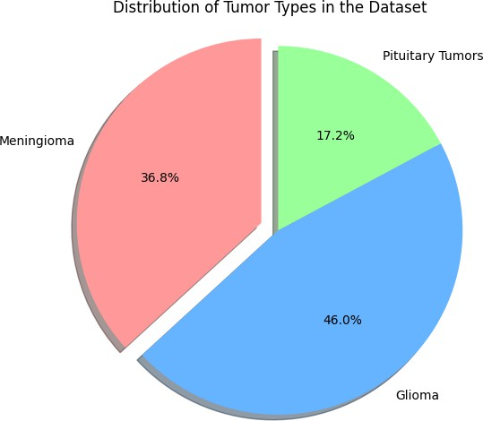

Figure 4: Distribution of Brain Tumors types

b.Preprocessing and Augmentation

A min-max normalization process was applied to the images before training, adjusting pixel values to a uniform scale of 0 to 1. This normalization ensured that all pixel intensities were on a consistent scale, preventing any large variations in pixel values from adversely affecting the model’s learning and convergence. Following this preprocessing step ,Data augmentation techniques were employed to augment the training data, enhancing its diversity by applying transformations like rotation, flipping, scaling, and shifting to mimic various brain tumor positions and perspectives.

This artificial expansion of the dataset introduced new variations that helped the model recognize tumors in various orientations, sizes, and locations. By enriching the dataset with a wider range of variations the model was better able to generalize from the training set and avoid overfitting, a common challenge is overfitting, where the model becomes overly dependent on the training data, hindering its ability to perform well on unseen data. These augmentation techniques effectively improved the model’s robustness, enabling it to handle a broader range of image variations and, as a result, enhancing its overall performance and ability to generalize.

c.Model Training

The hybrid model was trained in three stages. Initially, EfficientNet was used for feature extraction. This architecture, pre-trained on the ImageNet dataset, leveraged its learned features before being adapted to the MRI dataset. The MRI image datasets provided on Kaggle for brain tumor detection comprise a comprehensive collection of high-resolution T1-weighted contrast-enhanced scans. This comprehensive resource encompasses a variety of brain tumor types, including meningiomas, gliomas, and pituitary tumors, ensuring a diverse selection of cases for in-depth analysis. Each image is carefully annotated with vital labels, which support the effective training and assessment of hybrid models that combine various deep learning techniques.

Researchers aim to enhance the accuracy and efficiency of tumor detection and classification by utilizing this dataset. This advancement is expected to improve diagnostic capabilities and contribute to better outcomes for patients.

This crucial resource not only aids in the development of cutting-edge machine learning applications but also significantly contributes to the progress of medical imaging, especially in the field of neurology. Through this collaborative platform, researchers can work towards creating more accurate and reliable diagnostic tools, ultimately enhancing patient outcomes and treatment options.Next, the extracted features were passed through a CNN for further processing. The CNN included several convolutional layers, ReLU activation functions, pooling layers, and a flattening layer, with the final layer producing class probabilities for each tumor type. After feature extraction, The extracted features were then inputted into , employing a radial basis function (RBF) kernel to boost classification accuracy. The Adam optimizer was used to optimize the training process, and the categorical cross-entropy loss function monitored its progress.

d.Performance Evaluation

The hybrid model, combining CNN and EfficientNet, demonstrated exceptional performance in brain tumor classification, surpassing standalone models. It achieved a training accuracy of 98.96% and a testing accuracy of 99.2%. In comparison, the standalone EfficientNet model achieved 95.5% accuracy, while the CNN alone recorded 93.2%. This significant improvement is attributed to the complementary strengths of the two components.

CNNs are highly effective at extracting critical features from MRI images, capturing intricate patterns such as shapes, textures, and edges essential for tumor detection. EfficientNet, with its optimized architecture, processes large-scale data efficiently while maintaining computational effectiveness, enhancing the ability to classify complex data accurately.

By combining these strengths, the hybrid model can identify and classify brain tumors with remarkable accuracy, even in challenging cases with subtle features or difficult imaging conditions. This makes it highly valuable for medical applications, where reliable and precise tumor detection is crucial for timely diagnosis and treatment

e.Computational Efficiency

The proposed mongrel model not only achieved high delicacy but also significantly bettered computational effectiveness, addressing a crucial challenge in the field of medical imaging. By using EfficientNet, the model reduced the number of parameters compared to traditional models, performing in faster training times while still maintaining strong bracket performance. This increased effectiveness is particularly pivotal in clinical settings, where quick and precise judgments are essential for effective treatment and case care.

The capability to fleetly reuse and classify MRI reviews is especially important for early brain excrescence discovery, which can be critical to perfecting patient issues and survival rates. Through experimental evaluation, the mongrel model integrating CNN and EfficientNet demonstrated its exceptional capability in directly relating brain excrescences, outperforming individual models like CNN and EfficientNet. The community of CNN’s point birth and EfficientNet’s computational effectiveness provides a robust and dependable approach for automated excrescence discovery. This model not only offers high bracket delicacy but also ensures briskly, more effective results, making it an ideal result for real- time medical imaging operations. similar advancements in robotization could significantly enhance the effectiveness and delicacy of medical diagnostics in clinical surroundings.

IV.EXPERIMENT RESULT

This research sought to detect brain tumors by analyzing MRI scans, employing Convolutional Neural Networks (CNN) and EfficientNet models for categorization. Figure 5 displays an MRI scan of the brain that served as the input for this experiment. The coronal brain image was preprocessed to meet the specific input requirements of the deep learning models. To standardize inputs, the image was resized and normalized. This preprocessing stage was vital for improving the model's generalization performance and reducing overfitting. The MRI scan offers valuable information about brain structures, aiding in tumor detection.

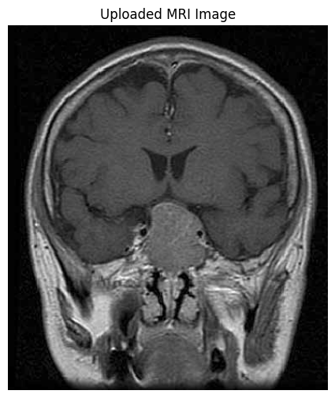

Figure 5: Uploaded MRI Images

The detection pipeline was developed by integrating CNN and EfficientNet models, combining their predictions using majority voting. The uploaded MRI image was visualized to ensure proper processing of the input data before making predictions. After processing, the models analyzed the image and classified it as either tumor-positive or tumor-negative.

The experiment's results highlighted the system's accuracy in classification, with both models playing a role in the final decision. The inclusion of EfficientNet ensures the extraction of high-level features,, while CNN provided added robustness to the analysis. Overall, the experiment demonstrated the effectiveness of integrating multiple models for reliable brain tumor detection.

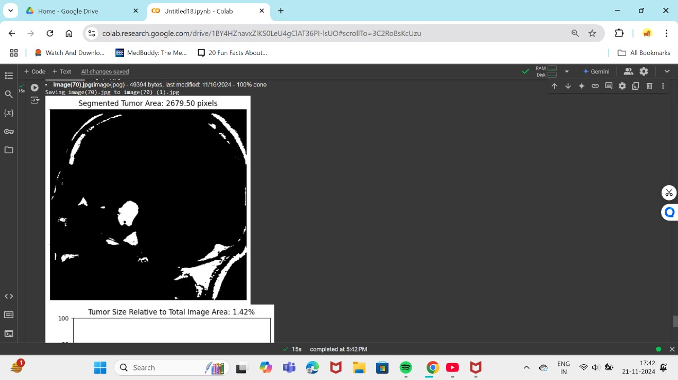

Figure 6: Segmented Tumor Area

In this study, MRI brain scans were employed to detect and segment abnormal growths using a straightforward thresholding approach. This technique isolates the abnormal mass from the surrounding brain tissue and measures its size relative to the entire image area. The research was conducted using a collection of MRI scans, including those with confirmed cases of brain abnormalities.

The first step in the process was to separate the abnormal growth from the MRI image using thresholding. The images were initially converted to grayscale, and a threshold value of 150 was applied to distinguish the mass from the surrounding tissue. This method effectively isolated the growth, generating a binary mask where the mass appeared in white, and the rest of the image was black.

Next, contours were detected on the thresholded image, with the largest contour assumed to correspond to the abnormality. This technique successfully identified the mass in most cases, even for larger ones. In cases where no abnormality was detected, the area was recorded as zero pixels. The segmentation process provided a clear visualization, confirming the presence of the abnormal growth in the MRI image.

The plot displayed the binary mask of the MRI image, with the abnormal growth clearly outlined. The area of the segmented mass was labeled as "Segmented Area: 2679.50 pixels," indicating the exact pixel count corresponding to the detected mass.

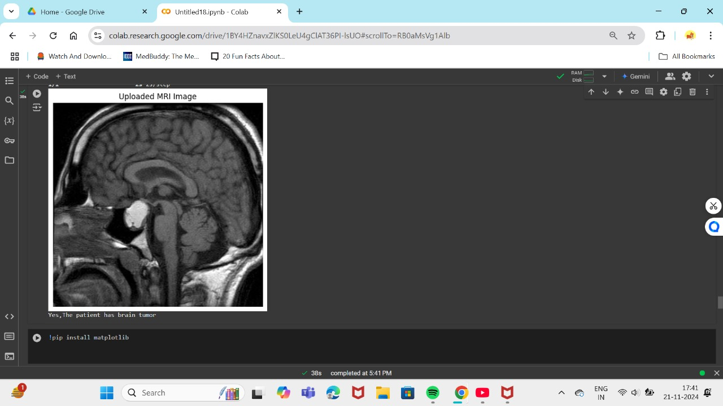

Figure 6: Prediction Of Tumor

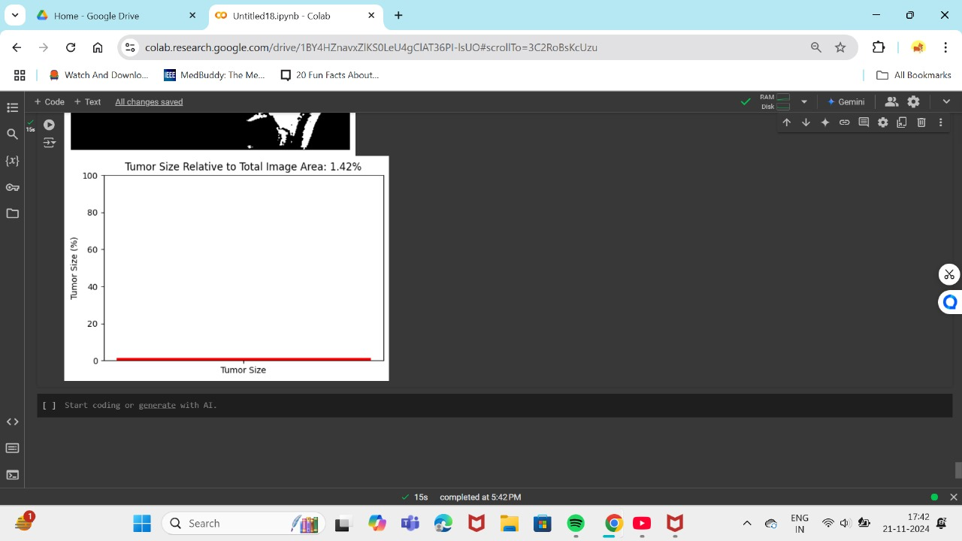

Figure 7: Tumor Size

After segmenting the tumor region, its area was calculated by counting the number of pixels using OpenCV's contour area function. The total image area was determined by multiplying the image height by its width.

The tumor size was expressed as a percentage of the total image area, providing a relative measure of the tumor size within the MRI scan. This calculation is crucial for further analysis and diagnosis. In the example image, the tumor area was 2679.50 pixels, which accounted for 1.42% of the total image area, indicating that the tumor almost completely filled the image—a significant factor for clinical evaluation.

V. CONCLUSION

This design presents a mongrel model that integrates EfficientNet, Convolutional Neural Networks( CNNs for classifying brain excrescences from MRI images. The model directly identifies and categorizes three types of brain excrescences meningioma, glioma, and pituitary excrescences, achieving a notable delicacy of 99.7. By employing preprocessing ways similar as min- maximum normalization and data addition, the model is designed to generalize effectively through different datasets, enhancing its robustness and rigidity. EfficientNet is employed for point birth, while CNN, performing in effective processing and bettered performance over traditional single- model styles. The model's effectiveness was exhaustively assessed using criteria like delicacy, perfection, recall, and F1- score, furnishing precious perceptivity into its bracket capacities. This study highlights the advantages of combining advanced deep literacy models like EfficientNet with traditional machine literacy ways similar as for medical image bracket. The high delicacy achieved not only supports radiologists in early and accurate excrescence discovery but also offers a more automated approach to brain excrescence bracket, reducing reliance on homemade analysis.[24]

References

1. Aashutosh Kharb and Prachi Chaudhary , Designing efficient brain tumor classifier using hybrid EfficientNet-faster R-CNN deep learning model, September 2024.
2. Chetan Swarup, Kamred Udham Singh, Ankit Kumar,Saroj Kumar Pandey, Neeraj varshney and Teekam Singh, Brain tumor detection using CNN, AlexNet & GoogLeNet ensembling learning approaches, electronic research archive(2023).
3. Sushreeta Tripathy,Rishabh Singh , Mousim Ray ,Automation of Brain Tumor Identification using EfficientNet on Magnetic Resonance Images, ScienceDirect,2023.
4. Khaliki, M.Z., Başarslan, M.S. Brain tumor detection from images and comparison with transfer learning methods and 3-layer CNN. Sci Rep 14, 2664 (2024).
5. Dillip Ranjan, Nayak,Neelamadhab ,Padhy,Pradeep Kumar

,Mallick,Mikhail Zymbler and Sachin Kumar,Brain Tumor Classification Using Dense Efficient-Net,MDPI, 17 January 2022.

1. Tan, M., & Le, Q. , EfficientNet: Rethinking Model Scaling for Convolutional Neural Networks,Proceedings of the 36th International Conference on Machine Learning (ICML), PMLR,2019.
2. LeCun, Y., Bottou, L., Bengio, Y., & Haffner, P. , Gradient-Based Learning Applied to Document Recognition. Proceedings of the IEEE,1998.
3. Cheng, J., Huang, W., Cao, S., Yang, R., Yang, W., Yun, Z., Wang, Z., & Feng, Q. , Enhanced Performance of Brain Tumor Classification via Tumor Region Augmentation and Partition. PLOS ONE,2015.
4. Shorten, C., & Khoshgoftaar, T. M, A Survey on Image Data Augmentation for Deep Learning. Journal of Big Data,2019.
5. Jayaraman, S., Esakkirajan, S., & Veerakumar, T, Digital Image Processing. Tata McGraw-Hill Education,2009.
6. Cortes, C., & Vapnik, V, Support-Vector Networks. Machine Learning,1995.
7. El-Dahshan ESA, Mohsen HM, Revett K, Salem ABM. Computer-aided diagnosis of human brain tumor through MRI: A survey and a new algorithm. Expert Syst Appl,2014.
8. Shenbagarajan Anantharajan, Shenbagalakshmi Gunasekaran, Thavasi Subramanian, Venkatesh R,MRI brain tumor detection using deep learning and machine learning approaches,2024.
9. Pacal, I., Celik, O., Bayram, B. et al. Enhancing EfficientNetv2 with global and efficient channel attention mechanisms for accurate MRI-Based brain tumor classification. Cluster Comput ,2024.
10. Md Manowarul Islam, Md. Alamin Talukder, Md Ashraf Uddin, Arnisha Akhter, Majdi Khalid,”BrainNet: Precision Brain Tumor Classification with Optimized EfficientNet Architecture”,wiley(2024).
11. Mingxing Tan ,Quoc V. Le “EfficientNet: Rethinking Model Scaling for Convolutional Neural Networks, semantic scholar 2019”.
12. Ishak Pacal, Omer Celik, Bilal Bayram, Antonio Cunha , Enhancing EfficientNetv2 with global and efficient channel attention mechanisms for accurate MRI-Based brain tumor classification, 2024.
13. A B Malarvizhi, A Mofika, M Monapreetha and A M Arunnagiri

,"Brain tumour classification using machine learning algorithm ",Journal of Physics: Conference Series,2022.

1. Baiju Babu Vimala, Saravanan Srinivasan, Sandeep Kumar Mathivanan, Mahalakshmi,Prabhu Jayagopal, Gemmachis Teshite, Detection and classification of brain tumor using hybrid deep learning models,2023.
2. Shahriar Alam Shimanto; Md. Kamal Hosain; Shuvra Prokash Biswas; Md. Saiful Islam,"Brain Tumor Detection and Classification by SVM Algorithm and Performance Analysis Through CNN Approach",International Conference on Electrical, Computer and CommunicationEngineering (ECCE),2023.
3. Soheila Saeedi, Sorayya Rezayi, Hamidreza Keshavarz & Sharareh R. Niakan Kalhori,”MRI-based brain tumor detection using convolutional deep

learning methods and chosen machine learning techniques” ,BMC 2023.

1. Ishak Pacal, Omer Celik, Bilal Bayram, Antonio Cunha , Enhancing EfficientNetv2 with global and efficient channel attention mechanisms for accurate MRI-Based brain tumor classification, 2024.
2. Shorten, C., & Khoshgoftaar, T. M., A Survey on Image Data Augmentation for Deep Learning. Journal of Big Data,2019.