LAB:01
QUESTION:01
ALGORITHM
input = temperature in degree centigrade
output = temperature in degree fahrenhiet
STEPS:
1. input temperature in degree centigrade
2. convert it in fahrenhiet
3. T in F = (9/5*T in C) +32
4.output temperature in degree fahrenhiet
FLOWCHART
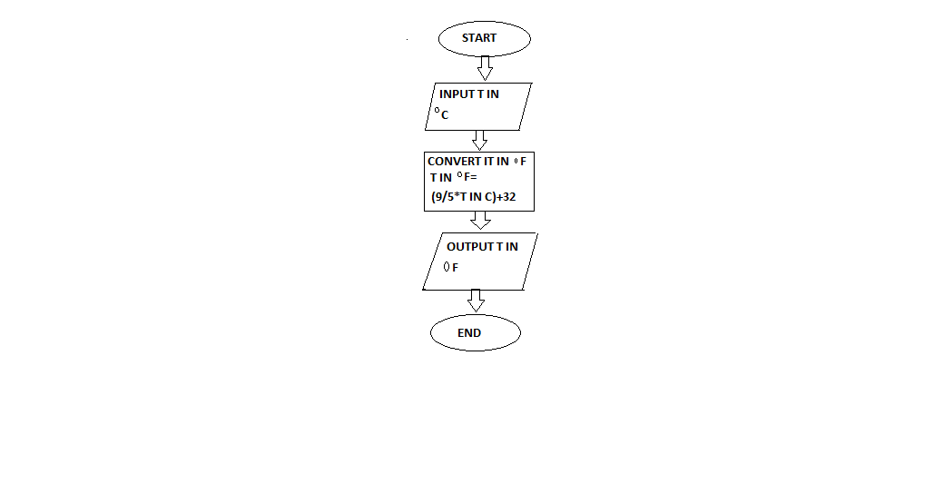
PROGRAM
INPUT:
from math import*
temp=int(input("enter temperature in degree centigrade"))
ans=(9/5*temp)+32
print("temperature in degree fahrenhiet is",ans)
OUTPUT:
enter temperature in degree centigrade44
temperature in degree fahrenhiet is 111.2
Process finished with exit code 0

