LAB:01
QUESTION:02
ALGORITHM
input=temperature in degree fahrenhiet
output=temperature in degree celcius
STEPS:
1. input temperature in degree fahrenhiet
2. convert it in degree centigrade
3. T in C = 5/9*( T in F -32 )
4. output temperature in degree centigrade
FLOWCHART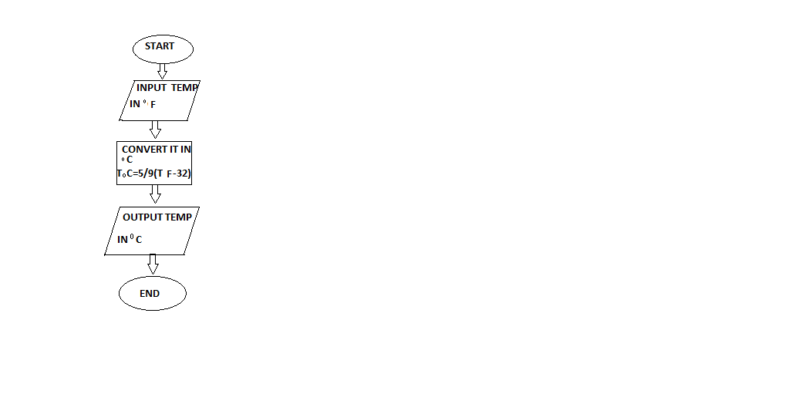
PROGRAM
INPUT:
from math import*
temp=int(input("enter temperature in degree fahrenhiet"))
ans=(5/9*(temp -32))
print("temperature in degree centigrade is",ans)
OUTPUT:
enter temperature in degree fahrenhiet37
temperature in degree centigrade is 2.7777777777777777

Process finished with exit code 0

