LAB:01
QUESTION:03
ALGORITHM
input= two
length and width of rectangle
output=area of rectangle
STEPS:
1. input length and width of rectangle
2. if input is positive, calculate area of rectangle
3. area=length*width
4. output area of rectangle
FLOWCHART
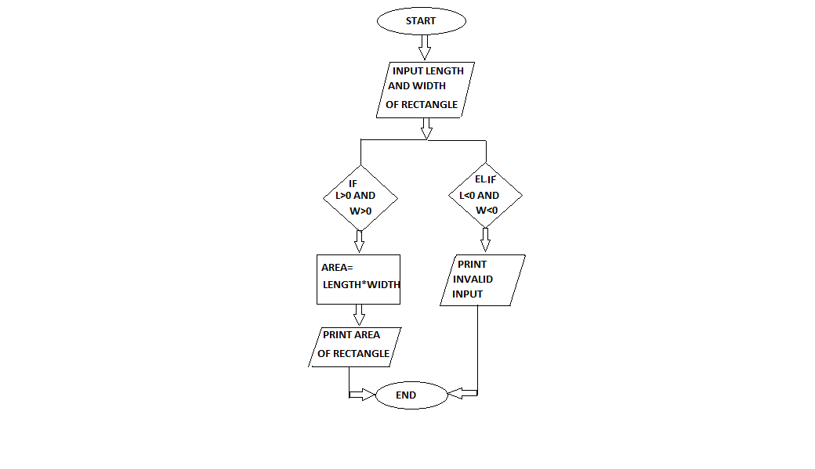
PROGRAM
INPUT:
from math import*
leng=float(input("enter length of rectangle"))
wid=float(input("enter width of rectangle"))
if(leng>0 and wid>0):
area=leng*wid
print("the area of rectangle is",area)
else:
print("invalid input")
OUTPUT
enter length of rectangle4.2
enter width of rectangle3.3
the area of rectangle is 13.86

Process finished with exit code 0

