LAB:01
QUESTION:04
ALGORITHM
input = radius of sphere
output = volume of sphere
STEPS:
1. input radius of sphere
2.if positive, calculate volume of sphere
3.V = 4/3*(3.142*radius**3)
4. output volume of sphere
FLOWCHART
PROGRAM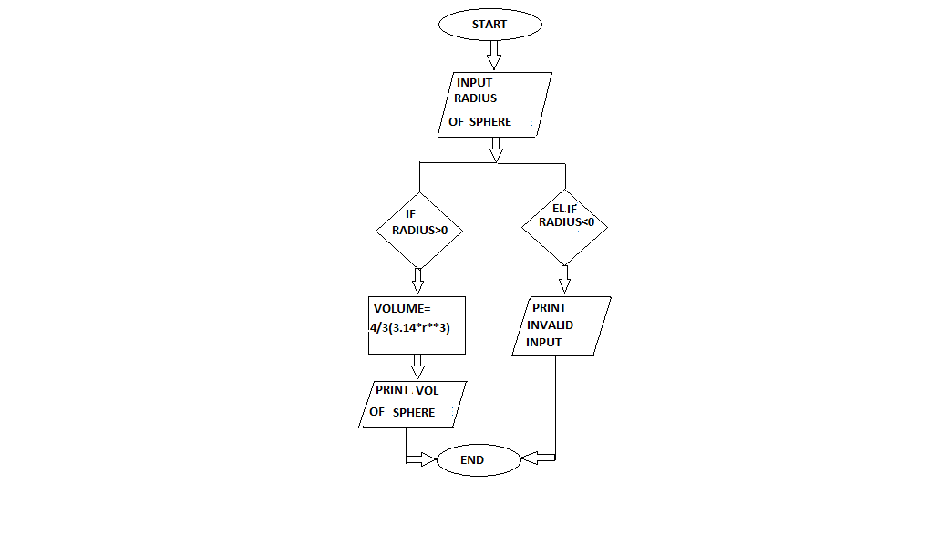
INPUT
from math import*
rad=float(input("enter radius"))
if(rad>0):
vol=(4/3*(3.142*rad**3))
print("the volume of sphere is",vol)
elif(rad<0):
print("invalid input")
OUTPUT
enter radius-3.4
invalid input

Process finished with exit code 0

