

**The University of Azad Jammu and Kashmir**

**Lab Task # 02**

**Course Instructor:** Engr. Sidra Rafique **Semester:** Fall-2024

**Session:** 2022-2026 **Submission Date:** Oct 31, 2024

**Submitted By:** Syeda Urwa Ajmal **Roll No:** 2022-SE-16

**Course Name:** SC&D **Code:** SE-3102

**Installation of Visual Paradigm**

Contents

Installation of Visual Paradigm 3

Why do we use visual paradigm? 7

Setting up workspace in Visual Paradigm 9

UML Modeling with Visual Paradigm 10

# Installation of Visual Paradigm

**Step 01:**

Click on setup

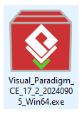

**Step 02:**

Start Installation

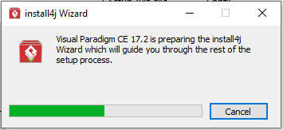

**Step 03:**

Click on next

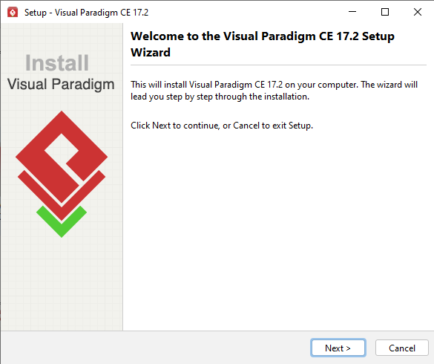

**Step 04:**

Select I accept agreement and then click on next

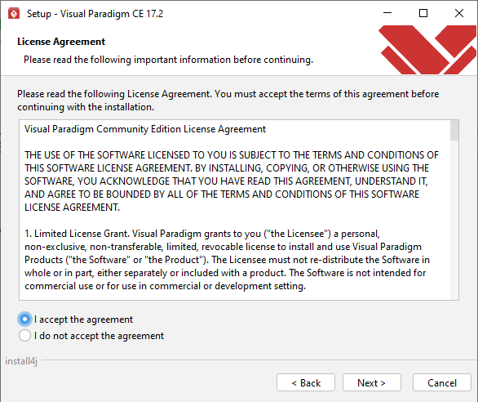

**Step 05:**

Select the E drive to install visual paradigm.

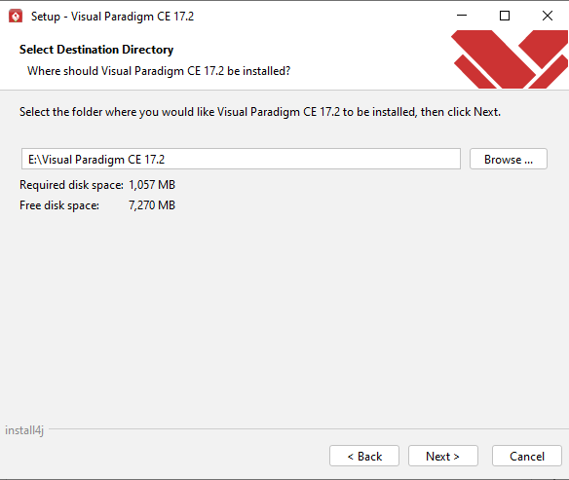

**Step 06:**

Creating the name of this app by own choice.

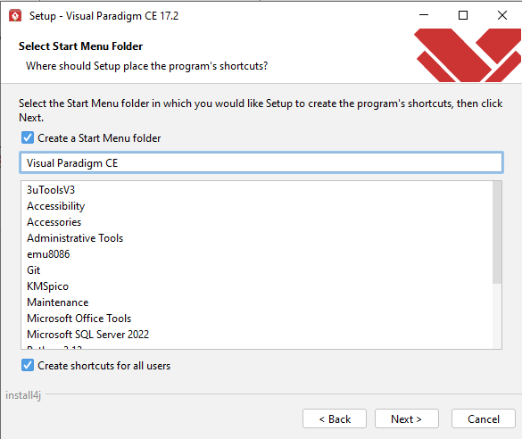

**Step 07:**

Select File Associations.

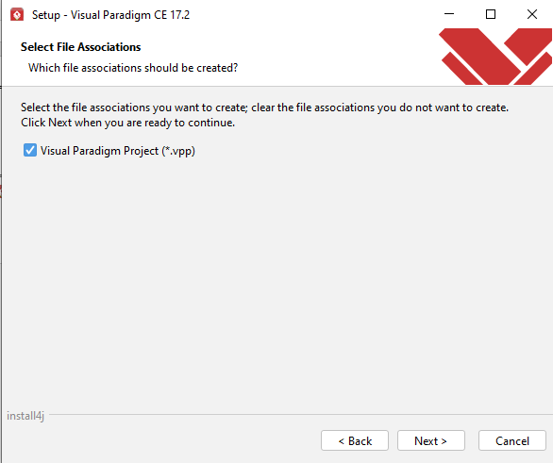

**Step 08:**

Enter Name and Email address.

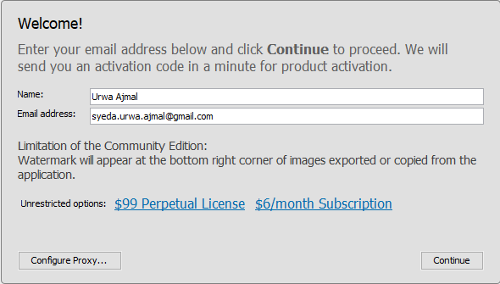

**Step 09:**

Email verification.

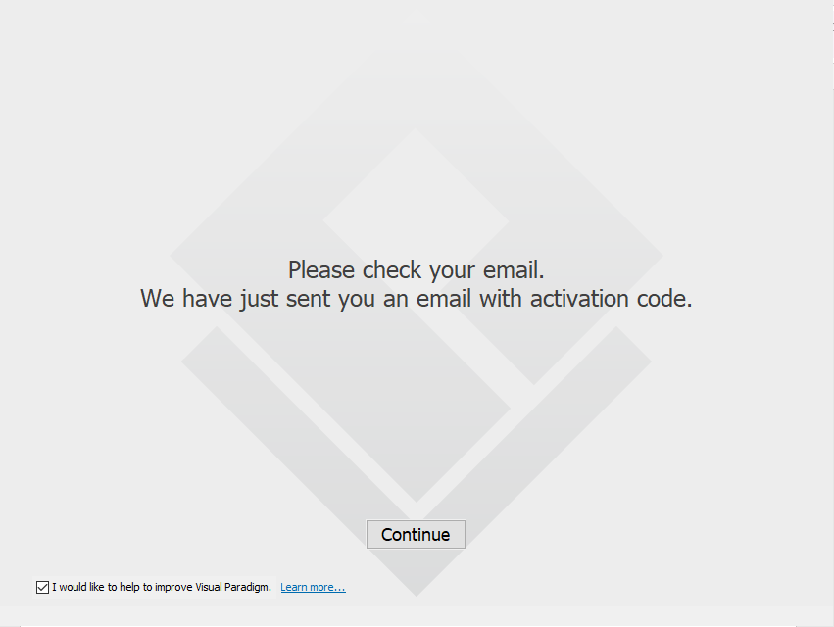

**Step 10:**

Entering Activation code.

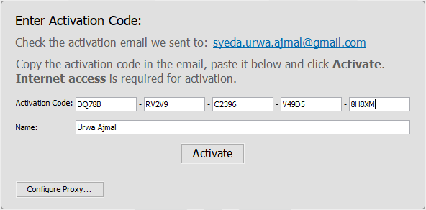

**Step 11:**

Visual paradigm community is activated. Click on start.

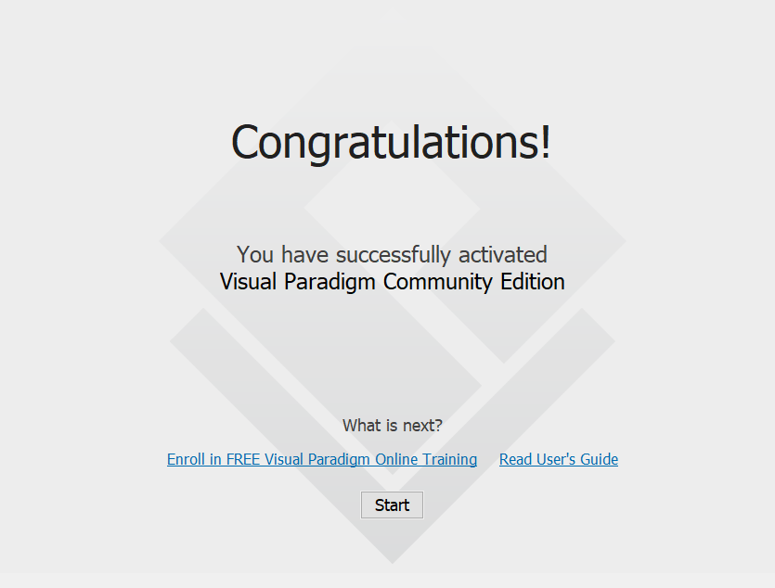

**Step 12:**

Opening the software.

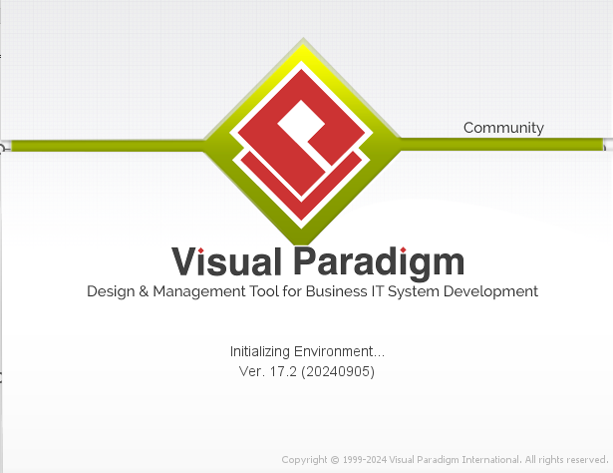

**Step 13:**

Software working space is openend.

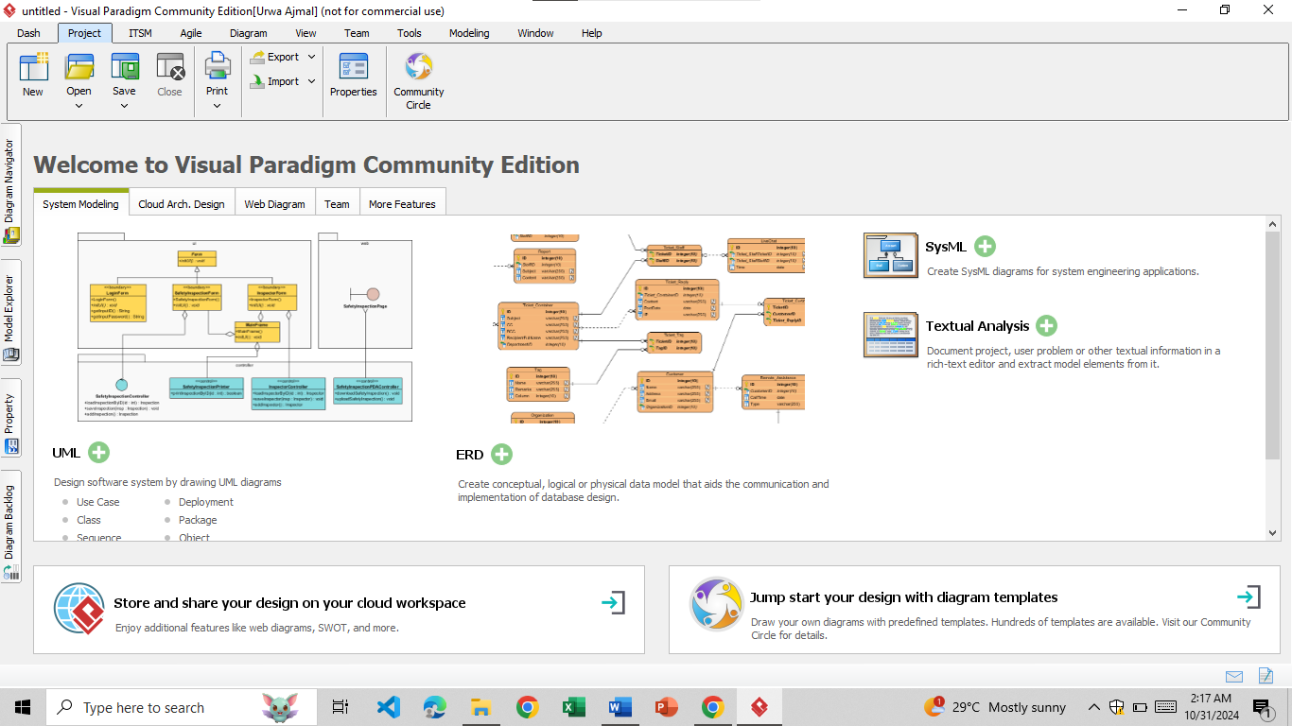

# Why do we use visual paradigm?

1. **What is Visual Paradigm, and what are its key features?**

Visual Paradigm is a comprehensive software modeling and diagramming tool used in software development. It supports a wide range of diagram types, especially UML (Unified Modeling Language), for modeling software systems and business processes. Key features include:

* UML Modeling: Full support for UML diagrams, such as class diagrams, sequence diagrams, use case diagrams, and more.
* Business Process Modeling (BPMN): Tools to create BPMN diagrams, process maps, and flowcharts.
* Project Management Tools: Integrates tools for task management, Gantt charts, and Agile development practices.
* Requirements Gathering: Support for user stories, use cases, and requirement specifications.
* Code Engineering: Code generation and reverse engineering for languages like Java, C#, PHP, etc.
* Database Design: ERD (Entity-Relationship Diagram) capabilities for designing and managing databases.

1. **How does Visual Paradigm support UML modeling?**

Visual Paradigm provides comprehensive support for all types of UML diagrams, making it an ideal tool for object-oriented modeling and system design. It includes:

* Pre-built UML Diagrams: A wide array of UML templates and easy drag-and-drop features.
* Real-Time Collaboration: Team members can collaborate in real-time on UML diagrams.
* Automatic Layouts: Simplifies complex diagrams with automatic layout adjustments for readability.
* Code Generation: Can generate code from UML class diagrams, saving time in the development process.

1. **What benefits does Visual Paradigm provide for software development, such as improved design, collaboration, and documentation?**

Visual Paradigm enhances software development by:

* Improved Design: Provides detailed visual representations, helping in clear, structured design and identification of potential issues early.
* **Enhanced Collaboration:** Allows teams to work together on designs in real-time and track changes, which is especially useful in distributed teams.
* **Comprehensive Documentation:** Auto-generates documentation for UML and other diagrams, ensuring that documentation is accurate and up-to-date.
* **Traceability and Consistency:** Provides traceability for requirements, design elements, and code, ensuring all are aligned throughout the project lifecycle.
* **Flexibility:** Supports multiple modeling methodologies, like Agile and Waterfall, to suit different project needs.

1. **How does Visual Paradigm integrate with other development tools and methodologies?**

Visual Paradigm supports integration with a wide range of development tools and methodologies, such as:

* **IDE Integration:** Works with popular IDEs like Eclipse, IntelliJ IDEA, and Visual Studio for streamlined workflow.
* **Code Generation and Reverse Engineering:** Supports forward and reverse engineering with multiple programming languages.
* **Version Control Systems:** Integrates with Git, SVN, and CVS for managing project versioning and collaboration.
* **DevOps & Agile Support:** Provides tools for Agile and Scrum practices (e.g., Kanban boards, story mapping) and integrates with DevOps workflows.
* **Cloud and Team Collaboration:** Cloud-based storage and team functionalities make it easy to collaborate, share, and review designs remotely.

# Setting up workspace in Visual Paradigm

1. **What are the steps to install Visual Paradigm?**

To install Visual Paradigm, follow these steps:

* **Download:** Visit [Visual Paradigm’s website] (https://www.visual-paradigm.com/) and download the installer for your operating system (Windows, macOS, or Linux).
* **Run Installer:** Open the downloaded file and run the installer.
* **Follow Setup Wizard:** The setup wizard will guide you through the installation process. Select your installation location, preferred language, and accept the license agreement.
* **Complete Installation:** Click "Install" and wait for the installation to complete. Once done, launch Visual Paradigm.
* **Activate License:** On the first launch, you’ll be prompted to activate a license. You can choose the free edition or enter a valid license key if you have one.

1. **How do I create a new project in Visual Paradigm?**

* **Launch Visual Paradigm:** Open Visual Paradigm on your computer.
* **Create New Project:** On the main screen, select **"New Project"** from the project dashboard or go to **File > New Project.**
* **Name and Configure Project:** Enter a project name and specify the location where you want to save it. Configure any additional settings, such as project type (UML, BPMN, etc.), if needed.
* **Save Project:** Click Create or Save to create the project. You’re now ready to start modeling in Visual Paradigm.

1. **What are the different workspace views and layouts in Visual Paradigm?**

Visual Paradigm provides multiple views and layouts to enhance user experience and accessibility:

* **Diagram View:** The primary workspace where diagrams (UML, BPMN, ERD) are created and edited.
* **Model Explorer:** A hierarchical tree view showing all project elements, such as diagrams, classes, and use cases, for quick navigation.
* **Properties Panel:** Displays the properties of the selected item, allowing you to adjust details like names, attributes, and relationships.
* **Resource Catalog:** Provides a list of diagram elements you can use, helping you drag and drop items quickly.
* **Team Collaboration View:** If using team collaboration features, this view shows real-time collaboration options, including project versioning and comments.
* **Documentation Pane**: Allows you to add descriptions and notes to project elements for documentation.

1. **How do I customize my workspace to suit my needs?**

* **Arrange Panels and Views:** Drag and dock panels (Model Explorer, Properties) to desired locations. You can also hide or show panels via the Window menu.
* **Switch Layouts:** Visual Paradigm offers preset layouts for different purposes (e.g., diagram-focused, documentation-focused). Access these through Window > Layouts.
* **Customize Toolbars:** Right-click on toolbars to add or remove tool icons based on frequently used functions.
* **Personalize Diagram Themes:** Choose a preferred color theme, fonts, and styles for diagrams via Window > Application Options > Diagramming
* **Set Keyboard Shortcuts**: Visual Paradigm allows custom shortcuts for various actions, accessible through Tools > Configure Shortcuts.

# UML Modeling with Visual Paradigm

1. **What are the basic UML diagrams supported by Visual Paradigm?**

Visual Paradigm supports a comprehensive range of UML diagrams, including:

* **Class Diagram:** Defines the structure of classes, attributes, methods, and relationships.
* **Use Case Diagram:** Illustrates functional requirements and interactions between users (actors) and the system.
* **Sequence Diagram:** Shows object interactions over time, focusing on the sequence of messages.
* **Activity Diagram:** Represents workflows, decision points, and parallel processes within the system.

1. **How do I create and edit UML diagrams in Visual Paradigm?**

* **Create a New Diagram:**

- Open your project and go to Diagrams > New Diagram

- Select the type of UML diagram (e.g., Class, Use Case) you want to create.

* **Add Elements:**

- Use the Diagram Toolbar to drag and drop elements like classes, actors, or messages onto the canvas.

- Alternatively, right-click on the diagram and select elements from the context menu.

* **Edit Elements:**

- Click on an element to edit its properties in the Properties Panel, such as name, attributes, or methods.

- Customize relationships and add labels to improve readability.

* **Save and Organize:**

- Save your diagram regularly, and organize diagrams in the Model Explorer for easy access.

1. **What are the best practices for modeling complex systems using UML in Visual Paradigm?**

* **Start with High-Level Diagrams:** Begin with simpler diagrams like Use Case or Component Diagrams to outline the system structure and interactions, gradually refining details with Class or Sequence Diagrams.
* **Maintain Consistency:** Ensure that naming conventions and element relationships remain consistent across diagrams.
* **Modularize Complex Diagrams:** Divide complex systems into smaller, manageable sub-diagrams or views, focusing on one aspect of the system at a time.
* **Document Details:** Use notes or comments on diagrams to provide context, especially for complex relationships.
* **Validate Regularly:** Use Visual Paradigm’s validation tools to check for errors, unlinked elements, or incomplete relationships.

1. **How do I generate code from UML models in Visual Paradigm?**

* **Select the Diagram:** Open the Class Diagram or relevant diagram from which you want to generate code.
* **Configure Code Generation:**

- Go to Tools > Code > Generate Code or right-click the diagram and select Generate Code.

- Choose the programming language (e.g., Java, C#, PHP) and configure package settings if needed.

* **Generate Code:**

- Click Generate to produce code files in the selected directory.

- Visual Paradigm will create code with the defined class structure, methods, and relationships.

* **Review and Adjust Code:** Once generated, you can review the code within Visual Paradigm or in an IDE, making adjustments as required.