PROJECT REPORT
ON
Design and Development of a WIFI Controlled Smart Surveillance Robot Using ESP32-CAM
Submitted In Partial Fulfillments of the Requirement for the Award of the Degree in
BACHELOR OF TECHNOLOGY
In
Electronics and Communication Engineering.
SUBMITTED BY:
SYED ASGHAR ABBAS
(2300102975) UNDER THE GUIDANCE
Prof. SYED HASAN SAEED
Bachelor of Technology


DEPARTMENT OF ELECTRONICS & COMMUNICATION ENGINEERING INTEGRAL UNIVERSITY
KURSI ROAD LUCKNOW-226026 2026

CERTIFICATE

This is to certify that the project report entitled “Design and Development of a WIFI Controlled Smart Surveillance Robot Using ESP32-CAM” submitted by Syed Asghar Abbas in partial fulfilment for the award of the degree of Bachelor of Technology in Electronics and Communication Engineering is a record of original work carried out by the student under my supervision.
The work presented in this report has not been submitted elsewhere for the award of any degree or diploma.

Project Supervisor
(Signature)

Head of Department Integral University
(Signature) Lucknow

DECLARATION

I SYED ASGHAR ABBAS (2300102975) student of B.Tech. Electronics & Communication Engineering, hereby declare that the last year project report on Design and Development of a WIFI Controlled Smart Surveillance Robot Using ESP32-CAM which is submitted by me to the Department of Electronics & Communication Engineering, Integral University, Lucknow in partial fulfilment of the requirements for the award of the degree of Bachelor of Technology has not previously formed the basis for the award of any Degree, Diploma, Associate ship. Fellowship or other similar title or recognition.

Place: Lucknow
Date:
Signature of the Candidate Syed Asghar Abbas
B-Tech (ECE)
Integral University, Lucknow

ACKNOWLEDGEMENT

I would like to express my sincere gratitude to my project guide (Prof. SYED HASAN SAEED) for his continuous support, valuable guidance, and encouragement throughout the development of this project. His suggestions and technical advice helped me successfully complete this work.
I would also like to express my heartfelt thanks to the Head of the Department guide (Prof. SYED HASAN SAEED), Department of Electronics and Communication Engineering, Integral University, for providing the necessary facilities and support required to complete this project.
I am grateful to all the faculty members of the Department of Electronics and Communication Engineering for their guidance and encouragement during my academic journey.
Finally, I would like to thank my family and friends for their constant motivation, support, and encouragement throughout the completion of this project.

SYED ASGHAR ABBAS.
Date:

ABSTRACT

The rapid advancement in robotics and Internet of Things (IoT) technologies has opened new possibilities for intelligent monitoring and surveillance systems. Traditional surveillance methods mainly rely on fixed CCTV cameras that are installed at specific locations. Although these systems are widely used, they have several limitations such as restricted coverage area and lack of mobility. To overcome these limitations, mobile surveillance robots have become an effective solution for remote monitoring applications.
This project presents the design and development of a WIFI controlled smart surveillance robot using the ESP32-CAM module. The proposed system integrates robotics and IoT technologies to create a mobile monitoring platform capable of providing real-time video streaming and remote control through a smartphone or computer.
The ESP32-CAM module acts as the central controller of the system and performs multiple functions including wireless communication, camera streaming, and control of sensors and motors. The robot is equipped with a motor driver module that controls the movement of the DC motors, enabling the robot to move forward, backward, left, and right. A servo motor is used to rotate the camera so that the user can view different directions during surveillance.
To enhance the safety of the robot, an HC-SR04 ultrasonic sensor is integrated into the system for obstacle detection. The ultrasonic sensor continuously measures the distance between the robot and nearby objects. When an obstacle is detected within a predefined distance, the robot automatically stops to prevent collision.
The robot is controlled through a web interface that can be accessed using a smartphone or computer connected to the same WiFi network. The user can view live video streaming and send movement commands to control the robot in real time.
The experimental results demonstrate that the system successfully performs surveillance operations including remote movement control, real-time video streaming, and obstacle detection. The proposed system is low-cost, compact, and suitable for applications such as home security, industrial monitoring, disaster inspection, and educational robotics projects.
The project demonstrates the potential of combining robotics and IoT technologies to develop intelligent and efficient surveillance systems.

TABLE OF CONTENTS
Chapter 1 – Introduction 1
This chapter introduces the concept of the WIFI controlled surveillance robot, including the background, objectives, and importance of the project.
Chapter 2 – Literature Review……………………………… 5
This chapter discusses previous research and existing technologies related to surveillance robots and IoT based monitoring systems.
Chapter 3 – System Architecture and Design..…………………………………….…..9
This chapter explains the overall system architecture, block diagram, and interaction between hardware and software components.
Chapter 4 – Hardware Components 14
This chapter describes the hardware components used in the project such as ESP32-CAM, motor driver, ultrasonic sensor, servo motor, DC motors, and power supply.
Chapter 5 – Software Design and Programming 23
This chapter explains the programming environment, Arduino IDE setup, WIFI communication, and control algorithms used in the system.
Chapter 6 – Circuit Design and Implementation 29
This chapter presents the circuit diagram and explains the connections between all hardware components.
Chapter 7 – Working Principle and Testing 36
This chapter describes the working mechanism of the robot and the testing procedures used to evaluate the system.
Chapter 8 – Results, Conclusion and Future Scope 43
This chapter discusses the results obtained from the project, system advantages, and possible future improvements.
References... 48

LIST OF FIGURES
S. No. Figure Content Page No.
Block Diagram of the WIFI Controlled Surveillance
1
Robot 10

- ESP32-CAM Module 14

- Arduino Uno Microcontroller Board 15

- L298N Motor Driver Module 16

- HC-SR04 Ultrasonic Sensor 17

- Servo Motor 17

- DC Gear Motor 18

- Robot Chassis 19

- Battery Pack 20

- Jumper Wires 20

- IR Obstacle Detection Sensor 21

- OLED Display Module 21

- Arduino IDE Programming Interface 24

- Mobile Phone Robot Control Interface 26

- Software Flowchart of Robot Operation 27
Circuit Diagram of the WIFI Controlled Surveillance Robot 30
16
- Hardware Assembly of the Surveillance Robot 33
- Experimental Setup for Robot Testing 40
- Live Video Streaming Interface 41

CHAPTER 1
INTRODUCTION

Introduction
In recent years, the development of robotics and Internet of Things (IoT) technologies has significantly improved the capabilities of automated systems. Robots are now widely used in different industries such as manufacturing, healthcare, agriculture, security, and disaster management. One of the most important applications of robotics is in the field of surveillance and monitoring.
Surveillance systems are used to observe environments and detect unusual activities to ensure safety and security. Traditional surveillance systems mainly rely on fixed CCTV cameras installed at specific locations. Although these systems are widely used, they have several limitations. Fixed cameras cannot move to different locations and therefore cannot provide complete coverage of large areas.
To overcome these limitations, mobile surveillance robots have been developed. These robots are capable of moving through different areas while capturing and transmitting real-time video. Mobile robots provide greater flexibility and can be remotely controlled by users through wireless communication technologies.
The development of WIFI enabled microcontrollers such as the ESP32 has made it possible to design smart surveillance robots that can transmit live video and be controlled remotely through a smartphone or computer. The ESP32-CAM module is a compact and powerful microcontroller that includes a built-in camera and WIFI capability. This makes it suitable for applications involving video streaming and remote monitoring.
In this project, a WIFI controlled surveillance robot using ESP32-CAM has been developed. The robot can transmit live video to a mobile device while being controlled remotely through a web interface. The system also includes an ultrasonic sensor that detects obstacles in front of the robot and prevents collisions by automatically stopping the robot when an obstacle is detected.
In this project, an Arduino Uno is also used to interface with the IR sensor and OLED display. The IR sensor detects nearby obstacles, while the OLED display shows system status and sensor information. Using a separate Arduino Uno for these components helps reduce the processing load on the ESP32-CAM and improves the overall performance of the system.

Background of the Project
Robotics has become an important part of modern technology. Robots are machines designed to perform tasks automatically or with minimal human intervention. The use of robots has

increased in many sectors because they can perform tasks faster, more accurately, and more safely than humans in certain situations.
One of the major advancements in robotics is the integration of wireless communication technologies. Wireless communication allows robots to be controlled remotely from a distance without the need for physical connections.
With the introduction of IoT technology, devices can communicate with each other over the internet. IoT enables smart systems that can collect, analyse, and transmit data in real time. In the context of surveillance systems, IoT allows users to monitor environments remotely through smartphones or computers.
The ESP32 microcontroller is widely used in IoT projects because it supports both WIFI and Bluetooth connectivity. The ESP32-CAM module further enhances these capabilities by integrating a camera with the microcontroller. This makes it possible to build compact surveillance systems capable of transmitting live video.
The integration of robotics, IoT, and wireless communication technologies has made it possible to develop advanced surveillance robots capable of remote monitoring and navigation.

Problem Statement
Traditional surveillance systems are usually based on fixed cameras installed at specific locations. These cameras can only monitor the area within their field of view. As a result, large areas require multiple cameras, which increases the cost and complexity of the system.
Furthermore, fixed surveillance systems cannot move to investigate suspicious activities occurring in different locations. In certain situations, it may also be dangerous for humans to enter specific environments for monitoring purposes.
Examples of such situations include:
    - Hazardous industrial environments
    - Disaster areas
    - Military surveillance zones
    - Large warehouses and storage facilities
In such cases, a mobile surveillance robot can provide a more flexible solution. The robot can move through different locations, capture live video, and transmit the data to a remote user.
The challenge is to design a robotic system that can:
    - Stream live video in real time
    - Be controlled remotely through a smartphone
    - Detect obstacles in its path
    - Avoid collisions while moving

This project aims to develop a low-cost and efficient surveillance robot capable of performing these tasks.

Objectives of the Project
The main objective of this project is to design and develop a WIFI controlled surveillance robot using ESP32-CAM.
The specific objectives of the project include:
- To design a mobile robotic platform capable of moving in different directions.
- To implement real-time video streaming using the ESP32-CAM module.
- To enable remote control of the robot through a smartphone using WIFI.
- To integrate an ultrasonic sensor for obstacle detection.
- To prevent collisions by automatically stopping the robot when an obstacle is detected.
- To develop a cost-effective surveillance solution suitable for educational and research purposes.

Features of the Proposed System
The surveillance robot developed in this project includes several important features that improve its functionality.

Wireless Control
The robot can be controlled remotely through a smartphone using WIFI. The user can send commands such as forward, backward, left, and right.

Live Video Streaming
The ESP32-CAM module captures video and streams it in real time to the user’s device through a web interface.

Obstacle Detection
An ultrasonic sensor is used to detect obstacles in front of the robot. If an obstacle is detected within a certain distance, the robot automatically stops to prevent collision.

Camera Rotation
A servo motor is used to rotate the camera, allowing the user to change the viewing direction.

Mobile Surveillance
The robot can move around different areas, providing flexible monitoring capabilities.

Scope of the Project
The main focus of this project is to develop a surveillance robot capable of performing remote monitoring tasks using wireless communication.

The system includes:
    - Real-time video streaming
    - Remote control through smartphone
    - Obstacle detection using ultrasonic sensor
This project demonstrates how robotics and IoT technologies can be integrated to create intelligent monitoring systems.

Applications of the System
The developed surveillance robot can be used in various applications such as:
    - Home security monitoring
    - Industrial inspection
    - Warehouse surveillance
    - Disaster monitoring
    - Military reconnaissance
    - Educational robotics projects
These applications demonstrate the usefulness and flexibility of mobile surveillance robots.

Organization of the Report
This report is divided into several chapters that explain the development of the surveillance robot.
Chapter 1 introduces the project and explains its background, objectives, and importance.
Chapter 2 presents the literature review and discusses previous research related to surveillance robots.
Chapter 3 explains the system architecture and design of the proposed system. Chapter 4 describes the hardware components used in the project.
Chapter 5 explains the software design and programming used to control the robot. Chapter 6 presents the circuit design and implementation of the hardware system. Chapter 7 explains the working principle of the robot and the testing procedures used.
Chapter 8 presents the results, conclusion, and possible future improvements of the project.

CHAPTER 2
LITERATURE REVIEW

Introduction
A literature review is an important part of any research or engineering project. It provides an overview of previous studies, technologies, and research related to the proposed system. The purpose of a literature review is to understand existing solutions, identify their limitations, and determine how the proposed system improves upon them.
In recent years, robotics and Internet of Things (IoT) technologies have been widely used to develop smart surveillance systems. Researchers and engineers have developed various robotic systems capable of performing remote monitoring and surveillance tasks. These systems typically include cameras, sensors, microcontrollers, and wireless communication modules.
This chapter reviews several technologies related to surveillance robots, wireless robotic control systems, and obstacle detection mechanisms.

Evolution of Surveillance Systems
Surveillance systems have evolved significantly over the past few decades. Initially, surveillance was performed manually by security personnel monitoring specific locations. Later, the introduction of Closed Circuit Television (CCTV) systems allowed continuous monitoring through fixed cameras.
Traditional CCTV systems are still widely used in homes, offices, and public areas. However, these systems have certain limitations because they remain fixed at specific positions. As a result, they cannot move to monitor different locations or investigate suspicious activities.
To overcome these limitations, mobile surveillance systems have been developed. Mobile surveillance robots can move through different areas and provide real-time monitoring. These robots can be controlled remotely and can capture video from multiple locations.

Wireless Controlled Robots
Wireless communication technologies have played a significant role in the development of modern robotic systems. Earlier robotic systems required wired connections to control the robot, which limited their mobility.
With the advancement of wireless communication technologies such as WIFI, Bluetooth, and RF communication, robots can now be controlled remotely from long distances.

Wireless controlled robots are commonly used in:
    - military operations
    - industrial automation
    - disaster management

    - surveillance and monitoring
WIFI-based robotic systems are particularly popular because they allow communication through standard internet networks. Users can control robots using smartphones, laptops, or web interfaces.
The ESP32 microcontroller has become a popular choice for wireless robotic systems because it supports both WIFI and Bluetooth connectivity.

IoT Based Monitoring Systems
The Internet of Things (IoT) refers to a network of interconnected devices that can communicate with each other through the internet. IoT technology enables devices to collect, transmit, and process data in real time.
IoT-based monitoring systems have become increasingly popular in applications such as:
    - smart homes
    - industrial monitoring
    - environmental monitoring
    - healthcare systems
In surveillance systems, IoT allows users to monitor locations remotely through internet- enabled devices. IoT-based surveillance systems can transmit live video, sensor data, and alerts to users in real time.
The ESP32 microcontroller is widely used in IoT applications because it provides integrated WIFI connectivity and sufficient processing power for embedded systems.

ESP32 Based Robotic Systems
The ESP32 microcontroller is one of the most widely used platforms for IoT and robotic applications. It is a low-cost and high-performance microcontroller developed by Espressif Systems.
The ESP32 provides several advantages including:
    - built-in WIFI and Bluetooth connectivity
    - high processing speed
    - multiple GPIO pins for sensor and actuator connections
    - low power consumption
The ESP32-CAM module further enhances these capabilities by integrating a camera with the microcontroller. This allows the system to capture and transmit live video over the internet.
Many researchers have used the ESP32-CAM module to develop surveillance robots capable of real-time video streaming and remote control.

Obstacle Detection Technologies
Obstacle detection is an important feature in mobile robotic systems. It allows the robot to detect objects in its path and avoid collisions.
Several types of sensors can be used for obstacle detection, including:
    - ultrasonic sensors
    - infrared sensors
    - LiDAR sensors
    - camera-based vision systems
Among these, ultrasonic sensors are commonly used in small robotic systems because they are inexpensive, reliable, and easy to use.
The HC-SR04 ultrasonic sensor is widely used in robotics projects. It works by emitting ultrasonic waves and measuring the time taken for the reflected waves to return. This information is used to calculate the distance between the sensor and an object.
By integrating an ultrasonic sensor with the robot, it becomes possible to detect obstacles and prevent collisions.

Comparison of Existing Systems
Several surveillance robot systems have been developed using different microcontrollers and communication technologies. Some systems use Arduino-based controllers with Bluetooth communication, while others use Raspberry Pi with camera modules.
Bluetooth-based robots are limited by their communication range. On the other hand, Raspberry Pi-based systems provide powerful processing capabilities but are more expensive and require more power.
ESP32-based systems provide a balanced solution because they are cost-effective, support wireless communication, and can perform real-time video streaming.
Therefore, the ESP32-CAM module is an ideal choice for developing a smart surveillance robot.

Limitations of Existing Systems
Although many surveillance robot systems have been developed, they still have certain limitations.
Some of the common limitations include:
    - limited wireless communication range
    - high system cost in advanced robotic platforms
    - lack of obstacle detection in simple robotic systems

    - limited battery life
The proposed system aims to overcome some of these limitations by developing a low-cost robot capable of remote monitoring and obstacle detection.

Summary
This chapter presented a review of existing research and technologies related to surveillance robots and IoT-based monitoring systems. It discussed the evolution of surveillance systems, wireless robotic control technologies, ESP32-based robotic platforms, and obstacle detection methods.
The literature review shows that combining IoT technology with robotics can significantly improve surveillance capabilities. The ESP32-CAM module provides an efficient platform for developing a wireless surveillance robot capable of transmitting live video and performing obstacle detection.
Based on the insights gained from the literature review, the proposed system has been designed to provide an effective and cost-efficient surveillance solution.

CHAPTER 3 SYSTEM ARCHITECTURE AND DESIGN

Introduction
System architecture describes the overall structure of the proposed system and explains how different hardware and software components interact with each other. In the proposed project, a WIFI controlled surveillance robot using ESP32-CAM has been designed to provide real- time monitoring and remote control.
The system consists of several hardware components including the ESP32-CAM module, motor driver, ultrasonic sensor, servo motor, DC motors, and power supply unit. These components work together to enable the robot to move, detect obstacles, and transmit live video to the user.
The ESP32-CAM module acts as the central controller of the system. It handles video streaming, WIFI communication, and control of motors and sensors. The robot can be controlled remotely through a web interface accessed using a smartphone or computer.

Use of Dual Microcontroller Architecture
In the proposed surveillance robot system, two microcontrollers are used to manage different tasks efficiently. The ESP32-CAM module acts as the primary controller responsible for video streaming, WIFI communication, and motor control.
An additional Arduino Uno microcontroller is used to handle the OLED display and IR sensor. The Arduino Uno reads the data from the IR sensor and displays system information on the OLED display. This separation of tasks reduces the processing load on the ESP32-CAM and improves the overall performance of the system.
By using two microcontrollers, the system becomes more stable and efficient because each controller handles specific operations independently.

Overview of the Proposed System
The proposed surveillance robot is designed to perform the following functions:
    - Capture live video using the ESP32-CAM module
    - Transmit video over WIFI to a mobile device
    - Move in different directions based on user commands
    - Detect obstacles using an ultrasonic sensor
    - Stop automatically to prevent collision
    - Rotate the camera using a servo motor

The system operates through a wireless network where the user sends control commands through a web interface. These commands are received by the ESP32-CAM module, which processes them and controls the robot's movement.

Block Diagram of the System
The block diagram represents the overall structure of the surveillance robot and shows the interaction between different components.
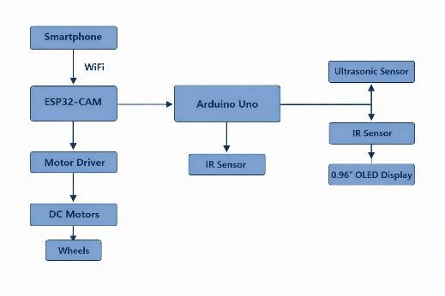
Figure 1 Block Diagram of the WIFI Controlled Surveillance Robot

The main blocks of the system include:
    - ESP32-CAM module
    - Motor driver module
    - Ultrasonic sensor
    - Servo motor
    - DC motors
    - Power supply
    - User interface (smartphone)
Each component performs a specific function within the system.

Hardware Architecture
The hardware architecture of the system consists of several electronic modules connected together to form the robotic platform.

ESP32-CAM Module

The ESP32-CAM module acts as the brain of the system. It controls all the operations of the robot including video streaming, wireless communication, and sensor data processing.

Motor Driver Module
The motor driver module (L298N) is used to control the movement of the DC motors. Since the ESP32 cannot directly supply enough current to drive the motors, the motor driver is used as an interface between the microcontroller and the motors.

Ultrasonic Sensor
The ultrasonic sensor (HC-SR04) is used to measure the distance between the robot and obstacles in front of it. The sensor sends ultrasonic waves and measures the time taken for the echo to return.

Servo Motor
The servo motor is used to rotate the camera so that the user can change the viewing direction.

DC Motors
DC motors are used to move the robot in different directions such as forward, backward, left, and right.

Power Supply
The system requires a stable power supply to operate the ESP32-CAM module, motors, sensors, and other components.

Software Architecture
The software architecture of the system includes the programming logic that controls the robot. The software performs several important tasks including:
    - Establishing WIFI communication
    - Capturing and streaming video
    - Receiving control commands from the user
    - Controlling the motors based on commands
    - Reading distance data from the ultrasonic sensor
    - Stopping the robot when an obstacle is detected
The software is developed using Arduino IDE and programmed in C/C++ language.

Communication Architecture
The communication between the robot and the user is established through WIFI. The ESP32- CAM module connects to a wireless network and acts as a web server.

The user connects to the robot using a smartphone or computer through a web browser. The web interface provides control buttons that allow the user to move the robot and view live video streaming.
The communication process works as follows:
- The ESP32-CAM connects to the WIFI network.
- The user accesses the robot through a web interface.
- Control commands are sent from the user interface to the ESP32-CAM.
- The ESP32-CAM processes the commands and controls the motors accordingly.

Data Flow in the System
The flow of data in the system occurs between sensors, the microcontroller, and the user interface.
The ultrasonic sensor continuously measures the distance in front of the robot and sends this information to the ESP32-CAM module. If the distance is below a predefined threshold, the robot stops automatically.
At the same time, the ESP32-CAM captures video frames using its camera and streams them to the user's device through WIFI.
The user sends movement commands through the web interface, which are processed by the ESP32-CAM to control the motors.

Control Mechanism
The control mechanism of the robot is based on commands received from the web interface. The main control commands include:
    - Forward movement
    - Backward movement
    - Left turn
    - Right turn
    - Stop
These commands are received by the ESP32-CAM and processed to generate appropriate signals for the motor driver module.
The motor driver then controls the DC motors accordingly, allowing the robot to move in the desired direction.

Camera Streaming Architecture
The ESP32-CAM module captures images using the onboard camera sensor. These images are processed and transmitted over the WIFI network as a video stream.
The video stream is displayed on the user's device through a web browser. This allows the user to monitor the robot's surroundings in real time.
Real-time video streaming is one of the key features of the surveillance robot because it allows remote monitoring of different locations.

Summary
This chapter explained the system architecture and design of the proposed surveillance robot. It described the overall system structure, hardware components, software architecture, communication process, and data flow within the system.
The ESP32-CAM module serves as the central controller that integrates wireless communication, video streaming, and robotic control. The combination of sensors, motors, and wireless communication technologies enables the robot to perform surveillance tasks effectively.
The next chapter describes the hardware components used in the development of the surveillance robot.

CHAPTER 4
HARDWARE COMPONENTS

Introduction
Hardware components are the physical elements used to build the surveillance robot system. These components work together to perform various functions such as processing data, detecting obstacles, controlling movement, capturing images, and providing power to the system.
The proposed WIFI controlled surveillance robot consists of several important hardware components including the ESP32-CAM module, motor driver module, ultrasonic sensor, servo motor, DC motors, robot chassis, and power supply unit. Each component performs a specific function within the system.
This chapter explains the working principle and features of each hardware component used in the project.

ESP32-CAM Module
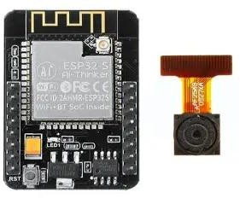
Figure 2 ESP32-CAM Module
The ESP32-CAM module is the main controller used in the surveillance robot. It is a powerful microcontroller developed by Espressif Systems that includes an integrated camera and WIFI capability.
The ESP32-CAM module performs several important tasks in the system. It processes sensor data, controls the motors, and transmits live video through WIFI. The built-in camera allows the robot to capture images and stream video to the user's device.

Features of ESP32-CAM
    - Built-in OV2640 camera
    - Integrated WIFI and Bluetooth
    - Multiple GPIO pins for sensors and motors
    - Low power consumption
    - Compact and low-cost module
Because of these features, the ESP32-CAM module is widely used in IoT-based surveillance systems.

Arduino Uno Microcontroller Board

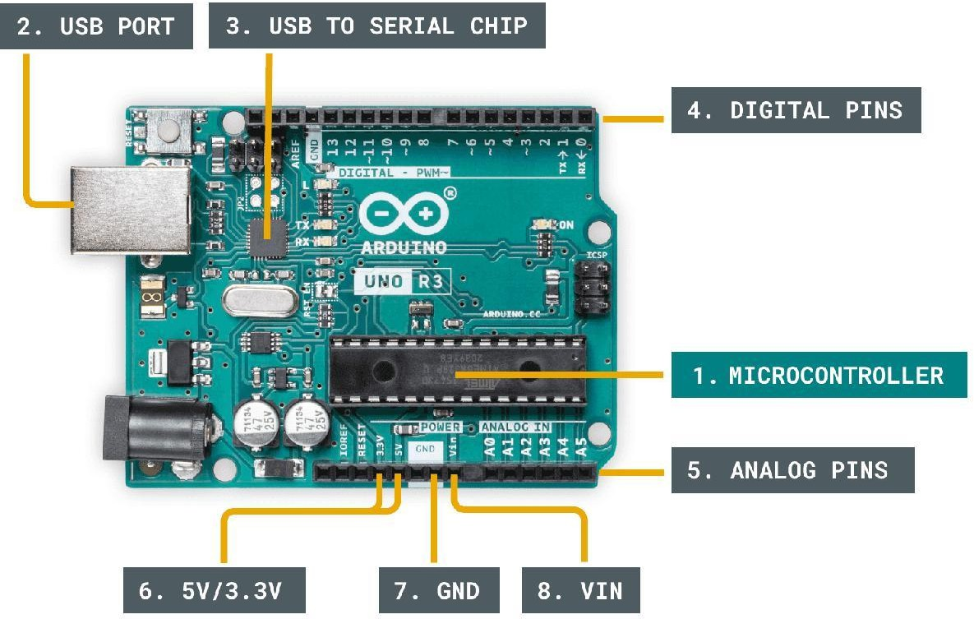

Figure 3 Arduino Uno Microcontroller Board
The Arduino Uno is a widely used microcontroller board based on the ATmega328P microcontroller. It is commonly used for embedded systems, robotics, and IoT applications.
In this project, the Arduino Uno is used as a secondary controller to handle the OLED display and IR sensor operations.

Features of Arduino Uno
    - ATmega328P microcontroller
    - 14 digital input/output pins
    - 6 analog input pins
    - USB interface for programming

    - Easy programming using Arduino IDE
The Arduino Uno reads the IR sensor signals and displays relevant information on the OLED display.

L298N Motor Driver Module
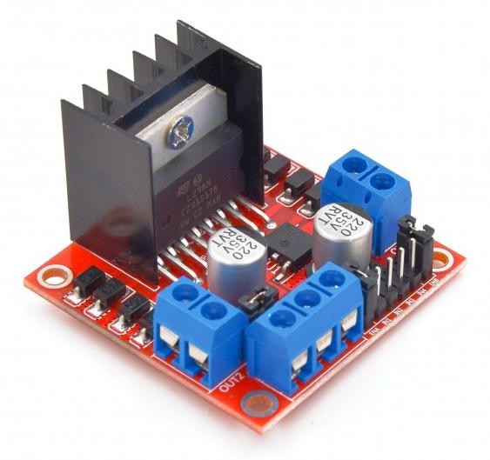
Figure 4 L2S8N Motor Driver Module

The L298N motor driver module is used to control the DC motors of the robot. The ESP32- CAM cannot directly drive the motors because motors require higher current than the microcontroller can provide.
The motor driver acts as an interface between the microcontroller and the motors. It receives control signals from the ESP32-CAM and supplies sufficient power to the motors.

Features of L298N Motor Driver
    - Dual H-Bridge motor driver
    - Can control two DC motors simultaneously
    - Supports forward and reverse motor movement
    - Operates with motor voltage up to 12V
This module is commonly used in robotics projects for controlling motor movement.

HC-SR04 Ultrasonic Sensor
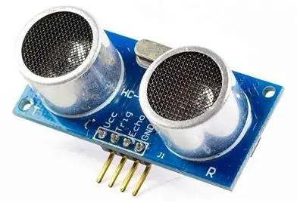
Figure 5 HC-SR04 Ultrasonic Sensor
The ultrasonic sensor is used for obstacle detection in the robot. The HC-SR04 sensor measures the distance between the robot and objects in front of it.
The sensor works by transmitting ultrasonic sound waves and receiving the reflected waves from objects. The time taken for the echo to return is used to calculate the distance.

Features of Ultrasonic Sensor
    - Distance measurement range: 2 cm to 400 cm
    - High accuracy and reliability
    - Simple interface with microcontrollers
    - Low power consumption
By integrating this sensor with the robot, the system can detect obstacles and avoid collisions.

Servo Motor
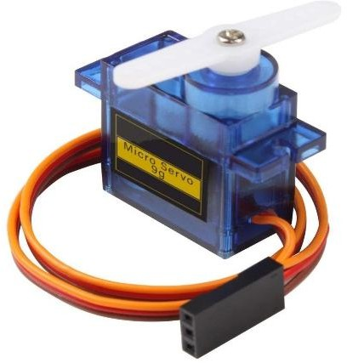
Figure c Servo Motor

A servo motor is used in the surveillance robot to rotate the camera module in different directions. This enables the user to adjust the camera’s viewing angle and monitor the surroundings more effectively. The servo motor provides precise angular movement, which makes it suitable for controlled positioning of the camera.
Servo motors work on the principle of Pulse Width Modulation (PWM). The microcontroller sends PWM signals to the servo, and the width of these pulses determines the position of the servo shaft. By varying the pulse width, the camera can be rotated smoothly to the desired angle. This feature improves the flexibility and coverage area of the robot’s surveillance system.

Features of Servo Motor
    - Precise angular control
    - Easy interface with microcontrollers
    - Lightweight and compact design
The servo motor helps improve the surveillance capability by providing a wider field of view

DC Gear Motors
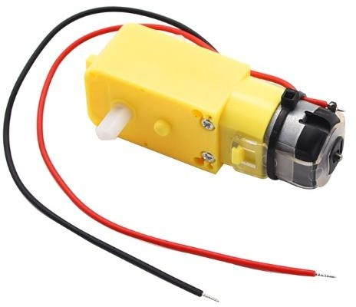

Figure 7 DC Gear Motor

DC gear motors are used in the surveillance robot to provide movement and mobility. These motors convert electrical energy into mechanical motion, which helps the robot move on the ground. The gear mechanism inside the motor reduces the speed and increases the torque, making it suitable for driving the robot wheels.

In this robot, DC gear motors are connected to the wheels through the chassis. By controlling the rotation direction of these motors using the motor driver (L298N), the robot can move in different directions such as forward, backward, left, and right. This controlled movement allows the user to navigate the robot remotely using a mobile phone or web interface.
Features of DC Gear Motors
    - High torque output
    - Simple control mechanism
    - Suitable for small robotic platforms

Robot Chassis
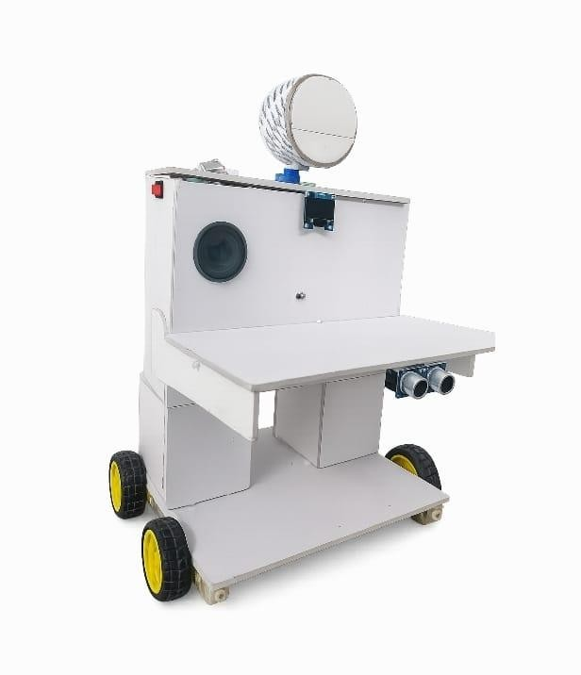
Figure 8 Robot Chassis

The robot chassis is the mechanical base structure on which all components are mounted. It provides support and stability to the robot.
The chassis typically includes mounting points for motors, battery, microcontroller, and sensors.
A well-designed chassis ensures smooth movement and proper balance of the robot.

Power Supply

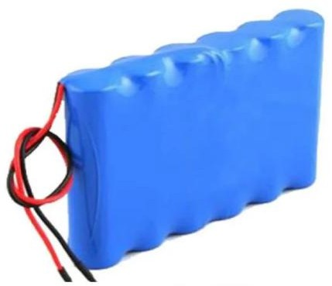

Figure S Battery Pack

The power supply provides electrical energy required for operating the robot. The system uses batteries to power the motors, microcontroller, and sensors.
Different components require different voltage levels. The motor driver typically operates at higher voltage, while the ESP32-CAM requires a stable 5V supply.
Proper power management is important to ensure stable operation of the robot.

Jumper Wires
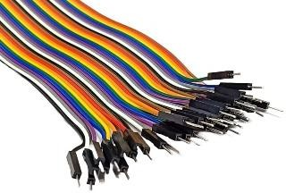

Figure 10 Jumper Wires

Jumper wires are used to connect different electronic components together. These wires provide electrical connections between the microcontroller, sensors, motor driver, and other modules.
They are commonly used in prototyping and robotics projects because they allow easy modification of circuit connections.

: IR Sensor

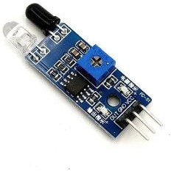
Figure 11 IR Obstacle Detection Sensor

The Infrared (IR) sensor is used for detecting nearby objects using infrared light. It consists of an infrared transmitter and receiver. The transmitter emits infrared radiation, and when an object comes in front of the sensor, the radiation is reflected back and detected by the receiver.
In the surveillance robot, the IR sensor helps in detecting obstacles or objects that are very close to the robot. It works as an additional safety sensor along with the ultrasonic sensor.

Features of IR Sensor
    - Short range object detection
    - Fast response time
    - Low power consumption
    - Simple interface with microcontrollers
The IR sensor improves the obstacle detection capability of the robot by detecting objects that are very close to the robot.

OLED Display Module
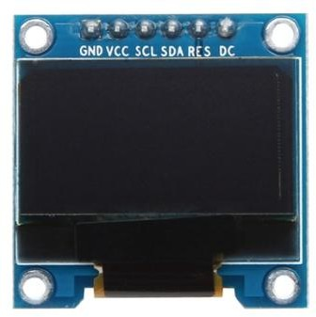

Figure 12 OLED Display Module

The OLED display is used to show information related to the robot system. OLED stands for Organic Light Emitting Diode. It is a small display module that provides clear text and graphics output.
In this project, the OLED display is used to show system information such as:
    - WIFI connection status
    - Robot status
    - Sensor readings
    - System messages
The OLED display communicates with the ESP32 microcontroller using the I2C communication protocol, which requires only two signal wires (SDA and SCL).

Features of OLED Display
    - High contrast display
    - Low power consumption
    - Compact size
    - Easy interface using I2C communication
The OLED display helps the user monitor the system status directly on the robot.

Hardware Integration
The hardware components described above are integrated together to form the complete surveillance robot.
The ESP32-CAM module acts as the main controller and communicates with all other components. The ultrasonic sensor provides obstacle detection, while the motor driver controls the movement of the robot. The servo motor controls the camera direction, and the power supply provides energy for all components.
The proper integration of these components ensures that the robot can perform surveillance tasks effectively.

Summary
This chapter described the hardware components used in the development of the WIFI controlled surveillance robot. Each component plays a specific role in the system.
The ESP32-CAM module acts as the central controller, while the motor driver controls the DC motors. The ultrasonic sensor enables obstacle detection, and the servo motor allows camera rotation. Together, these components create a functional mobile surveillance robot.
The next chapter explains the software design and programming used to control the robot and enable wireless communication.

CHAPTER 5 SOFTWARE DESIGN AND PROGRAMMING

Introduction
Software plays a very important role in controlling the surveillance robot. The hardware components such as sensors, motors, and camera require proper programming to function correctly. The software is responsible for establishing communication between the user and the robot, processing sensor data, controlling motors, and streaming live video.
In this project, the robot is programmed using the Arduino IDE platform. The ESP32-CAM microcontroller executes the program that enables WIFI communication, motor control, camera streaming, and obstacle detection.
This chapter explains the software tools, programming environment, and algorithms used to develop the system.

Arduino IDE
The Arduino Integrated Development Environment (IDE) is used to write, compile, and upload the program to the ESP32-CAM module. It provides a simple and user-friendly interface for developing embedded system applications.
The Arduino IDE supports programming in C and C++ languages and includes many libraries that simplify hardware control.

Features of Arduino IDE
    - Easy programming interface
    - Supports multiple microcontrollers
    - Built-in debugging tools
    - Large collection of libraries
    - Open-source platform
The Arduino IDE is widely used in robotics and IoT projects because it allows quick development and testing of embedded systems.

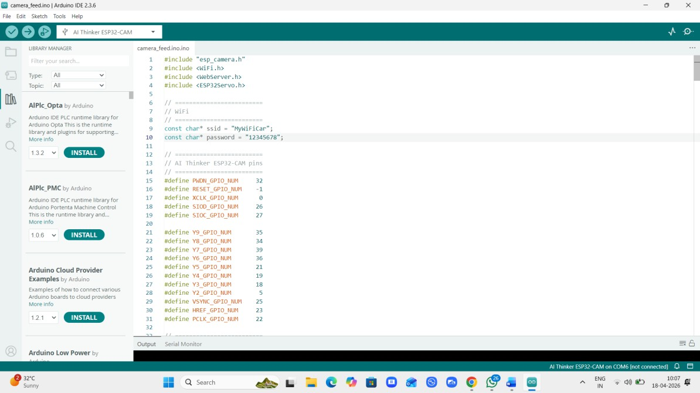

Figure 13 Arduino IDE Programming Interface

ESP32 Board Configuration
Before uploading code to the ESP32-CAM module, it is necessary to configure the ESP32 board in the Arduino IDE.
The following steps are used to configure the ESP32 board:
- Install the ESP32 board package in Arduino IDE.
- Select AI Thinker ESP32-CAM as the board type.
- Select the correct serial port for uploading the program.
- Configure the upload speed and flash settings.
Proper configuration ensures that the program is uploaded correctly to the microcontroller.

WIFI Communication
The surveillance robot communicates with the user through WIFI. The ESP32-CAM module connects to a wireless network and acts as a web server.
When the user opens the robot’s IP address in a web browser, a control interface appears on the screen. This interface includes buttons that allow the user to control the movement of the robot.
The ESP32 receives commands from the web interface and processes them to control the motors.

WIFI Communication Process
- ESP32 connects to WIFI network.

- ESP32 starts a web server.
- User opens the robot control page in the browser.
- Commands are sent from the browser to the ESP32.
- ESP32 controls motors according to the received commands.

Motor Control Algorithm
The robot movement is controlled by sending signals to the motor driver module. The motor driver receives control signals from the ESP32-CAM and drives the motors accordingly.
The robot supports the following movement commands:
    - Forward
    - Backward
    - Left
    - Right
    - Stop
The ESP32 sends HIGH or LOW signals to the motor driver pins to control the direction of the motors.

Motor Movement Logic
Forward movement occurs when both motors rotate in the same direction. Backward movement occurs when both motors rotate in the opposite direction. Turning is achieved by rotating the motors in different directions.

Ultrasonic Sensor Programming
The ultrasonic sensor is used to detect obstacles in front of the robot. The sensor measures the distance between the robot and nearby objects.
The sensor works by sending an ultrasonic pulse and measuring the time taken for the echo to return.
The distance is calculated using the following formula:
Distance = (Speed of Sound × Time) / 2
If the measured distance is less than a predefined threshold, the robot automatically stops to avoid collision.
This safety feature helps protect the robot from hitting obstacles.

Servo Motor Control

The servo motor is used to rotate the camera mounted on the robot. The servo motor is controlled using Pulse Width Modulation (PWM) signals generated by the ESP32.
The angle of the servo motor depends on the width of the PWM signal. By adjusting the PWM signal, the camera can be rotated to different angles.
This allows the user to observe different directions while controlling the robot.

Web Interface Design
The web interface allows the user to control the robot using a smartphone or computer browser. The interface contains:
    - Control buttons for robot movement
    - Live video streaming window
    - Servo control slider
When the user presses a control button, a command is sent to the ESP32-CAM through the WIFI network.
The ESP32 processes the command and performs the corresponding action.
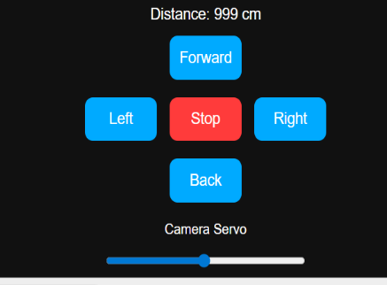
Figure 14 Mobile Phone Robot Control Interface

Software Flowchart
A flowchart is used to represent the sequence of operations performed by the system.

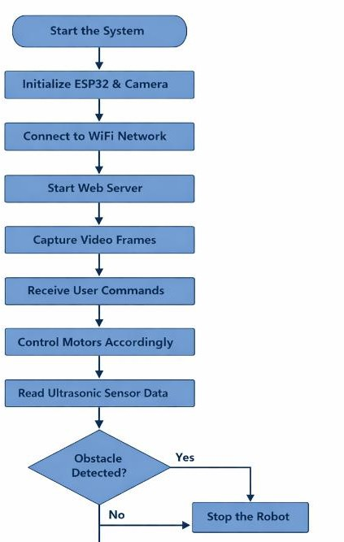

Figure 15 Software Flowchart of Robot Operation

The flowchart includes the following steps:
- Start the system
- Initialize ESP32 and camera
- Connect to WIFI network
- Start web server
- Capture video frames
- Receive user commands
- Control motors accordingly
- Read ultrasonic sensor data
- Stop robot if obstacle detected
This process continues as long as the robot is powered on.

Summary

This chapter explained the software design and programming used to control the surveillance robot. The system is programmed using Arduino IDE and uses various libraries to enable WIFI communication, motor control, and video streaming.
The ESP32-CAM module processes commands received from the user interface and controls the movement of the robot accordingly. The ultrasonic sensor ensures safety by detecting obstacles and stopping the robot when necessary.
The next chapter explains the circuit design and implementation of the hardware system.

CHAPTER 6 CIRCUIT DESIGN AND IMPLEMENTATION

Introduction
Circuit design is a crucial stage in the development of any embedded system. It defines how different electronic components are interconnected in order to perform a specific task. In the proposed surveillance robot, the circuit design plays a vital role in ensuring proper communication between the microcontroller, sensors, motors, and other hardware components.
The WIFI controlled surveillance robot integrates several hardware modules including the ESP32-CAM module, L298N motor driver, HC-SR04 ultrasonic sensor, servo motor, DC gear motors, and power supply system. These components are connected together through electrical circuits that allow the system to function as a unified robotic platform.
A properly designed circuit ensures reliable operation of the robot and prevents issues such as unstable power supply, signal interference, and hardware damage. This chapter explains the detailed circuit design of the surveillance robot and describes how each component is connected within the system.

Overview of Circuit Design
The circuit of the surveillance robot is designed to integrate multiple modules that perform different functions. The ESP32-CAM module acts as the central controller that communicates with all other components.
The motor driver module controls the DC motors that move the robot. The ultrasonic sensor detects obstacles in front of the robot. The servo motor controls the rotation of the camera. All these components are powered by a battery pack and connected through jumper wires.
The overall circuit design ensures that signals from sensors are processed by the microcontroller and appropriate control signals are sent to the motors and other actuators.

Complete Circuit Diagram
The circuit diagram illustrates how the ESP32-CAM module is connected to the motor driver, ultrasonic sensor, and servo motor. The diagram also shows the power supply connections required for operating the system.

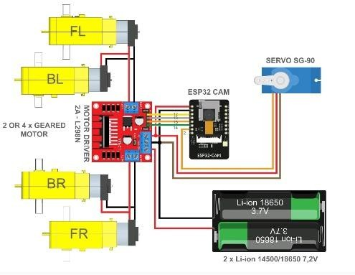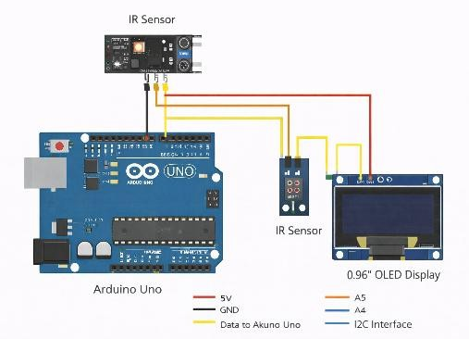
Figure 1c Circuit Diagram of the WIFI Controlled Surveillance Robot
The ESP32-CAM acts as the central processing unit that receives commands from the user and controls the hardware components accordingly.

ESP32-CAM Interface Connections
The ESP32-CAM module provides several General Purpose Input Output (GPIO) pins that are used to interface with sensors and actuators.
In this project, specific GPIO pins are assigned to control the motor driver and read data from the ultrasonic sensor.
Example connections include:
    - GPIO12 → Motor Driver Input 1
    - GPIO13 → Motor Driver Input 2
    - GPIO14 → Motor Driver Input 3
    - GPIO15 → Motor Driver Input 4
These pins generate control signals that determine the direction of rotation of the motors.
The ESP32-CAM also generates PWM signals to control the servo motor used for camera rotation.
Because the ESP32-CAM has limited available pins, careful planning of pin connections is necessary.

Motor Driver Circuit Design
The DC motors used in the robot require higher current than the ESP32-CAM can supply directly. Therefore, a motor driver module is used as an interface between the microcontroller and the motors.
The L298N motor driver module is based on an H-bridge circuit configuration. An H-bridge allows the direction of current flow through the motor to be reversed, enabling forward and reverse rotation.

Motor Driver Inputs
The motor driver receives four control inputs from the ESP32-CAM:
    - IN1 and IN2 control Motor A
    - IN3 and IN4 control Motor B
By changing the logic levels of these inputs, the direction of motor rotation can be controlled.

Motor Driver Outputs
The motor driver provides two output channels:
    - OUT1 and OUT2 connected to the left motor
    - OUT3 and OUT4 connected to the right motor

These outputs supply power to the motors based on the control signals received from the ESP32-CAM.

Ultrasonic Sensor Circuit
The HC-SR04 ultrasonic sensor is used for obstacle detection. It is connected to the ESP32- CAM through two signal pins.
The sensor includes the following pins:
    - VCC – power supply
    - GND – ground
    - TRIG – trigger signal
    - ECHO – echo signal
The TRIG pin sends ultrasonic pulses when activated by the ESP32-CAM. The ECHO pin receives the reflected signal from nearby objects.
The time taken for the signal to return is measured and converted into distance using the speed of sound.
The ultrasonic sensor is positioned at the front of the robot so that it can detect obstacles directly in its path.

Servo Motor Circuit
The servo motor is used to rotate the camera mounted on the robot. It receives a Pulse Width Modulation (PWM) signal from the ESP32-CAM.
The servo motor has three connections:
    - VCC – power supply
    - GND – ground
    - Signal – control signal
The control signal determines the angle of rotation of the servo motor.
Servo motors typically rotate within a range of 0° to 180°. By changing the PWM signal, the ESP32-CAM can control the direction of the camera.

Power Supply Circuit
Power supply design is an important part of the circuit implementation. Different components require different voltage levels to operate properly.
The ESP32-CAM module requires a stable 5V power supply. The DC motors require higher current and are powered through the motor driver module.
A battery pack is used as the primary power source for the robot.

Proper voltage regulation ensures stable operation of the system and prevents damage to electronic components.

Grounding and Signal Stability
Proper grounding is essential for reliable circuit operation. All components in the system must share a common ground connection.
Common grounding ensures that voltage levels are consistent throughout the circuit and prevents signal noise.
Improper grounding may cause communication errors between components or unstable system behaviour.
Therefore, careful attention must be given to grounding during circuit design.

Hardware Integration
After completing the circuit connections, the hardware components are mounted on the robot chassis.
The motors are attached to the wheels of the robot. The motor driver module is placed near the motors to reduce wiring complexity.
The ESP32-CAM module is mounted at the top of the robot to provide a clear view for the camera. The ultrasonic sensor is placed at the front for accurate obstacle detection.
The servo motor is mounted with the camera so that the viewing direction can be adjusted.
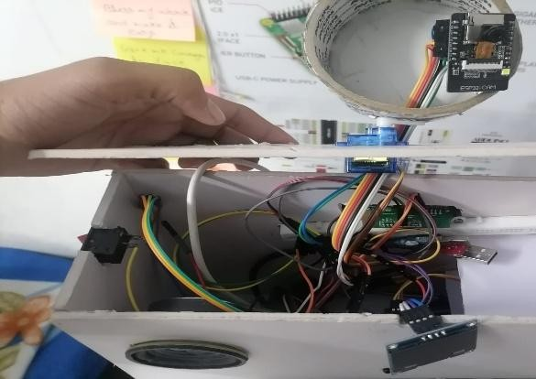
Figure 17 Hardware Assembly of the Surveillance Robot

Testing of Circuit Connections
After assembling the circuit, several tests were conducted to verify the connections. The following checks were performed:
    - verification of power supply connections

    - testing of motor driver signals
    - testing of ultrasonic sensor readings
    - testing of servo motor rotation
Each component was tested individually before integrating the entire system. These tests helped identify and correct any wiring errors.

Arduino Uno Connections
The Arduino Uno is used to interface with the IR sensor and OLED display. Connections include:
IR Sensor → Arduino Uno OLED Display → Arduino Uno

IR Sensor Connections
    - VCC → 5V (Arduino Uno)
    - GND → GND
    - OUT → Digital Pin (Arduino)

OLED Display Connections (I2C)
    - VCC → 5V
    - GND → GND
    - SDA → A4 (Arduino Uno)
    - SCL → A5 (Arduino Uno)
The Arduino Uno reads the IR sensor output and sends data to the OLED display using I2C communication.

Advantages of the Circuit Design
The circuit design of the surveillance robot provides several advantages.
First, the system uses simple and low-cost components, making it suitable for educational and research projects.
Second, the modular design allows easy replacement or modification of individual components.
Third, the use of a motor driver ensures that the ESP32-CAM is protected from high current loads.
Finally, the integration of sensors and actuators allows the robot to perform intelligent surveillance tasks.

Limitations of the Circuit Design
Although the circuit design is effective, there are some limitations.
The ESP32-CAM module has a limited number of GPIO pins, which restricts the number of additional sensors that can be connected.
The system also relies on battery power, which may limit the operating time of the robot.
Despite these limitations, the circuit design provides a reliable platform for developing a surveillance robot.

Summary
This chapter presented the circuit design and hardware implementation of the WIFI controlled surveillance robot. The ESP32-CAM module acts as the central controller and communicates with the motor driver, ultrasonic sensor, and servo motor.
The circuit connections enable the robot to move in different directions, detect obstacles, and stream live video to the user.
Proper circuit design ensures stable operation of the system and allows all components to function together effectively.

CHAPTER 7 WORKING PRINCIPLE AND TESTING

Introduction
The working principle of the surveillance robot explains how the entire system operates when it is powered on. The robot integrates several hardware and software components to perform surveillance tasks such as movement control, video streaming, and obstacle detection.
The ESP32-CAM module acts as the central controller of the system. It receives commands from the user through a wireless network and controls the movement of the robot accordingly. At the same time, the camera mounted on the ESP32-CAM captures video and streams it to the user in real time.
The ultrasonic sensor continuously measures the distance between the robot and objects in front of it. If an obstacle is detected within a certain distance, the system automatically stops the robot to prevent collision.
This chapter explains the detailed working of the system and the testing procedures used to evaluate its performance.

System Initialization
When the robot is powered on, the ESP32-CAM module begins the initialization process. During this stage, all the hardware components connected to the microcontroller are configured.
The following steps occur during system initialization:
    - The ESP32-CAM module starts executing the program stored in its memory.
    - The camera module is initialized for capturing images.
    - WIFI communication is established between the ESP32-CAM and the wireless network.
    - The web server is started to allow remote control through a browser.
    - GPIO pins are configured for controlling motors, sensors, and the servo motor.
    - The ultrasonic sensor begins measuring distance continuously.
Once the initialization process is complete, the robot becomes ready to receive commands from the user.

WIFI Communication Process
Wireless communication is one of the most important features of the surveillance robot. The ESP32-CAM module connects to a WIFI network and acts as a web server.

The user can control the robot through a smartphone or computer connected to the same network. The control interface is accessed through a web browser.
The communication process works as follows:
    - The ESP32-CAM connects to the WIFI network.
    - The module starts a web server and assigns an IP address.
    - The user opens the IP address in a browser.
    - A control interface appears on the screen.
    - The user sends movement commands through the interface.
    - The ESP32-CAM receives the commands and processes them.
This wireless communication allows the user to control the robot from a distance without physical connections.

Robot Movement Control
The movement of the robot is controlled using two DC motors connected to the motor driver module. The motor driver receives control signals from the ESP32-CAM module and drives the motors accordingly.
The robot supports the following movements:
- Forward
- Backward
- Left turn
- Right turn
- Stop

Forward Movement
When the forward command is received, both motors rotate in the same direction. This causes the robot to move forward.

Backward Movement
When the backward command is received, both motors rotate in the opposite direction, causing the robot to move backward.

Left and Right Movement
Turning is achieved by controlling the motors differently. For example, when turning left, one motor rotates while the other stops or rotates in the opposite direction.
This method allows the robot to navigate in different directions.

Live Video Streaming
One of the key features of the surveillance robot is real-time video streaming. The ESP32- CAM module contains a built-in camera that captures images continuously.
The captured images are processed and transmitted over the WIFI network as a video stream. The video stream is displayed on the user's device through a web interface.
The user can monitor the robot's surroundings in real time while controlling its movement. The video streaming system works through the following process:
    - The camera captures image frames.
    - The ESP32-CAM processes the frames.
    - The frames are converted into a video stream.
    - The stream is transmitted through WIFI.
    - The user's browser displays the live video.
This feature enables remote surveillance and monitoring.

Obstacle Detection Mechanism
Obstacle detection is implemented using the HC-SR04 ultrasonic sensor. The sensor is mounted at the front of the robot to detect objects in its path.
The sensor works by transmitting ultrasonic sound waves and receiving the reflected waves from nearby objects.
The distance between the robot and an obstacle is calculated using the following formula: Distance = (Speed of Sound × Time) / 2
Where:
- Speed of Sound = 343 meters per second
- Time = Time taken for the ultrasonic wave to return
If the calculated distance is less than a predefined threshold value, the robot stops automatically. This mechanism helps prevent collisions and protects the robot from damage.

Camera Rotation Mechanism
The surveillance robot uses a servo motor to rotate the camera. This allows the user to adjust the viewing angle of the camera.

The servo motor is controlled using Pulse Width Modulation (PWM) signals generated by the ESP32-CAM module.
By adjusting the PWM signal, the servo motor rotates to different angles, allowing the camera to view different directions.
This feature improves the surveillance capability of the robot by increasing the field of view.

Safety Control Logic
Safety is an important aspect of any robotic system. The surveillance robot includes a safety mechanism that prevents collisions with obstacles.
The safety control logic works as follows:
    - The ultrasonic sensor continuously measures distance.
    - The ESP32-CAM receives distance data from the sensor.
    - If the distance is below the safety threshold, the robot stops automatically.
    - The user can then change the direction of the robot.
This safety feature ensures smooth and secure operation of the robot.

Experimental Setup
To evaluate the performance of the surveillance robot, several tests were conducted in a controlled environment.
The experimental setup included:
- A flat testing surface
- Obstacles placed at different distances
- A WIFI network for communication
- A smartphone for controlling the robot
The robot was powered using a battery supply, and its performance was evaluated based on movement control, video streaming, and obstacle detection.

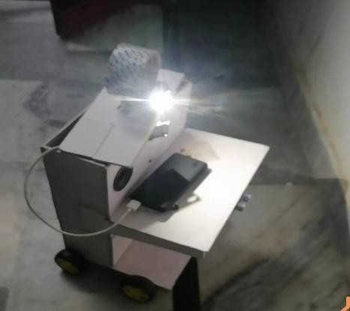
Figure 18 Experimental Setup for Robot Testing

Motor Testing
The DC motors were tested to verify their ability to move the robot in different directions. Each movement command was tested separately.
The robot successfully performed forward, backward, left, and right movements. The motor driver module responded correctly to control signals from the ESP32-CAM.

Ultrasonic Sensor Testing
The ultrasonic sensor was tested by placing obstacles at different distances in front of the robot.
The sensor successfully detected objects within the detection range and stopped the robot when the distance fell below the safety threshold.
This confirmed that the obstacle detection mechanism was functioning correctly.

Camera Streaming Testing
The camera module was tested to evaluate video streaming performance. The ESP32-CAM successfully transmitted live video to the user's device through the web interface.
The video stream provided a clear view of the robot's surroundings and allowed the user to monitor the environment effectively.

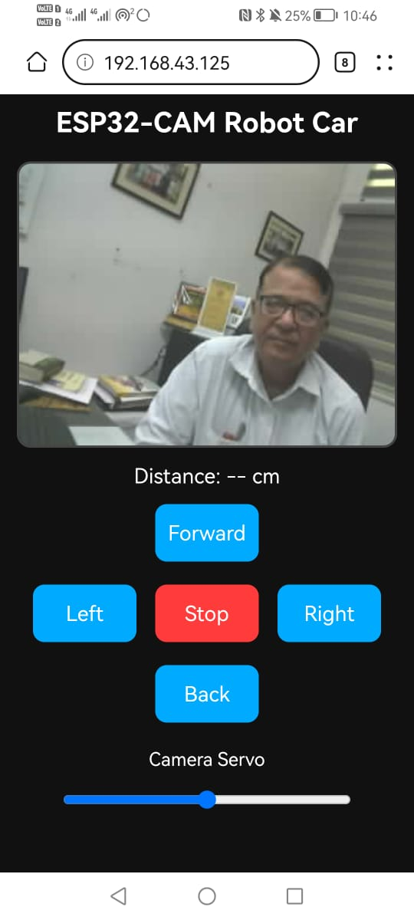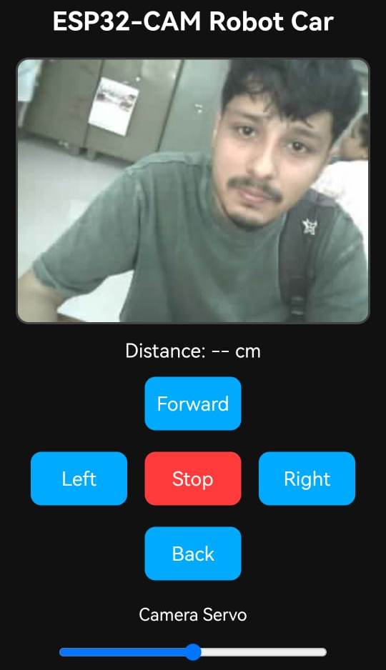

Figure 1S Live Video Streaming Interface

System Performance Evaluation
The overall performance of the system was evaluated based on several factors including:
- responsiveness of movement commands
- video streaming quality
- obstacle detection accuracy
- system stability
The results showed that the robot was able to perform surveillance tasks effectively.

Advantages of the System
The proposed surveillance robot provides several advantages:
- low-cost design
- real-time video streaming
- wireless control through smartphone
- obstacle detection and safety mechanism
- compact and portable system

Limitations of the System
Despite its advantages, the system also has some limitations:
- limited battery life

- dependence on WIFI connectivity
- limited processing capability of the microcontroller
Future improvements can address these limitations by integrating advanced technologies.

Summary
This chapter explained the working principle and testing of the surveillance robot. The system integrates WIFI communication, video streaming, motor control, and obstacle detection to perform surveillance tasks.
Experimental testing confirmed that the robot was able to move in different directions, stream live video, and detect obstacles effectively.
The next chapter presents the final results, conclusions, and future improvements of the project.

CHAPTER 8 RESULTS, CONCLUSION AND FUTURE SCOPE

Introduction
This chapter presents the results obtained from the development and testing of the WIFI controlled surveillance robot using the ESP32-CAM module. The performance of the system was evaluated based on several parameters such as robot movement, obstacle detection accuracy, video streaming quality, wireless communication stability, and overall system reliability.
The main objective of the project was to design and implement a mobile surveillance robot that can be controlled remotely through a smartphone while providing live video streaming and obstacle detection capability. The results obtained from the experimental testing confirm that the system successfully achieves these objectives.
This chapter also discusses the advantages, applications, limitations, and possible future improvements of the proposed system.

Experimental Results
After assembling the hardware and uploading the program to the ESP32-CAM module, the robot was tested under different conditions. The tests were performed to evaluate the performance of the robot in terms of movement control, video streaming, obstacle detection, and wireless communication.
The robot successfully performed all the intended operations. The ESP32-CAM module established a stable WIFI connection and started a web server for remote control. When the user entered the IP address in the browser, the control interface appeared on the screen along with the live video stream.
The robot responded correctly to the control commands sent from the mobile device. Commands such as forward, backward, left, right, and stop were executed successfully.
The ultrasonic sensor was able to detect obstacles placed in front of the robot. When an obstacle was detected within the predefined distance threshold, the robot stopped automatically to prevent collision.
The camera module captured live video and transmitted it through the WIFI network. The video stream was displayed in real time on the user's smartphone or computer.

Robot Movement Performance
The movement performance of the robot was tested by sending different control commands from the web interface. The motor driver module received control signals from the ESP32- CAM and drove the motors accordingly.
The robot was able to move smoothly in different directions. Forward and backward movement were stable, and turning operations were performed correctly.

The responsiveness of the robot was also tested. It was observed that the robot responded to user commands with minimal delay. This indicates that the communication between the user interface and the ESP32-CAM module was functioning effectively.
The motor driver module provided sufficient power to the motors, enabling the robot to move smoothly across the testing surface.

Obstacle Detection Performance
Obstacle detection is an important safety feature of the surveillance robot. The ultrasonic sensor continuously measured the distance between the robot and nearby objects.
During testing, obstacles were placed at different distances in front of the robot. The sensor successfully detected obstacles within its operating range.
When the obstacle distance fell below the predefined threshold, the robot automatically stopped. This safety mechanism prevented the robot from colliding with objects.
The ultrasonic sensor demonstrated reliable performance and provided accurate distance measurements during the testing process.

Video Streaming Performance
The ESP32-CAM module successfully captured and transmitted live video over the WIFI network. The video stream was displayed in the browser interface on the user's smartphone.
The quality of the video stream was suitable for surveillance purposes. The user was able to observe the surroundings of the robot in real time while controlling its movement.
Although the ESP32-CAM has limited processing capability compared to more powerful computing platforms, it was still able to provide smooth video streaming for monitoring purposes.
The video streaming feature significantly enhances the surveillance capability of the robot.

Wireless Communication Performance
Wireless communication between the robot and the user's device was established through a WIFI network.
During testing, the ESP32-CAM module successfully connected to the WIFI network and maintained a stable connection throughout the operation.
The control commands sent from the web interface were received and executed by the ESP32- CAM module without significant delay.
The WIFI communication allowed the robot to be controlled remotely without the need for physical connections. This feature makes the system highly flexible and suitable for remote monitoring applications.

Overall System Performance
The overall performance of the surveillance robot was evaluated based on several criteria including:
    - ease of operation
    - system stability
    - response time
    - sensor accuracy
    - video streaming capability
The results indicated that the robot was able to perform all surveillance functions successfully.
The integration of WIFI communication, video streaming, motor control, and obstacle detection created an efficient and functional surveillance system.
The project demonstrates how low-cost hardware components can be combined to develop an intelligent robotic monitoring system.

Advantages of the Proposed System
The WIFI controlled surveillance robot offers several advantages compared to traditional monitoring systems.

Remote Monitoring
The robot can be controlled remotely using a smartphone or computer. This allows the user to monitor different locations without being physically present.

Real-Time Video Streaming
The ESP32-CAM module provides live video streaming, enabling real-time observation of the environment.

Obstacle Detection
The ultrasonic sensor helps prevent collisions by detecting obstacles in front of the robot.

Low Cost
The system uses inexpensive electronic components, making it affordable for educational and research applications.

Compact Design
The robot has a compact and portable design, making it easy to deploy in different environments.

Applications of the System
The surveillance robot developed in this project can be used in various real-world applications.

Home Security
The robot can be used to monitor homes and detect unusual activities.

Industrial Monitoring
Industries can use surveillance robots to inspect machinery and monitor working environments.

Disaster Management
Robots can be used in disaster areas to inspect damaged buildings and locate survivors.

Military Surveillance
The robot can be used for monitoring restricted areas and collecting visual information.

Educational Purposes
The system can be used as a learning platform for students studying robotics and IoT technologies.

Limitations of the System
Although the proposed system performs well, it also has certain limitations.
One limitation is the dependence on WIFI connectivity. If the WIFI connection is weak or unavailable, the robot cannot be controlled remotely.
Another limitation is the limited battery life of the robot. Continuous operation may require frequent battery recharging.
The processing capability of the ESP32-CAM module is also limited compared to more advanced computing platforms such as Raspberry Pi.
Despite these limitations, the system provides an effective and low-cost surveillance solution.

Future Scope
The proposed surveillance robot can be further improved by integrating advanced technologies.

Artificial Intelligence
Future systems can include artificial intelligence algorithms for automatic object detection and tracking.

Face Recognition
Face recognition technology can be added to identify individuals in the surveillance area.

Autonomous Navigation

Instead of manual control, the robot can be designed to navigate automatically using advanced sensors.

Cloud Data Storage
Video data can be stored on cloud platforms for future analysis and monitoring.

GPS Tracking
GPS technology can be integrated to track the location of the robot.
These improvements can significantly enhance the functionality and performance of the surveillance robot.

Conclusion
The WIFI controlled surveillance robot using ESP32-CAM was successfully designed and implemented in this project. The system integrates robotics and IoT technologies to create a smart monitoring platform.
The robot can be controlled remotely through a smartphone while providing real-time video streaming and obstacle detection capabilities.
Experimental testing confirmed that the system performs effectively in terms of movement control, video streaming, and obstacle detection.
The project demonstrates that low-cost hardware components can be used to develop intelligent surveillance systems capable of performing remote monitoring tasks.
The proposed system provides a foundation for future research and development in the field of robotic surveillance and IoT-based monitoring systems.

REFERENCES
- Espressif Systems, ESP32 Technical Reference Manual, Espressif Systems.
- Arduino, Arduino IDE Documentation, Arduino Official Website.
- HC-SR04 Ultrasonic Sensor Datasheet, SparkFun Electronics.
- L298N Motor Driver Datasheet, STMicroelectronics.
- Servo Motor SG90 Technical Datasheet.
- K. Ogata, Modern Control Engineering, Prentice Hall.
- R. Siegwart, Introduction to Autonomous Mobile Robots, MIT Press.
- M. Schwartz, Internet of Things with ESP32, Packt Publishing.
- S. Monk, Programming Arduino: Getting Started with Sketches, McGraw Hill.
- IEEE Research Papers on Surveillance Robotics.
- Robotics and Embedded Systems Research Journals.
- IoT Based Smart Surveillance Systems – Research Publications.
- https://randomnerdtutorials.com (ESP32 Projects).
- https://iotprojectsideas.com (IoT Robotics Projects).
- https://arduino.cc (Arduino Official Website).
- https://esp32.com (ESP32 Community Documentation).
- Robotics Applications in Surveillance Systems – IEEE Papers.
- Wireless Controlled Robots – Research Studies.
- Embedded Systems Design for IoT Applications.
- Smart Robotics Systems for Security Monitoring.

