



Enrollment & Activation of MobilePASS Application

# 

# Setting up Capgemini SafeNet MobilePASS Application on Capgemini device (Laptop)

1. Open browser and enter the URL –[**https://selfportal.capgemini.com**](https://selfportal.capgemini.com/)

Note: This is accessible only in Capgemini environment and its inaccessible via Internet.

1. This link is SSO enabled. If you are prompted to login, login with Capgemini (CORP) **Username** and **Password**

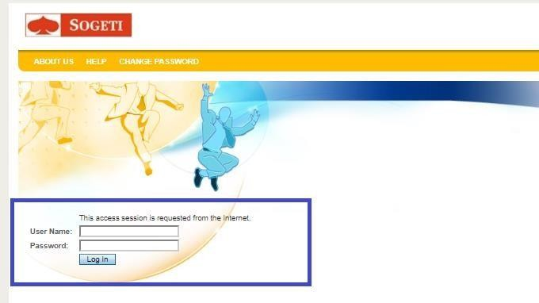

1. Go to **Actions** Pane *(right side of the screen)* and select **Assign MobilePASS Token** as shown in the below image.

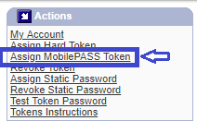

1. Select **Add value button** to enter the joining date as shown in the below image.

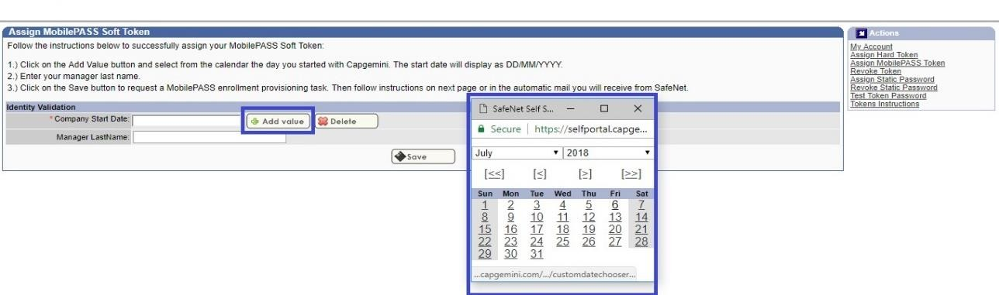

1. Enter **Manager’s Last name** and click on **Save** as shown below.

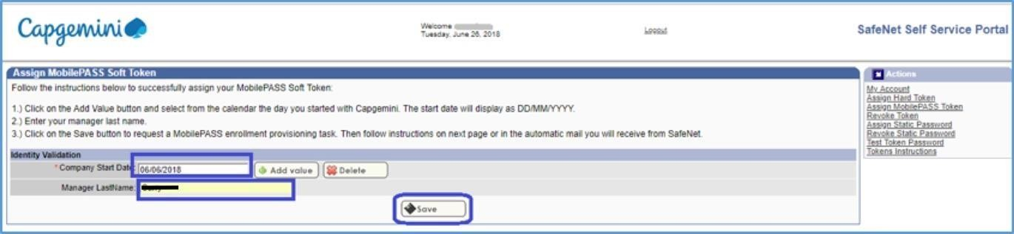

Note: If you are not aware of your date of Joining and /or Your Manager’s last name, please contact your Manager / BU HR.

1. Click on **enrollment URL** to launch the **MobilePASS download** page as shown in the below image.

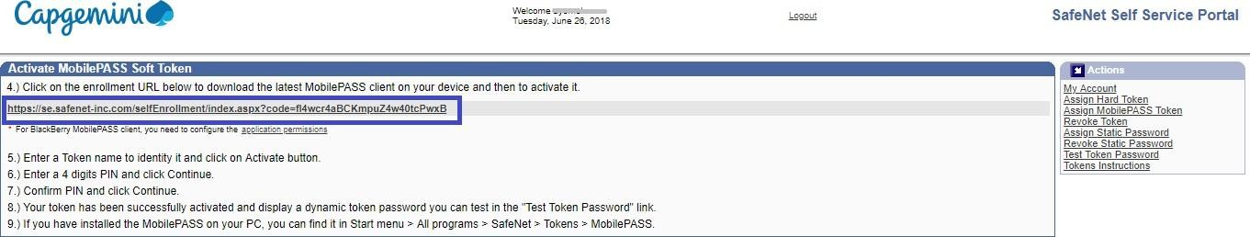

The below window will be popped up.

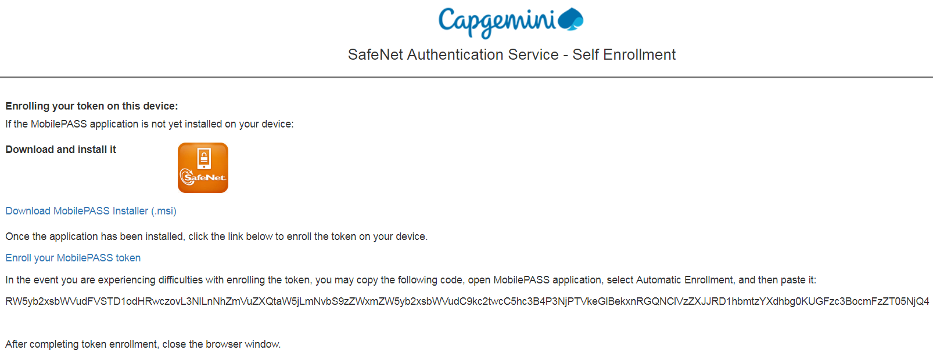

Please note that the MobilePASS token client is already pushed on your Laptop. You can verify by checking the same in the Control Panel >Programs > Programs & Features.

If the Mobile Pass application is available go directly to point 14.

If it is not available, you may download it via Software Centre.

* Open the **Software Centre** on your system and search for **Safenet Mobile Pass.**
* Open the application details and click on **install**.
* Go to point 14 and follow the steps for enrollment.

1. The setup can also be downloaded via self-service portal itself.

Click on **Download MobilePASS Installer (.msi)** link as shown below.

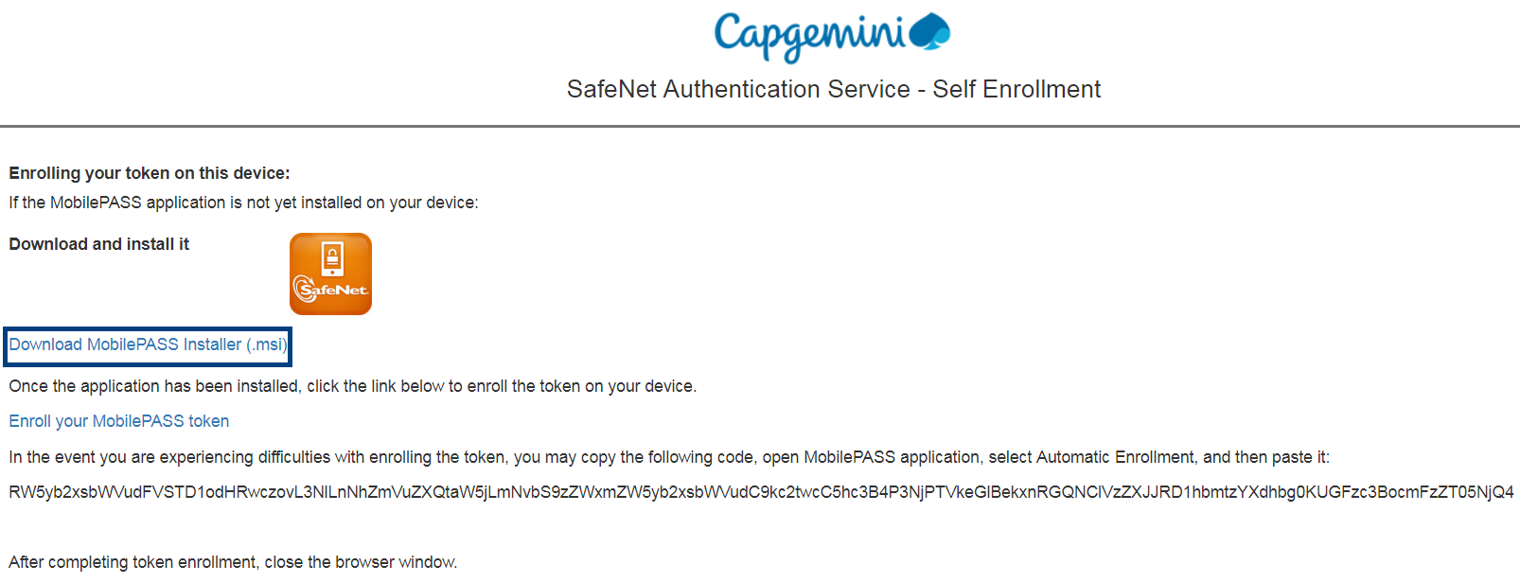

1. Once the exe file is downloaded, Start the installation (*double click on the downloaded file*) of **MobilePass application**



1. Click on **Next** in **SafeNet MobilePASS InstallShield wizard** as shown in the below image

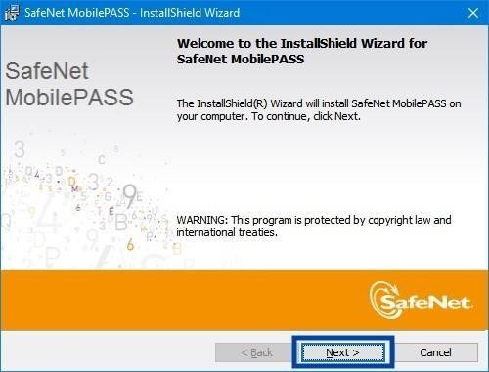

1. Select the checkbox **I accept the terms in the license agreement** and click on **Next as below image.**

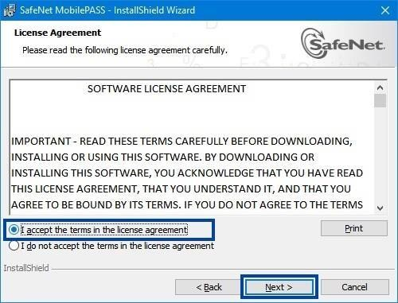

1. Click on **Next** as shown in the below image.

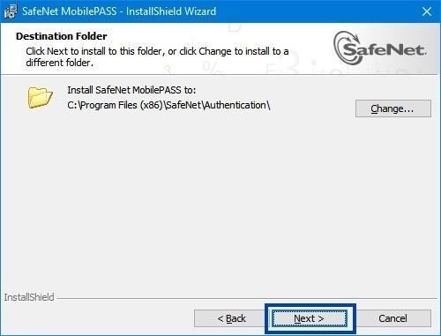

1. Ensure **Enable Manual Enrollment** is unchecked and click on **Install** as shown in the below image

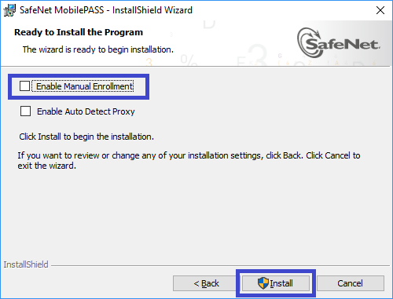

1. Click on **Finish** button to complete the installation of **SafeNet MobilePASS.**
2. **DO NOT** launch on MobilePASS app yet, go back to the browser page and click on “**Enroll your MobilePASS token**” as show in the below image.

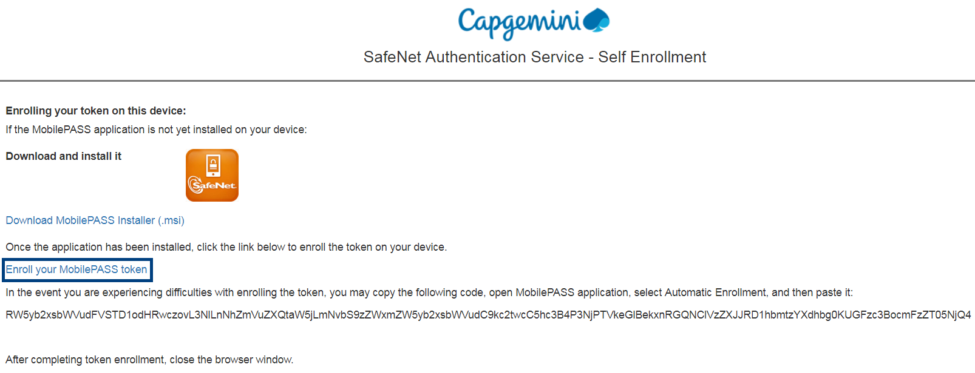

1. Click on **Open MobilePass** button on the pop-up screen as shown below.

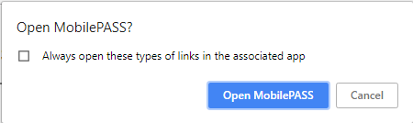

1. This will launch **MobilePASS application**,

* Please enter a token **Name** of your choice (minimum of 4 characters)
* Click **Activate** button and **Wait for Auto Enrollment to complete**
* Set a Token PIN by entering a **4- digit Pin** of your choice
* Click **Continue** button
* **Re-enter the same 4-digit Token Pin**
* Click **Continue** button as show in the below image.
* This will complete the MobilePASS application configuration. (You need to remember this 4 digit passcode to use Mobile Pass application.

|  |  |  |  |
| --- | --- | --- | --- |
|  |  |  |  |

17. The MobilePASS application will generate a random Passcode which will be valid for ten (10) seconds

**Note:** You have successfully installed and setup MobilePASS application and can Re-launch whenever a Passcode is needed to gain access to Capgemini infrastructure.

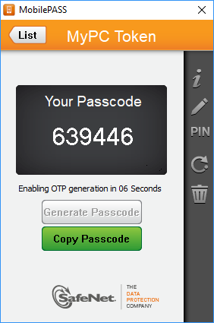

Setting up Capgemini SafeNet MobilePASS Application on Non-Capgemini device (Mobile Phones: Android & iOS)

To configure Mobile Pass on your mobile devices, **you are requested to contact Service Desk.**

**Service Desk agents will generate an enrollment task for you and will help you with the Static Password.**

Once you obtain static password which will be valid for at the most 3 days, you may follow below steps to enroll Mobile Pass on your device.

1. Go to Play Store (for Android) or Apple Store (for iOS) and install **SafeNet MobilePASS** in you device.
2. Open Webmail from your device’s browser.

Link for Webmail (On-Premise): <https://webmail.capgemini.com/owa/>

Link for Webmail (O365): <https://outlook.office365.com>

1. Use your Capgemini email ID & Password to **Sign in** to the Webmail application.

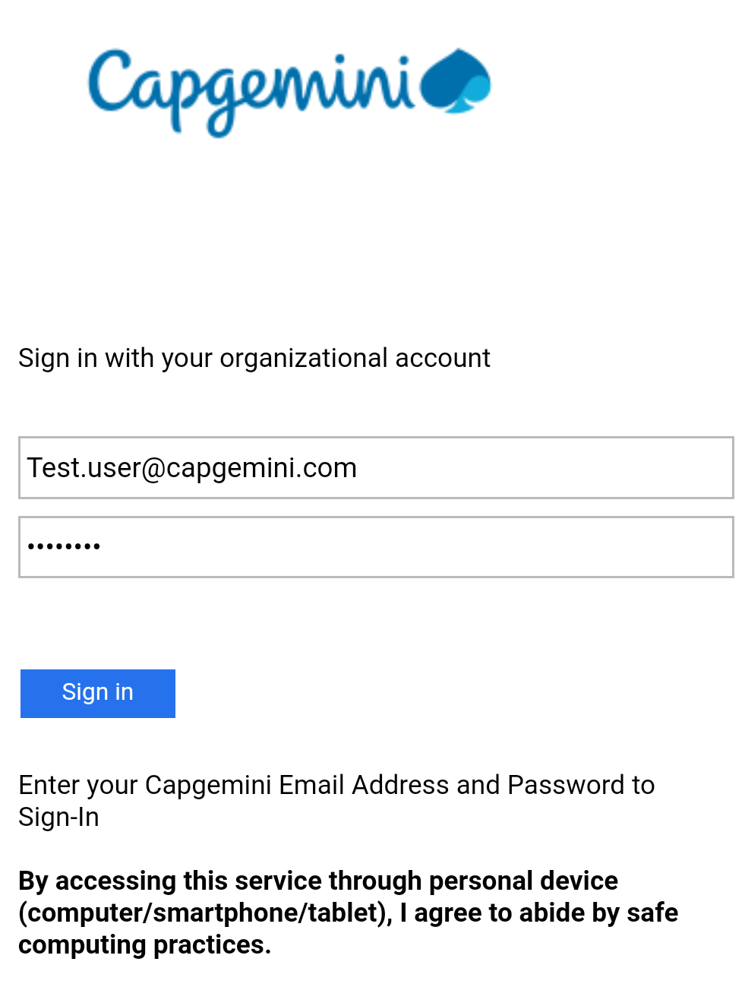

1. You’ll be prompted to enter SafeNet Passcode for additional security. Enter the Static Password and click on **Submit.**

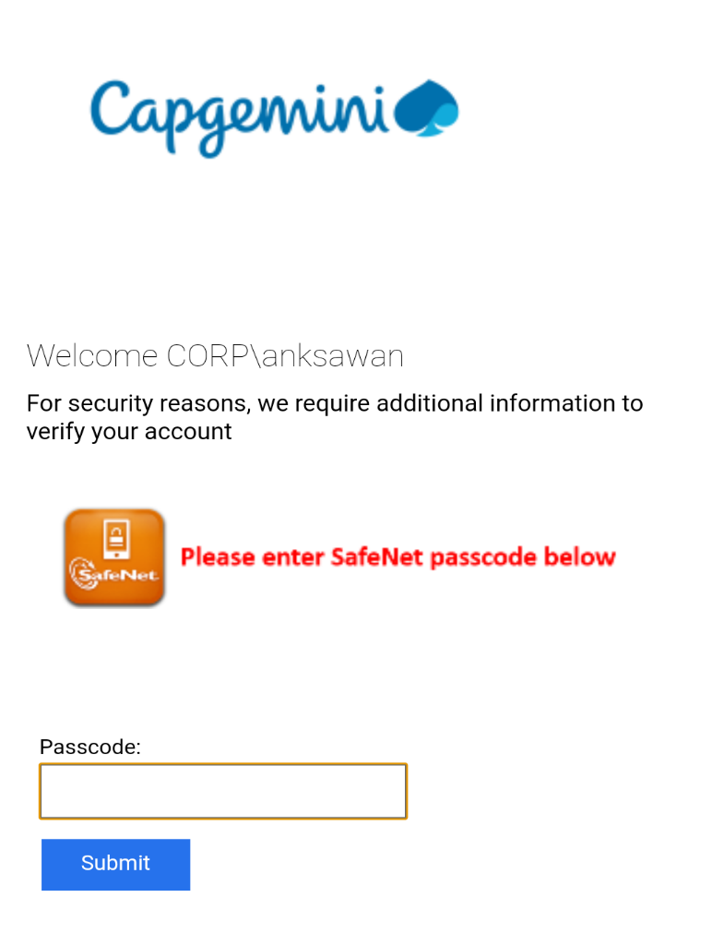

1. Once you login to the Webmail, Open the email that contains activation link as shown below.

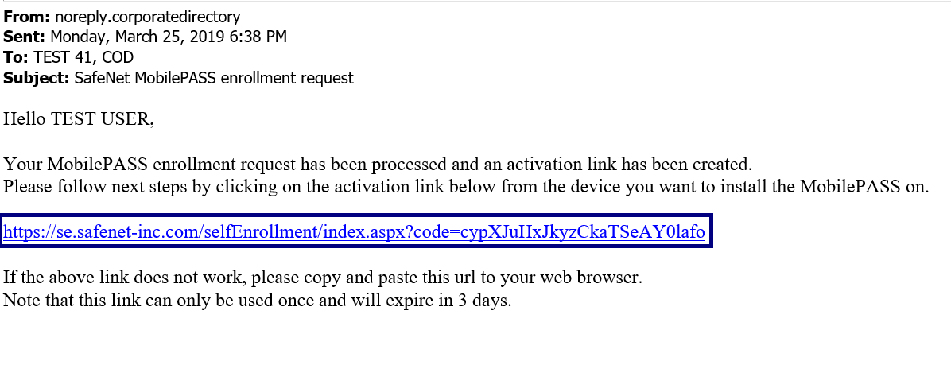

1. Once you click on the activation link, below window screen would appear.

Click on **Enroll your MobilePASS.**



1. This will launch **MobilePASS application**,

* Please enter a token **Name** of your choice (minimum of 4 characters)
* Click **Activate** button and **Wait for Auto Enrollment to complete**
* Set a Token PIN by entering a **4- digit Pin** of your choice
* Click **Continue** button
* **Re-enter the same 4-digit Token Pin**
* Click **Continue** button as show in the below image.

|  |  |  |  |
| --- | --- | --- | --- |
|  |  |  |  |

1. This will complete the MobilePASS application configuration. (You need to remember this 4 digit passcode to use Mobile Pass application.

The MobilePASS application will generate a random Passcode which will be valid for ten (10) seconds.

**Note:** You have successfully installed and setup MobilePASS application and can Re-

Launch whenever a Passcode is needed to gain access to Capgemini infrastructure.

