CONTENT
S.NO | CONTENTS | PAGE NO
1. | ABSTRACT | 01
2. | INTRODUCTION  2.1 Objective  2.2 Purpose  2.3 Scope | 02-03
3. | SYSTEM ANALYSIS AND STUDY  3.1 EXISTING SYSTEM  3.2 PROPOSED SYSTEM  3.3 FEASIBILITY STUDY | 04-05
4. | SOFTWARE SPECIFICATION  4.1 ABOUT SOFTWARE | 06-9
5. | SYSTEM SPECIFICATION  5.1 HARDWARE REQUIREMENT  5.2 SOFTWARE REQUIREMENT | 10
6. | PROJECT DESCRIPTION  6.1. Module Description | 11
7. | SYSTEM ARCHITECTURE  7.1 Data Flow Diagram  7.2 ER Diagram  7.3 External Interface Requirements  7.4 System Design  7.5 User Interface Design | 12-19
8. | DEVELOPMENT AND IMPLEMENTATION  8.1 Sample Code  8.2 Screen Shots | 20-26
9. | TESTING | 27-30
10. | CONCLUSION | 31
11. | FUTURE ENHANCEMENT | 32
12. | BIBLIOGRAPHY | 33

Online Book Donate Management System
1.ABSTRACT
- Online Book Donate Management is a website, developed to buy, sell or donate the books. It maintains the information about the personal details of their customers, also manage the books purchased or donated by them.
- It is simple to understand and can be used by anyone who is not even familiar with simple Book Donate system. This software package has been developed using the powerful coding tools of HTML, CSS & Bootstrap at Front End and MySQL Server at Back End.
- The application provides a user-friendly interface for both donors and administrators. Donors can register, log in, and submit their book donations, including relevant details such as book title, author, condition, and quantity.
2.INTRODUCTION
Online Book Donate and Donation is a form of e commerce website which allows customer for buying, Donate and donation of books directly from a seller over the Internet using a web browser.
Objective
- To provide a simple interface for users to donate and receive books.
The main objective of the project is to create an online book Donate and donation store that allows users to search and buy a book online based on title, author and subject.
There are many online book stores like Amazon Kindle, e-readers which were designed using Html.
- In our website, we focused on donation section which is the most important part of our website.
Online Book store is an online web application where the customer can buy, sell and donate books online. Through a web browser the user can search for a book by its title or author.
Purpose
Using this website, user can purchase a book, resell and donate online instead of going out to a book store and wasting time.
Scope
This system is intended for use by educational institutions, non-profit organizations, libraries, and individuals who wish to donate or receive books. It offers functionalities such as:

3.SOFTWARE SPECIFICATION

HTML – Hypertext Markup Language:
HTML, which stands for Hypertext Markup Language, is the standard markup language used to create web pages. It is the basic building block of the world wide web and is used to create the structure and content of web pages.
To create documents that could be easily viewed and linked together using the hypertext system he was developing. HTML allowed web developers to create pages with text, images, and links, and to link those pages together to form a web of information.
Tags like:
- <!DOCTYPE html> declares that the document is an HTML5 document.
- <html> indicates the beginning of the HTML document.
- <head> contains meta information about the document, such as the title of the web page
- <title> specifies the title of the web page.
- <h1> </h1> indicates the beginning and end of the level 1 heading
- <p> </p> indicates the beginning and end of the level 1 heading

<!DOCTYPE html>
<html>
<head>
<title> my web page </title>
</head>
<body>
<h1>welcome to my web page! </h1>
<p> this is a paragraph of text on my web page. </P>
</body>
</html>
CSS - Cascading Style Sheets:
Cascading Style Sheet (CSS) is a style sheet language used to described the presentation
Of a document written in HTML(hypertext markup language).CSS is used to add colors, fonts, spacing and other visual styling to web pages. CSS works by selecting HTML elements and applying styles to them. The styles are defined in a separate CSS file or in the head section of an HTML document.
There are different ways to declare CSS styles:
- Inline CSS: you can declare CSS style directly in an HTML elements using the style attribute. For ex: <p style=”color:blue;”> this is a blue paragraph. </p> apples the blue color directly to the <p> element.
- Internal CSS: you can declare CSS styles in the head section of an HTML document using the <style> tag. For ex: <style> p {color:red}</style> applies the red color to all <p> elements on the page.
- External CSS: you can declare CSS styles in external CSS file and link it to an HTML document using the <link> tag. For ex:<link rel=”stylesheet” type=”text/css” href=”styles.css”> links an external CSS file named “styles.css” to the HTML document.
PHP – Hypertext Preprocessor:
Php stands for hypertext pre-processor. It is a server side scripting language and powerful programming language that is widely used for building dynamic websites and web application. PHP is an open source software and free to download and use.
PHP is used for web development. It can be embedded within HTML.
PHP scripts are executed on the server. PHP support database like MYSQL.
- PHP files can contain text, HTML tags and scripts
- PHP files have extensions “.php”, “.phtml”
PHP typically used in combination with a web server like Apache, request for PHP script are received by the web server, and handle by the PHP interpreter.
MySQL
MySQL is very fast multi-threaded, multi-user and robust SQL relational database server. MySQL is free software
- MySQL is a database management system
- MySQL is a relational database management system
- MySQL software is open source
- The MySQL database is very fast, reliable and easy to use
- MySQL server was originally developed to handle the large database much faster than existing solution and has been successfully used highly demanding production environment for several years.
The MySQL database software is a client/server system that consists of multi threaded SQL server support different backend, several clients programs and libraries and wide range of Application Programming Interface (APIs).

4.SYSTEM SPECIFICATION
HARDWARE REQUIREMENT
The development of the web application was done on a system with the following hardware profile:
- PROCESSOR : Intel Core i5.
- RAM : 8 GB DDR4 RAM
- MONITOR : 15” COLOR
- HARD DISK : 512 GB
- Operating System : Windows 11

SOFTWARE REQUIREMENT
The software packages used, as well as the languages employed in each one of them are as follows:
- Front End : HTML, CSS, JavaScript
- Back End : PHP
- DBMS : MYSQL
- Web Server : APACHE, MYSQL

5.PROJECT DESCRIPTION
Some Modules are to be maintained for proper functioning. Those may be:
MODULES:
- Administration Module
- Donors’ Module
Administration Module: The webpage or the network may be run by library professionals on voluntary basis. Role of Administrative body will include:
- Maintenance of Webpage
- Delete users
- Organising awareness Programmes
- Maintenance of donors’ profile, receivers’ profile, document profile, etc.
- Managing feedback and take actions as required
- Report generation

Donors’ Module: Every new donor must get registered himself/herself and receive User ID & Password for getting access to the web page.
Functional Requirements
- User Registration: Donors and recipients need to create accounts.
- Book Donation: Donors can add books to the system by providing details like book title, author, condition, and category.
- Recipient Search: Recipients can search for available books based on criteria such as category, author, and location.
- Donation Confirmation: Once a donation is made, the system confirms the receipt of the book and updates the database.
- Book Tracking: The system tracks the status of donated books (pending, in progress, delivered).

6.SYSTEM ARCHITECTURE
The system follows a client-server architecture. The client-side is the user interface, where users can interact with the system to donate or receive books. The server handles the processing of data and communication with the database. The database stores information related to users, books, donations, and recipients.
Data Flow Diagram or System Flow:
- The donor logs into the system and registers a book.
- The recipient browses the available books based on their needs.
- Once a match is found, the system processes the donation and tracks it until it is successfully delivered.
Here's a ER (Entity-Relationship) Diagram for the Book Donation Management System that captures the main entities and their relationships. The entities involved typically include Users, Books, Donations, and Recipients. I'll describe the diagram in a structured way, which you can then use to create the actual ER diagram visually using a tool like draw.io, Lucidchart, or any other ER diagram tool.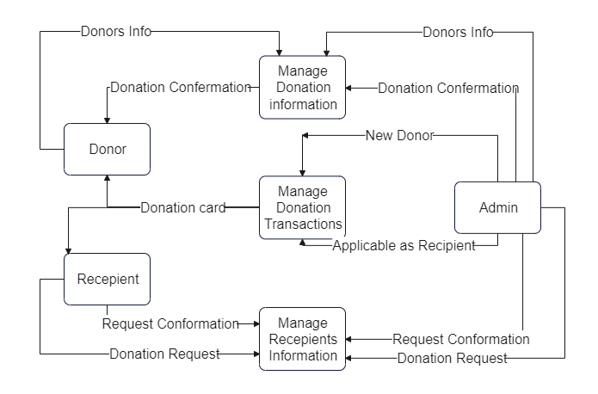

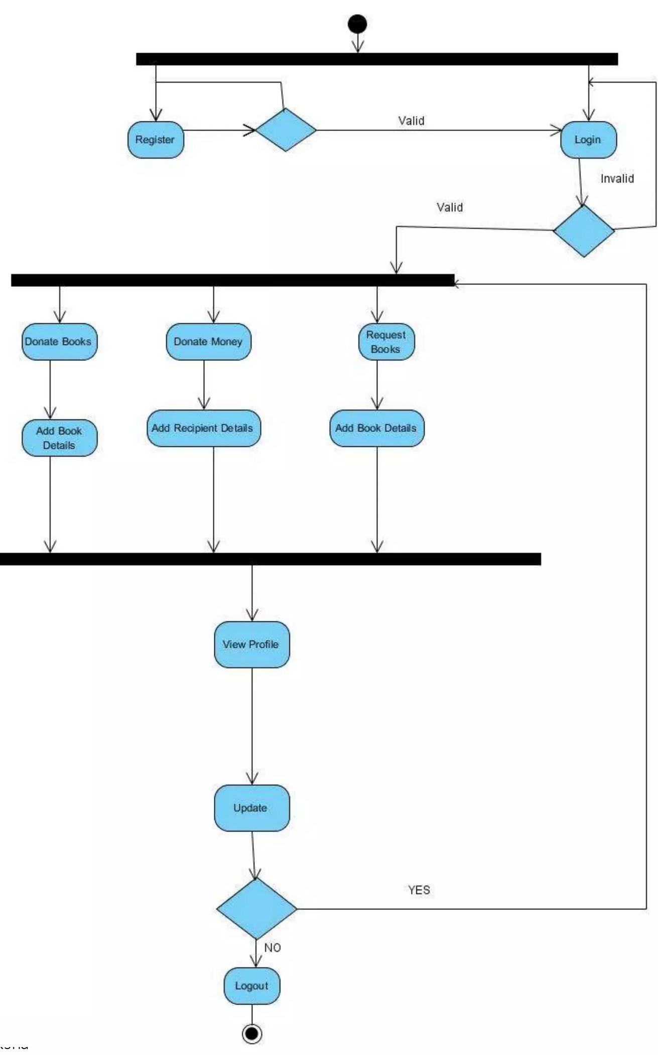

Entities and Relationships:
- User
  - Attributes: UserID, Name, Email, Password, UserType (Donor/Recipient)
  - Relationships:
    - A User can make Donations (for Donors).
    - A User can request Donations (for Recipients).
- Book
  - Attributes: BookID, Title, Author, ISBN, Category, Condition, DonorID (FK), AvailableStatus (Available, Donated, InProgress, Delivered)
  - Relationships:
    - A Book belongs to a Donor (One-to-Many relationship).
    - A Book can be requested by a Recipient.
- Donation
  - Attributes: DonationID, BookID (FK), DonorID (FK), RecipientID (FK), DonationDate, Status (Pending, Confirmed, Delivered)
  - Relationships:
    - A Donation involves a Donor and a Recipient (Many-to-One relationship from Donation to Donor and Recipient).
    - A Donation is linked to a Book (One-to-One relationship between Donation and Book).
- Recipient
  - Attributes: RecipientID, Name, Email, Address, Phone
  - Relationships:
A Recipient can request multiple Donations.
ER Diagram Description:
- User and Donation:
  - A User (either a Donor or a Recipient) can be involved in a Donation. If the user is a Donor, they will donate Books. If the user is a Recipient, they will receive Books. This is a Many-to-Many relationship, which we break down using the Donation entity.

- Book and Donation:
  - A Book is donated by a Donor and can be received by a Recipient. Each donation links a Book to a Recipient. The Book entity is connected to the Donation entity.
- Book and User:
  - A Book is donated by a User (Donor). This establishes a One-to-Many relationship between the User and Book.
- Recipient and Donation:
  - A Recipient can request a Donation, which corresponds to receiving Books. This is a One-to-Many relationship.

ER Diagram (Textual Representation):
+----------------+ +------------------+ +-----------------+
| User | | Book | | Donation |
+----------------+ +------------------+ +-----------------+
| UserID (PK) | 1 * | BookID (PK) | 1 * | DonationID (PK) |
| Name |--------| Title |--------| BookID (FK) |
| Email | | Author | | DonorID (FK) |
| Password | | ISBN | | RecipientID (FK)|
| UserType | | Category | | DonationDate |
+----------------+ | Condition | | Status |
| DonorID (FK) | +-----------------+
| AvailableStatus |
+------------------+
^
|
|
|
+-----------------+
| Recipient |
+-----------------+
| RecipientID (PK)|
| Name |
| Email |
| Address |
| Phone |
+-----------------+
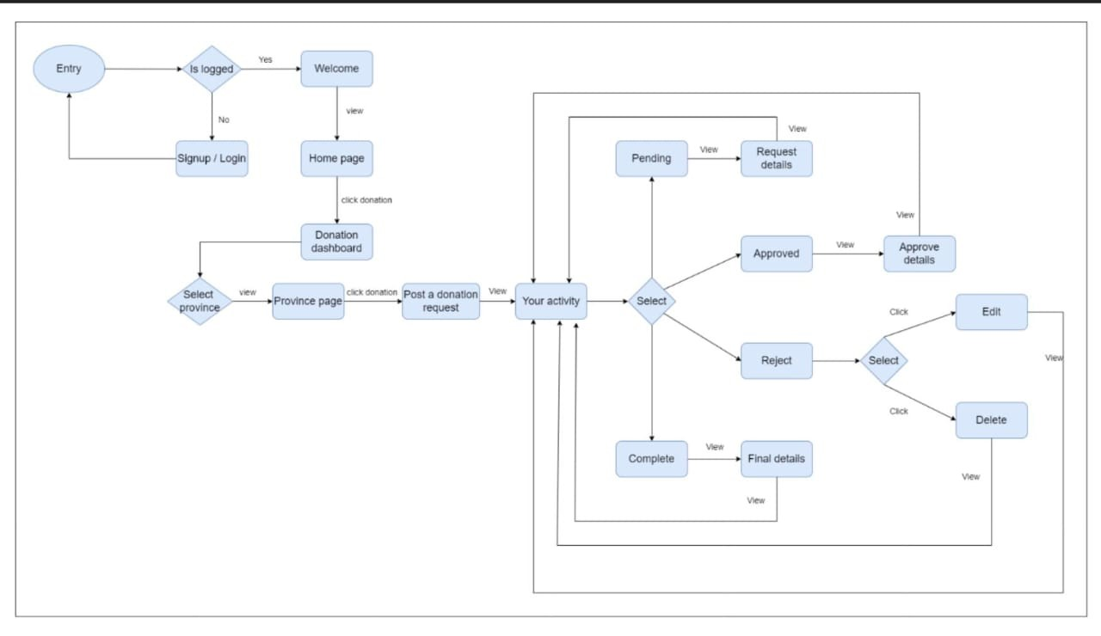

Screen Shots:

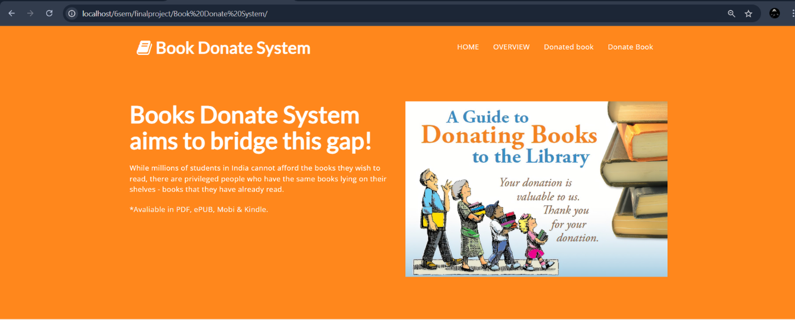

Admin Dashboard:

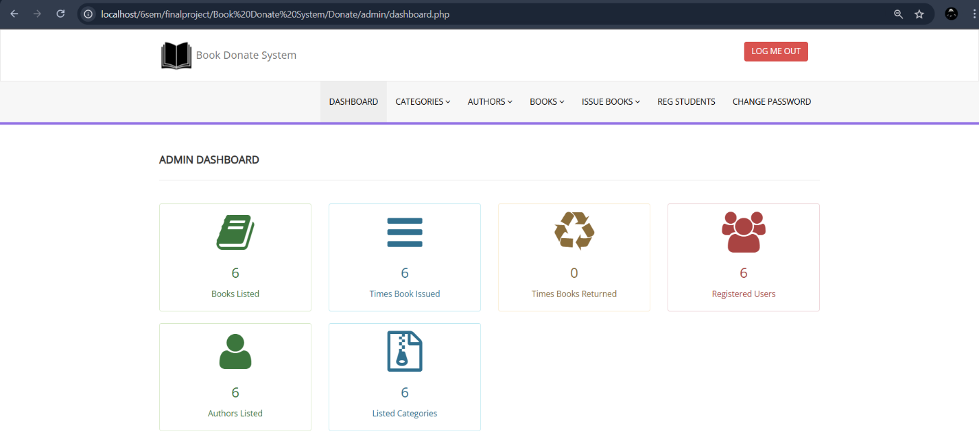

Categories:

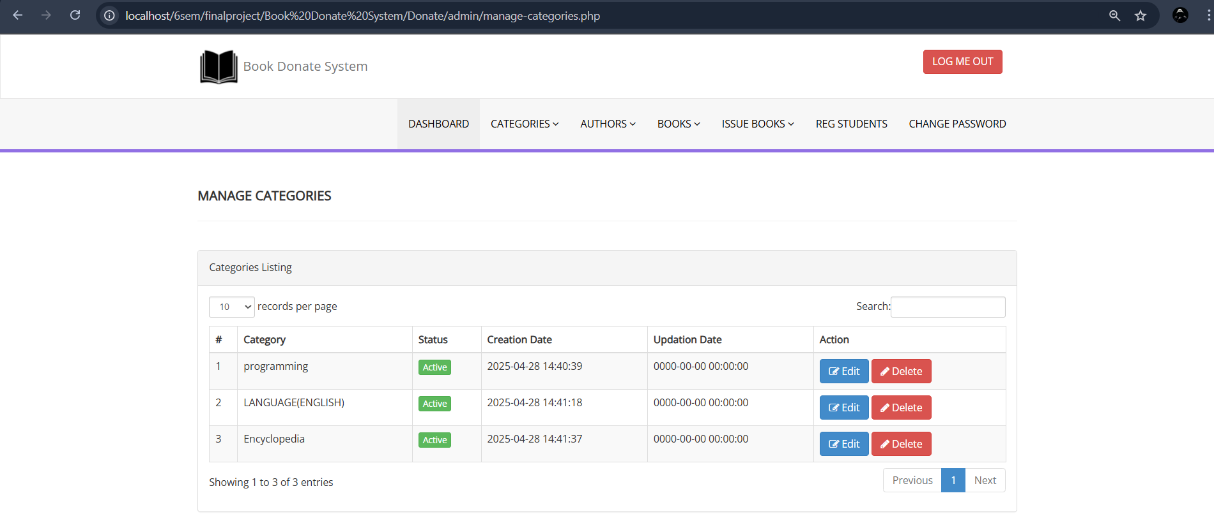
Authors: 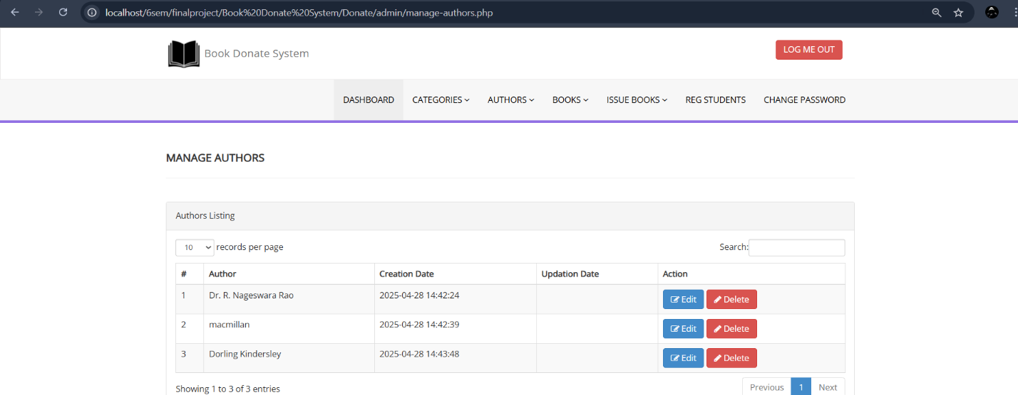
Book:
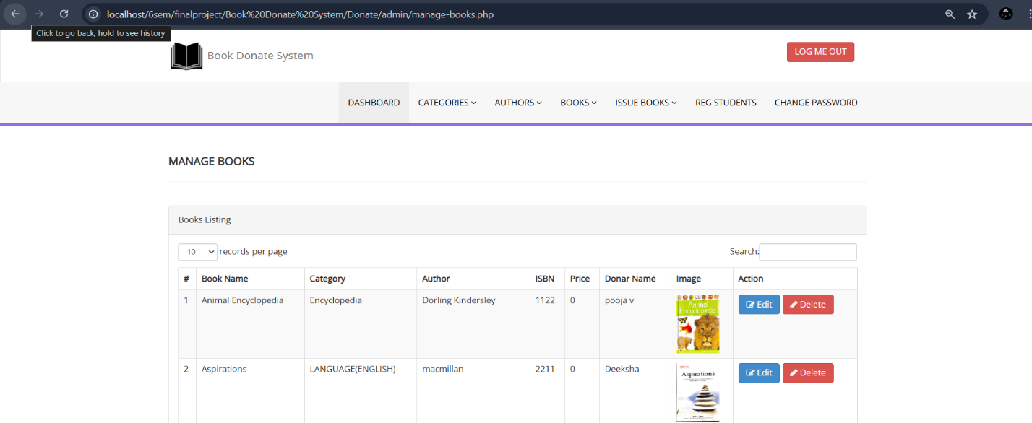

Issue Books:
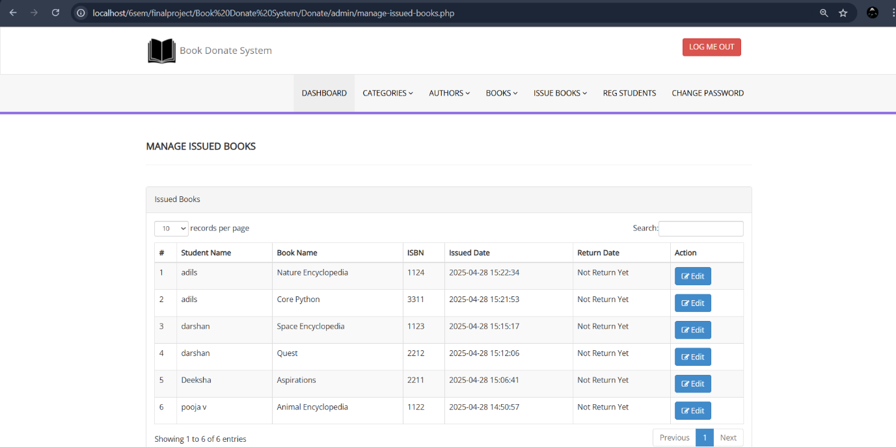
Reg Students:
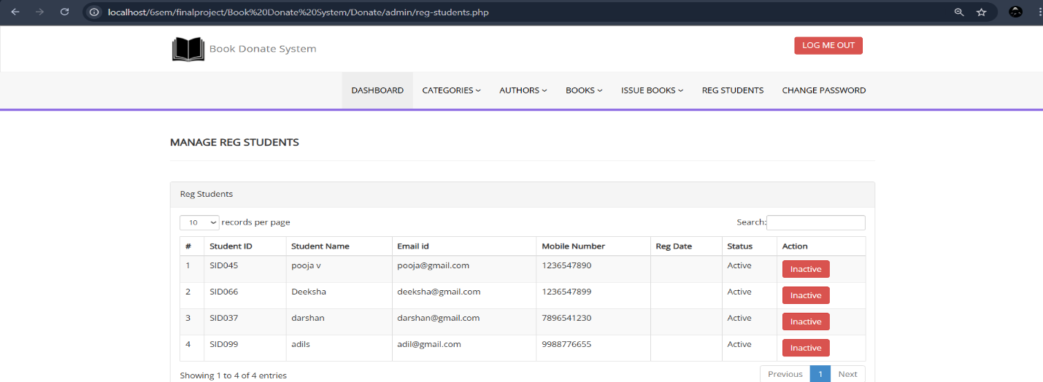
User Login:
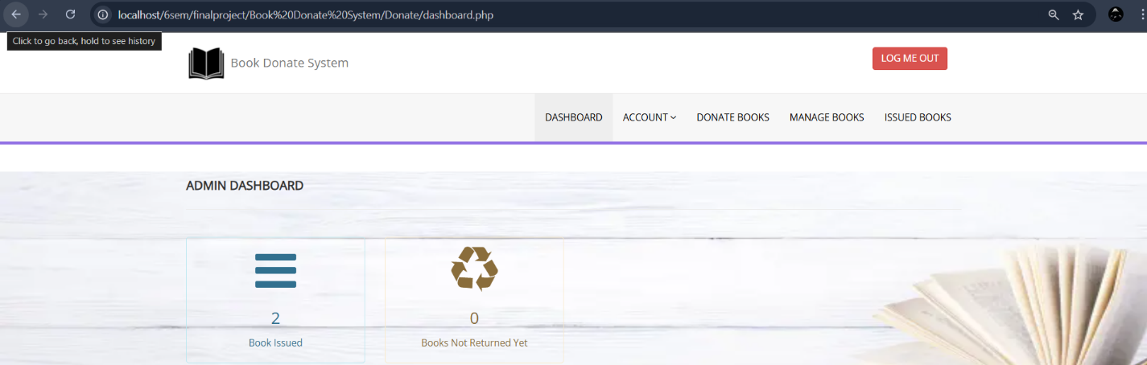

Donate Books:
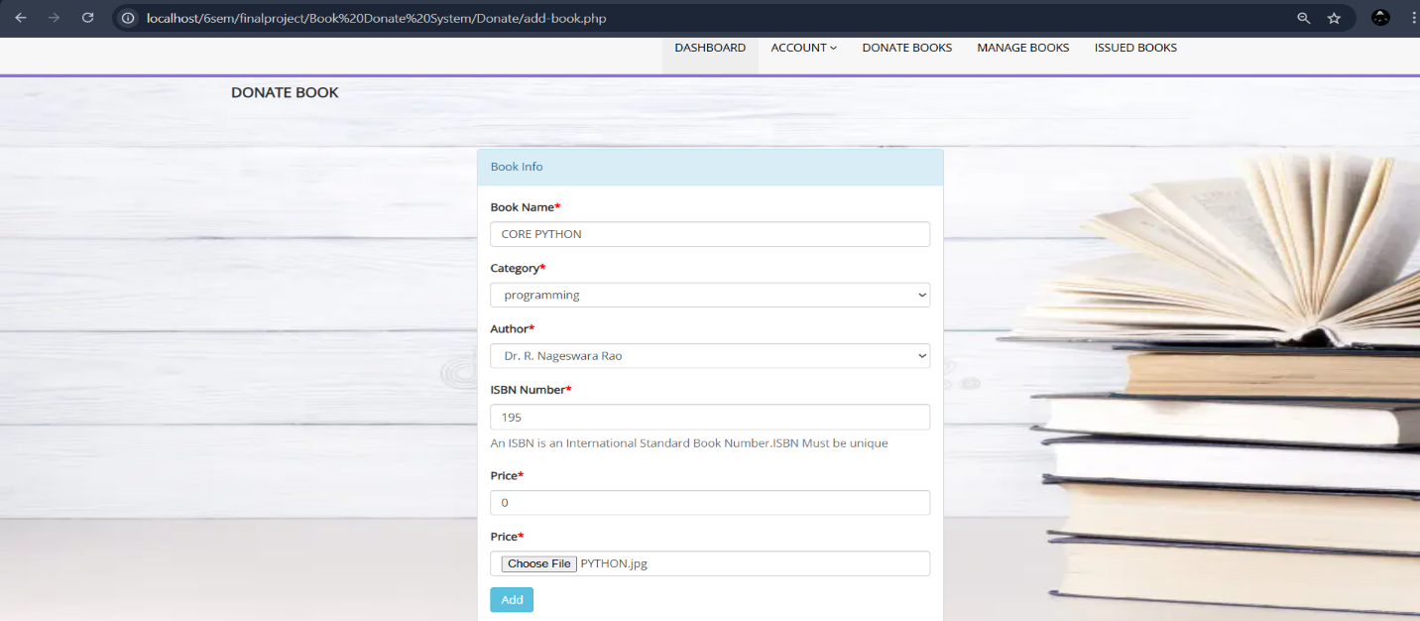

Manage Books:
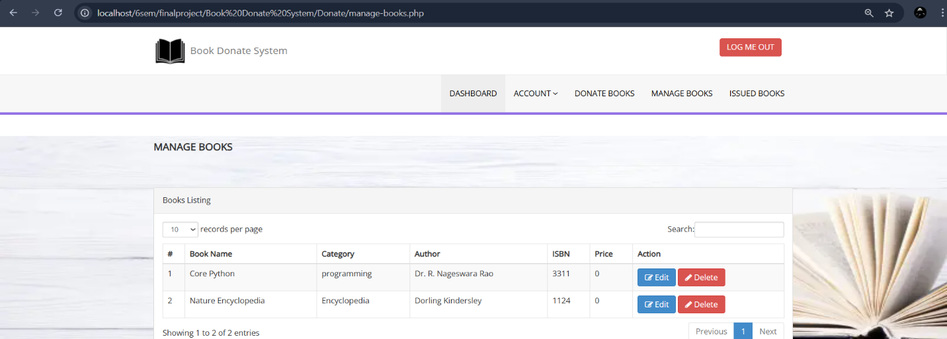
Issued Books:
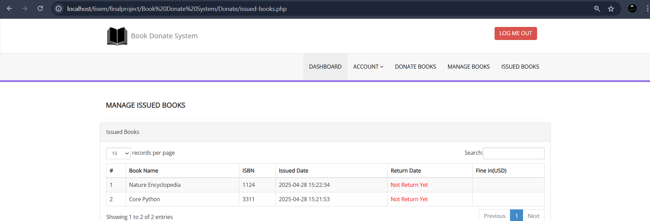

TESTING
Testing is the process in which the system is run on manually created input so that the system is correctly working as desired or not. During systems testing, the system is used experimentally to ensure that the software does not fail. In other words, we can say that it will run according to its specifications and in the way users expect. Special test data are input for processing, and the results examined. A limited number of users may be allowed to use the system so that analyst can see whether they try to use it in unforeseen ways. It is desirable to discover any surprises before the organization implements the system and depends on it. Testing of a system is generally done in two phases – One is Unit Testing which is done for each module independently on its completion and the other one is System Testing which is done at the end of a project.
VALIDATION CRITERIA
The validation criteria in this project are as follows..
All the screens have a similar look and feel. They all have the almost same color combinations in its background. This provides a better user interface to the users.
1) The primary key values cannot be duplicated.
2) All the entries in any combo box have been sorted in alphabetical order. This helps a user while selecting a value from the combo box.
IMPORTANCE OF TESTING
During systems testing, the system is used experimentally to ensure that the software does not fail. In other words, we can say that it will run according to its specifications and in the way users expect. Special test data are input for processing, and the results examined. The importance of system testing is that the system is expected to run according to member’s requirement before delivering it to the customer. The System is tested on the basis of specification so that it does not fail on user site.
Implementation and Testing
Implementation Detailed Design of Implementation
This phase of the systems development life cycle refines hardware and software specifications, establishes programming plans, trains users and implements extensive testing procedures, to evaluate design and operating specifications and/or provide the basis for further modification.
Technical Design - This activity builds upon specifications produced during new system design, adding detailed technical specifications and documentation.
Test Specifications and Planning - This activity prepares detailed test specifications for individual modules and programs, job streams, subsystems, and for the system as a whole.
Programming and Testing - This activity encompasses actual development, writing, and testing of program units or modules.
User Training - This activity encompasses writing user procedure manuals, preparation of user training materials, conducting training programs, and testing procedures
Acceptance Test - A final procedural review to demonstrate a system and secure user approval before a system becomes operational.
Installation Phase - In this phase the new Computerized system is installed, the conversion to new procedures is fully implemented, and the potential of the new system is explored.
System Installation: The process of starting the actual use of a system and training user personnel in its operation.
Review Phase - This phase evaluates the successes and failures during a systems development project, and to measure the results of a new Computerized Transystem in terms of benefits and savings projected at the start of the project.
Development Recap - A review of a project immediately after completion to find successes and potential problems in future work.
Post-Implementation Review - A review, conducted after a new system has been in operation for some time, to evaluate actual system performance against original expectations and projections for cost-benefit improvements. Also identifies maintenance projects to enhance or improve the system
THE STEPS IN THE SOFTWARE TESTING
The steps involved during Unit testing are as follows:
- Preparation of the test cases.
- Preparation of the possible test data with all the validation checks.
- Complete code review of the module.
- Actual testing done manually.
- Modifications done for the errors found during testing.
- Prepared the test result scripts.

The unit testing done included the testing of the following items:
1) Functionality of the entire module/forms.
2) Validations for user input.
3) Checking of the Coding standards to be maintained during coding.
4) Testing the module with all the possible test data.
5) Testing of the functionality involving all type of calculations etc.
6) Commenting standard in the source files. After completing the Unit testing of all the modules, the whole system is integrated with all its dependencies in that module. While System Integration, We integrated the modules one by one and tested the system at each step. This helped in reduction of errors at the time of the system testing.
The steps involved during System testing are as follows:
- Integration of all the modules/forms in the system.
- Preparation of the test cases.
- Preparation of the possible test data with all the validation checks.
- Actual testing done manually.
- Recording of all the reproduced errors.
- Modifications done for the errors found during testing.
- Prepared the test result scripts after rectification of the errors.
The System Testing done included the testing of the following items:
1. Functionality of the entire system as a whole.
2. User Interface of the system.
3. Testing the dependent modules together with all the possible test data scripts.
4. Verification and Validation testing.
5. Testing the reports with all its functionality.
After the completion of system testing, the next following phase was the Acceptance Testing. Clients at their end did this and accepted the system with appreciation. Thus, we reached the final phase of the project delivery. There are other six tests, which fall under special category. They are described below:
- Peak Load Test: It determines whether the system will handle the volume of activities that occur when the system is at the peak of its processing demand. For example, test the system by activating all terminals at the same time.
- Storage Testing: It determines the capacity of the system to store transaction data on a disk or in other files.
- Performance Time Testing: it determines the length of time system used by the system to process transaction data. This test is conducted prior to implementation to determine how long it takes to get a response to an inquiry, make a backup copy of a file, or send a transmission and get a response.
- Recovery Testing: This testing determines the ability of user to recover data or re-start system after failure. For example, load backup copy of data and resume processing without data or integrity loss.
- Procedure Testing: It determines the clarity of documentation on operation and uses of system by having users do exactly what manuals request. For example, powering down system at the end of week or responding to paper-out light on printer.
- Human Factors Testing: It determines how users will use the system when processing data or preparing reports.
CONCLUSION
Online Book Donate & Donation system is an attempt to overcome the present time-conducing process of locating, issuance and purchasing quality materials available in the shop. Through automated book shop system, it provides an easy way of searching, keeping record and purchasing of books. It’s worth analyzing and identifying the benefits as it would directly influence the productivity of the shop. Our Effort Is to create our website’s “Donation” Feature more efficient, Flexible and more user friendly to our customer. The Book Donation Management System was successfully developed and implemented, providing a platform that connects book donors with recipients in need. The system has proven to be effective in promoting the culture of book donation and streamlining the donation process. Future improvements may include expanding the platform to include features such as tracking donations in real-time and integrating with other educational resource platforms.

FUTURE ENHANCEMENT
- Mobile Application: A mobile version of the system could be developed to increase accessibility and user engagement.
- Real-Time Book Tracking: Implementing a real-time tracking system for donations could improve the transparency of the donation process.
- Expanded User Base: The system can be scaled to include more diverse groups of donors and recipients, including international users.

BIBLIOGRAPHY
- http://www.bluedart.com/
- http://www.wampserver.com/en/
- http://www.php.net/
- http://www.tutorialspoint.com/mysql/
- httpd.apache.org/docs/2.0/misc/tutorials.html

