Database Management System
Assignment 3

CAB BOOKING SYSTEM

Name | Syed Afnan Nayaz
Roll No | 2511021240058
Course | Database Management System
Programme | BCA AI/ML
Semester | III

Introduction
A cab booking system is a database-based system that lets customers book a cab to travel from one place to another. In this assignment I have chosen the Cab Booking System as my domain. The system keeps and manages important information such as customer details, driver details, car details, bookings and payments.
Everything is stored in a database so that the data stays organised and is easy to find whenever it is needed. I have used primary keys to identify every record uniquely and foreign keys to connect one table with another. Overall, this system is useful for managing cab bookings and all the information related to them.

Name and Purpose of the Application
Application name: Cab Booking System
Purpose: The Cab Booking System is a database management system where customers can reserve a cab for their travel. It stores the data about customers, drivers, cars, bookings and payments. With this system we can easily find out which customer booked which car, which driver is going to take them, and how much they paid for the trip.

Tables Required
To build this system I need five tables:
- Customer
- Driver
- Car
- Booking
- Payment

Entities and Attributes
The system has five main entities. These are the same five I used in my first DBMS assignment. The primary key (PK) of each entity is marked in the table below.
Entity | Primary Key | Other Attributes
CUSTOMER | Customer_ID (PK) | Customer_Name, Phone, Email, Address
DRIVER | Driver_ID (PK) | Driver_Name, Phone, License_No, Availability
CAR | Car_ID (PK) | Car_Number, Car_Model, Car_Type, Fare_Per_KM
BOOKING | Booking_ID (PK) | Booking_Date, Pickup_Location, Drop_Location, Distance_KM, Booking_Status
PAYMENT | Payment_ID (PK) | Amount, Payment_Date, Payment_Method, Payment_Status

Columns of Each Table

Customer Table
Column | Description | Key
Customer_ID | Unique ID of the customer | Primary Key
Customer_Name | Name of the customer | -
Phone | Phone number of the customer | -
Email | Email of the customer | -
Address | Address of the customer | -

Driver Table
Column | Description | Key
Driver_ID | Unique ID of the driver | Primary Key
Driver_Name | Name of the driver | -
Phone | Phone number of the driver | -
License_No | Driving license number | -
Availability | Whether the driver is available or not | -

Car Table
Column | Description | Key
Car_ID | Unique ID of the car | Primary Key
Car_Number | Vehicle registration number | -
Car_Model | Model of the car | -
Car_Type | Sedan, SUV, Hatchback, etc. | -
Fare_Per_KM | Cost per kilometre | -
Driver_ID | Driver assigned to the car | Foreign Key

Booking Table
Column | Description | Key
Booking_ID | Unique ID of the booking | Primary Key
Customer_ID | Customer who made the booking | Foreign Key
Car_ID | Car that was booked | Foreign Key
Booking_Date | Date of the booking | -
Pickup_Location | Starting location | -
Drop_Location | Destination | -
Distance_KM | Travel distance in km | -
Booking_Status | Status of the booking | -

Payment Table
Column | Description | Key
Payment_ID | Unique ID of the payment | Primary Key
Booking_ID | Booking linked with the payment | Foreign Key
Amount | Amount paid | -
Payment_Date | Date of the payment | -
Payment_Method | Cash / UPI / Card | -
Payment_Status | Paid / Pending | -

Relationships and Cardinality
Relationship | Cardinality | Description
CUSTOMER makes BOOKING | One-to-Many (1:N) | A customer can make many bookings over time, but each booking is made by exactly one customer.
DRIVER is assigned to CAR | One-to-Many (1:N) | A driver can be assigned to many cars, but each car is assigned to exactly one driver at a time.
CAR is used for BOOKING | One-to-Many (1:N) | A car can be used for many bookings over time, but each booking uses exactly one car.
BOOKING has PAYMENT | One-to-One (1:1) | Each booking generates exactly one payment record, and each payment is linked to exactly one booking.

ER Diagram
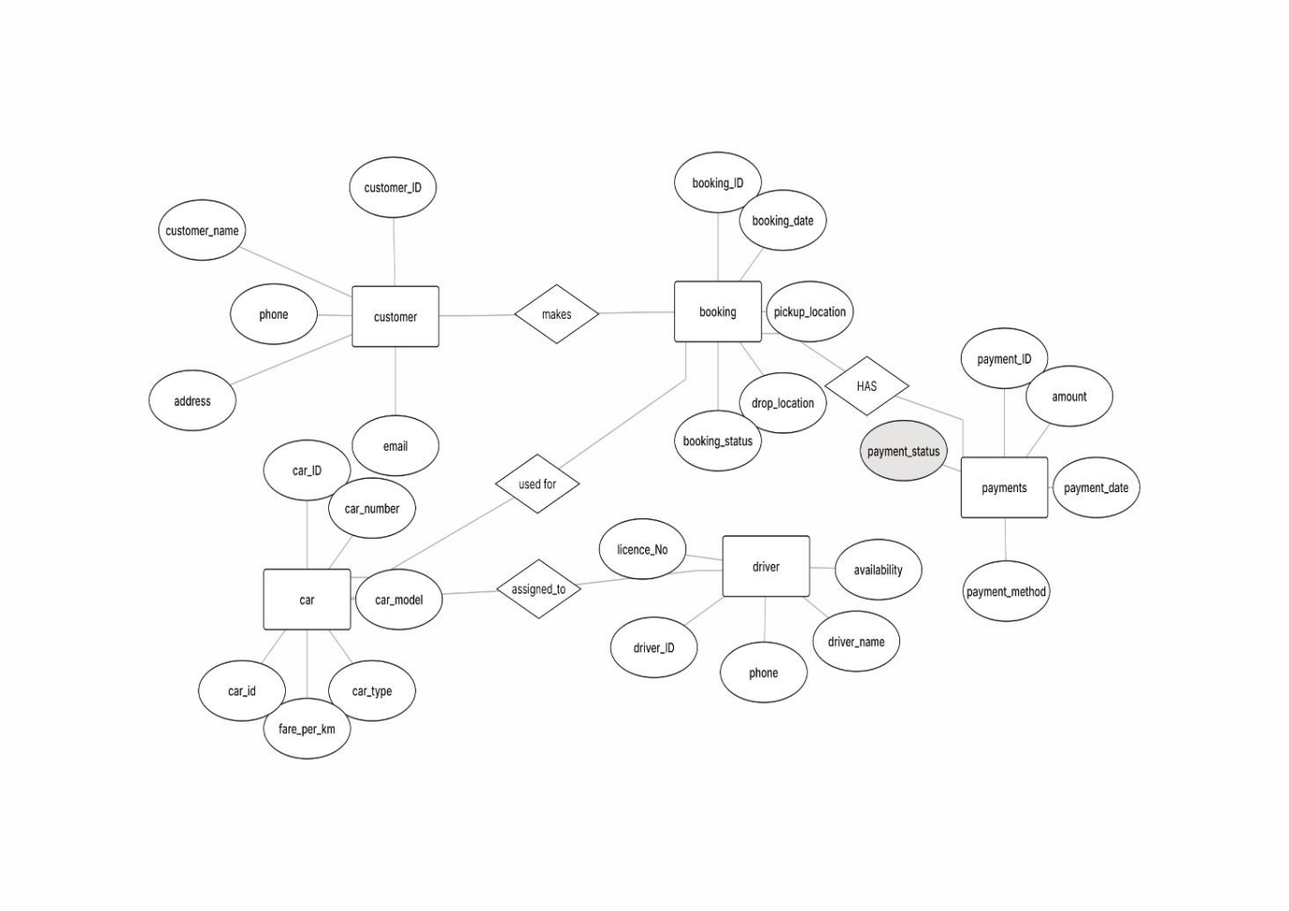

Relational Schema
Next I converted the ER diagram into a relational schema. Each entity becomes one table. For every 1:N relationship, the foreign key is placed on the "many" side, and for the 1:1 relationship it can be placed on either side. My design has no many-to-many relationships, so I did not need any extra junction tables.
CUSTOMER
- Customer_ID (PK)
- Customer_Name
- Phone
- Email
- Address
DRIVER
- Driver_ID (PK)
- Driver_Name
- Phone
- License_No
- Availability
CAR
- Car_ID (PK)
- Car_Number
- Car_Model
- Car_Type
- Fare_Per_KM
- Driver_ID (FK → DRIVER)
BOOKING
- Booking_ID (PK)
- Customer_ID (FK → CUSTOMER)
- Car_ID (FK → CAR)
- Booking_Date
- Pickup_Location
- Drop_Location
- Distance_KM
- Booking_Status
PAYMENT
- Payment_ID (PK)
- Booking_ID (FK → BOOKING)
- Amount
- Payment_Date
- Payment_Method
- Payment_Status

Relationship Explanation

CUSTOMER – MAKES – BOOKING (1:N)
One customer can make many bookings over time, for example different trips on different dates. But every single booking is made by only one customer. To show this, I stored Customer_ID as a foreign key in the BOOKING table.

DRIVER – ASSIGNED TO – CAR (1:N)
A driver can be assigned to more than one car over time, but at any given moment a car has only one driver. So Driver_ID is placed as a foreign key in the CAR table.

CAR – USED FOR – BOOKING (1:N)
A single car can be used for many bookings during its lifetime, but each booking uses just one car for that trip. This is shown by keeping Car_ID as a foreign key in the BOOKING table.

BOOKING – HAS – PAYMENT (1:1)
Every booking results in one payment record, and every payment belongs to one booking only. I implemented this by storing Booking_ID as a foreign key in the PAYMENT table.

10. Sample Data
Here is some example data for each table to show how the records look.

Customer Table
Customer_ID | Customer_Name | Phone | Email | Address
CU01 | Rahul | 9876543210 | rahul@mail.com | Bangalore
CU02 | Arjun | 9876543211 | arjun@mail.com | Chennai
CU03 | Kiran | 9876543212 | kiran@mail.com | Krishnagiri

Driver Table
Driver_ID | Driver_Name | Phone | License_No | Availability
D01 | Ravi | 9123456780 | DL1001 | Available
D02 | Kumar | 9123456781 | DL1002 | Busy
D03 | Suresh | 9123456782 | DL1003 | Available

Car Table
Car_ID | Car_Number | Car_Model | Car_Type | Fare_Per_KM | Driver_ID
C01 | KA01AB1234 | Swift | Hatchback | ₹12 | D01
C02 | KA02CD5678 | City | Sedan | ₹15 | D02
C03 | KA03EF9012 | Creta | SUV | ₹20 | D03

Booking Table
Booking_ID | Customer_ID | Car_ID | Booking_Date | Pickup | Drop | Distance | Status
B01 | CU01 | C01 | 07-09-2026 | Airport | MG Road | 25 km | Completed
B02 | CU02 | C02 | 07-09-2026 | Mall | Railway Station | 12 km | Completed
B03 | CU03 | C03 | 08-09-2026 | College | Airport | 30 km | Confirmed

Payment Table
Payment_ID | Booking_ID | Amount | Payment_Date | Payment_Method | Status
P01 | B01 | ₹300 | 07-09-2026 | UPI | Paid
P02 | B02 | ₹180 | 07-09-2026 | Card | Paid
P03 | B03 | ₹600 | 08-09-2026 | UPI | Pending

Purpose of Each Table
No. | Table | Purpose
1 | Customer | Stores the details of customers such as customer ID, name, phone number, email and address.
2 | Driver | Stores information about drivers, including driver ID, name, phone number, license number and availability.
3 | Car | Stores details of the cars such as car ID, registration number, model, type, fare per kilometre and the assigned driver.
4 | Booking | Stores information about each booking, including the customer, the car, booking date, pickup location, drop location, distance and booking status.
5 | Payment | Stores the payment details of bookings such as payment ID, booking ID, amount, payment date, payment method and payment status.

Conclusion
The Cab Booking System is a good way to manage customers, drivers, cars, bookings and payments in one place. By using related tables, all the data is kept in a clean and well-organised manner. The primary key identifies each record in a table uniquely, while the foreign key connects one table to another. Working on this assignment helped me understand how an ER diagram is converted into a relational schema and how the tables in a database are linked together.

