ALLIANCE UNIVERSITY
DBMS ASSIGNMENT 2
Entity Relationship (ER) Diagram
and Relational Schema

Details | Information
Application / Domain | College Management System
Name | Syed Afnan
Registration Number | 2511021240058
Course / Section | BCA SEM 3 2025
Based On | First DBMS Assignment

Objective: Design a complete Entity Relationship (ER) Diagram for the same College Management System selected in the First DBMS Assignment and convert it into a Relational Schema.

1. List of Entities and Attributes
This assignment uses the same eight core tables identified in the First DBMS Assignment: Departments, Students, Faculty, Courses, Enrollments, Attendance, Examinations, and Results.
Entity | Attributes | Primary Key
Departments | department_id, department_name, hod_name, office_email | department_id
Students | student_id, student_name, date_of_birth, gender, email, phone, department_id, admission_year | student_id
Faculty | faculty_id, faculty_name, email, phone, designation, department_id | faculty_id
Courses | course_id, course_name, credits, semester, department_id, faculty_id | course_id
Enrollments | enrollment_id, student_id, course_id, enrollment_date, academic_year | enrollment_id
Attendance | attendance_id, student_id, course_id, total_classes, classes_attended, attendance_percentage | attendance_id
Examinations | exam_id, course_id, exam_name, exam_date, max_marks | exam_id
Results | result_id, student_id, exam_id, marks_obtained, grade, result_status | result_id
2. Relationships and Cardinalities
Relationship | Cardinality | Explanation
Departments → Students | 1 : M | One department can have many students, while each student belongs to one department.
Departments → Faculty | 1 : M | One department can have several faculty members, while each faculty member belongs to one department.
Departments → Courses | 1 : M | A department can offer multiple courses, while each course belongs to one department.
Faculty → Courses | 1 : M | One faculty member can teach multiple courses, while each course is assigned to a faculty member.
Students → Enrollments | 1 : M | One student can have several enrollment records.
Courses → Enrollments | 1 : M | One course can have many enrolled students.
Students → Attendance | 1 : M | A student can have attendance records for multiple courses.
Courses → Attendance | 1 : M | A course can have attendance records for many students.
Courses → Examinations | 1 : M | A course can have multiple examinations.
Students → Results | 1 : M | A student can have multiple examination results.
Examinations → Results | 1 : M | One examination can produce results for many students.
Students ↔ Courses | M : N | Students and courses have a many-to-many relationship, resolved through the Enrollments table.

3. ER Diagram
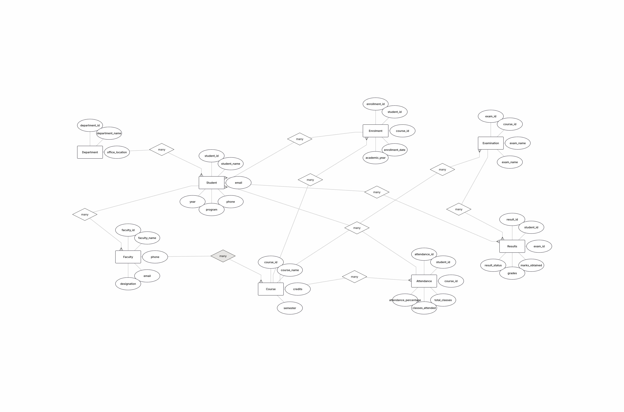

4. Convert into Relational Schema
The following relational schema preserves the eight tables and foreign-key connections from the First DBMS Assignment.
Table | Relational Schema
DEPARTMENTS | DEPARTMENTS(department_id PK, department_name, hod_name, office_email UNIQUE)
STUDENTS | STUDENTS(student_id PK, student_name, date_of_birth, gender, email UNIQUE, phone, department_id FK, admission_year)
FACULTY | FACULTY(faculty_id PK, faculty_name, email UNIQUE, phone, designation, department_id FK)
COURSES | COURSES(course_id PK, course_name, credits, semester, department_id FK, faculty_id FK)
ENROLLMENTS | ENROLLMENTS(enrollment_id PK, student_id FK, course_id FK, enrollment_date, academic_year)
ATTENDANCE | ATTENDANCE(attendance_id PK, student_id FK, course_id FK, total_classes, classes_attended, attendance_percentage)
EXAMINATIONS | EXAMINATIONS(exam_id PK, course_id FK, exam_name, exam_date, max_marks)
RESULTS | RESULTS(result_id PK, student_id FK, exam_id FK, marks_obtained, grade, result_status)
Primary Key and Foreign Key Identification
• DEPARTMENTS.department_id — Primary Key.
• STUDENTS.student_id — Primary Key; department_id is a Foreign Key referencing DEPARTMENTS.department_id.
• FACULTY.faculty_id — Primary Key; department_id is a Foreign Key referencing DEPARTMENTS.department_id.
• COURSES.course_id — Primary Key; department_id references DEPARTMENTS.department_id and faculty_id references FACULTY.faculty_id.
• ENROLLMENTS.enrollment_id — Primary Key; student_id references STUDENTS.student_id and course_id references COURSES.course_id.
• ATTENDANCE.attendance_id — Primary Key; student_id references STUDENTS.student_id and course_id references COURSES.course_id.
• EXAMINATIONS.exam_id — Primary Key; course_id references COURSES.course_id.
• RESULTS.result_id — Primary Key; student_id references STUDENTS.student_id and exam_id references EXAMINATIONS.exam_id.
5. Relationship Explanation
Departments provide the organizational structure for students, faculty and courses. Each of these relationships is one-to-many. Faculty members teach courses, giving a one-to-many Faculty–Courses relationship in the simplified model. Students and Courses are many-to-many because a student can study multiple courses and a course can have multiple students; this is represented through ENROLLMENTS. Attendance records connect students and courses, while Examinations belong to courses and Results connect students with examinations. Thus, the foreign keys maintain the connections among all eight tables.
6. Conclusion
The ER model and relational schema provide a structured representation of the same College Management System defined in the First DBMS Assignment. The design contains the eight original tables—Departments, Students, Faculty, Courses, Enrollments, Attendance, Examinations and Results—and preserves their primary keys, foreign keys and stated cardinalities.

