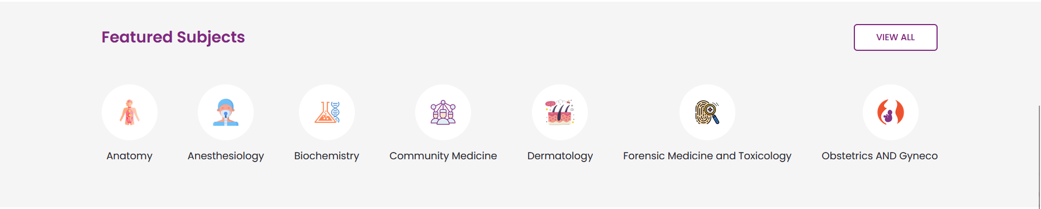



1️⃣ Online Payment Gateway (Razorpay / Stripe)
Best choice for India: ✅ Razorpay
What we add
- Razorpay Checkout on checkout.html
- Payment verification webhook
- Save payment_id, order_id, is_paid=True
Model update
class Order(models.Model):
...
payment_method = models.CharField(max_length=20, default="COD")
payment_id = models.CharField(max_length=100, blank=True, null=True)
Flow
Checkout → Razorpay popup → Payment success → Order marked PAID
Result
✔ COD + Online Payment
✔ More conversions
✔ Professional checkout

8️⃣ Combo Packs (Bundles)
Example:
BUMS 1st Prof Complete Set
Model
class Bundle(models.Model):
name = models.CharField(max_length=200)
books = models.ManyToManyField(Book)
bundle_price = models.DecimalField(max_digits=10, decimal_places=2)
UI
- One “Add Bundle to Cart” button
- Discounted total
✔ Higher order value
✔ Perfect for students

1️⃣1️⃣ Admin Analytics Dashboard
Custom dashboard with charts:
Shows
- 📈 Sales per day/month
- 🔥 Best selling books
- ⚠ Low stock alerts
Tech
- Django Admin customization
- Chart.js
✔ Smart restocking
✔ Data-driven decisions

That is a very practical question! Since you are running this on your own computer (localhost), you need to manually "start the engine" every time you want to use the website.
Here is your "Start Up Checklist" for whenever you want to work on or view your project again.

Step 1: Open Your Project
- Open VS Code.
- Go to File > Open Folder.
- Select your Idara_Bookstore folder.

Step 2: Start the Server
The website won't load unless the Python server is running.
- Open the Terminal in VS Code (Terminal > New Terminal).
- Type this command and hit Enter:
PowerShell
python manage.py runserver
- Wait until you see the text: Starting development server at http://127.0.0.1:8000/.

Step 3: Open the Pages
Once the server is running, you can open your browser (Chrome, Edge, etc.) and type in these addresses:
- 🏠 Home Page (Shop):
http://127.0.0.1:8000/
(This is where customers land)
- 🛒 Shopping Cart:
http://127.0.0.1:8000/cart/
- ⚙️ Admin Panel (For You):
http://127.0.0.1:8000/admin/
(Use this to add new books or view orders)

Summary Table
Action | URL / Command
Start Site | python manage.py runserver (in Terminal)
Customer View | http://127.0.0.1:8000/
Owner View | http://127.0.0.1:8000/admin/
Stop Site | Click in Terminal and press Ctrl + C
Recommendation: I suggest you bookmark these links in your browser so you don't have to type them every time!

Did you finish the "Final Step" from my previous message (adding OrderAdmin to admin.py)? If you do that, you will be able to see the customer orders inside your Admin link!

