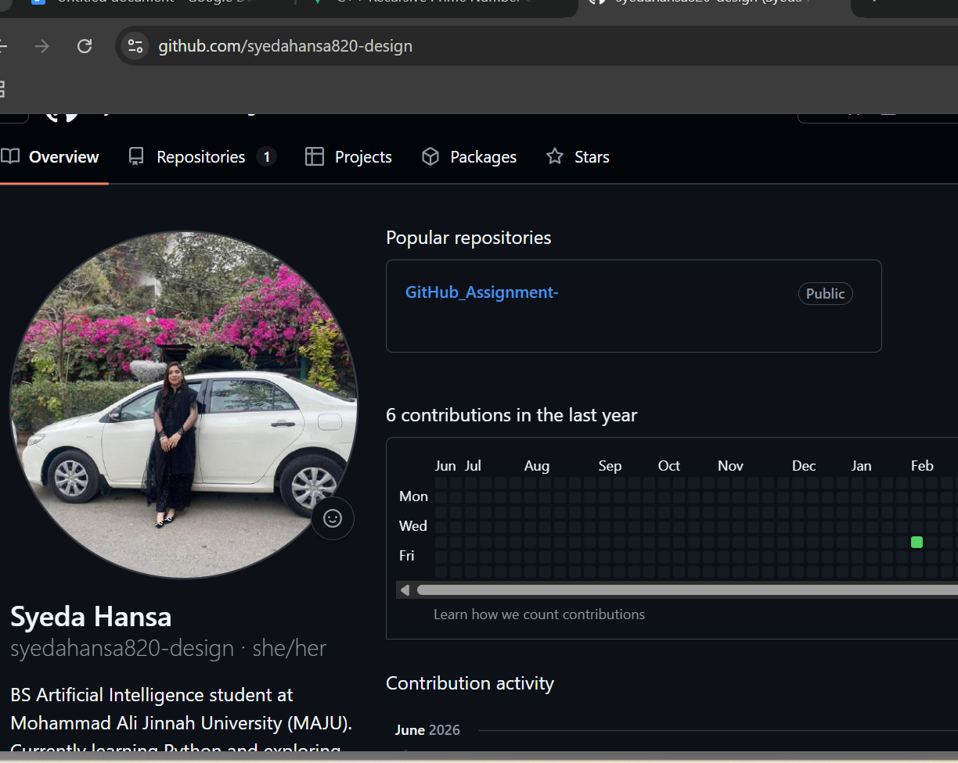
https://github.com/syedahansa820-design/GitHub_Assignment-

