**LAB-07**

**Configure the following scenario (inter VLAN routing) in ENSP:**

**eNSP simulation:**

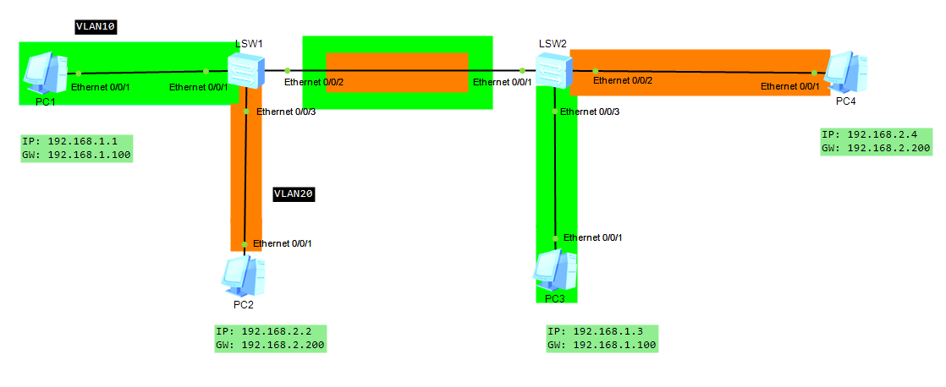

**First, we have to assign the Ip address and gateway to each PC then we have to configure these commands on switches.**

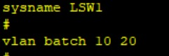**Configuration on Switch (LSW1):**

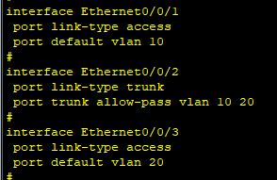

**We make Vlanif interfaces and assign gateway as ip address to them which results in inter vlan routing**

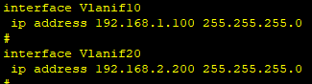

**Vlanif Interface Configuration**

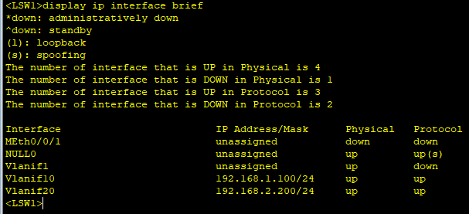

**VLAN Configuration**

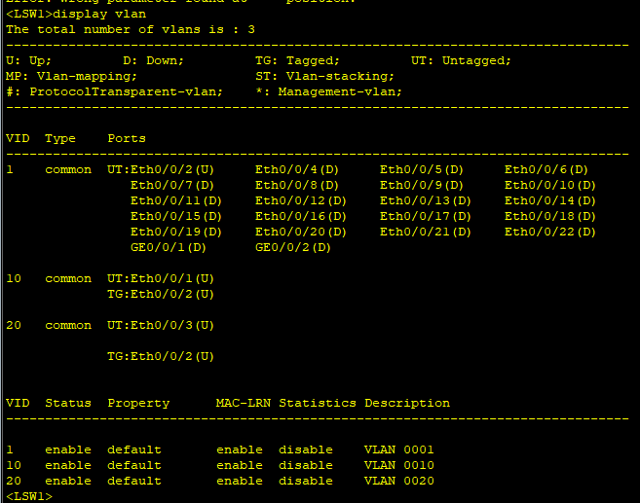

**Configuration on Switch (LSW2):**

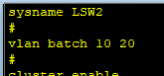

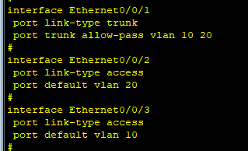

**We make Vlanif interfaces and assign gateway as ip address to them which results in inter vlan routing**

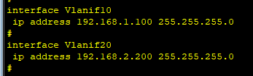

**Vlanif Interface Configuration**

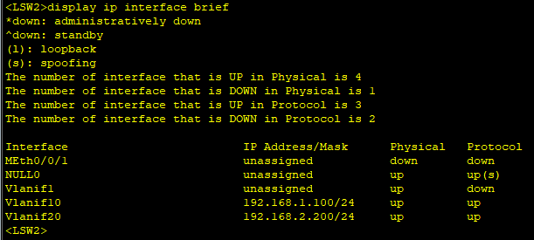

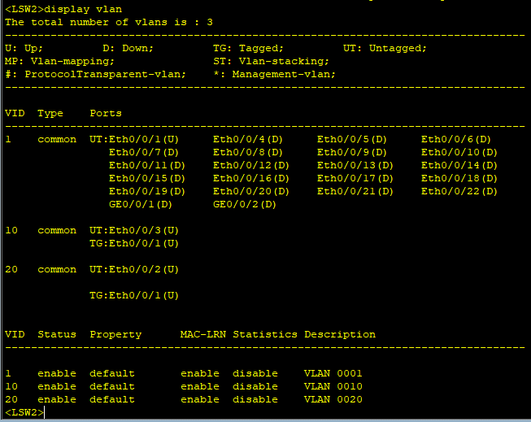**VLAN Configuration**

**TESTING**

**Ping PC4 from PC1**

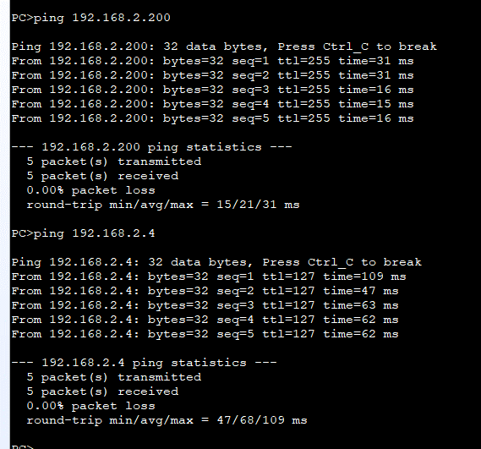

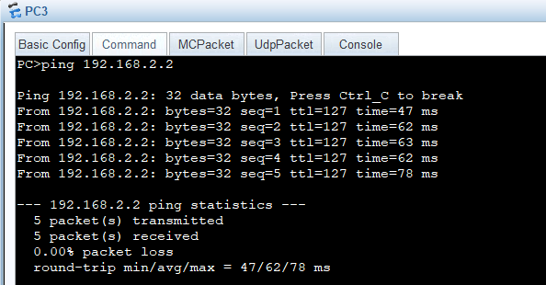**PC2 from PC3:**

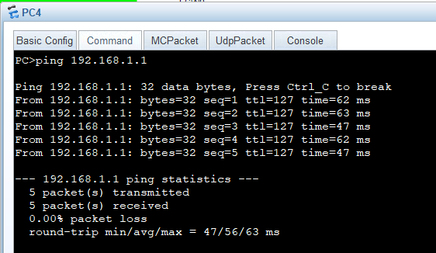**PC1 from PC4**

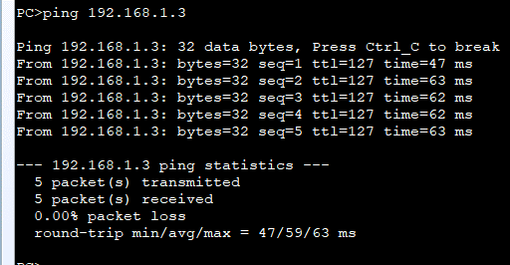**PC3 from PC2**