

Phase I: Business Case Selection

Conversational AI System Assignment

Authors

Shaheera Kashif (i230063)

Areesha Hussain (i230123)

Irha Azhar Kazmi (i230029)

Use Case

Customer Support Chatbot – TresBakery

Submission Date

March 5, 2026

- Use-Case Description
Business Name: Tres Bakery
Business Type: Small local bakery specialising in custom cakes, pastries, and seasonal treats
Tres Bakery is a walk-in and pre-order bakery that bakes fresh daily. The chatbot acts as a 24/7 virtual assistant named Bella that handles customer inquiries entirely through prompt-engineered intelligence - no tools, no RAG, no external APIs.
Bella can:
- Share the full menu with live emoji-formatted display
- Take orders - confirm each item, maintain a running total, and issue a 6-character Order ID
- Guide customers through custom and wedding cake enquiries
- Provide allergen and dietary information (vegan, gluten-free) with safety escalation
- Explain pickup, pre-order, and delivery policies
- Detect complaints and redirect to human staff with contact details
- Refuse off-topic queries (weather, politics, etc.) and off-menu item requests
Bella now fully takes orders, tracks totals, and generates Order IDs, making the system more useful and realistic.
- Conversation Policies & Constraints
Policy | Rule
Tone | Warm, cheerful, welcoming - like a friendly baker. Uses customer name when known.
Scope | Strictly Tres Bakery topics only. Off-topic queries (weather, sports, etc.) are redirected.
Orders | Takes full orders - confirms each item, tracks running total, issues Order ID on completion
Menu Enforcement | ONLY items in the hardcoded menu are accepted. Off-menu requests are rejected with suggestions.
Allergens | Always escalates severe allergies to staff. Never makes safety guarantees
Escalation | Complaint/safety keywords trigger empathetic response + contact info (555-214-8830)
Language | English only. No Chinese characters or foreign text. Strict prompt rule enforced
Uncertainty | Admits limitations, directs to human staff or contact info.
- Menu & Knowledge Base (Hardcoded in System Prompt)

Cakes
Item | Price | Notes
Classic Chocolate Cake (6") | $28 | GF option available
Vanilla Buttercream Cake (6") | $26 | Most popular
Red Velvet Cake (6") | $30 | Cream cheese frosting
Custom Celebration Cake | From $45 | 48hr pre-order required
Custom Wedding Tier Cake | From $150 | 1-week notice required

Pastries & Daily Bakes
Item | Price | Notes
Butter Croissant | $3.50 | Fresh daily, sell out by noon
Almond Croissant | $4.50 | Fan favourite
Cinnamon Roll | $4.00 | Vegan option available
Danish Pastry | $4.00 | Seasonal fillings
Pain au Chocolat | $4.50 | -

Cupcakes
Item | Price | Notes
Classic Vanilla Cupcake | $3.50 | -
Double Chocolate Cupcake | $3.50 | -
Strawberry Shortcake Cupcake | $4.00 | Seasonal
Cupcake Box (6-pack) | $19.00 | Mix and match
Cupcake Box (12-pack) | $35.00 | Mix and match

Drinks
Item | Price
Drip Coffee | $3.00
Latte / Cappuccino | $4.50
Hot Chocolate | $4.00
Dietary: Gluten-free, vegan options available on select items
Allergens: Facility handles nuts, dairy, eggs, and gluten - severe allergies must speak with staff
Shelf Life: Cakes: 3 days refrigerated | Pastries: best same day | Cupcakes: 2 days
Hours: Tuesday-Sunday, 7:30 AM - 6:00 PM (Closed Mondays)
Pre-orders: Minimum 48 hours for custom items; 1 week for wedding cakes
Delivery: Within 10km, $5 flat fee, minimum order $25
Contact: (555) 214-8830 | hello@tresbakery.com

- Example Dialogues

Dialogue 1- Menu Browsing (Happy Path)
User: Show me the menu
Bella: Here you go!
CAKES - Chocolate ($28) | Vanilla ($26) | Red Velvet ($30) | Custom from $45 | Wedding from $150
PASTRIES - Butter Croissant ($3.50) | Almond Croissant ($4.50) | Cinnamon Roll ($4) | Danish ($4) | Pain au Chocolat ($4.50)
CUPCAKES - Vanilla ($3.50) | Chocolate ($3.50) | Strawberry ($4) | 6-pack ($19) | 12-pack ($35) ($4) What would you like to order?
DRINKS - Coffee ($3) | Latte ($4.50) | Hot Chocolate
What would you like to order?
Dialogue 2 - Order Taking with Running Total
User: I'd like a chocolate cake and a latte please
Bella: Adding Chocolate Cake ($28.00). Adding Latte ($4.50). Current total: $32.50. Anything else?
User: Nothing else, that's all
Bella: Your order is complete!
• Chocolate Cake - $28.00
• Latte - $4.50
Total: $32.50 Your Order ID: KQ7B2X. Please save this Order ID. Call (555) 214-8830 and mention Order ID KQ7B2X to track your order progress.
Dialogue 3 - Off-Menu Rejection
User: Can I get a brownie and a cheesecake?
Bella: Sorry, we don't carry brownies or cheesecakes! We do have amazing cupcakes - Vanilla, Chocolate, or Strawberry from $3.50. Or perhaps a slice of one of our cakes? What would you like?

Dialogue 4 - Allergen Escalation
User: I have a severe nut allergy, is everything safe?
Bella: I really appreciate you flagging that! Our products are made in a facility that handles nuts, so there is a risk of cross-contamination. For severe allergies, please speak directly with our staff before ordering - call (555) 214-8830 or email hello@tresbakery.com so we can advise you and keep you safe.
Dialogue 5 - Custom / Wedding Cake Enquiry
User: I'm getting married in 3 months. Can you do a wedding cake?
Bella: Congratulations! We absolutely love making wedding cakes! Our tiered wedding cakes start from $150 and are fully customisable - flavours, tiers, floral designs, you name it. We require at least 1 week's notice, but for weddings we always recommend reaching out early to secure your date. Please get in touch at hello@tresbakery.com or call (555) 214-8830 to book a tasting consultation!
Dialogue 6 - Complaint Escalation
User: I want to complain - my order was completely wrong
Bella: I'm so sorry to hear that, and I completely understand your frustration. That's not the experience we want for you at all! Please reach out to our team directly so we can make this right: call (555) 214-8830 or email hello@tresbakery.com. We'll take great care of you!
Dialogue 7 - Out-of-Scope Redirect
User: What do you think about the stock market today?
Bella: Ha, I'm better with croissants than stocks! I can only help with Tres Bakery topics - menu, orders, delivery, hours, and more. Is there something I can help you with today?
- Conversation Flow Design
Step | Module | Action
1 | Frontend (index.html) | User types message. Mood detection updates UI theme in real time.
2 | Websocke / ws / chat (main.py) | Message received, session looked up or auto-created.
3 | check_policy () (conv_manager) | Message classified: escalation / out-of-scope / order / end-of-chat.
4 | compress_history () (memory.py) | Facts extracted. History compressed: keep recent 6 turns + high-signal older turns.
5 | build_messages () (prompts.py) | System prompt assembled with menu, policies, structured memory, and optional warning.
6 | stream_chat () (llm.py) | Tokens streamed from Ollama (qwen3:1.7b) via HTTP chunked response.
7 | Frontent (index.html) | Tokens appended to bubble in real time. TTFT displayed, mood badge shown.
8 | Session Update (conv_manager) | Full response saved. Turn count, latency log updated. Session ended if farewell detected.

Policy Routing Logic
Condition | Keyword Source | Outcome
Normal bakery query | No match | LLM answers using context window
Order request | ORDER_REQUEST_WORDS | LLM tracks items + running total + issues Order ID
End of conversation | END_OF_CONVERSATION_WORDS | LLM farewells, session.ended = True, input disabled
Complaint / safety | ESCALATION_WORDS | Warning injected to system prompt, contact info include
Off-topic message | OUT_OF_SCOPE_WORDS | Warning injected to system prompt, polite redirect.
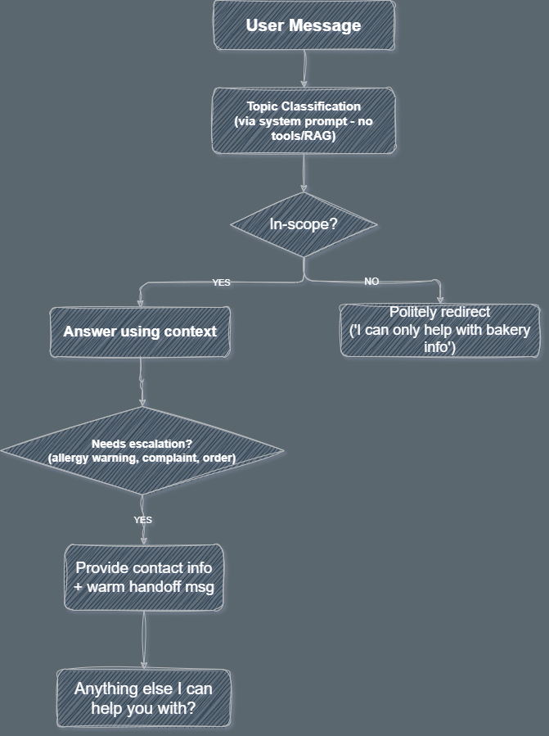

Frontend Features (index.html)
The frontend is a single-file vanilla HTML/CSS/JS application with a distinctive bakery-themed dark UI. It implements several features beyond a basic chat window:

Mood-Adaptive Theming
The UI detects the emotional tone of the user's message and dynamically re-themes the entire interface by updating CSS custom properties. There are 5 mood states:

Mood | Trigger Keywords | Colour Theme | Suggested Item Cate
Happy | happy, great, awesome, thank, love | Warm yellow-gold | Cupcakes / Cakes
Excited | wow, amazing, party, celebrate, order | Hot pink / magenta | Cakes / Cupcakes
Cozy | warm, cozy, coffee, morning, evening | Terracotta / rose | Pastries / Drinks
Calm | fine, okay, maybe, wondering, browse | Teal / cyan | Drinks / Pastries
Hungry | hungry, starving, craving, delicious | Amber / orange | Cakes / Pastries / Cupcake

Each mood also drives the Vibe Check sidebar widget - it updates the emoji, name, bar fill, and suggests a specific real menu item from the mood's preferred food category.

Today's Special
A randomly selected menu item is picked on every page load (excluding wedding cake and multipacks) and shown as a floating animated bubble in the header. Clicking it sends a quick enquiry about that item into the chat. The item is drawn from the same MENU object used for mood suggestions, ensuring only real, in-scope items appear.

Multi-Chat History with Sidebar
Every New Chat creates a new session and adds it to the sidebar history list. Users can switch between past conversations, which are rendered from the in-memory chat history array. Each chat item has a delete button with a bin-shake animation and a toast notification. Chat titles are auto-generated from keywords in the conversation (e.g. 'Cake Selection', 'Delivery', 'Custom Cake').

Real-Time Streaming
Responses are received token-by-token over WebSocket. A typing indicator (three blinking dots) appears immediately while waiting for the first token. Each token is appended to the bubble as it arrives. On completion, total latency is displayed in the sidebar and a mood badge is shown on the assistant's bubble.

Quick-Send Chips & Crumb Animations

The empty state shows four quick-send chips (Menu, Hours, Custom Cake, Delivery). Mood transitions and special item clicks spawn falling pastry emoji crumbs across the screen for a playful, on-brand effect.

- System Architecture
Component | File | Responsibility
Frontend | index.html | Chat UI, mood engine, WebSocket client, session history
API Server | main.py | FastAPI, REST + WebSocket endpoints, CORS, error handling
Session Manager | conversation_manager.py | Session CRUD, policy detection, history append, latency log
Memory Module | memory.py | Fact extraction, signal/noise filter, history compression
Prompt Builder | prompts.py | System prompt template, message assembly with memory + warnings
LLM Engine | llm.py | Ollama HTTP streaming, token yield, latency measurement
Unit Tests | test_system.py | 46 tests covering session, memory, policy, multi-turn flow
Stress Tests | stress_test.py | Latency benchmark, concurrent users, WebSocket, policy smoke
Container | Dockerfile + docker-compose.ym | l Ollama + backend + frontend containerised deployment

Memory Management Strategy
Tier | What it stores | How used
Structured Memory | Extracted facts: name, occasion, dietary, allergy, delivery interest | Injected as compact summary in system prompt
Short-term Memory | Full verbatim last 6 turns (12 messages) | Always passed to LLM
Compressed History | High-signal older user messages only (allergy, custom, birthday etc.) | Prepended before recent turns; noise (ok, thanks) dropped

Performance Benchmarks

Results measured by stress_test.py on 2026-03-03. Hardware: standard laptop, CPU-only inference, qwen3:1.7b via Ollama, no GPU.

Sequential Latency (5 turns, single user)
Metric | Value
Average response | 19.86s
Min response | 9.22s
Max response (turn 1 cold start) | 46.88s
Std deviation | 15.34s

Turn 1 (46.88s) is a cold-start outlier - model loads into memory on first request.
Turns 2-5 stabilise at 9-17s.

WebSocket Streaming
Metric | Value
Time to First Token (TTFT) | 6.97s
Total streaming latency | 8.10s
Tokens received | 61

Streaming delivers a significantly better user experience than waiting - the user reads the response beginning at ~7s rather than waiting the full ~8s for generation to complete.

Concurrent Users (5 simultaneous)
Metric | Value
Total requests | 10
Successful | 10 (100%)
Failed | 0
Avg latency | 42.14s
Max latency | 65.75s
Wall-clock time | 94.73s

All requests succeeded with zero errors. Latency multiplies under concurrency because Ollama serialises requests on CPU - a known limitation of single-instance CPU inference.
Metric | Value
Cycles | 20 / 20 (0 errors)
Throughput | 0.1 cycles/sec

Session Lifecycle Throughput

  - Policy Enforcement Smoke Test
Policy Type | Result | Latency
Escalation (complaint) | PASS | 10.01s
Out-of-scope redirect | PASS | 10.44s
Off-menu rejection (brownie) | PASS | 10.74s
End-of-conversation detection | PASS | 5.98s

All 4/4 policy checks passed.

- Key Design Decisions

No RAG / No Tools
The full menu, pricing, hours, and policies are embedded directly in the system prompt. The LLM reasons purely from this context - keeping the system simple, deterministic, and fast.

Warning Injection via System Prompt
Policy flags (escalation, out-of-scope) inject a warning string into the system prompt rather than as a fake user message. This keeps conversation history clean and avoids confusing the model with artificial turns.
- Streaming via WebSocket with TTFT
Token-by-token streaming over WebSocket reduces perceived latency. TTFT of ~7s is far better than waiting the full ~8-20s for a complete non-streamed response.

Mood-Adaptive UI
The frontend detects emotional tone from user input and re-themes the entire UI (colours, glow, gradients) in real time using CSS custom properties. Mood also drives item suggestions from the real menu - ensuring suggestions are always in-scope.

Structured + Compressed Memory
Three-tier memory (structured facts, recent verbatim turns, compressed older signal) keeps the context window bounded while preserving all facts needed for consistency across long conversations.

Safety-First on Allergens
Severe allergy mentions always trigger escalation to human staff rather than an AI safety guarantee. This is enforced both via the ESCALATION_WORDS policy check and the system prompt instruction.

- Known Limitations
Limitation | Detail
High CPU latency | Avg 10-20s per response on laptop CPU. GPU or a smaller model (0.5b) would reduce this significance.
Concurrency bottleneck | Ollama serialises requests on CPU; latency multiplies linearly with concurrent user count.
In-memory sessions | Sessions lost on restart. Production system would require Redis or a database for persistence.
Cold-start penalty | First inference after startup takes ~47s due to model loading into memory.
English enforcement | Small quantised models occasionally produce non-English output despite explicit prompt instructions.
No real order database | Orders are tracked within the conversation only - no backend persistence or order management system.

