**FINAL ORAL EXAMINATION**

*OF*

Syed Alam Abbas

B.E., University of Mumbai, 2007.

M.S., University of Central Florida, 2013.

*FOR THE DEGREE OF*

**DOCTOR OF PHILOSOPHY**

IN ELECTRICAL ENGINEERING

Friday, April 21st, 2017, 11.00 A.M

Engineering 2, Conference Room 202A,

DISSERTATION COMMITTEE

Dr. Hassan Foroosh, *Chairman,* [*foroosh@eecs.ucf.edu*](mailto:foroosh@eecs.ucf.edu)

Dr. Qiyu Sun, *Co-advisor*, *qiyu.sun@ucf.edu*

Dr. Ulas Bagci, *Committee Member*, *bagci@crcv.ucf.edu*

Dr. Nazanin Rahnavard, *Committee Member,* *nazanin@eecs.ucf.edu*

Dr. George Atia, *Committee Member,* *George.Atia@ucf.edu*

Dr. Alexander I. Katsevich*, External Committee Member, alexander.katsevich@ucf.edu*

**DISSERTATION RESEARCH IMPACT**

Medical imaging, wireless communications and power systems of the future will experience more data processing conditions and wider range of applications requirements than the systems of today. Such systems will require more powerful, efficient and flexible signal processing algorithms that are well designed to handle such needs. No matter how advanced our hardware technology becomes we will still need intelligent and efficient algorithms to address the growing demands in signal processing. In this thesis, we investigate novel techniques to solve a suite of four fundamental problems in signal processing that have a wide range of applications. The relevant equations, literature of signal processing applications, analysis and final numerical algorithms/methods to solve

them using Fourier analysis are discussed for different applications studied in the electrical engineering / computer science.

**SELECTED PUBLICATIONS**

[1] Syed Alam Abbas, "*A New Fast Algorithm to Estimate Real-Time Phasors Using Adaptive*

*Signal Processing*", IEEE Transactions on Power Delivery, vol. 28, no. 2, pp 807-815, 2013.

[2] Syed Alam Abbas, Qiyu Sun, and Hassan Foroosh, "*Frequency Estimation of Sinusoids*

*from Nonuniform Samples*", Signal Processing - A publication of the European Association for Signal Processing (EURASIP), Elsevier, 2016.

[3] Syed Alam Abbas, Qiyu Sun, and Hassan Foroosh, "*An Exact and Fast Computation of*

*Discrete Fourier Transform for Polar and Spherical Grid*", IEEE Transactions on Signal Processing, Volume: 65, Issue: 8, April 15, 2017.

**DISSERTATION**

SIGNAL PROCESSING WITH FOURIER ANALYSIS, NOVEL ALGORITHMS AND

APPLICATIONS

Fourier analysis is the study of the way general functions may be represented or approximated by sums of simpler trigonometric functions, also analogously known as sinusoidal modeling. The original idea of Fourier had a profound impact on in mathematical analysis, physics and engineering because it diagonalizes time-invariant convolution operators. In the past signal processing was a topic that stayed almost exclusively in electrical engineering, where only the experts could cancel noise, compress and reconstruct signals. Nowadays it is almost ubiquitous, as everyone now deals with modern digital signals.

Medical imaging, wireless communications and power systems of the future will experience more data processing conditions and wider range of applications requirements than the systems of today. Such systems will require more powerful, efficient and flexible signal processing algorithms that are well designed to handle such needs. No matter how advanced our hardware technology becomes we will still need intelligent and efficient algorithms to address the growing demands in signal processing. In this thesis, we investigate novel techniques to solve a suite of four fundamental problems in signal processing that have a wide range of applications. The relevant equations, literature of signal processing applications, analysis and final numerical algorithms/methods to solve them using Fourier analysis are discussed for different applications in the electrical engineering / computer science. The first four chapters cover the following topics of central importance in the field of signal processing:

* Fast Phasor Estimation using Adaptive Signal Processing (Chapter 2)
* Frequency Estimation from Nonuniform Samples (Chapter 3)
* 2D Polar and 3D Spherical Polar Nonuniform Discrete Fourier Transform (Chapter 4)
* Robust 3D registration using Spherical Polar Discrete Fourier Transform and Spherical Harmonics

(Chapter 5)

The main contribution of this thesis is the innovation in the analysis, synthesis, discretization of certain well known problems like phasor estimation, frequency estimation, computations of a particular non-uniform Fourier transform and signal registration on the transformed domain. We conduct propositions and evaluations of certain applications relevant algorithms such as, frequency estimation algorithm using non-uniform sampling, polar and spherical polar Fourier transform. The techniques proposed are also useful in the field of computer vision and medical imaging. From a practical perspective, the proposed algorithms are shown to improve the existing solutions in the respective fields where they are applied/evaluated. The formulation and final proposition is shown to have a variety of benefits. Future work with potentials in medical imaging, directional wavelets, volume rendering, video/3D object classifications, high dimensional registration are also discussed in the final chapter. Finally, in the spirit of reproducible research we release the implementation of these algorithms to the public using Github.

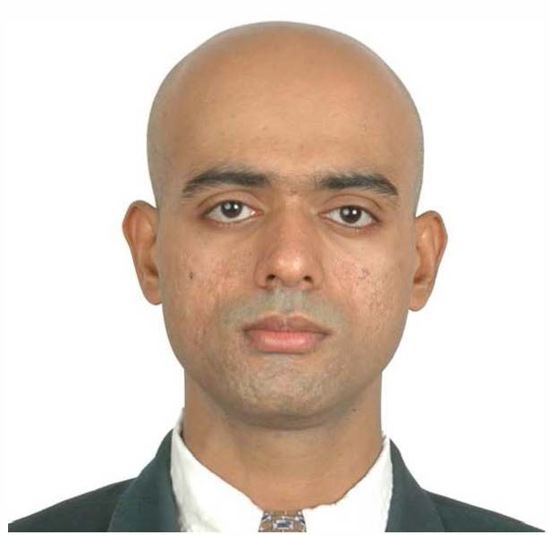

**SYED ALAM ABBAS**

1985 Born on October 11, Mumbai, India.

2003–07 B.E., University of Mumbai, Mumbai, India.

2007–10 Software Engineer, General Electric (GE Energy division), Mumbai, India.

2011–13 M.S, University of Central Florida, Orlando, Florida.

2012–17 GRA, Computational Imaging Lab, EECS, UCF.

2011-17 Ph.D., University of Central Florida, Orlando, Florida.

**SELECTED AWARDS & HONORS**

2009 Awards of recognition for productivity and efficiency from GE India.

2011-14 Trustees Doctoral Fellowship $25,000 per year.