B2B Lead Engine: Developer Project Guideline
Oct 19, 2026 · @Yaseen Khan
We are building a locally hosted system that finds B2B tech companies, verifies their data, researches them, runs compliant outreach, and gives callers a full briefing before every call. This guideline covers the start of the sales funnel only.

Goal and scope
The system turns a list of target companies into verified leads, runs personalized and compliant outreach, and hands a caller everything needed to open a real conversation. A human closes the deal. The AI does the volume work.
What the system does:
- Finds B2B technology companies that match our target profile.
- Collects, checks and scores their data until it is trustworthy.
- Researches each company and its decision maker so every message is personal.
- Sends outreach across email, LinkedIn, SMS, social media and website forms, within the rules of each channel.
- Tracks every reply and every sign of interest.
- Shows the caller a full briefing on a dashboard, backed by a CRM.
What is out of scope for this phase:
- Appointment booking, meetings and warm up sequences after the first call.
- Fully autonomous AI calling. Calls are made by people.
- Sending any real message before the founder approves the system's safety checks.
The tools named in this document are examples. Clay is mentioned only as a picture of the orchestration we want. We do not plan to use it. Developers may choose better tools, as long as the system runs on our own machines and the cost stays low.

How it works
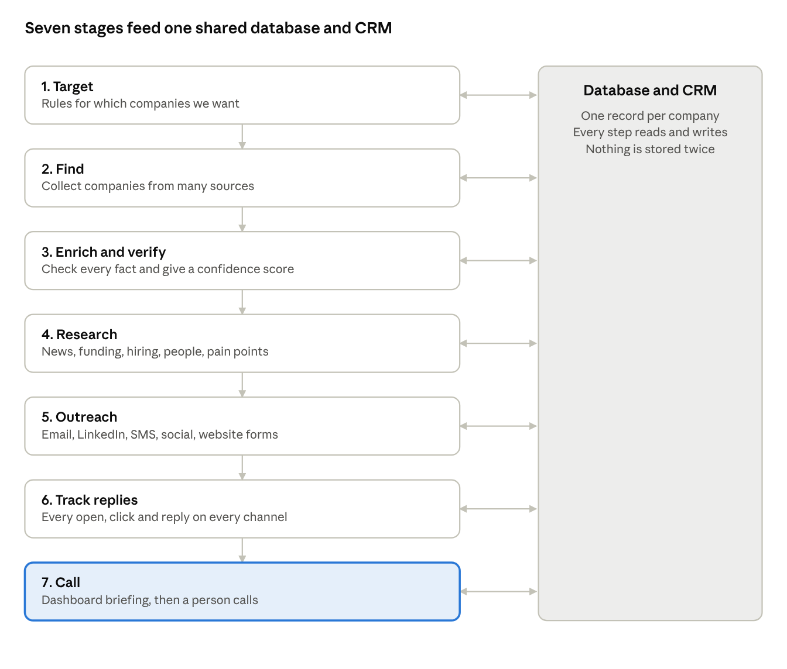
lead engine flow · 7 stages and one shared database
Each stage passes a verified record to the next. The database and CRM hold the single record for every company and person, so the caller always sees the full history.

Who we target
The target is a settings page, not fixed code. Different services need different company sizes, so every rule below must be changeable per campaign without touching code.
Setting | Starting value | Notes
Sector | B2B technology companies | Software, IT services, communications, data and similar. The list of sub sectors is editable.
Company size | 20 to 200 employees | Must be adjustable per campaign. Some services suit larger teams, some suit smaller ones.
Country | United States first | Add countries later without a rebuild.
Decision makers | Founder, CEO, operations and sales leaders, IT heads | Titles are editable. Store the title exactly as found.
Exclusions | Existing clients, competitors, anyone on a do not contact list | Checked before every message, not only at the start.
Every campaign saves its own copy of these settings, so results can be compared later.

Find, enrich and verify
Bad data ruins everything after it. A lead is only released to outreach after it is confirmed, validated and scored. The output of this stage is a verified list.
Finding companies. Use several sources together, and store where each fact came from.
- Public company websites and technology signals, for example which tools a company uses.
- Job posts, which also show what the company is missing.
- Public business listings, news, funding announcements and review sites.
- Open data sets and free tiers of data providers, where the terms allow it.
Enriching. For each company collect the legal name, website, size, location, sector, phone system if known, and the decision makers with their titles.
Verifying. Every important fact is checked a second way before it counts.
- Email addresses: check the format, the domain, and whether the mailbox exists, without sending to it.
- Phone numbers: check the number type and the carrier.
- Company facts: confirm the same fact on at least two sources.
- Person and title: confirm the person still works there.
- Duplicates: merge records that are the same company.
Scoring. Each lead gets a confidence score and a plain list of what was and was not confirmed. Leads below the set score never go to outreach. They go to a review queue.
Acceptance test: take 100 leads and check them by hand. At least 90 percent of the facts the system marked verified must be correct.

Research and personalization
Research starts at the very beginning of the funnel, not at the call. Every email, message and call must feel human and specific. A message that could be sent to anyone fails.
For every verified company, the system builds one research profile:
Topic | What to capture
Company | What they do, who they sell to, size, location, tools they use
Recent news | Announcements, launches, awards, press
Funding | Rounds, investors, dates, if public
Hiring | Open roles, which show what they are building and what they are missing
Decision maker | Role, background, public posts, shared interests, anything that helps start a real conversation
Problems | Likely pain points, with the evidence behind each guess
Connection points | Mutual contacts, shared groups, events, topics both sides care about
The system then writes a short personal opening for each channel. Example of the standard we want: a real client was emailed about the green and white stripes in the decision maker's public photo, and it worked because it was a genuine detail only a person would notice.
Rules for personalization:
- Use only public information and only what is relevant to a business conversation.
- Every personal detail must show its source, so a person can check it.
- Never invent a detail. If nothing real is found, say so and use the company level opening.
- Avoid anything that feels like surveillance, such as family details or home addresses.
- A person approves the opening line before the first message goes out.

Orchestration
Orchestration means every step is connected and nothing is done by hand in between. A company moves forward automatically when it passes a check, and stops when it fails. Think of a visual workflow where each step is a block, in the style of tools like Clay. We want that behavior, built on our own stack.
Step | Starts when | The system does | Passes on | If it fails
Find | A campaign starts | Collects companies that match the target settings | Raw company record | Logs the source and retries later
Enrich | A new company is saved | Adds company and people details | Enriched record | Marks fields as missing
Verify | Enrichment finishes | Checks facts and scores confidence | Verified list | Sends to review queue
Research | A lead is verified | Builds the research profile and openings | Briefing and openings | Falls back to company level opening
Approve | Openings are ready | Shows them to a person | Approved messages | Person edits or rejects
Outreach | Messages are approved | Sends by channel within the limits and rules | Send record | Pauses the channel and alerts the team
Track | Anything is sent | Records opens, clicks, replies and bounces | Engagement history | Retries the check
Hand over | A lead shows interest or a time is reached | Puts the lead on the caller dashboard | Call ready lead | Keeps it in the sequence
Requirements for the orchestration layer:
- Every step can be paused, retried and viewed in a log.
- Rules and limits live in settings, not in code.
- If any service or the local AI model is down, the step waits and retries. It never skips ahead with bad data.
- One person can see the state of every lead in one place.

Outreach by channel
Outreach begins only after a lead is verified, researched and approved. The goal is to reach people the right way and stay out of spam folders and account bans. Quality and low volume beat blasting.
Channel | How it works | Rules the system must enforce
Email | Personal message from a warmed up domain, then follow ups | Authenticate every sending domain with SPF, DKIM and DMARC. Use separate sending domains, never the main one. Warm up slowly and cap daily volume. Send only to verified addresses. Include a clear opt out and a real business address. Stop at once on a reply, bounce or opt out.
LinkedIn | System prepares the profile view, connection note and message for a person to send | Do not automate actions on LinkedIn. It breaks their terms and gets accounts banned. A person sends, using the drafts. Keep daily limits low.
SMS | Short follow up after a lead has shown interest or given consent | Cold SMS to people who never agreed is not allowed in the US. Send only with consent, through a registered 10DLC campaign, with opt out handling and quiet hours. In phase one, build this as a stub that queues messages and sends nothing.
Social media | System finds the right profile and prepares a natural comment or message | A person posts and sends. No bulk automation. Follow each platform's rules.
Website form | System prepares a short personal message for the company's contact form | Low volume, a person reviews each one, no fake details, respect any no solicitation notice.
Rules for every channel:
- A shared do not contact list is checked before every send and every follow up.
- The sequence for each lead is planned once, so channels do not contradict or flood the same person.
- Messages come from the approved research opening, not from a generic template.
- Every send, open, click, reply and opt out is written back to the CRM.
- In the first build, nothing is sent to real people. The system shows what it would send. The founder turns on real sending channel by channel after review.

Replies and the calling dashboard
The caller must know everything useful before dialing. The dashboard is the caller's single screen for one company, built from the CRM and the research profile. Behind it, the CRM keeps the full history of what happened before and what is happening now.
Reply tracking comes first, because it decides who gets a call. For every lead and every channel the system records whether it was sent, seen, clicked and answered.
- Email replies, opens and bounces are read from the sending mailbox.
- LinkedIn and social replies are logged by the person who sends, with one click, or from notifications where the platform allows it.
- SMS replies come from the SMS provider and any opt out stops all texts at once.
- Website form replies are logged by hand or by the reply email.
The dashboard shows these panels:
Panel | What the caller sees
Who and why now | Company, decision maker, title, phone, local time, and the reason this lead is ready for a call
Engagement | Every message sent, with opened, clicked and replied marked per channel, newest first
Company briefing | What they do, their size, the tools and phone system they use, and likely problems
News and funding | Recent news and funding, with links to the source
Hiring | Open roles and what they say the company is missing or building
Connection points | The personal and business details from research, for a human opening
Suggested opening | A short natural opening line and two questions to ask, which the caller may change
Safety check | Do not contact status, consent status and best time to call
Call result | Quick buttons for outcome and a notes box, saved straight to the CRM
The caller can open any panel's source to see where a fact came from. The system never hides uncertainty. A fact with low confidence is marked as such.

Build approach
The system runs on our own machines, with open source tools, local AI models and free tiers wherever possible. We judge it on return on investment, not on the lowest possible bill. Money is fine to spend when it clearly pays for itself.
Layer | Examples developers may choose from | Note
Database | PostgreSQL or similar | The single source of truth for every company, person and event
Orchestration | n8n, a code based workflow engine, or a queue | Must show logs, retries and pause controls
Local AI | Open weight models run on our own hardware | Used for summaries, openings and sorting. Choice is open.
Search and data | Public sites, open data, free tiers of data tools | Respect each source's terms
Email sending | Own mail server or a low cost provider | Several domains, with authentication set up
CRM | GoHighLevel if the founder confirms, or an open source CRM | Must accept and send data through an API
Dashboard | A simple web app on the same database | Fast, plain and easy for callers
Points the developers must respect:
- Facts come from sources, never from model memory. A local model may summarize and draft. It must not invent company facts. Every fact stored needs a source link.
- A person approves before sending. The system prepares. A human releases.
- Measure cost. Track the cost of each verified lead and each reply, so we can see the return.
- Plan for failure. If the model, a data source or an email service stops, the system waits and tells us. It never sends partial or guessed data.
- Keep it simple. A working small version beats an unfinished big one.

Compliance rules
These rules protect the company from fines, blocked accounts and a damaged name. They are written as far as we know them. A US lawyer should confirm them before real sending begins.
- Email. Follow US commercial email rules: honest sender and subject lines, a real business address, a working opt out that is honored quickly, and no sending to people who opted out.
- Phone calls. Check the national and company do not call lists before any call. Record the result of the check in the CRM.
- SMS. Send only with consent and only through a registered campaign. Honor stop requests at once. Respect quiet hours.
- Platforms. Follow the terms of LinkedIn and every social site. No bots that act as a person on these sites.
- Data collection. Collect only public business information. Do not break a website's rules to get data. Keep a record of the source and date of every fact.
- Privacy. Store the minimum personal data needed. Delete or correct data when a person asks. If contacts in Europe, the UK or states with privacy laws appear, flag them and follow the stricter rules.
- One do not contact list. It covers every channel. Once a person is on it, no part of the system may contact them.
- Audit trail. Log what was sent, to whom, when, and which rule check it passed.
If a rule and a target conflict, the rule wins.

Build phases
Build in this order. Each phase must pass its test before the next begins, so problems show up early and cheaply. Dates are for the team and the founder to agree.
Phase | What is built | Done when
1. Foundation | Database, target settings, workflow engine, logs, one do not contact list | A test company moves through empty steps and every step is logged
2. Find and verify | Discovery from several sources, enrichment, verification and confidence score, review queue | A hand check of 100 leads shows the verified facts are correct at the agreed rate
3. Research | Research profile, source links, personal openings, approval screen | Every opening shows a real source, and a person can approve or reject it
4. Outreach dry run | Email setup, channel drafts, rule checks, SMS stub | The system produces the right messages and blocks anyone on the do not contact list, with nothing sent
5. Replies and dashboard | Reply tracking, caller dashboard, CRM sync | A caller can prepare for a call from the dashboard alone
6. Controlled pilot | Real sending in small volume, one channel at a time, founder approved | Deliverability and replies are measured, and no rule was broken
The first working version does not need every source or every channel. It needs the whole chain working end to end on a small list.

Open questions
The founder should answer these before or during phase 1.
- ☐ Which CRM is the system of record? GoHighLevel is assumed.
- ☐ Which sub sectors of B2B technology come first, and which services are we selling to them?
- ☐ What accuracy do we require? The starting target is 90 percent correct on verified facts.
- ☐ How many leads per week should the first version handle?
- ☐ Which hardware will host the system and the local models?
- ☐ What monthly budget is allowed for data, domains and mailboxes?
- ☐ Which phase dates do we agree with the developers?
- ☐ Who approves openings and releases real sending?
- ☐ Does SMS stay a stub until consent is collected through a form or a reply?

