CMP7200 — Individual Masters Project

PROJECT PROPOSAL

An Intelligent Multi-Agent AI Interview Platform:
Integrating Voice Interaction, Skill Graph Reasoning,
and Comparative Answer Evaluation Using
LLM Judgement

Birmingham City University
Faculty of Computing, Engineering and the Built Environment
MSc Computer Science
Session 2025-26

Table of Contents
Abstract
1. Background and Rationale
1.1 Project Aim
1.2 Objectives
2. Literature Review
2.1 AI-Driven Recruitment Systems
2.2 LLMs as Evaluators
2.3 Knowledge Graphs for Skills Mapping
2.4 Fairness and Bias in Algorithmic Hiring
2.5 Conceptual Framework
3. System Overview
3.1 Technology Stack
3.2 Use Case Model
3.3 Interview Process Flow
4. Research Methodology
4.1 Module 6: Answer Evaluation Pipeline
4.2 Behavioural Integrity Detection (Module 9)
4.3 Data Collection and Training Strategy
4.4 Evaluation Metrics
4.5 Alternative Approaches Considered
4.6 Limitations and Mitigation Strategies
4.7 Ethical Considerations
4.8 Development Tools and Environment
5. Project Schedule
6. References
Appendix A: Module Summary Table

Abstract
The following is a proposal for the design and developmental plans of an intelligent multi-agent AI interview platform. It uses large language models, a knowledge-based skill graph, real-time voice interaction, and trained machine learning classifiers to perform, track and analyze candidate interviews. The platform is divided into 12 modules which correspond to the four stages – pre-interview setup, live interview session, answer evaluation, reporting. The main research contribution is Module 6 where two parallel answer score models are implemented: LLM-as-Judge, and a supervised classifier trained on Sentence-BERT embeddings and XGBoost; and their accuracy, consistency, and explainability are compared. The trained model (Isolation Forest) is used to detect behavioral anomaly in interviews. The project is designed in a 14 week development cycle using a Design Science Research approach. This document includes the project rationale, critical literature review, proposed methodology and alternatives and project timeline.

1. Background and Rationale

The recruitment industry is undergoing a major transformation. Over the last five years, AI tools have increasingly taken over candidate screening, ranking, and interviewing at scale. Platforms such as HireVue, Pymetrics, and my Interview now handle millions of evaluations annually, often without any human recruiter involvement. The primary advantage is efficiency: faster screening cycles, reduced costs, and greater consistency across large applicant pools.

However, this shift has raised serious concerns. In 2019, the Electronic Privacy Information Centre challenged HireVue over its facial analysis algorithms, citing opacity and potential discriminatory bias (EPIC, 2019). By early 2021, HireVue discontinued facial analysis but continued scoring verbal responses via natural language processing (HireVue, 2021). The core problem persisted: candidates received scores with no meaningful explanation of how they were determined.

Regulation has since responded. The EU AI Act (2024) explicitly classifies AI systems used in recruitment as "high-risk," mandating transparency, human oversight, and bias testing (European Commission, 2024). Large language models such as GPT-4, Claude, and Llama 3 now offer the conversational sophistication needed to conduct structured interviews and deliver scored evaluations.

This project addresses a central question: can an interview platform combine the conversational capability of LLMs with the measurability and explainability of trained classifiers? The goal is not another black-box scoring system, but a transparent one where every evaluation decision is traceable, multiple scoring methods are comparable, and the gap between a score and its explanation is minimal.

1.1 Project Aim

To design, build and evaluate multi-agent AI interview platform that perform a voice interview on the technical aspects, match candidate skills with job requirements using a knowledge graph and judge candidate answers, comparing the accuracy, consistency and explainability of the answers from the LLM and trained machine learning classifiers.

1.2 Objectives
- Objective 1: Use NetworkX and data from the ESCO taxonomy to create a skill knowledge graph based on candidate CV and job description inputs, and map candidate skills to job requirements, highlighting particular skill gaps.
- Objective 2: Create a responsive QG agent that tailors interview questions based on the skill graph structure and the responses of the candidate during the interview to cover the key skills without redundant questioning.
- Objective 3: Create a voice-based interview agent that can transcribe speech to text and generate text to speech for natural human conversation, enabling hands-free interviews.
- Objective 4: Train and design an answer evaluation classifier using Sentence-BERT embeddings and XGBoost, and compare the scoring accuracy of the trained model with an LLM-as-Judge baseline using inter-rater agreement analysis (Cohen's Kappa, Spearman correlation).
- Objective 5: Develop a behavioral integrity detection module that leverages an isolation forest model trained on a set of normal interactions, such as response time, tab switching frequency, typing consistency to detect potential suspicious interactions.
- Objective 6: Evaluate the whole system by conducting experiments on scoring agreement with human ratings, consistency with paraphrasing the answers, and the quality of explanations generated using SHAP.

2. Literature Review
This section critically reviews four streams of research, which directly influence the proposed system, before integrating them into a conceptual framework for a project design.

2.1 AI-Driven Recruitment Systems
The automated interview system has been growing quickly from keyword-based resume screening to a multimodal assessment system. Hickman et al. (2022) examined text analysis methods in organizational research and determined that although NLP tools have been shown to increase the reliability of scoring, against all unstructured human scoring, they often lack the criterion validity evidence that has been accumulated over decades by traditional structured interviews. These tools are consistent but not necessarily accurate in other words.

Langer et al. (2019) studied applicant reactions to AI-based interviews and discovered that applicants who interview with AI systems rate them as much less fair as those who are interviewed by humans, particularly if there is no feedback or explanation from the system. Consequences of this: candidates who feel the process is unfair are less likely to accept offers, thus defeating the purpose of automating the process in the first place. This perception problem is the direct motivation for the explainability focus for this project.

2.2 LLMs as Evaluators
Using large language models as automated judges gained significant attention following the MT-Bench study by Zheng et al. (2023), which demonstrated that GPT-4 judgements agree with human evaluator preferences at over 80% on open-ended conversation tasks. However, this promising result must be interpreted carefully. Stureborg et al. (2024) subsequently identified systematic positional bias in LLM judges — models tend to favour whichever response appears first, regardless of actual quality. Wang et al. (2024) found a complementary problem: verbosity bias, where longer answers receive higher scores even when the additional length adds no substance.
The strength of LLM evaluation is its contextual understanding — it can assess whether an answer genuinely addresses the question. Its weakness is the lack of transparency and the susceptibility to these systematic biases. A trained classifier, by contrast, relies on measurable features and can explain its scores through feature attribution, but may miss nuances that require deeper language understanding. This trade-off is precisely what Module 6 is designed to investigate.

2.3 Knowledge Graphs for Skills Mapping
Knowledge graphs offer a structured method for representing relationships between concepts. Chen et al. (2021) applied graph-based models to identify prerequisite relationships in online learning, showing that graph traversal algorithms can effectively recommend learning paths. The ESCO framework (European Commission, 2023) provides a standardised taxonomy of over 13,000 skills linked to occupations across Europe, making it particularly well-suited for recruitment applications where skills need to be matched against job requirements.
In this project, the skill graph is not merely decorative. It serves two functional purposes: gap analysis (comparing what the candidate knows against what the role requires) and adaptive question targeting (asking questions that probe the edges of the candidate's skill set rather than testing what is already obvious from their CV). This makes the interview both more efficient and more informative.

2.4 Fairness and Bias in Algorithmic Hiring
Raghavan et al. (2020) audited several commercial hiring algorithms and found that most lacked any formal fairness testing protocol. Bogen and Rieke (2018) warned that algorithmic tools risk encoding historical biases from training data, particularly around gender, ethnicity, and socioeconomic background. The EU AI Act now requires documented bias testing for high-risk systems (European Commission, 2024), creating regulatory pressure for the kind of transparency this project aims to provide.
This project addresses fairness at two levels. The trained classifier uses exclusively skill-based and linguistic features — semantic similarity, keyword coverage, grammar quality, response structure — rather than features that could serve as demographic proxies. Additionally, the SHAP explanation layer enables auditing of whether any feature disproportionately influences scores for particular candidate groups. This does not guarantee fairness, but it makes unfairness detectable.

2.5 Conceptual Framework
Combining the four research themes above a conceptual model becomes apparent. The three related issues with current AI interview tools are opacity (no ability to explain their decision), bias susceptibility (potential for past discrimination to be embedded in the tool) and fragility of a single method (no validation of a single evaluation method). This project tackles all three through a multi-agent architecture:
- Explainability is embedded in the evaluation pipeline using SHAP
- Fairness is fostered by including skill-based features and auditability
- Robustness is enabled by two independent ways of evaluating, which act as mutual checks. Skill graph introduces the fourth dimension, structured knowledge representation, which makes the interview process more grounded in a competency framework that is documented, and uses it instead of picking questions on random.

3. System Overview
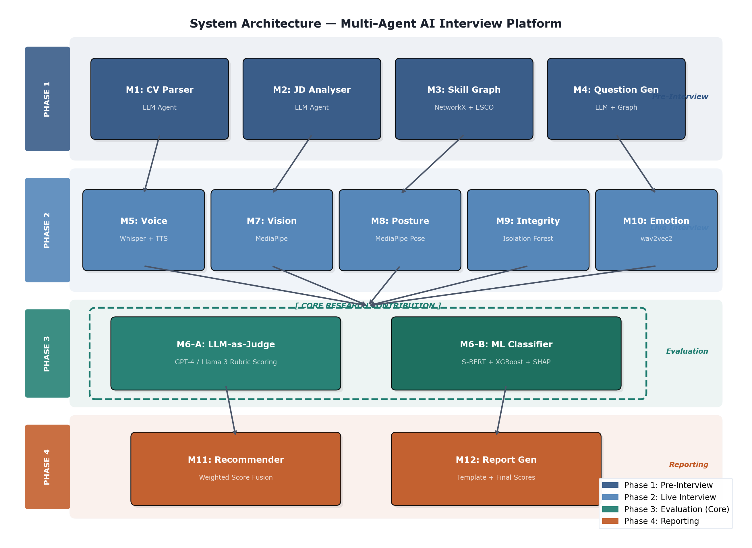
There are 12 modules, which are divided into 4 sequential phases. All modules have clearly specified inputs and outputs, so they can be developed, tested and replaced independently if needed. The overall system architecture is shown in figure 1.

Figure 1: System Architecture — Four-Phase Layered Design

3.1 Technology Stack
Table 1 summarises the core technology behind each module and indicates whether the component is pretrained, trained by the researcher, or rule-based. Two modules (M6 and M9) involve model training — these form the primary research contribution.
Module | Function | Core Technology | Type
M1 | CV Parsing | LLM (GPT-4 / Llama 3) | Pretrained
M2 | JD Understanding | LLM (same) | Pretrained
M3 | Skill Graph | NetworkX + ESCO Taxonomy | Rule-based
M4 | Question Generation | LLM + Graph Traversal | Pretrained
M5 | Voice Interview | Whisper STT + Google TTS | Pretrained
M6 | Answer Evaluation | LLM + S-BERT + XGBoost | Trained
M7 | Vision Monitor | MediaPipe Face Mesh | Pretrained
M8 | Posture Analysis | MediaPipe Pose | Pretrained
M9 | Behavioural Integrity | Isolation Forest | Trained
M10 | Emotion Detection | wav2vec2-emotion | Pretrained
M11 | Recommendation | Weighted Fusion + LLM | Hybrid
M12 | Report Generation | Template Engine | Rule-based

Table 1: Module Technology Stack — Trained vs Pretrained Components

3.2 Use Case Model
Two primary actors interact with the system. The Candidate provides their CV, participates in the voice interview, and answers technical questions. The Recruiter receives the evaluation report, reviews flagged answers, and makes the final hiring decision. Figure 2 shows these interactions.
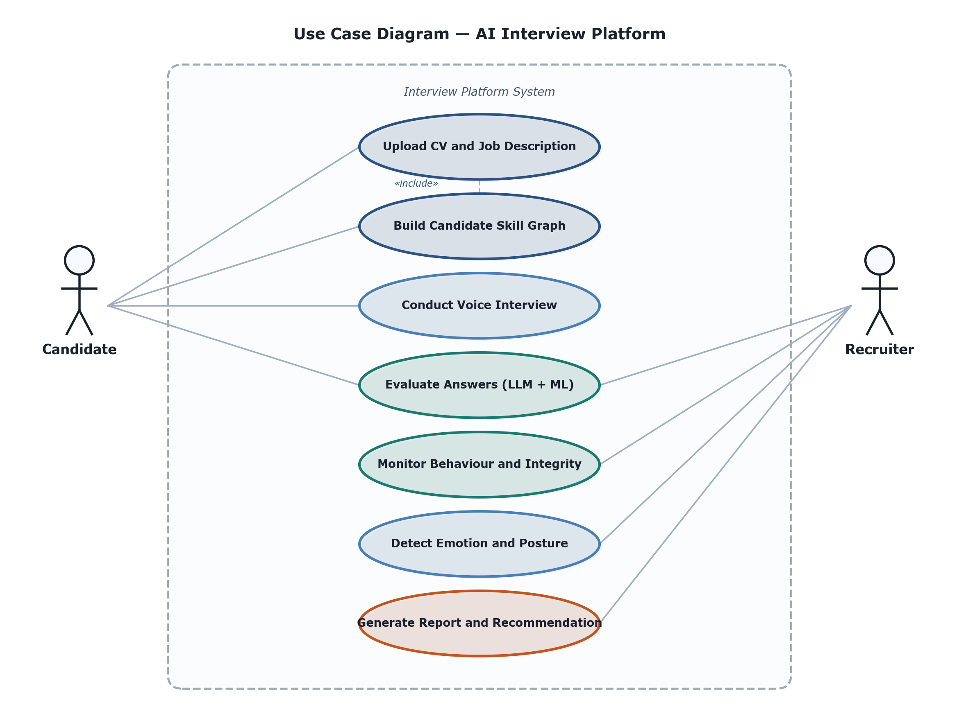
Figure 2: Use Case Diagram — Candidate and Recruiter Interactions

3.3 Interview Process Flow
Figure 3 shows how data moves through the system during a complete interview session, from initial CV upload through skill mapping, voice interview, evaluation, and final reporting.
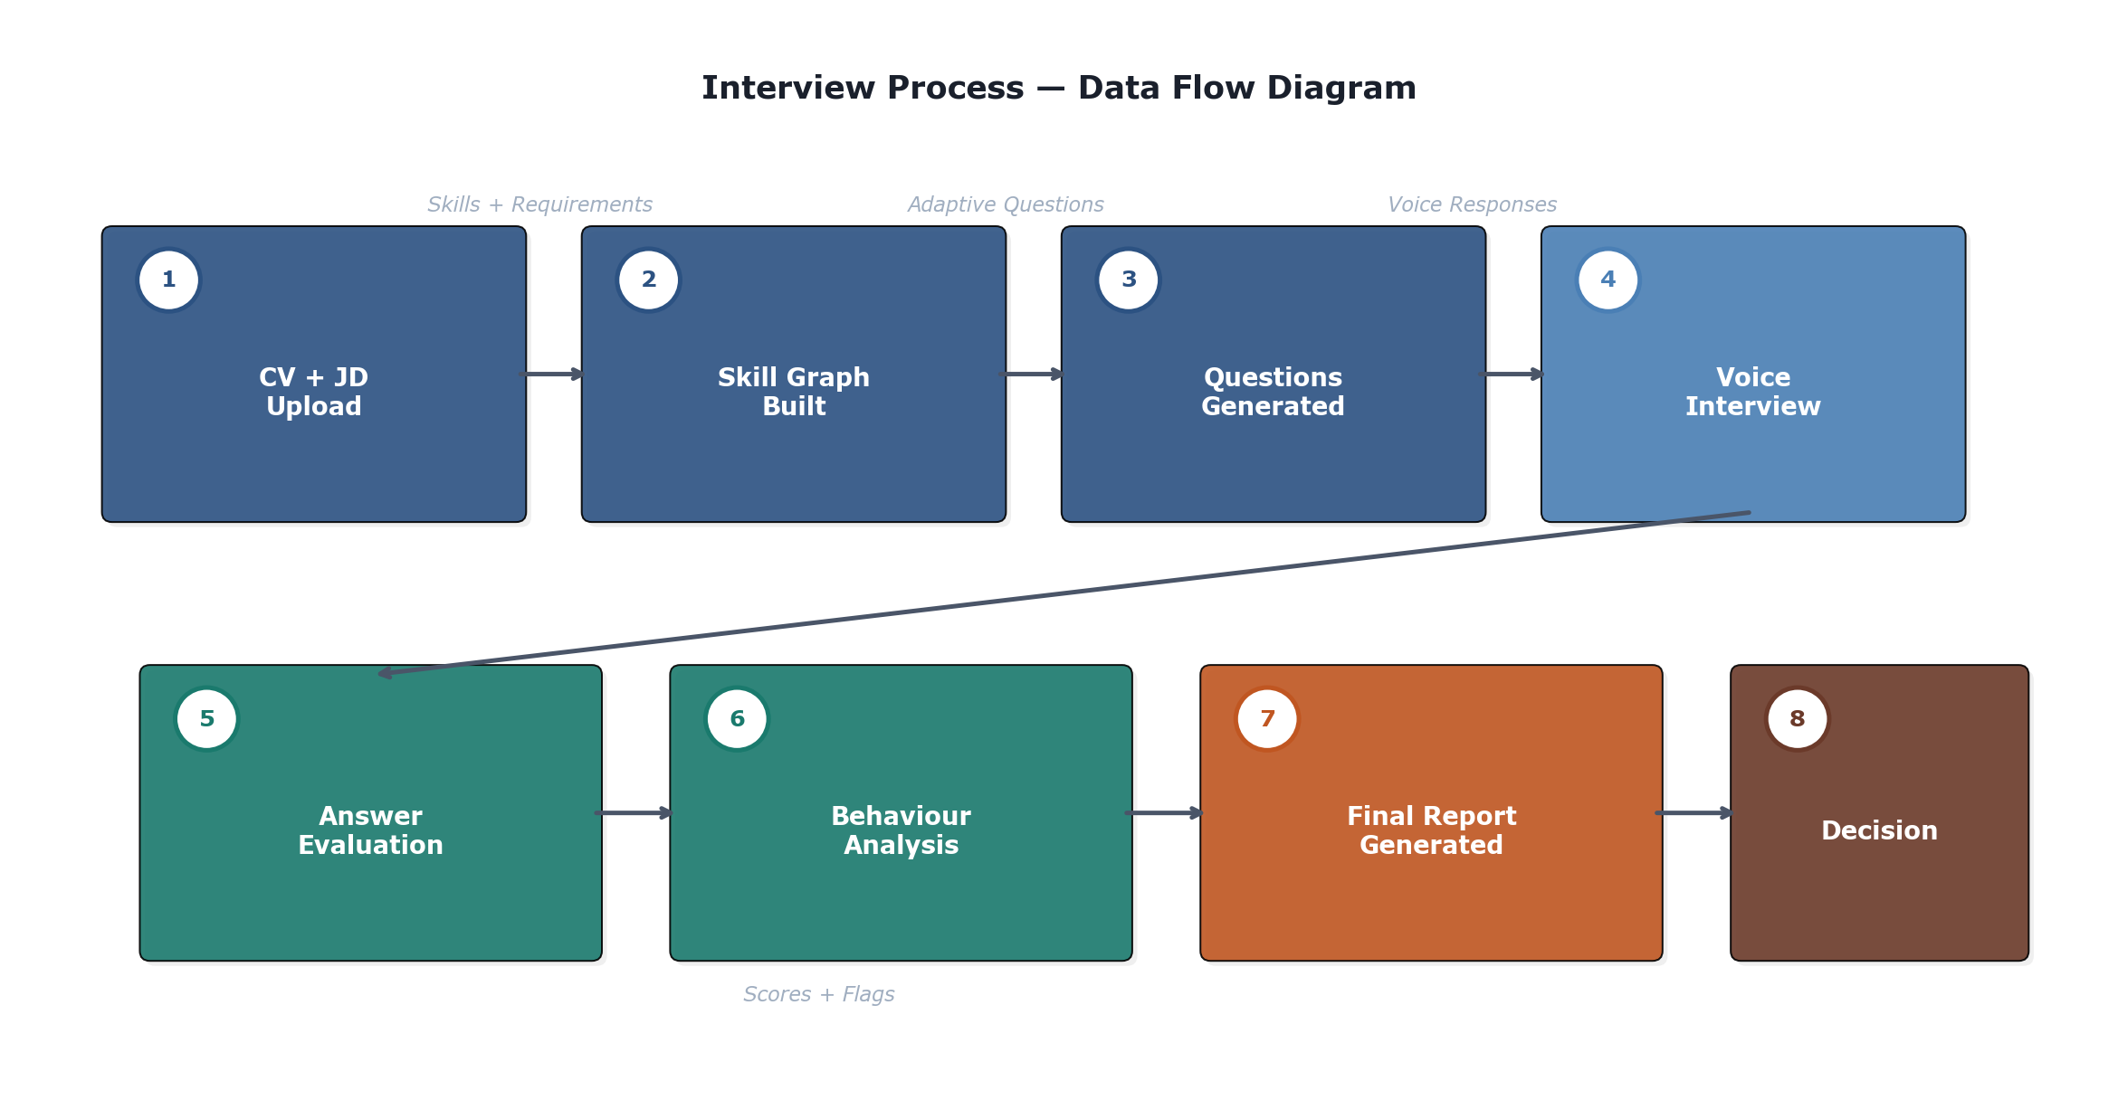
Figure 3: Data Flow Diagram — End-to-End Interview Process

4. Research Methodology
The methodology of this project is based upon the Design Science Research (DSR) approach, as defined by Hevner et al. (2004). It is a research methodology specifically designed for research that focuses on the creation and evaluation of IT artefacts and is suitable for a project that develops a working software system and then tests it. The process is an iterative process where design, implementation and evaluation occur in cycles. The main research question is:
A trained supervised classifier (Sentence-BERT + XGBoost) versus an LLM-as-Judge approach to assess the quality of interview responses in terms of agreement with human ratings, consistency in scores when paraphrasing, and explainability of scores?

4.1 Module 6 — Answer Evaluation Pipeline (Core Contribution)
Module 6 represents the primary research contribution. It implements two independent evaluation strategies that process every candidate answer in parallel, then compares their outputs to determine where they agree and where they diverge. Figure 4 illustrates this dual-track pipeline.
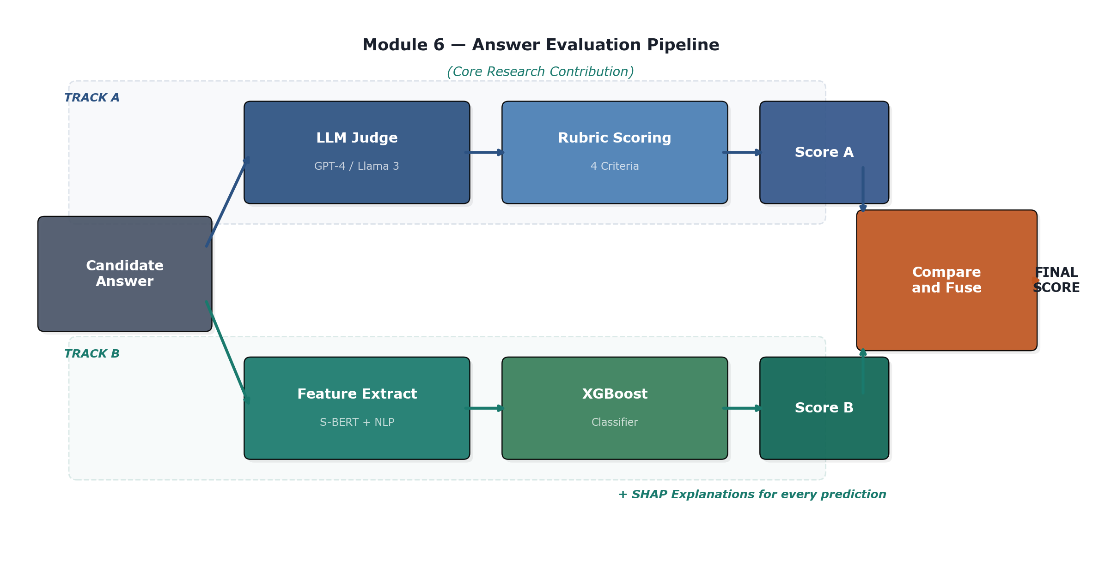
Figure 4: Module 6 — Dual-Track Answer Evaluation Pipeline

4.1.1 Track A: LLM-as-Judge

The candidate's transcribed response is then passed to a large language model (LLM) such as GPT-4 or Llama 3) and a structured rubric prompt that includes four criteria for scoring: technical accuracy, completeness, clarity, and relevance. The model scores between 0 and 100 and provides a short explanation. To address the positional bias that has been reported by Stureborg et al. (2024), the ordering of prompt elements is randomized in multiple calls to the system and then averaged.

4.1.2 Track B: Trained ML Classifier
The second one works by transforming each answer into a set of measurable features prior to classification. The following features are includes:
- Sentence-BERT embedding (384 dimensional semantic vector)
- The Cosine similarity between the answer and the ideal reference answer.
- Keyword coverage score (percentage of technical terms in the keywords)
- Grammar and fluency score (using language-tool-python)
- The length of the answers and the structure (sentences, paragraphs)
- The proportion of words that are concrete versus vague filler words
These features are input to an XGBoost classifier trained on labelled interview data. For every prediction, SHAP values are computed to identify which features contributed most to the score, providing full transparency into the decision.

4.1.3 Comparison and Fusion Strategy
Each track receives a score of its own for each answer. The system compares outputs using Cohen's Kappa (categorical agreement), Pearson correlation (numerical alignment) and disagreement threshold analysis (flags cases that have a score difference greater than 20 points). High confidence is reported where there is agreement between both methods. When there is a significant difference of opinion, the answer is marked for human adjudication.

4.2 Behavioral Integrity Detection (Module 9)

In module 9, an Isolation Forest is used as an unsupervised anomaly detection algorithm that was trained with the normal interview interaction patterns. Input tasks consist of response time distribution, tab-switching, browser focus, mouse movement entropy, typing speed consistency and speech hesitation pattern. Sessions which differ markedly from the baseline session are also identified as potentially compromised. This module does not decide to hire or not, it gives a confidence annotation to the recruiter that they can use in context.

4.3 Data Collection and Training Strategy

The trained classifier needs labeled data for interview answer. A combination of three data sources will be used. Publicly available interview Q&A datasets on Kaggle and Hugging Face with quality ratings. Second, a set of synthetic training data points that are generated by prompting LLMs to produce answers at a pre-defined quality level (strong, medium, weak) (a technique used in augmentation and proven to work by Ye et al. 2022). Third, a small (about 200) manually labelled validation set with two independent raters, which was only used when testing for real world performance.

The baseline data for the Isolation Forest will be obtained from pilot sessions where volunteer participants are tasked with conducting mock interviews with no anomalies, and the distribution of such interviews will serve as the threshold for measuring anomalies.

4.4 Evaluation Metrics

The system will be assessed is in three aspects:

Scoring Accuracy — this measures the agreement between the different methods and human judgement. The Cohen's Kappa statistic (quadratic weighted) and the Spearman rank correlation were used to measure the performance with respect to the manually labelled validation set.

Consistency — Are scores consistent across different stable versions of the system that produce semantically equivalent answers? Paraphrased 50 answers and variance of scores measured within paraphrase sets.

Explainability — can the system make sense for why it scores the way it does? Qualitative, checking if feature attributions is consistent with expert intuition of good/poor answers.

4.5 Alternative Approaches Considered
A number of different options have been taken into account and the design as put forward is the one that was accepted. To evaluate the results of the answers, one possibility was to employ only LLM-as-Judge, a process that would be easier to implement. This would, however, not offer any independent validation and would carry all the biases reported in the literature (Stureborg et al., 2024; Wang et al., 2024). An alternative was to replace XGBoost with a deep neural network (e.g. a fine-tuned BERT classifier). This may raise the accuracy of the model, but it would be at the cost of the interpretability that SHAP offers for the tree-based model, which is part of the project's goal of explainability.
A graph neural network (GNN) approach was initially proposed for the skill graph but was ultimately dismissed due to the fact that the ESCO taxonomy is well structured and does not require learned embeddings, which would be simpler and more transparent of a deterministic graph traversal. The fully custom ASR model was briefly looked at for voice interaction, but this was rejected in favor of Whisper which has already been shown to perform near-human accuracy on English speech and would distract from the core research question.

4.6 Limitations and Mitigation Strategies
There are some limitations known. Firstly, the quality and diversity of the training data affects the performance of the trained classifier. If the data used for interviewing is too limited in scope, the classifier may not perform well in a test set of questions outside of the scope of the data. This will be alleviated by the synthetic data augmentation of a broad variety of technical topics as well as by having the model's performance limits clearly specified.
Second, the LLM-as-Judge approach requires access to commercial models, and this means of course that it is costly and slow. This will be accomplished by storing all responses to the API, and allocating about £100 for experiment runs, with open-source Llama 3 as a backup.
Thirdly, the multimodal sensor modules (M7, M8, M10) are not the main focus of the evaluation research. They will be trimmed down to basic implementations so Module 6 will get their attention if they prove too time consuming. This is made explicit in the modular architecture: Each module can be developed or deferred without disrupting the other modules.

4.7 Ethical Considerations

No actual hiring is involved in this project and no person's employment is impacted. Only synthetic or publicly available data is used for all evaluation experiments. For baseline collection in Module 9, pilot testing is used and human participants will be involved: BCU ethical approval will be taken prior to data collection. Participants will provide informed written consent, and their data will be anonymized and kept securely in compliance with GDPR, and the participant will always have the right to withdraw at any time without any consequences. The system is not intended to be used as a hiring tool, but for research purposes.

4.8 Development Tools and Environment
The system will be designed with 'Python 3.11' as the programming language and 'FastAPI' as the backend framework. The frontend will be implemented using Stream lit for quick-prototyping and to be remade to react if time allows. Key libraries: NetworkX (graph operations), Hugging Face Transformers (Sentence-BERT and Whisper), XGBoost and SHAP (trained Classifier), scikit-learn (evaluation metrics), Media Pipe (vision and posture). The design principles governing the use of Git for version control of the source code will be adhered to. Weights and Biases will be used for experiment tracking, guaranteeing full reproducibility of the model training runs and hyper parameter searches.

5. Project Schedule
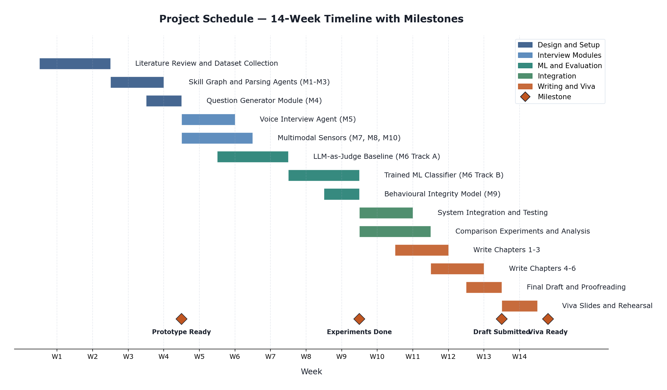
The project covers a total of 14 weeks, which is divided into five overlapping phases, including literature review and set-up, development of core module, training and experimentation of ML models, integration of system, and writing of the dissertation. Figure 5 shows the schedule and four major milestones.
Figure 5: 14-Week Project Schedule with Milestones
M1 (Week 4-5): A working prototype of the CV upload to the question generation to voice interaction interview flow. Week 9 – 10, Milestone 2 – Both evaluation models trained and comparison experiments completed. Milestone 3 (Week 13): Final draft of dissertation given to supervisor. M4 (Week 14): Prepared and rehearsed Viva presentation.
The schedule accounts for intentional “slack” time during the weeks 10–11 in case of delays in training of the model or data preparation. The writing process for a dissertation is a gradual process that extends well into the implementation phase, so as not to have a short period of dissertation writing at the end. In the event that the multimodal sensor modules take longer than expected, they will be reduced in scope and the core Module 6 research will be given priority.

References
- Bogen, M. and Rieke, A. (2018) Help Wanted: An Examination of Hiring Algorithms, Equity, and Bias. Washington, DC: Upturn.
- Chen, Y., Li, X. and Zhang, J. (2021) 'A knowledge graph approach to prerequisite identification in online learning', Computers and Education: Artificial Intelligence, 2(1), pp. 1-12. doi: 10.1016/j.caeai.2021.100016.
- EPIC (2019) Complaint and Request for Investigation of HireVue, Inc. Washington, DC: Electronic Privacy Information Centre.
- European Commission (2023) ESCO: European Skills, Competences, Qualifications and Occupations. Available at: https://esco.ec.europa.eu/ (Accessed: 15 March 2026).
- European Commission (2024) Regulation (EU) 2024/1689 laying down harmonised rules on artificial intelligence (Artificial Intelligence Act). Official Journal of the European Union, L series.
- Hevner, A.R., March, S.T., Park, J. and Ram, S. (2004) 'Design science in information systems research', MIS Quarterly, 28(1), pp. 75-105.
- Hickman, L., Thapa, S., Tay, L., Cao, M. and Srinivasan, P. (2022) 'Text preprocessing for text mining in organizational research: Review and recommendations', Organizational Research Methods, 25(1), pp. 114-146.
- HireVue (2021) HireVue Leads the Industry with Removal of Visual Analysis from Assessments. Press Release, 11 January.
- Langer, M., Konig, C.J. and Papathanasiou, M. (2019) 'Highly automated job interviews: Acceptance under the influence of stakes', International Journal of Selection and Assessment, 27(3), pp. 217-234.
- Raghavan, M., Barocas, S., Kleinberg, J. and Levy, K. (2020) 'Mitigating bias in algorithmic hiring: Evaluating claims and practices', in Proceedings of the 2020 ACM Conference on Fairness, Accountability, and Transparency. New York: ACM, pp. 469-481.
- Stureborg, R., Alikaniotis, D. and Suhara, Y. (2024) 'Large language models are inconsistent and biased evaluators', arXiv preprint, arXiv:2405.01724.
- Wang, P., Li, L., Chen, L. and Song, D. (2024) 'Large language models are not fair evaluators', in Proceedings of the 62nd Annual Meeting of the Association for Computational Linguistics. ACL.
- Ye, J., Chen, J., Liu, Q., Xu, Z. and Wan, X. (2022) 'Generative data augmentation for commonsense reasoning', in Findings of the Association for Computational Linguistics: EMNLP 2022, pp. 1008-1025.
- Zheng, L., Chiang, W.L., Sheng, Y., Zhuang, S., Wu, Z., Zhuang, Y., Lin, Z., Li, Z., Li, D., Xing, E., Zhang, H., Gonzalez, J.E. and Stoica, I. (2023) 'Judging LLM-as-a-Judge with MT-Bench and Chatbot Arena', Advances in Neural Information Processing Systems, 36.

Appendix A: Module Summary
Table A1 provides a complete summary of all twelve modules, their phase allocation, and their role within the system.
Module | Phase | Role | Technology | Training
M1 | 1 | Extract skills and experience from CV | LLM | No
M2 | 1 | Parse job requirements and skill needs | LLM | No
M3 | 1 | Map skills into knowledge graph | NetworkX | No
M4 | 1 | Generate adaptive interview questions | LLM + Graph | No
M5 | 2 | Conduct voice-based interview | Whisper + TTS | No
M6 | 3 | Score answers (dual-track evaluation) | LLM + XGBoost | Yes
M7 | 2 | Track facial attention and gaze | MediaPipe | No
M8 | 2 | Analyse body language and posture | MediaPipe | No
M9 | 2 | Detect anomalous interview behaviour | Isolation Forest | Yes
M10 | 2 | Detect emotional state from voice | wav2vec2 | No
M11 | 4 | Fuse scores into recommendation | Rules + LLM | No
M12 | 4 | Generate final candidate report | Templates | No
Table A1: Complete Module Summary

