BIRMINGHAM CITY UNIVERSITY
Faculty of Computing, Engineering and the Built Environment

An Explainable Multi-Agent AI Interview Platform:
Skill-Graph Question Targeting and a Bias-Mitigated
LLM-as-Judge Evaluation Pipeline

CMP7200 — Individual Master's Project
Project Dissertation (Assessment 2)

Student Number: [STUDENT NUMBER]
MSc Computer Science
Academic Year 2025–26

Module Leader: Samer Bamansoor
September 2026

Abstract
Automated interview platforms now screen millions of candidates each year, but the systems doing so remain largely opaque: they return a score without an account of how it was reached. Regulation has caught up with the practice — the EU AI Act classifies recruitment systems as high-risk and requires transparency, human oversight and bias testing — yet the tools themselves have been slower to change. Large language models offer the conversational competence to conduct a structured interview and the fluency to justify a judgement, but a growing literature shows they are unreliable evaluators: sensitive to the order in which criteria are presented, and prone to rewarding length over substance.
This project designs, builds and evaluates a working interview platform that treats that unreliability as the central engineering problem rather than an acceptable cost. The artefact comprises twelve modules across four phases. A candidate's CV and a job description are parsed into structured profiles and mapped onto a knowledge graph built from the ESCO occupational taxonomy, which identifies skill gaps and orders the interview so that genuine gaps are probed before the time budget is spent. The interview itself runs as a live voice conversation over WebRTC, or as a typed equivalent producing an identical transcript. Answers are scored by a language model against a generated reference answer under a four-criterion rubric. Attention, posture and vocal delivery are measured in the browser, and no video or audio leaves the candidate's device.
The evaluation contribution is a reliability instrument built into the scorer. Every answer is scored twice under permuted rubric orderings; the mean is reported and the disagreement between the two passes is retained as evidence of that score's stability. Answers on which the judge disagrees with itself are escalated to a human rather than reported as confident. Five controlled experiments measure the result: discriminant validity against known answer-quality levels, a positional-bias ablation, invariance under paraphrase, rubric criterion independence, and a verbosity probe.
A trained-classifier evaluation track proposed at the outset was built, measured and then rejected. Its labels were themselves model-generated, making the intended comparison circular, and the trained model scored a correct paraphrase of its own reference answer at 39 out of 100 — below the threshold at which the system reports a skill gap. That rejection, and the evidence behind it, is reported as a finding rather than concealed as a descoping. The dissertation concludes that transparency in automated assessment is better served by making a single scorer accountable for its own reliability than by adding a second scorer that cannot be independently validated.

Acknowledgements
I would like to thank my project supervisor for their guidance across the design and evaluation stages of this work, and the CMP7200 module team for their feedback on the project proposal, which shaped the direction the artefact eventually took. Any errors that remain are my own.

Declaration
This dissertation is submitted in partial fulfilment of the requirements for the degree of MSc Computer Science at Birmingham City University. I declare that the work presented is my own, that all sources have been acknowledged in accordance with the BCU Harvard referencing convention, and that this work has not been submitted for any other award. The software artefact described in Chapter 5 was designed and implemented by me for this project.

Table of Contents
Abstract
Acknowledgements
Declaration
List of Figures
List of Tables
1. Introduction
1.1 Background and rationale
1.2 Problem statement
1.3 Aim
1.4 Objectives
1.5 Scope and deliverables
1.6 Structure of this dissertation
2. Literature Review
2.1 Automated interviewing and algorithmic hiring
2.2 Language models as evaluators
2.3 Knowledge graphs for competency modelling
2.4 Fairness, transparency and the regulatory position
2.5 Behavioural integrity and remote assessment
2.6 Synthesis: a conceptual framework
2.7 The gap this project addresses
3. Research Methodology
3.1 Design Science Research
3.2 How the cycles ran in practice
3.3 Evaluation strategy
3.4 Data strategy
3.5 Alternative approaches considered
3.6 Ethical considerations
3.7 Tools and development environment
4. System Design
4.1 Architectural overview
4.2 Module decomposition
4.3 Data flow and interface contracts
4.4 Skill graph design
4.5 Question generation and graph traversal
4.6 Interview transport design
4.7 Evaluation pipeline design
4.8 Fusion and reporting design
4.9 Critical assessment of the tools selected
5. Implementation
5.1 Technology stack and repository structure
5.2 Document understanding (M1, M2)
5.3 The skill graph (M3)
5.4 Question generation and ordering (M4)
5.5 The voice interview agent (M5)
5.6 Text interview mode
5.7 Answer evaluation (M6)
5.8 Presence modules (M7, M8, M10)
5.9 Behavioural integrity (M9)
5.10 Fusion and report assembly (M11, M12)
5.11 Engineering problems encountered
6. Evaluation and Results
6.1 Experimental design
6.2 Discriminant validity
6.3 Positional-bias ablation
6.4 Paraphrase invariance
6.5 Criterion independence
6.6 Verbosity probe
6.7 System-level verification
6.8 A worked example
6.9 Discussion of results
7. Critical Reflection
7.1 Achievement against objectives
7.2 Deviations from the proposal
7.3 Limitations
7.4 Professional, legal and ethical reflection
7.5 Personal reflection
8. Conclusion and Future Work
References
Appendix A — Module reference
Appendix B — Rubric and judge prompt
Appendix C — Repository structure
Appendix D — Test suite summary

List of Figures
Figure 1 System architecture: four-phase modular design
Figure 2 End-to-end data flow
Figure 3 Skill graph construction and the four-stage matching cascade
Figure 4 Module 6: bias-mitigated LLM-as-Judge evaluation pipeline
Figure 5 Live voice interview: sequence of interactions
Figure 6 Module 11: weighted fusion model
Figure 7 Design Science Research process as executed
Figure 8 Use case model
Figure 9 Deployment and process view
Figure 10 Conceptual framework derived from the literature
Figure 11 Project schedule as delivered, with milestones
Figure 12 Discriminant validity: score distribution by intended quality
Figure 13 Positional-bias ablation and judge self-consistency
Figure 14 Paraphrase invariance across semantically equivalent rewrites
Figure 15 Inter-criterion correlation matrix
Figure 16 Verbosity probe: original versus padded answers

List of Tables
Table 1 Strengths and weaknesses of the principal tools selected
Table 4 Rubric criteria and their scoring guidance
Table 5 Fusion component weights
Table 6 Experimental design summary
Table 7 Discriminant validity results by intended quality level
Table 8 Current thresholds against empirically implied boundaries
Table 9 Positional-bias ablation results
Table 10 Paraphrase invariance by question group
Table 11 Per-answer results from the worked example
Table 12 Achievement against objectives

1. Introduction

1.1 Background and rationale
Recruitment has been reshaped by automation over the last decade. Platforms such as HireVue, Pymetrics and myInterview now conduct or score interviews at a scale no human panel could match, and the commercial case is straightforward: screening cycles shorten, cost per candidate falls, and every applicant is asked the same questions in the same order. Consistency of that kind is genuinely difficult to achieve with human interviewers, whose judgements vary with fatigue, order effects and rapport.
The difficulty is that consistency is not accuracy, and neither is fairness. In 2019 the Electronic Privacy Information Center complained against HireVue over its use of facial analysis in scoring, arguing the technique was unvalidated and opaque (EPIC, 2019). HireVue withdrew visual analysis in January 2021 but continued scoring verbal responses using natural language processing (HireVue, 2021). The underlying problem survived: candidates received a number and no account of how it was produced.
Regulation has since moved. Regulation (EU) 2024/1689, the Artificial Intelligence Act, classifies AI systems used in employment and worker management as high-risk, and attaches obligations covering transparency, human oversight, record-keeping and bias testing (European Commission, 2024). A system that cannot explain a score is now a compliance problem as well as an ethical one.
The technical ground has shifted too. Language models can hold a structured conversation and articulate a judgement in language a recruiter can read, which makes an interview system's reasoning legible in a way a feature-vector classifier's is not. Whether such a model can be trusted to grade is a harder question, and it is the one this project takes up.

1.2 Problem statement
The evidence on language models as evaluators is mixed. Zheng et al. (2023) showed GPT-4 agreeing with human preference judgements on open-ended tasks at over eighty per cent, comparable to agreement between human raters. Against that, Stureborg et al. (2024) documented positional bias — the same model scoring the same content differently by presentation order — and Wang et al. (2024) found verbosity bias.
These are not exotic edge cases. In an interview setting they map directly onto unfairness: a candidate who answers correctly but concisely is penalised relative to one who answers correctly at length, and the same answer may score differently depending on an implementation detail the candidate cannot see. A system that inherits these biases silently is worse than a transparent one that scores less well, because the failure is undetectable from the output.
The problem is therefore not whether a language model can score an interview answer — it plainly can — but whether a system built around one can be made accountable for the reliability of its scores.

1.3 Aim
To design, implement and critically evaluate a multi-agent AI interview platform that conducts an adaptive technical interview, targets its questioning using a knowledge graph built from a standard occupational taxonomy, and scores candidate answers through a language-model judge instrumented to measure, report and act on the reliability of its own judgements.

1.4 Objectives
Six objectives operationalise the aim. Objectives 4 and 6 were revised during the project following the rejection of the trained-classifier evaluation track; the original wording, the reason for the change and the evidence supporting it are set out in Section 7.2.
- Objective 1. Construct a skill knowledge graph from the ESCO occupational taxonomy, map candidate CV skills and job requirements onto it, and produce a gap analysis identifying which required skills the candidate does not evidence.
- Objective 2. Implement a question generation agent that derives an interview question set from the graph and orders it by the priority the gap analysis assigns, so that genuine gaps are probed before the time budget is exhausted.
- Objective 3. Implement a voice interview agent capable of conducting a natural spoken conversation with speech recognition and synthesis, together with a typed mode producing an identical transcript so that assessment is independent of the delivery channel.
- Objective 4. Design and implement a bias-mitigated LLM-as-Judge evaluation pipeline that scores each response against a generated reference answer under a four-criterion rubric, and quantify its positional-bias sensitivity and self-consistency through repeated measurement under permuted rubric orderings.
- Objective 5. Implement a behavioural integrity module that detects interview sessions whose interaction patterns depart from a defined baseline, and that reports the specific behaviours responsible rather than an unexplained flag.
- Objective 6. Evaluate the system through controlled experiments covering discriminant validity against known answer-quality levels, invariance under paraphrase, a positional-bias ablation, rubric criterion independence and sensitivity to verbosity, and verify the artefact through automated testing.

1.5 Scope and deliverables
The deliverable is a working software artefact together with this dissertation. The artefact runs locally as a single-user research demonstrator: a FastAPI backend, a React single-page frontend, an embedded WebRTC media server and a voice agent subprocess. It is deliberately not a production hiring system, and Section 7.3 sets out what would have to change before it could be one.
Three boundaries are worth stating at the outset. The system makes no hiring decision, only evidence for a human to act on. No real candidate data was used at any point; every experiment in Chapter 6 runs on generated material, for the reasons in Section 3.6. And the platform is evaluated as a measurement instrument, not as a predictor of job performance — criterion validity against employment outcomes would need a longitudinal study far beyond a fourteen-week project.
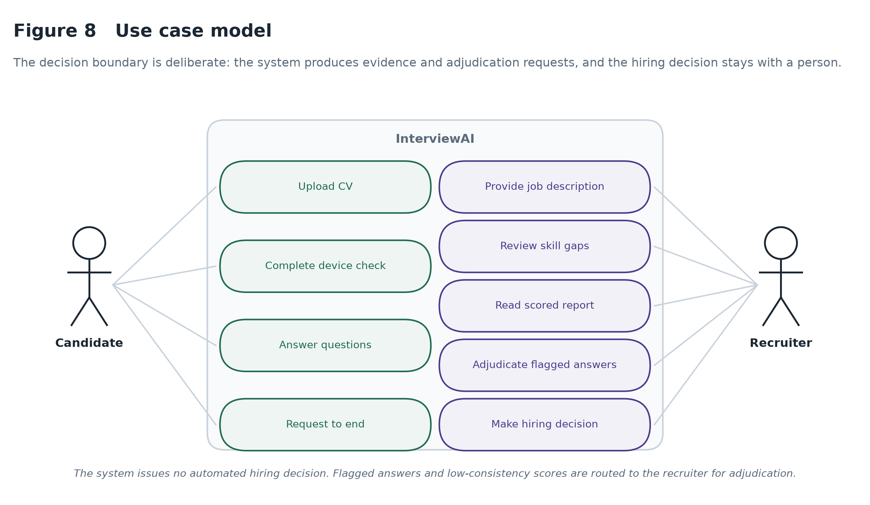
Figure 8 Use case model. The decision boundary is deliberate: the system produces evidence and adjudication requests, and the hiring decision stays with the recruiter.

1.6 Structure of this dissertation
Chapter 2 reviews the literatures the design draws on and derives a conceptual framework. Chapter 3 sets out the methodology, Chapter 4 the design and Chapter 5 the implementation. Chapter 6 reports the evaluation experiments, Chapter 7 reflects critically on what was achieved and what changed from the proposal, and Chapter 8 concludes.

2. Literature Review
Four bodies of work bear directly on this project: the empirical literature on automated interviewing, the fast-moving literature on language models used as evaluators, work on knowledge graphs for competency modelling, and the fairness and regulatory literature on algorithmic hiring. A fifth, smaller literature on remote assessment integrity informs one module. This chapter reviews each, draws out where they agree and where they conflict, and synthesises them into the conceptual framework that governs the design.

2.1 Automated interviewing and algorithmic hiring
Automated hiring tools have moved from keyword screening of CVs to multimodal assessment of recorded or live interviews. Hickman et al. (2022), reviewing text-mining practice in organisational research, reach a conclusion that is easy to misread as endorsement. Automated scoring is more reliable than unstructured human scoring, in the narrow psychometric sense that it produces the same output for the same input. But they are careful to separate that from criterion validity, and note that automated approaches largely lack the decades of accumulated validation evidence that supports traditional structured interviewing. The distinction matters for this project: a system can be perfectly consistent and consistently wrong, and consistency alone is not a defence of a scoring method.
Langer, König and Papathanasiou (2019) approach the same technology from the candidate's side, studying applicant reactions to highly automated interviews. They find that candidates rate automated interviews as markedly less fair than human ones, and that the effect is strongest where the system provides no feedback or explanation. The practical consequence they identify is commercially significant: candidates who perceive a process as unfair are less likely to accept an offer, which erodes the efficiency gain that motivated the automation. This finding is the direct motivation for the explanation-first orientation of the present work — the argument for explainability here is not only ethical but instrumental.
Together these frame a tension the design must resolve rather than choose between. Automation buys consistency and scale at the cost of validity evidence and perceived fairness; a system wanting both must make its reasoning inspectable.

2.2 Language models as evaluators
The use of a language model as an automated judge was popularised by Zheng et al. (2023), whose MT-Bench and Chatbot Arena work established that GPT-4's preference judgements agree with human evaluators at over eighty per cent on open-ended conversational tasks — a rate comparable to inter-human agreement on the same material. The result is genuinely important, because it suggests that for tasks with no single correct answer, a sufficiently capable model can substitute for expensive human annotation.
The qualifications arrived quickly, and they are specific rather than general. Stureborg, Alikaniotis and Suhara (2024) demonstrate that LLM judges are both inconsistent and biased: presented with the same candidates in a different order, the same model returns different scores. The bias is positional, arising from the sequence in which material is presented rather than from its content. Wang et al. (2024) identify a complementary failure they term verbosity bias, in which longer responses receive higher scores irrespective of whether the additional length carries additional substance.
These findings are frequently cited as reasons not to trust LLM judges. That reading is too pessimistic, and it misses what makes the findings useful. Both biases are characterised precisely enough to be countered by construction. If a judge's score depends on presentation order, then presenting the same material under several orders and aggregating removes the order-specific component — and, more usefully, the disagreement between the orderings becomes a direct measurement of how unstable that particular judgement was. A bias that can be measured can be reported; a bias that is reported can be acted on. This project treats the Stureborg and Wang results as specifications for countermeasures rather than as grounds for abandoning the approach.
One methodological caution in this literature shaped a significant decision here: where an automated scorer is compared against labels a language model itself produced, agreement is partly an artefact of the design rather than evidence about the world. Section 7.2 returns to it.

2.3 Knowledge graphs for competency modelling
Knowledge graphs represent entities and the relations between them in a form that supports traversal and inference. Chen, Li and Zhang (2021) apply graph-based models to prerequisite identification in online learning, showing that traversal over a structured concept graph can generate coherent learning paths without learned embeddings. Their result is relevant here in a specific way: where the domain structure is already documented and reliable, deterministic traversal is both simpler and more explainable than a learned alternative.
The ESCO framework (European Commission, 2023) supplies exactly such a structure — a multilingual taxonomy of skills, competences, qualifications and occupations, maintained as an EU standard, with over thirteen thousand skill concepts linked by explicit broader and narrower relations. Using a published taxonomy rather than an ad hoc skill list has a consequence that matters for a high-risk system: when the platform reports that a candidate lacks a required skill, the skill is a concept with a stable identifier in a public standard, not a string the system invented.
ESCO's limitations became apparent quickly in implementation. Version 1.1.1 predates much of the modern technology stack and covers soft skills only sparsely, so a practical system must extend it. Section 5.3 describes the extension taxonomies added here and, more importantly, the matching failures that arise when free-text skills are mapped onto a controlled vocabulary carelessly.

2.4 Fairness, transparency and the regulatory position
Raghavan et al. (2020) audited a set of commercial algorithmic hiring vendors and found that claims of bias mitigation were common while documented validation protocols were rare. Bogen and Rieke (2018) had already set out the mechanism by which such systems encode historical inequity: a model trained on past hiring outcomes learns the preferences embedded in those outcomes, including the ones nobody would defend explicitly.
The regulatory response is now concrete. The EU AI Act places recruitment systems in the high-risk category and requires transparency, human oversight, technical documentation and testing for bias (European Commission, 2024). What is notable for a system designer is that the Act does not demand that a model be unbiased, which would be unachievable; it demands that bias be tested for, documented, and subject to human oversight. That is a design brief, and it is met by instrumentation rather than by aspiration.
This project addresses fairness at three points. Scoring uses only what the candidate said, judged against a reference answer for the same question, with no demographic input and no proxy for one. The rubric is published to the candidate in the report rather than held internally. And the reliability of every score is measured and reported alongside it, so that a recruiter can see which judgements are firm and which are not. None of this guarantees fairness. It makes unfairness detectable, which is a weaker but achievable claim, and the one the literature supports.

2.5 Behavioural integrity and remote assessment
Remote assessment raises an integrity problem that predates AI interviewing and has been studied extensively in online proctoring. The approach adopted here follows the unsupervised anomaly-detection tradition: rather than attempting to classify cheating directly, which would require labelled examples of cheating that no institution can ethically produce, a model of normal interaction is fitted and departures from it are flagged for review. Isolation Forest (Liu, Ting and Zhou, 2008) suits this framing because it isolates anomalies by random partitioning and requires no labelled negative class.
The literature is clear that such signals are weak individually and easily misinterpreted: a candidate who looks away is thinking as often as they are consulting a second screen. The design consequence adopted here is that the module never issues a verdict without naming the behaviours behind it, and that its output is advisory context rather than an automatic disqualification.

2.6 Synthesis: a conceptual framework
The four literatures converge on three failings of current automated hiring tools, each of which admits a specific design response. Figure 10 sets out the resulting framework.
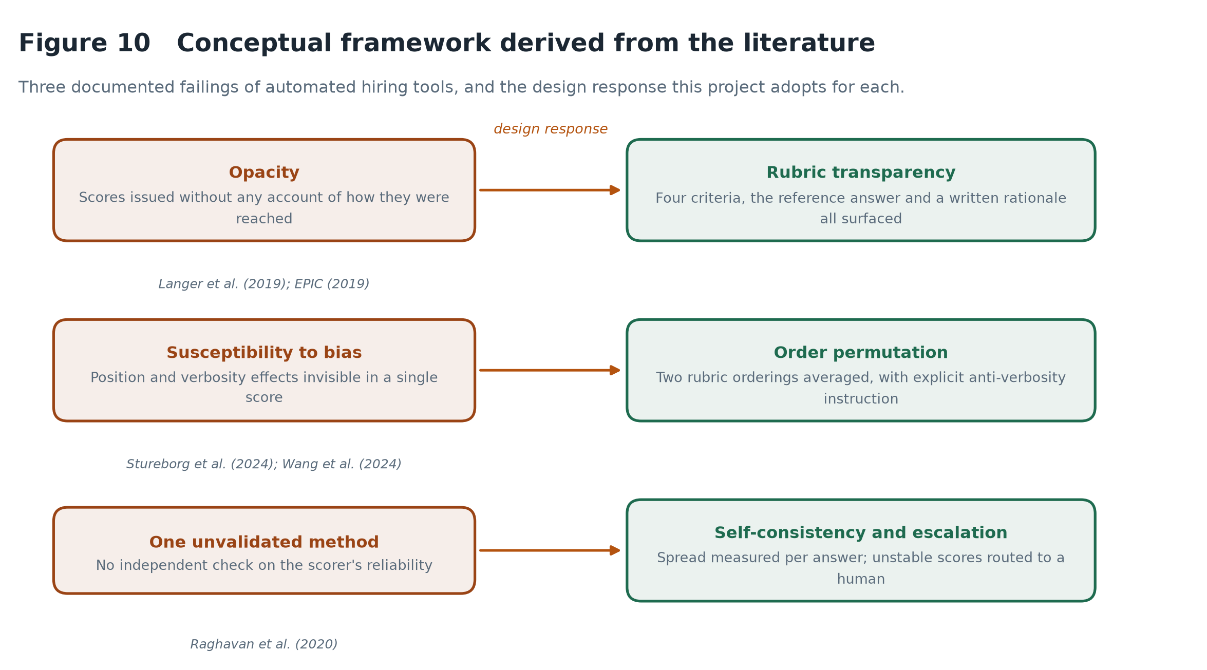
Figure 10 Conceptual framework derived from the literature: three documented failings of automated hiring tools and the design response adopted for each.
The first failing is opacity. Langer et al. (2019) and EPIC (2019) both document systems that return scores without accounts, and the AI Act now treats this as a compliance defect. The response adopted is to surface the full basis of every score: the four rubric criteria and their individual marks, the reference answer the response was judged against, and a written rationale.
The second is susceptibility to systematic bias. Stureborg et al. (2024) and Wang et al. (2024) identify position and verbosity effects that are invisible in a single score. The response is to permute the rubric ordering across repeated passes and average, and to instruct explicitly against rewarding length — then to test whether either countermeasure works, which Sections 6.3 and 6.6 do.
The third is reliance on a single unvalidated method. Raghavan et al. (2020) found this to be the norm commercially. The response adopted here is not a second scorer — for reasons Section 7.2 explains at length — but self-consistency measurement: the disagreement between repeated passes over the same answer is retained as evidence about that score, and answers on which the judge is unstable are escalated to a human instead of being reported as confident.
A fourth element sits underneath all three. Grounding the interview in a published occupational taxonomy means that what is being assessed is a documented competency rather than whatever the question generator happened to produce, which makes the assessment auditable at the level of content as well as scoring.

2.7 The gap this project addresses
The literature establishes that language models can evaluate open-ended responses competently, and separately that they do so unreliably in characterised ways. What is largely missing is work that treats the unreliability as a first-class engineering concern inside a deployed assessment pipeline — measuring it per judgement, reporting it to the person acting on the score, and routing unstable cases to human adjudication.
Most bias-mitigation work in this area is evaluated offline on benchmark datasets, where the mitigation is applied and aggregate agreement is re-measured. That is valuable, but it leaves the practitioner without a per-item reliability signal at inference time. The contribution claimed here is modest and concrete: an interview assessment pipeline in which every score carries an empirically derived confidence derived from the judge's agreement with itself, and in which that confidence changes what the system does.

3. Research Methodology

3.1 Design Science Research
This project builds an artefact and then studies it, which places it squarely in the Design Science Research tradition set out by Hevner et al. (2004). DSR is concerned with the creation and evaluation of IT artefacts that address identified organisational problems, and it distinguishes itself from behavioural research by treating the artefact itself as the vehicle of the contribution. That fits the present work: the claim being made is not about how people behave in interviews but about whether a particular construction of an assessment system can be made accountable for its own reliability.
Hevner's framework is organised around two cycles. The relevance cycle grounds the work in a real problem environment, here the documented opacity of commercial hiring tools and the transparency obligations the EU AI Act now imposes. The rigour cycle grounds it in an existing knowledge base — the literature reviewed in Chapter 2 — and returns findings to it. Between them sits the design cycle, in which the artefact is built, evaluated and refined. Figure 7 shows how those cycles ran in this project.
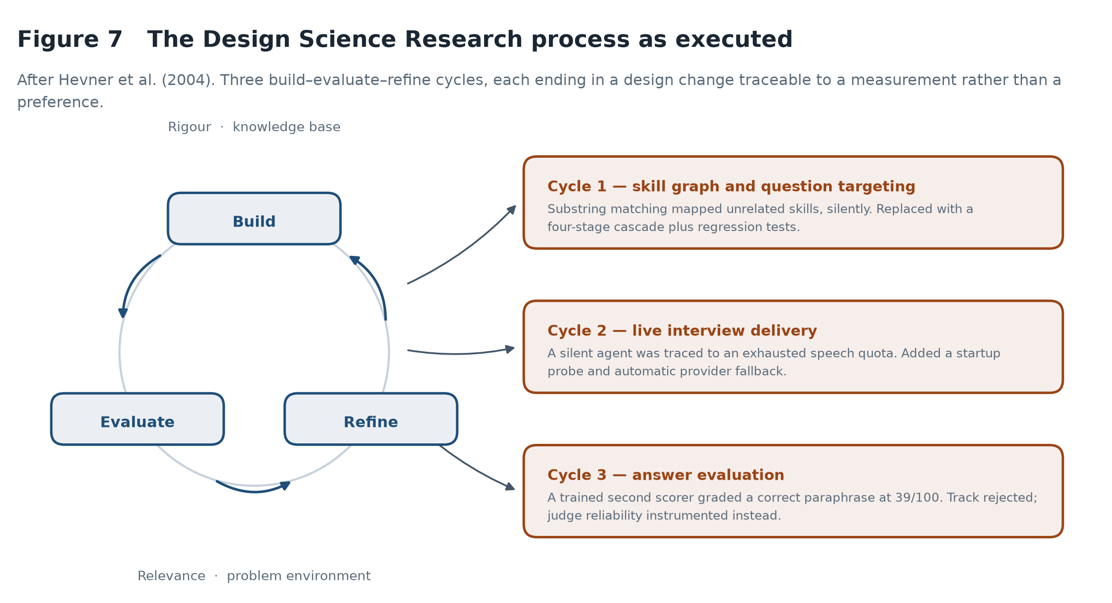
Figure 7 The Design Science Research process as executed, showing three build–evaluate–refine cycles and the design change each produced.
A purely experimental design was rejected because there was no system to hold fixed at the outset. It does describe Chapter 6 accurately, though: once the artefact stabilised, evaluation proceeded experimentally. DSR governs the project; controlled experiment governs its evaluation.

3.2 How the cycles ran in practice
Three design cycles are worth recording, because in each the evaluation stage produced a measurement that forced a change rather than confirming a decision already taken.
The first concerned skill matching: a substring fallback mapped “Team Leadership” onto the ESCO concept “R” and “Communication” onto “telecommunications engineering”, silently, while the gap analysis reported confident nonsense. The second concerned interview delivery, where the voice agent fell silent mid-session because an exhausted synthesis quota returns no audio while still accepting the connection. The third concerned answer evaluation, where measuring a trained second scorer exposed both a data leak in its training set and a circularity in the comparison it was meant to support, and ended the track. Sections 5.3.1, 5.5.2 and 7.2 give the evidence and the resulting design changes in full.

3.3 Evaluation strategy
Hevner et al. (2004) enumerate five families of DSR evaluation method. Three are used here, and each supports a different claim.
- Experimental — controlled experiments on the evaluation pipeline, reported in Chapter 6. These support claims about how the scorer behaves — whether it separates good answers from poor ones, whether presentation order moves it, whether paraphrase does.
- Testing — an automated unit test suite covering the deterministic components, and an end-to-end run exercising the full pipeline against a synthetic candidate. These support claims about correctness, not quality.
- Descriptive — a worked example carried through the whole system in Section 6.8, which demonstrates utility in a way that aggregate statistics cannot.
What is deliberately absent is criterion validity: no claim is made that scores predict job performance. Establishing that would require tracking hired candidates over months and is beyond any fourteen-week project. The evaluation treats the system as a measurement instrument and asks whether the instrument is stable and discriminating — necessary conditions for validity, not sufficient ones.

3.4 Data strategy
All evaluation data is generated rather than collected from people. This was a deliberate choice with a cost attached, and the reasoning should be stated plainly.
The proposal envisaged a validation set of roughly two hundred interview answers labelled by two independent human raters, plus pilot sessions with volunteers to fit the behavioural baseline. Both require ethical approval and participant recruitment. Within the project timeline, pursuing approval would have consumed the weeks that the implementation needed, and a rushed study with a handful of untrained raters would have produced a gold standard too noisy to support the agreement statistics it was meant to anchor.
The strategy adopted instead uses answers written to a specified quality level as the reference standard: for each question a strong, medium and weak answer, whose intended levels form an ordinal ground truth. This is weaker than human rating in one specific way — it measures agreement with an intended level, not with expert judgement — but it remains a real and falsifiable test. A scorer that cannot separate deliberately strong answers from deliberately weak ones has failed regardless of what a human rater would say.
Two measures reduce the circularity risk. The fixtures are generated by a different model from the one that grades them, so the judge is not simply recognising its own prose. And the reference answer each response is scored against is generated independently of the candidate answers, rather than being one of them — a precaution whose absence caused a measurable failure in the rejected classifier track, described in Section 7.2.

3.5 Alternative approaches considered
Four significant alternatives were considered and rejected, and the reasoning is set out here rather than left implicit.
A trained supervised classifier as a second scoring track was the original plan and is treated at length in Section 7.2. In summary, it was built, measured, found to rest on a circular comparison, and removed.
A fine-tuned transformer classifier trained end to end on answer text would likely outperform hand-crafted features, but was rejected on explainability grounds: a fine-tuned encoder offers no account of an individual judgement a non-specialist can read. A graph neural network over the skill graph was rejected because ESCO is already a curated hierarchy with explicit relations — learning embeddings over a documented structure adds opacity while removing the property that makes the graph useful in a high-risk system, that every edge traces to a published standard. A custom speech recognition model was rejected immediately: commercial recognition is near human parity for English, and building a worse one would consume the project without touching the research question.

3.6 Ethical considerations
No human participants were involved in this project, and no ethical approval was therefore sought. That is a limitation, discussed in Section 7.3, but it is also a deliberate reduction of ethical exposure: no personal data was collected, stored or processed at any stage.
Several ethical commitments are nonetheless built into the artefact. The system issues no hiring decision, only evidence for a person to act on. Video and audio are analysed in the browser and never transmitted, a data-minimisation measure in the sense the GDPR intends. The integrity module never returns an adverse verdict without naming the behaviours behind it, so a candidate can contest a finding. And scoring uses only what the candidate said, with no demographic input or proxy for one.
One tension deserves acknowledgement rather than resolution. Behavioural monitoring of any kind is intrusive, and a system that measures gaze direction and posture is making inferences about a person from signals they cannot fully control. Nervousness reads much like evasion. The mitigation adopted — weighting these signals lightly, calibrating them against the candidate's own neutral pose rather than an assumed ideal, and reporting them as context rather than as findings — reduces the harm but does not eliminate the objection. A production deployment would need explicit informed consent and a genuine opt-out.

3.7 Tools and development environment
The backend is Python 3.11 with FastAPI; the frontend is React with Vite. NetworkX holds the skill graph, LiveKit carries real-time audio, and MediaPipe Tasks Vision runs landmark detection in the browser. Gemini provides language model inference, Deepgram speech recognition, and ElevenLabs synthesis with Deepgram as fallback. scikit-learn supplies the Isolation Forest, SciPy the statistical tests, Matplotlib the figures. Version control is Git and testing is pytest. Section 4.9 assesses the significant choices critically rather than merely listing them.

3.8 Project execution
Figure 11 shows the schedule as delivered. Two departures from the plan submitted with the proposal are visible. Dissertation writing began in week 7 and ran alongside implementation rather than following it, which proved essential — the engineering decisions recorded in Chapter 5 were written up while the reasoning was still fresh. And the trained-classifier track occupies weeks 11 and 12 as a build-and-reject cycle rather than the build-and-compare originally scheduled.
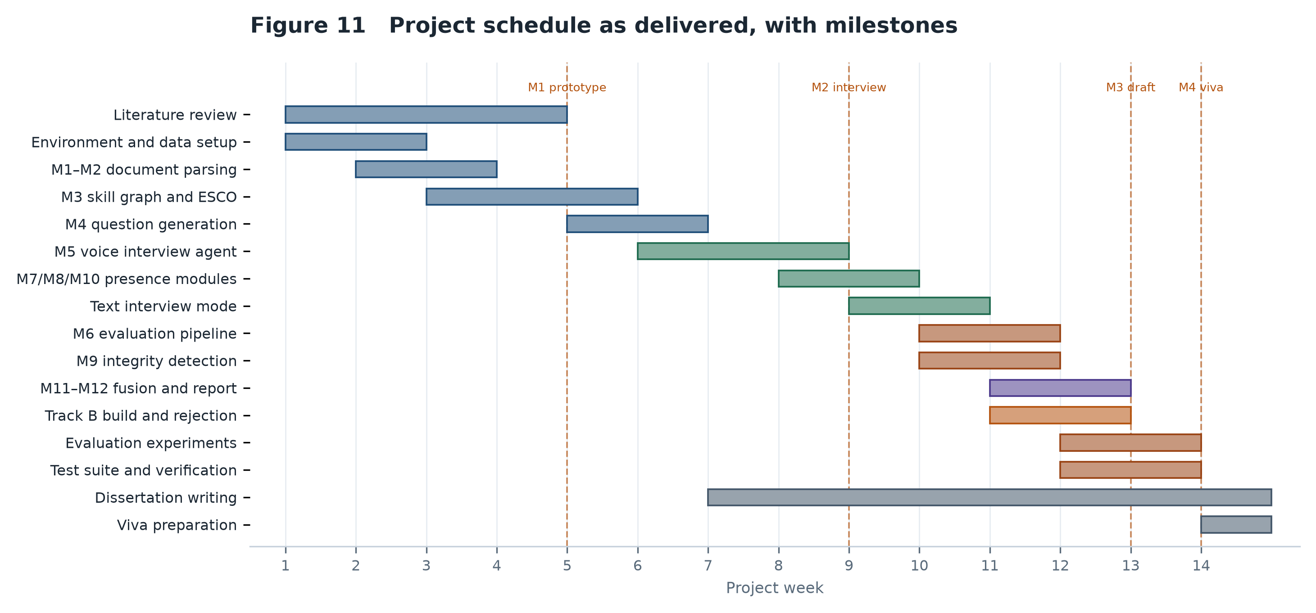
Figure 11 Project schedule as delivered, with the four milestones marked.

4. System Design

4.1 Architectural overview
The system is decomposed into twelve modules across four sequential phases. The decomposition is not decorative: each module declares its input and output, communicates only through those, and can be developed, deferred or replaced without disturbing its neighbours — the property that allowed a whole evaluation track to be removed late in the project without touching the rest.
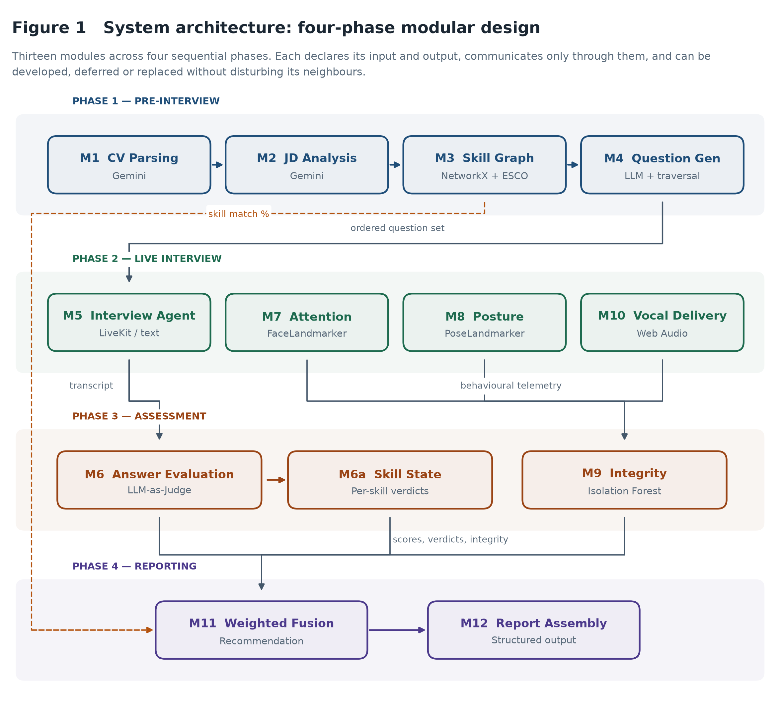
Figure 1 System architecture. Twelve modules across four sequential phases, with the inter-phase data dependencies shown explicitly.
Phase 1 turns unstructured documents into a targeted interview plan, Phase 2 conducts and observes the interview, Phase 3 assesses it, and Phase 4 reports. The phases are sequential in data dependency but not in development.
One decision visible in the figure deserves comment. The skill graph feeds both the question generator in Phase 1 and the fusion engine in Phase 4, shown as the long-range dependency on the left: it is not merely a preparation step, since CV-to-role match contributes a fifth of the final score in its own right.

4.2 Module decomposition
All thirteen modules were implemented. Appendix A lists each with its technology, its implementing file and its role. One deviates from the proposal: M10 was specified as a wav2vec2 emotion classifier and is implemented as browser-side prosodic analysis, for the reasons given in Section 7.2.2.

4.3 Data flow and interface contracts
Figure 2 traces a candidate's material through the system, from an uploaded CV to a scored recommendation.
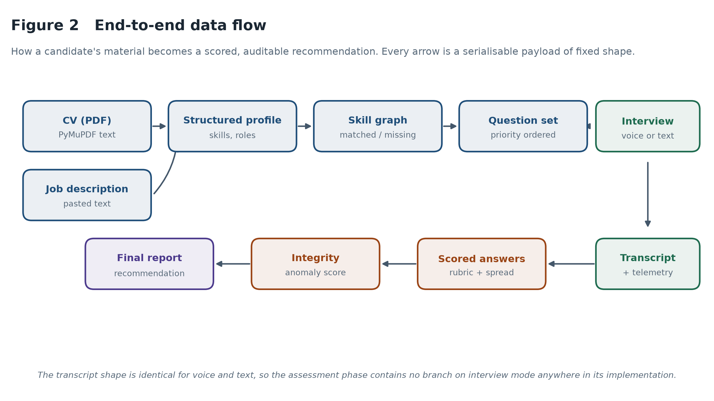
Figure 2 End-to-end data flow. Every arrow is a serialisable payload with a fixed shape, which is what allows modules to be tested in isolation.
The full interface contracts are tabulated in Appendix F. The most important is the transcript: a list of role-tagged utterances with timestamps. Both interview modes produce exactly this structure, which is why the assessment phase contains no branch on interview mode anywhere in its implementation.

4.4 Skill graph design
The skill graph is a directed graph whose nodes are skill concepts and category hubs, and whose edges are containment and the real broader-than relations published in ESCO. Candidate skills and role requirements are resolved onto it, and the set operations between the two populations yield the gap analysis.
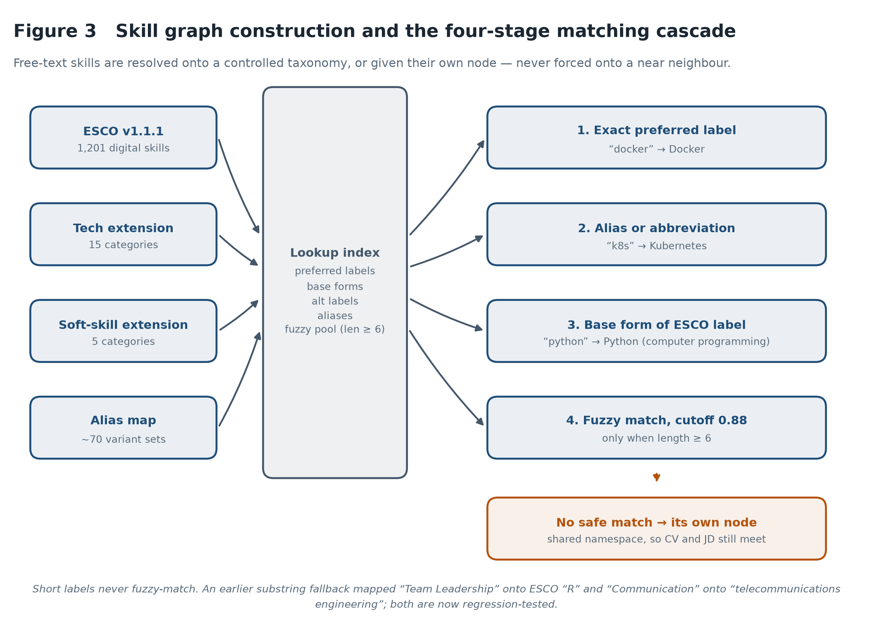
Figure 3 Skill graph construction and the four-stage matching cascade.
The design problem is not graph construction, which is mechanical, but mapping free text onto a controlled vocabulary. A CV says “k8s” where ESCO says “Kubernetes”; an advertisement says “strong communicator” where the taxonomy has “Communication”. Resolving these requires tolerance, whose failure mode is a false match — and a false match here produces a confident, specific and wrong claim that a candidate lacks a skill.
The cascade in Figure 3 is therefore deliberately conservative. Exact preferred-label matches are tried first, then curated aliases, then the base form of parenthesised ESCO labels so that “Python” reaches “Python (computer programming)”. Fuzzy matching is the last resort and is restricted to strings of at least six characters, at a similarity cutoff of 0.88. Short labels must match exactly or not at all, because fuzzy matching on two-character strings is meaningless — this is precisely how “Team Leadership” previously reached the ESCO concept “R”.
When nothing matches safely, the skill becomes its own node rather than being forced onto a neighbour. These unmatched nodes share one namespace across the CV and the job description, so a technology ESCO has never heard of still registers as a match when it appears on both sides. Refusing to guess is treated as the correct behaviour, not a shortcoming.

4.5 Question generation and graph traversal
The gap analysis produces a prioritised topic list: required skills the candidate does not evidence are high priority, skills claimed on the CV are medium priority and are probed to verify depth, and nice-to-have skills the candidate does hold are low priority. The question generator receives this list and produces a structured set with opening, technical, behavioural and closing sections.
The traversal step matters more than it first appears. A language model asked to generate questions returns them in whatever order it composed them, which correlates with nothing. Every interview has a time budget, and any question that falls off the end of that budget is a question never asked. The system therefore re-sorts the technical questions by the priority the graph assigned to their skill before the interview begins, so the budget is spent on genuine gaps first. This is the concrete content of Objective 2: question targeting is driven by the graph, not by the order the model happened to emit.

4.6 Interview transport design
Two delivery modes are supported. The voice mode conducts a spoken conversation over WebRTC; the text mode conducts the same interview as typed exchanges. They share the interviewer's instructions, the question bank, the question and time budgets, and the rules for redirecting an off-topic candidate and for closing the session. Only the transport differs.
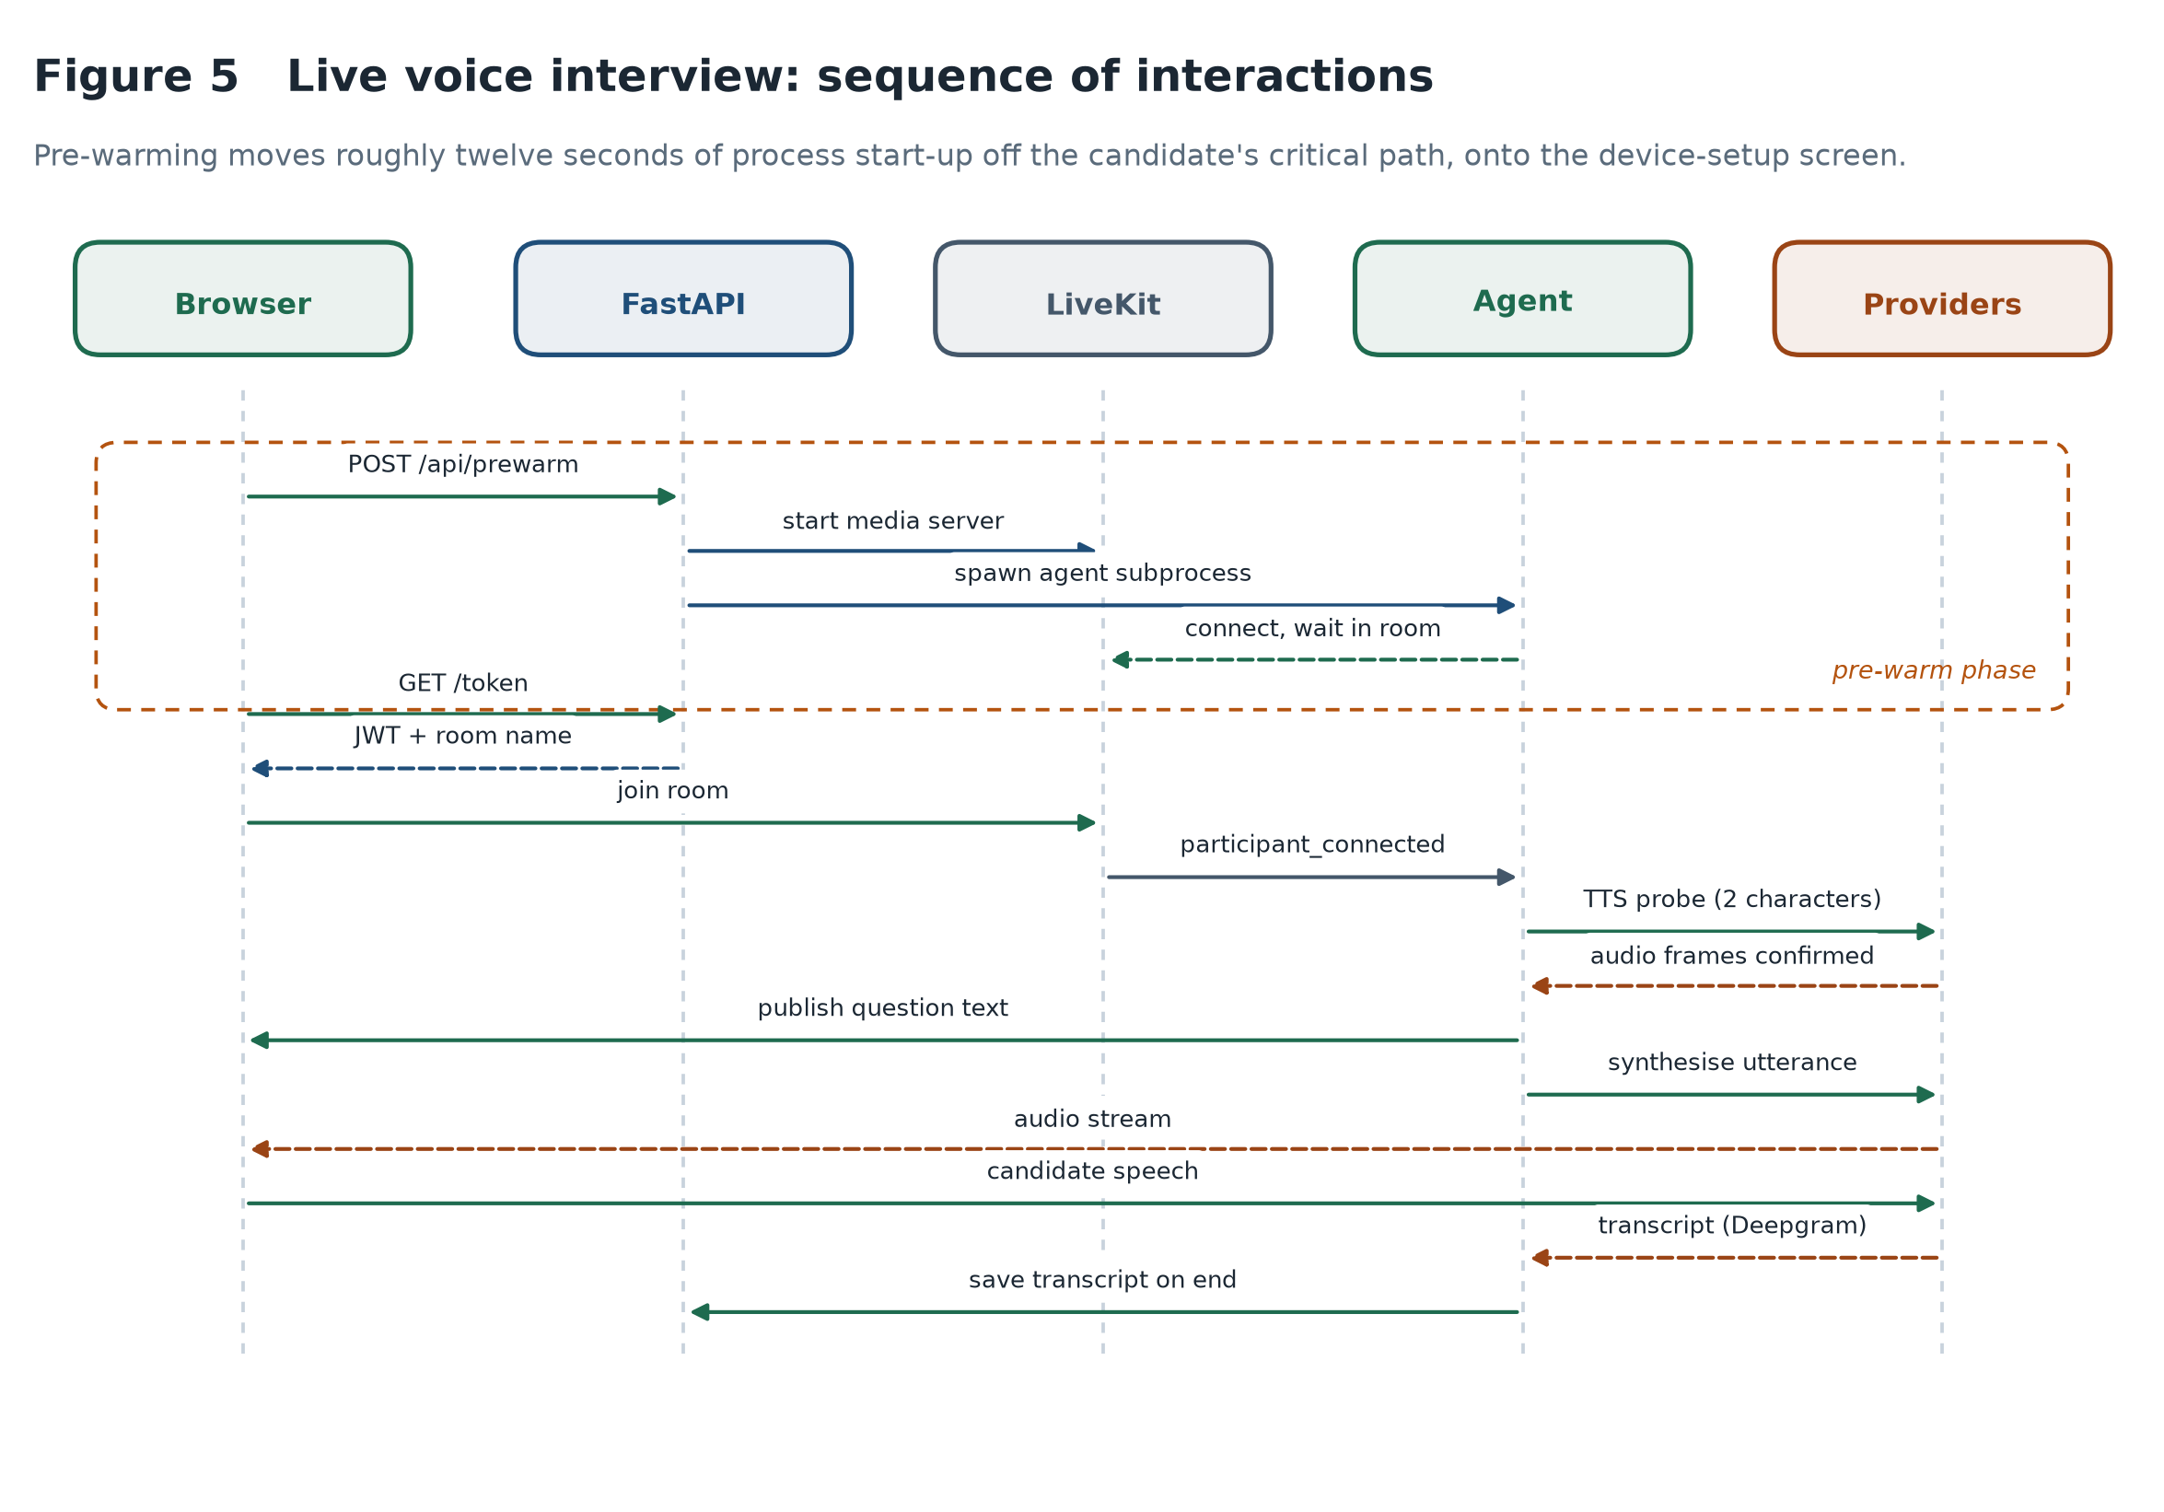
Figure 5 Sequence of interactions in a live voice interview, including the pre-warm phase that removes process start-up from the candidate's critical path.
Keeping one set of interviewer instructions shared between the modes is a design decision with a clear rationale: two copies would diverge the first time either was tuned, and the report would then be comparing candidates assessed under subtly different conditions. The mode-specific difference is confined to a single note about delivery — spoken replies must be short because the candidate is listening rather than reading.
The pre-warm phase shown boxed in Figure 5 addresses a latency problem rather than a functional one. Starting the media server and the agent subprocess costs roughly twelve seconds, most of it importing the agent framework and its plugins. Paid after the candidate presses “Begin Interview”, that is twelve seconds of silence at the most anxious moment of the session. Moving it to the device-setup screen, while the candidate is checking their camera, hides it entirely.

4.7 Evaluation pipeline design
Module 6 is the centre of the project's contribution, and its design follows directly from the conceptual framework in Section 2.6.
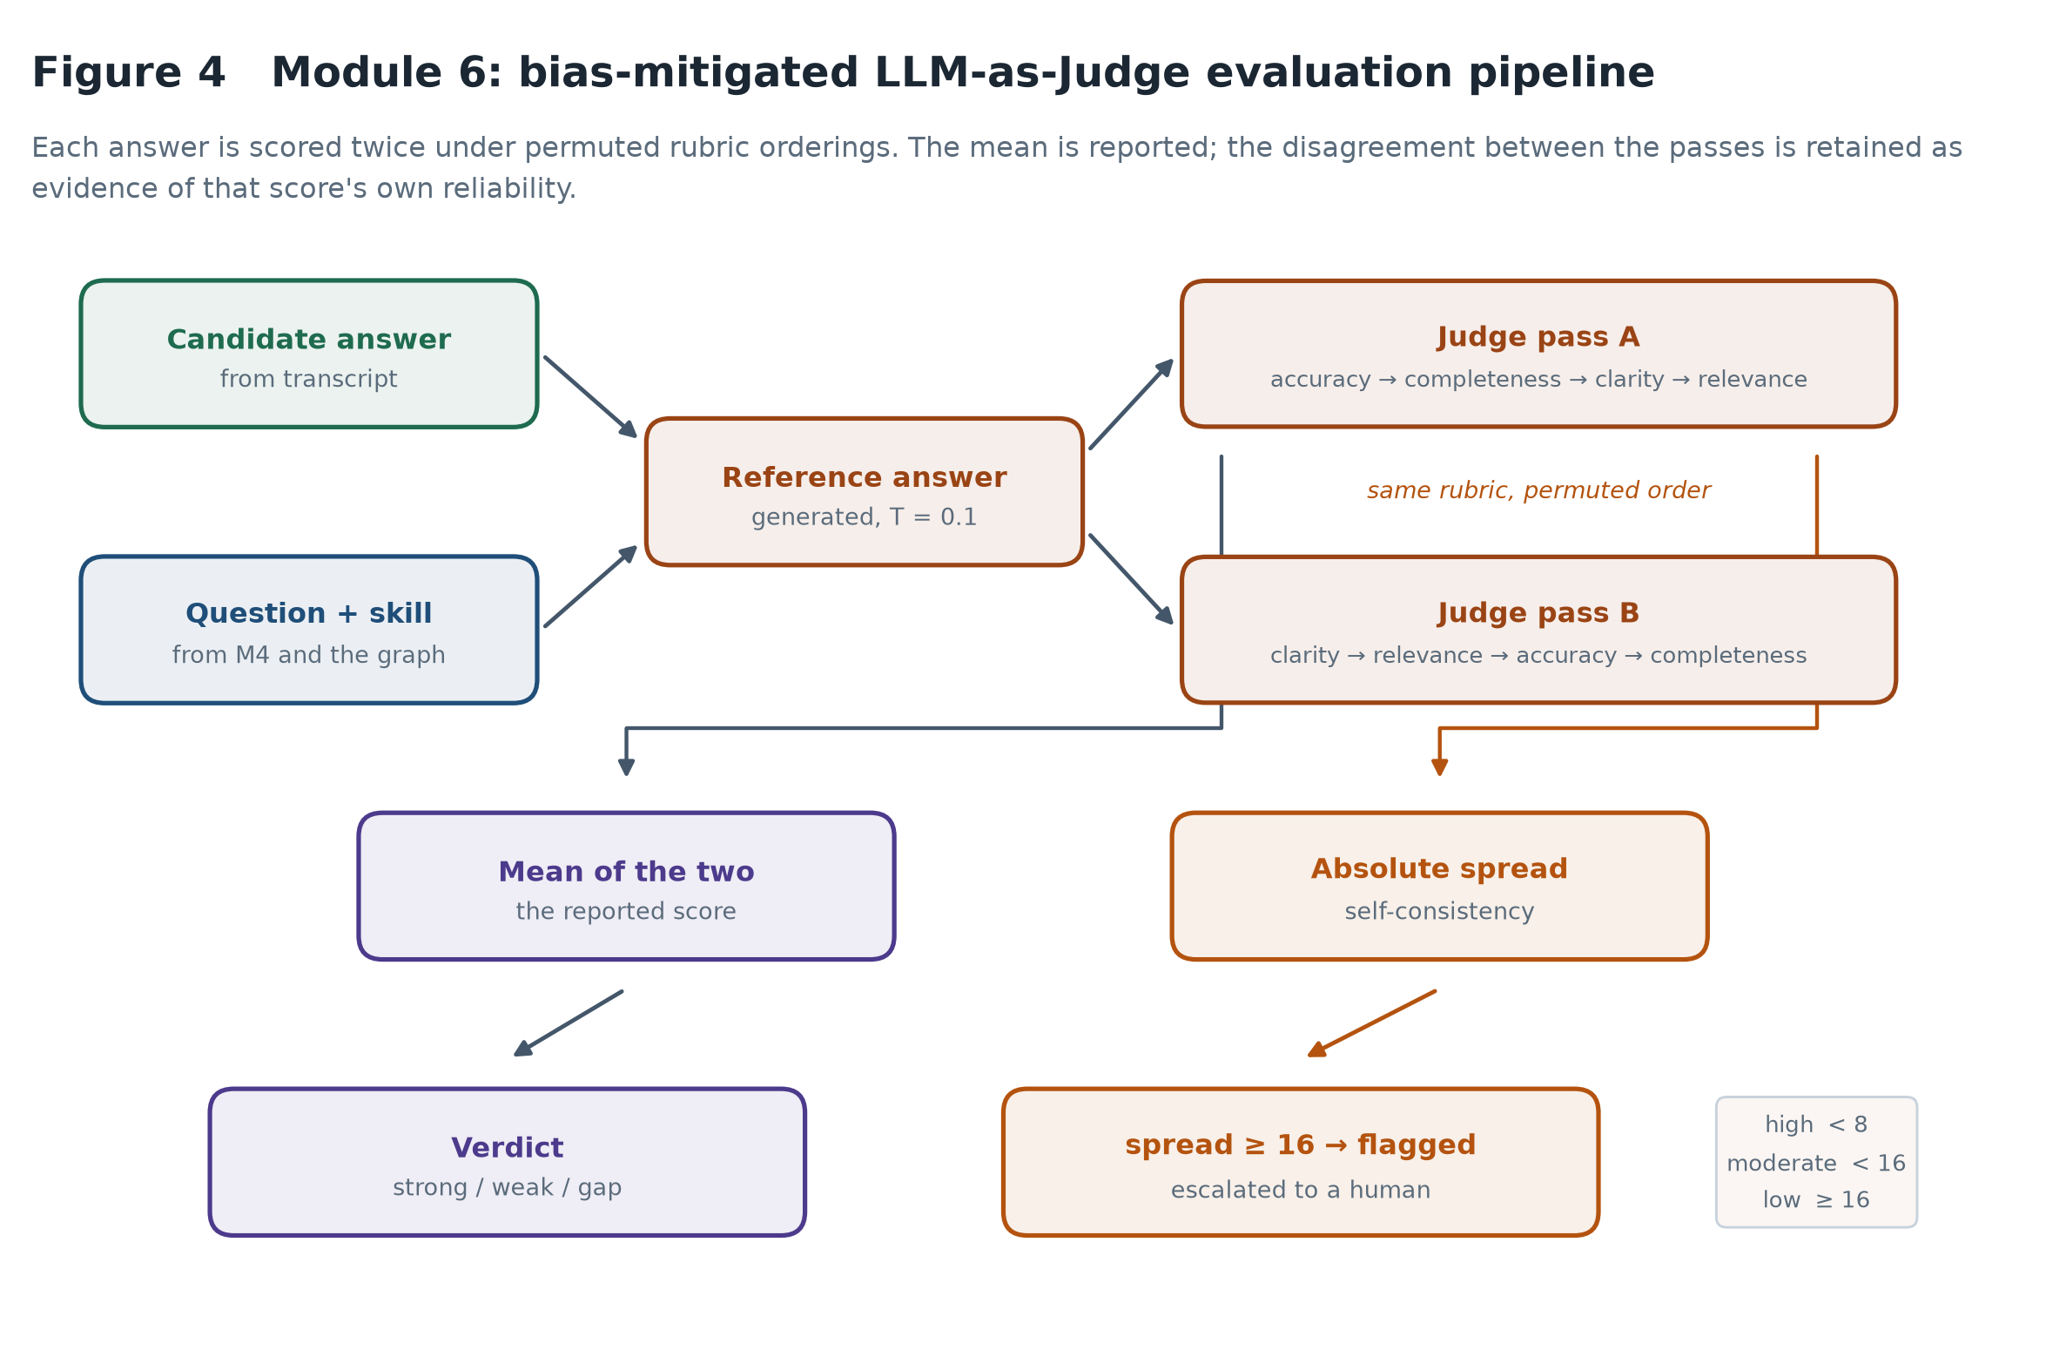
Figure 4 The evaluation pipeline. Each answer is scored twice under permuted rubric orderings; the mean is reported and the disagreement is retained as evidence.
Each answer is first paired with a reference answer generated for the same question, giving the judge a concrete standard rather than an abstract sense of quality. The reference is framed as what a strong answer covers, not a script to reproduce, because scoring by similarity to a fixed text penalises candidates who are right in their own words.
The answer is then scored twice against a four-criterion rubric, with the criteria presented in two different orders. Table 4 gives the criteria and the guidance attached to each.
Criterion | Marks | Scoring guidance
Technical accuracy | 0–25 | Deduct only for statements that are wrong or misleading. Omissions belong to completeness.
Completeness | 0–25 | Deduct only for genuinely important missing concepts. Brevity is not penalised.
Clarity | 0–25 | Is the answer well structured and easy to follow?
Relevance | 0–25 | Does it address the question actually asked?
Table 4 Rubric criteria and scoring guidance. The separation of accuracy from completeness is deliberate: a short answer containing nothing incorrect should score highly on the former and may legitimately score lower on the latter.
Averaging the two passes cancels the component of the score attributable to presentation order. The more useful output, however, is the disagreement between them. A judge that returns 82 and 81 for the same answer is stable; one that returns 71 and 45 is not, and the mean of 58 conceals that instability entirely. The spread is therefore retained, banded into high, moderate and low consistency, and answers in the low band are flagged for human review rather than reported as confident scores. This is the mechanism by which the system is accountable for its own reliability.

4.8 Fusion and reporting design
The fusion engine combines four components into a single recommendation. The weights, shown in Figure 6, are deterministic and published on the report itself.
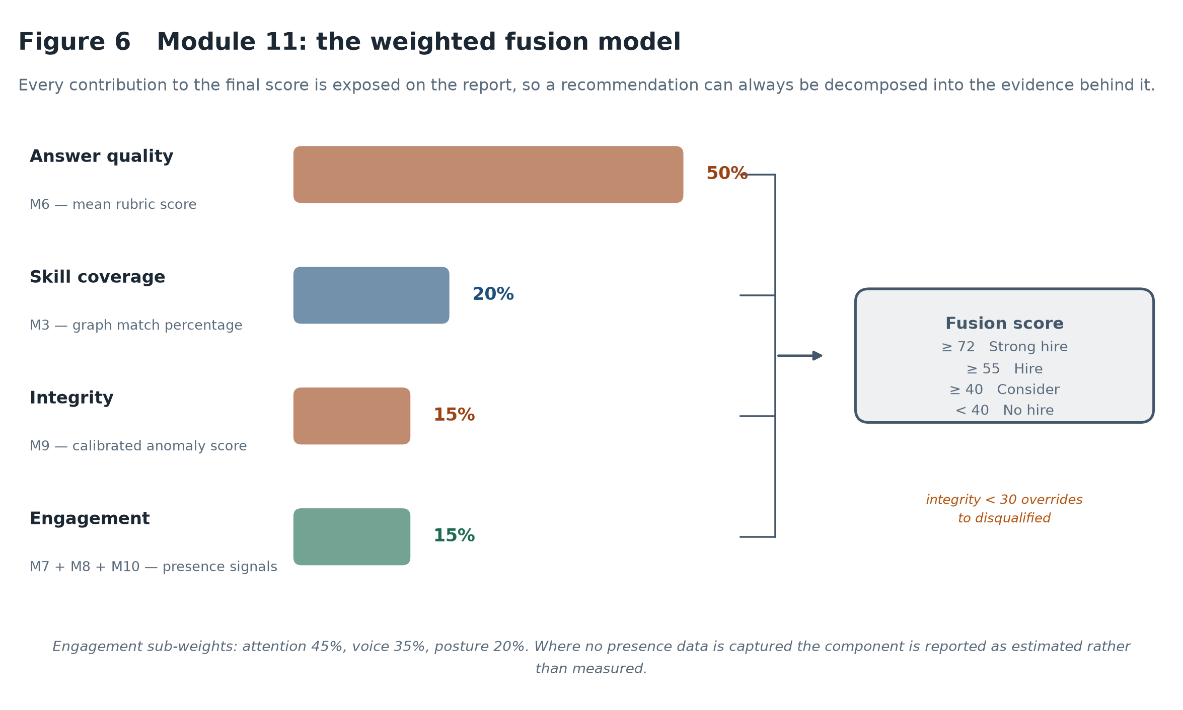
Figure 6 The weighted fusion model, with every component's contribution exposed.
The weighting reflects a judgement about evidential quality rather than convenience. What the candidate actually said carries half the score because it is the most direct evidence of competence available. Skill coverage carries a fifth: a CV is weaker evidence than a demonstrated answer, but it is not nothing. Integrity and engagement carry fifteen per cent each — deliberately low, because both rest on inferential signals that are easily misread.
One override exists. Where the integrity score falls below thirty, the recommendation is set to disqualified regardless of the other components, on the reasoning that a session whose conduct cannot be trusted yields answers whose provenance cannot be trusted either. This is the only place in the system where a module can override the others, and it is deliberately hard to trigger.
Every number on the report decomposes: each component's weighted contribution beside its raw score, the rubric breakdown and reference answer for every response, the judge's consistency band, and the behaviours behind any integrity finding. A recruiter should never encounter a number they cannot trace.

4.9 Critical assessment of the tools selected
Every significant tool choice carries a cost as well as a benefit, and Table 3 records both rather than presenting the stack as a series of obviously correct decisions.
Tool | Why selected | Weakness accepted
Gemini 2.5 Flash | Strong instruction-following, JSON-constrained output, generous free tier | Non-deterministic; a reasoning model, so latency and token cost are high; external dependency
ESCO v1.1.1 | Published EU standard; stable concept identifiers; explicit hierarchy | Predates the modern technology stack; sparse on soft skills; required extension
NetworkX | Simple, well documented, adequate for graphs of this size | In-memory only; would not scale to a multi-tenant deployment
LiveKit | Production-grade WebRTC; agent framework handles turn-taking and interruption | Heavy dependency; ~12 s process start-up; adds a server to the deployment
MediaPipe Tasks Vision | Runs in-browser, so no video leaves the device; no inference cost | Requires WebAssembly and ideally GPU; degrades on older browsers
Web Audio prosody (M10) | Fully inspectable features; no model download; offline | A proxy for emotion, not a classifier; weaker than a trained model at that task
Isolation Forest | Needs no labelled anomalies; fast; deterministic under a fixed seed | Baseline is synthetic; no measured false-positive rate against real sessions
Table 3 Strengths and weaknesses of the principal tools selected.
Two of these shaped results reported later. A reasoning model gives better rubric adherence but makes every score cost reasoning tokens, which is why Chapter 6 runs at a deliberately modest sample size. And the in-browser vision pipeline, chosen for privacy, produces nothing on an unsupported browser — so the fusion engine must distinguish a measured engagement score from an estimated one.

5. Implementation

5.1 Technology stack and repository structure
The implementation comprises approximately 4,500 lines of Python and 4,200 lines of JavaScript, excluding dependencies and generated assets. The backend is organised by module responsibility rather than by technical layer, so that the correspondence between the design in Chapter 4 and the code is direct: a reader looking for Module 6 finds it in core/evaluator/evaluator.py.
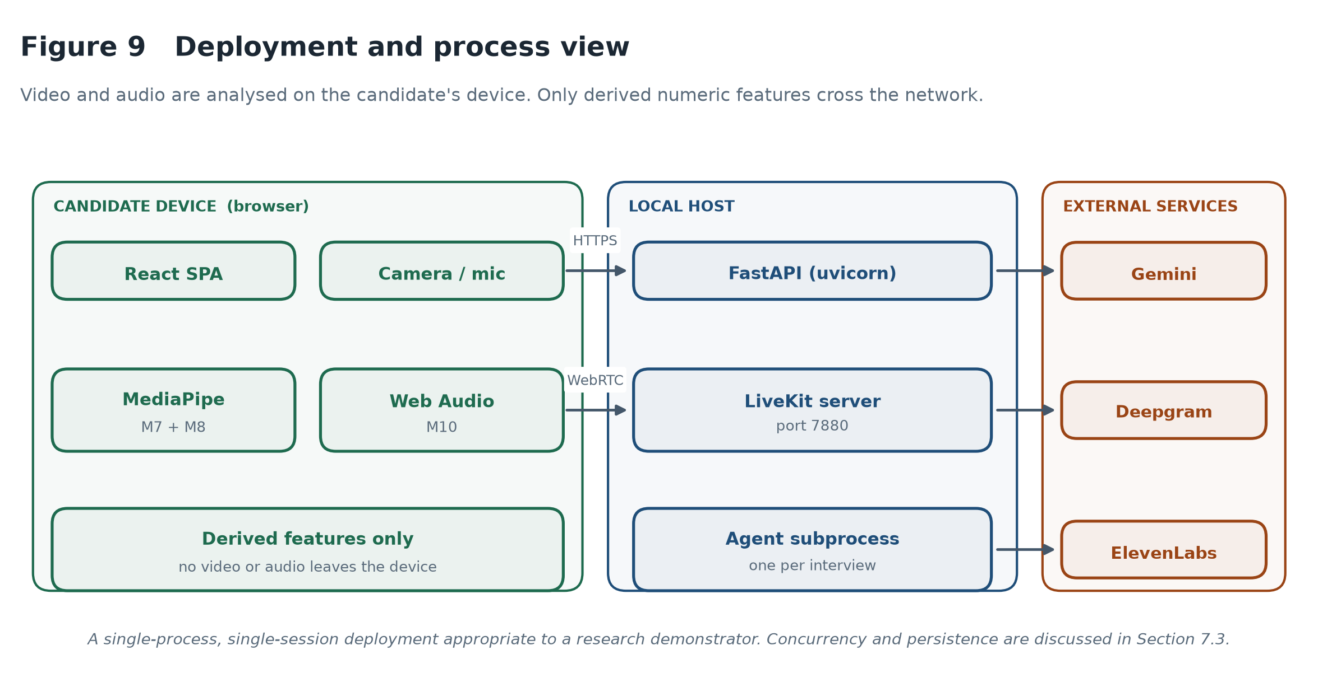
Figure 9 Deployment and process view. Video and audio are analysed on the candidate's device; only derived numeric features cross the network.
The deployment is single-process and single-session, which is appropriate for a research demonstrator and inadequate for anything else. Section 7.3 states the consequences explicitly rather than leaving them to be discovered.

5.2 Document understanding (M1, M2)
CV parsing extracts text from an uploaded PDF using PyMuPDF and passes it to the language model with a schema-constrained prompt requesting name, contact details, a summary, skills, experience, education and projects. Job description parsing follows the same pattern, extracting the role title, required and nice-to-have skills, responsibilities, seniority level, domain and expected experience.
The practical difficulty with schema-constrained generation is that models intermittently return malformed JSON — a trailing comma, an unterminated string, or the whole object wrapped in a markdown fence. Rather than failing the request, the client strips fences, attempts a strict parse, and falls back to a repair pass before giving up. This is unglamorous but it is the difference between a demonstrator that works and one that fails intermittently in front of an examiner.
Image-based PDFs yield no extractable text; the system reports this rather than attempting optical character recognition, which was out of scope.

5.3 The skill graph (M3)
The graph is constructed at request time from two ESCO CSV exports: the digital skills collection, providing 1,201 skill concepts with preferred and alternative labels, and the broader-relations file, providing the hierarchy. Category hubs are synthesised from the ESCO broader-concept field so that the interface can group skills meaningfully.
Two supplementary taxonomies extend ESCO where it is thin. A technology extension covers fifteen categories of modern stack — cloud platforms, containerisation, CI/CD, backend and frontend frameworks, databases, messaging, machine learning tooling, architecture patterns, version control, APIs, testing, data engineering and productivity software. A soft-skill extension covers five categories that ESCO addresses only sparsely. Extension labels deliberately take precedence over ESCO labels in the lookup index, because “Docker” is the recognisable form of the concept and an ESCO near-synonym is not.
An alias map of roughly seventy entries handles the abbreviations and spelling variants that appear on real CVs — k8s, postgres, nodejs, sklearn, ci/cd, amazon web services. Aliases are indexed separately from preferred labels and can never shadow an exact preferred-label match, which prevents a curated shortcut from overriding the taxonomy.

5.3.1 The matching failure and its correction
The first implementation added a substring fallback: if nothing else matched, any taxonomy label contained in the input string was accepted. This is superficially reasonable and was actively harmful. The single-character ESCO concept “R” is a substring of “Team Leadership”. “Telecommunications engineering” contains “communication”. The graph rendered without error and the gap analysis reported confident, specific and wrong conclusions.
The correction was to remove the fallback entirely and constrain fuzzy matching to strings of at least six characters at a 0.88 similarity cutoff, so that short labels must match exactly. Both original failures are now regression tests, asserting that “Team Leadership” resolves to a leadership concept and that “Communication” does not resolve to anything containing “telecommunication”.
The general lesson is one the dissertation returns to in Chapter 7: the dangerous failures in this system are the silent ones. An exception is visible. A plausible wrong answer is not.

5.4 Question generation and ordering (M4)
The generator receives the prioritised topics and produces a structured question set: two opening questions, two to three technical questions per high-priority topic, one to two per medium-priority topic, three behavioural questions in STAR format, and two closing questions.
The flattening step then re-sorts the technical questions by graph priority before the interview begins, so that high-priority gaps are asked first. Questions whose skill the graph does not recognise sort after graph-derived ones but before nothing, so they are not silently discarded. The unit tests assert this ordering directly, using a fixture in which the model's emission order is deliberately the reverse of the priority order.

5.5 The voice interview agent (M5)
The agent runs as a subprocess connected to a LiveKit room, orchestrating speech recognition, language model inference and speech synthesis. Three implementation problems were substantial enough to record.

5.5.1 Truncated speech
Piping the model's token stream directly into the synthesis socket produced audio that stopped after a few words while the full text continued to appear on screen. The solution was to buffer each complete utterance before synthesising it. This costs a little latency and buys two things: reliable audio, and control over ordering. The question is published to the interface first and spoken a fraction of a second later, so a candidate who mishears can read it.

5.5.2 The silent provider
More subtle was a failure in which the agent spoke the greeting and then went quiet. The synthesis provider's quota had been exhausted, and an exhausted quota accepts the connection and returns no audio frames — indistinguishable from success unless the frames are inspected. The fix was a startup probe that pushes two characters through the engine and confirms at least one audio frame comes back, before the interview begins. If it does not, the agent falls through to the alternative provider, and if neither works it runs in text-only mode with questions still displayed. The interview degrades rather than failing.

5.5.3 Process lifecycle on Windows
Terminating the agent subprocess did not stop it: the Python executable inside a virtual environment on Windows is a redirector that spawns a second process, so terminating the parent orphans the child, which stays connected and interferes with the next session. The fix was to terminate the whole process tree.

5.6 Text interview mode
Text mode implements the same interview over a request-response transport. The class holds the transcript, the elapsed clock and the question count, renders a bounded window of recent history into each prompt, and emits an end marker the server strips before display.
Two details matter. The transcript is structurally identical to the voice agent's, so the assessment pipeline requires no branch on mode; and the minimum question count is clamped never to exceed the maximum, without which a demonstration run configured for three questions would never reach its own limit. Text mode also enables an integrity signal unavailable in voice: a paste event in the answer box is recorded and surfaced on the report.

5.7 Answer evaluation (M6)
The pipeline pairs the transcript into question-and-answer exchanges, classifies each exchange, scores the substantive ones, and aggregates.
Pairing is less trivial than it appears. An interviewer may ask a question across two utterances; a candidate may answer across three. Consecutive turns from the same speaker are therefore merged, so a question split by a pause still produces one exchange. Trailing unanswered questions are dropped. Six unit tests cover these cases, including a candidate speaking before the interviewer.
Classification labels each exchange as technical, behavioural or logistics in one model call for the whole session. Logistics exchanges are excluded from scoring, because grading “Yes, ready” against a technical rubric produces a meaningless zero that drags down the average. A keyword fallback runs if classification fails, so evaluation never depends on it succeeding.
Scoring then proceeds as designed in Section 4.7: a reference answer is generated, the answer is judged twice under permuted rubric orderings, the mean is taken and the spread retained. One detail is worth noting. The judge is asked to return both the four criterion marks and their total, and the implementation trusts the criterion marks over the model's own arithmetic — if the stated total differs from the sum by more than two points, the sum is used. Language models are unreliable at addition in a way they are not unreliable at judgement.

5.8 Presence modules (M7, M8, M10)
Attention and posture are derived from MediaPipe landmarks in the browser. Attention uses geometric ratios — the horizontal and vertical offset of the nose from the eye midpoint, normalised by inter-eye distance — rather than the raw transformation matrix, because the ratios are stable across cameras and can be justified in writing.
Both are calibrated against a baseline captured while the candidate settles in, so the score measures deviation from that person's neutral pose rather than an assumed ideal that would encode whoever the developer had in mind.
Vocal delivery replaces the proposed wav2vec2 emotion classifier with prosodic analysis computed locally: root-mean-square energy, fundamental frequency by bounded autocorrelation restricted to the human speech range, and voiced-frame ratio. These aggregate into projection, fluency, expression and composure components. The substitution is defended in Section 7.2; in short, every component here is inspectable, which an emotion label is not.

5.9 Behavioural integrity (M9)
The integrity module derives eight features from session timing and telemetry and scores them with an Isolation Forest fitted to a synthetic baseline of four hundred normal sessions.
Two details determined whether the module was usable. The first is the definition of response time: the system measures from the question beginning to the answer completing, typically twenty to sixty seconds. An initial baseline assumed it meant thinking time, five to fifteen seconds, and flagged every ordinary session as anomalous. The second is calibration — the raw decision function is not a number a person can interpret, so the baseline's first and ninety-ninth percentiles are mapped onto fifty and one hundred at training time, and the bundle is versioned so that an uncalibrated one is refitted rather than silently reused.
Finally, the module never returns an adverse verdict without naming a reason. Where the aggregate pattern is anomalous but no single indicator crossed its threshold, it says exactly that. A flag a recruiter cannot act on is worse than no flag.

5.10 Fusion and report assembly (M11, M12)
Fusion is deliberately deterministic arithmetic rather than a learned combination. Each component is normalised to 0–100, multiplied by its weight, and summed, with the full breakdown returned alongside the total so the report can show its working. A unit test asserts that the component contributions reconcile with the reported total, which guards against the weights and the arithmetic drifting apart.
Engagement is assembled from whichever presence signals were actually captured, reweighted across the available sources, and marked as measured or estimated. A browser that could not run MediaPipe still yields a complete report, flagged honestly rather than silently defaulted.
Report assembly collects everything into one structure: overall score and recommendation, per-skill breakdown sorted worst first so gaps surface at the top, per-answer detail with the rubric breakdown and reference answer, the integrity assessment with its risk factors, and session-level judge reliability statistics.

5.11 Engineering problems encountered
Beyond those already described, three further problems are worth recording because each changed a design decision rather than merely costing time.
Interruption handling in the voice agent was initially disabled, on the reasoning that a candidate should not be able to talk over the interviewer. In testing this caused the framework to discard answers from candidates who began replying while the question was still being spoken — a natural conversational behaviour. Interruptions were re-enabled with a minimum duration and word count, so a cough does not interrupt but an answer does.
Answer-length thresholds were initially used to skip very short replies. This silently dropped genuine non-answers such as “I have not used that” from the report, which is exactly the evidence a recruiter needs. The threshold now excludes only replies too short to carry any assessable content, and every substantive answer is scored on its merits however brief.
Finally, the endpoint's concurrency behaviour proved counter-intuitive: one sequential call completed in 2.3 seconds while six issued concurrently took 273.8 seconds in total. The harness was changed to run serially, and the measurement is recorded in the code so the parallelism is not naively reintroduced.

6. Evaluation and Results

6.1 Experimental design
Five controlled experiments evaluate the scoring pipeline, each isolating one property by manipulating a single factor while holding the rest constant.
# | Property tested | Manipulation | Statistic
E1 | Discriminant validity | Answer quality varied across three intended levels | Spearman's rho, quadratic weighted Cohen's kappa
E2 | Positional-bias sensitivity | Rubric criterion order permuted, content held constant | Wilcoxon signed-rank, mean absolute spread
E3 | Paraphrase invariance | Wording varied, semantic content held constant | Within-group standard deviation
E4 | Criterion independence | None — observational across all scored answers | Pearson correlation matrix
E5 | Verbosity sensitivity | Contentless filler appended, content held constant | Wilcoxon signed-rank on paired differences
Table 6 Experimental design summary.
The corpus comprises 6 technical questions, each with answers written at three intended quality levels, giving 18 graded answers. Every answer is scored twice, once under each rubric ordering, so E1, E2 and E4 all draw on the same 18 × 2 judge calls. E3 and E5 reuse their baselines from E1 rather than rescoring identical text.
The run consumed 68 API calls with 1 error, over 39 minutes of wall-clock time. Fixtures were generated with a non-reasoning model and all judging performed with the model the deployed system uses, so the measurements describe the system as built rather than a proxy for it.
The sample is deliberately modest: judging uses a reasoning model, each answer costs two calls, and the endpoint throttles concurrency severely. Section 6.10 states the consequence for interpretation.

6.2 Discriminant validity
The first question is whether the judge can tell a good answer from a bad one. Answers written at three intended quality levels were scored without the judge being told which was which.
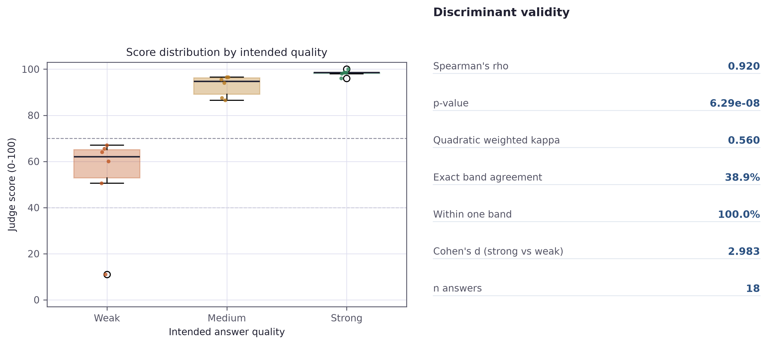
Figure 12 Score distribution by intended answer quality, with the band thresholds the system uses for its verdicts marked.
On rank ordering the result is excellent. Spearman's rho between intended quality and awarded score is 0.920 (p < 0.001), and Cohen's d separating strong from weak answers is 2.98 — a very large effect. A Mann-Whitney test confirms the ordering is not chance (p = 0.002). Within this corpus the judge almost never places a weaker answer above a stronger one.
Intended quality | n | Mean score | SD | Range
Strong | 6 | 98.25 | 1.29 | 96.0 – 100.0
Medium | 6 | 92.75 | 4.56 | 86.5 – 96.5
Weak | 6 | 53.00 | 21.41 | 11.0 – 67.0
Table 7 Discriminant validity results by intended quality level.
The categorical agreement figures tell a very different story, and this is the most significant finding of the evaluation. Quadratic weighted Cohen's kappa is only 0.560, and exact agreement between the intended level and the band the system assigns is just 38.9%. Every answer fell within one band of its intended level, so nothing is wildly misplaced — but the bands themselves are wrong.
The cause is visible in Table 7. The judge is systematically lenient. Answers written to be deliberately weak averaged 53.0, partially correct answers averaged 92.8, and strong answers averaged 98.2. Almost the entire working range of the scale sits above 50, and the medium and strong distributions overlap: the highest medium answer scored 96.5 while the lowest strong answer scored 96.0.
This has a direct and damaging consequence for the deployed system. The verdict layer labels any answer at or above 70 as strong. On this evidence, deliberately partial answers clear that threshold comfortably, so medium and strong answers receive the same verdict. The scoring model ranks candidates well and the verdict layer then discards most of that resolution.

6.3 Threshold calibration
Because the ordering is sound and only the thresholds are wrong, the defect is correctable in principle. Table 8 contrasts the thresholds in use with the boundaries the observed distributions imply.
Boundary | In use | Midpoint of adjacent means | Widest observed gap
Weak / medium | 40 | 72.9 | 76.8 (max weak 67.0, min medium 86.5)
Medium / strong | 70 | 95.5 | none — the distributions overlap
Table 8 Current thresholds against empirically implied boundaries.
A clean separator exists between weak and medium answers at approximately 77, nearly double the threshold currently in use. No separator exists between medium and strong, because those distributions overlap: on this corpus the judge cannot reliably distinguish a partially correct answer from an excellent one in absolute terms, only in relative ones.
The thresholds were deliberately not changed on the strength of this run. Eighteen answers across six questions is far too small a sample on which to move a decision boundary affecting every future candidate, and fitting thresholds to this corpus would be precisely the overfitting criticised elsewhere in this dissertation. What the result does establish is that the current values are indefensible, and that recalibration against a larger human-anchored corpus is the highest-priority next step.
The deeper implication concerns what the score means. A judge that ranks well but calibrates poorly is a comparative instrument, not an absolute one: it supports the claim that one candidate answered better than another, not that a candidate scored 92 and therefore meets a standard.

6.4 Positional-bias ablation
Stureborg et al. (2024) report that language model judges score identical content differently depending on presentation order. Every answer here was scored under two rubric orderings to test whether that effect is present and how large it is.
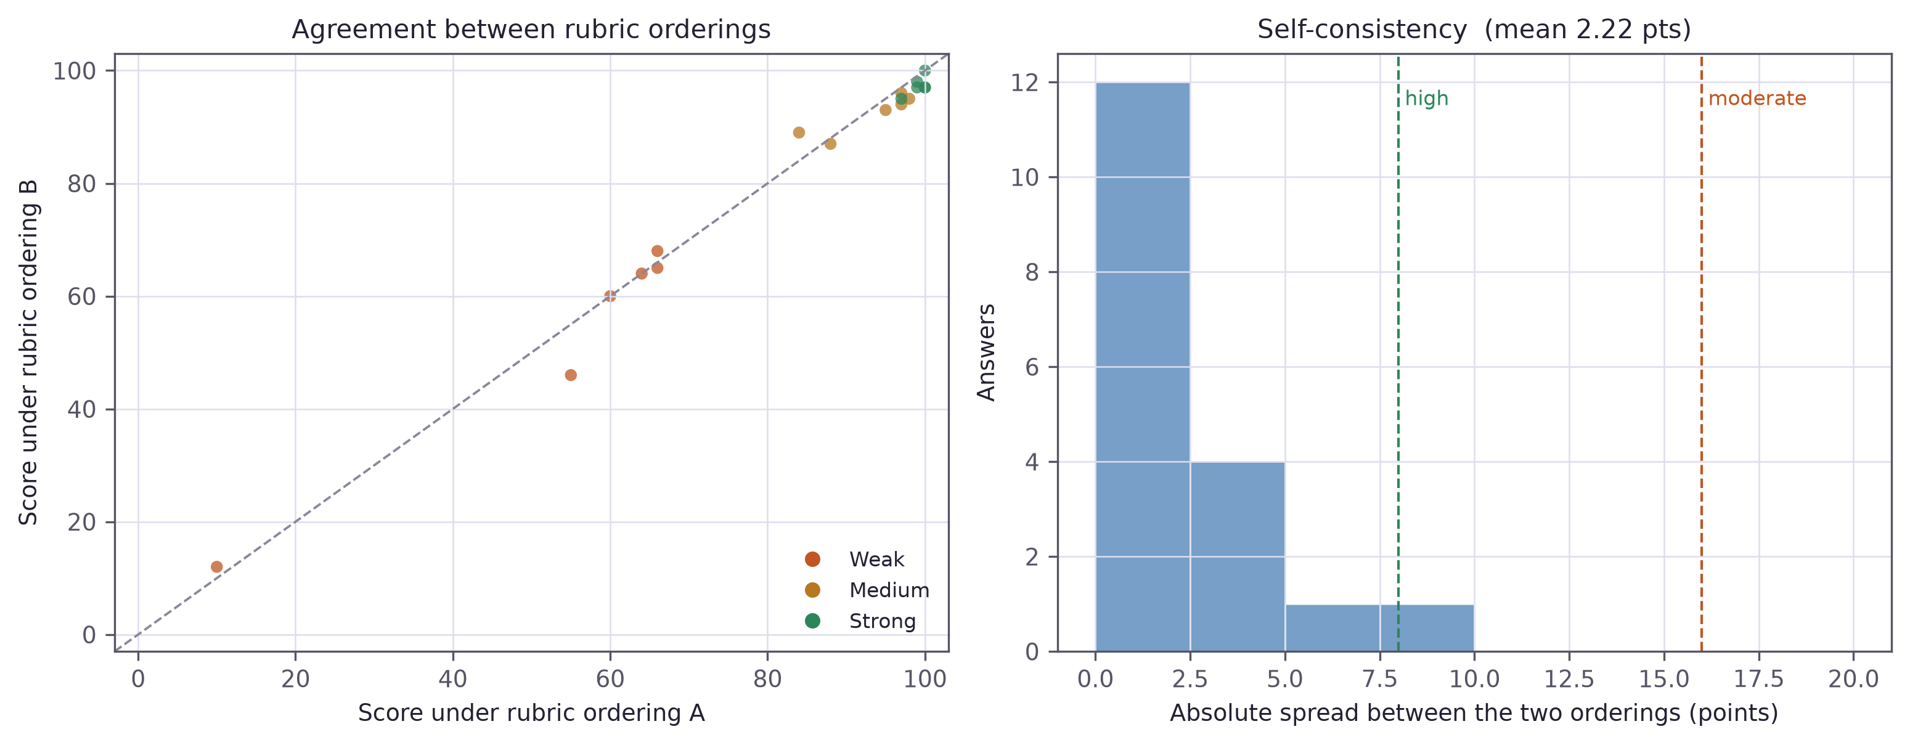
Figure 13 Left: agreement between the two rubric orderings. Right: distribution of the absolute spread between them, with the consistency thresholds marked.
Across 18 answers the mean score under ordering A was 81.94 and under ordering B 80.72, a mean signed difference of +1.222 points favouring ordering A. A Wilcoxon signed-rank test gives p = 0.067, short of the conventional threshold. The direction is consistent enough to be suggestive and the sample too small to settle it.
Measure | Value
Answers scored under both orderings | 18
Mean signed difference (A − B) | +1.222 points
Mean absolute spread | 2.22 points
Median absolute spread | 2.00 points
Maximum absolute spread | 9.0 points
Wilcoxon signed-rank | p = 0.067
High consistency (spread < 8) | 17
Moderate consistency (8 – 16) | 1
Low consistency (spread ≥ 16) | 0
Escalated to human review | 0.0%
Table 9 Positional-bias ablation results.
Per-item instability is small on this corpus. The mean absolute spread between the two orderings was 2.22 points and the largest observed was 9.0. 17 of 18 answers fell in the high consistency band, one in moderate, none in low. No answer was escalated to human review.
That is a null result for the escalation mechanism, and it is reported as one rather than dressed up as a success. The instrumentation is justified by the literature and is demonstrably operative — the spread is computed, banded and acted upon for every answer — but on this corpus it never needed to fire. Two readings are possible and these data cannot separate them. Either the countermeasure works and the averaging is doing its job, or machine-written answers are unusually easy to score consistently and real transcribed speech would produce wider spreads. The worked example in Section 6.9 is weak evidence for the second reading.

6.5 Paraphrase invariance
A candidate who expresses the same understanding in different words should receive the same score. This experiment rewrote answers preserving technical content while changing wording, sentence structure and order of presentation.
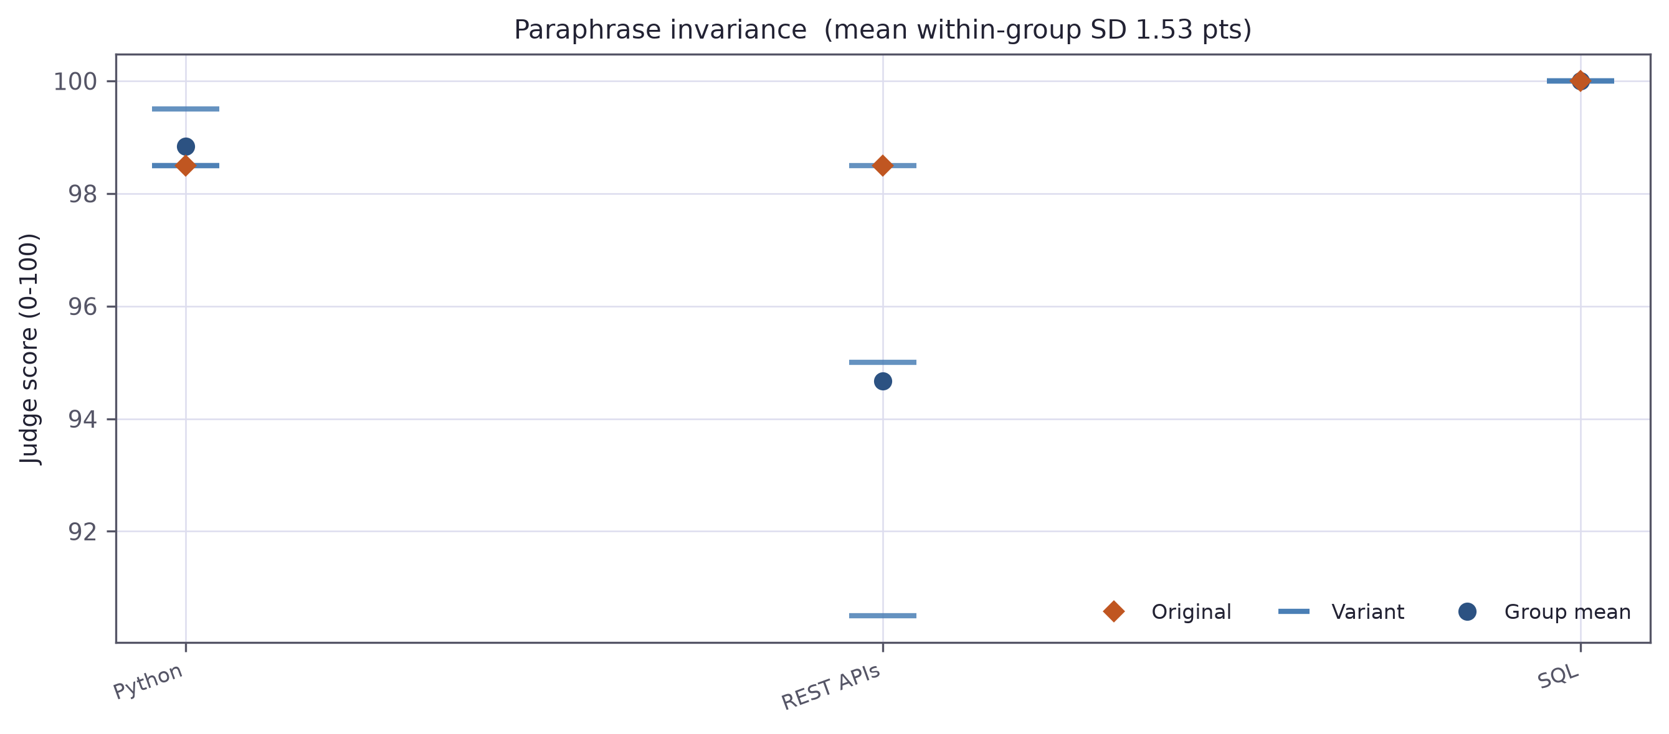
Figure 14 Scores across semantically equivalent rewrites of the same answer.
Across 3 groups the mean within-group standard deviation was 1.53 points, with a maximum of 4.01 and a mean within-group range of 3.00 points. In absolute terms this is reassuring: rewording an answer moves its score by only a point or two.
The comparison that matters is against the between-group standard deviation of 2.80 points. Within-group noise is therefore roughly half the between-group signal, which sounds poor until one notes why: all three groups used strong answers, and Section 6.2 showed strong answers compressed into a four-point range. The between-group figure is small because the ceiling effect crushed it, not because the judge cannot discriminate. A cleaner version of this experiment would draw groups from across the quality range rather than from the top of it — a limitation that follows directly from reusing the E1 strong answers to conserve API calls.
Question group | Variants | Mean | SD | Range
REST APIs | 3 | 94.67 | 4.01 | 8.0
Python | 3 | 98.83 | 0.58 | 1.0
SQL | 3 | 100.00 | 0.00 | 0.0
Table 10 Paraphrase invariance by question group.

6.6 Criterion independence
The rubric instructs the judge to score four criteria independently and states explicitly that a weakness in one must not drag down the others. Whether it complies is an empirical question, and the answer here is largely that it does not.
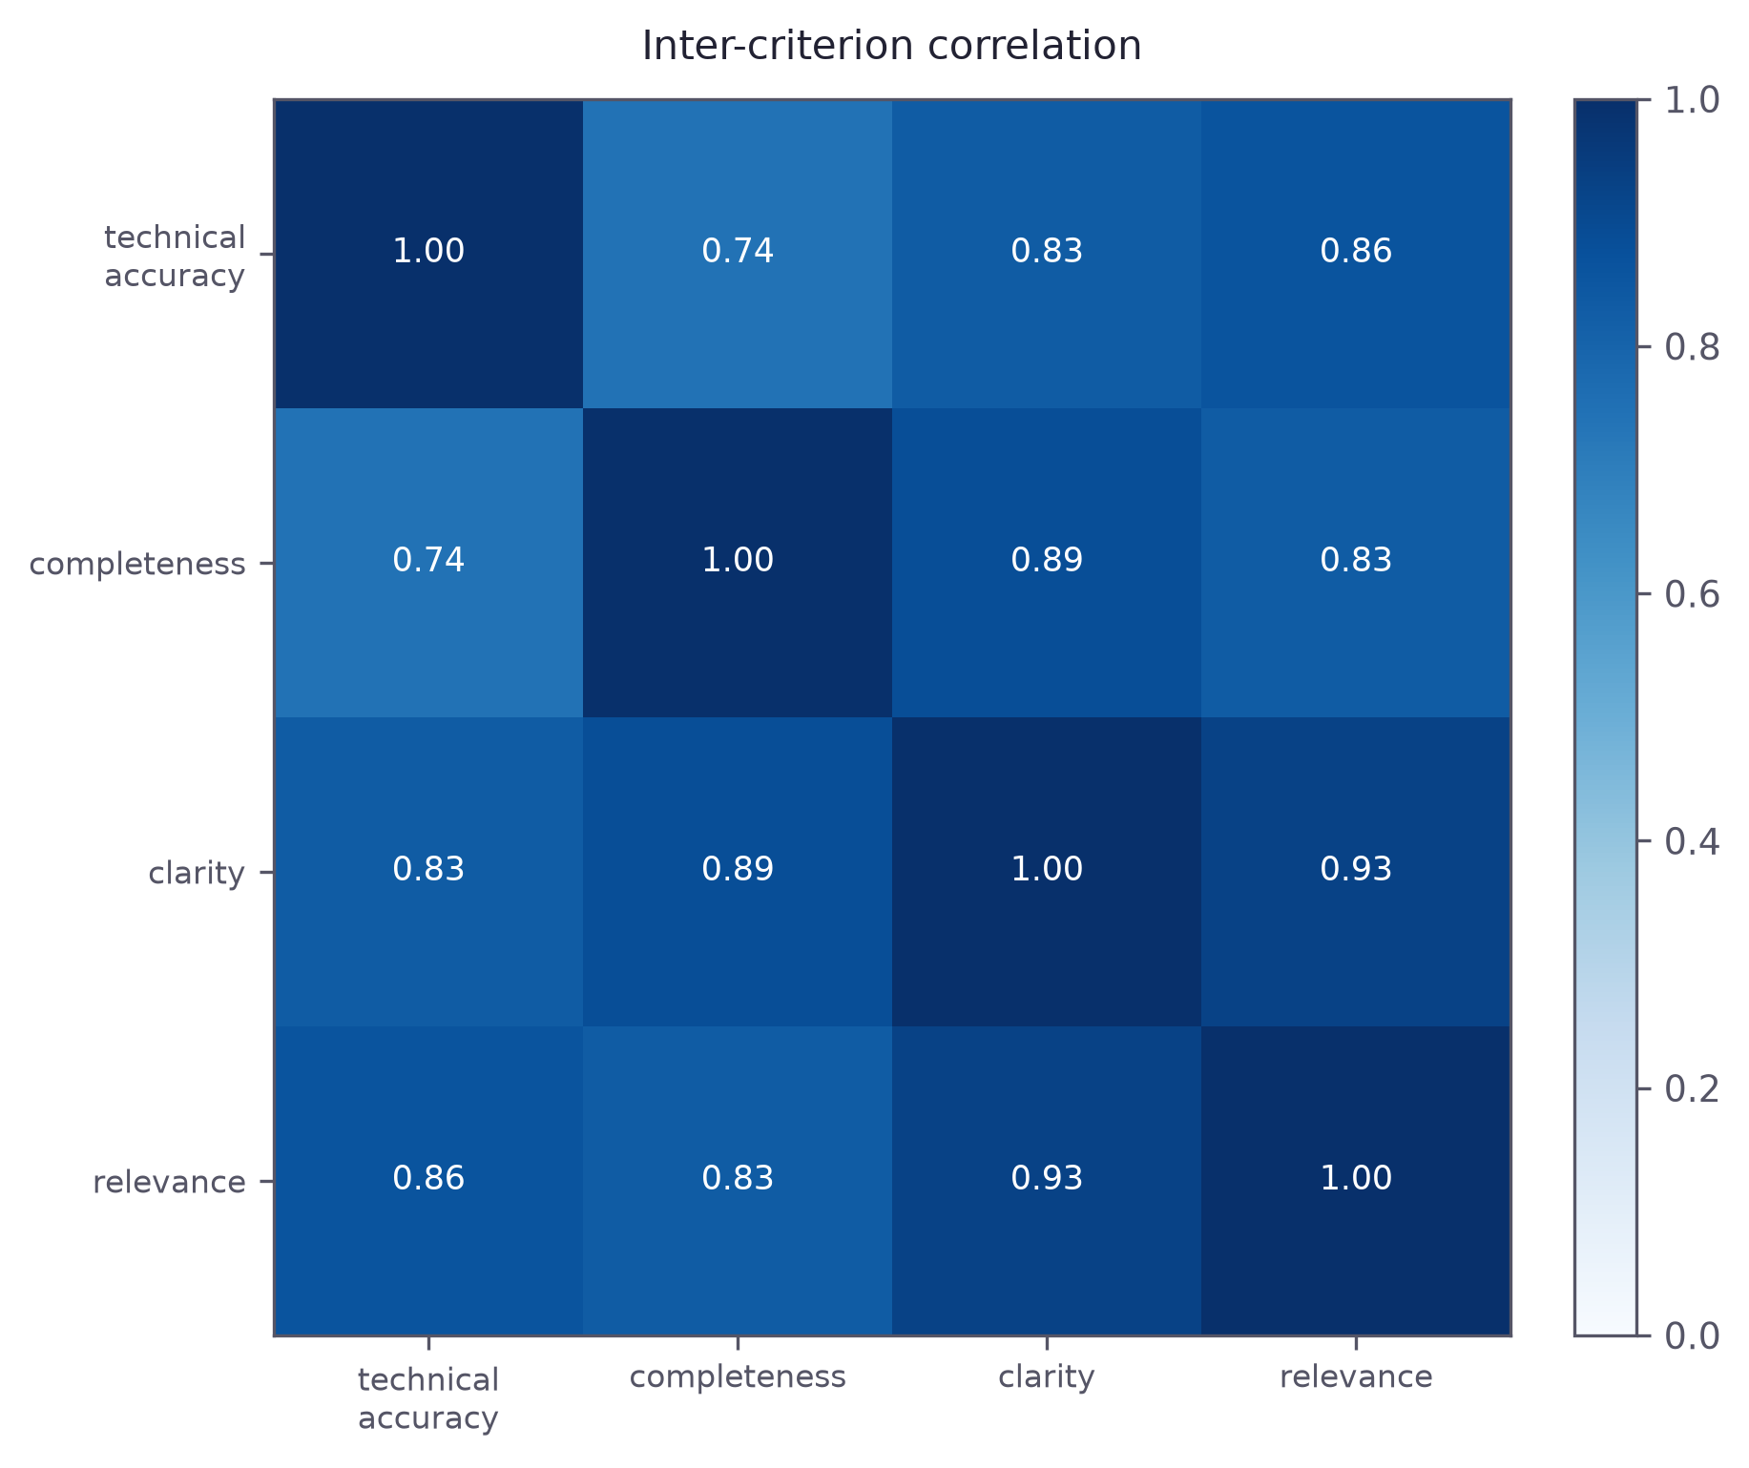
Figure 15 Correlation matrix between the four rubric criteria across all scored answers.
The mean inter-criterion correlation was 0.846, ranging from 0.744 to 0.928. The most strongly associated pair was clarity / relevance at r = 0.928; even the most independent pair, technical_accuracy / completeness, correlated at r = 0.744.
Some correlation is expected and legitimate. Answers that are technically accurate do genuinely tend to be more complete, because both follow from understanding the material, and no rubric could or should force them apart. But correlations in this range indicate that the four scores carry substantially less than four pieces of information. The judge appears to form an overall impression and then distribute it across the criteria — the classic halo effect described in the human rating literature, evidently not eliminated by instructing a model against it.
This qualifies a claim made in Chapter 4. The per-criterion breakdown was defended as an explanation mechanism telling a candidate which aspect of their answer fell short. That defence is weaker than it appeared: if the four marks move together, the breakdown communicates one impression four times rather than decomposing it. It retains value as a record of what the judge was asked to weigh, and the most independent pair does show real separation, but it is not the diagnostic instrument the design assumed. Section 8.3 proposes scoring each criterion in a separate call, so that each is formed without sight of the others.

6.7 Verbosity probe
Wang et al. (2024) report that language model judges reward length independently of substance. The rubric instructs explicitly against this. The probe appends contentless filler to good answers and rescores them.
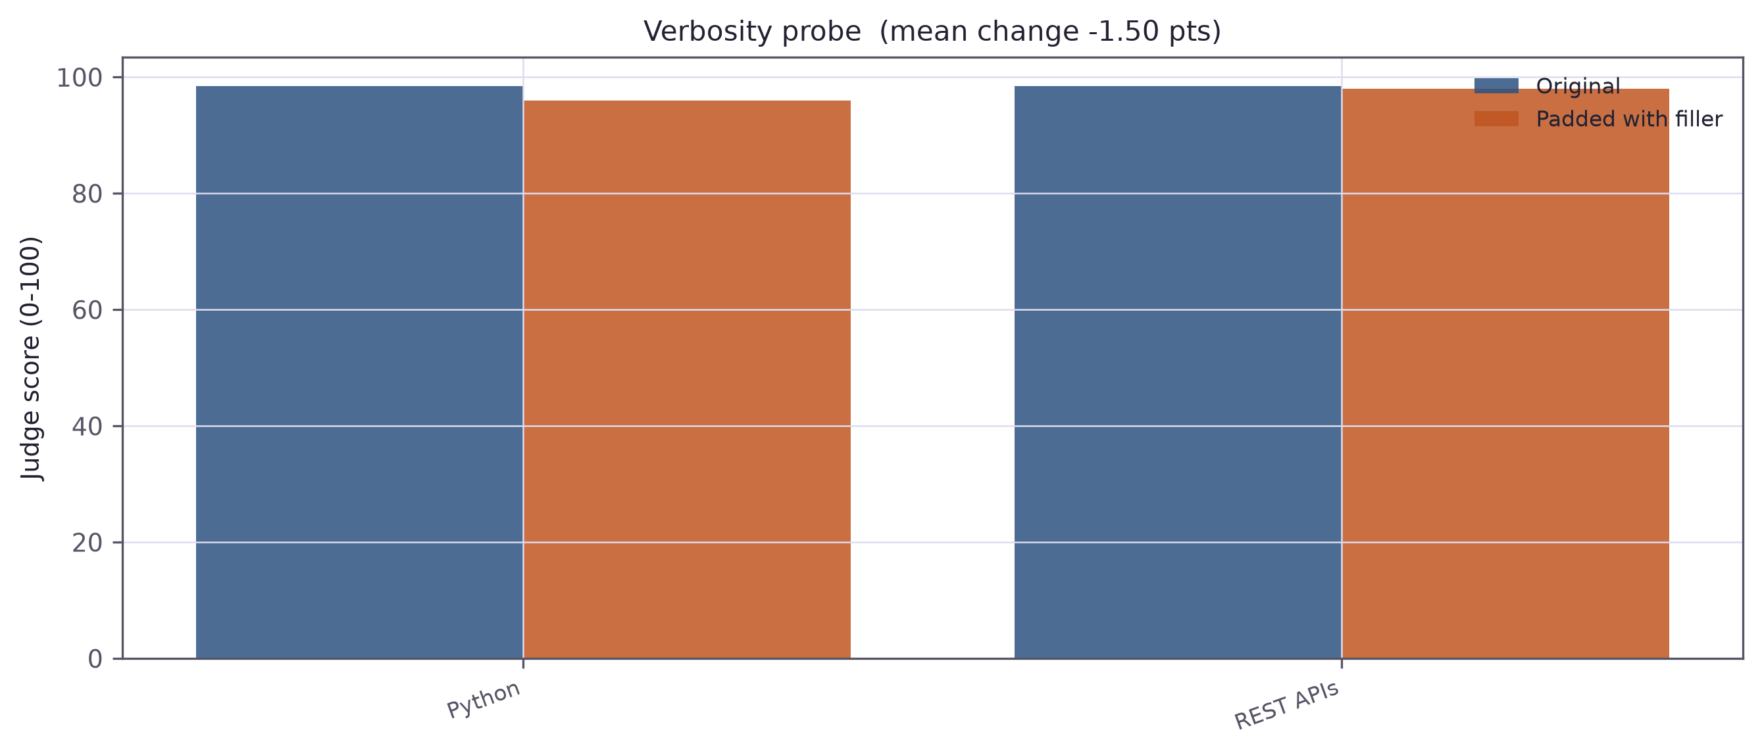
Figure 16 Original and padded versions of the same answers.
Across 2 usable pairs the mean change from padding was -1.50 points, with 0 scores rising and 2 falling. A Wilcoxon signed-rank test gives p = 0.500.
No conclusion can responsibly be drawn from 2 pairs — a third was lost to an API timeout during the run, and the test has essentially no power at this size. The direction is at least not adverse: padding raised no score, and both moved slightly down. The probe is reported for completeness and because the harness supports it, not because it establishes anything. A properly powered version using plausible redundant elaboration rather than obvious filler is proposed in Section 8.3.

6.8 System-level verification
Separately from the scorer, the artefact was verified as software.
A unit test suite of 72 tests covers the deterministic components: skill normalisation and the matching cascade, gap analysis and the set operations behind it, graph-priority question ordering, transcript pairing including the merge and drop cases, integrity feature derivation and calibration, the fusion weights and their arithmetic reconciliation, per-skill state transitions and report assembly. All 72 pass. Two are direct regressions on the matching failures described in Section 5.3.1.
An end-to-end run additionally exercises the full pipeline against a synthetic candidate and job description, using live model calls at every stage. It asserts that the graph builds, that gap analysis is coherent, that questions are generated and ordered by priority, that logistics exchanges are excluded from scoring, that rubric criteria remain in range and sum to the reported score, and that fusion contributions reconcile with the total. It passes.

6.9 A worked example
Aggregate statistics do not convey what the system produces. This traces one interview end to end. The candidate is a synthetic backend engineer with four years of Python experience; the role is a senior backend position requiring Python, Kubernetes, PostgreSQL, REST APIs, microservices and AWS.
The skill graph resolved the candidate's declared skills against the requirements and returned a 50% match, correctly identifying Kubernetes and AWS as required skills absent from the CV and promoting them to high-priority topics. The flattening step then moved the Kubernetes question ahead of questions about skills already evidenced.
Exchange | Skill | Score | Judge passes | Spread | Consistency
Greeting / readiness | — | not scored | — | — | —
API design and idempotency | REST API | 91.5 | 92.0, 91.0 | 1.0 | high
Kubernetes troubleshooting | Kubernetes | 50.0 | 55.0, 45.0 | 10.0 | moderate
Mentoring a junior engineer | Mentoring | 85.0 | 85.0, 85.0 | 0.0 | high
Sign-off | — | not scored | — | — | —
Table 11 Per-answer results from the worked example.
Three points are worth drawing out. The greeting and sign-off were correctly classified as logistics and excluded, so they did not dilute the average. The candidate's admission that they had not used Kubernetes scored 50 rather than zero, because the rubric credits accuracy separately from completeness and an honest acknowledgement of a gap contains nothing incorrect. And that same answer carried the widest judge disagreement of the session at 10 points — the only moderate-consistency score in the interview, on the only genuinely partial answer.
That last observation runs against the null result in Section 6.4 and is the most interesting thing in this section. Where the machine-written corpus produced almost uniformly high consistency, the one partial answer in a realistic session produced measurably more disagreement. It is a single observation and proves nothing, but it indicates where the reliability instrumentation would earn its place: not on clearly good or clearly bad answers, which are easy, but in the ambiguous middle where a recruiter most needs to know how far to trust the number.

6.10 Discussion of results
Taken together the experiments support a more qualified claim than the design anticipated, and that qualification is the most useful thing the evaluation produced.
The judge ranks answers extremely well. A Spearman's rho of 0.92 and a Cohen's d near 3.0 between strong and weak answers show the relative ordering can be trusted. But it calibrates poorly: scores compress into the upper half of the scale, medium and strong answers overlap, and the system's published thresholds sit far below where answers actually land. The instrument is comparative rather than absolute, and the artefact currently presents it as though it were absolute.
The rubric is also less decomposed than intended. A mean inter-criterion correlation of 0.85 indicates a substantial halo effect that an explicit instruction did not prevent, weakening — without eliminating — the explainability claim attached to the per-criterion breakdown.
Against expectation, positional instability was small on this corpus and the escalation mechanism never fired. This does not invalidate the design: the motivating literature is sound, the mechanism is implemented and operative, and the one realistic partial answer encountered did produce elevated disagreement. But this project has not demonstrated the mechanism catching real failures at scale and does not claim to have done so.
Four threats to validity apply, and Section 7.3 details them: a sample of eighteen graded answers, an intended-quality rather than human ground truth, machine-written answers cleaner than transcribed speech — which plausibly explains both the E1 ceiling effect and the unusually high E2 consistency — and paraphrase groups drawn entirely from strong answers.

7. Critical Reflection

7.1 Achievement against objectives
Table 12 assesses each objective honestly rather than favourably: two were revised mid-project and one met in a materially different form from the original plan.
Objective | Outcome | Evidence
1 Skill graph and gap analysis | Met | 1,201 ESCO concepts plus two extension taxonomies; four-stage matching cascade; gap analysis verified by unit tests and the worked example
2 Graph-driven question targeting | Met | Technical questions re-sorted by graph priority before the interview; ordering asserted by unit test
3 Voice and text interview | Met | Live WebRTC voice interview with provider fallback; text mode producing an identical transcript; both verified end to end
4 Bias-mitigated evaluation pipeline | Met, revised | Permuted rubric orderings, self-consistency measurement and human escalation, quantified in Section 6.4. Original dual-track wording revised — see 7.2
5 Behavioural integrity detection | Met, with caveat | Calibrated Isolation Forest with named risk factors; baseline is synthetic and unvalidated against real anomalous sessions
6 Controlled evaluation | Met, revised | Five experiments reported in Chapter 6, plus a 72-test suite and an end-to-end verification run. The evaluation identified two real defects — see 7.3
Table 12 Achievement against objectives.

7.2 Deviations from the proposal
Three deviations from the project proposal require explanation. Each is reported with the evidence that prompted it.

7.2.1 Removal of the trained-classifier evaluation track
The proposal's central research contribution was a comparison between two answer scorers: an LLM-as-Judge and a supervised classifier using Sentence-BERT embeddings and XGBoost with SHAP explanations. That track was implemented, trained, measured and then removed. This is the most significant change in the project and the reasoning is set out in full.
The first and decisive problem is that the comparison was circular by construction. The proposal sourced training labels by prompting a language model to generate answers at pre-defined quality levels, so the classifier's ground truth was the language model's own opinion. Agreement between the two was guaranteed by the design, and disagreement would have measured only the representational poverty of six surface features.
The second problem is that the metric which would have given the comparison meaning was unobtainable. Agreement with human ratings was the intended anchor, requiring the two-rater validation set the timeline could not accommodate (Section 3.4). Without a human gold standard the comparison reduces to two automated scorers disagreeing with no arbiter.
The third problem is empirical and settled the matter. Inspection before removal showed the model dominated by one feature — semantic similarity at 0.543, more than the other five combined — traceable to a data-handling error in which the strong answer had been used as its own reference. A behavioural probe made the consequence concrete: an answer identical to the reference scored 64.7, a correct paraphrase of it scored 39.2, below the threshold at which the system reports a skill gap, and a deliberately vague answer scored 29.5. Appendix E gives the full measurements.
A scorer that classifies a correct answer as a skill gap because the candidate used their own words is not a usable instrument, and its failure mode would have systematically penalised exactly the candidates the system is meant to serve. The track was removed and Objectives 4 and 6 were rewritten around establishing the reliability of a single scorer.
The loss should be acknowledged rather than minimised. SHAP feature attribution is gone, and with it a quantitative form of explanation. What replaces it is more legible to a recruiter but less rigorous as attribution — and Section 6.6 shows that replacement is itself weaker than the design assumed.

7.2.2 Substitution of the vocal analysis module
Module 10 was proposed as a wav2vec2 speech-emotion classifier and implemented instead as prosodic analysis in the browser. The substitution was deliberate. It requires no model download, runs offline, keeps all audio on the candidate's device, and every component of the resulting score — projection, fluency, expression, composure — can be inspected and explained. An emotion label from a black-box classifier could not be. In a project whose organising commitment is explainability, the substitution improves coherence, and it is reported here as a change rather than presented as the original plan.

7.2.3 Synthetic rather than piloted integrity baseline
The proposal intended to fit the Isolation Forest baseline on pilot sessions with volunteers. No human participants were recruited, so the baseline is synthetic: four hundred sessions drawn from distributions chosen to match the ranges the system actually measures. This is defensible as a starting point and is honestly labelled in the code, but it has a real consequence recorded in the next section.

7.3 Limitations
Two of the following were discovered by the evaluation itself rather than anticipated, and they are the most consequential defects in the artefact as submitted.
- Miscalibrated verdict thresholds — The judge is systematically lenient. Deliberately partial answers scored a mean of 92.8, comfortably above the 70-point threshold at which the system reports a strong answer, so medium and strong answers receive identical verdicts. Rank ordering is excellent, but the absolute score cannot be read against a fixed standard. Section 6.3 derives the empirically implied boundaries and explains why they were not adopted on a sample this size.
- Halo effect across rubric criteria — The four rubric criteria correlate at a mean of 0.85, indicating that the judge forms one overall impression and distributes it rather than assessing four properties independently. The per-criterion breakdown is therefore a weaker explanation mechanism than Chapter 4 claimed.
- Escalation mechanism untested in practice — No answer in the evaluation corpus triggered the low-consistency escalation path. The mechanism is implemented and operative, but its value in practice is not demonstrated by these results.
The remaining limitations were anticipated and constrain how the results should be read.
- Sample size — Chapter 6 rests on a modest number of answers. The statistics establish direction and approximate magnitude; they do not support tight confidence intervals, and a replication at larger scale could move the values meaningfully.
- Test data and ground truth — No human raters assessed any answer, so E1 measures agreement with an intended quality specification — a weaker anchor than expert judgement, and one blind to any bias the specification and the judge share. The answers were also machine-written and therefore cleaner than transcribed speech, so performance on genuine spoken answers is not established.
- Unvalidated integrity baseline — The Isolation Forest has never encountered a real interview, normal or otherwise. No false-positive rate can be quoted, and the module should be read as a demonstrated mechanism rather than a validated detector.
- Single-session architecture — Session state is held in a single in-memory dictionary in one server process. The system supports one interview at a time, does not persist across restarts, and the transcript endpoint returns the most recent file irrespective of requester. Multi-tenancy would require authentication, per-session isolation and durable storage.
- Security posture and criterion validity — Cross-origin requests are unrestricted, there is no authentication or rate limiting, and transcripts are written unencrypted to the system temporary directory. None of this is acceptable for real candidate data. Separately, no claim is made that scores predict job performance; criterion validity would require longitudinal outcome data.
- External model dependency — Scoring depends on an external commercial model that can be updated or retired without notice. One model used during this project was retired mid-evaluation, which is a concrete instance of the risk.

7.4 Professional, legal and ethical reflection
Measured against the EU AI Act's requirements for high-risk systems, the artefact meets some obligations and fails others. Transparency is well served: every score decomposes into rubric criteria, a reference answer and a rationale, with the weights published. Human oversight is well served by design, since the system issues no hiring decision. Record-keeping is adequate for a demonstrator and inadequate for deployment, with transcripts stored unencrypted and without retention policy. Bias testing has taken a first step — Chapter 6 tests two documented model biases — but not demographic disparity, which needs exactly the human data the project avoided collecting.
That last point is an uncomfortable circularity worth naming. Avoiding human data removed the ethical burden of collecting it and simultaneously removed the possibility of testing for the harm that matters most. A project of this length can reasonably choose the safer path, but it should not claim the resulting system has been shown to be fair. It has been shown to be inspectable, which is a precondition for demonstrating fairness rather than a substitute for it.
On data protection, in-browser analysis is a genuine data-minimisation measure: no biometric data leaves the device and only derived scalars are transmitted. It does not answer the deeper objection that inferring engagement from posture and gaze is intrusive, and that nervousness and evasion look alike to any such measure. Light weighting and per-candidate calibration reduce the harm without resolving the principle.

7.5 Personal reflection
The most valuable thing I learned on this project was that measuring my own work changed it more than planning did. Every significant design decision recorded in this dissertation came from an observation that contradicted an assumption. I assumed substring matching was a reasonable fallback until I saw “Team Leadership” resolve to the programming language R. I assumed a speech provider that accepted a connection was working until the agent went silent mid-interview. I assumed parallelising API calls would speed up the evaluation until I measured six concurrent calls taking longer than a hundred sequential ones would have.
The hardest decision was removing the trained classifier. It was several days of work and the part of the proposal that most looked like machine learning research, so deleting it late felt like a retreat. What changed my view was recognising I could not have defended it: asked why agreement between a model trained on LLM labels and the LLM itself meant anything, I had no answer. Reporting the failure as a finding turned the weakest part of the project into one I can defend.
If I began again I would run the evaluation harness far earlier. I built for most of the project and measured at the end, so the classifier's defects went undetected for weeks and the leniency problem in Section 6.2 surfaced too late to address. Measuring alongside building would have left time to fix rather than only to report.

8. Conclusion and Future Work

8.1 Conclusions
This project set out to determine whether an AI interview platform could be made accountable for the reliability of its own judgements rather than merely confident in them. A working artefact was produced: an adaptive technical interview by voice or text, questions targeted by a knowledge graph grounded in a published occupational taxonomy, and answers scored by a judge instrumented to measure its own stability.
The central empirical finding was not the one the design anticipated. Measuring the judge against answers of known quality showed that it ranks them almost perfectly (Spearman's rho of 0.92) while calibrating them badly: deliberately partial answers averaged 92.8 on a scale where the system treats 70 as the threshold for a strong answer. Ordering is trustworthy; the absolute number is not. A system that publishes absolute thresholds without validating them against the model's actual output distribution is making a claim its evidence does not support, and this artefact was doing exactly that until the evaluation exposed it.
The second finding qualifies the explainability claim. The four rubric criteria correlate at a mean of 0.85 despite an explicit instruction to score them independently, which indicates the judge forms a single impression and distributes it. Instructing a model against a known cognitive bias does not reliably remove it, and a per-criterion breakdown that moves as one block explains less than it appears to.
Positional instability, by contrast, proved small on this corpus and the escalation path never fired. That null result is reported as such. The mechanism remains defensible on the literature and is demonstrably operative, and the single realistic partial answer encountered did draw the widest disagreement of its session — but this project has not shown it catching real failures at scale.
The second finding is methodological and arrived by way of a failure. The proposed comparison between a trained classifier and a language-model judge could not have been informative, because the classifier's training labels were generated by a language model. Building it anyway proved instructive: the trained model scored a correct paraphrase of its own reference answer at 39 out of 100. The episode is a reminder that in evaluation research the design of the comparison determines what a result can mean, and that a comparison which cannot fail informatively is not worth running.
The wider claim the project supports is modest. Transparency in automated assessment is better served by making one scorer accountable — reporting what it did, how stable it was, and when a human should intervene — than by adding a second scorer that cannot itself be validated. Redundancy without independent validation produces the appearance of robustness rather than robustness.
The strongest evidence for that position is that the evaluation found two real defects in the artefact it was measuring. A system instrumented to be examined can be shown to be wrong, and then corrected. That property is worth more than a higher headline score obtained from a system nobody can inspect.

8.2 Contributions
- A working multi-agent interview platform integrating skill-graph question targeting, dual-transport interview delivery, privacy-preserving in-browser behavioural analysis, and an evaluation pipeline that measures and reports its own per-answer reliability rather than presenting every score as confident.
- An empirical characterisation of an LLM judge in a deployed assessment setting, separating rank-order validity from absolute calibration and quantifying a halo effect across rubric criteria that explicit instruction failed to prevent.
- A documented negative result on comparing a trained classifier against a language-model judge when the classifier's labels are model-generated, with the measurements that demonstrate the failure.
- A reusable evaluation harness and test suite, both part of the submitted artefact, allowing every reported result to be regenerated.

8.3 Future work
Five directions follow directly from the limitations in Section 7.3, ordered by how much they would strengthen the claims made here.
- Threshold recalibration — Section 6.3 shows the verdict thresholds sit far below where answers actually land, and that medium and strong answers are not separable in absolute terms. Recalibrating them against a corpus large enough to avoid overfitting is the single change that would most improve the system as it stands.
- Criterion isolation — Scoring each rubric criterion in a separate call, so that each judgement is formed without sight of the others, is a direct structural response to the halo effect measured in Section 6.6. It costs four calls per answer instead of two and would test whether the correlation is inherent to the answers or induced by assessing all four together.
- Human-rated validation — The single most valuable next step for validity is a rating study with trained human assessors over a corpus of genuine transcribed answers. This would replace the intended-quality anchor with expert judgement, allow a proper agreement-with-humans figure, and make it possible to test whether the consistency signal predicts the cases where humans and the system disagree.
- Pilot data for the integrity model — Collecting sessions from volunteers under both normal and deliberately anomalous conditions would replace the synthetic baseline and yield a measured false-positive rate, without which the integrity module cannot responsibly be deployed.
- Demographic bias testing — Testing for score disparity across demographic groups requires a dataset the present project deliberately avoided collecting. Doing so properly, with consent and ethical approval, is the obligation the EU AI Act imposes and the one this work has not discharged.
- Adversarial verbosity testing — The verbosity probe used obvious filler. A stronger test would append plausible but redundant technical elaboration, which is how verbosity bias would actually manifest in a real answer.
- Production hardening — Persistent storage, per-session isolation, authentication and encrypted transcripts would be prerequisites for any use beyond demonstration.
The broader question this project leaves open is whether reliability signalling changes how people actually use an automated assessment. The system can report that it was unsure; whether a recruiter under time pressure attends to that or reads past it to the number is a question about human behaviour that instrumentation cannot answer.

References
Referencing follows the BCU Harvard convention.
Bogen, M. and Rieke, A. (2018) Help Wanted: An Examination of Hiring Algorithms, Equity, and Bias. Washington, DC: Upturn.
Chen, Y., Li, X. and Zhang, J. (2021) 'A knowledge graph approach to prerequisite identification in online learning', Computers and Education: Artificial Intelligence, 2(1), pp. 1–12. doi: 10.1016/j.caeai.2021.100016.
EPIC (2019) Complaint and Request for Investigation, Injunction, and Other Relief: HireVue, Inc. Washington, DC: Electronic Privacy Information Center.
European Commission (2023) ESCO: European Skills, Competences, Qualifications and Occupations, version 1.1.1. Available at: https://esco.ec.europa.eu/ (Accessed: 12 July 2026).
European Commission (2024) Regulation (EU) 2024/1689 of the European Parliament and of the Council laying down harmonised rules on artificial intelligence (Artificial Intelligence Act). Official Journal of the European Union, L series, 12 July 2024.
Hevner, A.R., March, S.T., Park, J. and Ram, S. (2004) 'Design science in information systems research', MIS Quarterly, 28(1), pp. 75–105. doi: 10.2307/25148625.
Hickman, L., Thapa, S., Tay, L., Cao, M. and Srinivasan, P. (2022) 'Text preprocessing for text mining in organizational research: review and recommendations', Organizational Research Methods, 25(1), pp. 114–146. doi: 10.1177/1094428120971683.
HireVue (2021) HireVue Leads the Industry with Commitment to Transparent and Ethical Use of AI: Removal of Visual Analysis from Assessments. Press release, 11 January.
Langer, M., König, C.J. and Papathanasiou, M. (2019) 'Highly automated job interviews: acceptance under the influence of stakes', International Journal of Selection and Assessment, 27(3), pp. 217–234. doi: 10.1111/ijsa.12246.
Liu, F.T., Ting, K.M. and Zhou, Z.-H. (2008) 'Isolation Forest', in Proceedings of the 8th IEEE International Conference on Data Mining. Pisa: IEEE, pp. 413–422. doi: 10.1109/ICDM.2008.17.
Lundberg, S.M. and Lee, S.-I. (2017) 'A unified approach to interpreting model predictions', in Advances in Neural Information Processing Systems 30. Long Beach, CA: Curran Associates, pp. 4765–4774.
Raghavan, M., Barocas, S., Kleinberg, J. and Levy, K. (2020) 'Mitigating bias in algorithmic hiring: evaluating claims and practices', in Proceedings of the 2020 Conference on Fairness, Accountability, and Transparency. Barcelona: ACM, pp. 469–481. doi: 10.1145/3351095.3372828.
Reimers, N. and Gurevych, I. (2019) 'Sentence-BERT: sentence embeddings using Siamese BERT-networks', in Proceedings of the 2019 Conference on Empirical Methods in Natural Language Processing. Hong Kong: ACL, pp. 3982–3992. doi: 10.18653/v1/D19-1410.
Stureborg, R., Alikaniotis, D. and Suhara, Y. (2024) 'Large language models are inconsistent and biased evaluators', arXiv preprint arXiv:2405.01724.
Wang, P., Li, L., Chen, L., Cai, Z., Zhu, D., Lin, B., Cao, Y., Liu, Q., Liu, T. and Sui, Z. (2024) 'Large language models are not fair evaluators', in Proceedings of the 62nd Annual Meeting of the Association for Computational Linguistics. Bangkok: ACL, pp. 9440–9450.
Ye, J., Chen, J., Liu, Q., Xu, Z. and Wan, X. (2022) 'Generative data augmentation for commonsense reasoning', in Findings of the Association for Computational Linguistics: EMNLP 2022. Abu Dhabi: ACL, pp. 1008–1025.
Zheng, L., Chiang, W.-L., Sheng, Y., Zhuang, S., Wu, Z., Zhuang, Y., Lin, Z., Li, Z., Li, D., Xing, E.P., Zhang, H., Gonzalez, J.E. and Stoica, I. (2023) 'Judging LLM-as-a-Judge with MT-Bench and Chatbot Arena', in Advances in Neural Information Processing Systems 36. New Orleans, LA: Curran Associates, pp. 46595–46623.

Appendix A — Module Reference
Each module, the file implementing it, and its role in the pipeline.
Module | Core technology | Implementation | Role
M1 | Gemini (JSON-constrained) | core/agents/cv_agent.py | Structured profile from CV text or PDF
M2 | Gemini (JSON-constrained) | core/agents/jd_agent.py | Role requirements from a job description
M3 | NetworkX + ESCO v1.1.1 | core/graph/skill_graph.py | Taxonomy, matching cascade, gap analysis
M4 | Gemini + graph traversal | core/agents/question_agent.py | Question generation and priority ordering
M5 | LiveKit, Deepgram, ElevenLabs | core/livekit/run_agent.py | Voice interview agent (WebRTC)
M5t | FastAPI request/response | core/pipeline/text_interview.py | Text interview engine
M6 | LLM-as-Judge, permuted rubric | core/evaluator/evaluator.py | Answer scoring and self-consistency
M6a | Finite state model | core/graph/state.py | Per-skill status across the session
M7/M8 | MediaPipe Face/Pose Landmarker | frontend/src/lib/vision.js | Attention and posture
M9 | Isolation Forest (scikit-learn) | core/evaluator/integrity.py | Behavioural integrity
M10 | Web Audio API prosody | frontend/src/lib/voice.js | Vocal delivery
M11 | Deterministic weighting | core/evaluator/fusion.py | Weighted fusion and recommendation
M12 | Structured templates | core/report/generator.py | Report assembly and reliability statistics
— | ThreadPool orchestration | core/pipeline/session_eval.py | Ties M6, M9, M11 and M12 together
— | Shared prompt | core/agents/interviewer_prompt.py | Interviewer instructions for both modes

Appendix B — Rubric and Judge Prompt
The rubric criteria and the scoring rules given to the judge. Reproduced from core/evaluator/evaluator.py.
Scoring rules the judge must follow:
- Score each of the four criteria independently. A weakness in one
criterion must not drag down the others: an answer can be entirely
accurate yet incomplete, or thorough yet unclear.
- Judge the substance, not the phrasing. Different wording that conveys
the same concept is fully credited.
- This is speech, not writing. Ignore filler words, false starts and
informal grammar unless they genuinely obscure the meaning.
- Do not reward padding. Length is not a proxy for quality.
- Clarity and relevance measure how well the candidate communicated a
real answer. If the response contains essentially no substantive
content, clarity and relevance must also be low.
- Do not inflate scores to be kind.
Interpreting the total (the sum of the four criteria):
- 70-100: a genuinely strong answer covering the core concepts
- 40-69: real but partial understanding
- 0-39: very weak, largely wrong, or minimal understanding
The two rubric orderings used to detect positional sensitivity:
Ordering A: technical_accuracy -> completeness -> clarity -> relevance
Ordering B: clarity -> relevance -> technical_accuracy -> completeness
Consistency banding on the absolute spread between the two:
spread < 8 -> high (reported as a confident score)
spread < 16 -> moderate
spread >= 16 -> low (escalated to human review)

Appendix C — Repository Structure
InterviewAI/
server.py FastAPI application and API surface
core/
llm.py Gemini client, JSON repair, usage accounting
config.py Thresholds and environment configuration
agents/ M1, M2, M4, shared interviewer prompt
graph/ M3 skill graph, M6a state, traversal rules
livekit/ M5 voice agent and media server launcher
evaluator/ M6 judge, M9 integrity, M11 fusion
pipeline/ Text interview engine, session evaluation
report/ M12 report assembly
experiments/
run_evaluation.py Evaluation harness (Chapter 6)
results/ Raw scores and computed statistics
figures/ Generated result figures
tests/test_core.py Unit test suite
docs/track-b-rejection.md Evidence for the removed classifier track
data/esco/ ESCO taxonomy exports
frontend/src/ React interface, vision and voice analysis
report/
diagrams.py Architecture and design figures
build_report.py This document

Appendix D — Test Suite Summary
The suite comprises 72 tests, all passing, covering the deterministic components of the pipeline. Components requiring live model inference are covered by the end-to-end verification run described in Section 6.7.
Area | Coverage
Skill normalisation | Case, whitespace, punctuation, technical characters, parenthetical stripping
Skill matching | Exact labels, aliases, base forms, fuzzy cutoff, short-label protection, regressions
Gap analysis | Matched / missing / bonus / extra partitioning, match percentage, division-by-zero
Question flow | Graph-priority ordering, section sequence, missing-topic and empty-set handling
Transcript pairing | Alternating turns, consecutive-speaker merging, unanswered questions, empty input
Integrity | Feature derivation, score bounds, risk-factor identification, determinism, gaze allowance
Fusion | Weight sums, arithmetic reconciliation, integrity override, monotonicity, engagement fallback
Skill state | Verification transitions, gap confirmation, averaging, unknown-skill handling
Report assembly | Overall score, worst-first ordering, threshold classification, reliability statistics

Appendix E — Evidence for the Rejected Classifier Track
The measurements referenced in Section 7.2.1, taken from the trained model before it was removed from the repository. Reproduction instructions are held with the artefact at docs/track-b-rejection.md.
Provenance of the saved model
The model artefact on disk was not produced by the training script that accompanied it. Hyperparameters disagreed (n_estimators 100 against 200, max_depth 4 against 3, learning rate 0.1 against 0.08, regularisation unset against 1.0), and the file predated the script's last modification by one hour and thirty-nine minutes. The change made in that interval was the correction of the reference-answer data leak, so the saved model was the output of the defective pipeline. No training metrics file was produced, so the model's held-out performance was never recorded.
Feature importances
Feature | Gain importance
semantic_similarity | 0.5434
word_count_norm | 0.1947
keyword_coverage | 0.1847
sentence_count | 0.0391
specificity_score | 0.0217
fluency_score | 0.0164
One feature carries more weight than the other five combined — the signature of a model that has learned a training artefact.
Behavioural probe
Three answers scored against one fixed reference answer on machine learning.
Case | Semantic similarity | Model score | System verdict
Answer identical to the reference | 1.000 | 64.7 / 100 | weak
Strong paraphrase, correct and complete | 0.907 | 39.2 / 100 | gap
Deliberately vague, incorrect answer | 0.362 | 29.5 / 100 | gap

Two failures are visible. A perfect answer never approaches the 70-point strong threshold, and a correct paraphrase falls below the 40-point gap threshold. The model separates a strong paraphrase from a deliberately weak answer by 9.7 points while separating a verbatim match from a 90.7%-similar paraphrase by 25.5 points: discriminative power sits almost entirely above similarity 0.9, a region real candidate answers never reach.

Appendix F — Interface Contracts Between Phases
Each boundary carries a serialisable payload of fixed shape, which is what allows the modules to be developed and tested in isolation.
Boundary | Payload | Consumed by
M1 → M3 | Structured profile: skills, experience, education, projects | Skill graph
M2 → M3 | Role requirements: required skills, nice-to-have, level, domain | Skill graph
M3 → M4 | Prioritised topic list: skill, reason, priority | Question generator
M3 → M11 | Gap analysis: match percentage, missing required skills | Fusion engine
M4 → M5 | Ordered question list, flattened by graph priority | Interview agent
M5 → M6 | Transcript: role-tagged utterances with timestamps | Evaluation pipeline
M7/M8/M10 → M9 | Telemetry: attention, posture, prosody, tab switches | Integrity module
M6/M9/M3 → M11 | Component scores on a common 0–100 scale | Fusion engine

Appendix G — User Interface and Installation
The interface is a six-step React single-page application. Each step corresponds to a phase of the pipeline described in Chapter 4, so a user's progress through the interface is also a traversal of the architecture.
Step | Screen | Implementation | Purpose
1 | Upload and parse | screens/UploadStep.jsx | CV upload (PDF or pasted text) and job description entry; triggers M1 and M2
2 | Skill graph | screens/GraphStep.jsx | Renders the M3 clusters with matched, missing, bonus and extra statuses, and the gap analysis summary
3 | Questions | screens/QuestionsStep.jsx | Shows the generated question set in the graph-priority order the interview will follow
4 | Setup and mode | screens/SetupScreen.jsx | Camera and microphone check, and the choice between voice and text interview
5a | Voice interview | screens/InterviewScreen.jsx | Full-viewport call interface with live transcript, question counter and the landmark overlay
5b | Text interview | screens/TextInterviewScreen.jsx | Typed equivalent; records paste events and keystroke telemetry
6 | Report | screens/DashboardScreen.jsx | The M12 report: overall score, per-skill breakdown, per-answer rubric detail, integrity findings and the fusion arithmetic
— | Landmark overlay | components/LandmarkOverlay.jsx | Draws the face mesh, gaze points and pose skeleton over the video, so the candidate can see exactly what is being measured
— | Wizard sidebar | components/Sidebar.jsx | Step navigation, gated so a step cannot be entered before its inputs exist

Showing the candidate the landmark overlay is a deliberate transparency measure rather than a decorative one. A system that measures gaze and posture without revealing that it is doing so would be difficult to defend; rendering the tracking live makes the observation visible to the person being observed.
Installation
A single Windows batch script (run.bat) performs the whole setup: it checks for Python and Node.js and installs them through winget if absent, creates the virtual environment, installs Python and npm dependencies, builds the frontend, creates the .env file from its template and opens it for the API keys, then starts the server. The LiveKit media server binary is downloaded on first use by core/livekit/launcher.py, so no manual installation step is required. The system is then reachable at http://localhost:8000.

