InterviewAI
Project Guide

An explainable multi-agent AI interview platform:
what it does, how it is built, and why it is built that way.

CMP7200 — Individual Master's Project
Birmingham City University · 2025–26

This document is generated from the project itself. The file listing is checked against the working tree and the results are read from the measured data, so it cannot disagree with the code it describes.

1. The problem
Automated interview platforms screen millions of candidates a year. They return a score. What they rarely return is any account of how that score was reached, or how much it should be trusted.
This is not a hypothetical complaint. In 2019 the Electronic Privacy Information Center challenged HireVue over facial analysis used in candidate scoring, arguing the technique was unvalidated and its operation opaque. HireVue withdrew visual analysis in 2021 but continued scoring verbal responses. The underlying problem survived the change: candidates still received a number and no explanation.
Regulation has since caught up. The EU AI Act classifies recruitment systems as high-risk and requires transparency, human oversight and bias testing. Opacity is now a compliance defect as well as an ethical one.
There is a commercial argument too, and it is the one that shaped this project. Research on applicant reactions finds that candidates rate automated interviews as markedly less fair than human ones, and that the effect is worst where no explanation is given. Candidates who believe a process is unfair are less likely to accept offers — which erodes the efficiency that motivated the automation. Explainability is therefore not a nicety; it is a requirement.

1.1 The specific question
Large language models can now hold a structured interview and articulate a judgement in readable language. But the research literature shows they are unreliable graders: sensitive to the order in which scoring criteria are presented, and inclined to reward length over substance.
So the question this project asks is not whether a language model can score an interview answer — it plainly can. It is whether a system built around one can be made accountable for how reliable its own scores are.

2. Scope

2.1 What the system does
- Parses a candidate's CV and a job description into structured profiles.
- Maps both onto a knowledge graph built from the ESCO occupational taxonomy and identifies which required skills the candidate does not evidence.
- Generates an interview and orders it so genuine gaps are probed first.
- Conducts that interview as a live spoken conversation, or as a typed one.
- Measures attention, posture and vocal delivery in the browser, without any video or audio leaving the candidate's device.
- Scores every answer against a generated reference under a four-criterion rubric, and measures how stable each score is.
- Assesses whether the session was conducted normally.
- Produces a report in which every number can be traced to its inputs.

2.2 What it deliberately does not do
- No hiring decision. The system produces evidence and a recommendation. A person decides. Answers the judge scored inconsistently are escalated rather than reported as confident.
- No demographic input. Scoring uses only what the candidate said, judged against a reference answer for the same question. There is no demographic feature and no proxy for one.
- No claim of predicting job performance. The system is evaluated as a measurement instrument, not as a predictor of employment outcomes. That would need a longitudinal study.
- Not a production system. It runs one interview at a time, holds state in memory, and has no authentication. It is a research demonstrator.

3. The approach, and why
Three design commitments follow from the problem, and each answers a specific failing documented in the literature.

3.1 Ground the interview in a published taxonomy
Questions are not invented freely. They are derived from a skill graph built on ESCO, the EU occupational standard. When the system reports that a candidate lacks a required skill, that skill is a concept with a stable public identifier rather than a string the system made up. This makes the assessment auditable at the level of content, not merely of scoring.

3.2 Make the scorer measure its own reliability
This is the core of the project. Every answer is scored twice against the same rubric, with the four criteria presented in two different orders. The mean is reported — but the more useful output is the disagreement between the two passes.
A judge returning 82 and 81 for the same answer is stable. One returning 71 and 45 is not, and the mean of 58 conceals that completely. So the spread is kept, banded into high, moderate and low consistency, and answers in the low band are flagged for a human instead of being presented as confident scores.
This is not a claim that the judge is unbiased. It is a claim that when the judge is unstable, the system says so.

3.3 Keep the candidate's data on the candidate's machine
Attention, posture and vocal delivery are computed in the browser using MediaPipe and the Web Audio API. Only derived numbers — an attention score, a pitch variability figure — cross the network. No video or audio is transmitted or stored. This is a data-minimisation measure in the sense the GDPR intends, and it also means the analysis costs nothing to run.

4. Architecture
Thirteen modules across four sequential phases. Each declares its input and output, communicates only through them, and can be developed, deferred or replaced without disturbing its neighbours. That property earned its keep: an entire evaluation track was removed late in the project without touching anything else.
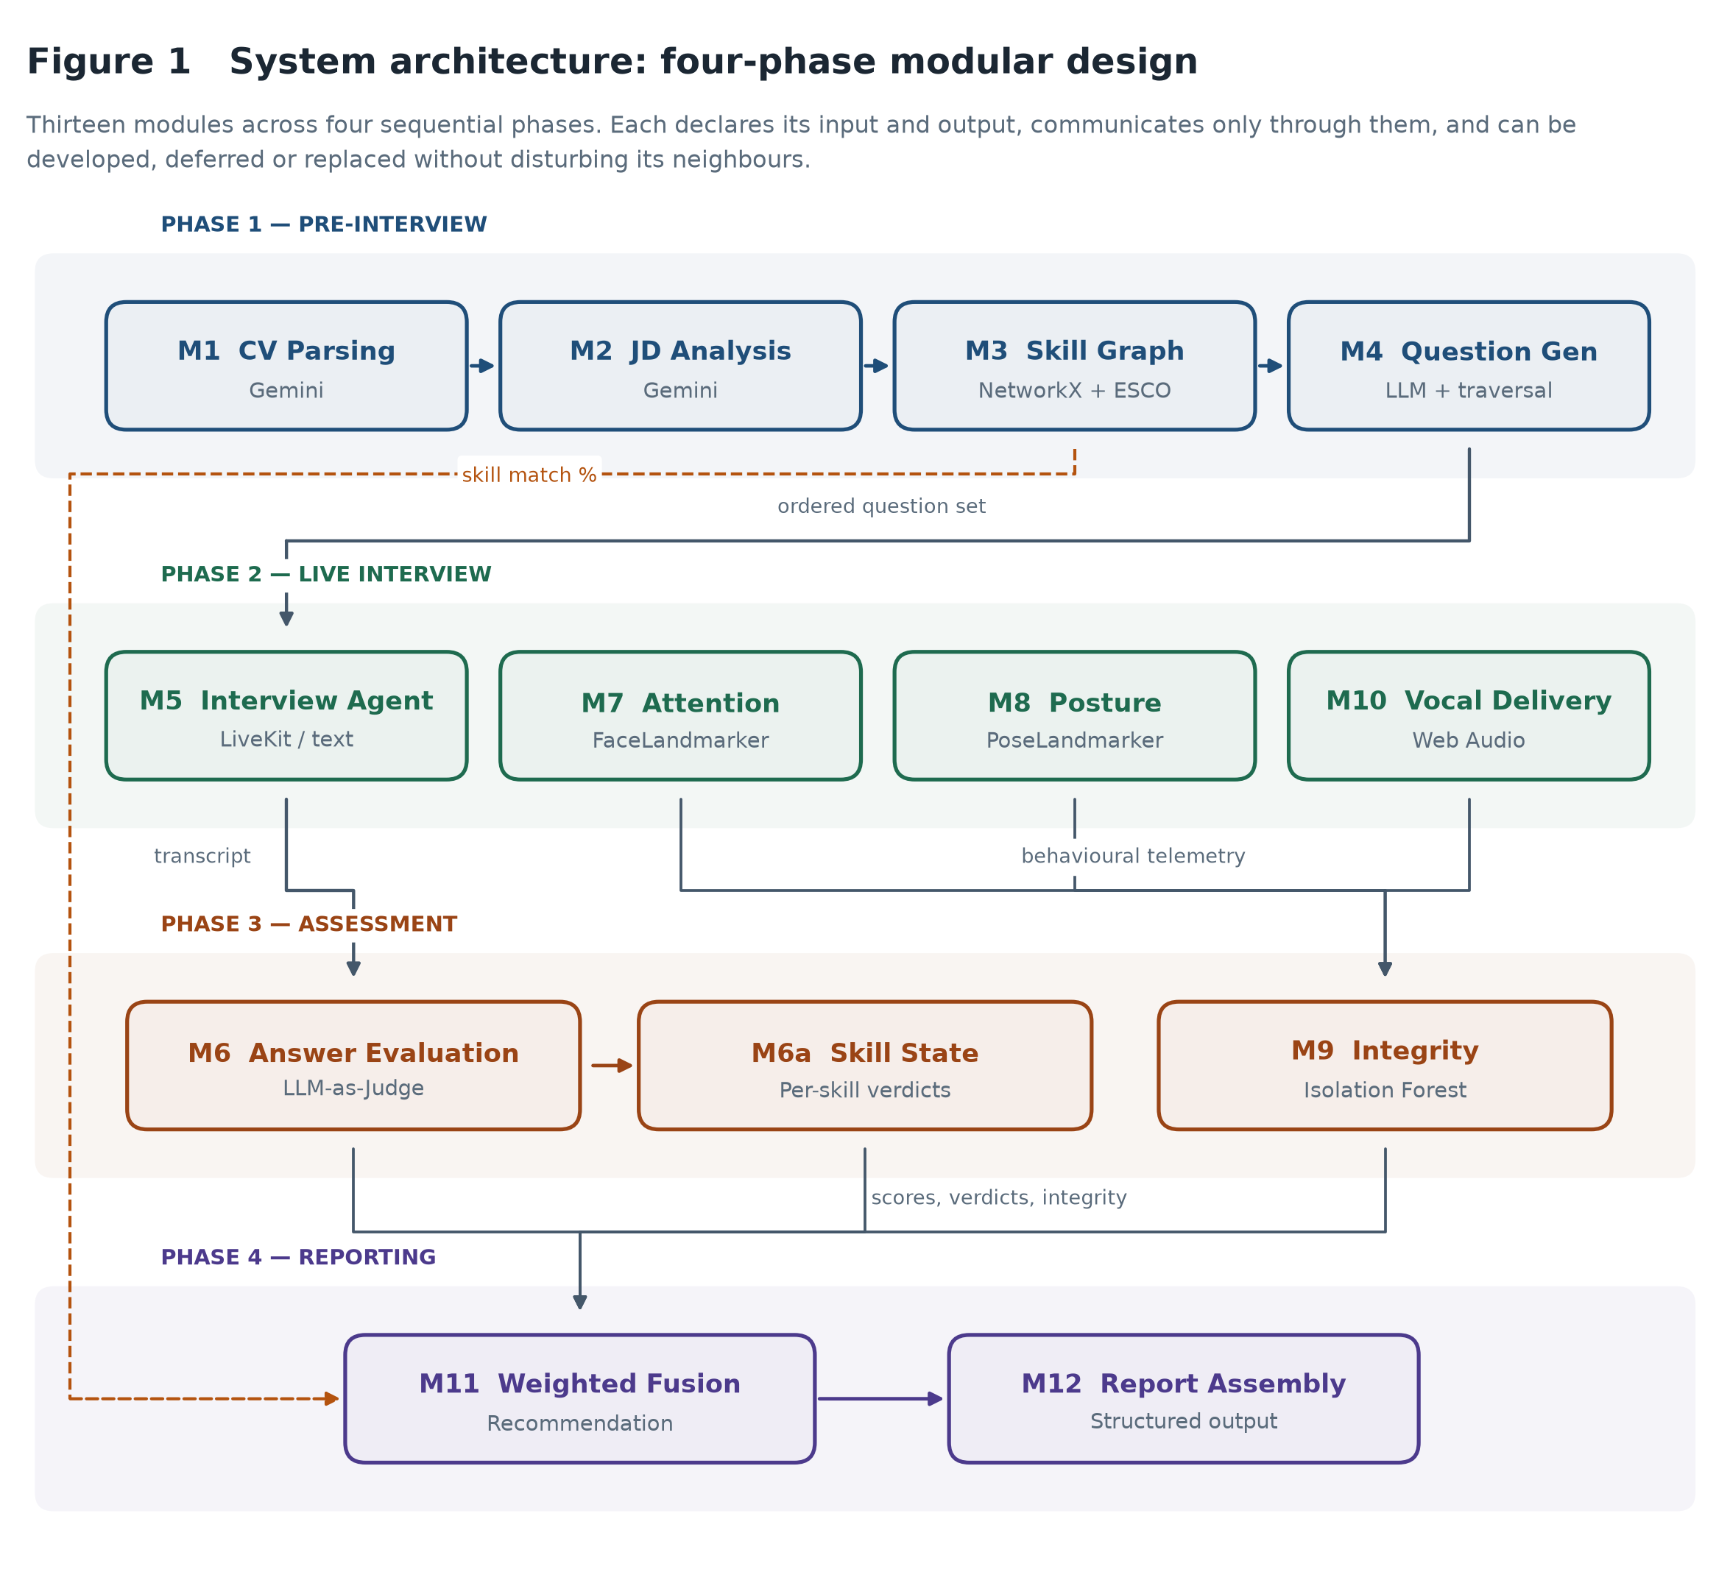
The four phases and the data that flows between them.
- Phase 1 — pre-interview. Turns two documents into a targeted interview plan.
- Phase 2 — live interview. Conducts the session and observes it.
- Phase 3 — assessment. Scores what was said and checks how the session ran.
- Phase 4 — reporting. Combines everything into a traceable recommendation.

5. The modules
What each module does, how it works, and where to find it.

M1 — CV parsing
Extracts text from the uploaded PDF, then asks the model for a structured profile: skills, experience, education, projects.
Technology: Gemini, PyMuPDF · File: core/agents/cv_agent.py

M2 — Job description analysis
Extracts required and nice-to-have skills, seniority, domain and expected experience from pasted text.
Technology: Gemini · File: core/agents/jd_agent.py

M3 — Skill graph and gap analysis
Builds a graph from 1,201 ESCO skills plus technology and soft-skill extensions, resolves both sides onto it through a four-stage matching cascade, and compares them to find gaps.
Technology: NetworkX, ESCO v1.1.1 · File: core/graph/skill_graph.py

M4 — Question generation
Generates opening, technical, behavioural and closing questions, then re-sorts the technical ones so the highest-priority gaps are asked first.
Technology: Gemini + graph traversal · File: core/agents/question_agent.py

M5 — Voice interview
Conducts a spoken interview over WebRTC. Buffers each utterance before synthesis, publishes the question to the screen before speaking it, and falls back between voice providers if one returns no audio.
Technology: LiveKit, Deepgram, ElevenLabs · File: core/livekit/run_agent.py

M5t — Text interview
The typed equivalent, sharing the interviewer prompt, question bank and budgets. Produces a transcript of identical shape.
Technology: FastAPI, Gemini · File: core/pipeline/text_interview.py

M6 — Answer evaluation
Scores each answer twice against a generated reference under a four-criterion rubric, with the criteria in two different orders. Reports the mean and keeps the disagreement as a reliability signal.
Technology: Gemini as judge · File: core/evaluator/evaluator.py

M6a — Skill state tracking
Moves each skill from pending to verified-strong, verified-weak or confirmed-gap as answers arrive.
Technology: Finite state model · File: core/graph/state.py

M7 — Visual attention
Derives gaze direction from face landmark geometry, calibrated against the candidate's own neutral pose rather than an assumed ideal.
Technology: MediaPipe FaceLandmarker · File: frontend/src/lib/vision.js

M8 — Posture analysis
Shoulder tilt, slouch and lean from pose landmarks.
Technology: MediaPipe PoseLandmarker · File: frontend/src/lib/vision.js

M9 — Behavioural integrity
Fits a baseline of normal interview behaviour and flags sessions that depart from it, always naming the specific behaviours responsible.
Technology: Isolation Forest (scikit-learn) · File: core/evaluator/integrity.py

M10 — Vocal delivery
Pitch, energy, voiced ratio and pause length, combined into projection, fluency, expression and composure.
Technology: Web Audio API · File: frontend/src/lib/voice.js

M11 — Weighted fusion
Combines answer quality (50%), skill coverage (20%), integrity (15%) and engagement (15%) into one recommendation, exposing every contribution.
Technology: Deterministic weighting · File: core/evaluator/fusion.py

M12 — Report assembly
Assembles the overall score, per-skill breakdown, per-answer rubric detail, integrity findings and the judge's reliability statistics.
Technology: Structured templates · File: core/report/generator.py

6. Technology choices
Every significant choice carries a cost as well as a benefit. Both are recorded here rather than presenting the stack as a series of obviously correct decisions.
Technology | Used for | Why chosen | What it costs
Gemini 2.5 Flash | Language model for parsing, question generation and scoring | Strong instruction-following; JSON-constrained output; generous free tier | Non-deterministic; a reasoning model, so each call is slow and costs thinking tokens; an external dependency that can be retired without notice
ESCO v1.1.1 | The skill taxonomy the graph is built from | A published EU standard, so a reported skill gap names a concept with a stable public identifier rather than a string the system invented | Predates much of the modern technology stack and covers soft skills sparsely, so it needed extending
NetworkX | Holds the skill graph | Simple, well documented, more than adequate at this size | In-memory only; would not scale to a multi-tenant deployment
LiveKit | Real-time audio transport and the agent framework | Production-grade WebRTC; handles turn-taking and interruption | Heavy dependency, about twelve seconds of process start-up, and adds a server to the deployment
MediaPipe Tasks Vision | Face and pose landmark detection | Runs in the browser, so no video leaves the candidate's device and there is no inference cost | Needs WebAssembly and ideally a GPU; degrades on older browsers
Web Audio API | Vocal delivery analysis | Every component of the score is inspectable; no model download; works offline | A prosodic proxy for emotion, not a trained classifier, and weaker at that task
Isolation Forest | Behavioural anomaly detection | Needs no labelled examples of cheating, which no institution could ethically produce; fast and deterministic under a fixed seed | The baseline here is synthetic, so no false-positive rate can be quoted
FastAPI + React | Backend API and the interface | Fast to build, good defaults, and the frontend is served by the same process | Session state is held in memory, so one interview at a time

7. How a session runs, end to end
- 1. Upload — The candidate uploads a CV and the recruiter pastes a job description. M1 and M2 turn both into structured data.
- 2. Skill graph — M3 resolves both sets of skills onto the ESCO graph and compares them, producing a match percentage and a prioritised topic list.
- 3. Questions — M4 generates the interview and re-sorts the technical questions so the highest-priority gaps are asked while time remains.
- 4. Device check — The candidate checks camera and microphone and chooses voice or text. Meanwhile the media server and agent start in the background, hiding about twelve seconds of start-up.
- 5. Interview — M5 conducts the session. M7, M8 and M10 measure presence in the browser. Tab switches and pasted answers are recorded.
- 6. Scoring — The transcript is paired into exchanges, greetings and sign-offs are excluded, and every substantive answer is scored twice by M6.
- 7. Integrity — M9 derives behavioural features from timing and telemetry and compares them against its baseline.
- 8. Report — M11 fuses the components and M12 assembles the report: overall score, per-skill verdicts, per-answer rubric detail, integrity findings, and how consistent the judge was with itself.

7.1 A real session
Taken from the end-to-end verification run: a synthetic backend engineer against a senior backend role, scoring 50% on the skill graph with Kubernetes and AWS correctly identified as missing.
Exchange | Skill | Score | Judge spread | Consistency
Greeting / readiness | — | not scored | — | —
API design and idempotency | REST API | 91.5 | 1.0 | high
Kubernetes troubleshooting | Kubernetes | 50.0 | 10.0 | moderate
Mentoring a junior engineer | Mentoring | 85.0 | 0.0 | high
Sign-off | — | not scored | — | —

The candidate's admission that they had not used Kubernetes scored 50 rather than zero, because the rubric credits accuracy separately from completeness and an honest acknowledgement contains nothing incorrect. That same answer drew the widest judge disagreement of the session — which is the pattern one would expect, since a partial answer is genuinely harder to score.

8. What the evaluation found
Five controlled experiments over 18 answers written at three known quality levels. The full analysis is in Chapter 6 of the dissertation; the headline is that the evaluation found two real defects in the system it was measuring.

8.1 It ranks well
Spearman's rho between intended quality and awarded score is 0.920, and Cohen's d separating strong from weak answers is 2.98 — a very large effect. The relative ordering can be trusted.

8.2 It calibrates badly
Intended quality | Mean score awarded
Weak | 53.0
Medium | 92.8
Strong | 98.2

The system reports any answer at or above 70 as strong. Deliberately partial answers averaged 92.8 — comfortably above it — so medium and strong answers receive the same verdict. Exact band agreement is only 38.9%.
The instrument is comparative, not absolute. It supports the claim that one candidate answered better than another; it does not support the claim that a candidate scored 92 and therefore meets a standard.

8.3 The rubric does not decompose as designed
The four criteria correlate at a mean of 0.846 despite an explicit instruction to score them independently. The judge appears to form one overall impression and distribute it — the classic halo effect, which instructing a model against did not remove.

8.4 Positional instability was small
Mean spread between the two rubric orderings was 2.22 points, and no answer required escalation. That is a null result for the escalation mechanism on this corpus, and it is reported as one rather than dressed up.

9. Directory guide
Every significant file, and what it is for.

(root)
File | Purpose
run.bat | One-click setup and launch for Windows: installs Python and Node.js if missing, builds the environment, and starts the server.
README.md | Repository overview — what the project is, how to run it, how to verify it, and the headline findings.
PROJECT_GUIDE.docx | This document.
build_guide.py | Generates this document from the live project.
.gitignore | Excludes build output and secrets; the measured results are deliberately tracked.
.gitattributes | Forces CRLF on batch files so run.bat survives cloning.

InterviewAI
File | Purpose
InterviewAI/server.py | FastAPI application. Defines every API endpoint, holds the session state, and spawns the voice agent subprocess.
InterviewAI/requirements.txt | Runtime dependencies, pinned to the verified versions.
InterviewAI/requirements-dev.txt | Test runner and document builders.
InterviewAI/SETUP.md | Setup guide and troubleshooting table.
InterviewAI/.env.example | Template for the three API keys.
InterviewAI/core/config.py | Thresholds and environment configuration in one place: score bands, question limits, the minimum answer length.
InterviewAI/core/llm.py | Gemini client. Handles JSON repair when the model returns malformed output, and counts API usage.
InterviewAI/core/agents/cv_agent.py | M1 — extracts a structured profile from a CV.
InterviewAI/core/agents/jd_agent.py | M2 — extracts requirements from a job description.
InterviewAI/core/agents/question_agent.py | M4 — generates the question set and orders it by the priority the graph assigned.
InterviewAI/core/agents/interviewer_prompt.py | The interviewer's instructions, shared by both voice and text modes.
InterviewAI/core/graph/skill_graph.py | M3 — builds the ESCO skill graph and runs the four-stage matching cascade and gap analysis.
InterviewAI/core/graph/state.py | M6a — tracks each skill's verdict across the session.
InterviewAI/core/graph/traversal.py | Decides which skills needed further probing.
InterviewAI/core/livekit/run_agent.py | M5 — the voice interviewer: speech recognition, model inference and synthesis over WebRTC.
InterviewAI/core/livekit/launcher.py | Downloads and manages the LiveKit server process.
InterviewAI/core/livekit/livekit.yaml | LiveKit server configuration.
InterviewAI/core/pipeline/text_interview.py | The typed interview engine, producing an identical transcript to the voice agent.
InterviewAI/core/pipeline/session_eval.py | Post-interview pipeline: pairs the transcript, classifies, scores, fuses.
InterviewAI/core/evaluator/evaluator.py | M6 — the LLM-as-Judge scorer with permuted rubric orderings and self-consistency.
InterviewAI/core/evaluator/integrity.py | M9 — Isolation Forest behavioural integrity.
InterviewAI/core/evaluator/fusion.py | M11 — weighted fusion into a recommendation.
InterviewAI/core/report/generator.py | M12 — assembles the candidate report.
InterviewAI/frontend/src/main.jsx | React entry point; mounts the application.
InterviewAI/frontend/src/App.jsx | Six-step navigation; the interview and the report each take the whole viewport.
InterviewAI/frontend/src/lib/vision.js | M7 and M8 — attention and posture from MediaPipe landmarks, in the browser.
InterviewAI/frontend/src/lib/voice.js | M10 — vocal delivery from Web Audio prosody.
InterviewAI/frontend/src/components/LandmarkOverlay.jsx | Draws the face mesh and pose skeleton over the video.
InterviewAI/frontend/src/components/Sidebar.jsx | Step navigation, gated by progress.
InterviewAI/frontend/src/screens/UploadStep.jsx | Step 1 — CV upload and JD entry.
InterviewAI/frontend/src/screens/GraphStep.jsx | Step 2 — renders the skill graph.
InterviewAI/frontend/src/screens/QuestionsStep.jsx | Step 3 — the generated questions.
InterviewAI/frontend/src/screens/SetupScreen.jsx | Step 4 — device check and mode choice.
InterviewAI/frontend/src/screens/InterviewScreen.jsx | Step 5a — the voice interview.
InterviewAI/frontend/src/screens/TextInterviewScreen.jsx | Step 5b — the text interview.
InterviewAI/frontend/src/screens/DashboardScreen.jsx | Step 6 — the final report.
InterviewAI/experiments/run_evaluation.py | The evaluation harness: five controlled experiments over the judge.
InterviewAI/experiments/results/statistics.json | Computed statistics — what the dissertation's Chapter 6 reads.
InterviewAI/experiments/results/raw_scores.json | Every individual score, cached so figures regenerate without API calls.
InterviewAI/experiments/results/track_b_evidence.json | Measurements from the rejected classifier, before deletion.
InterviewAI/experiments/results/worked_example.json | The end-to-end verification session.
InterviewAI/tests/test_core.py | The unit test suite over the deterministic components.
InterviewAI/docs/track-b-rejection.md | Why the trained classifier was removed, with the evidence.
InterviewAI/data/esco/digitalSkillsCollection_en.csv | ESCO digital skills export.
InterviewAI/data/esco/broaderRelationsSkillPillar.csv | ESCO hierarchy relations.

report
File | Purpose
report/build_report.py | Builds the dissertation end to end.
report/front_matter.py | Title page, abstract, contents.
report/ch1_introduction.py | Chapter 1 — the problem, aim and objectives.
report/ch2_literature.py | Chapter 2 — literature review and conceptual framework.
report/ch3_methodology.py | Chapter 3 — Design Science Research methodology.
report/ch4_design.py | Chapter 4 — system design and the tool trade-offs.
report/ch5_implementation.py | Chapter 5 — implementation and the problems met.
report/ch6_evaluation.py | Chapter 6 — rendered from the measured statistics.
report/ch7_reflection.py | Chapter 7 — critical reflection and limitations.
report/ch8_conclusion.py | Chapter 8 — conclusions and future work.
report/back_matter.py | References and appendices.
report/diagrams.py | Generates the eleven architecture figures.
report/figkit.py | Figure layout engine: reserved header, measured text wrapping, collision checking.
report/docx_kit.py | Document primitives — headings, tables, figures.
report/values.py | Shared access to the measured results.
report/CMP7200_Project_Report.docx | The dissertation (Assessment 2).

viva
File | Purpose
viva/build_viva.py | Builds the viva presentation.
viva/CMP7200_Viva_Presentation.pptx | The presentation (Assessment 3).
viva/VIVA_QA_PREP.md | Anticipated viva questions and prepared answers.

proposal
File | Purpose
proposal/AI_Interview_Final_Proposal.docx | The project proposal (Assessment 1).
proposal/CMP7200_Assignment_Brief.pdf | The assignment brief.

10. Running, verifying and rebuilding

10.1 Running it
Double-click run.bat. It installs Python and Node.js if they are missing, creates the environment, installs both dependency sets, builds the interface, and starts the server at http://localhost:8000. Three API keys go in InterviewAI\.env — Gemini and Deepgram are required, ElevenLabs is optional and falls back to Deepgram's voice.

10.2 Verifying it
cd InterviewAI
python -m pytest tests/ -q # unit tests, no API calls
python -m experiments.run_evaluation --figures-only # recompute from cache, free
python -m experiments.run_evaluation --quick # full re-run, ~69 API calls
The suite currently holds 72 tests, all passing. Two are direct regressions on a skill-matching bug that once mapped “Team Leadership” onto the ESCO concept “R”.

10.3 Rebuilding the documents
python build_guide.py # this guide
cd report && python build_report.py # the dissertation
cd viva && python build_viva.py # the presentation
No result in any of these documents is typed in by hand. They read the measured statistics, so re-running the evaluation and rebuilding produces documents consistent with the new numbers.

