BIRMINGHAM CITY UNIVERSITY
Faculty of Computing, Engineering and the Built Environment

An Explainable Multi-Agent AI Interview Platform:
Skill-Graph Question Targeting and a Bias-Mitigated
LLM-as-Judge Evaluation Pipeline

CMP7200 — Individual Master's Project
Project Dissertation (Assessment 2)

Student Number: [STUDENT NUMBER]
MSc Computer Science
Academic Year 2025–26
Module Leader: Samer Bamansoor
September 2026

Abstract
Today, millions of candidates are being analysed by automated platforms every year, but the processes these platforms use to do so are opaque – they provide a score with no explanation of how it was generated. Even though the practice has been regulated, the tools themselves have been slower to evolve; Regulation has caught up to the practice, the EU AI Act considers recruitment systems as high-risk, and calls for transparency, human oversight, and bias testing. Large language models can provide the conversational ability needed to undertake a structured interview and the fluency to make a judgement, but a recent body of literature reveals that these models are not a true source of evaluation, being selective in the order of criteria they are presented with, and rewarding length over substance.This project aims to design, develop and test a working interview platform where that unreliability is not simply an acceptable expense, but the main engineering challenge. The artefact consists of 12 modules over 4 phases. A candidate's CV is structured into profiles and aligned with a job description to a knowledge graph created from the ESCO occupational taxonomy that reveals the skill gaps and prioritize an interview sequence questioning real skill gaps before the time allocated for the interview is exhausted. The interview itself is conducted as a real-time voice interview over WebRTC (or a typed version which generates an identical transcript). Answer correctness is assessed by a language model based on a reference answer generated by a model and a four criterion rubric. Attention, posture and vocal delivery are evaluated in the browser and video and audio recordings do not leave the candidate's device.A reliability instrument embedded into the scorer that constitutes the evaluation contribution. All answers are marked twice for the different rubric orderings: the mean score is presented and the disagreement between the two readings is kept as an indicator of the stability of that score. Judges' answers that they do not agree with are passed up to a human and not reported confident. The result is measured across five controlled experiments, including discriminant validity against known levels of answer quality, a positional-bias ablation, an invariance under paraphrase, a rubric criterion independence, and a verbosity probe.A new track for training a Classifier was proposed at the beginning, it was constructed, tested and rejected. The model-generated labels were even sent to the model to be paraphrased with, and the trained model correctly paraphrased its own reference answer at 39 out of 100, which is below the point at which it would report a skill gap. Reporting the rejection and the evidence for it is not a descoping, but a finding. The dissertation ends in the conclusion that transparency is best achieved if there is only one scorer responsible for reliability, rather than two scorers that are not independently validated.

Acknowledgements

I would like to express my gratitude to my project supervisor for her guidance throughout the design and evaluation process of this project and the CMP7200 module team for their feedback on the project proposal, which informed the direction the artefact would ultimately take. All that's wrong is my own fault.

Declaration
This dissertation is submitted for the award of the Masters of Science in Computer Science at Birmingham City University as partial fulfilment of the requirements for the award. I state that this work is my own, that the sources used have been referenced in accordance with the BCU Harvard referencing system and that this work has not been submitted for another award. I designed and implemented an artefact of software for this project, as described in Chapter 5.

Table of Contents
Abstract
Acknowledgements
Declaration
List of Figures
List of Tables
1. Introduction
1.1 Background and rationale
1.2 Problem statement
1.3 Aim
1.4 Objectives
1.5 Scope and deliverables
1.6 Structure of this dissertation
2. Literature Review
2.1 Automated interviewing and algorithmic hiring
2.2 Language models as evaluators
2.3 Knowledge graphs for competency modelling
2.4 Fairness, transparency and the regulatory position
2.5 Behavioural integrity and remote assessment
2.6 Synthesis: a conceptual framework
2.7 The gap this project addresses
3. Research Methodology
3.1 Design Science Research
3.2 How the cycles ran in practice
3.3 Evaluation strategy
3.4 Data strategy
3.5 Alternative approaches considered
3.6 Ethical considerations
3.7 Tools and development environment
4. System Design
4.1 Architectural overview
4.2 Module decomposition
4.3 Data flow and interface contracts
4.4 Skill graph design
4.5 Question generation and graph traversal
4.6 Interview transport design
4.7 Evaluation pipeline design
4.8 Fusion and reporting design
4.9 Critical assessment of the tools selected
5. Implementation
5.1 Technology stack and repository structure
5.2 Document understanding (M1, M2)
5.3 The skill graph (M3)
5.4 Question generation and ordering (M4)
5.5 The voice interview agent (M5)
5.6 Text interview mode
5.7 Answer evaluation (M6)
5.8 Presence modules (M7, M8, M10)
5.9 Behavioural integrity (M9)
5.10 Fusion and report assembly (M11, M12)
5.11 Engineering problems encountered
6. Evaluation and Results
6.1 Experimental design
6.2 Discriminant validity
6.3 Positional-bias ablation
6.4 Paraphrase invariance
6.5 Criterion independence
6.6 Verbosity probe
6.7 System-level verification
6.8 A worked example
6.9 Discussion of results
7. Critical Reflection
7.1 Achievement against objectives
7.2 Deviations from the proposal
7.3 Limitations
7.4 Professional, legal and ethical reflection
7.5 Personal reflection
8. Conclusion and Future Work
References
Appendix A — Module reference
Appendix B — Rubric and judge prompt
Appendix C — Repository structure
Appendix D — Test suite summary

List of Figures
Figure 1 System architecture: four-phase modular design
Figure 2 End-to-end data flow
Figure 3 Skill graph construction and the four-stage matching cascade
Figure 4 Module 6: bias-mitigated LLM-as-Judge evaluation pipeline
Figure 5 Live voice interview: sequence of interactions
Figure 6 Module 11: weighted fusion model
Figure 7 Design Science Research process as executed
Figure 8 Use case model
Figure 9 Deployment and process view
Figure 10 Conceptual framework derived from the literature
Figure 11 Project schedule as delivered, with milestones
Figure 12 Discriminant validity: score distribution by intended quality
Figure 13 Positional-bias ablation and judge self-consistency
Figure 14 Paraphrase invariance across semantically equivalent rewrites
Figure 15 Inter-criterion correlation matrix
Figure 16 Verbosity probe: original versus padded answers
Figure 17 The skill graph built for a real CV and job advert
Figure 18 Generated questions, tagged with the skill each targets
Figure 19 Step 1: CV and job advert parsed into structured data
Figure 20 Step 4: device check and the disclosure screen

List of Tables
Table 1 Strengths and weaknesses of the principal tools selected
Table 4 Rubric criteria and their scoring guidance
Table 5 Fusion component weights
Table 6 Experimental design summary
Table 7 Discriminant validity results by intended quality level
Table 8 Current thresholds against empirically implied boundaries
Table 9 Positional-bias ablation results
Table 10 Paraphrase invariance by question group
Table 11 Per-answer results from the worked example
Table 12 Achievement against objectives

1. Introduction

1.1 Background and rationale
Automation has transformed recruitment.The recruitment process has been revolutionized by automation. Video interviewing systems like HireVue, Pymetrics and myInterview now conduct or score interviews at a level that a human panel never could, and the bottom line is simple: screening cycles are shorter, cost per candidate is lower, and all applicants are interviewed in the same way. Such consistency is hard to get from human interviewers whose evaluations change due to fatigue, order effects, rapport.It is hard to be consistent, consistent is not accurate and consistent is not fair. In 2019, Electronic Privacy Information Center filed a complaint against HireVue that they used facial analysis to score candidates, which is an unvalidated and opaque technique (EPIC, 2019). In January 2021, HireVue pulled visual analysis but retained the verbal scoring, which is based on natural language processing (HireVue, 2021). The problem itself lived on; candidates were given a number and no information about its origin.Since then, the regulation has changed its location. The Artificial Intelligence Act (European Commission, 2024) imposes requirements on transparency, human oversight, record keeping and bias testing for AI systems employed in the context of employment and worker management, which is considered as a high-risk application. If a system cannot explain a score, it's no longer a compliance issue and it's an ethical issue.The technical set-up has changed, too. A structured conversation can be maintained in language by language models, and a judgment can be expressed in language, as can happen with an interview system, but not with a feature-vector classifier, making the reasoning legible for a recruiter. The second question that is more difficult to answer, one this project addresses, is whether such a model is reliable for grading.

1.2 Problem statement
There is mixed evidence on the use of language models as evaluators. Zheng et al. (2023) demonstrated that GPT-4's agreement with human preference judgements on open-ended tasks was comparable to human raters' agreement at eighty per cent. or more. In contrast, Stureborg et al. (2024) reported positional bias, the different model scores to the same content presented in different order, and Wang et al. (2024) observed verbosity bias.These are NOT extreme edge-cases! In an interview scenario they perfectly correlate with unfairness: a candidate who gives the right answer, but the answer is brief, gets penalized compared to another candidate who gives the same right answer, but a lot longer, and the same right answer can be given in different ways, so that it also earns different points. The worst is when a system that is inherited contains these biases and it goes unrecognized, as opposed to a system that is transparent and scores worse.The issue isn't if a language model could get a job, it certainly can, it's whether a system that uses a language model could be made responsible for the reliability of its scores.

1.3 Aim
To design, implement and critically evaluate a multi-agent AI interview platform that conducts an adaptive technical interview, targets its questioning using a knowledge graph built from a standard occupational taxonomy, and scores candidate answers through a language-model judge instrumented to measure, report and act on the reliability of its own judgements.

1.4 Objectives
The aim is broken down into 6 objectives. Objectives 4 and 6 were modified during the project due to the rejection of the trained-classifier evaluation track; the following is the original wording with the reason for the change and evidence supporting this change.
- Objective 1. Create a skill knowledge graph based on the ESCO occupational taxonomy; match skills found on candidate CVs to the skill knowledge graph; create gap analysis to identify which skills, from the occupational taxonomy, the candidate does not evidence.
- Objective 2. Add a question generation agent to generate an interview question set from the graph and sort it according to the priority assigned by the gap analysis, to ensure that true gaps are explored before the time allotted is up.
- Objective 3. Adopt a voice interview agent that can have a natural dialogue (with speech recognition and synthesis) and a typed mode that will provide an identical transcript to enable assessment to be conducted with the same transcript regardless of the delivery channel.
- Objective 4. Create a pipeline for evaluating LLM-as-Judge that can evaluate each response against a generated reference answer, under a four criterion rubric, and measure the positional-bias sensitivity and self-consistency of the pipeline by varying the rubric ordering and repeating the measurement multiple times.
- Objective 5. Introduce a behavioural integrity module to identify interview sessions that do not conform to a known baseline, and that communicates what behaviours are identified as deviating and not just a flag.
- Objective 6. Evaluate Test the system in controlled tests against known answer quality levels, paraphrase-invariance, a positional-bias ablation, rubric criterion independence and sensitivity to verbosity, and verify the artefact with automated tests.

1.5 Scope and deliverables
The outcome will be a working software artefact together with this dissertation. The artefact is a single-user research demonstrator consisting of a FastAPI backend, a React single-page front end, an embedded WebRTC media server and a voice agent subprocess. It's not a production hiring system on purpose, and 7.3 outlines some of the changes that would need to occur for it to be a production hiring system.There are three rules that should be mentioned. The system doesn't make a decision but provides evidence for a human to make a decision. There was no actual candidate data used: all experiments in Chapter 6 were performed using generated data, for the reasons outlined in Section 3.6. The platform is not tested as a predictor of job performance — as a measurement instrument, it is tested. Criterion validity to job performance would require a longitudinal study so long as was a fourteen-week project.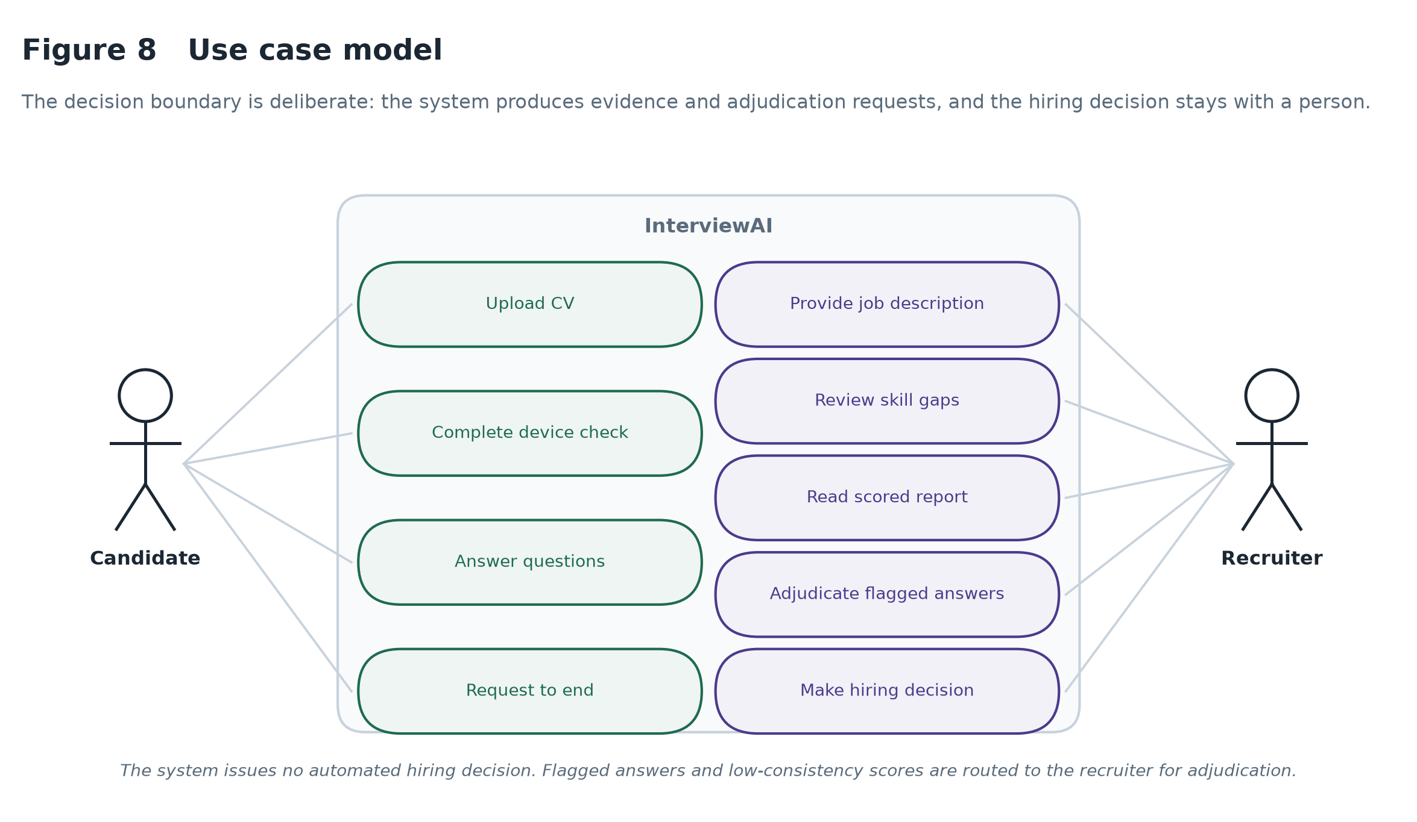
Figure 8 Use case model. The decision boundary is deliberate: the system produces evidence and adjudication requests, and the hiring decision stays with the recruiter.

1.6 Structure of this dissertation
The literatures on which the design is based are reviewed in Chapter 2 and a conceptual framework is derived. The methodology is detailed in Chapter 3, the design in Chapter 4 and the implementation in Chapter 5. Evaluation experiments are described in Chapter 6, critical reflection on what objectives were met and what has changed from the proposal is seen in Chapter 7 and closing is done in Chapter 8.

2. Literature Review

This is a project that is influenced by four bodies of research: the empirical literature on automated interviewing, the rapidly growing literature on the use of language models as evaluators, the literature on knowledge graphs for competency modelling, and the fairness and/or regulatory literature on algorithmic hiring. To inform one module, there is a fifth to discuss remote assessment integrity. Each is reviewed, their agreement and disagreement is identified, and they are combined in the structure that guides the design.

2.1 Automated interviewing and algorithmic hiring

Automated hiring has shifted from keyword to a multimodal evaluation of real-time interviews. In the rather narrow sense of being more reliable, in that it produces the same output for the same input, the conclusion that Hickman et al. (2022) come to is easy to misread as endorsement. They distinguish between criterion validity and automated approaches, which have not been validated over the decades like structured interviewing. Here it is an important distinction that a system may be perfectly consistent and always be wrong and consistency is not a defence of a scoring method.

Langer, König and Papathanasiou (2019) take a different perspective on the same technology from the candidate's point of view. When candidates' responses to automated interviews are compared to human interviews, they find that automated interviews are significantly less fair, especially when they receive no feedback or explanation. The result is a significant business impact: candidates who interpret a process as unfair will step down, thus limiting the optimization benefit driving automation. This is the direct motivation of this explain first orientation – it is not only an ethical one, but also an instrumental one.

These collectively create a tension that the design is faced with, but cannot choose any one side of. You can have consistency and scale but if you're going for both, you need to make the system's reasoning inspectable.

2.2 Language models as evaluators

The adoption of a language model as the judge was popularized by Zheng et al. (2023), who developed MT-Bench and Chatbot Arena, work that found that over eighty per cent of GPT-4's preference judgements match human evaluators on open-ended tasks, mirroring inter-human agreement on the same material. This is important because it implies that, for tasks where there is no single right or wrong answer, a good model can replace the costly human annotation.

Qualifications are specific, not general, and arrived quickly. Stureborg, Alikaniotis and Suhara (2024) show LLM judges are both inconsistent and biased: presented with the same candidates in a different order, the same model returns different scores. The bias is a position or sequence bias, not content. Wang et al. (2024) refer to a complementary failure – verbosity bias – where longer answers are given higher marks, regardless of the actual content of the additional length.

The results are often used as arguments against the use of LLM judges. There is nothing that defines the utility of that reading, and both biases are sufficiently well described so that they can be negated by construction. When a score is based on the order in which the material is presented, several different versions of the same material presented in different orders and the scores averaged to remove the order effect, and the disagreement between the different orderings becomes a direct measure of the instability of that judgement. If a bias can be measured it can be reported, and if it is reported, it can be acted upon. This project does not use these results as an excuse to turn a blind eye to the problem; it is the basis for the development of countermeasures.

A methodological word of warning in this literature that influenced a major decision here: When an automated scorer is compared with labels generated by a language model, agreement is not substantive but rather an artefact of the design of the model. It is again referenced in Section 7.2.

2.3 Knowledge graphs for competency modelling

Knowledge graphs are graphs that represent entities and their relationships in a way that is suitable for traversal and inference. Chen, Li and Zhang (2021) use graph-based models for prerequisite identification in online learning, and demonstrate that traversal from a structured concept graph can yield coherent learning paths without learned embeddings. The relevance here is specific: if there is already some existing documentation of domain structure and it is reliable, then it is simpler and more explainable to traverse than if it were learned.

The ESCO framework (European Commission, 2023) provides just such a structure: a multilingual taxonomy of skills, competences and occupations maintained as an EU standard and more than thirteen thousand skill concepts are connected to each other via explicit broader and narrower relations. The use of a published taxonomy and not an ad hoc list is important for a high risk system: if a platform reports a candidate has not the skill, that isn't a string that the platform has created, but a concept with a stable identifier in a public standard.

Implementation of ESO was quickly shown to be limited. There is a basic lack of the modern technology stack and soft skills are only sparsely covered in version 1.1.1, so a practical system needs to add to this. The extension taxonomies provided here are described in Section 5.3, and, very importantly, instances of matching failures that can occur when using a free-text skill to match a controlled vocabulary inappropriately.

2.4 Fairness, transparency and the regulatory position

To the extent that it is feasible, the agency will ensure that the rules and regulations it adopts are fair, transparent and in the regulatory position.

A team led by Raghavan (2020) evaluated a sample of commercial algorithmic hiring vendors and identified that many vendors claimed to be using measures for bias mitigation, but few vendors provided documentation of the validation procedures they used. But it was already laid out by Bogen and Rieke (2018) that such systems encode historical inequity in a manner.It had already been outlined by Bogen and Rieke (2018) that such systems encode historical inequity in a way.

Now the response of the regulatory authorities has become tangible. The EU AI Act is very specific about the category of high risks for the systems used in the recruitment process, which must be transparent, supervised by humans, documented, and tested for bias (European Commission, 2024). It is worthy of note that the Act does not require the model to be unbiased (unfeasible), but rather requires testing for bias, documentation and human oversight of bias. That's a design brief, not a design aspiration, which is achieved by instrumentation.

This project takes a holistic approach to fairness in three aspects. Audiences only score what the candidate has said and compare it to a reference answer for the same question, there are no proxy for one's or demographic inputs. The rubric is not kept in-house but is released to the candidate. The reliability of each of these scores is assessed and communicated with them, allowing a recruiter to understand which judgements are solid. But this is not a guarantee of fairness – it is weaker, but attainable, and the claim the literature supports.

2.5 Behavioural integrity and remote assessment

An integrity issue is a problem that predates AI interviewing and is a problem with the remote assessment. It is in line with the unsupervised anomaly-detection tradition where the model does not classify cheating but rather a model of normal interaction is fitted and any anomalies stand out for review. Isolation Forest (Liu, Ting and Zhou, 2008) is appropriate for this setting since it isolates anomalies through random partitioning, and does not need a labelled negative class.

There is no doubt in the literature that such signals are weak on their own and prone to misinterpretation: a candidate who is looking away is thinking just as much as using a second screen to look up definitions. The design consequence used in this case is that the module does not provide a verdict without referring to the behaviours that caused it, and that it does not automatically disqualify when it gives an advisory verdict.

2.6 Synthesis: a conceptual framework
All four literatures point to three common deficiencies of existing automated hiring tools and offer a particular design solution to each of those deficiencies.Each of the four literatures identifies a set of three common deficiencies in the existing automated hiring tools, and also suggests a particular design solution to each of these deficiencies. The framework that emerges is presented in Figure 10.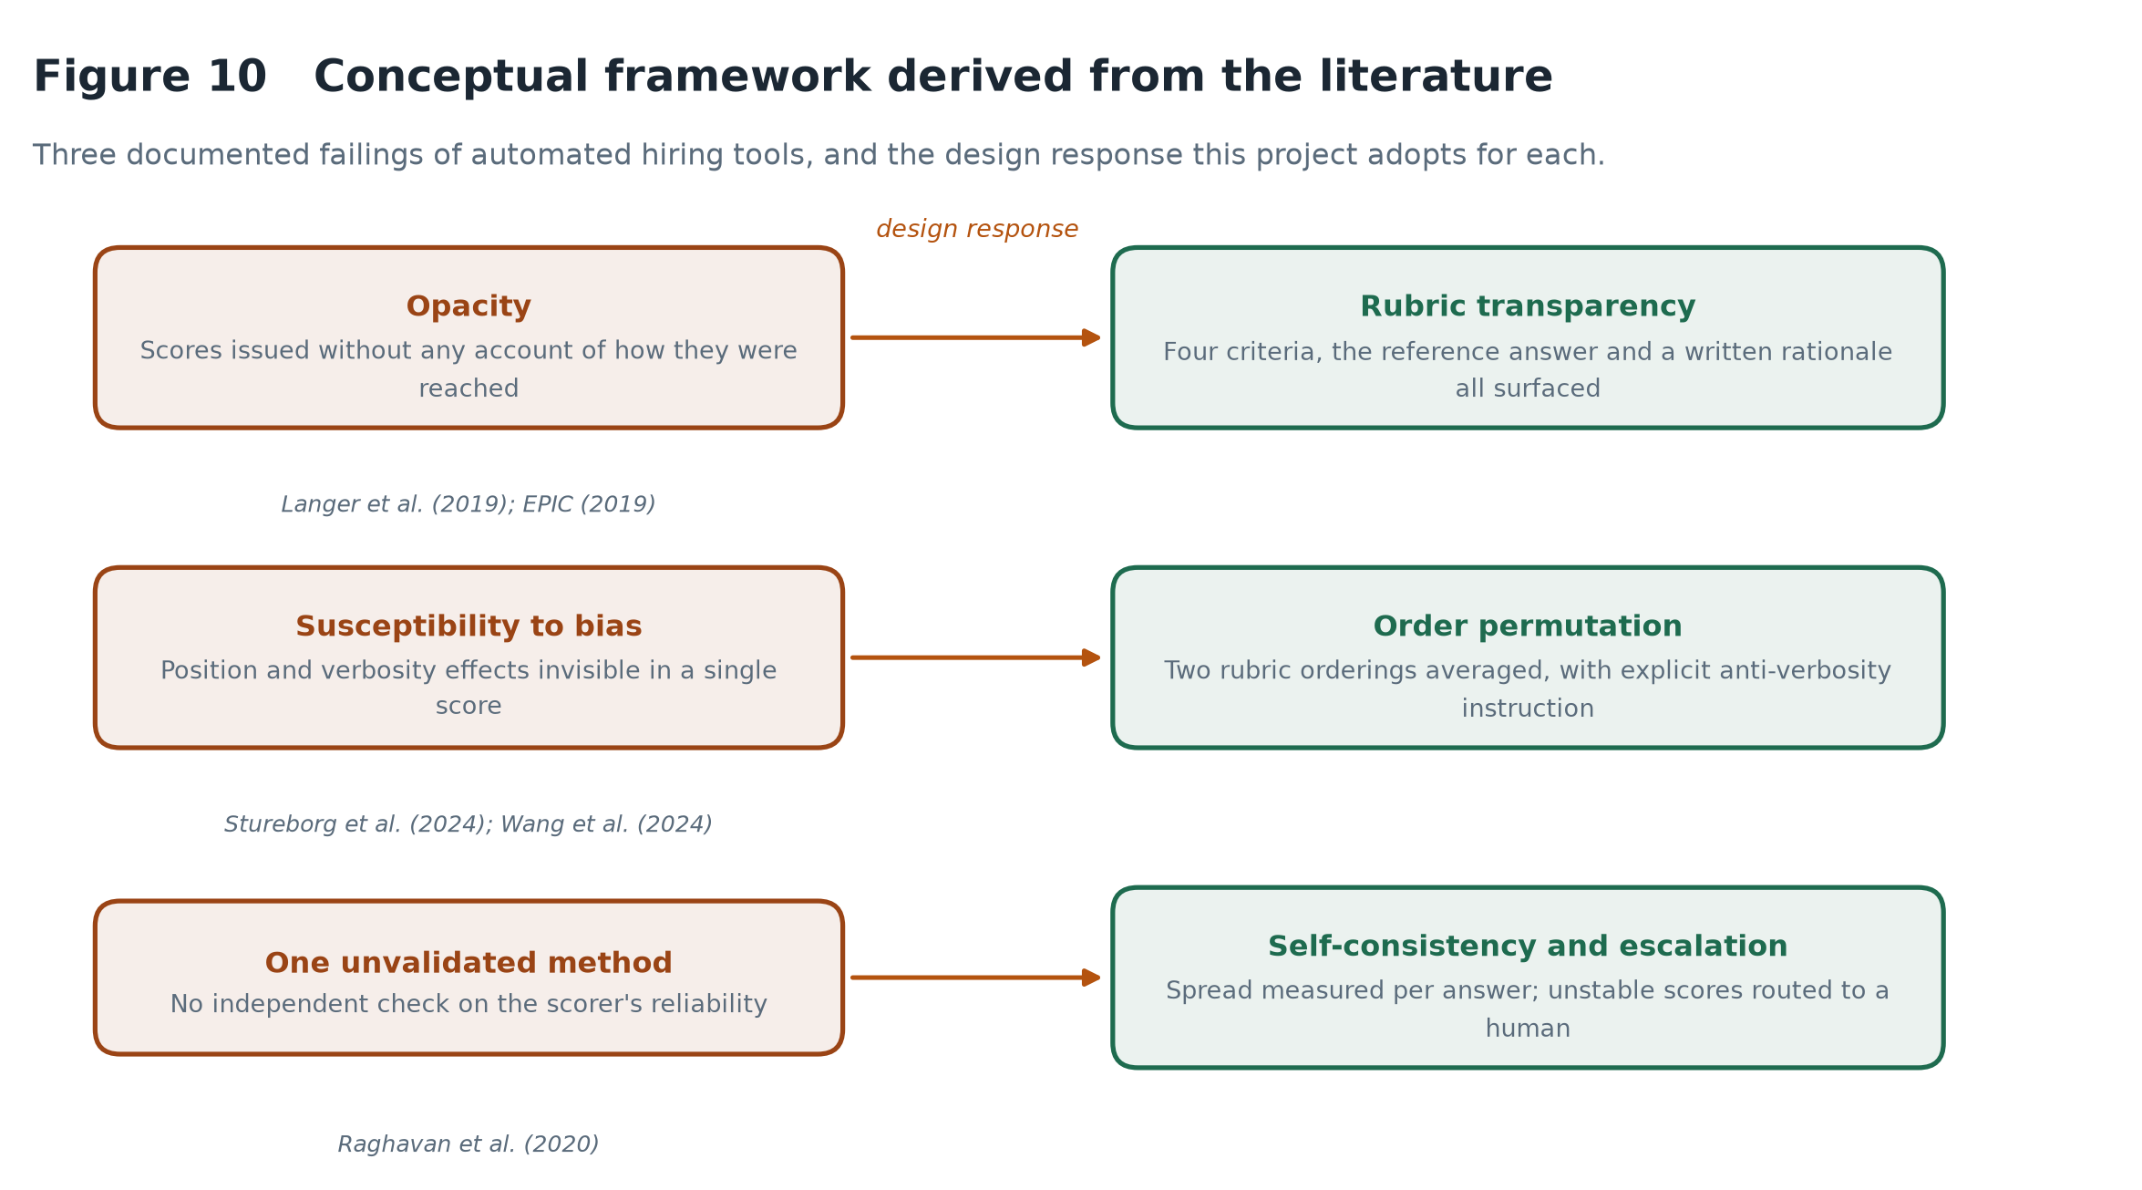
Figure 10 Conceptual framework derived from the literature: three documented failings of automated hiring tools and the design response adopted for each.

First, opacity – lack of transparency. The AI Act considers this a compliance failure, and both Langer et al. (2019) and EPIC (2019) describe systems that return scores in the absence of accounts. It is the responses that are judged against the reference answer, with the four rubric criteria and each criterion's marks as well as a written response rationale all surfaced.

The second is that it is easy to fall prey to systematic bias. Position effects and verbosity effects go beyond being invisible in a single score as identified by Stureborg et al., 2024 and Wang et al., 2024. The answer is to change the ordering of the rubrics across iterations and then average, and to make it clear that rewards are not to be based on length — then to try both of these fixes, as Sections 6.3 and 6.6 do.

The third one is that they rely on a single unvalidated method. This was found to be the norm in commerce by Raghavan et al. (2020). The answer chosen here is not to be a second scorer (for reasons explained in Section 7.2 in great detail) but to measure disagreement between repeated passes over the same answer as evidence about that pass, and to report answers on which the judge is not stable as "not confident".

A fourth one is under the three. When the interview is based on a published occupational taxonomy, the content being assessed is not a competency the question generator may have just written, but is a competency that has been documented and published. This makes the content of the interview as well as the content of the scoring auditable.

2.7 The gap this project addresses
The literature has validated that language models can make reasonably good assessments of open-ended responses and separately that they do unreliably in characterised fashion. Where this is lacking is work that recognizes the unreliability as a first-class engineering problem within a deployed assessment pipeline, rather than a manufacturing defect: measure and record it by judgement; report it to the person acting on the score; and deliver the cases that are proved to be unstable to human adjudication.
Most bias-mitigation efforts here are conducted on validation data sets offline, with the mitigation and re-measuring of the aggregate agreement. This is well, but does not provide the practitioner with an inference-time per-item reliability signal. The contribution made is small and tangible: an interview pipeline that makes it possible to assign to each score a confidence that comes from the judge's agreement with the score, which is derived empirically, and where this confidence influences what the system does.

3. Research Methodology

3.1 Design Science Research
This project follows the Design Science Research approach of Hevner, et al. (2004) following creation of an artefact and then study of that artefact as the vehicle of the contribution. That's what the present work is about: It isn't about what people do or don't do when they're being interviewed; it's about whether an assessment system can be built that is accountable for its own reliability.
Hevner's framework consists of two cycles. The relevance cycle is the idea that underpinning the work is a real problem space, in this case the reported opaque nature of commercial hiring tools and the transparency requirements that the EU AI Act now includes. The rigour cycle is based on a body of existing knowledge (literature reviewed in Chapter 2) and feeds back to it. In between there is the design process in which the artefact is constructed, tested and adapted. The cycles ran as shown in figure 7 in this project.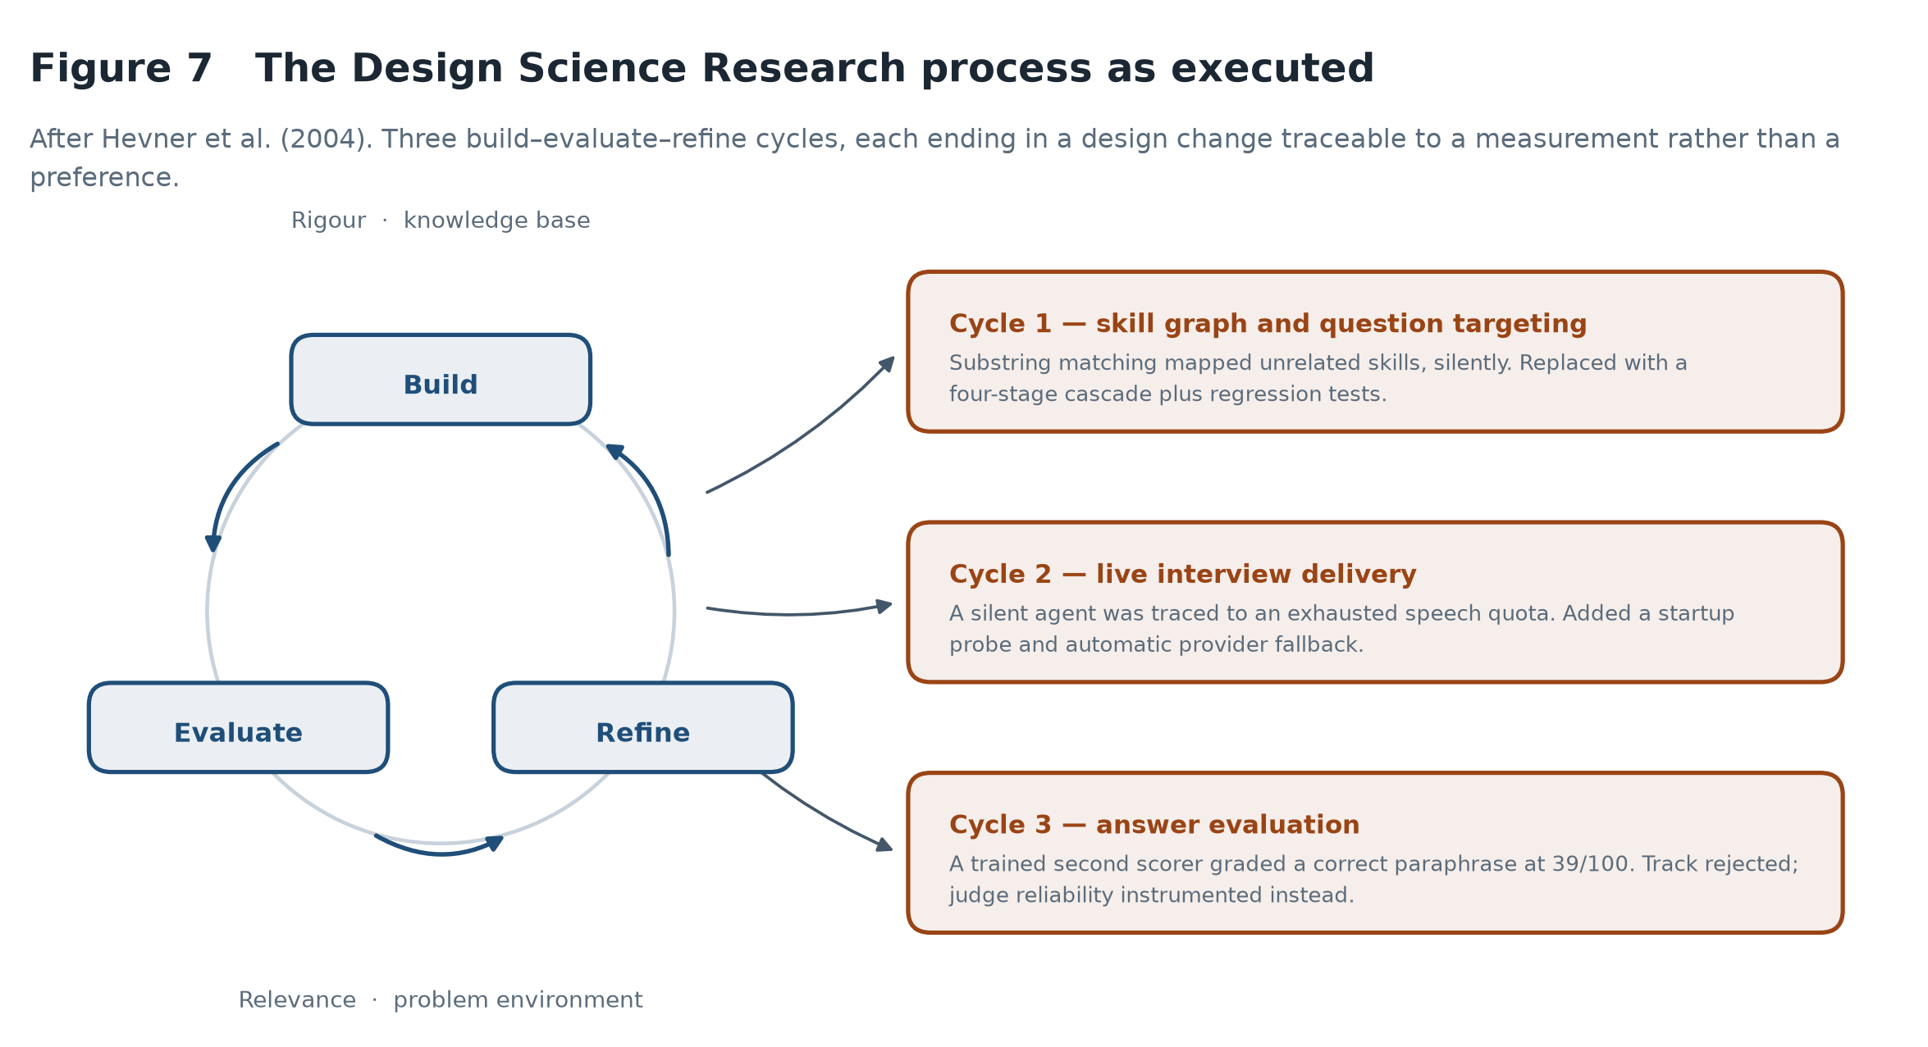
Figure 7 The Design Science Research process as executed, showing three build–evaluate–refine cycles and the design change each produced.

A purely experimental design was rejected due to the lack of a system fixed in the beginning. It does accurately describe Chapter 6, but: after stabilisation of the artefact evaluation was conducted in a manner of experimentation. The project is controlled by DSR, and the evaluation is controlled by controlled experiment.

3.2 How the cycles ran in practice
Three design cycles are worth recording, because in each the evaluation stage produced a measurement that forced a change rather than confirming a decision already taken.
The first concerned skill matching: a substring fallback silently mapped “Team Leadership” onto the ESCO concept “R”, while the gap analysis reported confident nonsense. The second concerned delivery, where the voice agent fell silent mid-session because an exhausted synthesis quota returns no audio while still accepting the connection. The third concerned evaluation, where measuring a trained second scorer exposed a data leak and a circularity, and ended the track. Sections 5.3.1, 5.5.2 and 7.2 give the evidence in full.

3.3 Evaluation strategy

According to Hevner et al. (2004) there are five families of DSR evaluation method. There are three here that make three different claims.

Experimental — controlled experiments on the evaluation pipeline (Chapter 6). These are claims about the way the scorer acts towards the answers: does the scorer distinguish between good and poor answers; does the sequence in which answers are presented affect the scorer; does paraphrasing affect the scorer.

Testing — an automated unit test suite for the deterministic components, and an end-to-end run that runs the entire pipeline with a synthetic candidate. These are support claims of correctness, not quality.

These are some of the other types of statistics that were of particular use or demonstrated in a worked example through the whole system (Section 6.8): descriptive.

The absence is criterion validity - no statement is made about scores predicting job performance. To do so would entail monitoring of recruited staff over a period of months, which is way too long to be covered by any fourteen-week project. The evaluation asks whether the system is stable and discriminating, which are necessary but not sufficient conditions for validity and therefore considers the system as a measurement instrument.

3.4 Data strategy
All evaluation data is created not collected from persons. This was made intentional and on a cost, and the reason must be clearly stated.
The proposed set of validation and pilot sessions included approximately two hundred interview responses rated independently by two human raters and fitment of the behavioural baseline with volunteers. Ethical approval and recruitment of participants is required for both. In the project schedule to have the approval taken during the project timeframe would have consumed the weeks that the implementation required, and a rushed study with a few untrained raters would have yielded a gold standard that would not have been informative for the agreement statistics it was intended to underpin.
Instead, the strategy takes the answers that are written to a given quality level as the ground truth; these are considered to be strong, medium and weak answers, where the quality is considered to be an ordinal standard. This is less than human rating in one respect, because it is based on an intended level of rating, not expert judgement, but a real and falsifiable test. If a scorer can't tell the difference between a strong answer and a weak one that was deliberately given, then they are wrong, no matter what a human scorer says.
There are two measures which mitigate circularity risk. Since the fixtures are created by a different model from the one that grades them, the judge is not just rewarding what they see, but also what they don't. Note that the reference answer to each response is not a candidate answer but is generated separately: this is a precaution that was necessary but not in place in the rejected Track of Classifiers, discussed in Section 7.2, and which affected the score of the Track.

3.5 Alternative approaches considered

There were four good alternatives which were rejected and these are explained here instead of being left out.

The initial design was to have a trained supervised classifier as a second scoring track and is discussed extensively in Section 7.2. To sum up, it was constructed, measured, found to stand on a circular comparison and taken away.

A finely-tuned transformer would likely be able to outperform hand-crafted features, but would provide no explanation for an individual judgement which a non-specialist could read. A graph neural network was not accepted because ESCO is already a curated hierarchy, adding opacity to the system by learning embeddings over a disclosed structure reduces the property that makes it useful in a system that has high risk — every edge leads to a disclosed standard. A custom recogniser was immediately dismissed as a bad idea: commercial recognition is almost at the level of humans for English, and making a worse one would not be doing anything to the research question.

3.6 Ethical considerations

This project involved no human participants, and so no ethical approval was sought. While this is a restriction (as mentioned in Section 7.3), it's also a conscious decrease in exposure of any kind: none of the personal data was collected, stored, or processed at any point.

A number of ethical obligations however are embedded in the artefact. All the system does is provide proof for the person to take action upon. The data-minimisation aspect of the GDPR is in that data is never sent, only analysed in the browser. The integrity module will not make an adverse decision without identifying the behaviours that led to the decision, and thus a candidate may challenge a decision. And, only what the candidate said is used to score—no demographic input or proxy for one.

There is one tension that is appropriate to be honored and not settled. The intrusive approach of behavioural monitoring, and the measurement of gaze, posture etc., implies a lot of what is going on in a person's mind that the person cannot control, and is in the form of evasion – nervousness. Weighing these signals lightly, relative to the candidate's own neutral expression, and reporting a neutral expression as a context, but not a finding minimizes and does not eliminate the objection. Informed consent and true opt-out are required for a production deployment.

3.7 Tools and development environment

Backend: Python 3.11 with FastAPI, Frontend: React with Vite. The skill graph is stored in NetworkX, real-time audio is provided by LiveKit, and landmark detection is applied in the browser by MediaPipe Tasks Vision. Language model inference: Gemini, speech recognition: Deepgram, synthesis (fallback): ElevenLabs, statistical tests: scikit-learn, figures: Matplotlib. Version control is about Git and testing is about pytest. Section 4.9 critically evaluates the important decisions, rather than just enumerating them.

3.8 Project execution
The schedule (Figure 11) was delivered as shown. There are two deviations from the plan which was submitted with the proposal. Chapter 5 decisions were made and documented during the implementation process, as opposed to after it, so this timing worked well for the dissertation writing that started in week 7. The trained-classifier track is a week 11 and 12 build-and-reject cycle, instead of the expected build-and-compare.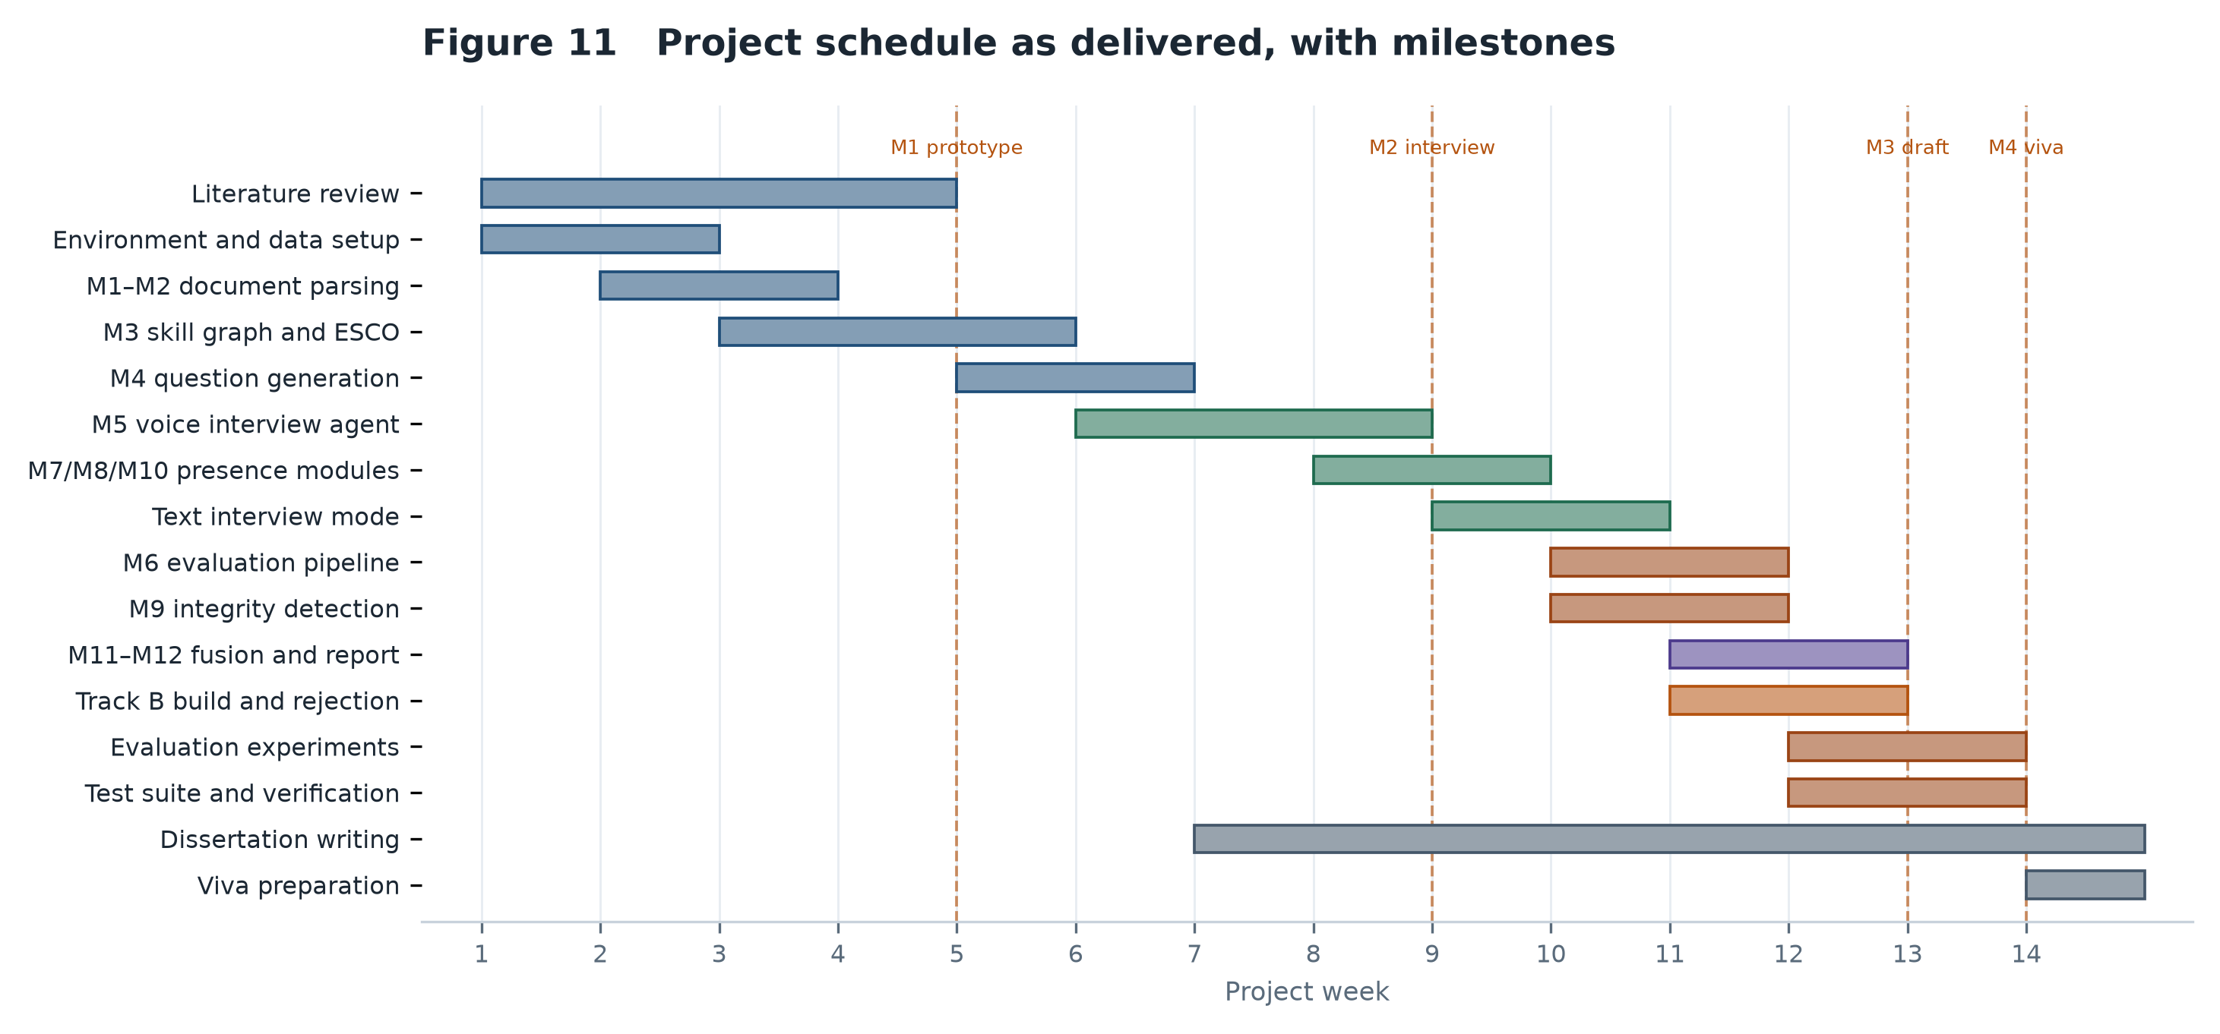
Figure 11 Project schedule as delivered, with the four milestones marked.

4. System Design

4.1 Architectural overview
The system is broken down into 12 modules, each in the four ordered phases. It's not just about aesthetics; each module specifies what it accepts as input, and what it provides as output, and it only communicates through those, and it can be developed, deferred, and replaced without affecting its neighbours, which allowed an entire evaluation track to be removed late in the project without any other part of it being affected.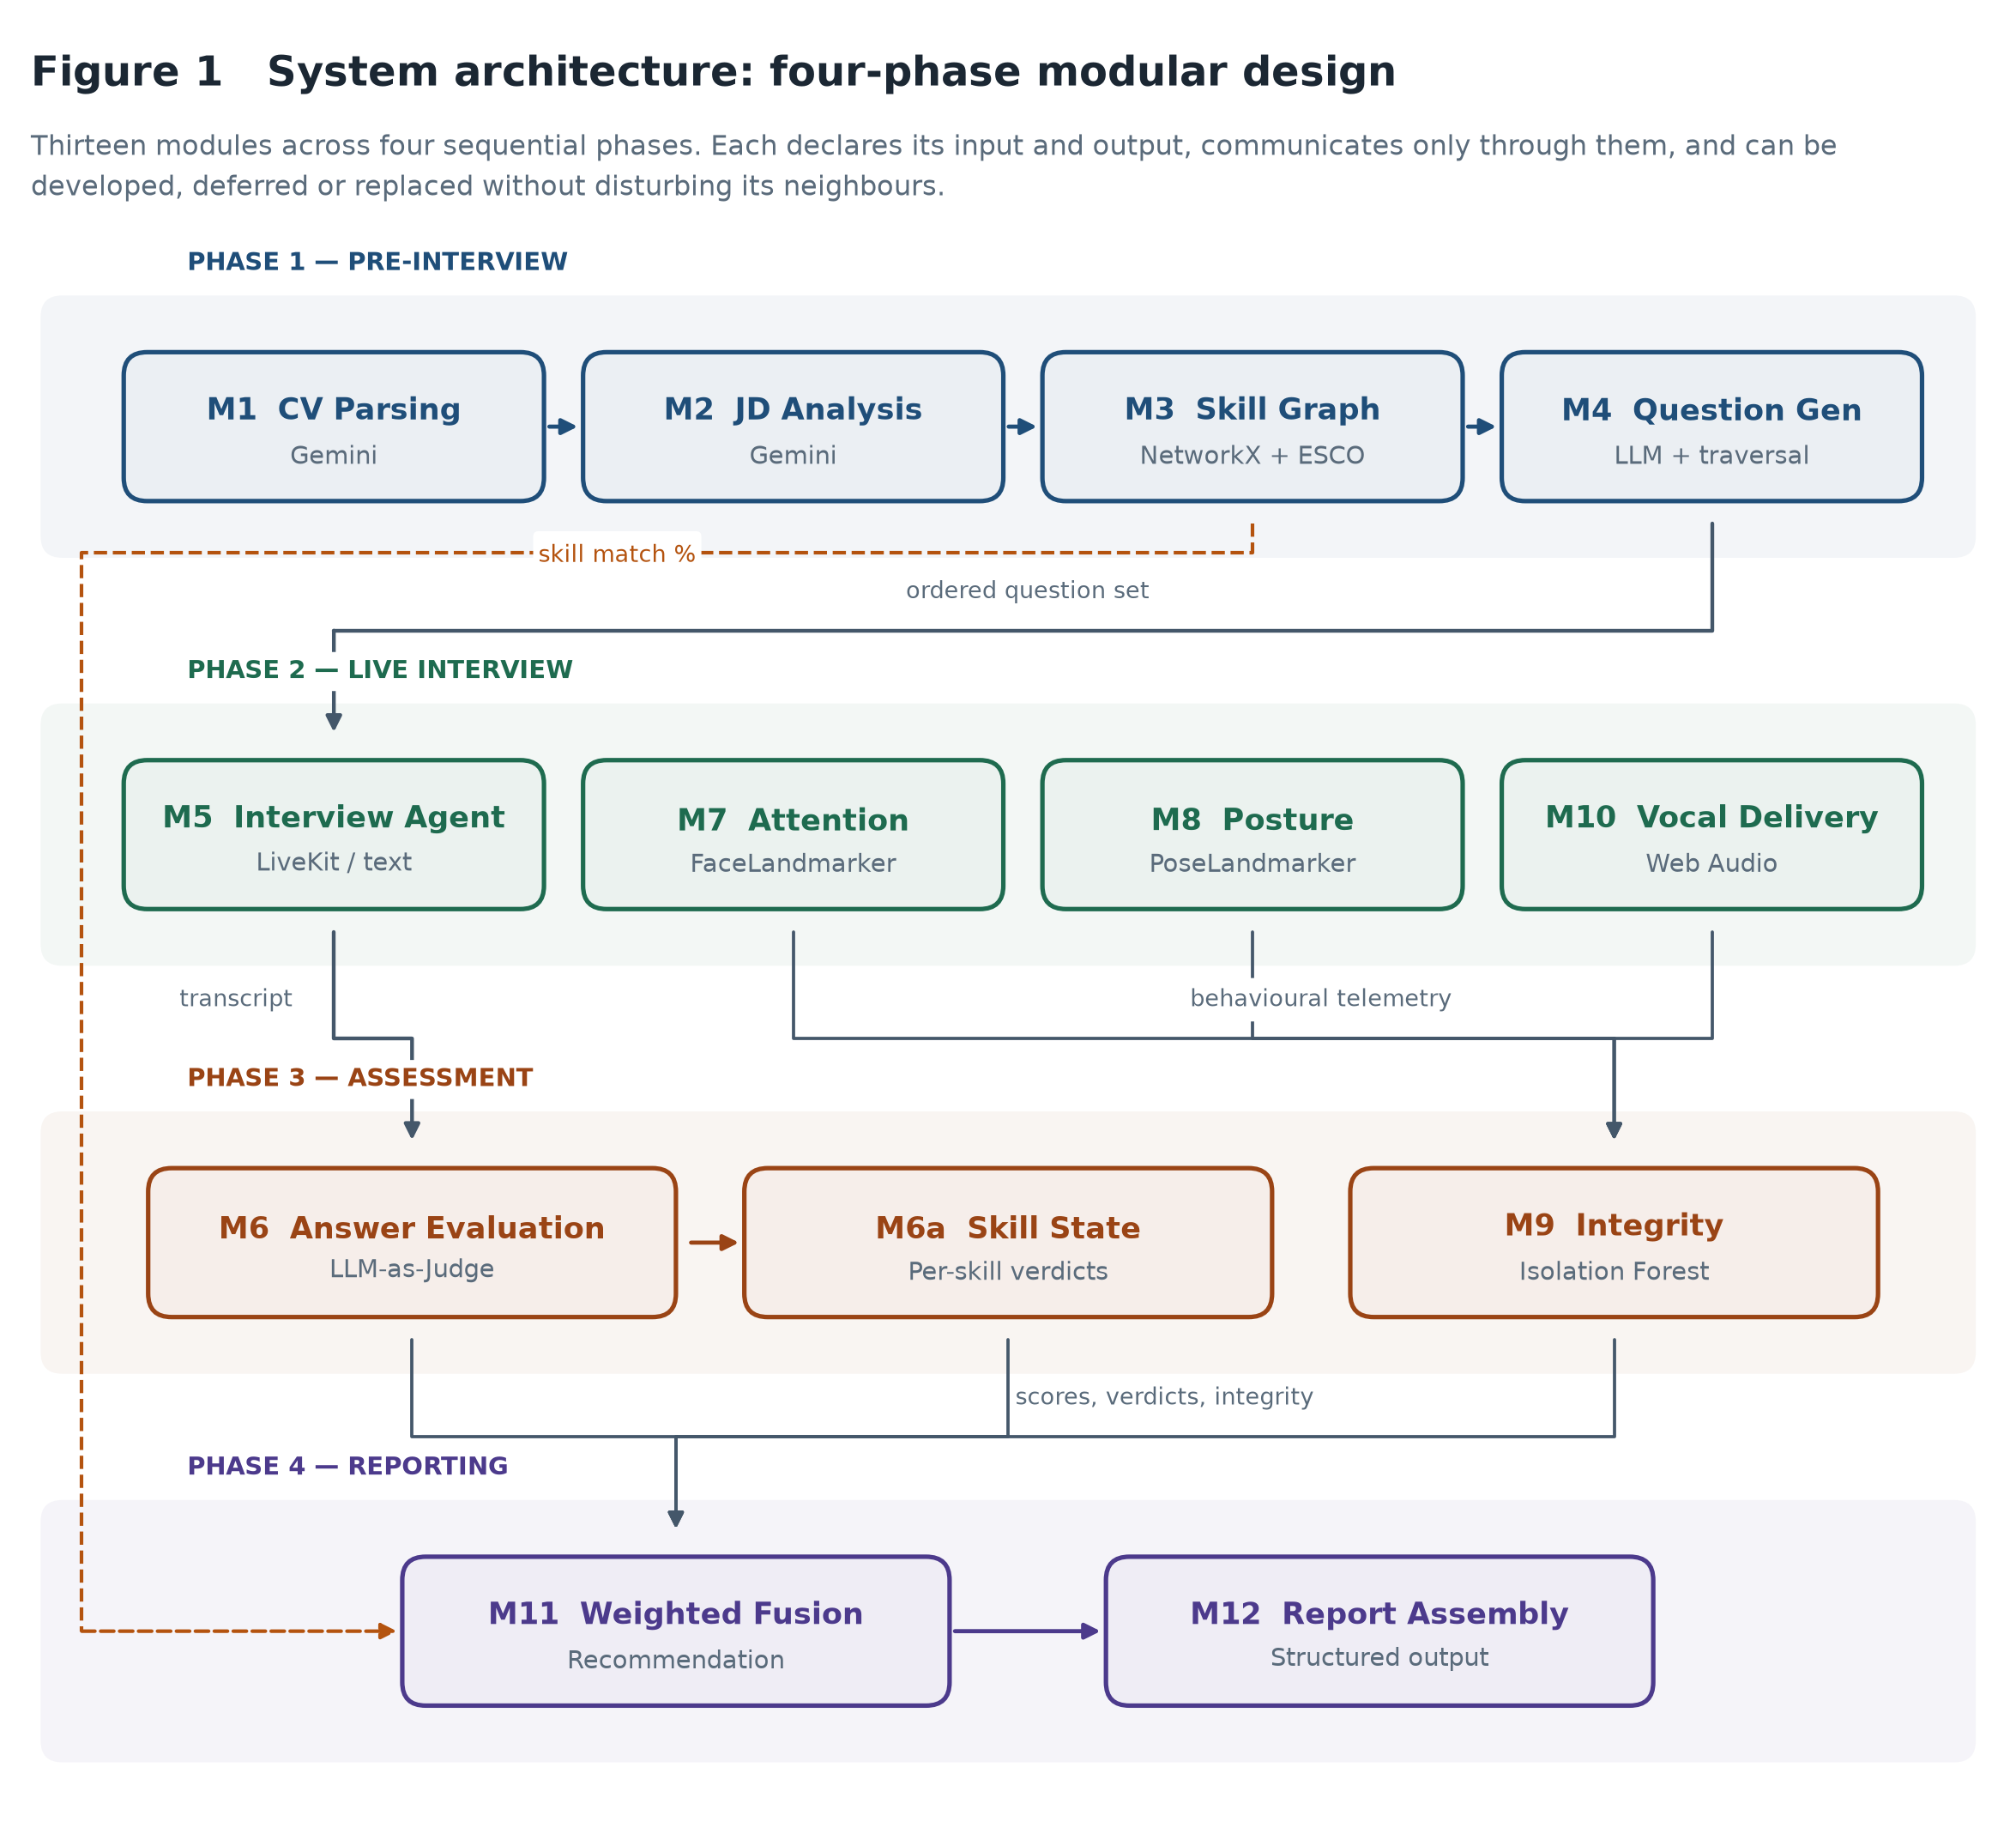
Figure 1 System architecture. Twelve modules across four sequential phases, with the inter-phase data dependencies shown explicitly.

Phase 1 consists of converting unstructured documents to a targeted interview plan, Phase 2 is conducting an interview and observing it, Phase 3 is the evaluation of the interview, and Phase 4 is the reporting of the interview. Phases are data dependent, but not necessarily developed sequentially.

There is one decision that is evident in the figure that deserves comment. In addition to being a preparation step, the skill graph is used in the fusion engine of Phase 4 (as the long-range dependency to the left), and it is a fifth of the final score on its own.

4.2 Module decomposition

All thirteen modules were put into place. Appendix A lists each with its technology, its implementing file and its role. One is different from the proposal: M10 is an emotion classification model using wav2vec2 and it is used as a browser-side prosodic analysis, as explained in Section 7.2.2.

4.3 Data flow and interface contracts
Figure 2 shows a candidate's material moving through the system – from their CV being uploaded to a recommended score.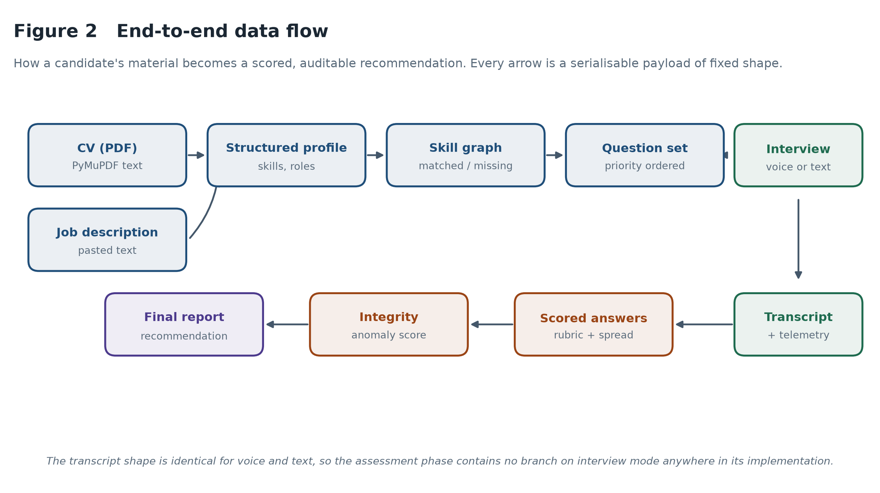
Figure 2 End-to-end data flow. Every arrow is a serialisable payload with a fixed shape, which is what allows modules to be tested in isolation.

The full interface contracts are also listed in Appendix F. The most important one is the transcript: a list of role tagged utterances with timestamps. The interview mode produces this very structure and it is for this reason that in all the implementation of the assessment phase there is no branch on interview mode.

4.4 Skill graph design
The skill graph is a directed graph where the nodes represent the concepts of the skills and the category hubs and the edges of the graph represent the real broader than and containment relationships that are published in ESCO. Skills and role requirements of the candidates are translated onto it, and the set operations between the two populations result in the gap analysis.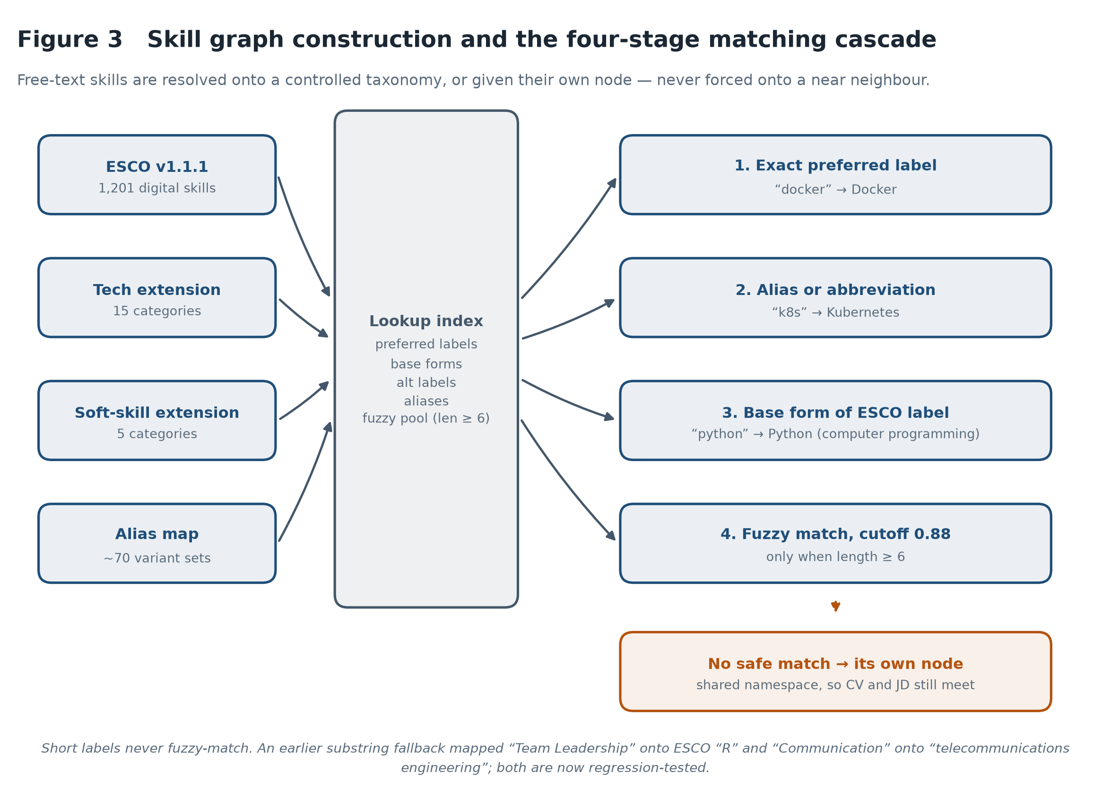
Figure 3 Skill graph construction and the four-stage matching cascade.

It is not a mechanical problem of creating a graph, but mapping a free text onto a controlled vocabulary. A CV reads “k8s” and an advertisement reads “strong communicator”, and the taxonomy is “Communication”. Solving these demands tolerance, the failure of which is a false match — and a false match here results in a confident, specific and incorrect assertion that a candidate isn't a competent in a skill.

The cascade of Figure 3 consequently is intended to be conservative. Preferred-label matches are attempted first, followed by curated aliases, then the root labels of parenthesized ESCO labels, to get to “Python (computer programming)” from “Python”. Fuzzy matching is reserved as a last resort and will only be used for strings of length at least six and similarity of at least 0.88. There should not be any variation in the short label at all: Fuzzy matching on two character strings is simply meaningless, which was how the previous “Team Leadership” concept mapped to the ESCO concept “R”.

The skill is added as a skill node if no skills match its description safely, instead of being inserted into a neighbour's skill description. These unmatched nodes are matched with one namespace on both CV and JD, therefore when a technology ESCO (one who hasn't heard of it before) shows up on both sides, it registers as a match. Not guessing is not a fault but the right way to do it.

4.5 Question generation and graph traversal

The gap analysis results in a prioritized list of topics – skills claimed on the CV are assumed to be of medium priority and investigated to check the depth of the candidate's knowledge and skills, while skills the candidate does not evidence are high priority. This list is sent to the question generator, which returns a structured list that contains opening, technical, behavioural and closing parts to it.

The step for traversing is not as insignificant as it may seem. Questions are returned in any order by a model, and there is a time budget for each interview, meaning that if a question is slipped at the end, it will not be included in the interview. Therefore, the system re-sorts technical questions by the priority the graph gave to its skill; and the budget is spent on real gaps first. This is the actual content of Objective 2 — the targeting is done according to the graph, not the order of emissions.

4.6 Interview transport design
There are two ways of delivering the product. Voice mode: This is a spoken dialogue using WebRTC, which also functions as a dialogue as typed exchanges. They are given the interviewer's directions, question bank, question and time budget, and off-topic candidate and session closure rules. The only difference is the transport.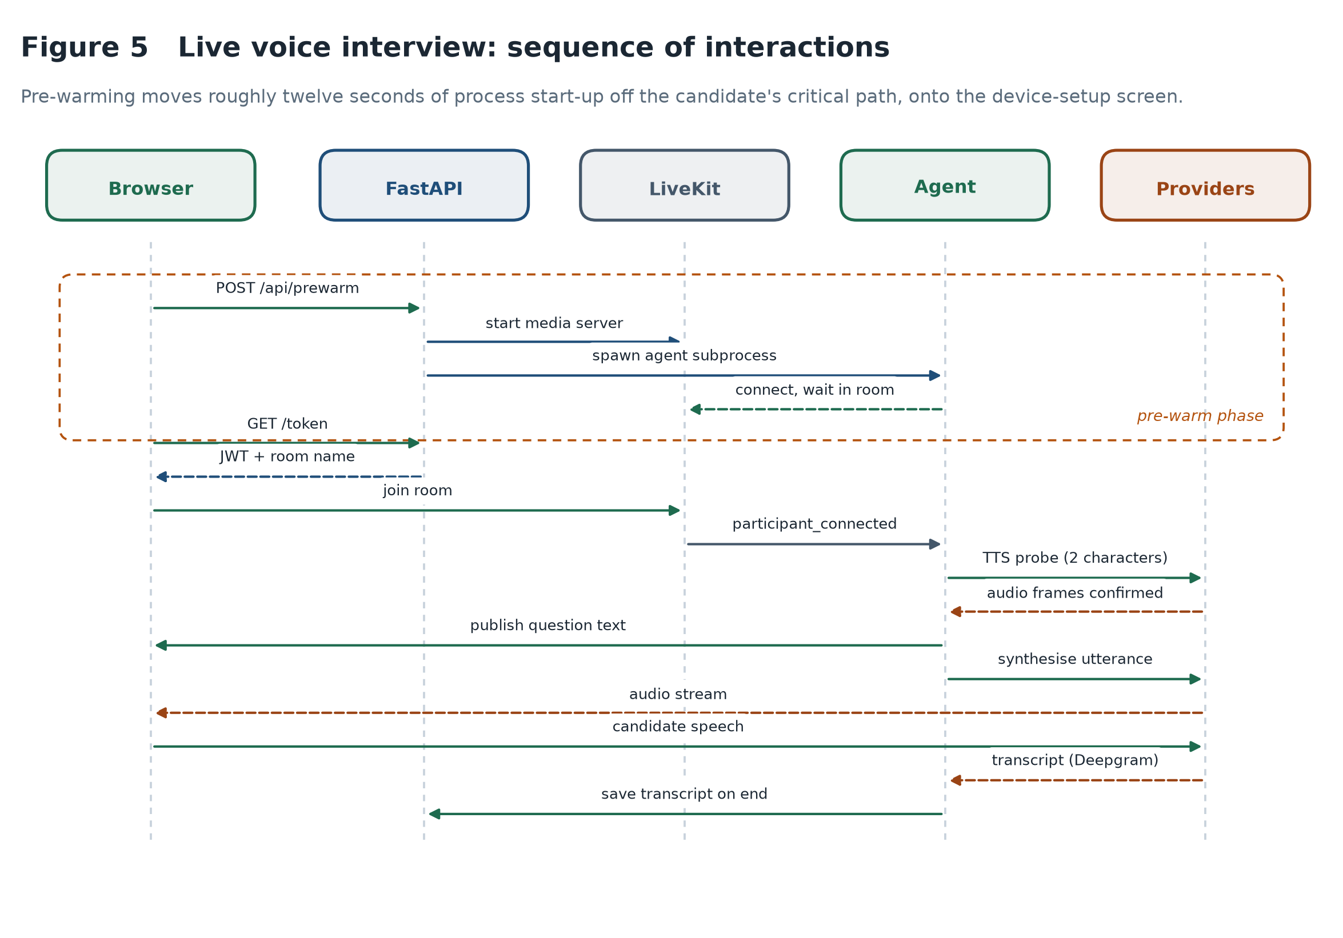
Figure 5 Sequence of interactions in a live voice interview, including the pre-warm phase that removes process start-up from the candidate's critical path.

The rationale behind this design choice is that having two copies of the instructions to the interviewers would cause them to tune them differently, leading to a comparison of candidates that have been assessed under slightly different conditions. The only mode-specific difference is that for spoken responses, the answers are short; for written responses, they are long.

The pre-warm boxed area in Figure 5 is not a functionality problem, but a latency issue. The first twelve seconds or so have to wait for the media server to start up and the agent subprocess to import the agent framework and its plugins. After the candidate pushes this “Begin Interview” button, this is the most nervous part of the interview, where she listens for 12 seconds, after which she will get paid. When the candidate is checking the device's camera, moving it to the device-setup screen will conceal it completely.

4.7 Evaluation pipeline design
The design of the centrepiece contribution of the project is directly linked to the conceptual framework presented in Section 2.6 and is presented in Module 6.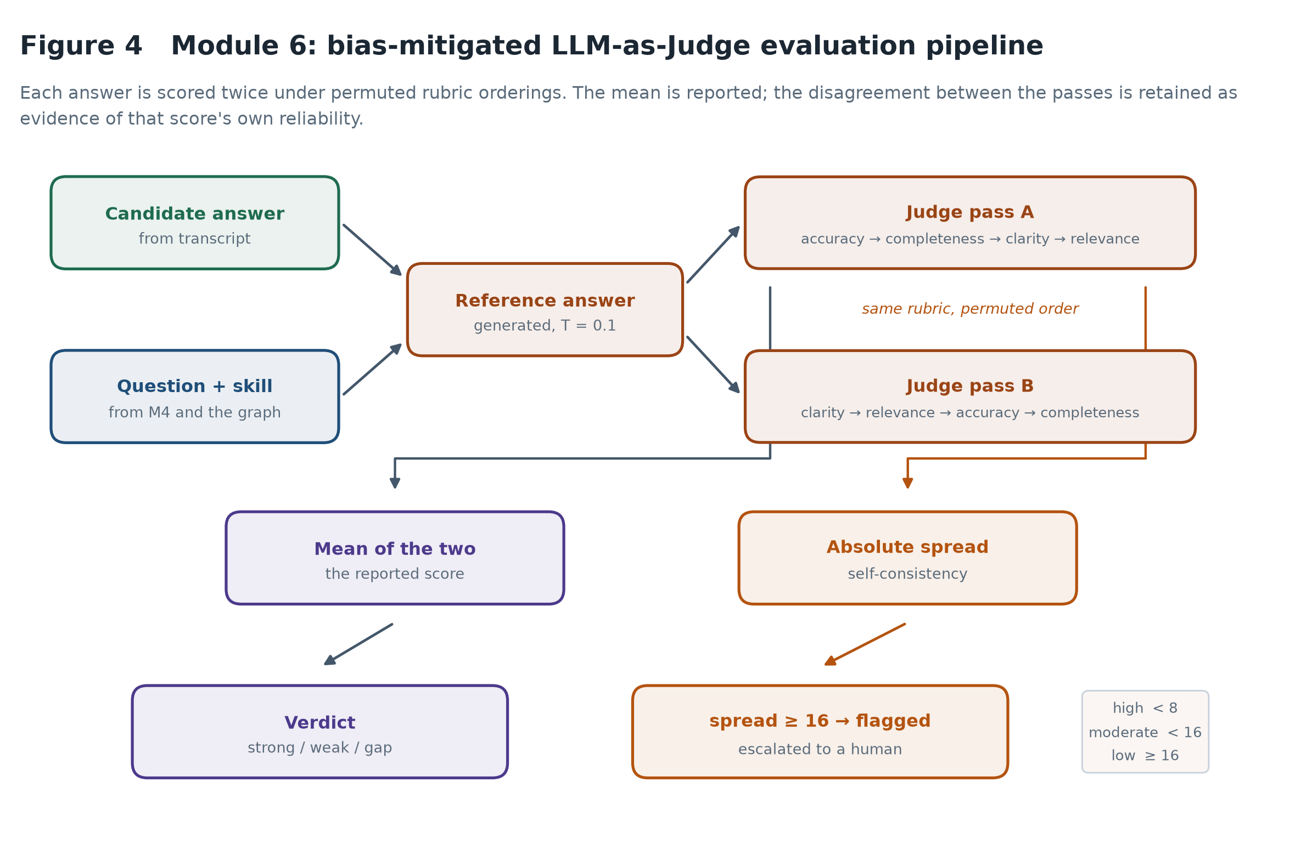
Figure 4 The evaluation pipeline, from a transcribed answer through to a verdict and, where the two passes disagree, an escalation.
Every answer is accompanied by a reference answer created in response to the same question, providing the judge with a concrete standard and not an abstract notion of "quality. The reference is not set out as a text to be reproduced, but as what a strong answer will include, as this is what will be penalised for if the candidate is right, but in their own words.
The responses are then judged twice on a four criterion rubric with the criteria in two different orders. The criteria and guidance attached to each are provided in Table 4.
Criterion | Marks | Scoring guidance
Technical accuracy | 0–25 | Deduct only for statements that are wrong or misleading. Omissions belong to completeness.
Completeness | 0–25 | Deduct only for genuinely important missing concepts. Brevity is not penalised.
Clarity | 0–25 | Is the answer well structured and easy to follow?
Relevance | 0–25 | Does it address the question actually asked?
Table 4 Rubric criteria and scoring guidance. The separation of accuracy from completeness is deliberate: a short answer containing nothing incorrect should score highly on the former and may legitimately score lower on the latter.

The two passes are averaged, eliminating the presentation order effect. What happens to be more helpful is their disaccord. The mean of 58 hides both of them, 82 and 81 are stable, while 71 and 45 aren't. The spread is thus kept high, moderate or low and low-band answers are marked up for human checking and not counted as confident bands. This is the way the system is responsible for its own reliability.

4.8 Fusion and reporting design

The Fusion engine consolidates 4 elements into one recommendation. The weights shown in Figure 6 are determined and can be found on the report itself.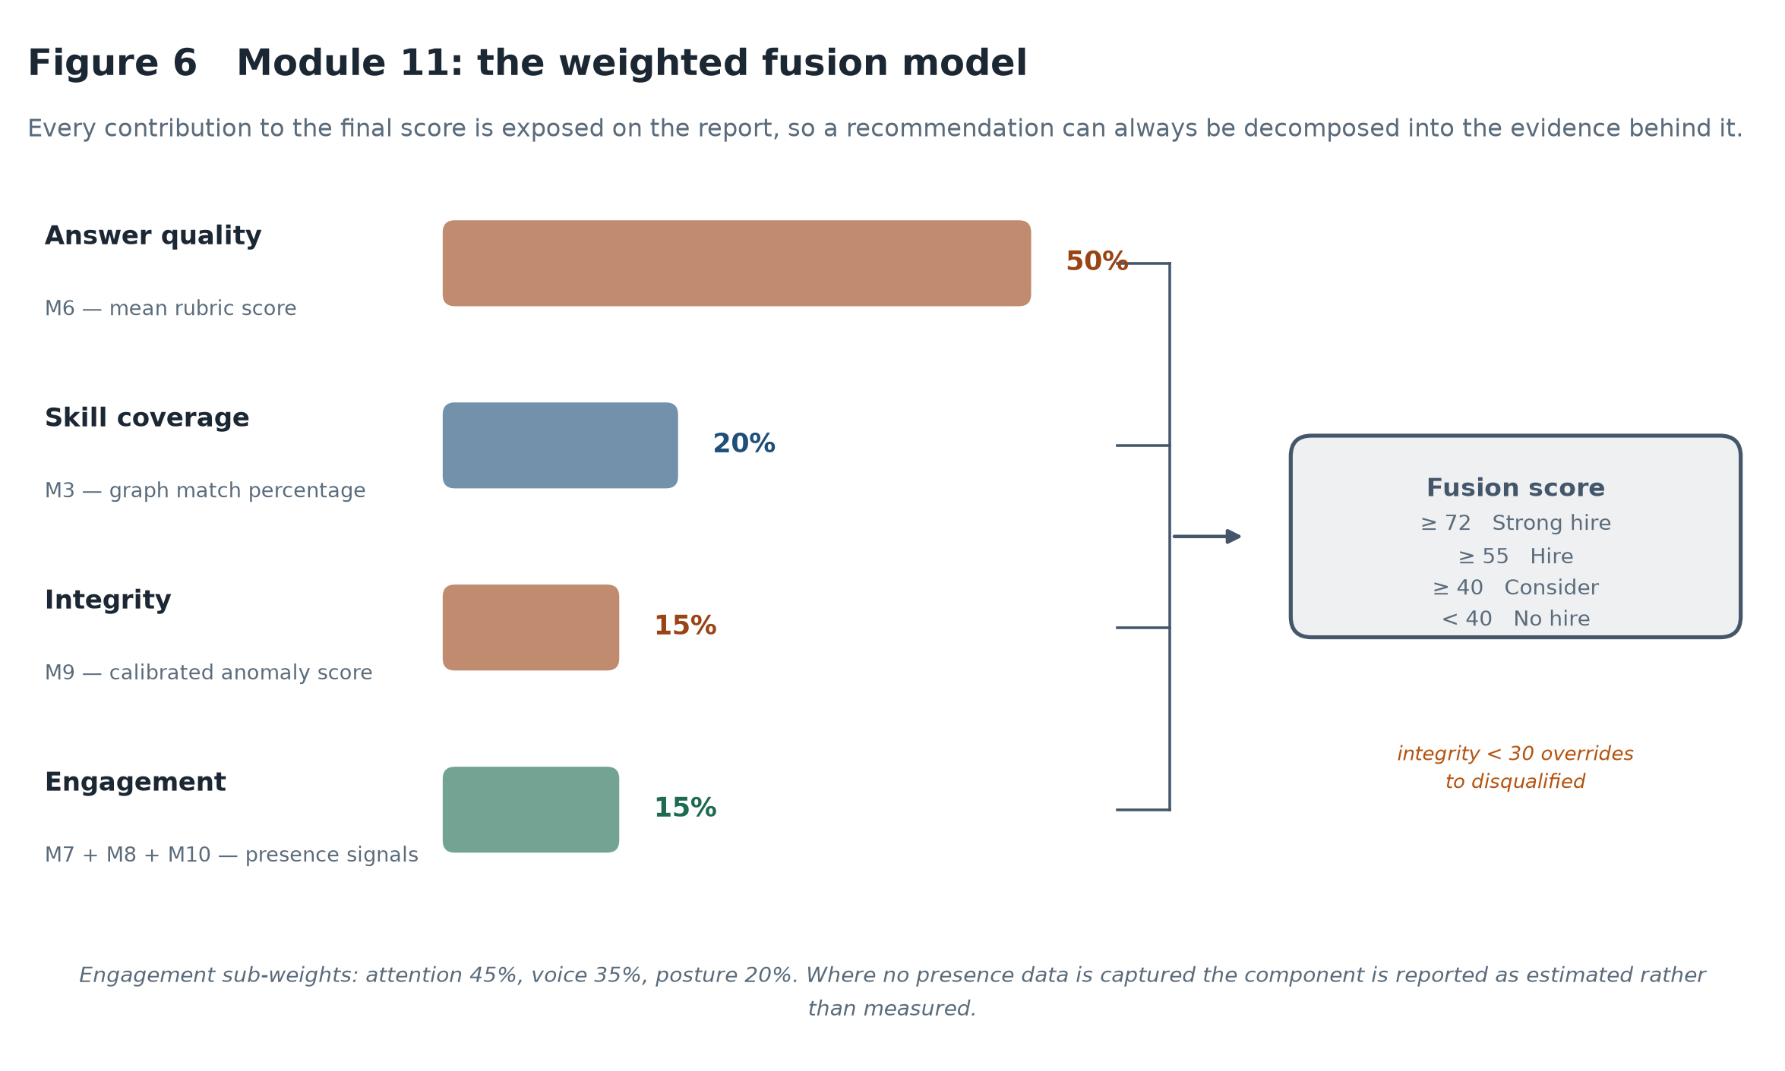
Figure 6 The weighted fusion model, with every component's contribution exposed.

The weighting does not represent convenience but is based on a judgment of the evidential quality. If the candidate actually says it, it is half as many points because it's the easiest evidence of competence to come by. Skilled coverage carries a fifth: A CV is a less strong evidence than demonstrated answer but it is not nothing. The two are split between integrity and engagement, each contributing fifteen per cent, but on purpose, since both depend on signals of inference that are prone to being misinterpreted.

One override exists. When the integrity score is less than thirty, the recommendation is disqualified, even if the other components are better, because if the session's behavior cannot be trusted then the answers from the session cannot be trusted either. The only part of the system where a module can override the others is this one and it’s on purpose and very hard to trigger.

Each number on the report is broken down: number components (weighted next to raw score); rubric breakdown and reference answer for each response; judge consistency band; behaviours for integrity finding. A recruiter should never come across a number that cannot be traced.

4.9 Critical assessment of the tools selected
Each major tool selection comes with its own trade-offs and trade-ups, and Table 3 documents both these trade-offs and trade-ups, not just the series of obviously correct tool selections.
Tool | Why selected | Weakness accepted
Gemini 2.5 Flash | Strong instruction-following, JSON-constrained output, generous free tier | Non-deterministic; a reasoning model, so latency and token cost are high; external dependency
ESCO v1.1.1 | Published EU standard; stable concept identifiers; explicit hierarchy | Predates the modern technology stack; sparse on soft skills; required extension
NetworkX | Simple, well documented, adequate for graphs of this size | In-memory only; would not scale to a multi-tenant deployment
LiveKit | Production-grade WebRTC; agent framework handles turn-taking and interruption | Heavy dependency; ~12 s process start-up; adds a server to the deployment
MediaPipe Tasks Vision | Runs in-browser, so no video leaves the device; no inference cost | Requires WebAssembly and ideally GPU; degrades on older browsers
Web Audio prosody (M10) | Fully inspectable features; no model download; offline | A proxy for emotion, not a classifier; weaker than a trained model at that task
Isolation Forest | Needs no labelled anomalies; fast; deterministic under a fixed seed | Baseline is synthetic; no measured false-positive rate against real sessions
Table 3 Strengths and weaknesses of the principal tools selected.

Two of these resulted in results that are reported below. A reasoning model provides greater rubric adherence, but requires the use of reasoning tokens for every score, so Chapter 6 uses a relatively small sample size. The in-browser vision pipeline is selected for privacy reasons and will not generate anything on an unsupported browser, so the fusion engine needs to differentiate between an actual engagement score and an estimated engagement score.

5. Implementation

5.1 Technology stack and repository structure
Implementation is made up of 5464 lines of Python and 4078 lines of JavaScript (excluding dependencies and generated assets). The figures are based on the repository when this document is published. The backend is structure around module responsibility, not technical layer, and consequently, the relationship between the design in Chapter 4 and the code is straightforward: A reader looking for Module 6 will find it in core/evaluator/answer_judge.py.
 | Module | Implemented in | Lines
M1 | CV parsing | cv_parser.py | 30
M2 | Job description parsing | jd_parser.py | 20
M3 | Skill graph and matching | skill_graph.py | 497
M4 | Question generation | question_generator.py | 125
M5 | Voice interview agent | voice_agent.py | 497
M5t | Text interview engine | text_interview.py | 172
M6 | Answer judge | answer_judge.py | 194
M6a | Skill state tracker | skill_state.py | 90
M7/M8 | Attention and posture | vision.js | 279
M9 | Behavioural integrity | behavioural_integrity.py | 183
M10 | Vocal delivery | voice.js | 162
M11 | Weighted fusion | score_fusion.py | 186
M12 | Report assembly | report_builder.py | 140
 | Total across the thirteen modules |  | 2,575
Table 5 Each design module and the file implementing it. Line counts exclude blank lines and comments, and are measured at build time.
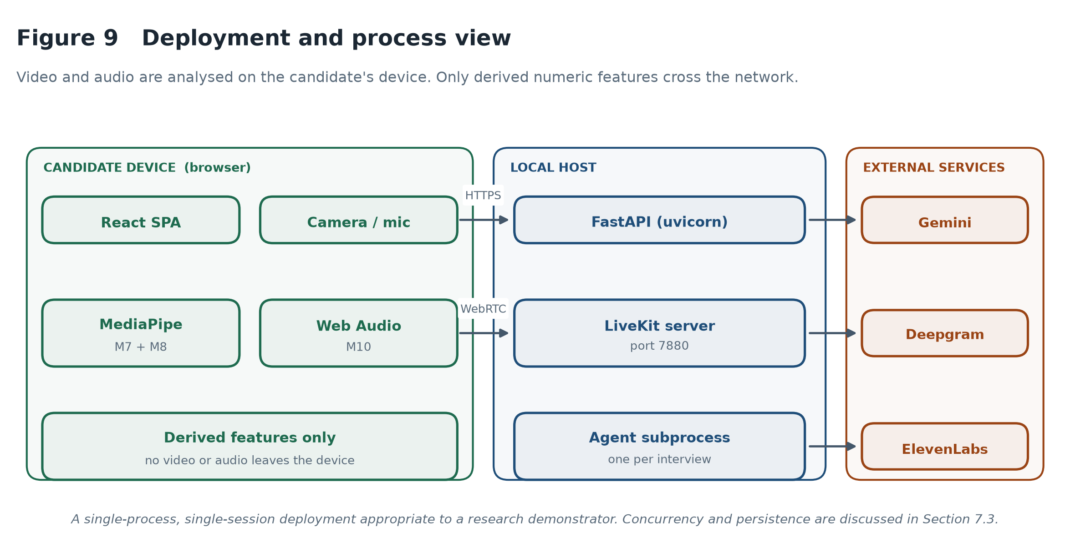
Figure 9 Deployment and process view. Video and audio are analysed on the candidate's device; only derived numeric features cross the network.

The deployment is single-process and single-session suitable only for a research demonstrator and not for anything else. The consequences are clearly stated in Section 7.3.

5.2 Document understanding (M1, M2)

The language model is fed text generated by CV parsing from an uploaded pdf file, using schema-constrained prompt to extract name, contact details, summary, skills, experience, education and projects. The parsing of the job description is the same, taking out the job title, required skills, nice to have skills, responsibilities, seniority level, domain, and expected experience.

In reality, the problem with schema-constrained generation is that models occasionally produce malformed JSON; either a trailing comma, an unterminated string or an entire object inside a markdown fence. The client however, does not fail but removes the fences, tries to perform a strict parse and falls back to a repair pass. This is not pretty and this is the difference between a demo that works and one that doesn't in front of an examiner.

The system does not report on image-based PDFs since there is no text to extract from them – which was beyond the scope.

5.3 The skill graph (M3)

The graph is created on the basis of two exports of the ESCO in CSV format: the first contains the set of digital skills (1,201 digital skill concepts) and the preferred and alternative labels, the second contains the hierarchy. The ESCO broader-concept field is compiled into category hubs, so that the interface can meaningfully group the skills.

Two extra taxonomies are added to ESCO at its thinnest point. The technology extension includes 15 categories of technology that are not covered extensively by soft-skill extensions, while the soft-skill extension includes 5 categories that are addressed, but not extensively by technology extensions. Extension labels are preferred in the lookup index for obvious reasons: “Docker” is the recognisable name of the concept, but not “ESCO”.

Aliases are mapped in a map of about 70 entries that are the normal abbreviations and spelling variations used on a real CV such as k8s, postgres, nodejs, sklearn, ci/cd, amazon web services. Aliases are indexed individually, and cannot ever be used to match an exact preferred-label, which would cause the taxonomy to be ignored by a curated shortcut.

5.3.1 The matching failure and its correction
The first implementation included a substring fall back: If no match was found, any taxonomy label appearing in the input string was accepted. This superficially makes sense and is damaging. The ESCO concept is “R” which is a substring of “Team Leadership”. “Communication” is included in the term “telecommunications engineering”. The graph was drawn without error and the gap analysis reported confident, specific and wrong conclusions.
The fix was to drop the fall back completely and only allow fuzzy matching for strings of at least 6 characters where the similarity level had to be 0.88 and above. The following is a recap of the original failures, which are now regression tests: “Team Leadership” resolves to "team leadership" as a concept; and “Communication” does not resolve to anything that contains “telecommunication”.
The general lesson that the dissertation comes back to in Chapter 7 is that the "silent failures" that are so dangerous in this system are the ones to be avoided. An exception is displayed. Not a possible incorrect response is not.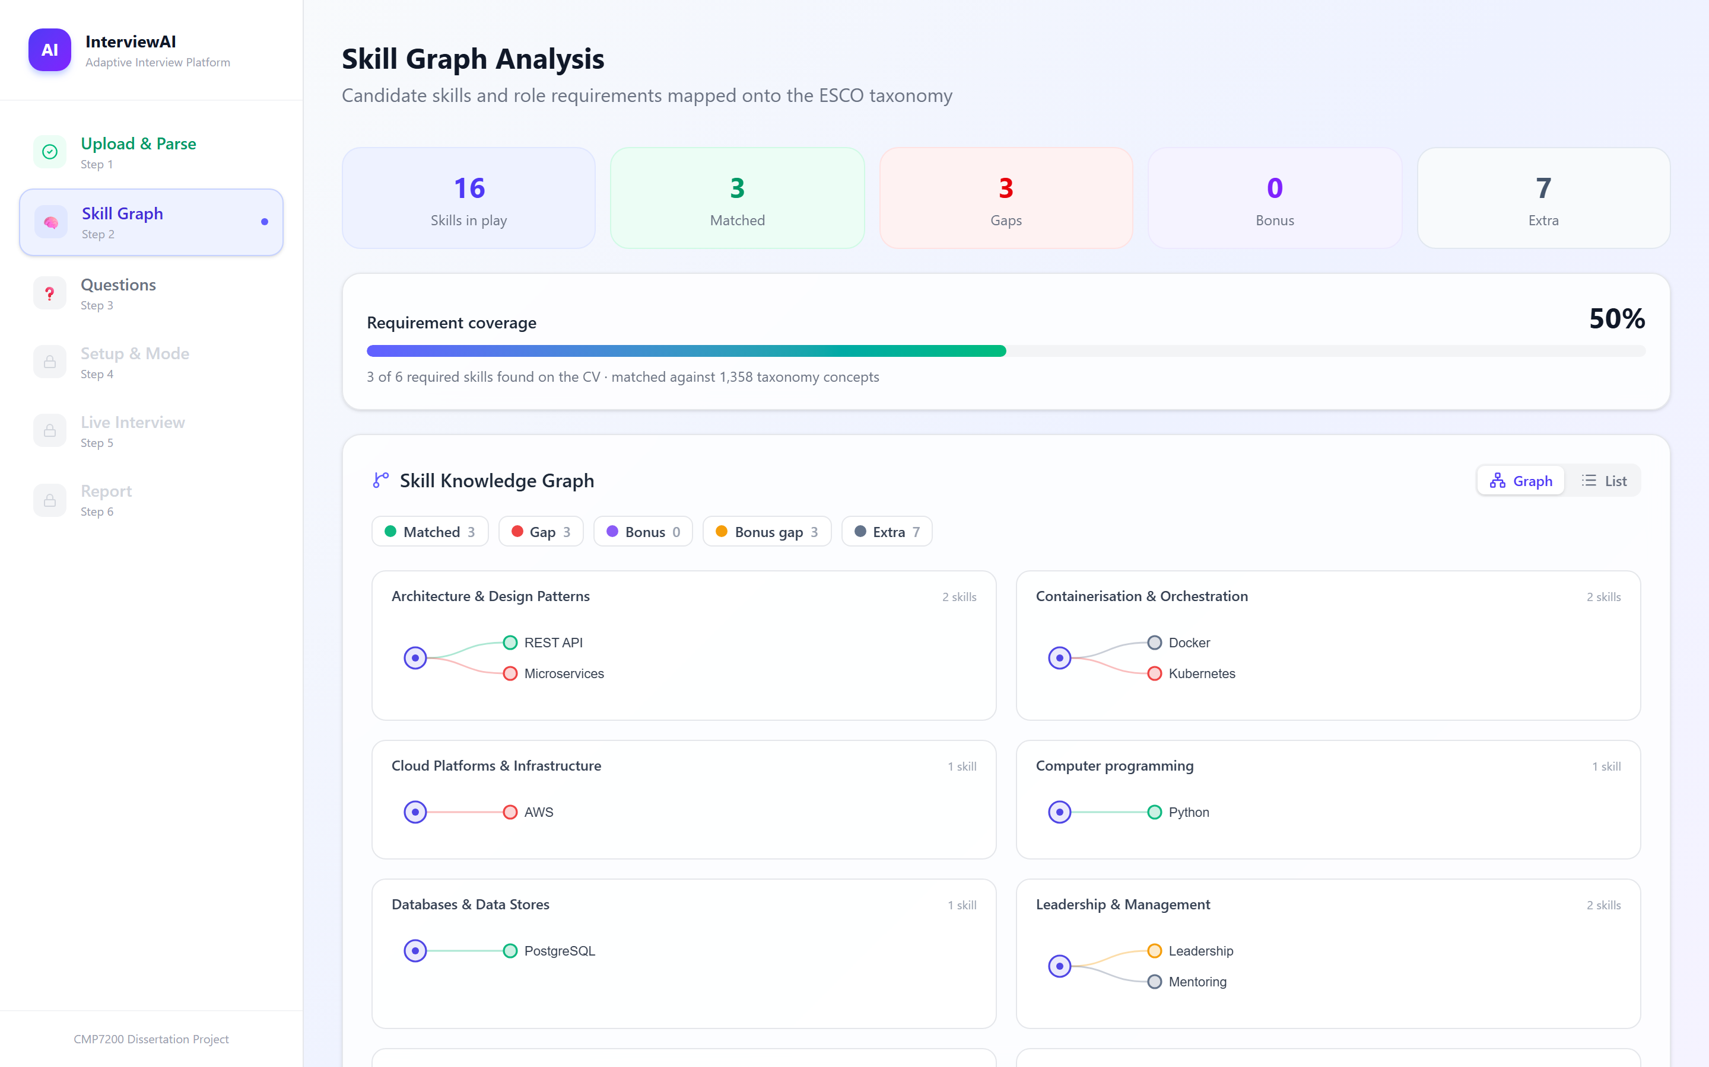
Figure 17 The skill graph as built for a real pair of documents. Three of six required skills were evidenced on the CV; Kubernetes, AWS and Microservices are reported as gaps against 1,358 matched taxonomy concepts.

5.4 Question generation and ordering (M4)
The generator is used to generate a structured set of questions: Two opening questions, 2-3 technical questions for a high priority topic, 1-2 technical questions for a medium priority topic, 3 STAR questions, and 2 closing questions.
The flattening step will re-sort technical questions by graph priority prior to the start of the interview, with higher priority gaps coming first. The graph-related questions are followed by the questions that are not related to the graph but the skill level is recognized by the graph. These unit tests make this assertion with the fixture in which emission order is opposite to priority order.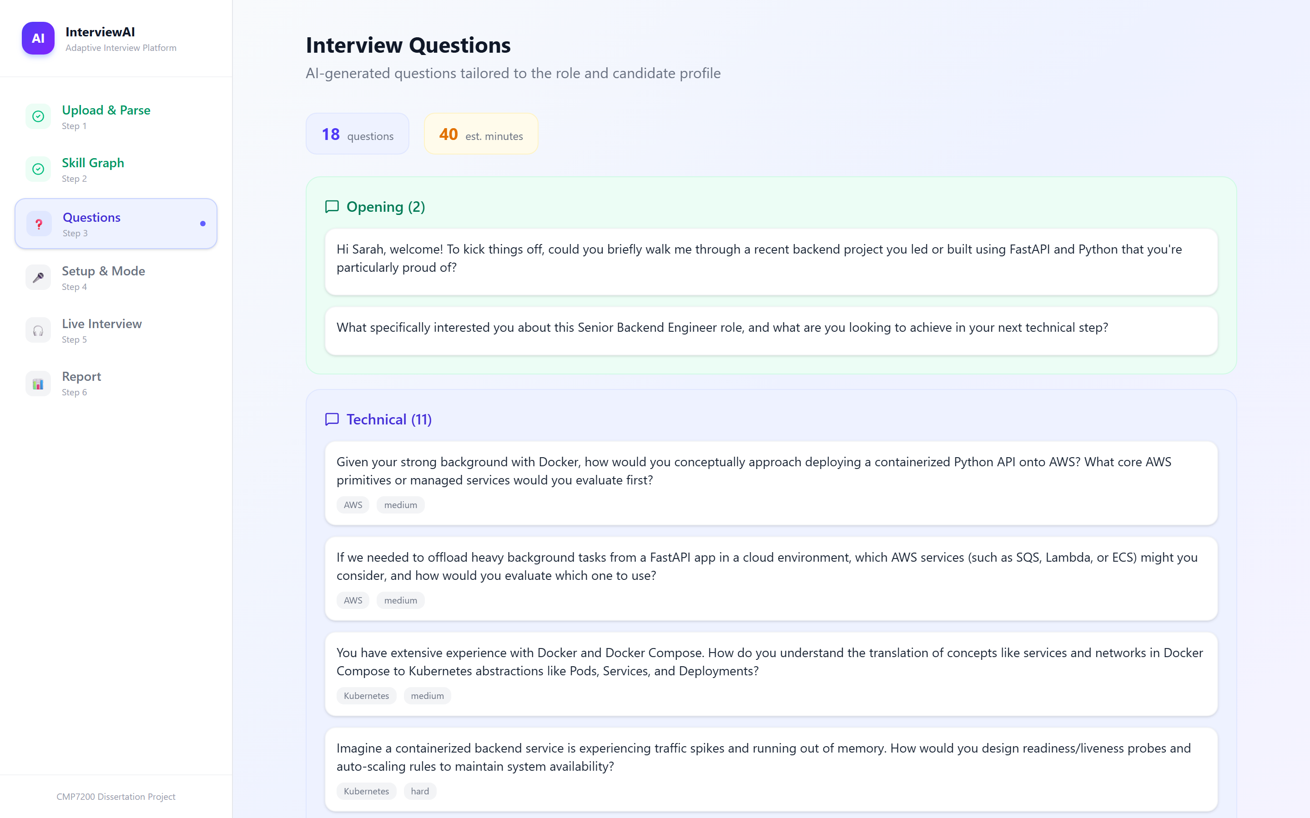
Figure 18 Generated questions for the same pair of documents. Each technical question carries the skill it targets and a difficulty; the AWS and Kubernetes questions are those the graph identified as gaps, which is Objective 2 operating end to end.

5.5 The voice interview agent (M5)

The agent is a subprocess that is linked to a LiveKit room, which manages speech recognition, language model inference, and speech synthesis. There are three implementation issues to note.

5.5.1 Truncated speech

When the model's token stream was piped straight into the synthesis socket, audio was cut off after a few words, but the entire text would still be displayed on screen. Having a buffer of each full sentence, and then synthesizing it, adds some latency and some control and reliability over ordering—question goes to the interface, then is spoken a bit later after the buffer, so if the question is misheard, the candidate can still read it.

5.5.2 The silent provider

A failure was more subtle if the agent said the greeting and then didn't speak. The quota has been exhausted, and an exhausted quota will accept the connection and return no audio (which is not distinguishable from a successful connection unless the frames are examined). A startup probe is now pushing two characters into the engine, confirming that audio returns prior to the interview, then the alternate provider (or failing that, it falls through to the other provider) and running only text, with questions still displayed. The interview doesn't go sideways, it just takes a turn for the worse.

5.5.3 Process lifecycle on Windows

Terminating the agent subprocess did not stop it: the Python executable is a redirector that spawns a second process, terminating it will orphan it, which will remain connected and interfere with the next process start. What was needed was to kill the whole process tree.

5.6 Text interview mode

The same interview is implemented in text mode on a request-response transport. Class contains transcript, a clock, the number of questions, and emits an end marker that the server removes before showing to the user.

Two details matter. The voice agent's transcript is structurally identical to the voice agent's, so there's no need to branch on mode for the assessment pipeline; and if the minimum question count was not capped, it would never exceed the max question count in a run, which is set by the voice agent. In addition, a signal not possible in voice mode, a paste event in the answer box is recorded and appears on the report.

5.7 Answer evaluation (M6)

The pipeline matches the transcript using Q&A pairs and categorizes, scores and summarizes each pair of exchanges for the content.

The process of pairing is not as simple as it may seem. The interviewer can ask a question in two turns, the candidate can answer a question in three turns. Consequences: Two consecutive turns from the same speaker will be combined (so a question split by a pause will still produce one exchange), and any trailing unanswered questions will be dropped. There are six unit tests relating to these scenarios, one of which is a candidate speaking in front of the interviewer.

Labels all exchanges as technical, behavioural or logistics in one model call for the whole session. Logistics exchanges are not scored as they would get a zero against the technical rubric which would have no meaning in making the average. Evaluation will never require the keyword fallback to work.

Scoring is carried out as outlined in Section 4.7; two reference responses are created, two of which are scored twice using different rubric orderings, the mean is calculated and the spread is retained. One detail matters. The judge gives 4 marks out of 10, and a total, and the implementation takes the marks and ignores the arithmetic of the model — if it is not within 2 marks of the total, the mark goes to the implementation. Models cannot be trusted in addition as they are in judging.

5.8 Presence modules (M7, M8, M10)

Attention and posture are computed based on MediaPipe landmarks in the browser. Attention chooses the geometric ratios, the horizontal and vertical distance of the nose from the midpoint of the eyes, normalized by the distance between the eyes, and not the actual transformation matrix, because it is stable from camera to camera, and can be explained/described in text.

They're both based on a baseline recorded when the candidate is settling into their pose, so they both measure how much the candidate deviates from their own baseline pose.

Vocal delivery takes the place of the proposed wav2vec2 emotion classifier, using the following prosodic features computed locally: root-mean-square energy, fundamental frequency computed using bounded autocorrelation (only in the human speech range) and voiced-frame ratio. These combine into the components of projection, fluency and expression and composure. This particular substitution is justified in Section 7.2; briefly, all of its parts here are examinable, whereas an emotion label is not.

5.9 Behavioural integrity (M9)

This module was designed to calculate 8 features from session timing and telemetry data to be scored by a synthetic baseline of 400 normal sessions using Isolation Forest.

There were two factors that decided whether or not the module was usable. The first is what response time means: If it's measured from the moment the question was started until the time it was answered, it's 20 to 60 seconds, but if it's measured from the moment the question was started until it was answered, with an assumption that someone would take 5 to 15 seconds to think about it, and a flag if they didn't, then that's an ordinary session. The second is calibration, the actual decision function itself is opaque and the first and ninety ninth percentile of the baseline correspond to the fifty and hundred percentile respectively, and the version of the bundle is such that an uncalibrated bundle is refitted and not reused silently.

Last but not least, the module never fails to return an adverse verdict without stating a reason. If the pattern is abnormal, but none of the indicators met their threshold, then the pattern indicates that. An unactable flag is worse than no flag.

5.10 Fusion and report assembly (M11, M12)

Fusion is the combination of arithmetic, which is deterministic. All components are scaled between 0 and 100, multiplied by the weight, and then totalled: the total and the breakdown are returned as well, so that the report can display the working. A unit test is used to ensure that the weights and the arithmetic do not separate.

Engagement is built up from the set of signals that were actually detected, their weights are adjusted from the available sources, and they are flagged as measured or estimated. If a browser does not support MediaPipe, it can still report a full result, albeit with a disclaimer.

All of this comes together in one report: overall score and recommendation, per-skill breakdown (worst first, gaps are at the top), per-answer detail (with rubric breakdown and reference answer), integrity assessment (with risk factors), session-level judge reliability statistics.

5.11 Engineering problems encountered
There are three additional problems that are worth noting that did not only cost time, but forced a change in design.
Initially, interruption handling was disabled, for the reason that the candidate shouldn't talk over the interviewer. However, when candidates began to answer while the question was being spoken, this made the framework to ignore the answers they gave, which would be typical conversational patterns. Interruptions were restored with a minimum length and number of words. Live use revealed that it was still too liberally worded: a pause for thought drew the game to a halt at the end of the turn and the remainder of the response coming in mid-reply terminated the question. Two glaring mistakes and one reason — timing for a conversation, not interview responses. Lengthened windows and now agent is resumed in case of apparent interruption with no speech.
Originally, the answers were not accepted if they were too short. This was the actual non-answer which was dropped quietly like, “I have not used that,” which is the exact kind of proof that the recruiter requires. The new threshold is now only for short replies without any content to be evaluated.
Finally, the endpoint's concurrency behavior was counter-intuitive – one sequential call took a total of 2.3 seconds, six calls concurrently took a total of 273.8 seconds. The harness was adjusted to run in a serial mode and the measurement is coded so that the parallelism is not reinstated.

6. Evaluation and Results

6.1 Experimental design
Five controlled experiments, each one varying one factor and keeping the other factors constant.
# | Property tested | Manipulation | Statistic
E1 | Discriminant validity | Answer quality varied across three intended levels | Spearman's rho, quadratic weighted Cohen's kappa
E2 | Positional-bias sensitivity | Rubric criterion order permuted, content held constant | Wilcoxon signed-rank, mean absolute spread
E3 | Paraphrase invariance | Wording varied, semantic content held constant | Within-group standard deviation
E4 | Criterion independence | None — observational across all scored answers | Pearson correlation matrix
E5 | Verbosity sensitivity | Contentless filler appended, content held constant | Wilcoxon signed-rank on paired differences
Table 6 Experimental design summary.

There are 6 technical questions each with 3 intended levels of answers, in the corpus there are 18 graded answers. All answers are twice scored, once for each rubric ordering, meaning that E1, E2 and E4 are based upon the same 18 × 2 judge calls. E3 and E5 do not rescore the same text, but rather use baselines from E1.

The run took 68 API calls (3 errors) in 39 minutes. All judgment was conducted with gemini-2.5-flash, and fixtures were generated independently with gemini-flash-lite-latest, a different type of flash to that used to judge, which lessens the objection that the judge knows their own prose.

The naming aspect is important, as it wasn't part of the project: gemini-2.5-flash was removed from new API keys, soon after these measurements, and the system now uses a newer version. The results therefore refer to gemini-2.5-flash only, not to language-model judges in general (as this external-dependency risk is faced and not expected).

The sample is intentionally small; each answer requires two calls and the endpoint's throttled concurrency sucks. The consequence is in section 6.10.

6.2 Discriminant validity
The first question is whether the judge can distinguish between a good and bad answer. Scoring of the three quality levels was done blind.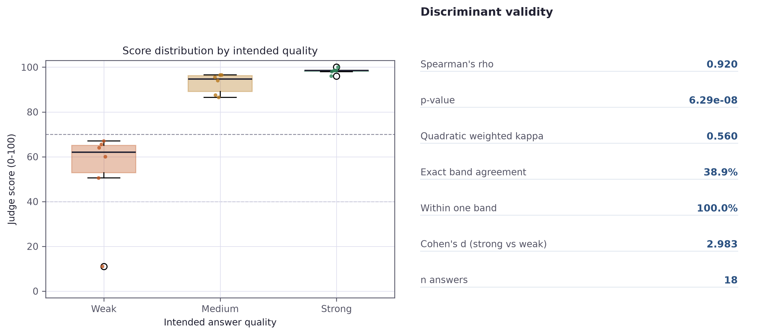
Figure 12 Score distribution by intended answer quality, with the band thresholds the system uses for its verdicts marked.
On rank ordering the result is excellent. The intended quality is correlated with the awarded score by Spearman's rho = 0.920, p < 0.001 and Cohen's d = 2.98, a very large effect. An ordering different from chance is confirmed by a Mann-Whitney test (p = 0.002). The judge rarely elevates a weaker answer, in this corpus, over a stronger one.
Intended quality | n | Mean score | SD | Range
Strong | 6 | 98.25 | 1.29 | 96.0 – 100.0
Medium | 6 | 92.75 | 4.56 | 86.5 – 96.5
Weak | 6 | 53.00 | 21.41 | 11.0 – 67.0
Table 7 Discriminant validity results by intended quality level.

The figures of categorical agreements tell a completely different story and are the most important result of the evaluation. The quadratic weighted Cohen's kappa is only 0.560 and exact agreement between the intended level and the level the system assigns is only 38.9%. All of the answers were in one band of their target level, nothing is radically misplaced, but the bands are misplaced.

The cause is indicated in Table 7. The judge is very gentle in nature. The average scores were 53.0 for answers deliberately weak, 92.8 for answers partially correct and 98.2 for answers strong. Nearly all of the working range of the scale was above 50, and the medium and strong distributions were overlapping: the highest medium answer = 96.5, and the lowest strong answer = 96.0.

This directly and adversely affects the deployed system. The verdict layer classifies any answer from 70 and above as good. Dedicated partially answers can be marked successfully on this evidence, and medium and strong answers will be judged similarly. The scoring model has a lot of score to throw away and the verdict layer throws a lot of that.

6.3 Threshold calibration
As the ordering is sound and only the thresholds are incorrect, in principle it is correctable. The thresholds currently in use are compared with the thresholds suggested by the observed distributions in Table 8.
Boundary | In use | Midpoint of adjacent means | Widest observed gap
Weak / medium | 40 | 72.9 | 76.8 (max lower 67.0, min upper 86.5)
Medium / strong | 70 | 95.5 | none — the distributions overlap
Table 8 Current thresholds against empirically implied boundaries.
An improvement of about 77 exists between weak and medium answers, compared to a 40 threshold that is in force. There is no line between medium and strong, as the two distributions overlap: the judge is not able to make an absolute judgment about the difference between a partially correct answer and an excellent one in this corpus, only a relative one.
This run was used to deliberately not change the thresholds. 18 answers from 6 questions is insufficient evidence to draw any decision criteria for all future candidates, and setting the thresholds on this collection would be the same overfitting that was discussed in other parts of this dissertation. The result does confirm, however, that the current values are indefensible and that a re-calibration with respect to a larger human anchored corpus is the most important next step.
The underlying message is the meaning of the score. If a judge is a comparative judge and a poorly calibrated judge, it is a comparative instrument, rather than an absolute one: it can be used to support the claim that one candidate answered better than another, but not to make a statement that a candidate scored 92 and that is a mark of a standard.

6.4 Positional-bias ablation
Stureborg et al. (2024) find that the presentation order has been shown to affect the language model judges' scores of identical content. All answers here have been given in two rubric orderings to check if there is this effect and to see its size.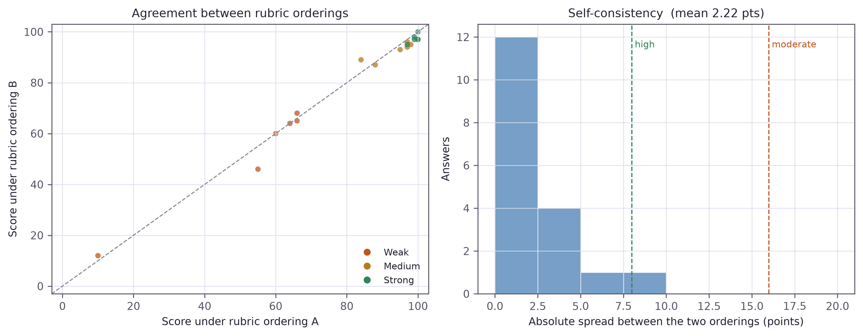
Figure 13 Left: agreement between the two rubric orderings. Right: distribution of the absolute spread between them, with the consistency thresholds marked.

A mean signed difference of +1.222 points favours ordering A across the 18 answers (mean score 81.94 under ordering A, and 80.72 under ordering B). A Wilcoxon signed-rank test yields a p value of 0.067 which is less than the typical threshold. It does have a strong direction, but is not definite enough to resolve the issue and the sample is too small.
Measure | Value
Answers scored under both orderings | 18
Mean signed difference (A − B) | +1.222 points
Mean absolute spread | 2.22 points
Median absolute spread | 2.00 points
Maximum absolute spread | 9.0 points
Wilcoxon signed-rank | p = 0.067
High consistency (spread < 8) | 17
Moderate consistency (8 – 16) | 1
Low consistency (spread ≥ 16) | 0
Escalated to human review | 0.0%
Table 9 Positional-bias ablation results.

This corpus exhibits small per-item instability. The average difference in absolute values between the two orderings was 2.22 points and the largest was 9.0. The 17 of 18 answers were in the high consistency band, with 1 in moderate and 0 in low consistency. There were no answers that were escalated to human review.

The results are null in the escalation mechanism, which is reported as one, and not made an item of success. The instrumentation is warranted by the literature and it is demonstrably in operation: the spread is computed, banded and implemented for each answer, but on this corpus, it was never called into action. There are two readings and these data cannot distinguish between them; either the countermeasure is successful, or machine-written answers are easier to score consistently, and real speech would generate a wider range of answers. The second is poorly evidenced in the worked example in Section 6.9.

6.5 Paraphrase invariance
A candidate who expresses the same understanding in other words should be given the same mark. This experiment reused answers while altering the wording, sentence structure, and order of presentation, but maintaining the technical content of the answers.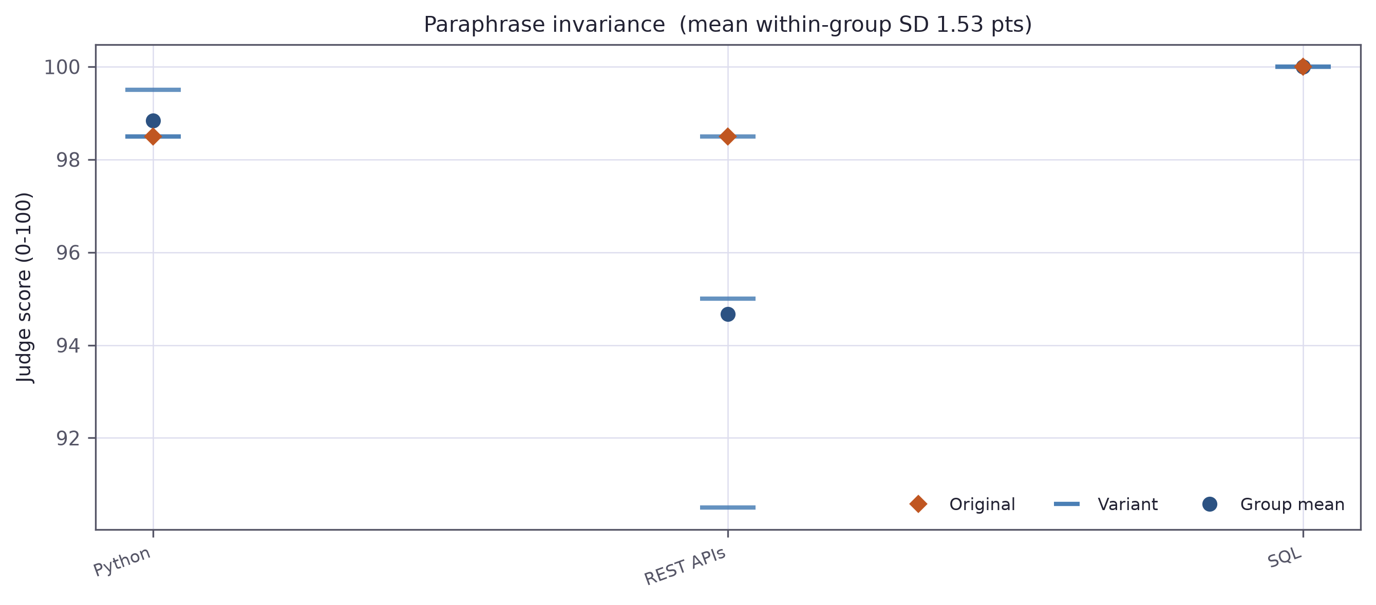
Figure 14 Scores across semantically equivalent rewrites of the same answer.

Within each of 3 groups the mean standard deviation was 1.53 points, the max was 4.01 points and the mean within group range was 3.00 points. It is indeed good news in absolute terms: a reworded answer will score at most points with a few points away from the original answer.
The comparison is to the between-group standard deviation of 2.80 points. All three groups made good answers, and Section 6.2 demonstrated that strong answers were clustered in a four-point range, so within-group noise is thus about half the between-group signal, which sounds rather poor until one realizes it's for a reason. The figure between groups is small, but not because the judge has a poor capacity to distinguish – it's because of the ceiling effect. A "cleaner" version of this experiment would have taken samples from the entire range of quality, not the best of the best, as a direct result of reusing the top strong answers to save API calls.
Question group | Variants | Mean | SD | Range
REST APIs | 3 | 94.67 | 4.01 | 8.0
Python | 3 | 98.83 | 0.58 | 1.0
SQL | 3 | 100.00 | 0.00 | 0.0
Table 10 Paraphrase invariance by question group.

6.6 Criterion independence
The rubric tells the judge to read the four criteria and give them their own score and explicitly says that a lack in one doesn't affect the other. The question of compliance is an empirical matter and here the answer is: No.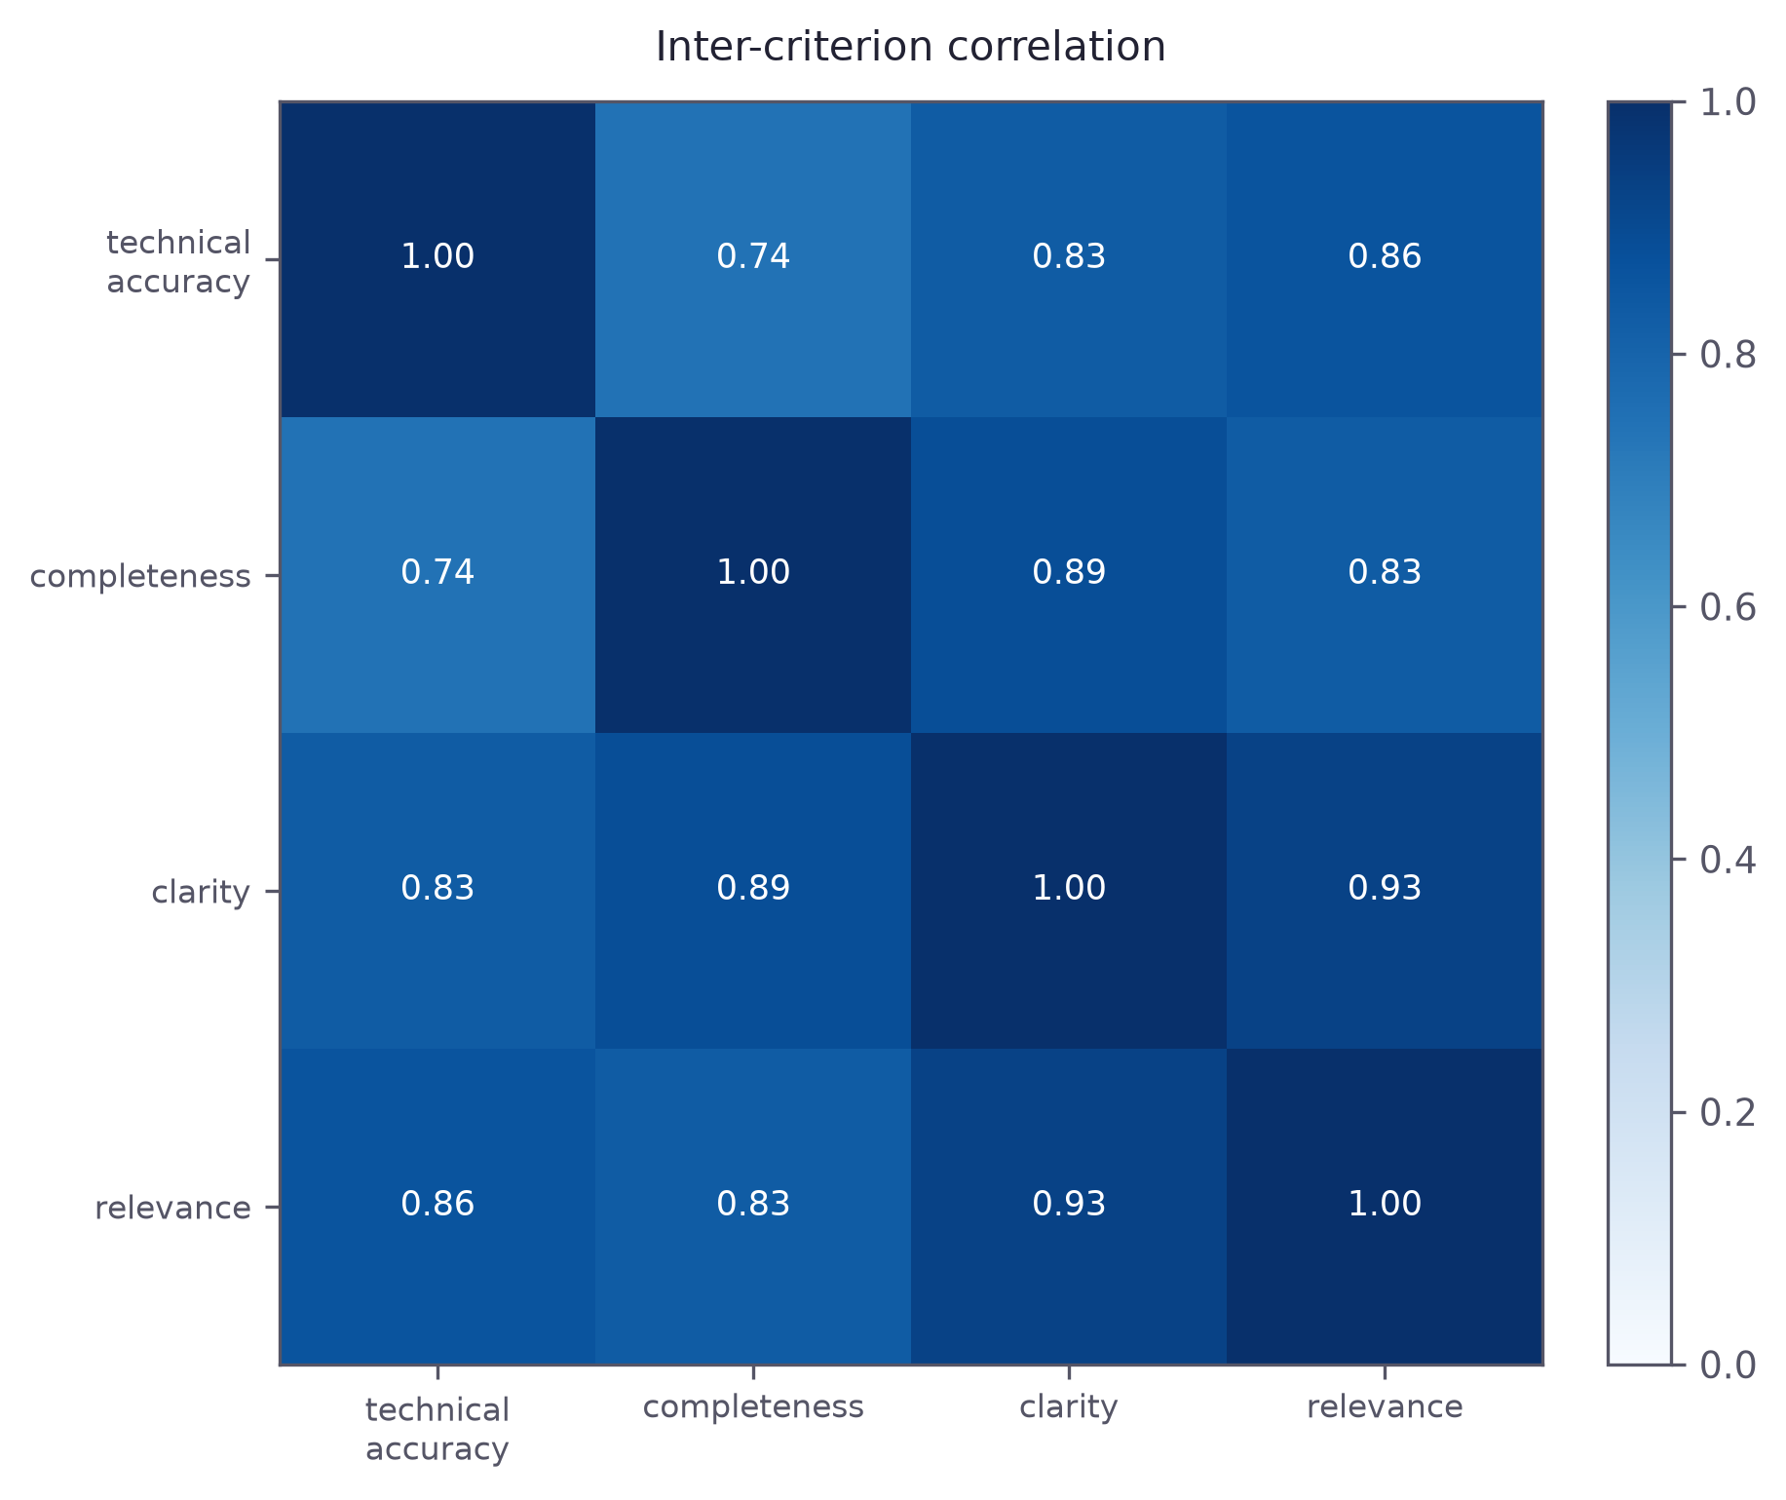
Figure 15 Correlation matrix between the four rubric criteria across all scored answers.

The inter-criterion mean correlation was 0.846 with a minimum value of 0.744 and a maximum value of 0.928. The strongest correlation was found between clarity and relevance (r = 0.928), with even the two most independent variables, technical_accuracy and completeness (r = 0.744).

There has to be some correlation; reasonably correct answers tend to be more comprehensive, and there should be no attempt to rip them apart. However, at this level, the four scores contribute only a little less than four pieces of information. The judge makes a global judgement, which they then allocate to the criteria (the halo effect from the human rating literature which isn't eliminated by telling the model not to do it).

This affirms a statement in Chapter 4. The per-criterion breakdown was justified as an explanation mechanism that told the candidate, which criterion was not met. That defence is less robust than it seemed: If the four marks are moving in tandem, they are telling one story four times, not breaking it. It serves as evidence of what the judge was asked to consider, and while it is not the diagnostic tool that it was designed to be, the most independent pair of it may do its job. Section 8.3 suggests a scoring system in which each criterion is given a score in its own call.

6.7 Verbosity probe
Wang et al. (2024) found that length is not correlated with language model judges' rewards regardless of content. This is clearly forbidden in the rubric. The probe adds filler text to answers that are good but without content and rescores them.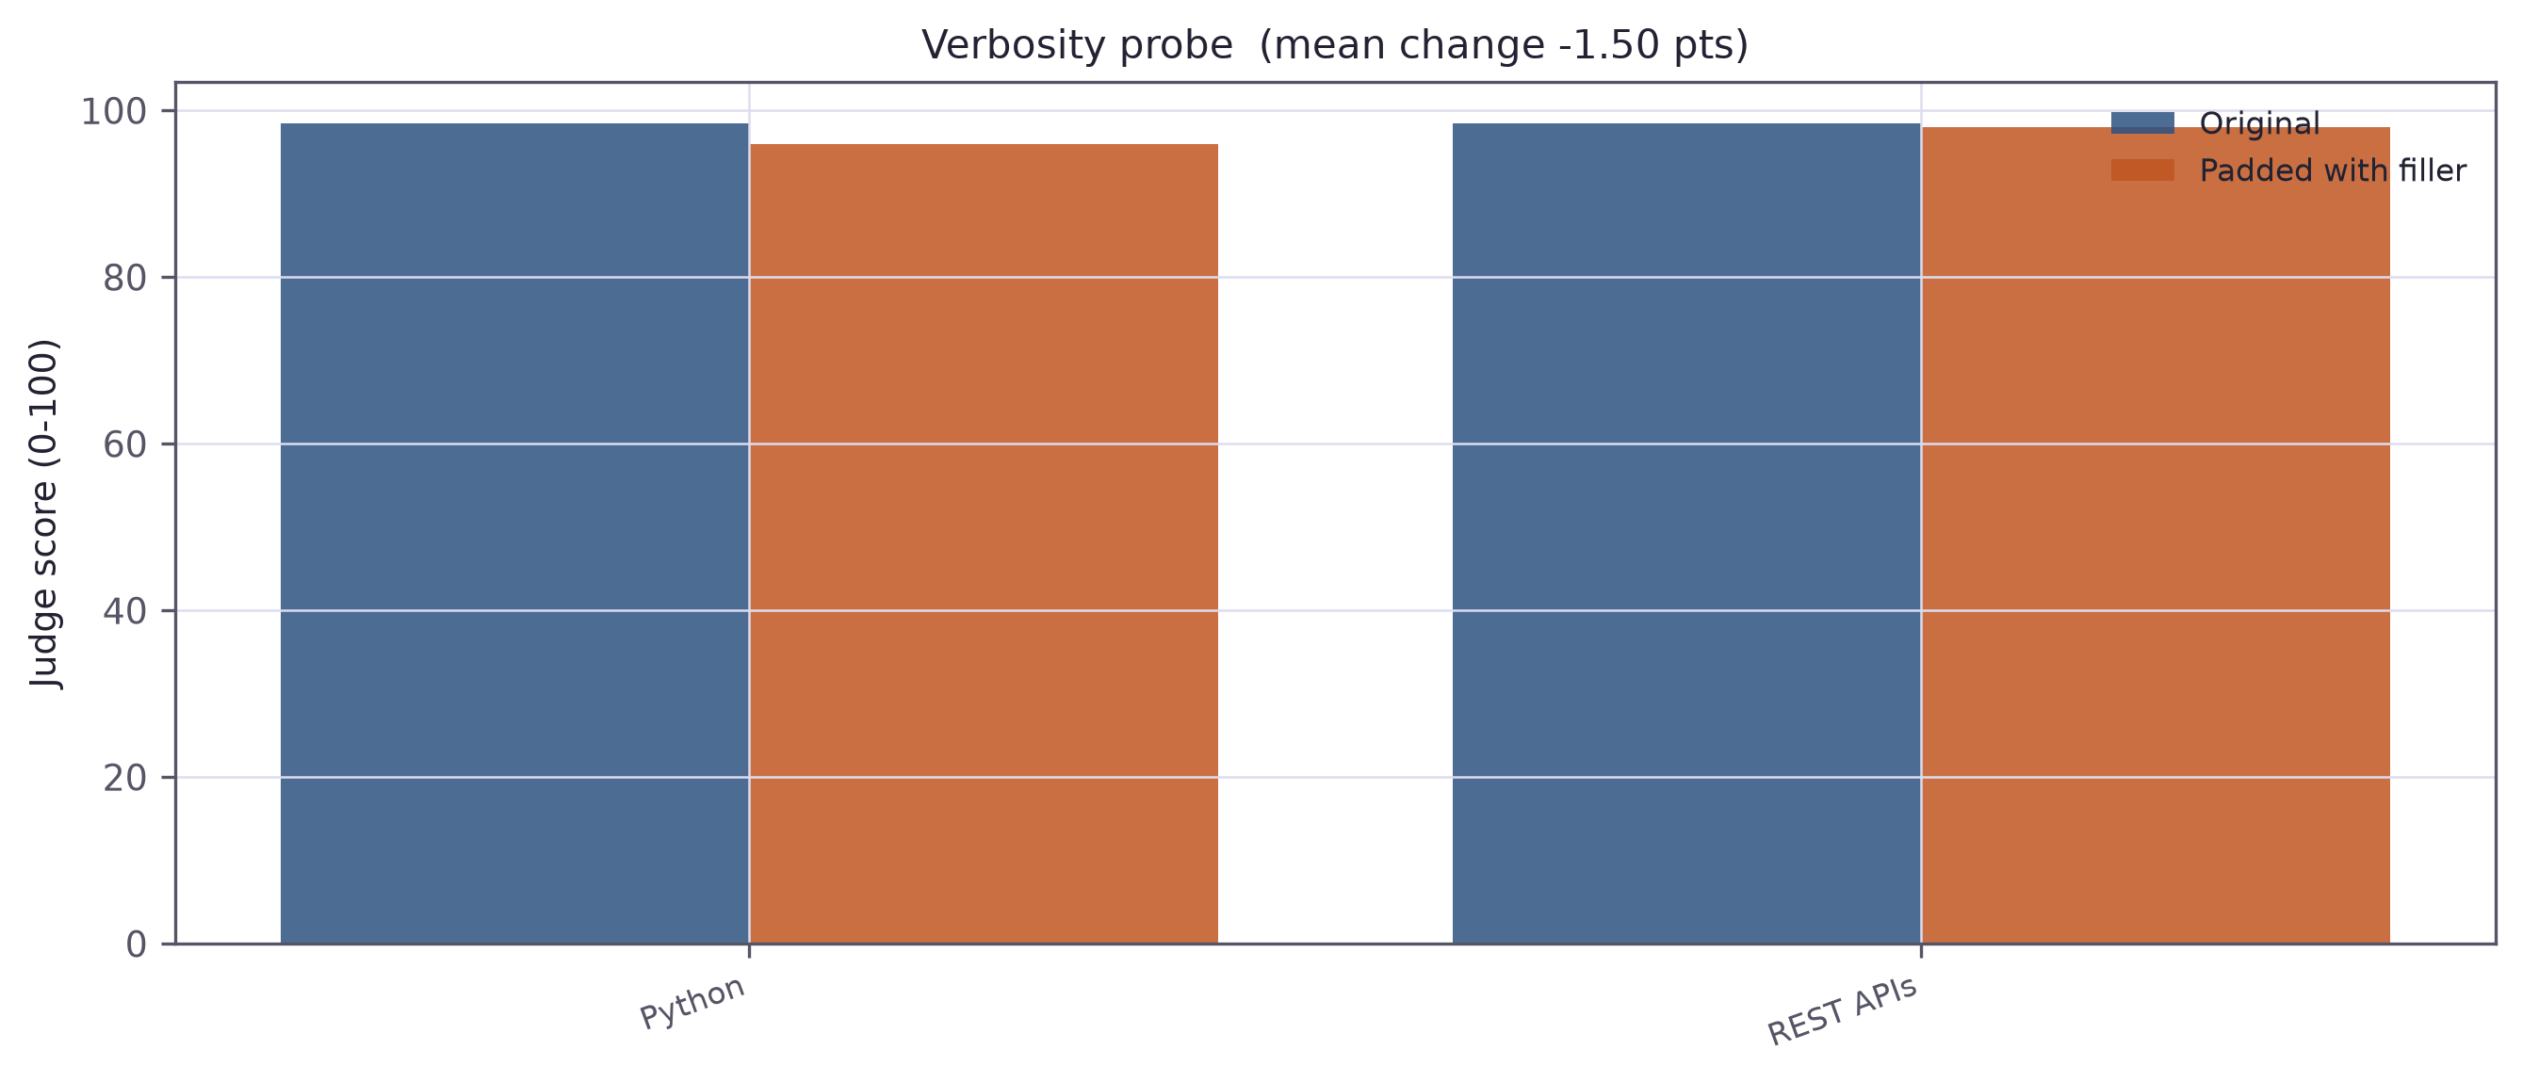
Figure 16 Original and padded versions of the same answers.

For 2 usable pairs the mean change on the padding was -1.50 points, with 0 points increasing and 2 points decreasing. A Wilcoxon signed rank test yields a p value of 0.500.

2 pairs is not adequate to draw a sensible conclusion, and the test has little power at this size, even though a third pair was lost due to an API timeout during the run. It is not a negative direction – there were no points scored from padding and both teams dropped a little. The probe is not reported for the sake of establishing anything, it is just reported for completeness and being harnessed to. In Section 8.3, a plausible redundant elaboration version is suggested for a properly powered version, instead of a filler version.

6.8 System-level verification

Separately from the scorer, the artefact was verified as software.

The deterministic components of the systems are addressed by a unit test suite consisting of 72 tests, covering skill normalisation, the matching cascade, gap analysis and the set operations supporting it, graph-priority question ordering, transcript pairing (the merge and drop cases), integrity feature derivation and calibration, the fusion weights and their arithmetic reconciliation, per-skill state transitions and report assembly. All 72 pass. Two are direct regressions on the matching failures as described in Section 5.3.1.

Each stage of the graph build, the ordering of questions by priority, the removal of logistics exchanges, the constraints on rubric criteria being within acceptable ranges and that they sum to the reported score, and the reconciliation of fusion contributions and the overall contribution are tested by performing an end-to-end run, where each of these stages is exercised with a synthetic candidate performing live model calls at each stage. It passes.

6.9 A worked example
They are not aggregates; this follows one interview through the system. Backend engineer who's a synthetic person with experience in Python for four years and is seeking a senior backend position that involves Python, Kubernetes, PostgreSQL, REST APIs, microservices and AWS.
The skill graph returned a 50% match, correctly recognizing that the skills that were missing from the CV are present in the required skills list and giving them higher priority. Then, the flattening step took the Kubernetes question to the next agenda item from the other "evidence" questions.
Exchange | Skill | Score | Judge passes | Spread | Consistency
Greeting / readiness | — | not scored | — | — | —
API design and idempotency | REST API | 91.5 | 92.0, 91.0 | 1.0 | high
Kubernetes troubleshooting | Kubernetes | 50.0 | 55.0, 45.0 | 10.0 | moderate
Mentoring a junior engineer | Mentoring | 85.0 | 85.0, 85.0 | 0.0 | high
Sign-off | — | not scored | — | — | —
Table 11 Per-answer results from the worked example.

There are three things to notice. Excluding greetings and sign-off from the list of logistics was a good one. The candidate admitted that they had not used Kubernetes and earned a 50, not a zero, because the rubric allows for points to be awarded for accuracy without the need to be complete, and an honest admission has no incorrect elements. That was the only answer in the session to which there was a split of opinion between the widest judges, at 10 points, on the only moderately-consistent answer.

The last of those observations contradicts the null result in Section 6.4, and is the most interesting element here. The one partial answer in a realistic session resulted in a measurably higher level of disagreement, while the machine-written corpus almost always gave a high consistency. One observation is not enough, but it's a sign of where the instrumentation is getting its role from – it isn't on the clearly good or bad answers, which are easy, it's on the blurred middle where the recruiter needs to know how far to trust the number.

6.10 Discussion of results

The experiments confirm the design's assumption to a greater degree than it had envisioned, and that greater degree is the most useful result of the evaluation.

Judge's answers are very good. The Spearman's rho and Cohen's d between strong and weak answers are 0.92 and 2.98, respectively, suggesting that the relative ordering is reliable. However, it does not work well as a measure, with many answers falling into the upper end of the range, medium and strong answers overlapping, and published thresholds for the system well below where answers actually fall. This is a comparative instrument and in the present context, the artefact plays the part of making it appear absolute.

The rubric is not fully broken down as intended. This is a mean inter-criterion correlation of 0.85, which reflects a significant halo effect, despite the explicit instruction, and thus calls into question the claim of explainability in the per-criterion breakdown.

Surprisingly, few positions were unstable in this corpus and the escalation mechanism was not triggered. This doesn't make the design wrong: The literature that inspired this design is correct, the mechanism is working, and one realistic partial solution did cause increased disagreement. However, this project has not proven to be successful at capturing actual failures at scale, nor does it claim to.

There are four threats to validity, outlined in Section 7.3: 18 graded answers; an intended-quality as opposed to a human-grounded one; machine-written answers that are cleaner than transcribed; and paraphrase groups made up entirely of strong answers, which also gives a plausible explanation for the E1 ceiling effect and the high E2 consistency.

7. Critical Reflection

7.1 Achievement against objectives
Table 12 assesses each objective honestly rather than favourably: two were revised mid-project and one met in a materially different form from the original plan.
Objective | Outcome | Evidence
1 Skill graph and gap analysis | Met | 1,201 ESCO concepts plus two extension taxonomies; four-stage matching cascade; gap analysis verified by unit tests and the worked example
2 Graph-driven question targeting | Met | Technical questions re-sorted by graph priority before the interview; ordering asserted by unit test
3 Voice and text interview | Met | Live WebRTC voice interview with provider fallback; text mode producing an identical transcript; both verified end to end
4 Bias-mitigated evaluation pipeline | Met, revised | Permuted rubric orderings, self-consistency measurement and human escalation, quantified in Section 6.4. Original dual-track wording revised — see 7.2
5 Behavioural integrity detection | Met, with caveat | Calibrated Isolation Forest with named risk factors; baseline is synthetic and unvalidated against real anomalous sessions
6 Controlled evaluation | Met, revised | Five experiments reported in Chapter 6, plus a 72-test suite and an end-to-end verification run. The evaluation identified two real defects — see 7.3
Table 12 Achievement against objectives.

7.2 Deviations from the proposal
Three deviations from the project proposal require explanation. Each is reported with the evidence that prompted it.

7.2.1 Removal of the trained-classifier evaluation track

The main contribution in the proposed work was the comparison of two answer scorers: LLM-as-Judge and a supervised classifier with embeddings obtained by Sentence-BERT and XGBoost with SHAP explanations. That track was put in place, trained, measured and then taken out. This is the most important alteration in the project and the rationale for this follows.

The first and most important issue is that the comparison by virtue of how it was designed is circular. The proposal used a language model to generate the answers according to a fixed criterion of quality, and a language model's opinion was the ground truth for the classifier. This was assured by the design and if not would have been a measure of the meager six features on the face.

The second problem is that the metric which would have given the comparison meaning was unobtainable. The chosen anchor was agreement with human ratings which could not be incorporated into the timeline (Section 3.4). If there is no human gold standard, then it's two automatic scorers fighting against each other, without an arbitrator.

The third problem was empirical and solved the problem. Inspection prior to removal revealed that the model was overwhelmingly based on one feature (semantic similarity at 0.543, more than all of the other five combined), which was the result of one data-handling error: the strong answer being used as the reference for itself. The consequence became concrete in a behavioural probe: An answer matching the reference received a score of 64.7, a paraphrase of the reference received 39.2 which is below the threshold at which the system calls attention to a skill gap, and a deliberately vague answer received a score of 29.5. Appendix E gives the full measurements.

A scorer which deems a correct response as a skill gap when it is phrased by the candidate is an unusable instrument and the failure mode would systematically punish those candidates who were being served by the instrument. The track was eliminated and Objectives 4 and 6 were reworded in terms of the reliability of a single scorer.

The loss is not a topic for discussion that should be downplayed. SHAP feature attribution is missing, as is a quantitative form of explanation. What takes the place of it is more readable by a recruiter and weaker as attribution — and there's evidence of that in Section 6.6 that replacement is weaker than the design proposed.

7.2.3 Synthetic rather than piloted integrity baseline

The plan was for volunteers to have pilot sessions with the Isolation Forest baseline to fit it. There were no human participants, and the baseline is synthetic, that is, four hundred sessions from distributions that span the range which the system measures. It's defensible as a starting point, and is explicitly labelled in the code, but with a consequence as noted in the following section.

7.3 Limitations

The two below were identified during evaluation, not expected, but are the most significant flaws in the artefact submitted.

• Verdict thresholds that are too high — The judge sets the verdict threshold too high. Partial answers that are deliberately given received a score that was on average 92.8 points, well above the 70 point threshold at which the system gives a strong answer, so that medium and strong answers are treated equally. Rank ordering is very good but the absolute score cannot be compared against a set standard. The empirically implied boundaries are derived in Section 6.3 and the reason why they were not used on a sample this size is explained.

The four rubric criteria are correlated and the mean correlation is 0.85, suggesting that the judge establishes a full picture and apportions it across the four properties instead of assessing the four properties individually. The per criterion breakdown is therefore a less strong explanation mechanism than Chapter 4 indicates.

No answer from the evaluation corpus was able to trigger an answer on the low consistency escalation path, which means the mechanism has not been exercised in practice. These results are achieved in the implementation of the mechanism and makes it work, but do not prove the value of the mechanism in the real world.

The other limitations were expected and limit the interpretation of results.

Sample size — There are relatively few answers in Chapter 6. The statistics are to identify direction and approximate magnitude, and not to provide tight confidence intervals; a replication on a larger scale could shift these values significantly.

The test data and ground truth — No human rater evaluated any answer, so E1 evaluates how well an answer fits an intended quality specification — a weak foundation as compared with expert judgement, and one that is unaware of any bias the specification and the judge share. The responses were also machine written and hence cleaner than hand written responses, so performance for genuine spoken answers is not guaranteed.

• Unvalidated integrity baseline — The Isolation Forest is not familiar with a real interview, either normal or abnormal. There is no false positive rate that can be given and the module should be viewed as an established mechanism and not as a validated detector.

Single-session architecture — The state of the session is stored in a single in-memory dictionary, in one server process. The system can only be used by one interviewee at a time, and it does not retain any information between restarts, and the transcript endpoint returns the last transcript created, regardless of who requested it. If this is a multi-tenancy application, then authentication, per-session isolation and durable storage would be needed.

Security Posture and criterion validity — There are no restrictions on cross-origin requests, no authentication, and no rate limiting, and transcripts are written to the system temporary directory without encryption. This is not OK for real candidate data. No claim is made on the predictive validity of scores of job performance, and criterion validity would call for longitudinal outcome data.

External model dependency — The external commercial model on which scoring is based may be retired at any time. Twice at this point, first with the fixture model, and then soon after the judging model. The artefact is older than the model it was measured with.

7.4 Professional, legal and ethical reflection

The artefact fulfills some of the obligations that are required by the EU AI Act, but it does not fulfill others, when measured against the requirements for high-risk systems of the EU AI Act. Transparency is well met: all scores are broken down into rubric criteria, there is a reference answer and rationale, and the weights are shown. It's designed to be human-supervised, as it will never make a hiring decision. Records kept for a demonstrator are adequate, but insufficient for deployment, and are stored in unencrypted form. There has been a first step in bias testing — Chapter 6 tests two documented model biases — but not yet in the case of demographic disparity, which requires exactly the kind of data this project didn't collect, human data.

The last is an awkward circularity to be called out. So, avoiding human data eliminated the ethical dilemma of collecting human data and eliminated the opportunity of testing for the harm that really matters. This is a reasonable choice for a project of this size, but a project should not claim that the resulting system has proved fair. It has been demonstrated to be inspectable and not a substitute for it, as fairness is a precondition of being inspectable.

When it comes to data protection in-browser analysis is a real data minimisation tool as no biometric data is ever sent away from the device and only derived scalars are sent. It does not resolve the deeper objection that when seeking to know if someone is engaged by inference from their body language and eyes, it is an invasion of their personal space, and nervousness and evasion are indistinguishable to any such measure. Possible solutions to the harm are light weighting and per candidate calibration.

7.5 Personal reflection

What I found to be most useful is that it was measuring my own work that changed it more than planning did. All major design decisions documented here were based on an observation of something that challenged the assumption. Until I read “Team Leadership” resolve to the programming language R I assumed it was a reasonable fallback. I thought a Speech Provider that accepted a connection was running until the agent became unresponsive during an interview. I thought if I could parallelize the API calls I will get the faster evaluation, which turned out to be wrong when I measured, 6 API calls took longer with parallel than with a hundred sequential calls.The most difficult task was eliminating the trained classifier. It was days of labour and what looked like machine learning research, and it was a late deletion and it felt like a retreat. But when I realised that I couldn't explain it to myself: when a model has been trained on LLM labels, why would the agreement with the LLM itself mean anything? If it fails to report, then the weakest part of this project is the one that I can defend!If I started from scratch I'd start executing the evaluation harness much earlier. It took weeks to discover the mistakes in the classifier, and the lenientness problem in Section 6.2, that I didn't find until it was too late to fix. If the building's length would have been measured along with the song, there would have been time to correct it instead of just report it.

8. Conclusion and Future Work

8.1 Conclusions

This project aimed to see if it's possible to create an AI interview platform that could be held accountable for the accuracy, rather than only the confidence, of its assessments. An adaptive technical interview by voice or text was created, questions were targeted using a knowledge graph linked to a published occupational taxonomy, and answers were judged using a judge instrument to measure its stability.The key empirical result was not the one that the design was looking for. When applied to answers of known quality, it was practically flawless (Spearman's rho = 0.92) but it was very poorly calibrated: a partial answer like "the only thing that is true" was given a score of 92.8, while it is regarded as a threshold for a strong answer of 70. Trusting the ordering is safe; the absolute number isn't. The artefact was making an assertion that it did not support, namely making absolute thresholds without checking them against the actual distribution of outputs from the model.It is a qualified claim for explainability that is made with the second finding. The mean of the four rubric criteria is 0.85 with the judges only being instructed to score the rubric criterion independently, suggesting that the judge makes a single impression and distributes this impression. Training a model on a known cognitive bias does not guarantee that it will be able to eliminate the bias; a per-criterion breakdown that is trained as a single block does not actually explain as much as it sounds like.The path of escalation, however, was not fired and positional instability was relatively insignificant on this corpus. The null result is indicated as such. The mechanism is defensible on the literature, and demonstrated to be effective, and the one potentially realistic partial answer found here elicited the broadest disagreement in its session — but in this project it has not been shown to be effective at scale.The third one is of a methodological nature, and it came about through a failure. A trained classifier and a language-model judge could not have been informative, since the labels used to train the classifier were generated by a language model. To build it anyway was an educational experience: The trained model achieved a correct paraphrase of its own reference answer on 39 out of 100 passages. It is a reminder that in evaluation research what a result means depends on the design of the comparison, and that a comparison that is not designed to be informative is not worth running.The overall goal of the project is modest. Transparency of automated assessment is more easily achieved by having one scorer responsible for reporting on what it has done, its stability and when to involve a human scorer, than by having a second, unvalidated scorer. If there is no independent validation of the redundancy, then it can only seem robust, not be.The best evidence for that position is the fact that the artefact it was assessing had two actual defects. An instrumented system that is to be investigated can be demonstrated as being incorrect and corrected. That's a property that is worth more than a higher headline score earned by a system that no one can examine.

8.2 Contributions
- An interview delivery platform that is multi-agent, with a skill-graph question-targeting system, dual-transport delivery, privacy-preserving in-browser behavioural analysis, and an evaluation pipeline that reports and measures its own per-answer reliability without offering any score as a confidant.
- Empirical characterization of the LLM judge in an actual assessment environment, with a distinction between the rank-order validity of the test and absolute calibration, and quantification of an LLM judge's halo effect on rubric elements despite explicit teaching to avoid it.
- A a documented negative result from comparing a trained classifier to a language-model judge in which the labels of the trained classifier are generated by a model, and the measurements that show the failure.A reusable evaluation harness and test suite (both to be submitted as part of the artefact) to be able to reproduce all reported results.
- A reusable evaluation harness and test suite, both provided as an artefact in the submission, to be able to regenerate all the reported results.

8.3 Future work
Five directions are directly related to the restrictions of Section 7.3, with the first being the direction with the most support in this book.
The verdict thresholds are very low, and medium and strong answers are not clearly distinguishable from an absolute point of view (see Section 6.3), as this is also the case for threshold recalibration. The one change that would make the system as it is significantly better would be to recalibrate them on a bigger corpus to prevent overfitting.
A direct structural response to the halo effect measured in Section 6.6 is criterion isolation — the scoring of each rubric criterion in isolation, that is, each judgement without reference to the other. It would also involve four calls per answer, instead of 2, and test if the correlation is intrinsic in the answers or extrinsic by testing all four together.
Human rated validation – This is the most valuable next step for validity, which can be achieved by rating a corpus of authentic transcribed responses. This would allow for an exact anchor value of the intended quality, a suitable value for agreement with humans, and test the consistency signal to see if it can predict cases where humans and the system differ.
Pilot data on the integrity model — If this model was to be considered for deployment in a real setting, it would be nice to have some data collected from volunteers under normal conditions and also deliberately anomalous conditions, and then have a measured false-positive rate that could be used to evaluate this model, but it is not possible at this time.

Demographic bias testing — Demographic data was intentionally not collected in the present project and thus cannot be used for testing the disparity of scores across demographic groups. It is the duty of the EU AI Act – and this work has not fulfilled – to do so properly, with consent and ethical approval.
Adversarial verbosity testing — Obvious filler was used for the verbosity probe. A more valid test would add meaningful but redundant technical detail – this would be the actual form of verbosity bias in a genuine response.
If it were used beyond demonstration, production hardening – Persistent storage, per-session isolation, authentication and encrypted transcripts – would be prerequisites.

The larger issue this project leaves for further exploration is whether the use of an automated assessment is changed by the use of reliability signalling. The system can report that it was uncertain, a question about the human behaviour of a recruiter, that instrumentation cannot answer, if they under time pressure are looking for that or skipping past it to the number.

References
Referencing follows the BCU Harvard convention.
Bogen, M. and Rieke, A. (2018) Help Wanted: An Examination of Hiring Algorithms, Equity, and Bias. Washington, DC: Upturn.
Chen, Y., Li, X. and Zhang, J. (2021) 'A knowledge graph approach to prerequisite identification in online learning', Computers and Education: Artificial Intelligence, 2(1), pp. 1–12. doi: 10.1016/j.caeai.2021.100016.
EPIC (2019) Complaint and Request for Investigation, Injunction, and Other Relief: HireVue, Inc. Washington, DC: Electronic Privacy Information Center.
European Commission (2023) ESCO: European Skills, Competences, Qualifications and Occupations, version 1.1.1. Available at: https://esco.ec.europa.eu/ (Accessed: 12 July 2026).
European Commission (2024) Regulation (EU) 2024/1689 of the European Parliament and of the Council laying down harmonised rules on artificial intelligence (Artificial Intelligence Act). Official Journal of the European Union, L series, 12 July 2024.
Hevner, A.R., March, S.T., Park, J. and Ram, S. (2004) 'Design science in information systems research', MIS Quarterly, 28(1), pp. 75–105. doi: 10.2307/25148625.
Hickman, L., Thapa, S., Tay, L., Cao, M. and Srinivasan, P. (2022) 'Text preprocessing for text mining in organizational research: review and recommendations', Organizational Research Methods, 25(1), pp. 114–146. doi: 10.1177/1094428120971683.
HireVue (2021) HireVue Leads the Industry with Commitment to Transparent and Ethical Use of AI: Removal of Visual Analysis from Assessments. Press release, 11 January.
Langer, M., König, C.J. and Papathanasiou, M. (2019) 'Highly automated job interviews: acceptance under the influence of stakes', International Journal of Selection and Assessment, 27(3), pp. 217–234. doi: 10.1111/ijsa.12246.
Liu, F.T., Ting, K.M. and Zhou, Z.-H. (2008) 'Isolation Forest', in Proceedings of the 8th IEEE International Conference on Data Mining. Pisa: IEEE, pp. 413–422. doi: 10.1109/ICDM.2008.17.
Lundberg, S.M. and Lee, S.-I. (2017) 'A unified approach to interpreting model predictions', in Advances in Neural Information Processing Systems 30. Long Beach, CA: Curran Associates, pp. 4765–4774.
Raghavan, M., Barocas, S., Kleinberg, J. and Levy, K. (2020) 'Mitigating bias in algorithmic hiring: evaluating claims and practices', in Proceedings of the 2020 Conference on Fairness, Accountability, and Transparency. Barcelona: ACM, pp. 469–481. doi: 10.1145/3351095.3372828.
Reimers, N. and Gurevych, I. (2019) 'Sentence-BERT: sentence embeddings using Siamese BERT-networks', in Proceedings of the 2019 Conference on Empirical Methods in Natural Language Processing. Hong Kong: ACL, pp. 3982–3992. doi: 10.18653/v1/D19-1410.
Stureborg, R., Alikaniotis, D. and Suhara, Y. (2024) 'Large language models are inconsistent and biased evaluators', arXiv preprint arXiv:2405.01724.
Wang, P., Li, L., Chen, L., Cai, Z., Zhu, D., Lin, B., Cao, Y., Liu, Q., Liu, T. and Sui, Z. (2024) 'Large language models are not fair evaluators', in Proceedings of the 62nd Annual Meeting of the Association for Computational Linguistics. Bangkok: ACL, pp. 9440–9450.
Ye, J., Chen, J., Liu, Q., Xu, Z. and Wan, X. (2022) 'Generative data augmentation for commonsense reasoning', in Findings of the Association for Computational Linguistics: EMNLP 2022. Abu Dhabi: ACL, pp. 1008–1025.
Zheng, L., Chiang, W.-L., Sheng, Y., Zhuang, S., Wu, Z., Zhuang, Y., Lin, Z., Li, Z., Li, D., Xing, E.P., Zhang, H., Gonzalez, J.E. and Stoica, I. (2023) 'Judging LLM-as-a-Judge with MT-Bench and Chatbot Arena', in Advances in Neural Information Processing Systems 36. New Orleans, LA: Curran Associates, pp. 46595–46623.

Appendix A — Module Reference
Each module, the file implementing it, and its role in the pipeline.
Module | Core technology | Implementation | Role
M1 | Gemini (JSON-constrained) | core/agents/cv_parser.py | Structured profile from CV text or PDF
M2 | Gemini (JSON-constrained) | core/agents/jd_parser.py | Role requirements from a job description
M3 | NetworkX + ESCO v1.1.1 | core/graph/skill_graph.py | Taxonomy, matching cascade, gap analysis
M4 | Gemini + graph traversal | core/agents/question_generator.py | Question generation and priority ordering
M5 | LiveKit, Deepgram, ElevenLabs | core/livekit/voice_agent.py | Voice interview agent (WebRTC)
M5t | FastAPI request/response | core/pipeline/text_interview.py | Text interview engine
M6 | LLM-as-Judge, permuted rubric | core/evaluator/answer_judge.py | Answer scoring and self-consistency
M6a | Finite state model | core/graph/skill_state.py | Per-skill status across the session
M7/M8 | MediaPipe Face/Pose Landmarker | frontend/src/lib/vision.js | Attention and posture
M9 | Isolation Forest (scikit-learn) | core/evaluator/behavioural_integrity.py | Behavioural integrity
M10 | Web Audio API prosody | frontend/src/lib/voice.js | Vocal delivery
M11 | Deterministic weighting | core/evaluator/score_fusion.py | Weighted fusion and recommendation
M12 | Structured templates | core/report/report_builder.py | Report assembly and reliability statistics
— | ThreadPool orchestration | core/pipeline/post_interview.py | Ties M6, M9, M11 and M12 together
— | Shared prompt | core/agents/interviewer_prompt.py | Interviewer instructions for both modes

Appendix B — Rubric and Judge Prompt
The rubric criteria and the scoring rules given to the judge. Reproduced from core/evaluator/answer_judge.py.
Scoring rules the judge must follow:
- Score each of the four criteria independently. A weakness in one
criterion must not drag down the others: an answer can be entirely
accurate yet incomplete, or thorough yet unclear.
- Judge the substance, not the phrasing. Different wording that conveys
the same concept is fully credited.
- This is speech, not writing. Ignore filler words, false starts and
informal grammar unless they genuinely obscure the meaning.
- Do not reward padding. Length is not a proxy for quality.
- Clarity and relevance measure how well the candidate communicated a
real answer. If the response contains essentially no substantive
content, clarity and relevance must also be low.
- Do not inflate scores to be kind.
Interpreting the total (the sum of the four criteria):
- 70-100: a genuinely strong answer covering the core concepts
- 40-69: real but partial understanding
- 0-39: very weak, largely wrong, or minimal understanding
The two rubric orderings used to detect positional sensitivity:
Ordering A: technical_accuracy -> completeness -> clarity -> relevance
Ordering B: clarity -> relevance -> technical_accuracy -> completeness
Consistency banding on the absolute spread between the two:
spread < 8 -> high (reported as a confident score)
spread < 16 -> moderate
spread >= 16 -> low (escalated to human review)

Appendix C — Repository Structure
InterviewAI/
server.py FastAPI application and API surface
core/
llm.py Gemini client, JSON repair, usage accounting
config.py Thresholds and environment configuration
agents/ M1, M2, M4, shared interviewer prompt
graph/ M3 skill graph, M6a state, traversal rules
livekit/ M5 voice agent and media server launcher
evaluator/ M6 judge, M9 integrity, M11 fusion
pipeline/ Text interview engine, session evaluation
report/ M12 report assembly
experiments/
run_evaluation.py Evaluation harness (Chapter 6)
results/ Raw scores and computed statistics
figures/ Generated result figures
tests/test_core.py Unit test suite
docs/track-b-rejection.md Evidence for the removed classifier track
data/esco/ ESCO taxonomy exports
frontend/src/ React interface, vision and voice analysis
report/
diagrams.py Architecture and design figures
build_report.py This document

Appendix D — Test Suite Summary
The suite comprises 72 tests, all passing, covering the deterministic components of the pipeline. Components requiring live model inference are covered by the end-to-end verification run described in Section 6.7.
Area | Coverage
Skill normalisation | Case, whitespace, punctuation, technical characters, parenthetical stripping
Skill matching | Exact labels, aliases, base forms, fuzzy cutoff, short-label protection, regressions
Gap analysis | Matched / missing / bonus / extra partitioning, match percentage, division-by-zero
Question flow | Graph-priority ordering, section sequence, missing-topic and empty-set handling
Transcript pairing | Alternating turns, consecutive-speaker merging, unanswered questions, empty input
Integrity | Feature derivation, score bounds, risk-factor identification, determinism, gaze allowance
Fusion | Weight sums, arithmetic reconciliation, integrity override, monotonicity, engagement fallback
Skill state | Verification transitions, gap confirmation, averaging, unknown-skill handling
Report assembly | Overall score, worst-first ordering, threshold classification, reliability statistics

Appendix E — Evidence for the Rejected Classifier Track
The measurements referenced in Section 7.2.1, taken from the trained model before it was removed from the repository. Reproduction instructions are held with the artefact at docs/track-b-rejection.md.
Provenance of the saved model
The model artefact on disk was not produced by the training script that accompanied it. Hyperparameters disagreed (n_estimators 100 against 200, max_depth 4 against 3, learning rate 0.1 against 0.08, regularisation unset against 1.0), and the file predated the script's last modification by one hour and thirty-nine minutes. The change made in that interval was the correction of the reference-answer data leak, so the saved model was the output of the defective pipeline. No training metrics file was produced, so the model's held-out performance was never recorded.
Feature importances
Feature | Gain importance
semantic_similarity | 0.5434
word_count_norm | 0.1947
keyword_coverage | 0.1847
sentence_count | 0.0391
specificity_score | 0.0217
fluency_score | 0.0164
One feature carries more weight than the other five combined — the signature of a model that has learned a training artefact.
Behavioural probe
Three answers scored against one fixed reference answer on machine learning.
Case | Semantic similarity | Model score | System verdict
Answer identical to the reference | 1.000 | 64.7 / 100 | weak
Strong paraphrase, correct and complete | 0.907 | 39.2 / 100 | gap
Deliberately vague, incorrect answer | 0.362 | 29.5 / 100 | gap

Two failures are visible. A perfect answer never approaches the 70-point strong threshold, and a correct paraphrase falls below the 40-point gap threshold. The model separates a strong paraphrase from a deliberately weak answer by 9.7 points while separating a verbatim match from a 90.7%-similar paraphrase by 25.5 points: discriminative power sits almost entirely above similarity 0.9, a region real candidate answers never reach.

Appendix F — Interface Contracts Between Phases
Each boundary carries a serialisable payload of fixed shape, which is what allows the modules to be developed and tested in isolation.
Boundary | Payload | Consumed by
M1 → M3 | Structured profile: skills, experience, education, projects | Skill graph
M2 → M3 | Role requirements: required skills, nice-to-have, level, domain | Skill graph
M3 → M4 | Prioritised topic list: skill, reason, priority | Question generator
M3 → M11 | Gap analysis: match percentage, missing required skills | Fusion engine
M4 → M5 | Ordered question list, flattened by graph priority | Interview agent
M5 → M6 | Transcript: role-tagged utterances with timestamps | Evaluation pipeline
M7/M8/M10 → M9 | Telemetry: attention, posture, prosody, tab switches | Integrity module
M6/M9/M3 → M11 | Component scores on a common 0–100 scale | Fusion engine

Appendix G — User Interface and Installation
The interface is a six-step React single-page application. Each step corresponds to a phase of the pipeline described in Chapter 4, so a user's progress through the interface is also a traversal of the architecture.
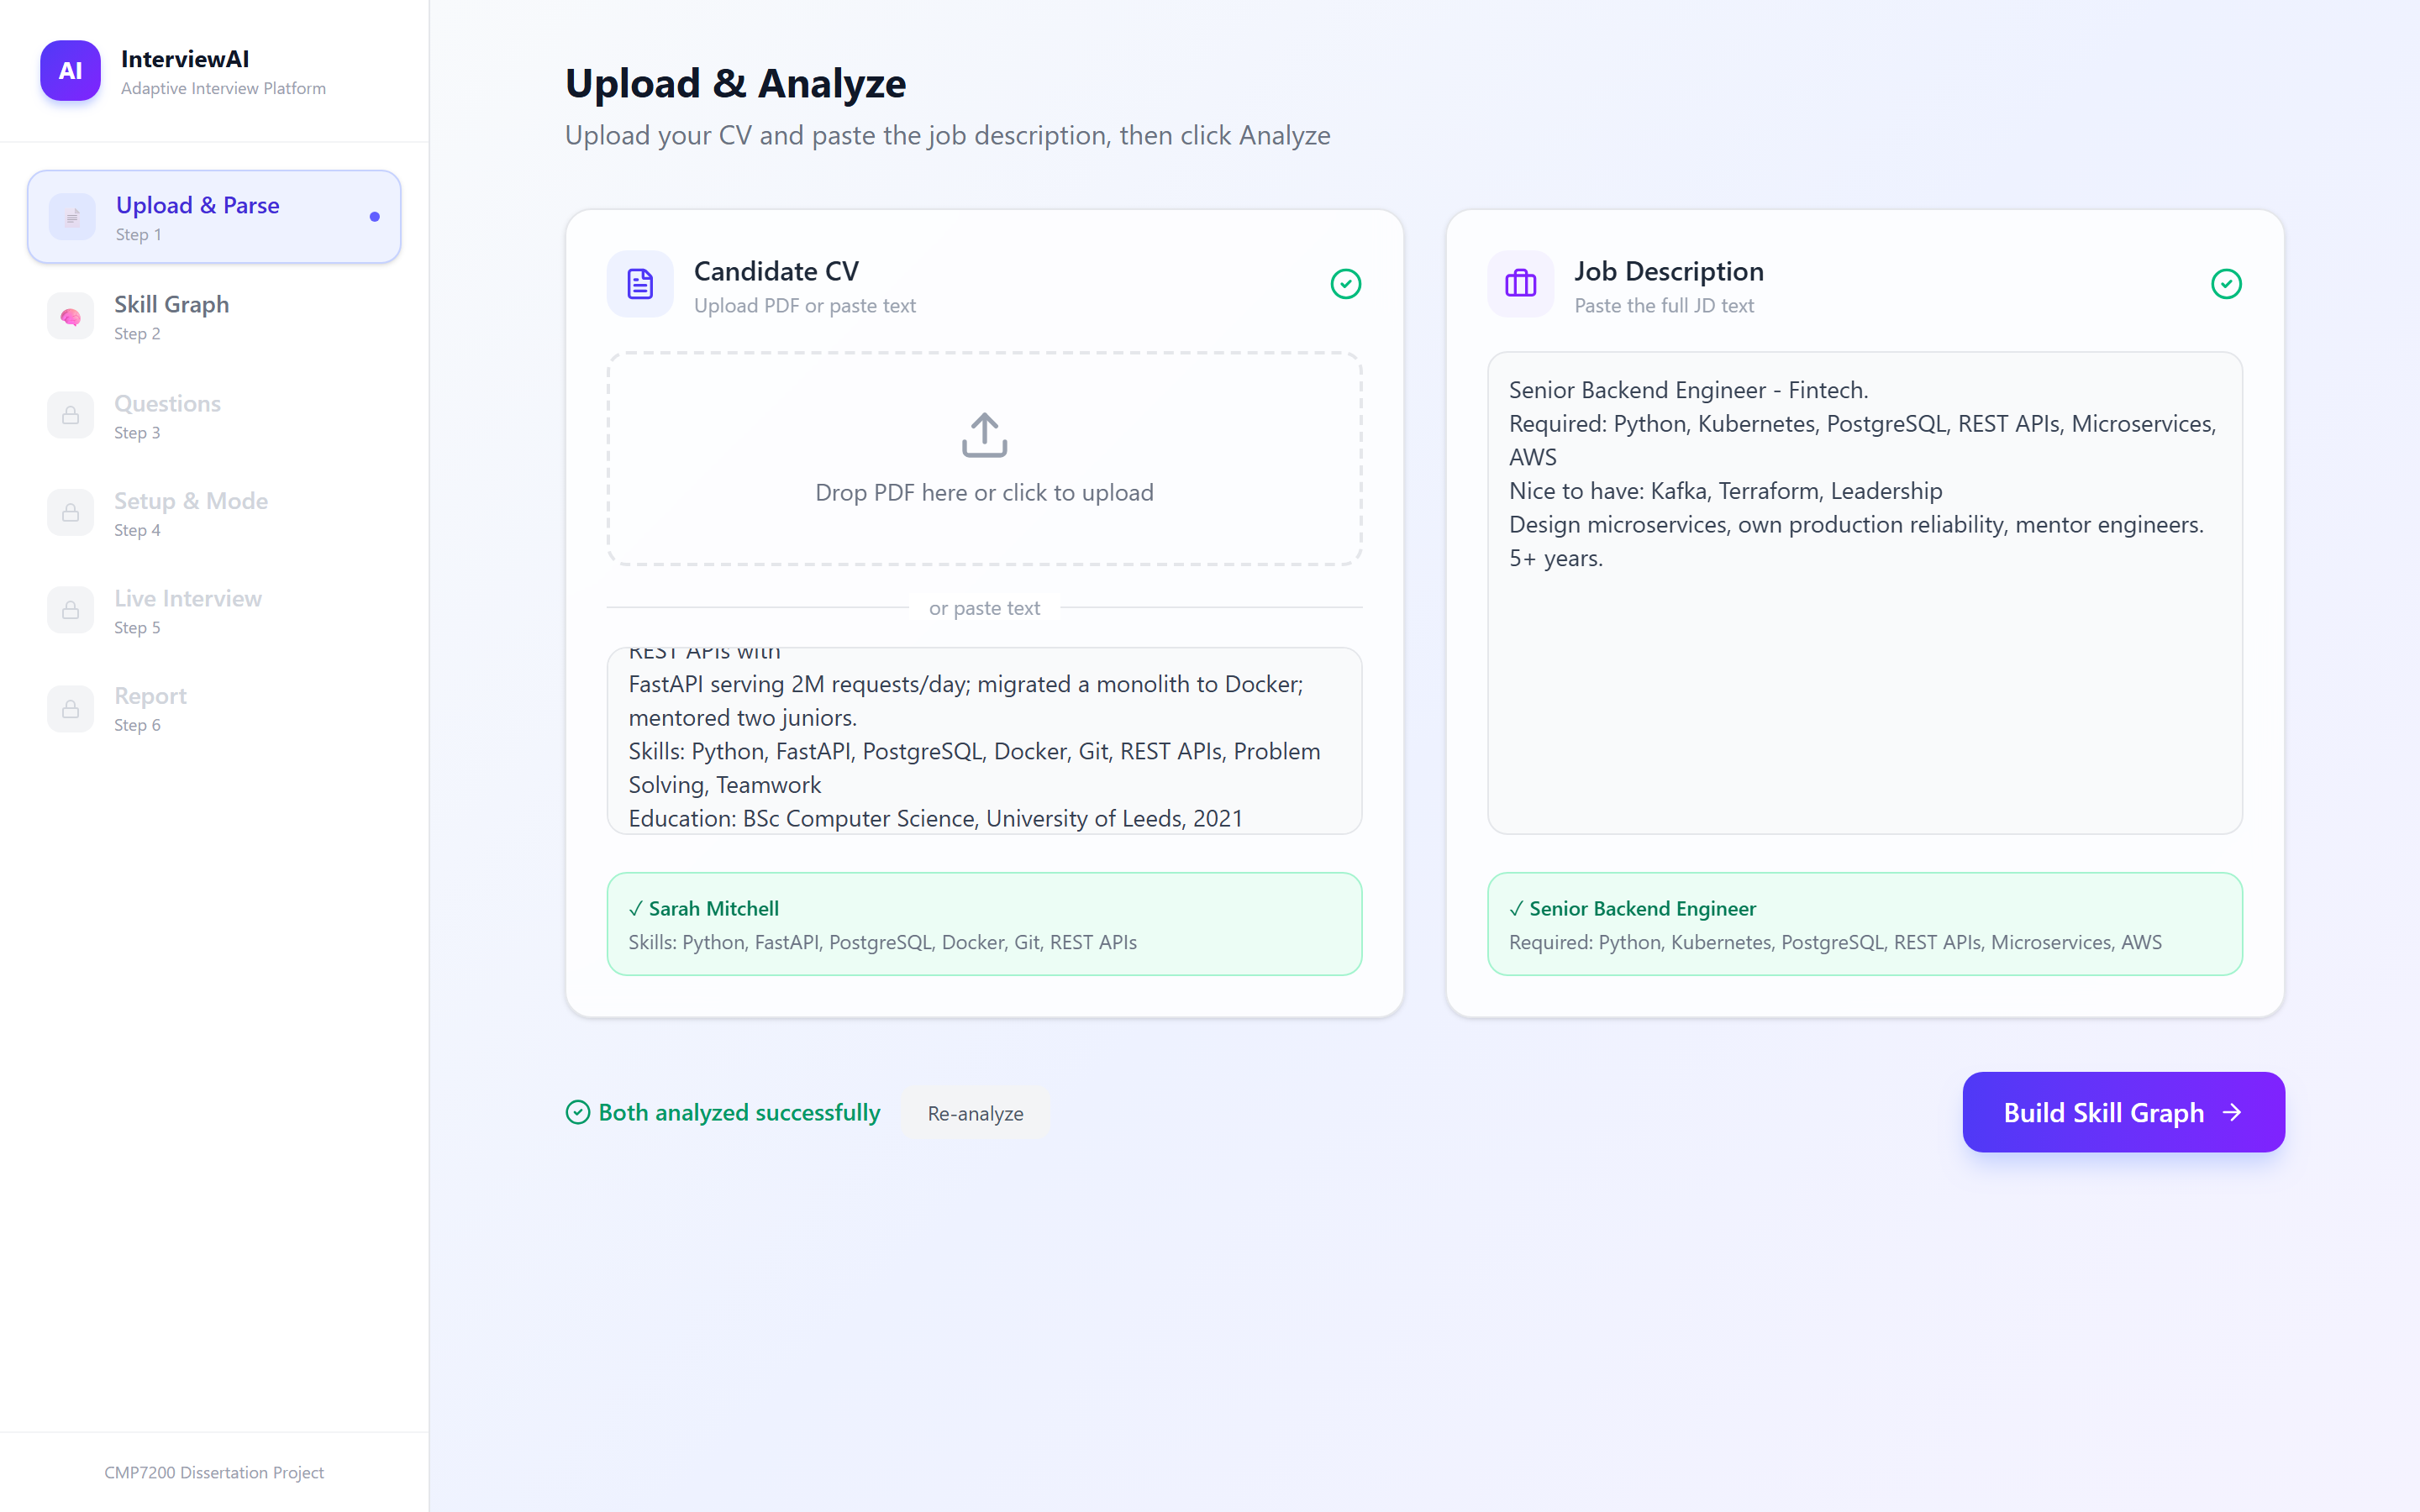
Figure 19 Step 1. A CV and a job advert are parsed into structured data before anything else runs; the confirmation panels show what was extracted.
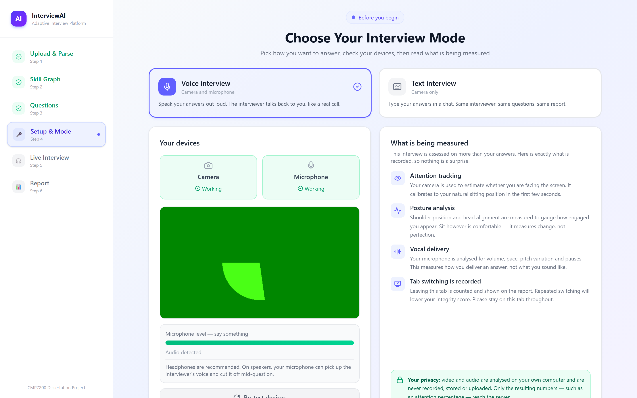
Figure 20 Step 4. The device check and the disclosure screen. Everything the system will measure is named before the interview starts, and the privacy notice states that video and audio are analysed on the candidate's own machine. The camera preview here is a synthetic feed used to capture the screenshot.
Step | Screen | Implementation | Purpose
1 | Upload and parse | screens/UploadStep.jsx | CV upload (PDF or pasted text) and job description entry; triggers M1 and M2
2 | Skill graph | screens/GraphStep.jsx | Renders the M3 clusters with matched, missing, bonus and extra statuses, and the gap analysis summary
3 | Questions | screens/QuestionsStep.jsx | Shows the generated question set in the graph-priority order the interview will follow
4 | Setup and mode | screens/SetupScreen.jsx | Camera and microphone check, and the choice between voice and text interview
5a | Voice interview | screens/InterviewScreen.jsx | Full-viewport call interface with live transcript, question counter and the landmark overlay
5b | Text interview | screens/TextInterviewScreen.jsx | Typed equivalent; records paste events and keystroke telemetry
6 | Report | screens/DashboardScreen.jsx | The M12 report: overall score, per-skill breakdown, per-answer rubric detail, integrity findings and the fusion arithmetic
— | Landmark overlay | components/LandmarkOverlay.jsx | Draws the face mesh, gaze points and pose skeleton over the video, so the candidate can see exactly what is being measured
— | Wizard sidebar | components/Sidebar.jsx | Step navigation, gated so a step cannot be entered before its inputs exist

Showing the candidate the landmark overlay is a deliberate transparency measure rather than a decorative one. A system that measures gaze and posture without revealing that it is doing so would be difficult to defend; rendering the tracking live makes the observation visible to the person being observed.
Installation
A single Windows batch script (run.bat) performs the whole setup: it checks for Python and Node.js and installs them through winget if absent, creates the virtual environment, installs Python and npm dependencies, builds the frontend, creates the .env file from its template and opens it for the API keys, then starts the server. The LiveKit media server binary is downloaded on first use by core/livekit/media_server.py, so no manual installation step is required. The system is then reachable at http://localhost:8000.

