***INTERPRETATION***

***1.***Sales of different countries

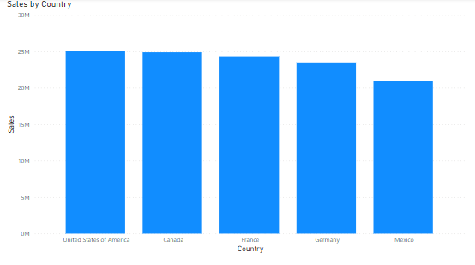

This clustered column chart shows that the sales are the highest in the United States Of America and is the lowest in Mexica. This chart shows that the sales are almost same but they are very low in Mexico. This data shows that it is positively skewed.

***2.***

Profit by Product  
   
Pie Chart   
  
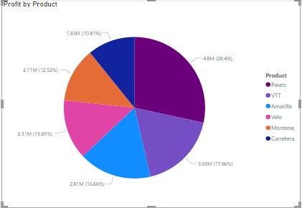

Tree Map

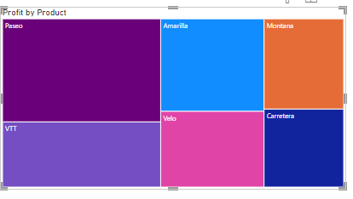

This pie Chart and Tree map shows that the Product that has provided with the most amount of the profit was gained by the product Pasea because it covers the largest areas on the map and the least amount of profit is gained by Carretera as it covers ther least amount of the area in the charts.

***3.***

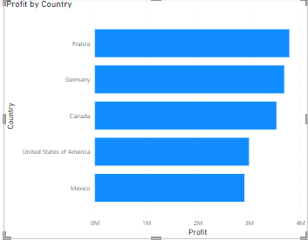

***4.***

Matrix   
  
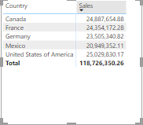

This data shows that the country with most amount of sales is USA and the numbers justifies all of it. Mexica is generating the least number of sales and not generating enough revenue.   
  
  
***Conclusion: -***

Overall by looking at this data we can say that the most business that is being provided and the most sales that have been generated is in USA so the team should look into this to provide more stock to this company and invest more in advertising there so more sales can be conducted and more revenue can be generated from there which would help financially. Also the high selling items should be looked into more and make sure there is a stock for each of it.