Cart-Pole Stabilization Using State-Feedback Control: Pole Placement and Linear Quadratic Regulation

Problem Statement:
The inverted pendulum, commonly represented by the cart-pole system, is a classical control-engineering problem used to study the stabilization of inherently unstable dynamic systems. The system consists of a pendulum mounted on a cart that is free to move horizontally. Unlike a conventional pendulum, whose natural equilibrium is the downward position, the objective is to maintain the pendulum in the upright position while simultaneously controlling the motion of the cart.
Without active control, even a small angular disturbance causes the pendulum to move away from the upright equilibrium. A controller must therefore continuously determine the horizontal force that should be applied to the cart in response to changes in the pendulum angle, angular velocity, cart position and cart velocity.
Two control strategies are considered:
- Pole-Placement state-feedback control
- Linear Quadratic Regulator (LQR) control
Both controllers are designed using a linearized state-space representation of the cart-pole system and subsequently evaluated using the original nonlinear dynamic model.

Project Objectives:
The main objectives of the project are to:
- Derive and implement a nonlinear dynamic model of the cart-pole system;
- Simulate the uncontrolled system and study its natural behavior;
- Linearize the nonlinear model around the upright equilibrium;
- Formulate the system in state-space form;
- Investigate the open-loop stability of the system using eigenvalues;
- Determine whether the system is controllable;
- Design a state-feedback controller using pole placement;
- Design an optimal state-feedback controller using LQR;
- Apply both controllers to the nonlinear cart-pole model;
- Evaluate their transient response and required control effort; and
- Compare the performance and practical trade-offs of the two approaches.

Software and Computational Tools:
The project was implemented entirely in Python using the Spyder development environment.
The main libraries used were:
- NumPy for vector and matrix calculations;
- SciPy for numerical integration of the nonlinear differential equations;
- Matplotlib for the visualization of the simulated control responses; and
- Python Control Systems Library (control) for the controllability analysis, pole placement, and LQR controller design.
The project was developed as separate Python modules for the physical model, linearized model, controllers and simulations. This modular structure separates the plant dynamics from the controller implementation and allows different controllers to be tested against the same nonlinear plant.

Description of the Cart-Pole System:
The physical system consists of a cart of mass$M$ that moves horizontally and a pendulum of mass$m$ mounted on a cart. A horizontal control force$F$ is applied to the cart. The pendulum angle$θ$ is measured relative to the upright vertical position. Therefore, $θ=0$ corresponds to the desired unstable upright equilibrium. The cart position along the horizontal track is denoted by$x$.
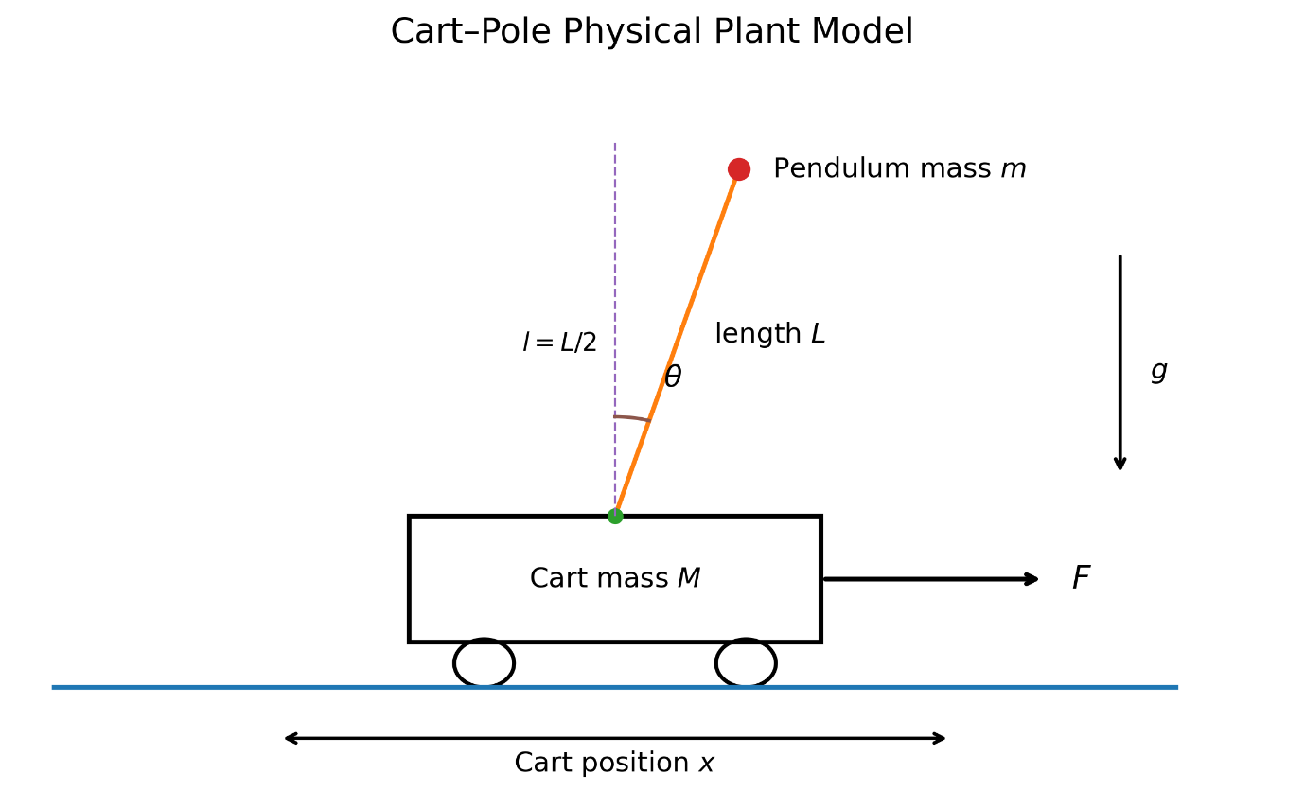
Figure 1 - Cart-Pole Physical Plant Model and Variables of the System
The parameters used in the simulation are also shown below in the table:
Parameter | Description | value
$$M$$ | Cart Mass | $$0.5 kg$$
$$m$$ | Pendulum Mass | $$0.2 kg$$
$$L$$ | Total Pendulum Length | $$0.6 m$$
$$l$$ | Pivot-to-center-of-mass distance | $$0.3 m$$
$$b$$ | Cart viscous-friction coefficient | $$0.1 N.s/m$$
$$g$$ | Gravitational acceleration | $$9.81 m/s^{2}$$
$$I$$ | Pendulum moment of inertia | $$0.006 kg.m^{2}$$
The pendulum was modeled as a uniform rod. Its moment of inertia about its center of mass was therefore calculated using:
$$I=\frac{mL^{2}}{12}$$
Substituting parameters gives:
$$I=0.006 kg.m^{2}$$

State Definitions:
Four state variables are required to describe the motion of the system:
$$x=\left[\begin{matrix}x \\ \dot{x} \\ θ \\ \dot{θ}\end{matrix}\right]$$
They represent,$x$ is cart position,$\dot{x}$ is cart velocity,$θ$ is pendulum angular displacement from upright, and$\dot{θ}$ is angular velocity.
The input is the horizontal cart force:
$$u=F$$
The controller therefore uses information about all four states to determine the force required to stabilize the system.

Nonlinear Mathematical Model:
Because the cart and pendulum are dynamically coupled, their accelerations cannot be calculated independently.
The nonlinear equations of motion were modeled as:
$$\left(M+m\right)\ddot{x}+ml\cos\left(θ\right)\ddot{θ}=F-b\dot{x}+ml{\dot{θ}}^{2} sin⁡(θ)$$
And:
$$ml\cos\left(θ\right)\ddot{x}+\left(I+ml^{2}\right)\ddot{θ}=mgl sin⁡(θ)$$
These equations can be expressed compactly in matrix form:
$$\left[\begin{matrix}M+m & ml cosθ \\ ml cosθ & I+ml^{2}\end{matrix}\right]\left[\begin{matrix}\ddot{x} \\ \ddot{θ}\end{matrix}\right]=\left[\begin{matrix}F-b\dot{x}+ml\dot{θ^{2}} sinθ \\ mgl sinθ\end{matrix}\right]$$
During numerical simulation, this two-equation system is solved at every integration step to obtain$\ddot{x}$, cart acceleration and$\ddot{θ}$, angular acceleration.
The derivative of the complete state vector is consequently:
$$\dot{x}=\left[\begin{matrix}\dot{x} \\ \ddot{x} \\ \dot{x} \\ \ddot{θ}\end{matrix}\right]$$
This nonlinear model was implemented in the model.py file and used as the plant for all subsequent simulations.

Verification of the Nonlinear Model:
Before performing a complete simulation, the nonlinear model was tested using the initial state
$$x\left(0\right)=\left[\begin{matrix}0 \\ 0 \\ 5° \\ 0\end{matrix}\right]$$
With no applied force,
$$F=0$$
The calculated initial state derivative was:
$$\dot{x}\left(0\right)=\left[\begin{matrix}0 \\ -0.2318 \\ 0 \\ 2.7148\end{matrix}\right]$$
The positive angular acceleration,
$$\ddot{θ}=2.7148 rad/s^{2}$$
Shows that a small$5°$ displacement from the upright equilibrium immediately produces motion away from the desired position.
This behavior is consistent with the expected instability of an inverted pendulum.

Open-Loop Simulation:
The nonlinear system was then simulated without any control input:
$$F=0$$
The initial pendulum displacement was again chosen as:
$$θ\left(0\right)=5°$$
While the remaining initial states were zero.
The nonlinear differential equations were integrated using SciPy’s numerical ODE solver over a simulation of five seconds.

Pendulum Response:
The open-loop pendulum response showed that the pendulum did not remain near the upright position.
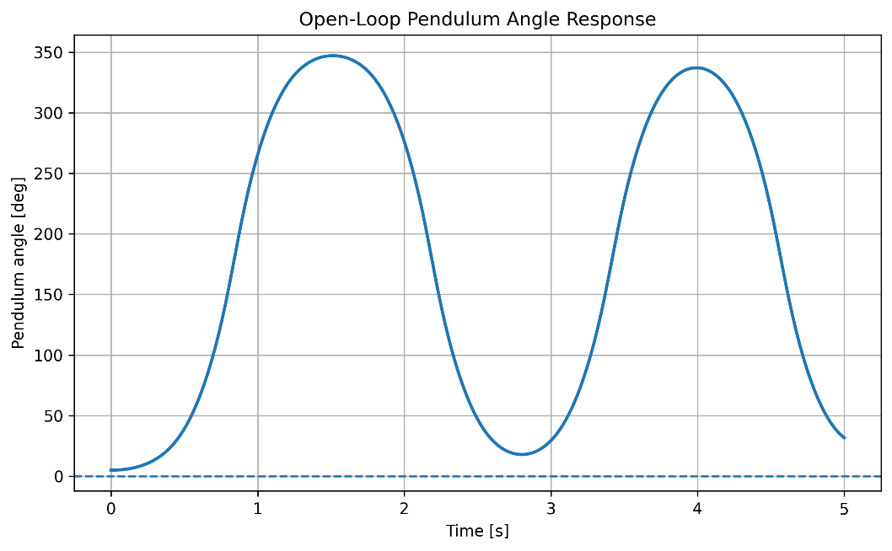
Figure 2 Nonlinear open-loop pendulum-angle response for an initial displacement of 5$°$
Starting at$5°$, it fell under the influence of gravity, passed through the downward orientation and continued swinging.
Since the angle is defined from the upright position,$0°$ represents upright,$180°$ represents vertically downward, and$360°$ again represent the upright orientation.
The simulation therefore demonstrates that the upright equilibrium cannot be maintained without feedback control.

Cart Response:
The cart also moved despite the absence of an externally applied force.
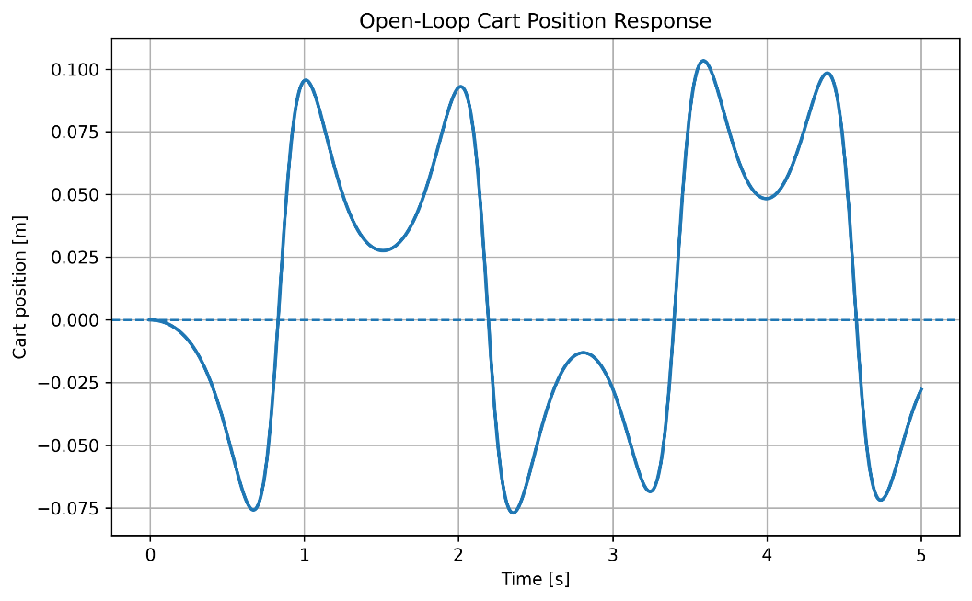
Figure 3 Open-loop cart displacement resulting from the uncontrolled pendulum motion.
This occurs because the motion of the pendulum transfers momentum to the cart. The open-loop simulations showed oscillatory cart displacement as the pendulum moved from one side to the other.
The simulation therefore establishes the first important result of the project “The cart-pole system cannot maintain the upright equilibrium in open loop” and a feedback controller is required.

Linearization Around the Upright Equilibrium:
Although the nonlinear model accurately represents the system dynamics, classical state-feedback methods are more conveniently designed using a linear state-space representation.
The nonlinear equations were therefore linearized around
$$θ=0$$
Using the small-angle approximations
$$sinθ≈θ$$
And,
$$cosθ≈1$$
The nonlinear higher-order term involving
$${\dot{θ}}^{2}sinθ$$
Is neglected during linearization.
The resulting system can be expressed as:
$$\dot{x}=Ax+Bu$$
For the selected physical parameters, the matrix was obtained as:
$$A=\left[\begin{matrix}0 & 1 & 0 & 0 \\ 0 & -0.1818 & -2.6755 & 0 \\ 0 & 0 & 0 & 1 \\ 0 & 0.4545 & 31.2136 & 0\end{matrix}\right]$$
And the input matrix as:
$$B=\left[\begin{matrix}0 \\ 1.8182 \\ 0 \\ -4.5455\end{matrix}\right]$$
The linearized model describes the behavior of the system about the upright operating point.

Open-Loop Stability Analysis:
The stability of the linearized system was examined using the eigenvalues of the state matrix A. The calculated open-loop eigen values were:
$$λ=\left\{0, -0.1482, -5.6069, +5.5680\right\}$$
For a continuous-time linear system, asymptotic stability requires all system eigenvalues to have negative real parts. One eigen value is$λ=+5.5680$ which lies in the right half of the complex plane. Therefore, “The upright open-loop cart-pole system is unstable.”
This mathematical result agree with the nonlinear open-loop simulation, in which the pendulum rapidly moved away from its initial$5°$ displacement.
This agreement between the nonlinear simulation and linear stability analysis provides an important validation of the model.

Controllability Analysis:
Before designing a state-feedback controller, it was necessary to determine whether the input force could influence all four states of the system.
For the linear system:
$$\dot{x}=Ax+Bu$$
The controllability matrix is:
$$C=\left[\begin{matrix}B & AB & A^{2}B & A^{3}B\end{matrix}\right]$$
The calculated controllability matrix was:
$$C=\left[\begin{matrix}0 & 1.8182 & -0.3306 & 12.213 \\ 1.8182 & -0.3306 & 12.2213 & -4.4332 \\ 0 & -4.5455 & 0.8264 & -142.0304 \\ -4.5455 & 0.8264 & -142.0304 & 31.3515\end{matrix}\right]$$
Its rank was calculated as:
$$rank\left(C\right)=4$$
Since the system contains four state variables,
$$n=4$$
The controllability matrix has full rank. Therefore, “The cart-pole system is fully controllable.”
This means that the single horizontal control force applied to the cart can be used, through the coupled system dynamics, to influence all four state variables.
Therefore, state-feedback controller design can proceed.

Pole-Placement State-Feedback Controller:
The first controller was designed using pole placement.
A full-state feedback law of the form:
$$u=-Kx$$
Was used, where:
$$K=\left[\begin{matrix}k_{x} & k_{\dot{x}} & k_{θ} & k_{\dot{θ}}\end{matrix}\right]$$
With state-feedback, the closed-loop system becomes:
$$\dot{x}=(A-BK)x$$
Because the system is full controllable, the closed-loop poles can be assigned to desired locations. The desired poles were selected as:
$$s_{PP}=[-2, -2.5, -3, -3.5]$$
These locations were chosen in the left half-plane to provide stable closed-loop behavior without making the controller unnecessarily aggressive.
The resulting state-feedback gain was:
$$K_{PP}=\left[\begin{matrix}-1.1774 & -1.885 & -17.1829 & -3.1353\end{matrix}\right]$$
The eigenvalues of$A-BK_{PP}$ were found to be:
$$λ_{PP}=\left[\begin{matrix}-3.5, & -3.0, & -2.5, & -2.0\end{matrix}\right]$$
Which corresponds to the requested pole locations. Thus, the state-feedback successfully transforms the unstable linear system into a stable closed-loop system.

Pole-Placement Controller Applied to the Nonlinear Model:
The gain obtained using the linearized system was next applied directly to the original nonlinear cart-pole system model.
The nonlinear simulation began again from:
$$θ\left(0\right)=5°$$
With zero initial cart position, velocity and pendulum angular velocity.
At every integration step, the control input was calculated from:
$$F=-K_{PP}x$$
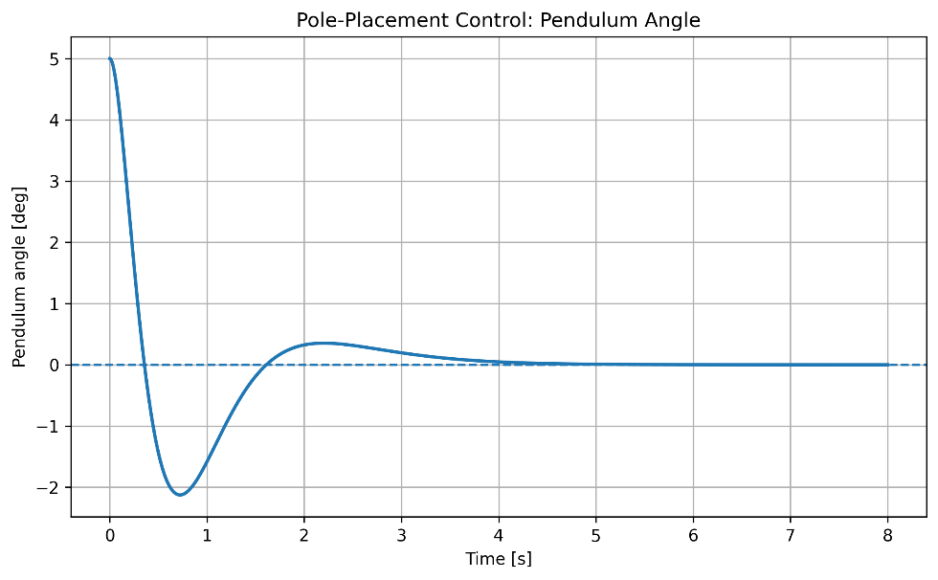
Figure 4 Pendulum-angle response of the nonlinear plan under pole-placement state feedback.
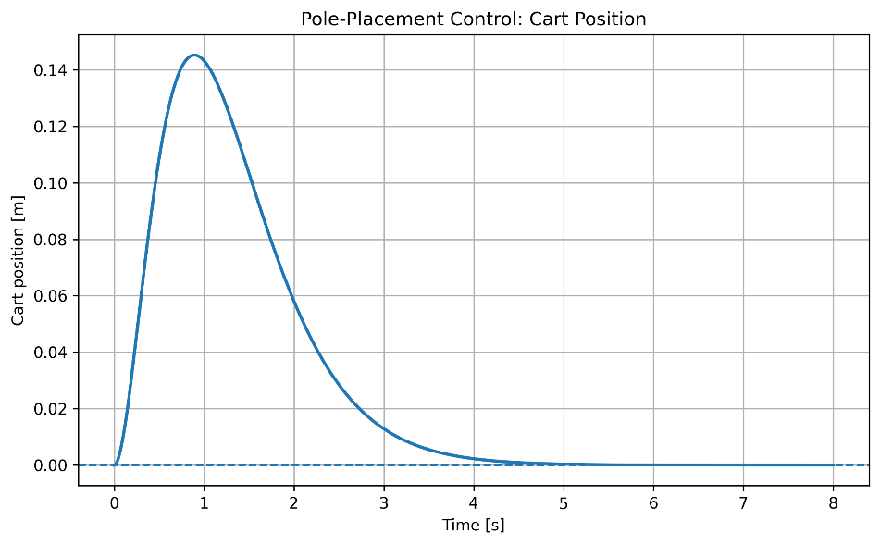
Figure 5 Cart-position response under pole-placement state feedback.
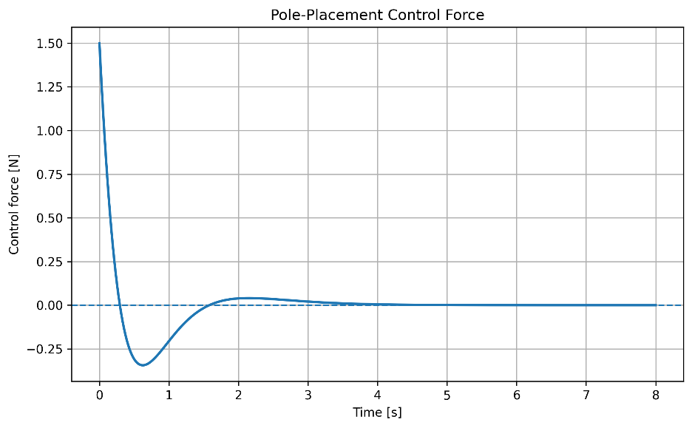
Figure 6 Control force generated by the pole-placement controller.
Unlike the open-loop system, the pendulum was successfully returned to the upright equilibrium. The cart initially moved in order to generate the required corrective acceleration, after which it returned toward its original position.
The controller therefore successfully stabilized the nonlinear plant despite having been designed from the linear approximation.
The calculated performance is shown in the table below:
Metric | Pole Placement
Maximum cart displacement | $$0.1453 m$$
Maximum control force | $$1.4995 N$$
Maximum pendulum angle | $$-2,1270°$$
Pendulum settling time within$± 0.1°$ | $$3.501 s$$
Cart settling time within$±1 mm$ | $$4.446 s$$

The pendulum began at$5°$, crossed the equilibrium position, reached an opposite-side excursion of approximately$-2.13°$ and subsequently converged to zero. The peak control force was approximately$1.50 N$.
This simulation demonstrated that pole-placement feedback can stabilize the nonlinear system for a moderate initial angular disturbance.

Linear Quadratic Regulator Design:
The second controller was designed using the Linear Quadratic Regulator approach.
Unlike pole placement, where the designer explicitly selects the desired closed-loop poles, LQR determines the state-feedback gain by minimizing a quadratic performance index.
The cost function is:
$$J=\int_{0}^{∞}{(x^{T}Qx+u^{T}Ru)dt}$$
The first term penalizes deviations of the system states from equilibrium, while the second term penalizes control effort.
The weighting matrices selected for the initial LQR design were:
$$Q=\left[\begin{matrix}10 & 0 & 0 & 0 \\ 0 & 1 & 0 & 0 \\ 0 & 0 & 100 & 0 \\ 0 & 0 & 0 & 1\end{matrix}\right]$$
And:
$$R=[1]$$
The relatively large weighting assigned to the pendulum angle,$Q_{θθ}=100$, reflects the primary design objective of maintaining the pendulum close to the upright equilibrium.
The resulting LQR gain was:
$$K_{LQR}=\left[\begin{matrix}-3.1624 & -3.9764 & -28.6082 & -5.1827\end{matrix}\right]$$
The corresponding closed-loop eigenvalues were:
$$λ_{LQR}=\left[\begin{matrix}-7.0293+2.5861j & -7.0293-2.5861j & -1.2257+1.0057j & -1.2257-1.0057j\end{matrix}\right]$$
All poles have negative real parts, confirming the stability of the linear closed-loop system. The complex-conjugate pole pairs indicate that the response contains damped oscillatory modes.

LQR Controller Applied to the Nonlinear Model:
The LQR controller was then applied to the same nonlinear cart-pole plant and evaluated using exactly the same initial condition:
$$θ\left(0\right)=5°$$
The control law was:
$$F=-K_{LQR}x$$
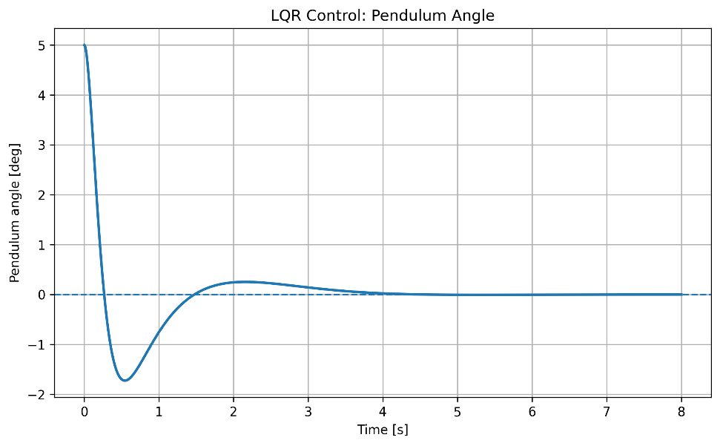
Figure 7 Pendulum-angle response of the nonlinear plant under LQR control.
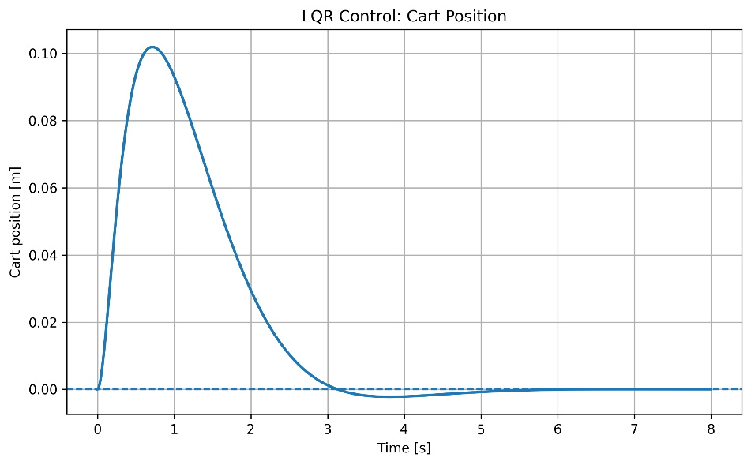
Figure 8 Cart-position response under LQR control.
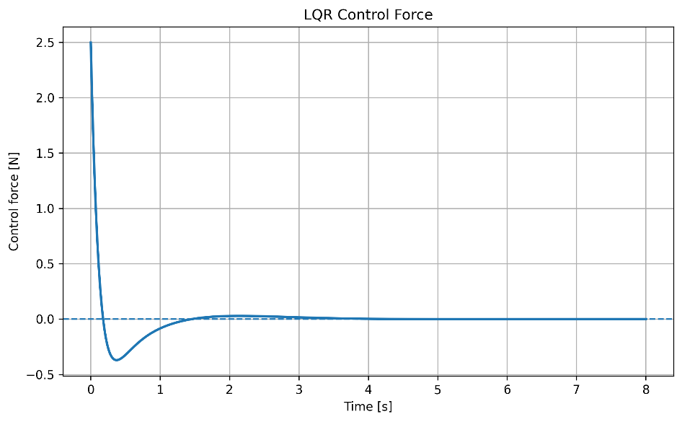
Figure 9 Control force generated by the LQR Controller.
The pendulum was again successfully stabilized around the upright equilibrium. The cart temporarily moved to generate the acceleration required to correct the pendulum angle and subsequently returned to its original position.
The calculated LQR performance is shown in the table below:
Metric | LQR
Maximum cart displacement | $$0.1019 m$$
Maximum control force | $$2.4965 N$$
Maximum pendulum angle | $$-1,7248°$$
Pendulum settling time within$± 0.1°$ | $$3.266 s$$
Cart settling time within$±1 mm$ | $$4.835 s$$

The LQR controller therefore successfully stabilized the nonlinear plant using a controller designed from the linearized model.

Interim Findings:
At this stage, the project has established that:
- The uncontrolled inverted pendulum is unstable around the equilibrium;
- The nonlinear simulation and linear eigenvalue analysis independently confirm this instability;
- The system is fully controllable using the horizontal cart force;
- Pole-placement feedback successfully stabilizes the nonlinear system;
- LQR feedback also successfully stabilizes the nonlinear system; and
- The two controllers produce noticeably different transient response and actuator demands.
So, the next stage of the analysis is therefore to compare the two controllers quantitatively and determine the performance trade-offs between state regulation and control effort.

Controller Performance Comparison:
To evaluate the two state-feedback control strategies, the nonlinear cart-pole model was simulated using the same initial condition of a$5°$ pendulum displacement from the upright equilibrium. The performances of the pole-placement and Linear Quadratic Regulator (LQR) controllers were then compared using cart displacement, pendulum response, settling time, and control effort.
From the simulation results we obtain the following results:
Metric | Pole Placement | LQR | Results (Performed Better)
Maximum cart displacement | $$0.1453 m$$ | $$0.1019 m$$ | LQR
Maximum control force | $$1.4995 N$$ | $$2.4965 N$$ | Pole placement
Minimum pendulum angle | $$-2.1370°$$ | $$-1.7248°$$ | LQR
Pendulum settling time | $$3.501 s$$ | $$3.266 s$$ | LQR
Cart settling time | $$4.446 s$$ | $$4.385 s$$ | Pole Placement
The results show that neither controller is universally superior. Instead, the two approaches produce different performance trade-offs. The LQR controller achieves a smaller cart excursion, reduced pendulum undershoot, and a slightly faster pendulum settling time. Pole placement, however, requires considerably less peak actuator force and returns the cart to its equilibrium position slightly faster.

Pendulum-Angle Comparison:
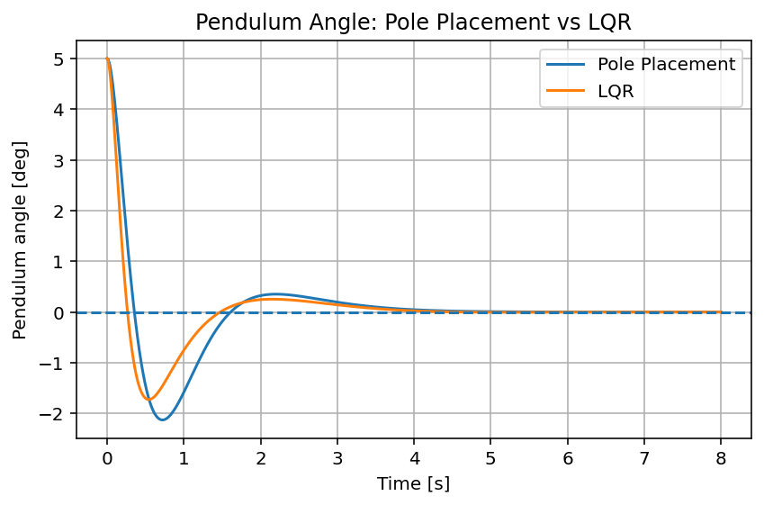
Figure 10 Comparison of pendulum-angle response under pole-placement and LQR control.
The two controllers both stabilize the pendulum successfully. However, the transient responses differ as shown in the figure above. The Pole-placement controller reaches a minimum angle of approximately$-2.127°$ , whereas the LQR controller reaches approximately$-1.725°$. Thus, the LQR controller reduces the opposite-side angular excursion by about$0.402°$.
It also shows that LQR controller settles within the selected$±0.1°$ tolerance slightly faster as$3.26 s$ compared with$3.501 s$ for pole-placement. And has a reduced undershoot as well.

Cart-Position Comparison:
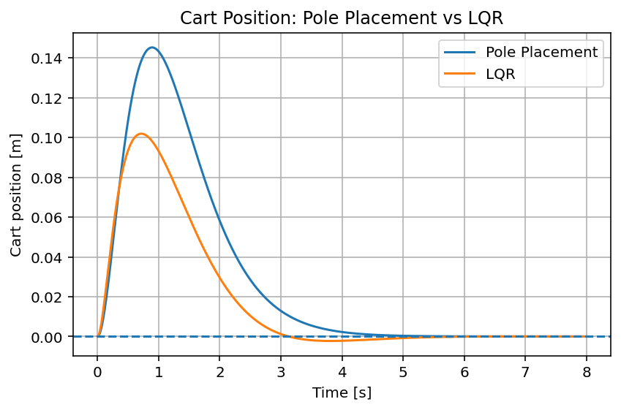
Figure 11 Comparison of cart-position response under pole-placement and LQR control.
One of the clearest differences between the controllers is the amount of cart travel required for stabilization. The pole-placement controller moves the cat by a maximum of$0.1453 m$, or approximately$14.5 cm$. The LQR reduces this to$0.1019 m$, or approximately$10.2 cm$. This corresponds to approximately a$30\%$ reduction in maximum cart excursion. This could be a meaningful improvement especially if the physical cart operates on a track with limited travel.
However, the pole-placement controller returns within the selected$±1 mm$ settling band slightly sooner,$4.446 s$ compared with$4.835 s$ for LQR. So, LQR moves the cart less, but final small residual cart motion takes slightly longer to disappear.

Control-Force Comparison:
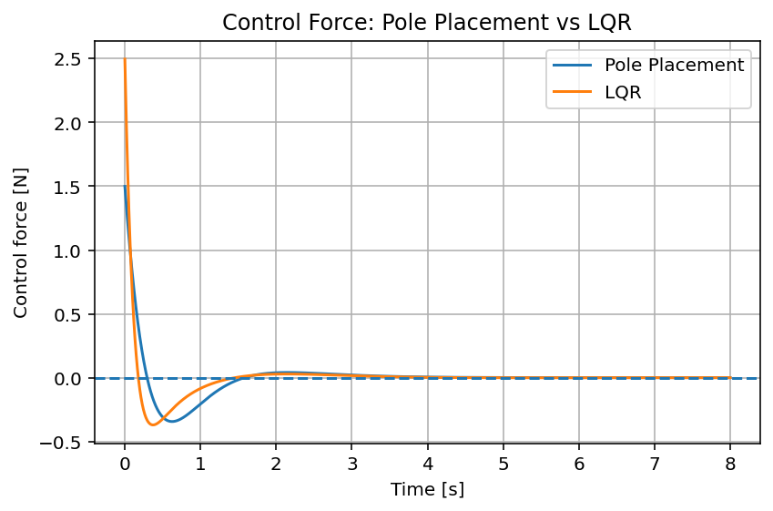
Figure 12 Comparison of control force generated by the pole-placement and LQR controllers
This figure shows the main cost of the improved LQR transient response. Pole placement requires a maximum force of only$1.4995 N$, whereas LQR requires$2.4965 N$. The increase is approximately$66.5\%$, therefore, the LQR controller requires approximately$66.5\%$ greater peak actuator force.
The LQR controller keeps the pendulum closer to the desired upright position and requires less cart displacement, but it does so by applying a substantially stronger initial corrective action.

Controller Gains Comparison:
The LQR state-feedback gain obtained from the selected weighting matrices was:
$$K_{LQR}=[-3.1623, -3.9764, -28.6082, -5.1827]$$
For the pole-placement controller, the desired closed-loop poles were selected as:
$$-2, -2.5, -3, -3.5$$
And the resulting feedback gain was:
$$K_{Pole-Placement}=[-1.1774, -1.8885, -17.1829, -3.1354]$$
A particularly important difference can be observed in the feedback gain associated with pendulum angle:
$$\left|K_{θ, LQR}\right|=28.61$$
Compared with:
$$\left|K_{θ, Pole-Placement}\right|=17.18$$
The larger LQR angle gain indicates that the controller reacts more strongly to deviations of the pendulum from the upright position. This behavior is consistent with the selected LQR state-weighting matrix:
$$Q=diag(10, 1, 100, 1)$$
Where the pendulum angle receives the largest penalty. In effect, the controller is instructed to treat angular deviation as particularly costly and therefore correct it more aggressively.
The very large value:
$$Q_{θθ}=100$$
This tells the optimizer that pendulum-angle is expensive. Correct it strongly. The result matches that design choice.

Interpretation of the Results:
The stronger angular correction provided by the LQR controller reduces the maximum cart displacement from approximately$14.5 cm$ to$10.2 cm$, while also reducing the pendulum’s opposite-side excursion from approximately$2.13°$ to$1.72°$.
The pendulum also settles slightly faster under LQR control, decreasing from approximately$3.50 s$ to$3.27 s$.
However, these improvements come at the cost of increased control effort. The peak control force rises from $1.50 N$ for pole placement approximately to$2.50 N$ for LQR, corresponding to an increase of about$66\%$ in the peak actuator demand.
This illustrates an important principle in control-system design “Improved transient performance generally requires greater control effort.” Therefore, controller selection should not be based solely on settling time or tracking performance. Practical factors such as actuator limits, available energy, allowable cart travel, and robustness must also be considered.

