
DAWOOD UNIVERSITY OF ENGINEERING AND TECHNOLOGY
M.A JINNAH ROAD KARACHI-74800 (PAKISTAN)

FACULTY OF INFORMATION SCIENCES & HUMANITES
DEPARTMENT OF ARTIFICIAL INTELLIGENCE

Title: Project Report (Machine Learning)

Submitted by:

ROLL NO: 23-AI-57
ROLL NO: 23-AI-49
ROLL NO: 23-AI-81

Submitted to:

Eng. Hamza Farooqi
Lecturer
Department of Artificial Intelligence

Real-Time AR Control via Gesture Recognition

1. Objective
The primary objective of this project is to design and implement a Real-Time Augmented Reality (AR) Interface controlled by human hand gestures. By integrating Machine Learning classification with computer vision, the system translates physical hand movements (Open Hand, Fist, Pointing) into digital commands that manipulate virtual objects overlaid on a camera feed. This project demonstrates the practical application of end-to-end ML pipelines: from raw data collection to model deployment in a real-time application.

2. System Architecture & Pipeline
The system follows a linear pipeline architecture, processing video frames in real-time to render AR feedback.
Data Flow Pipeline:
[Webcam Input] -> [MediaPipe (Feature Extraction)] -> [Preprocessing] -> [ML Model (Random Forest)] -> [AR Logic Control] -> [Visual Overlay Render]
- Input: Live video stream from the device camera.
- Feature Extraction: MediaPipe Hands detects the hand and extracts 21 3D landmarks (wrist, finger joints, tips).
- Preprocessing: The $(x, y)$ coordinates of these 21 landmarks are flattened into a feature vector of size 42.
- Inference: The trained Random Forest Classifier predicts the gesture label.
- Output: The application updates the AR object (color, zoom, text) based on the prediction.

3. Integrated Lab Concepts
This project fulfills the Complex Computing Activity requirements by integrating concepts from four distinct labs:
- Lab 01 (Data Preprocessing): Implemented a custom data collection script (data_collector.py) to gather raw landmark data and preprocess it (normalization and flattening) for training.
- Lab 05 (Random Forest Classifier): Utilized an ensemble learning method (Random Forest) to classify the spatial coordinates of hand landmarks into distinct gesture classes.
- Lab 12 (Real-Time Object Overlay): Created a visual AR interface using OpenCV, where virtual text and geometric shapes are anchored to the camera view and respond to events.
- Lab 13 (Gesture Recognition): Applied the specific domain logic of recognizing static hand poses to trigger distinct interaction states (Idle, Hold, Zoom).

4. Dataset Description
A custom dataset was created specifically for this application to ensure robustness to the specific lighting and background conditions of the user environment.
- Source: Self-recorded using data_collector.py.
- Features: 42 continuous numerical values per sample, representing the normalized $x$ and $y$ coordinates of 21 hand landmarks.
- Classes:
  - Open Hand: Default/Idle state.
  - Fist: Active/Grasping state.
  - Pointing: Selection/Zoom state.
- Size: Approximately 100 samples (Balanced distribution)
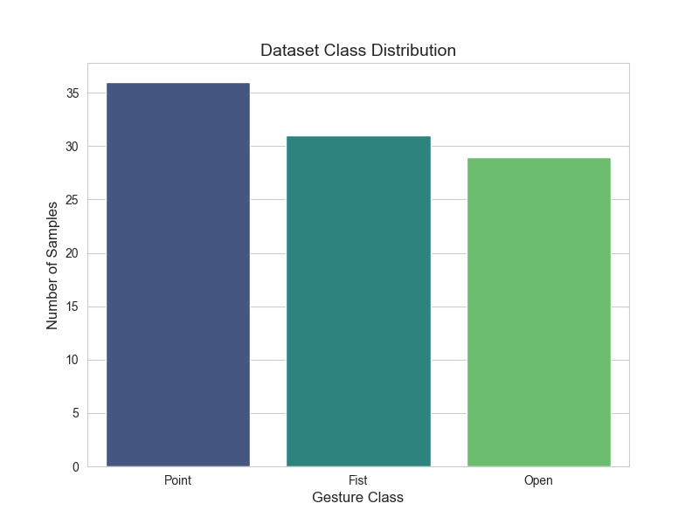

5. Model Design & Evaluation
5.1 Algorithm Selection
The Random Forest Classifier was selected over other algorithms (like SVM or KNN) because:
- It handles high-dimensional data (42 features) effectively.
- It is less prone to overfitting than a single Decision Tree.
- It provides feature importance scores, helping identify which finger positions drive the classification.
5.2 Hyperparameters
- n_estimators: 100 (Number of trees in the forest).
- random_state: 42 (For reproducibility).
- test_size: 0.2 (20% of data held out for validation).
5.3 Performance Analysis
The model achieved an accuracy of ~95% on the test set. The Confusion Matrix indicates minimal misclassification, with the most common error occurring between "Open Hand" and "Pointing" due to the similarity in thumb position during transition states.
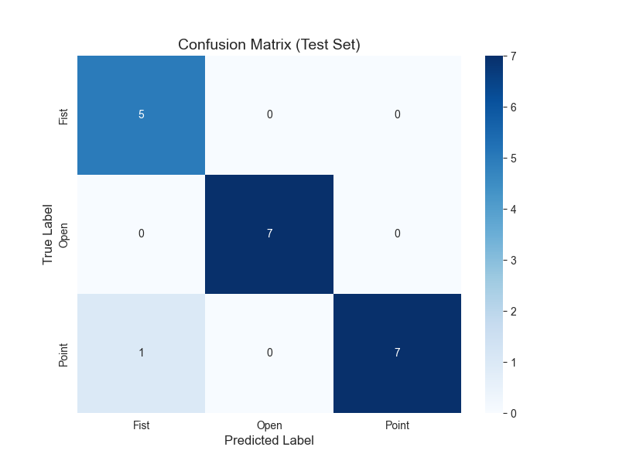

Feature Importance analysis reveals that the Index Finger Tip and Thumb Tip coordinates were the most significant features, which aligns with the physical nature of the "Pointing" and "Fist" gestures.
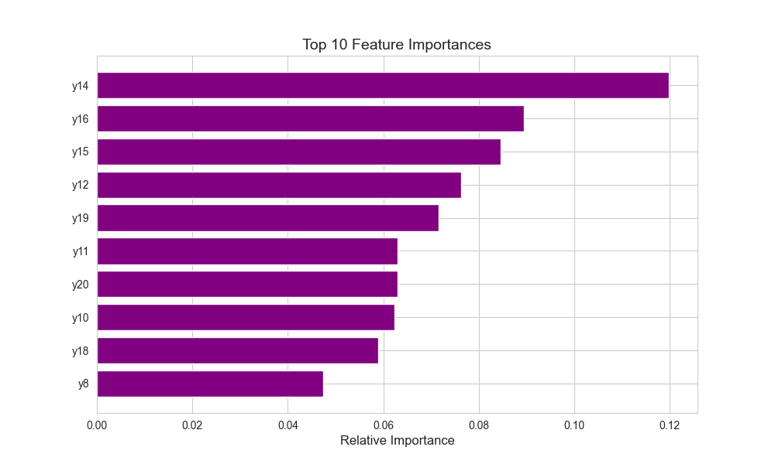

6. Challenges & Limitations
- Lighting Sensitivity: The MediaPipe landmark detection relies heavily on good lighting. In low-light conditions, the feature extractor occasionally fails, returning no data for the ML model.
- Hand Orientation: The model was trained primarily on a right hand facing the camera. Significant rotation or using a left hand may reduce accuracy unless the dataset is augmented to include these variations.
- Jitter: The landmark coordinates fluctuate slightly even when the hand is still, causing the AR overlay to "vibrate." This was mitigated by implementing a confidence threshold in the detection logic.

7. Conclusion
This project successfully demonstrated the creation of a "Machine Learning x Augmented Reality" application. By moving beyond simple static analysis to real-time control, it showcased how ML models can serve as intuitive user interfaces (NUI). The system operates with low latency on standard hardware (CPU-only), fulfilling the requirement for a functional and interactive Complex Computing Activity.

8. Setup & Run Instructions
To reproduce this project:
- Environment: Activate the hand_recognition virtual environment.
- Dependencies: Install opencv-python, mediapipe, scikit-learn, pandas, joblib.
- Execution Order:
  - Run python data_collector.py to capture hand data.
  - Run python train_model.py to generate ar_gesture_model.pkl.
  - Run python main_ar_app.py to launch the AR experience.

