Task 1: Dataset Loading Output
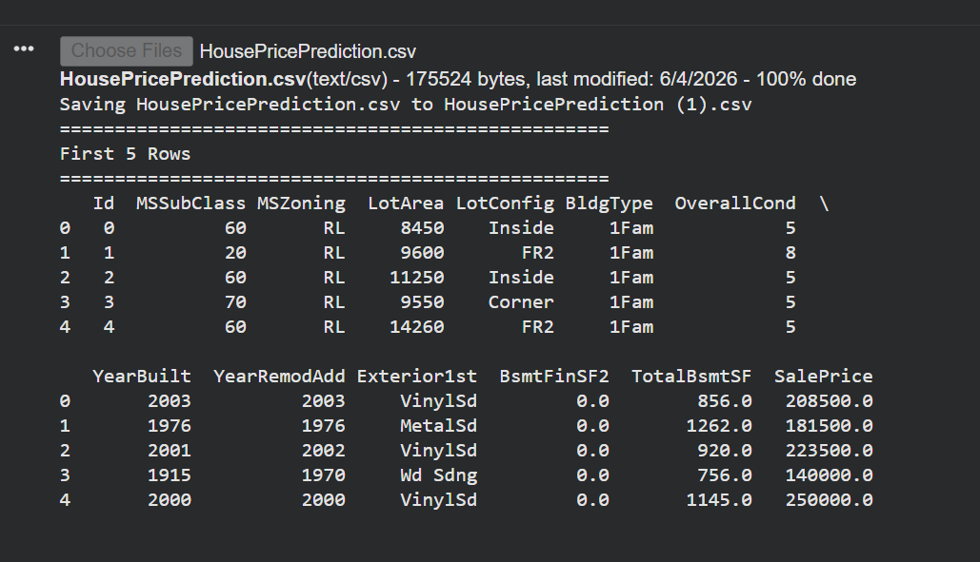

Task 2: Dataset Info Output
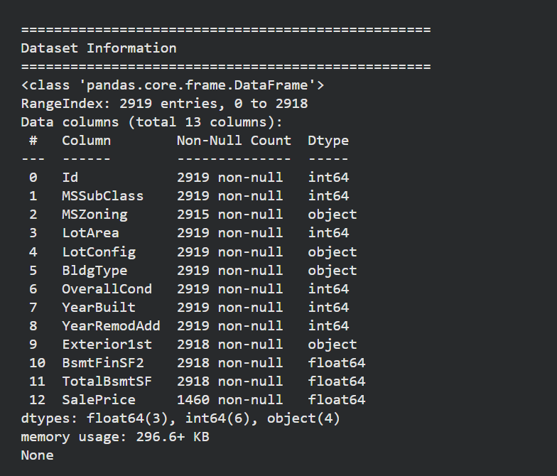
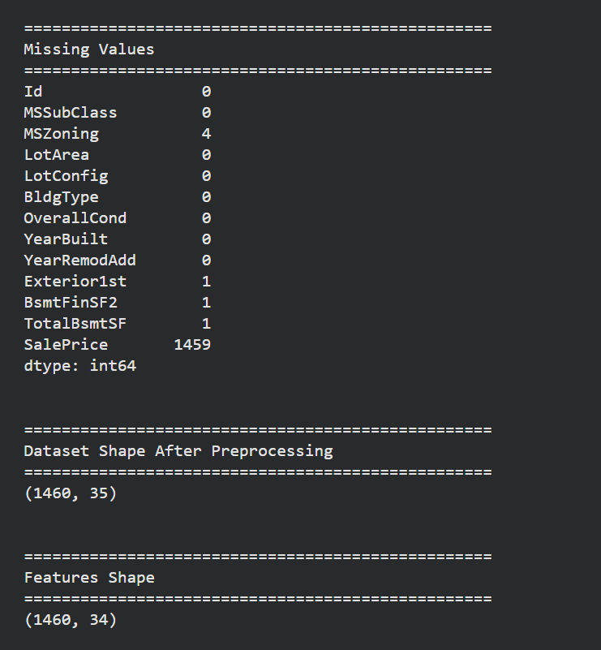
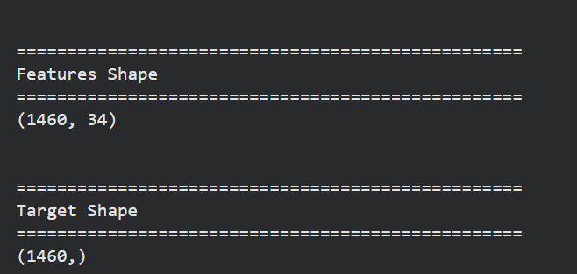

Task 3: Train-Test Split Output
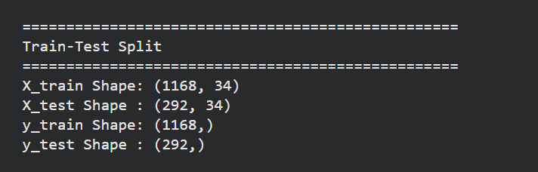

Task 4: Actual vs Predicted Prices Output
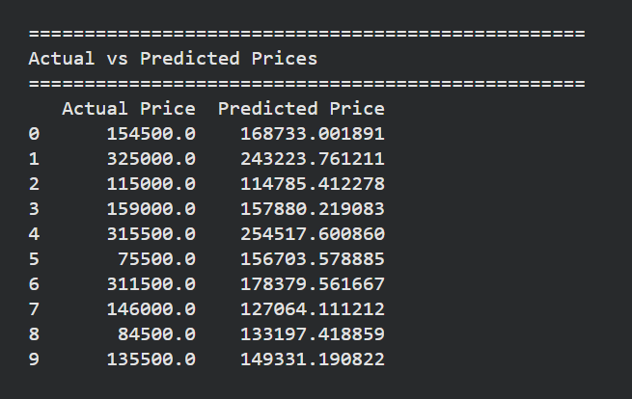

Task 5: MAE, MSE, RMSE and R² Score Output
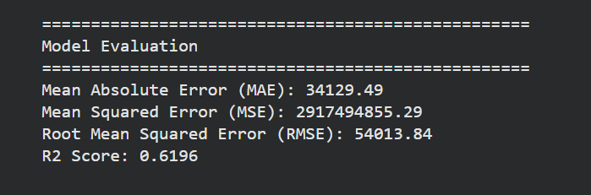

Task 6: Interpretation Output
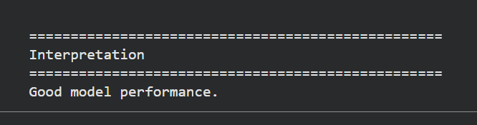

Code USED
# Import Libraries
import pandas as pd
import numpy as np

from google.colab import files
uploaded = files.upload()
# 1. Dataset Loading

# Load Dataset
df = pd.read_csv("HousePricePrediction.csv")

# House Price Prediction Using Linear Regression

from sklearn.model_selection import train_test_split
from sklearn.linear_model import LinearRegression
from sklearn.metrics import (
mean_absolute_error,
mean_squared_error,
r2_score
)

# Load Dataset

df = pd.read_csv("HousePricePrediction.csv")

print("=" * 50)
print("First 5 Rows")
print("=" * 50)
print(df.head())

print("\n")

print("=" * 50)
print("Dataset Information")
print("=" * 50)
print(df.info())

print("\n")

print("=" * 50)
print("Missing Values")
print("=" * 50)
print(df.isnull().sum())

# Data Preprocessing

# Remove rows with missing values
df = df.dropna()

# Convert categorical columns into numeric
df = pd.get_dummies(df, drop_first=True)

print("\n")
print("=" * 50)
print("Dataset Shape After Preprocessing")
print("=" * 50)
print(df.shape)

# Define Features and Target

# Target Column
target_column = "SalePrice"

# Features
X = df.drop(target_column, axis=1)

# Target
y = df[target_column]

print("\n")
print("=" * 50)
print("Features Shape")
print("=" * 50)
print(X.shape)

print("\n")
print("=" * 50)
print("Target Shape")
print("=" * 50)
print(y.shape)

# Train-Test Split

X_train, X_test, y_train, y_test = train_test_split(
X,
y,
test_size=0.20,
random_state=42
)

print("\n")
print("=" * 50)
print("Train-Test Split")
print("=" * 50)
print("X_train Shape:", X_train.shape)
print("X_test Shape :", X_test.shape)
print("y_train Shape:", y_train.shape)
print("y_test Shape :", y_test.shape)

# Train Linear Regression Model

model = LinearRegression()

model.fit(X_train, y_train)

print("\n")
print("=" * 50)
print("Model Training Completed")
print("=" * 50)

# Predict House Prices

y_pred = model.predict(X_test)

print("\n")
print("=" * 50)
print("Actual vs Predicted Prices")
print("=" * 50)

comparison = pd.DataFrame({
"Actual Price": y_test.values,
"Predicted Price": y_pred
})

print(comparison.head(10))

# Model Evaluation

mae = mean_absolute_error(y_test, y_pred)

mse = mean_squared_error(y_test, y_pred)

rmse = np.sqrt(mse)

r2 = r2_score(y_test, y_pred)

print("\n")
print("=" * 50)
print("Model Evaluation")
print("=" * 50)

print(f"Mean Absolute Error (MAE): {mae:.2f}")
print(f"Mean Squared Error (MSE): {mse:.2f}")
print(f"Root Mean Squared Error (RMSE): {rmse:.2f}")
print(f"R2 Score: {r2:.4f}")

# Model Coefficients

coefficients = pd.DataFrame({
"Feature": X.columns,
"Coefficient": model.coef_
})

print("\n")
print("=" * 50)
print("Top 10 Important Features")
print("=" * 50)

print(
coefficients.sort_values(
by="Coefficient",
ascending=False
).head(10)
)

# Interpretation

print("\n")
print("=" * 50)
print("Interpretation")
print("=" * 50)

if r2 >= 0.80:
print("Excellent model performance.")
elif r2 >= 0.60:
print("Good model performance.")
elif r2 >= 0.40:
print("Average model performance.")
else:
print("Model needs improvement.")

