Task 1: Salary Tax Calculator (Conditional Statements)

Code:
salary = float(input("Enter your salary: "))
if salary < 30000:
tax_rate = 0.05
elif 30000 <= salary <= 70000:
tax_rate = 0.15
else:
tax_rate = 0.25
tax = salary * tax_rate
final_salary = salary - tax
print("Tax Rate:", tax_rate * 100, "%")
print("Tax Amount:", tax)
print("Final Salary after tax:", final_salary)

Code Screenshot:
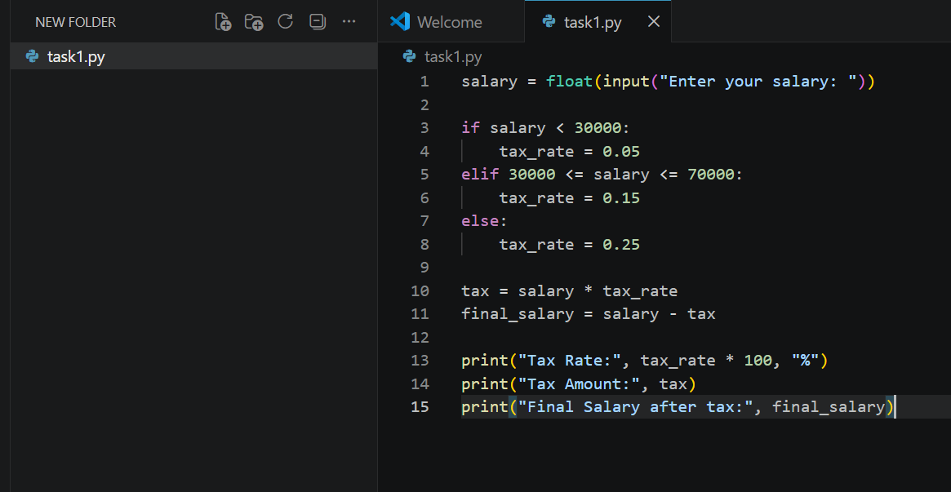

Test Case #1: 25000 as salary
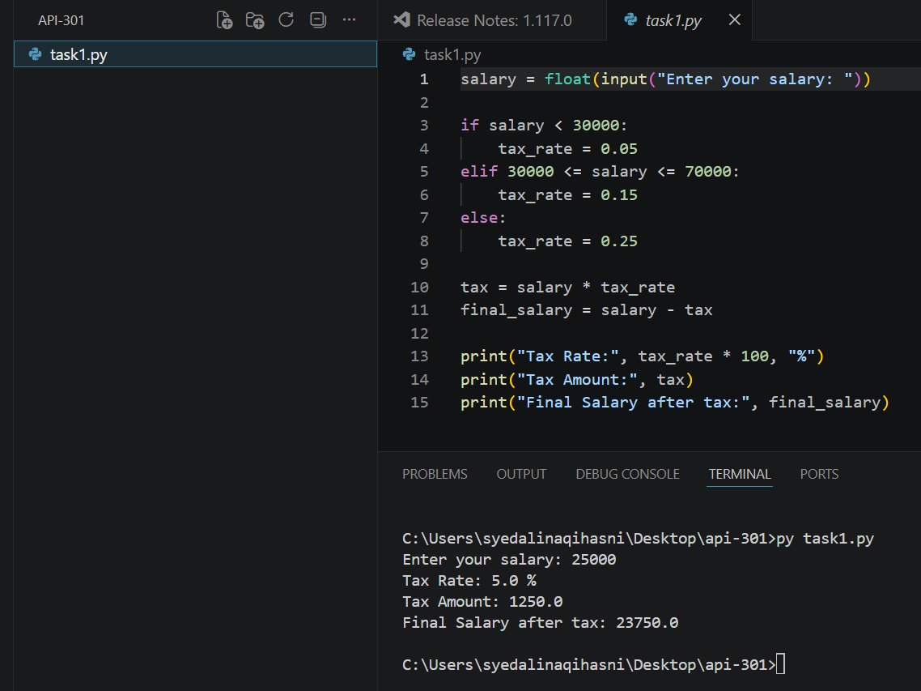

Test Case #2: 50000 as salary
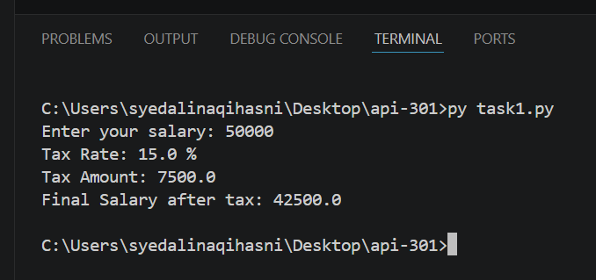

Test Case #3: 90000 as salary
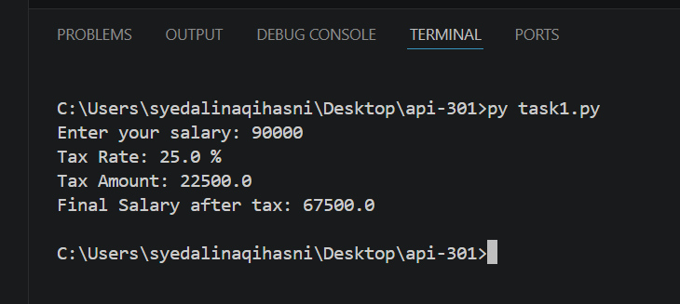

Task 2: List to Dictionary (Words Length Mapping)

Code:

words = ["apple", "banana", "kiwi", "cherry", "mango"]

word_length_dict = {}

for word in words:

word_length_dict[word] = len(word)

print(word_length_dict)

Code Screenshot with Output:
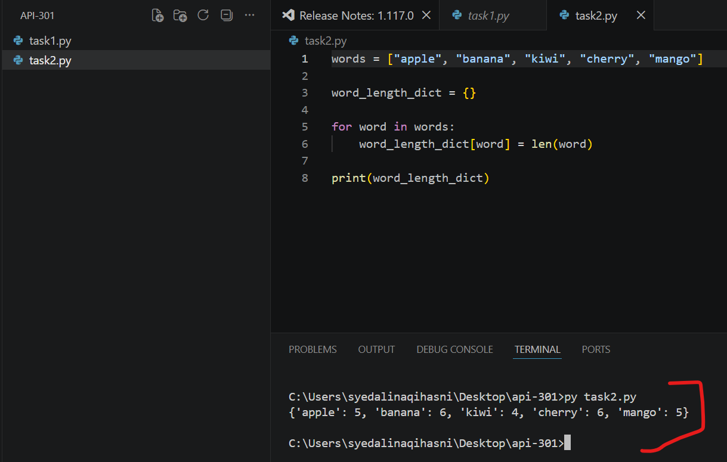

Task 3: Chat System using OOP

Code:
class User:
def __init__(self, name):
self.name = name

def send_message(self, chatroom, content):
message = Message(self, content)
chatroom.add_message(message)
class Message:
def __init__(self, user, content):
self.user = user
self.content = content
def display(self):
print(f"{self.user.name}: {self.content}")
class ChatRoom:
def __init__(self):
self.users = []
self.messages = []
def join(self, user):
self.users.append(user)
print(f"{user.name} joined the chat.")
def leave(self, user):
self.users.remove(user)
print(f"{user.name} left the chat.")
def add_message(self, message):
self.messages.append(message)
def show_chat(self):
print("\nChat History:")
for msg in self.messages:
msg.display()
# --- Testing

chatroom = ChatRoom()
user1 = User("Ali")
user2 = User("Sara")
chatroom.join(user1)
chatroom.join(user2)
user1.send_message(chatroom, "Hello everyone!")
user2.send_message(chatroom, "Hi Ali!")
chatroom.show_chat()
chatroom.leave(user2):
Code Screenshot
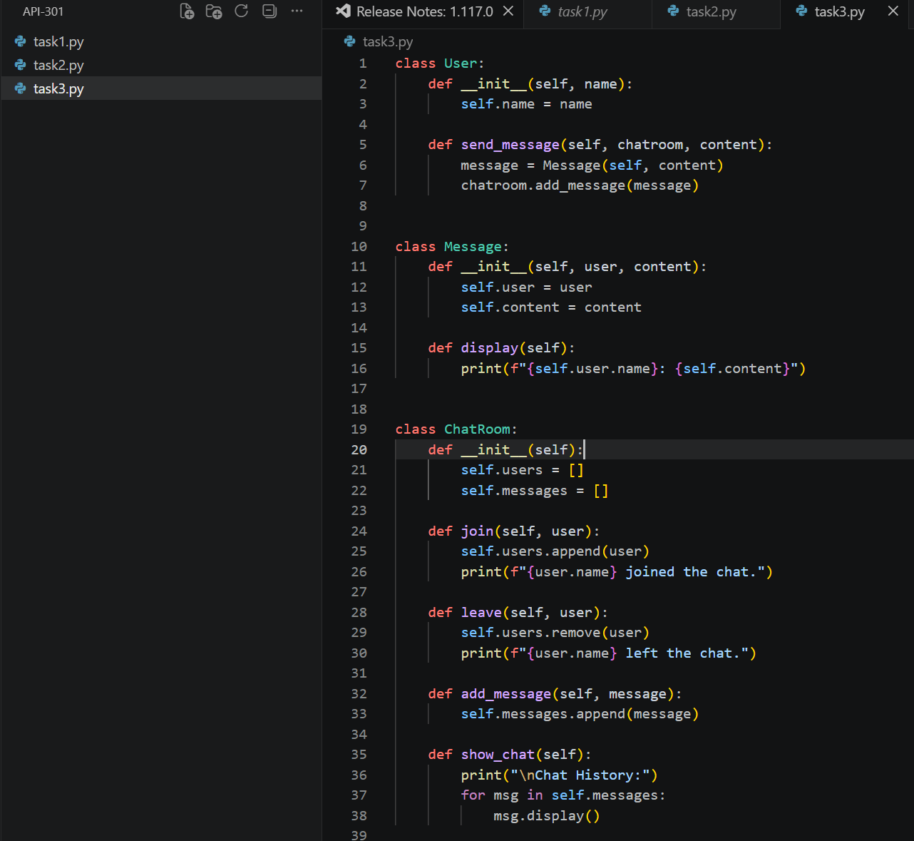

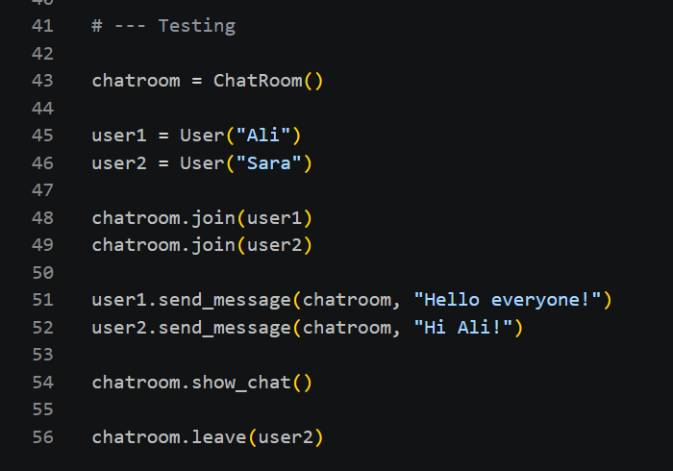

Chat Test Output:
