
Hands-on Exercise No. 1  Batch: 03  WordPress | Total Marks: 10  Due Date: 18 April 2019

Instructions:
Please read the following instructions carefully before submitting this Hands-on Exercise:
- Use WordPress to prepare exercise solution.
- You may consult tutorials and videos if the concept is not clear.
- Your submitted exercise will not be considered/counted if:
- It is submitted after due date.
- It is not in the format of MS Word File (.doc,.docx)
- It does not open, or file is corrupt.
- It is copied (partial or full) from any source (websites, forums, students, etc.)

Learning Outcome:

After completing this exercise, you shall be able to:

- Install WordPress on online or local host.
- Understand about the categories of websites.
- Create own website.
- Explore the dashboard of the website.

Problem Statement

- Install WordPress either online or on local host. If you install WordPress on online server, you do not need to purchase the domain name and hosting, rather use the free hosting services (e.g. 000webhost).
- Explore categories of websites (like Blog, Ecommerce, Website, Business Website, Portfolio Website, etc.). Choose the domain name that corresponds to the category of your planned website.
- Admin side of a website created in WordPress can be opened by adding /wp-admin or /wp-login.php after the website’s URL.
For example:
- www.abc.com/wp-admin
- www.abc.com/wp-login.php

Requirement:

MS word file (*.doc, *.docx) with following item:

- Complete screenshots of all the steps involved in above task.
- URL of website

BEST OF LUCK

How to submit a graded exercise on LMS?

Please perform the following steps for submitting your solution using LMS:

- Login to the LMS

- Click on the Exercises Tab within the My Activities section

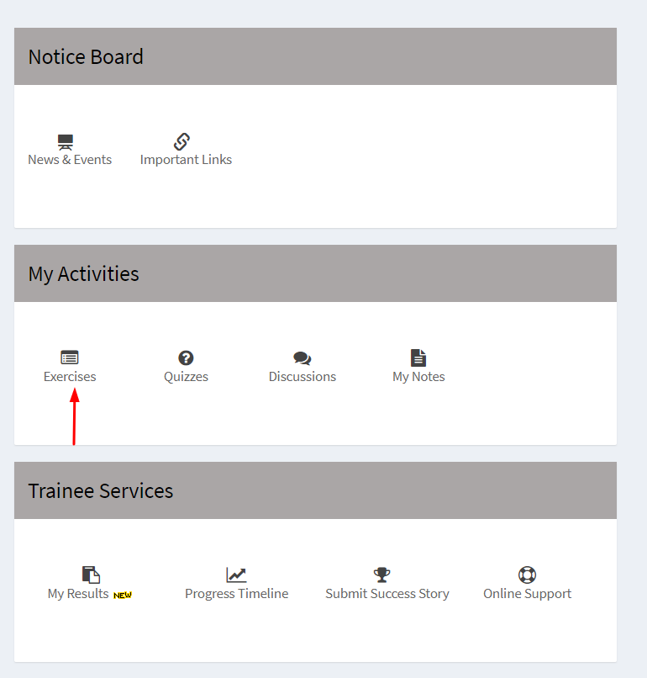

- Click on the submit button to upload your Solution.

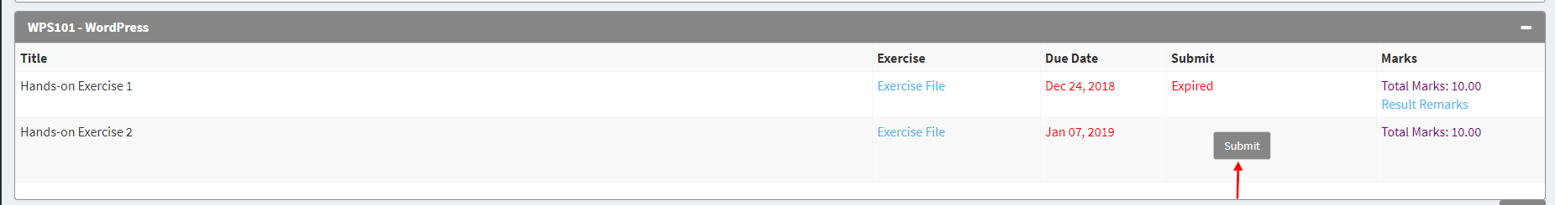

- Keep in mind to upload your Solution in .doc, docx format.

