RAJESWARI VEDACHALAM GOVERNMENT ARTS COLLEGE
CHENGALPATTU

Bachelor of computer Application

Identifying Patterns and Trends in Campus Placement Data using Machine Learning



TEAM MEMBERS:

H. SYED ALTHAF
A. KAMALI
S. UMAMAHESWARI
M. VISWANATH
Content
S.NO | TITLE | PAGE NO.
1 | INTRODUCTION | 4
2 | PROBLEM DEFINING & DESIGN THINKING | 5
3 | RESULT | 10
4 | ADVANTAGES & DISADVANTAGES | 13
5 | APPLICATIONS | 14
6 | CONCLUSION | 15
7 | FUTURE SCOPE | 16
8 | APPENDIX | 17

1. INTRODUCTION
Identifying trends and patterns in campus placement is an important aspect of understanding the job market and making informed decisions about career paths.
Campus placements refers to the process of recruiting students from educational institutions for employment opportunities

  - Overview

Campus recruitment is a strategy for sourcing, engaging and hiring young talent for internship and entry-level positions. College recruiting is typically a tactic for medium - to large-sized companies with high-volume recruiting needs, but can range from small efforts (like working with university career centers to source potential candidates) to large-scale operations (like visiting a wide array of colleges and attending recruiting events throughout the spring and fall semester).Campus recruitment often involves working with university career services centers and attending career fairs to meet in-person with college students and recent graduates. Our solution revolves around the placement season of a Business School in India. Where it has various factors on candidates getting hired such as work experience, exam percentage etc., Finally it contains the status of recruitment and remuneration details.

  - PURPOSE

Gain insights into job market and inform decision making related to the career paths and recruiting strategies.

This project can help students to make informed decisions about their career paths. For educational institution, this information can help them to better prepare their students for the job markets and tailor their curriculums and career services accordingly.

- PROBLEM DEFINING AND DESIGN THINKING

Defining the problem in campus placements involves identifying the specific questions or challenges that need to be addressed through the analysis of campus placement data.

  - EMPATHY MAP

An empathy map is a simple, easy-to-digest visual that captures knowledge about a user’s behaviours and attitudes. It is a useful tool to helps teams better understand their users.

In the ideation phase we have empathized as our client Placement Trend Analyzer and we have acquired the details which are represented in the empathy map given below.

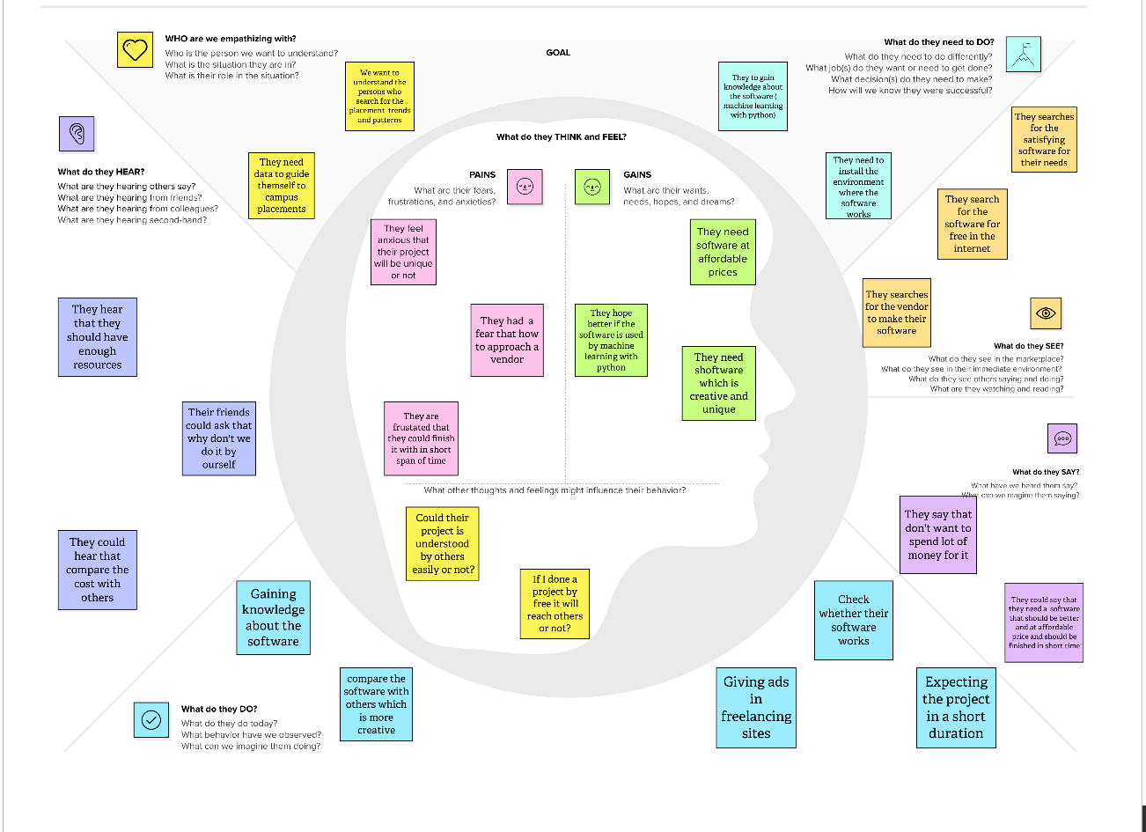

  - IDEATION AND BRAINSTORM MAP

A brainstorm map (also known as a mind map or concept map) is a visual tool used to organize and generate ideas.

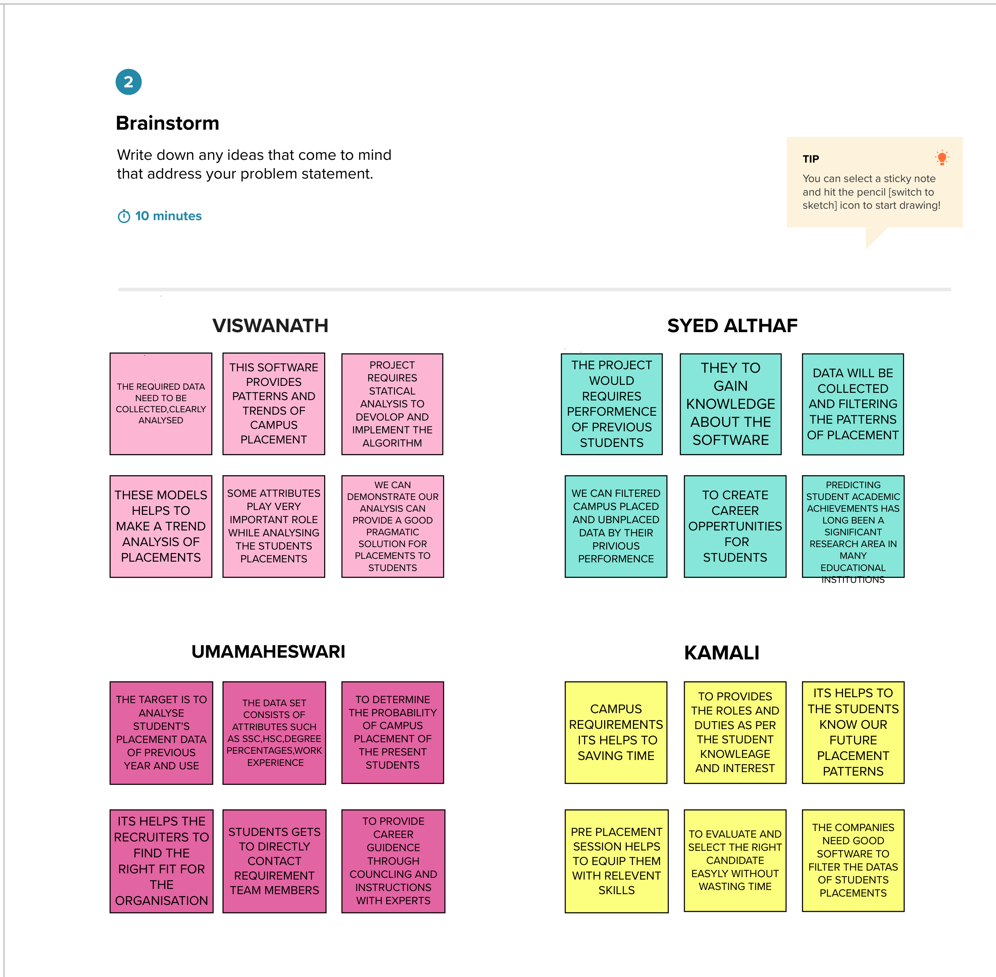

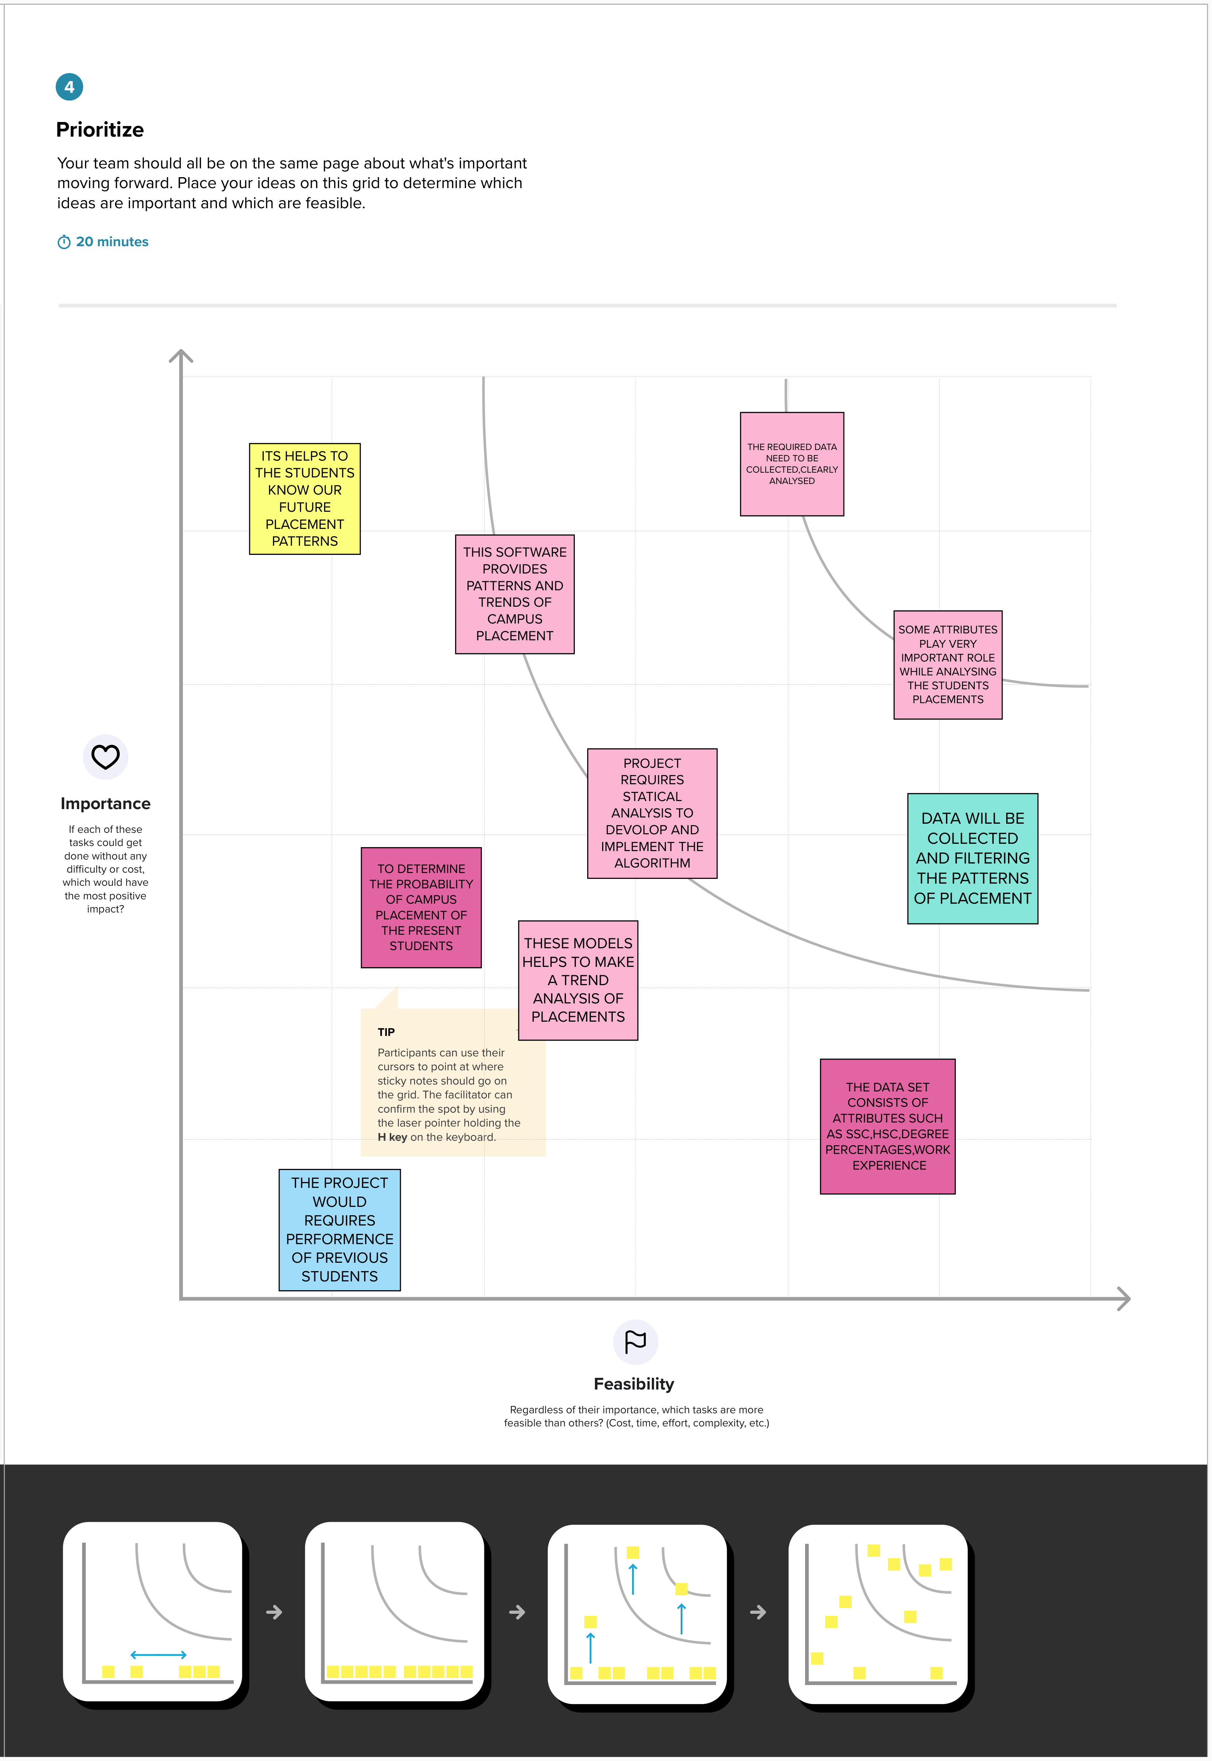

Milestone 1: Define Problem / Problem Understanding

- Activity 1: Specify the business problem
Refer Project Description
- Activity 2: Business requirements
The business requirements for a project aimed at "Identifying Patterns and Trends in Campus Placement Data using Machine learning” Learning" would likely include the following:
    - Access to campus placement data: The project would require access to data on student performance, qualifications, and job placement outcomes. This data would need to be collected, cleaned, and prepared for analysis.
    - Machine learning expertise: The project would require individuals with expertise in machine learning, data science and statistical analysis to develop and implement the algorithms and models needed to analyze the data.
    - Data storage and management: The project would require a robust and secure data storage and management system to store and organize the large amounts of data used in the analysis.
    - Infrastructure for model deployment: The project would require infrastructure for deploying the models and algorithms developed, including hardware, software, and cloud-based resources.

- Activity 3: Literature Survey

  - There have been several studies that have used machine learning techniques to identify patterns and trends in campus placement data.

  - One study by authors P. K. Rajesh and Dr. G. R. Suresh, published in the International Journal of Computer Science and Mobile Computing in 2015, used k-means clustering and decision trees to analyze campus placement data and identify patterns that could be used to predict placement outcomes.

  - Another study by authors V.V. Kulkarni and K.S. Patil, published in the International Journal of Engineering Research and Technology in 2012, used decision tree and neural network algorithms to analyze campus placement data and identify factors that influence student placement.
A study by authors S.S. Bhosale, S.S. Raut, and D.S. Kulkarni, published in the International Journal of Emerging Research in Management & Technology in 2013, used decision
  - It's important to note that all these studies are quite old now and you might find more recent studies and new techniques which can be useful for your project.

- Activity 4: Social or Business Impact.
❖ The business impact of a project that uses machine learning to identify patterns and trends in campus placement data could be significant. By analyzing data on factors such as student performance, qualifications, and job placement outcomes, the project could help organizations make more informed decisions about recruiting and hiring new graduates

- RESULT
Identifying patterns and trends in campus placement data can provide valuable insights into the job market and the hiring practices of companies. Some potential results of such analysis include
Campus placement data can reveal which industries are most popular among graduates. For example, if a majority of graduates are being placed in the technology or finance sectors, this may indicate that these industries are currently in high demand.

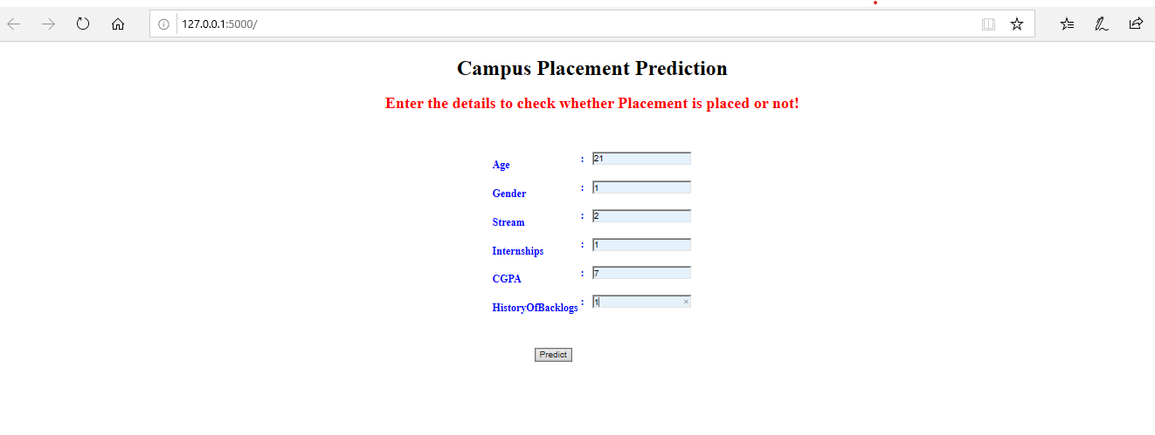
Technical Architecture:
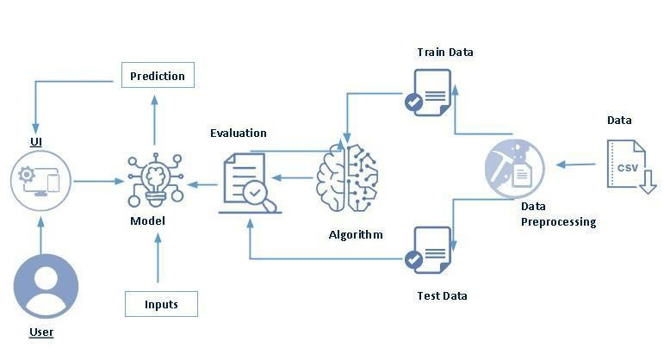

- User interacts with the UI to enter the input.
- Entered input is analyzed by the model which is integrated.
- Once model analyzes the input the prediction is showcased on the UI
To accomplish this, we have to complete all the activities listed below,
- Data collection
- Collect the dataset or create the dataset
- Visualizing and analyzing data
- Univariate analysis
- Bivariate analysis
- Multivariate analysis
- Descriptive analysis

- Data pre-processing

- Checking for null values
- Handling outlier
- Handling categorical data
- Splitting data into train and test

- Model building

- Import the model building libraries
- Initializing the model
- Training and testing the model
- Evaluating performance of model
- Save the model

  - Application Building

    - Create an HTML file
    - Build python code

Project flow:
Create the Project folder which contains files as shown below

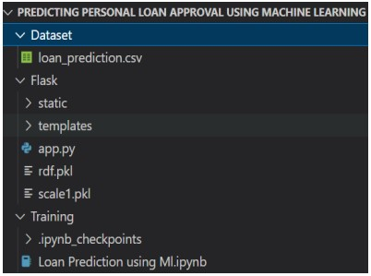

- We are building a flask application which needs HTML pages stored in the templates folder and a python script app.py for scripting

- rdf.pkl is our saved model. Further we will use this model for flask integration.
- Training folder contains a model training file

- ADVANTAGES AND DISADVANTAGES

ADVANTAGES

- Identifying patterns and trends in campus placements proposed system can provide several advantages, including:

- By identifying patterns and trends in campus placements, the proposed system can help decision-makers make informed decisions about recruitment strategies, target industries, and job roles.

- With a better understanding of hiring trends, recruiters can focus their efforts on the most promising candidates, resulting in a more efficient recruitment process.

- By analyzing past data, the proposed system can help identify which types of candidates are most likely to be successful in certain job roles or industries, allowing recruiters to make better job matches.

DISADVANTAGES

- While identifying patterns and trends in campus placements proposed system can provide several advantages, there are also some potential disadvantages to consider:

- The analysis of historical data can be biased, and the system may perpetuate existing inequalities in recruitment practices if not designed and trained properly.

- The analysis of historical data can only provide insights on past recruitment processes and may not account for new trends or changes in the job market.

- The proposed system may require significant resources, time, and expertise to develop, train, and maintain.

- APPLICATIONS

- Identifying patterns and trends in campus placements can be applied in various ways to optimize recruitment strategies and improve candidate experience.

- Career services: Universities and colleges can use the proposed system to provide career guidance, job placement support, and alumni engagement initiatives, helping students and graduates make informed career choices and develop relevant skills.

- Human resources: Organizations can use the proposed system to optimize their recruitment strategies, improve candidate experience, and support diversity and inclusion initiatives, helping to attract and retain top talent.

- Analytics and technology companies: Companies specialized in data analytics, machine learning, or artificial intelligence can develop and provide the proposed system as a software-as-a-service solution to different clients, including universities, organizations, and government agencies.

6. CONCLUSION

In conclusion, identifying patterns and trends in campus placements can provide valuable insights to optimize recruitment strategies, improve candidate experience, and support diversity and inclusion initiatives. By analyzing past data on job placements, career trajectories, candidate behavior, and market trends, organizations can make informed decisions, develop predictive models, and personalize their communication and offer to candidates.

Overall, identifying patterns and trends in campus placements is a promising area that can benefit various stakeholders, including students, graduates, employers, recruitment agencies, government agencies, and data analytics and technology companies. By leveraging the power of data and technology, we can create more efficient, equitable, and sustainable recruitment practices that align with the needs and aspirations of the talent market.

7. FUTURE SCOPE

- One of the most promising areas of future research in this field is the development of predictive models for campus placements. By analyzing historical placement data and identifying patterns and trends, machine learning algorithms can be used to predict the likelihood of a student being placed in a particular company or industry. This can help students and universities to make more informed decisions about their career paths and course offerings.

- Another area of research could be to analyze the factors that contribute to successful campus placements. By analyzing data on the academic performance, skills, and other relevant factors of successful candidates, universities and companies can identify the key traits that lead to success and tailor their recruitment processes accordingly.

- Additionally, with the rise of remote work and virtual job interviews, there is a growing need to analyze the impact of these trends on campus placements. This could involve analyzing data on the effectiveness of virtual recruitment processes and identifying best practices for remote campus placements.

- Overall, the future scope of identifying patterns and trends in campus placement data is vast and promising, and can help students, universities, and companies make better-informed decisions about their career paths and recruitment strategies.

8. APPENDIX

SOURCE CODE

Milestone 2: Data Collection & Preparation

ML depends heavily on data. It is the most crucial aspect that makes algorithm training possible. So this section allows you to download the required dataset.
- Activity 1: Collect the dataset
There are many popular open sources for collecting the data. Eg: kaggle.com, UCI repository, etc. In this project we have used .csv data. This data is downloaded from kaggle.com. Please refer to the link given below to download the dataset. Link:
https://www.kaggle.com/code/neesham/prediction-of-placements/data
- Activity 1.1: Importing the libraries
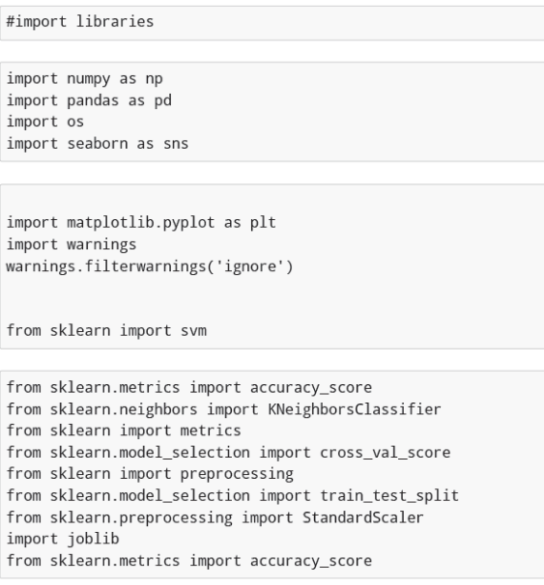

- Activity 1.2: Read the Dataset
Our dataset format might be in .csv, excel files, .txt, .json, etc. We can read the dataset with the help of pandas. In pandas we have a function called read_csv() to read the dataset. As a parameter we have to give the directory of the csv file.

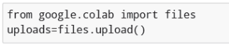
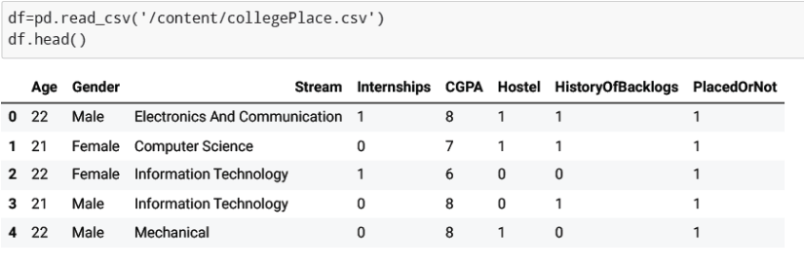

- Activity 2: Data Preparation
As we have understood how the data is, let's pre-process the collected data. The download data set is not suitable for training the machine learning model as it might have so much randomness so we need to clean the dataset properly in order to fetch good results. This activity includes the following steps.
- Handling Missing data
- Handling Categorical data
- Handling missing data
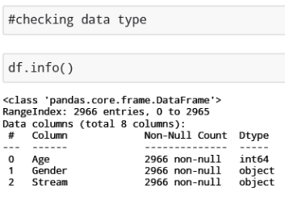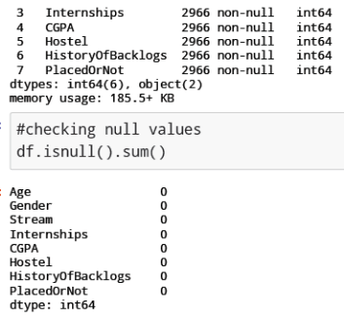
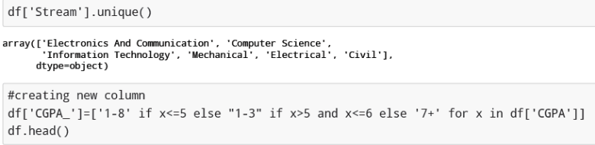
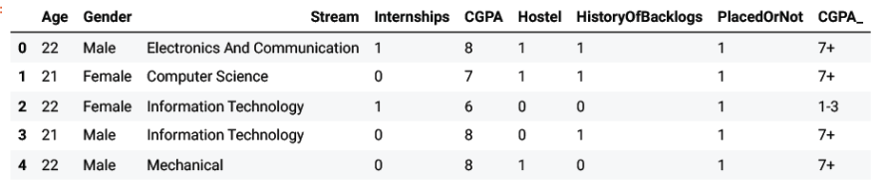
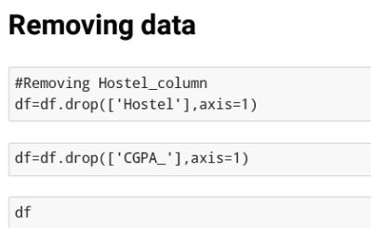
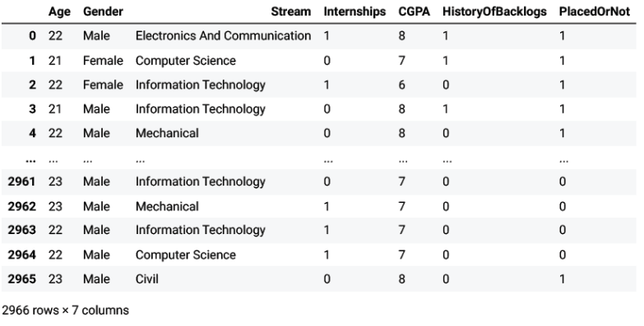
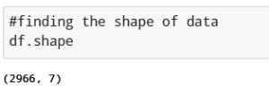
- Activity 2.1: Handling missing values
Let’s find the shape of our dataset first. To find the shape of our data, the df.shape method is used. To find the data type, df.info() function is used.
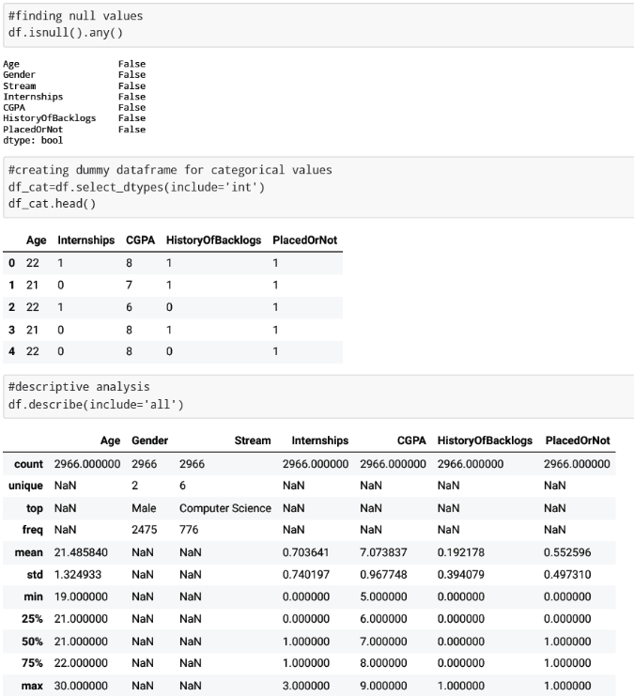

- Activity 2.2: Handling Categorical Values
As we can see our dataset has categorical data we must convert the categorical data to integer encoding or binary encoding.
To convert the categorical features into numerical features we use encoding techniques. There are several techniques but in our project we are using replacements as the distinct values are less.

df= df.replace ([‘Computer science’, ’Information Technology’, ’Electronics and Communication’, Mechanical’, ’Electrical’, ’Civics’],[0,1,2,3,4,5])
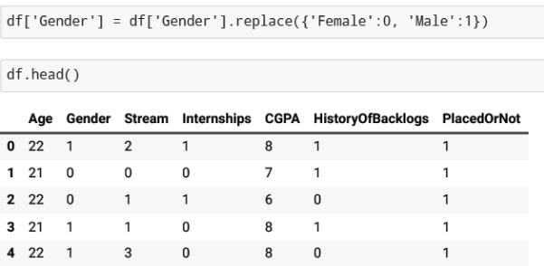

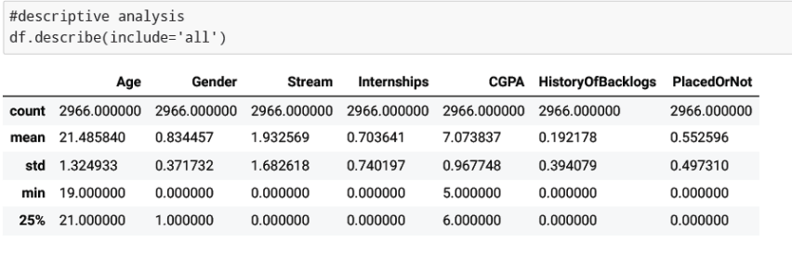
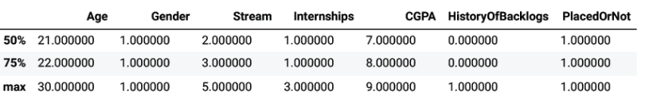

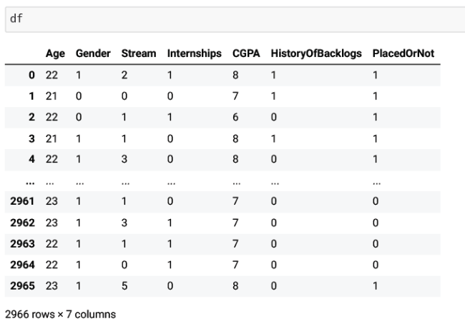

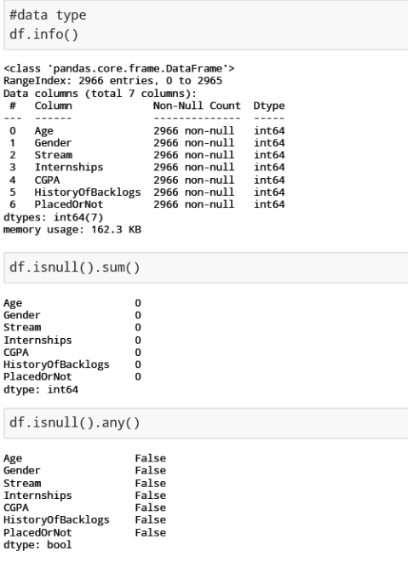

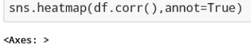
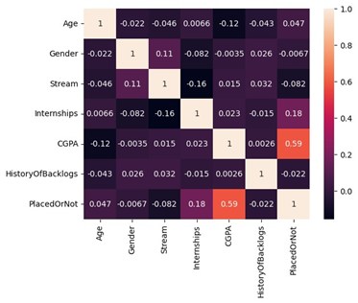
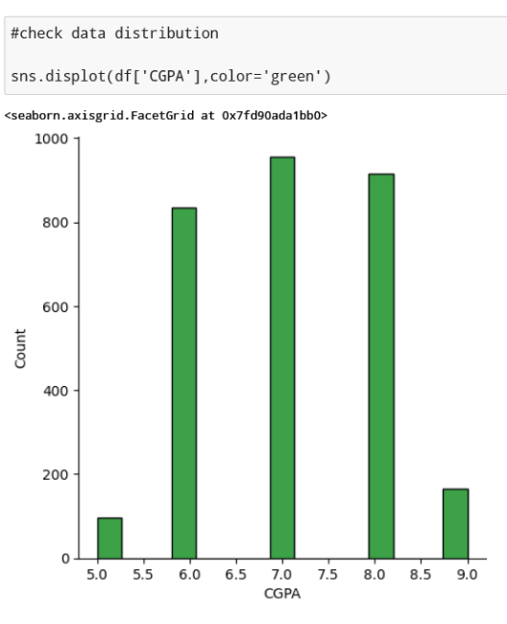

- Activity 2.2: Handling outliers

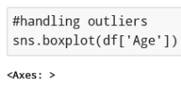

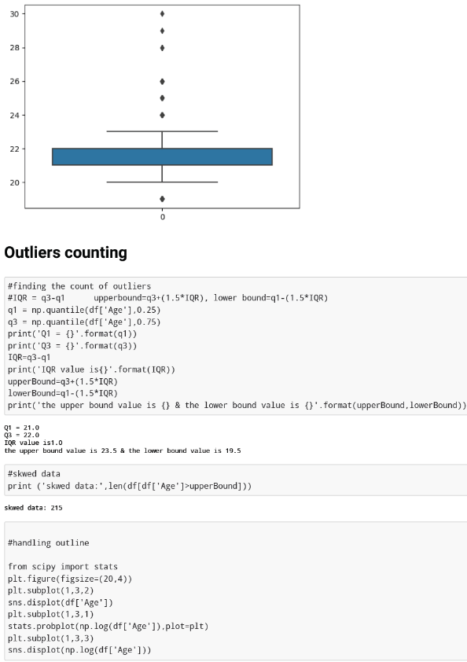
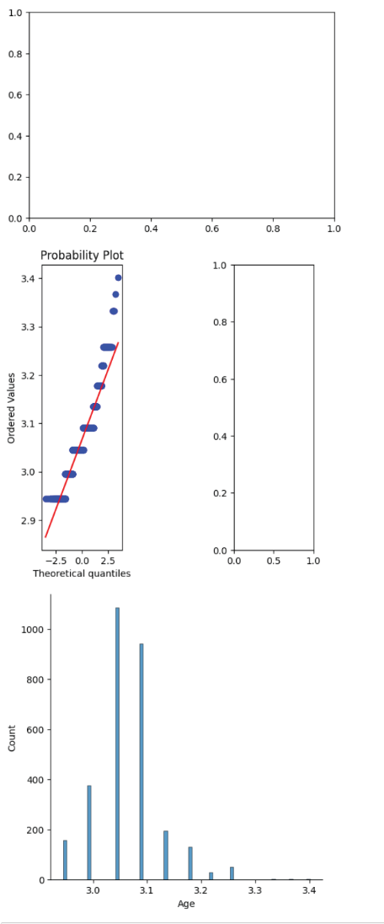
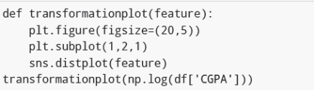

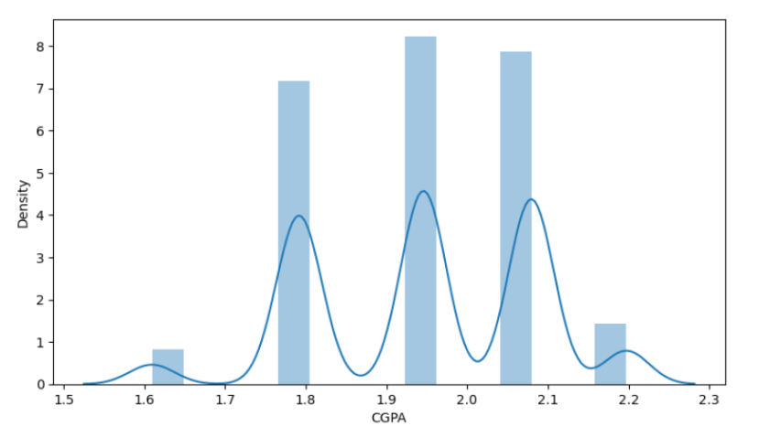
Milestone 3: Exploratory Data Analysis
● Activity 1: Visual analysis
Visual analysis is the process of using visual representations, such as
charts, plots, and graphs, to explore and understand data. It is a way to
quickly identify patterns, trends, and outliers in the data, which can
help to gain insights and make informed decisions.

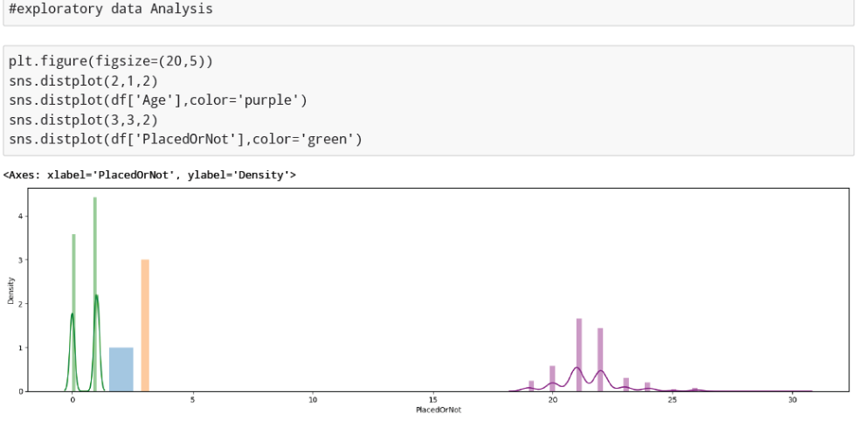
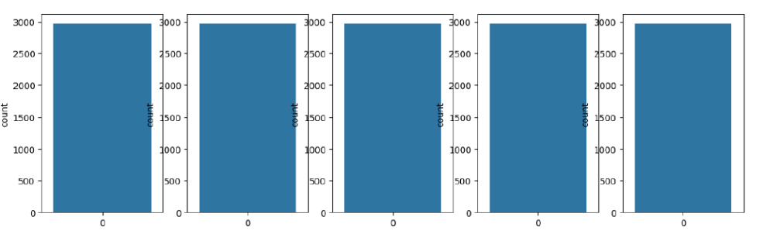

- Activity 1.1 : Univariate analysis
In simple words, univariate analysis is understanding the data with a single feature. Here we have displayed two different graphs such as distplot and countplot.

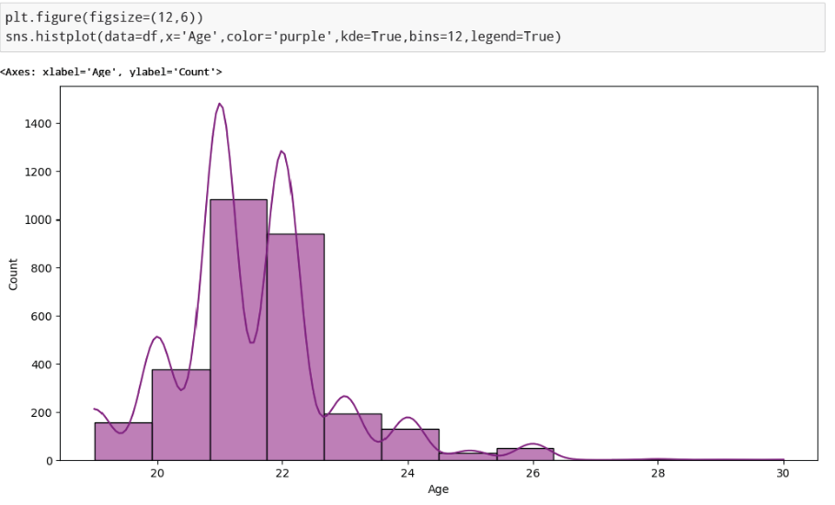
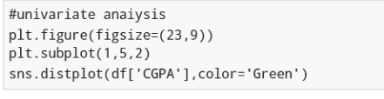
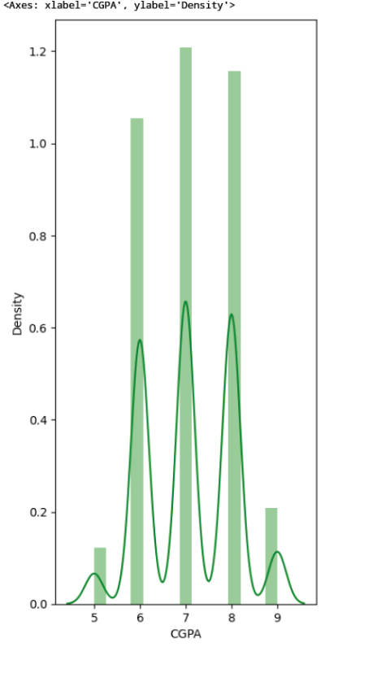
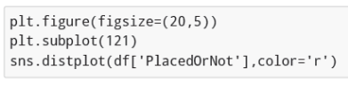
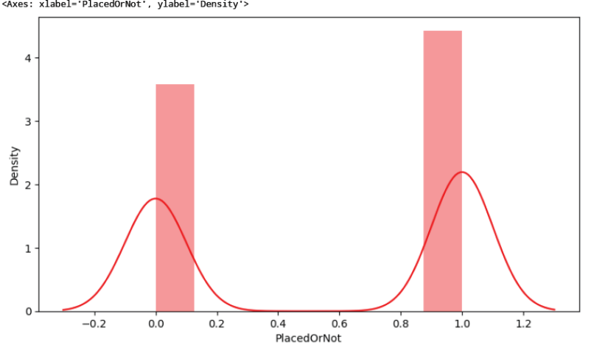
- Activity 1.2: Bivariate analysis
Countplot is used here. As a 1st parameter we are passing x value and as a 2nd parameter we are passing hue value.
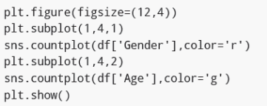
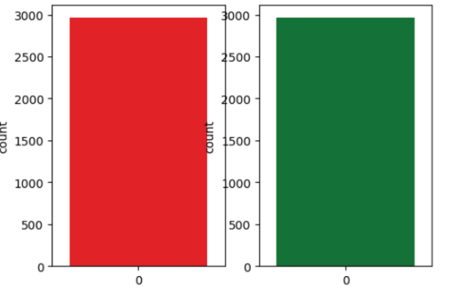
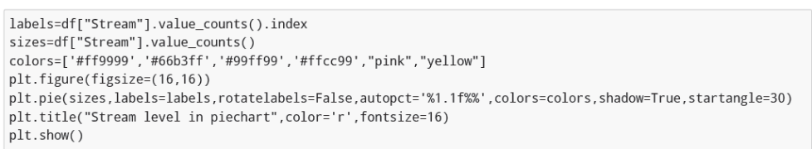

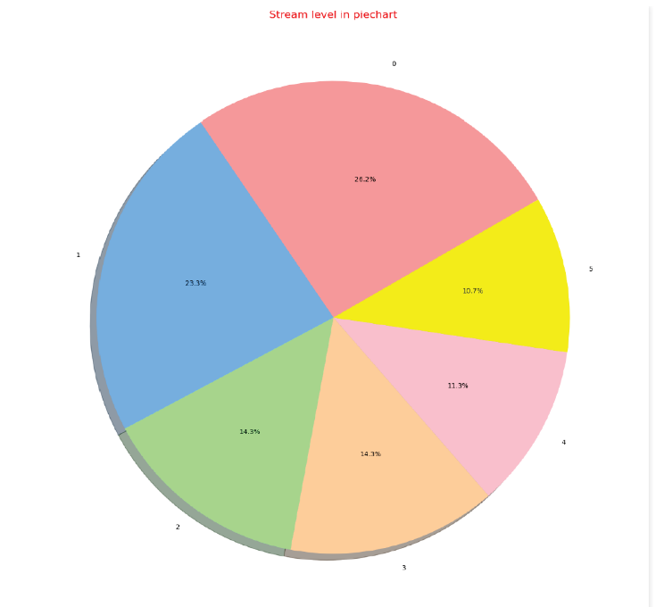
- Activity 1.3: Multivariate analysis

In simple words, multivariate analysis is to find the relation between multiple features. Here we have used swarmplot from the seaborn package.

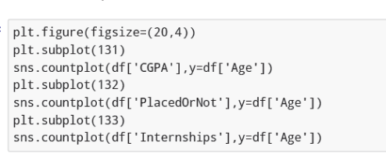
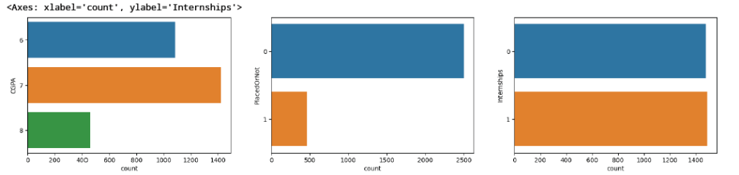
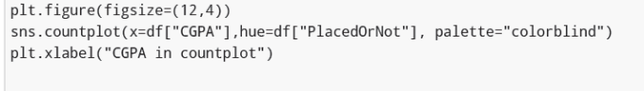
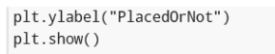
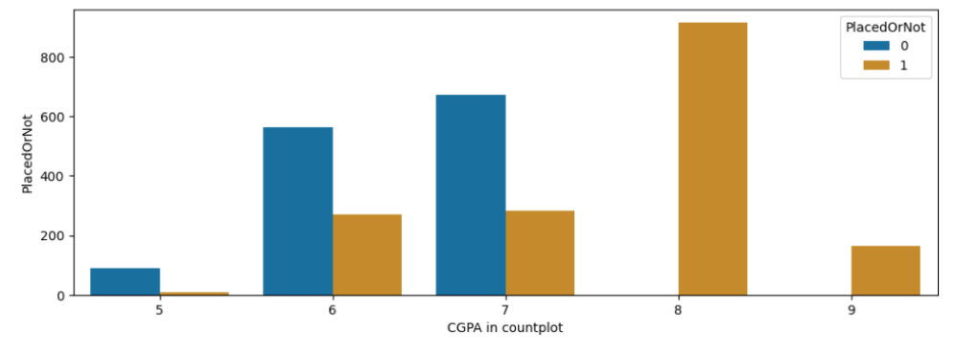
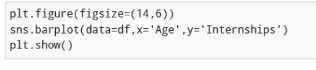
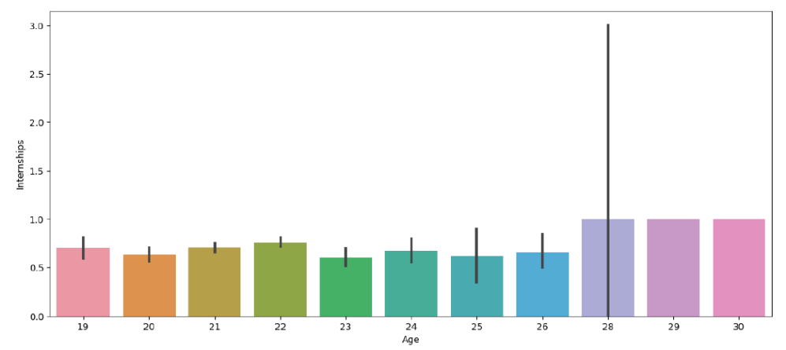
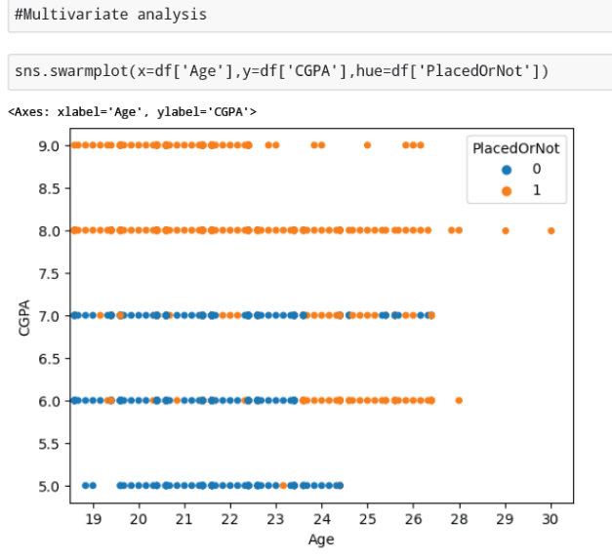
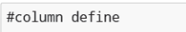
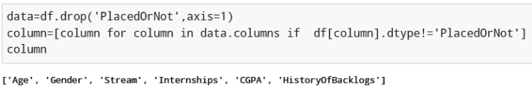
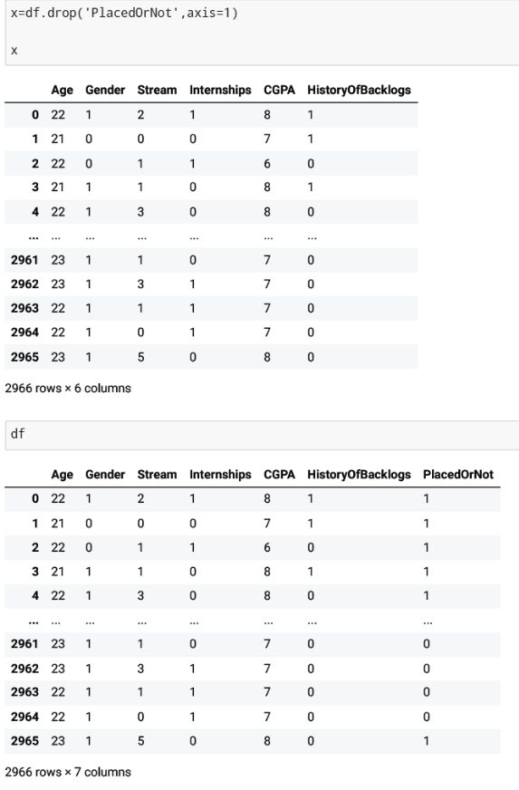

- Activity 2: Scaling the data
- Scaling is one the important processes we have to perform on the dataset, because data measures in different ranges can lead to mislead in prediction Models such as KNN, Logistic regression needs scaled data, as they follow distance based method and Gradient Descent concept.

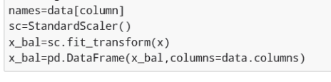
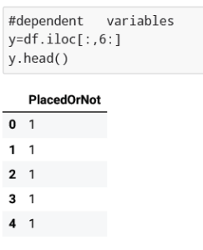

- Activity 3: Splitting the data into train and test

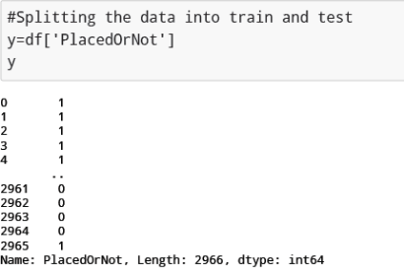
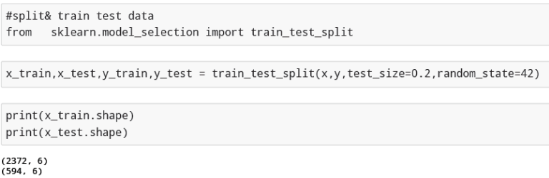
Milestone 4: Model Building
Now our data is cleaned and it’s time to build the model. We can train our data on different algorithms. For this project we are applying a few algorithms. The best model is saved based on its performance.
- Activity 1: Training the model in multiple algorithms
Now our data is cleaned and it’s time to build the model. We can train our data on different algorithms. For this project we are applying four classification algorithms. The best model is saved based on its performance.
- Activity 1.1: SVM model
A function named Support vector machine is created and train and test data are passed as the parameters. Inside the function, SVMClassifier algorithm is initialized initialized and training data is passed to the model with .fit() function. Test data is predicted with .predict() function and saved in a new variable. For evaluating the model, a confusion matrix and classification report is done.
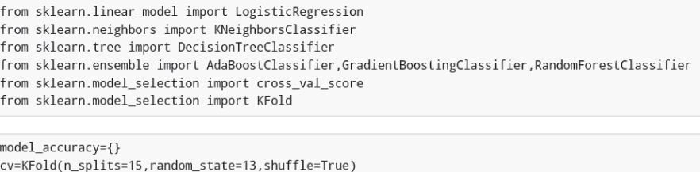
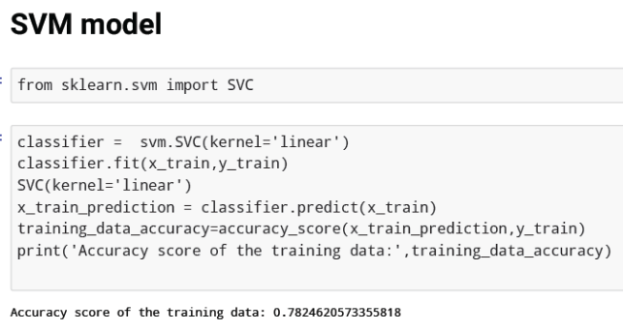
- Activity 1.2: KNN model
A function named KNN is created and train and test data are passed as the parameters. Inside the function, KNeighborsClassifier algorithm is initialized and train training data is passed to the model with .fit() function. Test data is predicted with .predict() function and saved in new variable. For evaluating the model, confusion matrix and classification report is done.
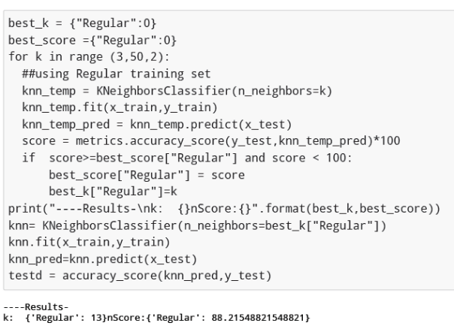
- Activity 1.3: Artificial neural network model
We will also be using a neural network to train the model.

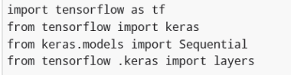
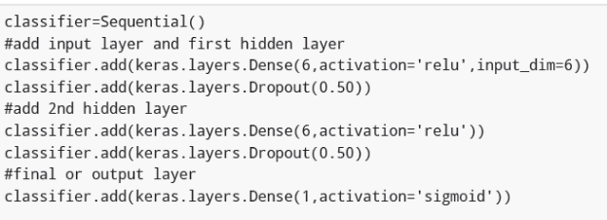
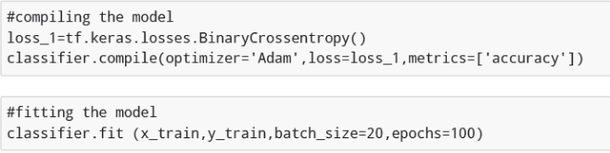
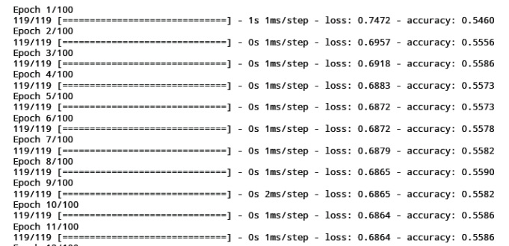
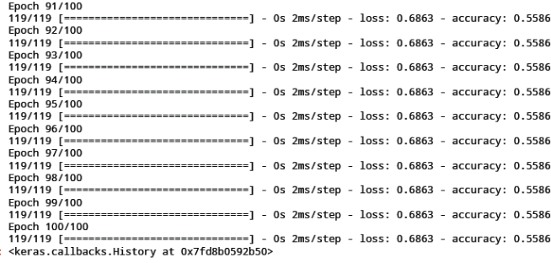

Milestone 5: Model Deployment
- Activity 1:Save the best model
Saving the best model after comparing its performance using different evaluation metrics means selecting the model with the highest performance and saving its weights and configuration. This can be useful in avoiding the need to retrain the model every time it is needed and also to be able to use it in the future
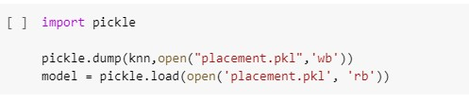
Building html pages

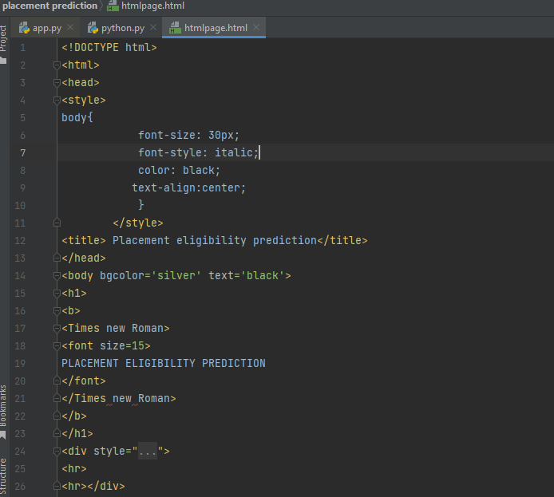

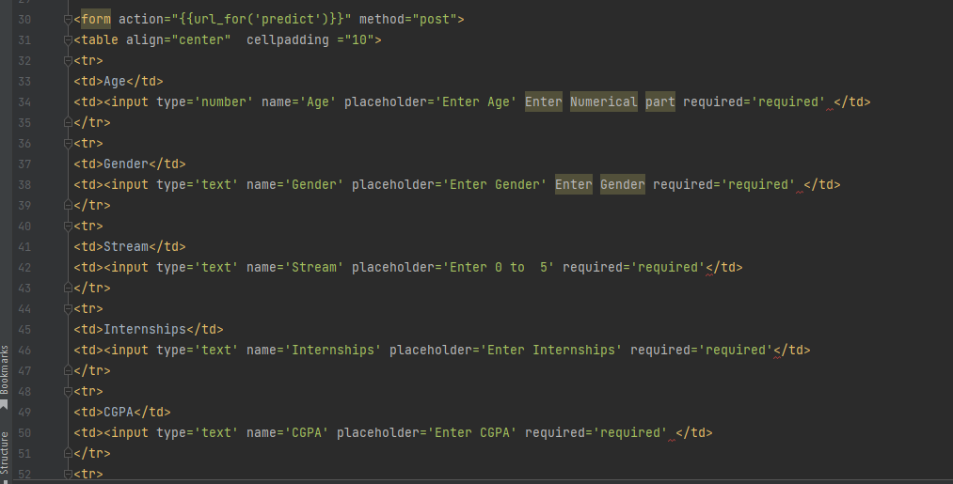

Build the python code


