FINAL INTERNSHIP REPORT
Applying Python for Data Science in the Beauty & Wellness Industry
A Synthesis of Six Weeks of Data Analysis, Modeling & Strategy
Virtual Python for Data Science Analyst Intern — Beauty & Wellness
Yuva Intern
Week 6 — Final Deliverable
Prepared by: Syeda Lubna Fatima
B.E 4Th year CSE, Methodist College of Engineering & Technology, Hyderabad
Role: Data Science Analyst Intern (Beauty & Wellness)

Table of Contents
1. Introduction and Background
2. Methodologies Used Across Tasks
2.1 Week 1 — Exploratory Data Analysis & Data Cleaning
2.2 Week 2 — Data Visualization & Storytelling
2.3 Week 3 — Predictive Modeling
2.4 Week 4 — Text Analytics & Sentiment Analysis
2.5 Week 5 — Strategic Proposal
3. Summary of Key Findings from Each Task
4. Performance Evaluation
5. Challenges Encountered
6. What I Learned
7. What I Would Improve Next
8. Conclusion

1. Introduction and Background
This report brings together the work I completed during my six-week virtual internship as a Python for Data Science Analyst in the Beauty & Wellness domain through Yuva Intern. The internship gave me an opportunity to work through different stages of a data science workflow, from understanding and cleaning data to building models and turning findings into business recommendations. Each week's task built on the previous one, so by the end I could see the complete journey rather than six separate assignments.
The core dataset throughout Weeks 1, 2, 3 and 5 was the "Cosmetics & Skincare Product Sales Data" (Kaggle) — 374 transactions recorded between January and August 2022, covering six countries (USA, UK, Canada, India, Australia, New Zealand), fifteen distinct products, and ten sales representatives. Week 4 required a second dataset — the "Cosmetics and Beauty Products Reviews — Top Brands" dataset from Nykaa.com (61,284 reviews) — since the sales data contained no text field suitable for sentiment analysis.
Across the six weeks, my work followed a clear progression:
- Week 1: Exploratory data analysis and data cleaning — establishing a trustworthy foundation
- Week 2: Data visualization and storytelling — turning cleaned data into a narrative
- Week 3: Predictive modeling — classifying transactions using machine learning
- Week 4: Text analytics and sentiment analysis — extending the analysis to unstructured customer feedback
- Week 5: Strategic proposal — synthesizing all prior insight into actionable business recommendations
- Week 6 (this report): A critical, reflective synthesis of the entire internship
In this final report, I have tried to go beyond simply describing what I did. I also looked back at how well each approach worked, where I faced difficulties, and what I would do differently in a real data science role. This reflection helped me understand that good data science is not only about getting results, but also about checking whether those results are reliable and useful in practice.

2. Methodologies Used Across Tasks

2.1 Week 1 — Exploratory Data Analysis & Data Cleaning
Week 1 gave me the foundation for the rest of the internship. I first inspected the dataset's structure using its shape, data types, sample rows, and summary statistics. I then checked data quality from five different angles, cleaned anything that needed attention, and created a few exploratory visualizations.

Data Quality Assessment
Each dimension was checked with dedicated pandas code:
Check | Result | Action Taken
Missing values | 0 across all 6 columns | None required
Duplicate rows | 0 | None required
Whitespace / case issues | 0 | None required
Invalid dates | 0 | Converted Date to datetime type
Outliers — Amount ($) | 1 (IQR method) | Retained — plausible large order, not an entry error
Outliers — Boxes Shipped | 0 | None required

for col in ['Amount ($)', 'Boxes Shipped']:
Q1 = df[col].quantile(0.25)
Q3 = df[col].quantile(0.75)
IQR = Q3 - Q1
lower, upper = Q1 - 1.5*IQR, Q3 + 1.5*IQR
outliers = df[(df[col] < lower) | (df[col] > upper)]
print(col, "-> outliers found:", len(outliers))
I also created a derived column, Price_per_box (Amount ÷ Boxes Shipped), which became useful in later analysis. One high-value Amount was flagged as an outlier. Instead of removing it automatically, I checked whether it made sense in context. Since the date was valid, the value was positive, and the price per box was plausible, I kept it. This was one of my first reminders that statistical rules should support judgment rather than replace it.
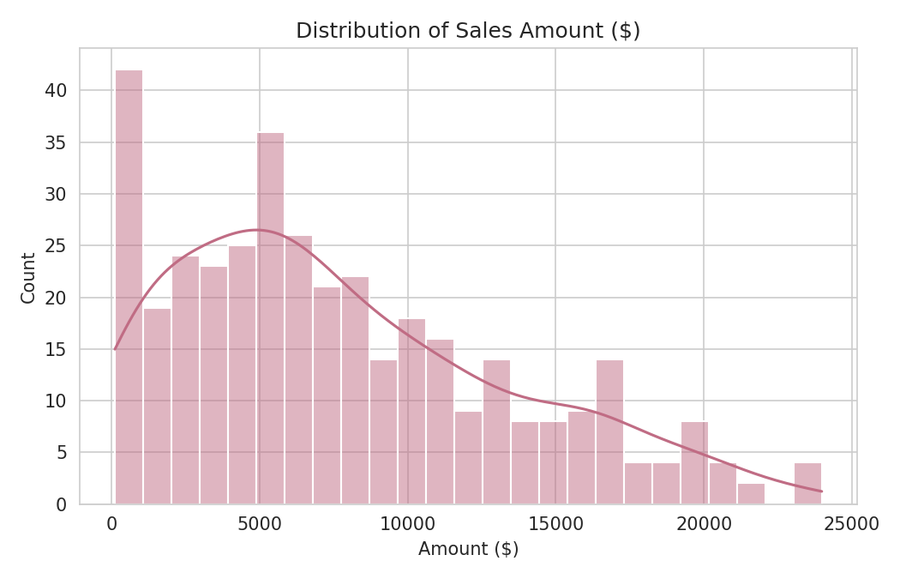
Figure 2.1 — Distribution of Sales Amount ($), showing right-skew with a long tail toward higher-value sales.
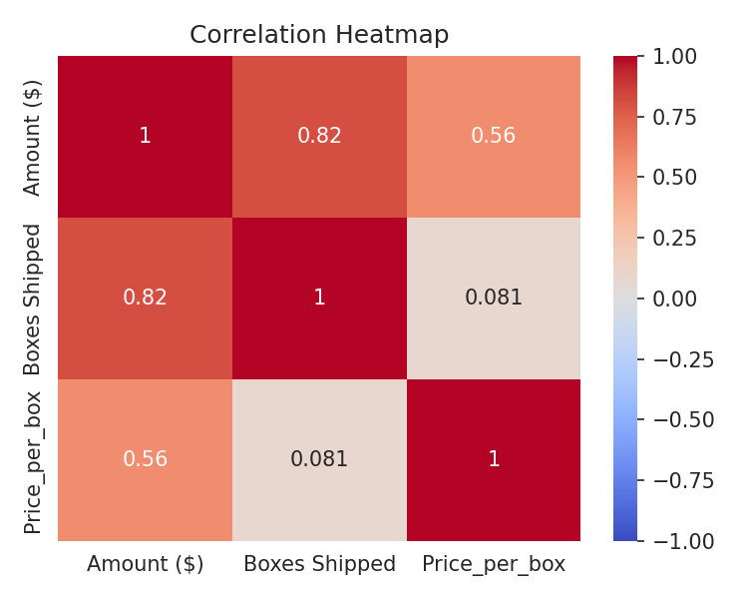
Figure 2.2 — Correlation heatmap: Amount, Boxes Shipped, and Price per box.

2.2 Week 2 — Data Visualization & Storytelling
In Week 2, I used the cleaned Week 1 dataset to build a simple "Where → When → Why" story. I used three types of Matplotlib charts, with each one focused on a different business question.
country_revenue = df.groupby('Country')['Amount ($)'].sum().sort_values(ascending=False)
plt.bar(country_revenue.index, country_revenue.values, color='indianred')

df['Month'] = df['Date'].dt.to_period('M').astype(str)
monthly_revenue = df.groupby('Month')['Amount ($)'].sum().sort_index()
plt.plot(monthly_revenue.index, monthly_revenue.values, marker='o')

pivot = df.pivot_table(index='Country', columns='Product', values='Amount ($)', aggfunc='sum', fill_value=0)
plt.imshow(pivot.values, cmap='OrRd', aspect='auto')
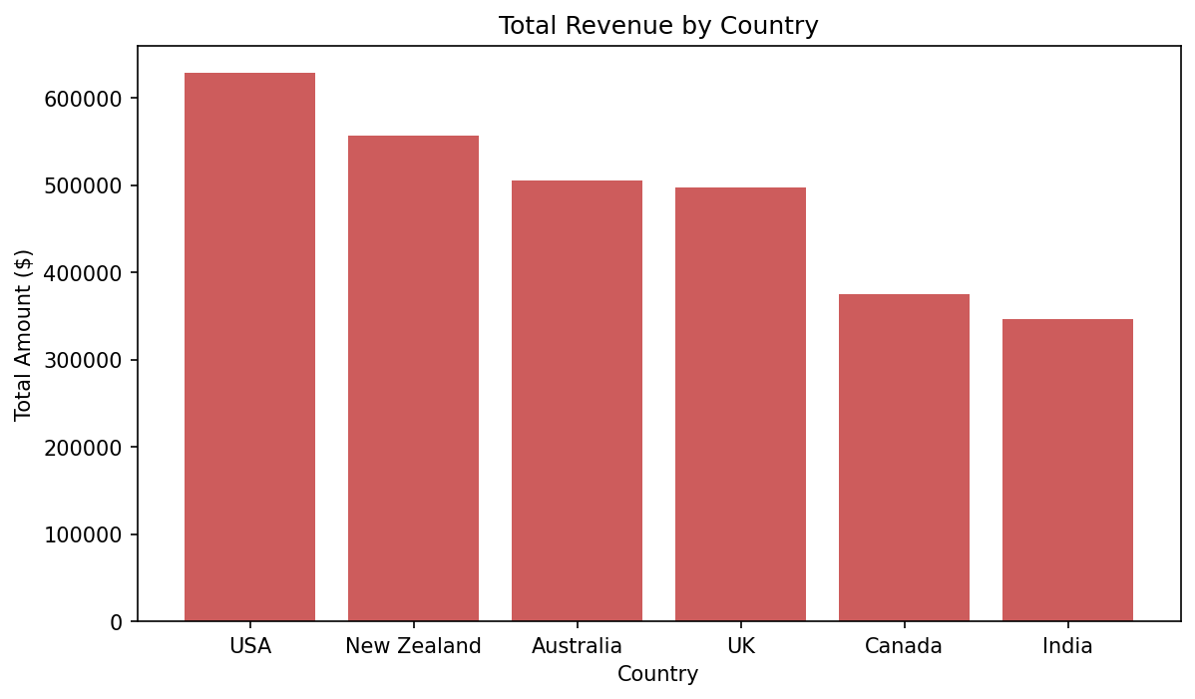
Figure 2.3 — Total Revenue by Country. USA leads at $628,487.86; India lowest at $346,434.92.
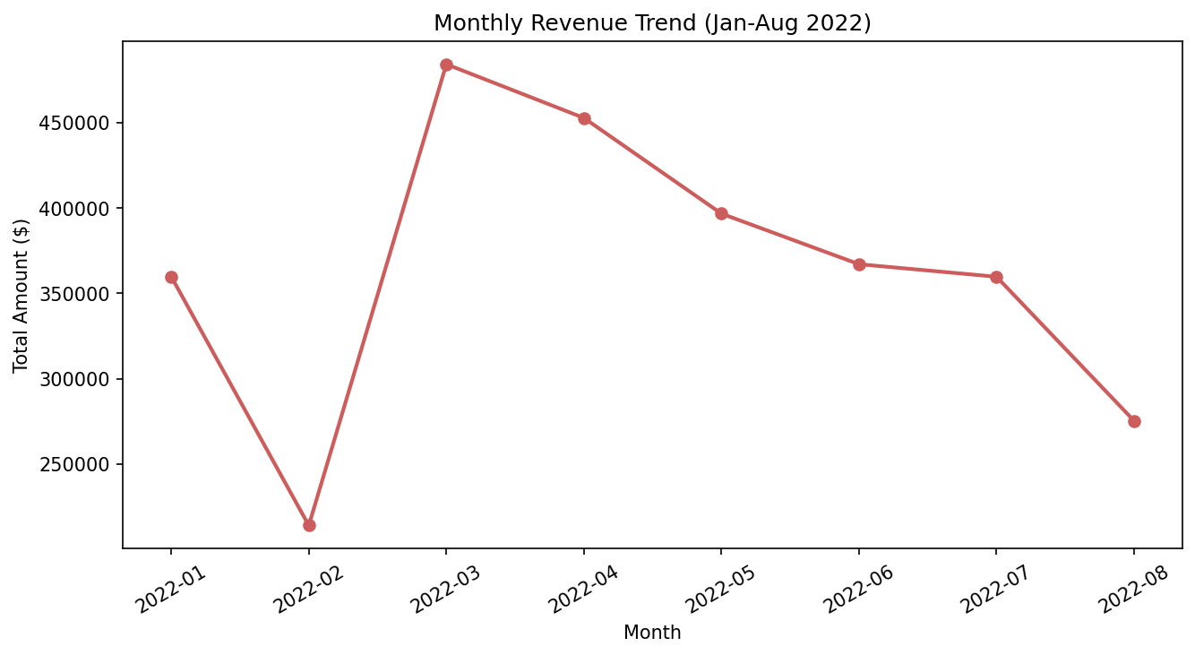
Figure 2.4 — Monthly Revenue Trend, Jan–Aug 2022.
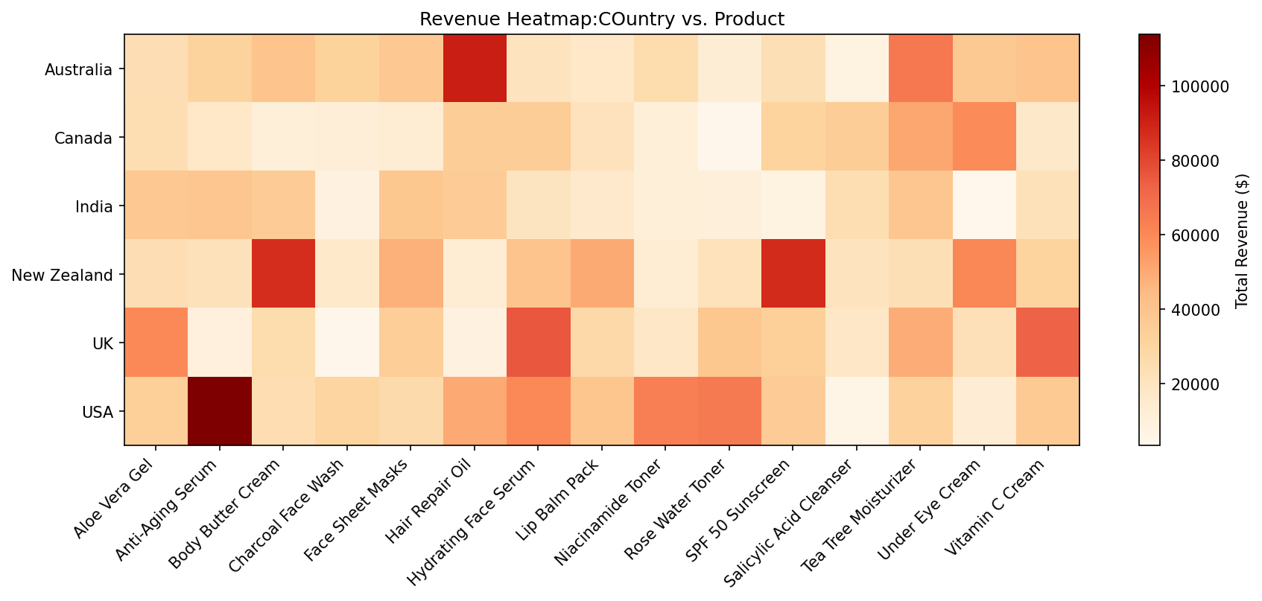
Figure 2.5 — Revenue Heatmap: Country × Product, revealing each market's "hero product."

2.3 Week 3 — Predictive Modeling
For Week 3, I turned the sales data into a binary classification problem. The goal was to predict whether a transaction would fall into the "High Revenue" or "Low Revenue" category, using the median Amount ($) as the dividing point. I left out Sales Person, Date, and Amount ($) from the model for specific reasons: Amount was used to create the target, Sales Person could make the model too dependent on individual representatives, and Date was represented through an extracted Month feature instead.
df['Price_per_box'] = df['Amount ($)'] / df['Boxes Shipped']
df['Month'] = df['Date'].dt.month
median_amount = df['Amount ($)'].median()
df['Revenue_Class'] = np.where(df['Amount ($)'] > median_amount, 'High', 'Low')

df_model = df.drop(columns=['Sales Person', 'Date', 'Amount ($)'])
df_encoded = pd.get_dummies(df_model, columns=['Country', 'Product'], drop_first=True)

X_train, X_test, y_train, y_test = train_test_split(
X, y, test_size=0.2, random_state=42, stratify=y)

model = LogisticRegression(max_iter=1000, random_state=42)
model.fit(X_train, y_train)
I checked the model using 5-fold cross-validation on the training data and then evaluated it on a separate 20% test set. I looked at several measures, including accuracy, precision, recall, F1-score, the confusion matrix, and ROC-AUC, rather than relying on a single metric.
Metric | Value
5-Fold CV Accuracy (mean) | 95.3% (± 2.4%)
Test Set Accuracy | 89.3%
ROC-AUC Score | 0.984
Precision / Recall (Low) | 0.92 / 0.87
Precision / Recall (High) | 0.87 / 0.92

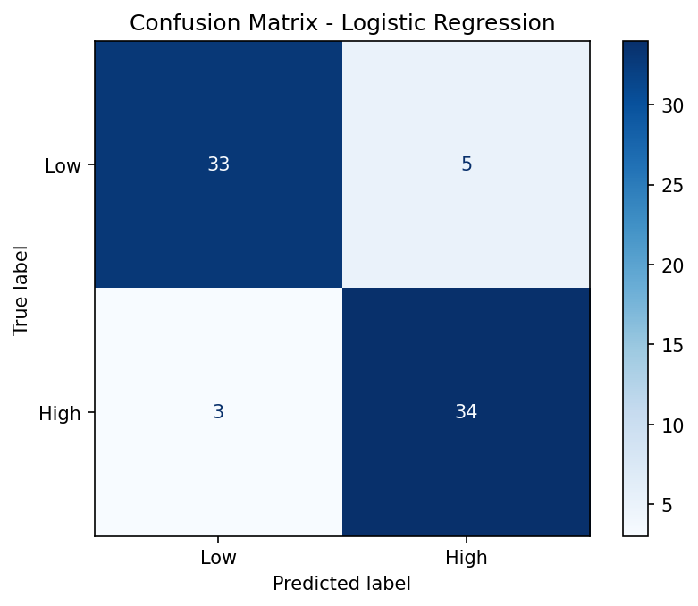
Figure 2.6 — Confusion Matrix: 33/38 Low and 34/37 High transactions correctly classified.
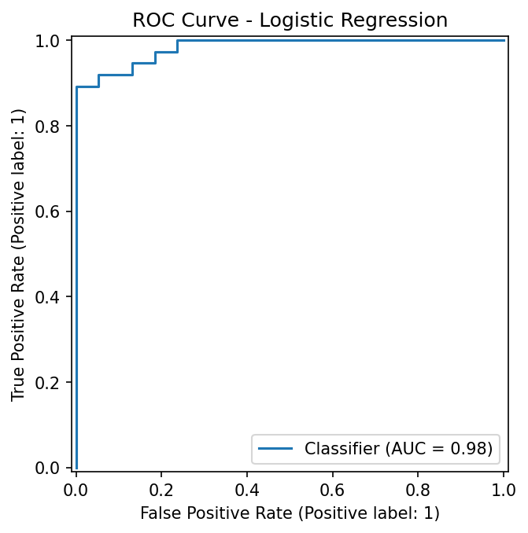
Figure 2.7 — ROC Curve (AUC = 0.98), indicating strong separation between classes.

2.4 Week 4 — Text Analytics & Sentiment Analysis
The sales dataset did not contain review text, so I used a second dataset containing 61,284 Nykaa product reviews from Kaggle. From it, I selected a random sample of 3,000 reviews using random_state=42. I then cleaned and processed the text before assigning sentiment scores.
def clean_text(text):
text = text.lower()
text = re.sub(r'[^a-z\s]', ' ', text)
return re.sub(r'\s+', ' ', text).strip()

df['tokens'] = df['cleaned_text'].apply(word_tokenize)
df['tokens_no_stopwords'] = df['tokens'].apply(remove_stopwords)
df['lemmatized_tokens'] = df['tokens_no_stopwords'].apply(lemmatize_tokens)

def get_sentiment(text):
polarity = TextBlob(text).sentiment.polarity
if polarity > 0: return 'Positive'
elif polarity < 0: return 'Negative'
else: return 'Neutral'
Sentiment | Count | Share
Positive | 2,618 | 87.3%
Negative | 209 | 7.0%
Neutral | 173 | 5.8%

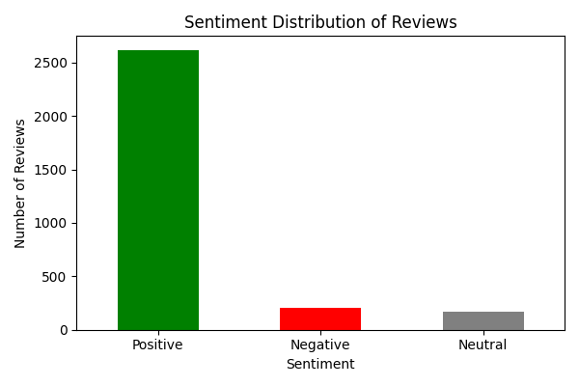
Figure 2.8 — Sentiment Distribution across the 3,000 sampled reviews.
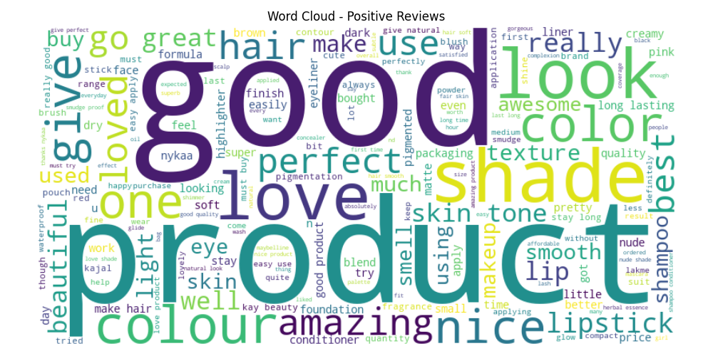
Figure 2.9 — Word cloud, Positive reviews: "good," "love," "amazing," "perfect."
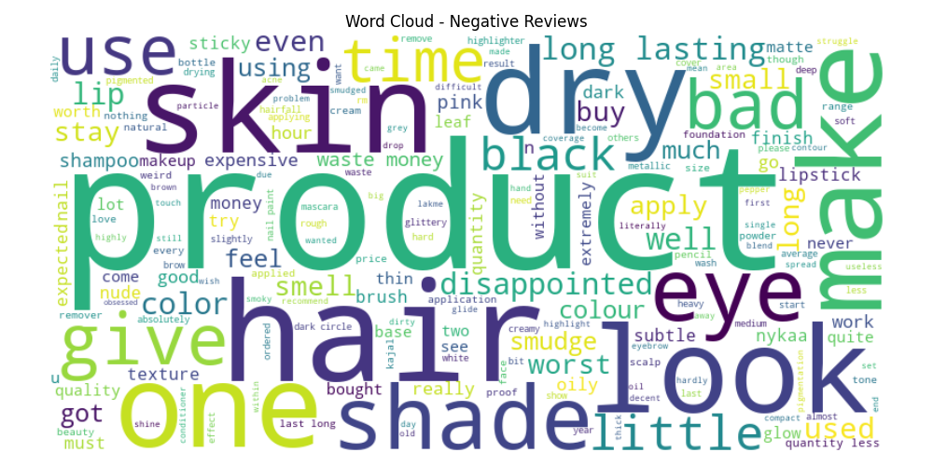
Figure 2.10 — Word cloud, Negative reviews: "dry," "skin," "disappointed," "expensive."

2.5 Week 5 — Strategic Proposal
In Week 5, I brought together two kinds of information. I revisited the sales dataset to answer questions that had not been explored in the earlier weeks, such as sales-representative performance, month-over-month growth, the relationship between price per box and sales volume, and country-product concentration. I also considered external market-trend research from 2025–26 industry reports.
sp = df.groupby('Sales Person').agg(
Total_Revenue=('Amount ($)', 'sum'),
Orders=('Amount ($)', 'count'))

monthly = df.groupby('Month')['Amount ($)'].sum().sort_index()
growth = monthly.pct_change() * 100

corr = prod['Avg_Price_per_box'].corr(prod['Total_Boxes']) # -0.283
Analysis | Key Result
Sales-rep performance | Olivia D’Souza top ($387,406); Mason Kapoor lowest ($223,433) — a 42% gap
Month-over-month growth | -40.5% (Feb) → +126.2% (Mar) → gradual decline through Aug
Price vs. volume correlation | -0.283 (weak negative) — price is not the main driver of volume
Country-product concentration | USA / Australia highest at ~18% — below the 40% risk threshold used

These findings were then used to develop five practical strategic objectives: reduce dependence on hero products in the USA and Australia, explore growth opportunities in India, reduce month-to-month revenue fluctuations through a subscription pilot, narrow the performance gap between sales representatives through mentoring, and position underperforming products around efficacy rather than price. For each objective, I also identified an owner, a measurable target, and a possible risk.

3. Summary of Key Findings from Each Task

Week 1 — EDA & Cleaning
- The dataset was clean by construction: 0 missing values, 0 duplicates, 0 text inconsistencies, all 374 dates valid.
- Amount ($) is right-skewed with one legitimate high-value outlier; Boxes Shipped is evenly spread with no outliers.
- Amount and Boxes Shipped are positively correlated; Price_per_box correlates weakly with both.

Week 2 — Visualization
- USA leads total revenue ($628,487.86); India is lowest ($346,434.92) — roughly 55% of USA’s total.
- Monthly revenue does not show a steady trend — it fluctuates across the eight-month window.
- Each country has a distinct "hero product": USA → Anti-Aging Serum, New Zealand → Body Butter Cream / SPF 50, Australia → Hair Repair Oil.

Week 3 — Predictive Modeling
- Logistic Regression achieved 89.3% test accuracy and a 0.984 ROC-AUC classifying High vs. Low revenue transactions.
- 5-fold CV accuracy averaged 95.3% (± 2.4%), suggesting consistent performance across folds.
- A key limitation was self-identified: Amount = Boxes Shipped × Price_per_box, so both predictors are mathematically tied to the target, likely inflating the metrics.

Week 4 — Sentiment Analysis
- 87.3% of the 3,000 sampled Nykaa reviews were classified Positive, 7.0% Negative, 5.8% Neutral.
- Positive vocabulary centered on satisfaction and quality; negative vocabulary centered on skin compatibility and value-for-money concerns.

Week 5 — Strategic Proposal
- Five objectives were derived directly from the data: reduce hero-product concentration (USA/Australia ~18%), grow India (55% of USA revenue), stabilize month-to-month volatility (-40% to +126% swings), close the 42% sales-rep performance gap, and reposition on efficacy given a weak -0.283 price-volume correlation.
- An earlier Week 1 assumption — that revenue was "growing" — was explicitly revised once percentage change was calculated and shown to be volatile, not growing.

4. Performance Evaluation
Here, I looked back not only at what I found, but also at how reliable and useful each method was.

Week 1 — Effective, but under-tested
The five-part quality-check process worked well and can be reused for other datasets. However, the dataset was already quite clean, so I did not get much practice handling serious missing values, duplicates, or inconsistent records. The decision to keep the Amount outlier was reasonable, but it was based on one case rather than a rule that had been tested repeatedly. Overall, Week 1 was useful for verification, although it gave me less hands-on cleaning experience than a messier dataset would have.

Week 2 — Clear story, but limited technical range
The "Where → When → Why" structure helped the charts work together as a story instead of feeling like three unrelated graphs. That was the strongest part of the week. At the same time, I used only three chart types, so there was room to explore more visualization techniques. The heatmap was also created with plt.imshow instead of seaborn.heatmap and did not include value annotations, which made exact values difficult to read without checking the underlying table.

Week 3 — Strong metrics, weaker validity
Week 3 taught me an important lesson about interpreting model results. The 89.3% accuracy and 0.984 AUC look strong at first, but there is an important limitation: Amount = Boxes Shipped × Price_per_box. Because the target was created from Amount, the two related predictors can make the classification task easier in a way that may not reflect genuine purchasing behavior. I also did not train a second model for comparison, so I cannot say how much of the performance would remain after removing this issue.

Week 4 — Fast but coarse
TextBlob was convenient and quick for getting an initial sense of sentiment. However, because it is rule-based, it may struggle with things like negation, sarcasm, or beauty-specific language. I also did not compare the 87.3% positive result with the dataset's review_rating column, even though that information was available. As a result, the sentiment percentages should be treated as a directional finding rather than a fully validated result.

Week 5 — Grounded, but partly speculative
A major strength of Week 5 was that the recommendations were linked to specific numbers, such as the 18% concentration, 42% representative gap, and -0.283 price-volume correlation, rather than being based only on general advice. I also revised the earlier assumption that revenue was simply "growing" after calculating the actual percentage changes. One area that could be improved is the external market research: the report did not include specific citations for those claims, so that part was not supported as strongly as the internal data analysis.

Cross-Cutting Observation
Effectiveness improved over the six weeks in one specific way: later reports (Weeks 3 and 5) actively interrogated their own results — flagging leakage risk, revising an earlier conclusion — while the earliest report (Week 1) mostly reported findings at face value. That progression toward self-scrutiny is itself a marker of growth across the internship.

5. Challenges Encountered
Area | Challenge
Data (Week 1) | Dataset was cleaner than a typical real-world dataset, reducing hands-on cleaning/remediation practice
Data (Week 1) | Deciding whether the single Amount outlier was a data error or a legitimate large order required judgment, not a purely statistical rule
Modeling (Week 3) | Late-discovered feature leakage risk: Boxes Shipped and Price_per_box are mathematically tied to the Amount-derived target
Modeling (Week 3) | Small, single-year dataset (374 rows) limits confidence in how well the model would generalize to future years or new markets
Text analytics (Week 4) | The original sales dataset had no text field, requiring an entirely separate dataset to be sourced
Text analytics (Week 4) | Recurring coding typos (df=['tokens']=... instead of df['tokens']=..., 'punk' instead of 'punkt', WordNetLemmetizer instead of WordNetLemmatizer) caused repeated runtime errors
Text analytics (Week 4) | Terminal line-wrapping visually dropped spaces between words (e.g. "great shade" appeared as "greatshade"), creating a false impression of a data bug
Text analytics (Week 4) | TextBlob’s sentiment corpora and the wordcloud/matplotlib libraries required separate installation steps
Strategy (Week 5) | External market-trend claims were harder to verify rigorously than the internal, dataset-grounded analysis
Scope (recurring) | A single-year, 8-month, single-source dataset limited how confidently seasonal or long-term patterns could be assessed throughout the internship

6. What I Learned
- Data quality work is not wasted even when data is clean — running the full checklist regardless of expected outcome is what makes a process trustworthy and repeatable.
- A single chart rarely tells the full story; layering complementary views (aggregate → trend → breakdown) surfaces insights, like hero-product concentration, that one chart alone would hide.
- Strong model metrics can mask a design flaw — high accuracy is a reason to ask why a model performs well, not a reason to stop asking.
- Text data requires the same scrutiny as numeric data. A precise-looking sentiment percentage is still only as trustworthy as the (unvalidated, rule-based) method behind it.
- Revising an earlier conclusion when a closer look contradicts it — as happened between Week 1’s "growing" read and Week 5’s recalculated volatility — is a sign of good analysis, not a failure.
- Numbers become genuinely useful once tied to an owner and a measurable target, rather than left as standalone observations.
- Small typos in library and function names are a common, recoverable source of friction in NLP work, and validating against saved output files is more reliable than trusting console/terminal display alone.

7. What I Would Improve Next

Technical
- Re-run the Week 3 model without Boxes Shipped and Price_per_box (or with a target not derived from Amount) to test whether the reported 89–95% accuracy holds once the leakage risk is removed.
- Train and compare a second model (Random Forest or Gradient Boosting) against the Logistic Regression baseline to check whether non-linear relationships add predictive value.
- Cross-validate the Week 4 sentiment labels against the Nykaa dataset’s own review_rating column to quantify agreement, and consider a trained classifier if the TextBlob-vs-rating mismatch rate is high.
- Extend the sales dataset’s time range beyond eight months to properly assess seasonality, and add fields like customer ID or channel to explain the causes of month-to-month volatility rather than only observing it.

Process
- Introduce a peer-review step before finalizing model features, specifically checking for data leakage — exactly the kind of check that caught the Week 3 issue only after the fact.
- Use a shared requirements file / linting to catch the kind of typos (WordNetLemmetizer, 'punk') that caused repeated Week 4 runtime errors.
- Cite specific sources for external market-trend claims (as in Week 5, Phase 1) so strategic recommendations rest on the same evidentiary footing as the internal data analysis.

Business Application
- Pilot the Week 5 recommendations in order of risk: the sales-rep mentoring pairing first (low-cost, low-risk), followed by the subscription pilot and cross-sell bundles, with the India market expansion piloted small before scaling.
- Track the specific metrics proposed in Week 5 (secondary-product share, India revenue as % of USA, month-to-month variance, performance gap, repositioned-product volume) on a recurring basis to test whether the objectives actually move the numbers.

8. Conclusion
Over these six weeks, I worked through most stages of a practical data science workflow within one domain. I started by cleaning and understanding data, then turned the findings into visual stories, built and evaluated a predictive model, worked with unstructured customer reviews, and finally translated the analysis into a set of business recommendations.
For me, the biggest takeaway was not one particular chart or performance score. It was learning to question my own results. In Week 3, I noticed the possibility of feature leakage in the model, and in Week 5, I went back and changed an earlier conclusion after calculating the month-to-month changes more carefully. This showed me that in data science, getting an impressive number is only the beginning; understanding why the number looks good and whether it can be trusted is just as important.
Through this internship, I strengthened my practical experience with pandas, Matplotlib/Seaborn, scikit-learn, NLTK, and TextBlob. More importantly, I learned to combine technical skills with judgment: knowing when an outlier should be kept, when a high accuracy score deserves another look, and when a sentiment result needs validation. That balance between technical work and critical thinking is the main learning I am taking forward from this internship.

