Text Analytics & Sentiment Analysis of
Beauty & Wellness Customer Reviews
Yuva Intern — Python for Data Science Analyst (Beauty & Wellness)
Week 4 Report
Prepared by: Syeda Lubna Fatima
BTech CSE, Methodist College of Engineering & Technology, Hyderabad

1. Objective
The main objective of this week's task was to understand how text data can be analyzed using Python. I worked with customer reviews of beauty and wellness products, cleaned the review text, and used sentiment analysis to classify the reviews as Positive, Negative, or Neutral. I also created visualizations to understand the overall customer feedback and identify some useful patterns.

2. Dataset
The sales dataset I used in Weeks 1–3 contained details such as Sales Person, Country, Product, Amount, and Boxes Shipped, but it did not contain any customer review or feedback text. Because of this, it was not suitable for sentiment analysis. For this week's task, I used a separate customer review dataset:
- Source: “Cosmetics and Beauty Products Reviews – Top Brands” (Nykaa.com), Kaggle
- Size: 61,284 reviews × 18 columns
- Key fields used: review_text, review_rating, brand_name, product_title
- To make the processing easier and reduce the runtime, I selected a random sample of 3,000 reviews using random_state = 42.

3. Methodology

3.1 Data Selection
First, I removed the reviews where the review_text field was missing. This made sure that every review in the sample had actual text that could be processed and analyzed.

3.2 Text Preprocessing
Before performing sentiment analysis, I cleaned and prepared the review text using a basic NLP pipeline. The main steps were:
- Cleaning: lowercased text; removed punctuation, digits, and special characters via regex; collapsed extra whitespace
- Tokenization: split cleaned text into individual word tokens using NLTK's word_tokenize
- Stopword removal: filtered out common low-information words (e.g. “the”, “is”, “and”) using NLTK's English stopword list
- Lemmatization: reduced words to their dictionary base form using NLTK's WordNetLemmatizer, so variants like “moisturizing” and “moisturized” group together
After preprocessing, the tokens were joined back into a clean text column called processed_text. I saved this output in preprocessed_reviews.csv for use in the next step.

3.3 Sentiment Analysis
For sentiment analysis, I used TextBlob. It gives each review a polarity score between -1, which represents very negative sentiment, and +1, which represents very positive sentiment. I classified the reviews using the following simple rules:
- Polarity > 0 → Positive
- Polarity < 0 → Negative
- Polarity = 0 → Neutral
The sentiment results were then saved in sentiment_results.csv so that I could use them for visualization.

3.4 Visualization
To make the results easier to understand, I created two types of visualizations using Matplotlib and WordCloud:
- A bar chart of sentiment class distribution
- Word clouds built separately from Positive and Negative reviews, to surface the vocabulary distinguishing satisfied from dissatisfied customers

4. Results

4.1 Sentiment Distribution
Sentiment | Count | Share
Positive | 2,618 | 87.3%
Negative | 209 | 7.0%
Neutral | 173 | 5.8%

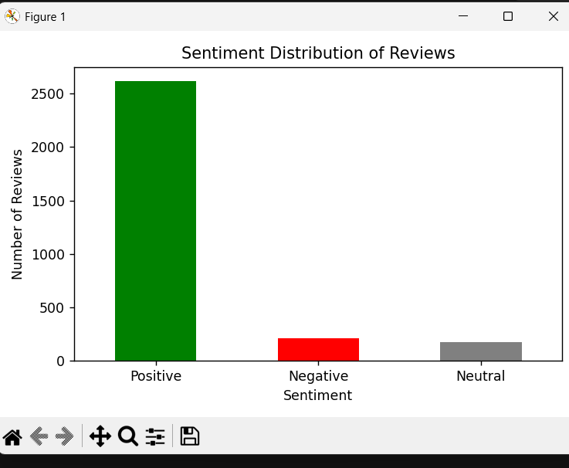
Figure 1: Sentiment distribution across the sampled reviews
The results show that most of the sampled reviews were positive, with 87.3% classified as Positive. This also fits with the generally high product ratings in the original dataset. One possible reason is that customers who are happy with a product may be more likely to leave a positive review.

4.2 Word Clouds
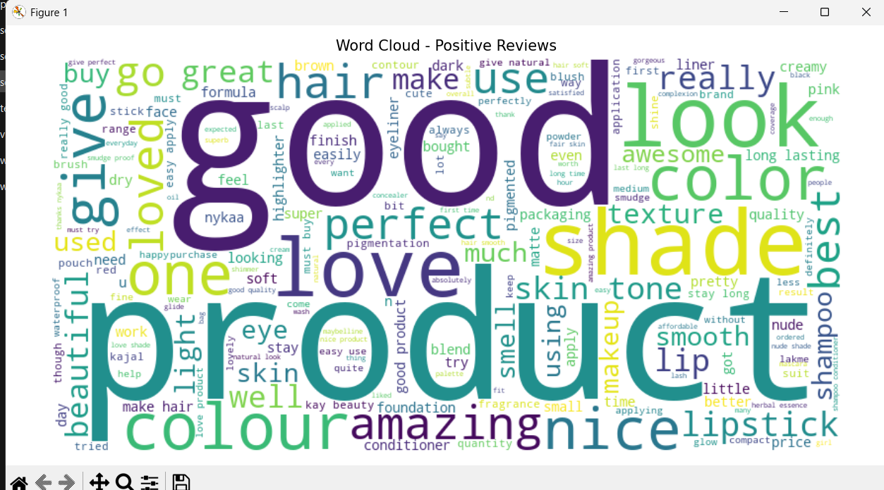
Figure 2: Most frequent words in Positive reviews — common words include “good”, “product”, “love”, “shade”, “perfect”, and “amazing”.
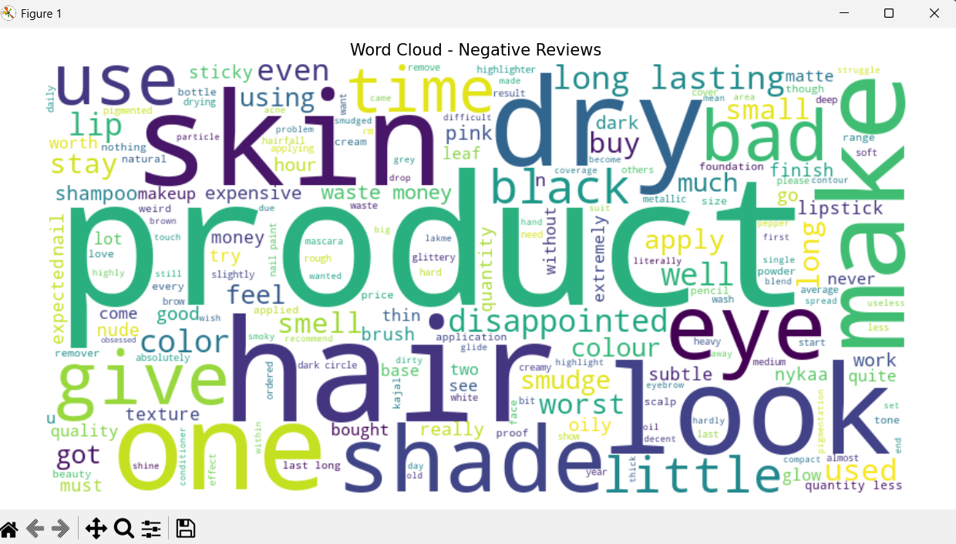
Figure 3: Most frequent words in Negative reviews — common words include “skin”, “dry”, “disappointed”, “bad”, “expensive”, and “waste”.
The two word clouds show a clear difference in the type of feedback. Positive reviews mainly contain words related to product quality and satisfaction, such as “love”, “amazing”, and “perfect”. Negative reviews include more words related to skin problems, such as “dry” and “skin”, as well as concerns about price and value, such as “expensive”, “waste”, and “money”.

5. Challenges Encountered
- The original sales dataset had no text field suitable for sentiment analysis, requiring a separate reviews dataset to be sourced from Kaggle
- Minor typos during coding caused several runtime errors: an incorrect assignment (df=['tokens']=... instead of df['tokens']=...), misspelled NLTK resource names (‘punk’ instead of ‘punkt’), and a misspelled class name (WordNetLemmetizer instead of WordNetLemmatizer)
- A file was accidentally saved with “python” embedded in its filename, and a terminal command included a stray path character, both of which produced confusing “file not found” style errors before being traced to the filename itself
- Long lines in the PowerShell terminal sometimes wrapped and visually dropped spaces between words (e.g. “great shade” appeared as “greatshade” on screen); verifying against the actual saved CSV confirmed the underlying data was correct and the issue was a terminal display artifact, not a data bug
- TextBlob's sentiment corpora and the wordcloud/matplotlib libraries needed separate installation steps not included in the base environment

6. Lessons Learned
- A complete NLP pipeline (clean → tokenize → remove stopwords → lemmatize) meaningfully improves the quality of text before sentiment scoring, by reducing noise and grouping word variants
- TextBlob offers a fast, low-setup way to get directional sentiment on review text, though its rule-based polarity scoring is coarser than model-based sentiment classifiers
- Small typos in library/function names are a common source of runtime errors in NLP work, since many NLTK resources (punkt, punkt_tab, wordnet) must be downloaded and named exactly
- Visual/terminal output can be misleading (e.g. line-wrapping hiding spaces); validating against the saved output file is a more reliable way to confirm correctness than reading console text alone
- Visualizing sentiment (distribution chart + word clouds) makes patterns far more interpretable than raw counts alone — particularly for spotting what specifically drives negative sentiment (skin compatibility, price) versus positive sentiment (quality, shade, packaging)

7. Conclusion
In this week's internship task, I worked on a complete text analytics and sentiment analysis process using the Nykaa beauty product reviews dataset. I selected and cleaned the review data, performed tokenization, stopword removal and lemmatization, and then used TextBlob to classify the reviews based on sentiment. I also created a sentiment distribution chart and separate word clouds for positive and negative reviews. The final results showed that 87.3% of the sampled reviews were positive, while the negative reviews were mainly related to skin compatibility and value-for-money concerns. Overall, this task helped me understand how customer review text can be processed and converted into useful information using Python.

