**Time allowed: 20–Minutes**

**Name____________________ Roll No ______________**

**Q1 Write Html Code for Following Form shown below (7)**

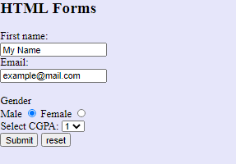

Write a html code by keeping above code in mind. First name should contain default value as displayed. Email value should also contain initial value and only email type values are allowed. In the Gender input only one type of input should be selected at a time and Male should be selected by default. Reset button should reset all the values in the form and upon click onto the submit button data in the form should be routed to ‘ok.com’ via URL.

Note:

No CSS and JavaScript should be used.

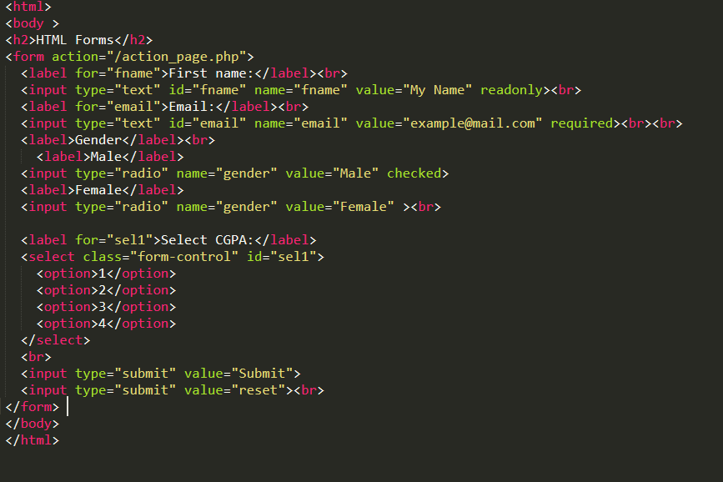

**Q2 What is meant by Descendant selector in CSS, Provide an example(3)?**

Sol:

Descendant Selector

The descendant selector matches all elements that are descendants of a specified element.

The following example selects all <p> elements inside <div> elements:

<!DOCTYPE html>

<html>

<head>

<style>

div p {

background-color: yellow;

}

</style>

</head>

<body>

<h2>Descendant Selector</h2>

<p>The descendant selector matches all elements that are descendants of a specified element.</p>

<div>

<p>Paragraph 1 in the div.</p>

<p>Paragraph 2 in the div.</p>

<section><p>Paragraph 3 in the div.</p></section>

</div>

<p>Paragraph 4. Not in a div.</p>

<p>Paragraph 5. Not in a div.</p>

</body>

</html>