ClickTrades- A Leading Forex & CFDs Trading Broker

ClickTrades Logo
Source: https://clicktrades.com/
The mounting numbers of traders and investors have intensified the competition between online brokerage platforms. Brokers are actively trying to incorporate unique services, offers, and tools for gaining users' trust.
One such all-inclusive broker is ClickTrades which allows commission-free trades and commits to providing an ultimate trading experience to its clients.

About the brand
ClickTrades is an FSA-regulated online broker that provides forex and CFD trading services on a variety of financial securities. The broker incorporates high-technology trading platforms and various market analysis tools to generate a meaningful trading environment.
ClickTrades takes a client-centric approach by supporting financial transparency and making the markets more accessible to all traders. The available account types ranging from Essential to Signature accommodate the needs of both beginner and professional traders.
Moreover, ClickTrades ensures the preservation of clients' funds and the development of a secure infrastructure by applying the highest security standards.

Assets
ClickTrades offers a wide range of tradable asset classes, including bonds, commodities, stocks, indices, ETFs, and cryptocurrencies. The broker also offers an investment portfolio according to your risk tolerance. High-risk traders are recommended to trade forex and commodities, whereas low-risk investors are suggested to primarily invest in bonds and ETFs.
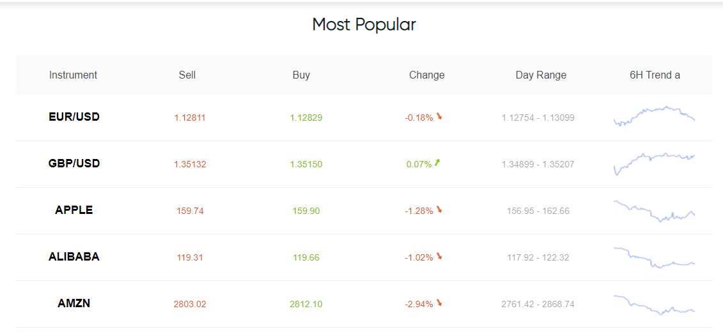
ClickTrades Popular Assets
Source: https://clicktrades.com/trading-instruments

With ClickTrades, you can access the highly liquid forex and stock markets to trade more than 2100 CFDs. Moreover, it is a one-stop platform that provides a great diversity among assets, including major, minor, and exotic currency pairs, soft and hard commodities, 26 global indices, shares, bonds, and low-fee ETFs.

Trading platforms
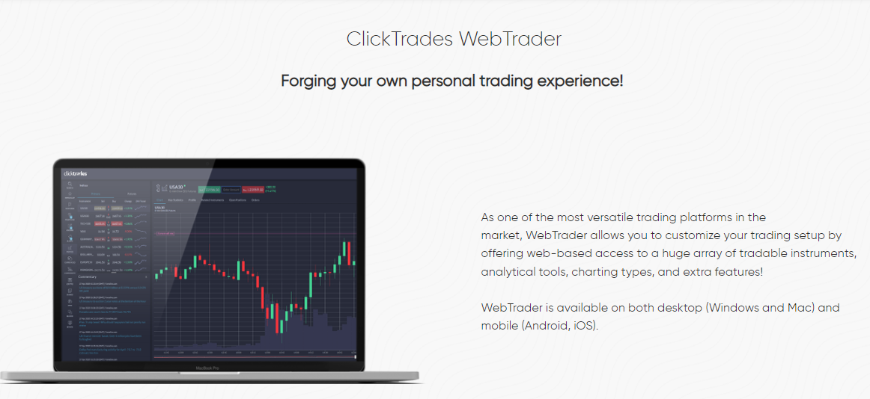
ClickTrades WebTrader
Source: https://clicktrades.com/webtrader

Traders can exercise their full trading potential with the ClickTrades trading platforms, i.e., WebTrader and MT5. ClickTrades WebTrader is a versatile and intuitive trading platform, accessible through both desktop and mobile devices. It is a customizable platform that consolidates 90+ technical indicators, six chart types, and various analytical tools.
Similarly, MT5 is a user-friendly and reliable platform with powerful analysis tools, 30 built-in and 2000+ custom indicators, various price charts, and live market data.
Traders can access the financial markets 24/5 and enjoy fast order execution speed through the MT5 trading terminal. Moreover, the platform incorporates top-level technology for providing an optimal trading experience to the users.
Trading Central
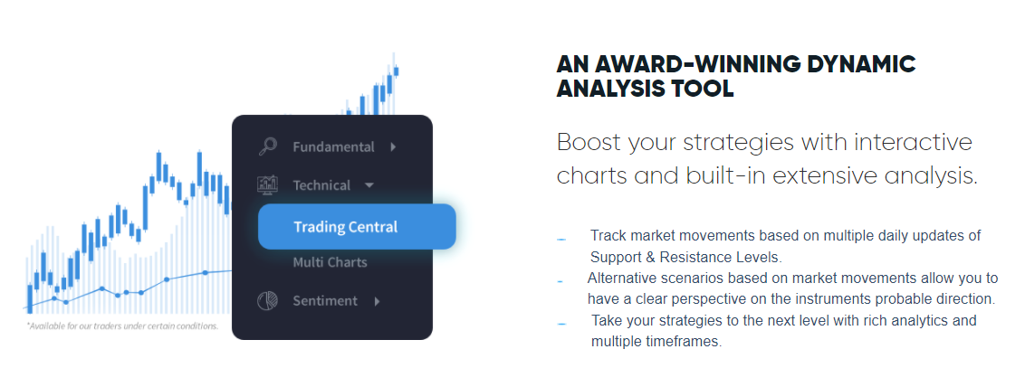
ClickTrades Trading Central
Source: https://clicktrades.com/trading-central
Trading Central is one of the most popular trading tools the ClickTrades platform provides. It is an efficient built-in software that exhibits the market data and provides access to various indicators to help traders refine their strategies.
Moreover, users can refine their knowledge and trading decisions by studying the regular analysis reports provided by Trading Central.

Pros
- An outstanding range of more than 2100 CFD instruments from seven asset classes.
- Multi-lingual and fast customer support.
- Commission-free trading.
- Top-technology and powerful trading platforms.
Cons
- Inactivity fee of $30 after three months.
- Relatively higher minimum account size of $1000.
Summary
ClickTrades is a dependable and well-reputed online broker supplying CFD trading services. Its top-notch trading platforms, advanced trading tools, and many tradable assets reinforce its versatility. However, CFD trading involves considerable risk and uncertainty; hence traders should only participate in it after gauging their risk appetite.

