Is The Gold’s bearish cycle over?
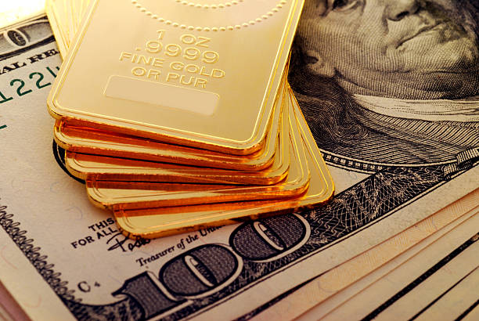

Gold bars on a dollar note
Source: https://www.gettyimages.com/detail/photo/gold-ingot-royalty-free-image/94984105?phrase=gold%20prices
Gold has entered this month with a bang, registering monumental gains amid a weakening dollar and better-than-expected US jobs and CPI figures. In the aftermath, the bullion’s price now stands above the $1750 level after a dizzying rally from the $1616 zone.
The spot gold price started last week at nearly $1,670 an ounce but exited it at around $1,765 belt, recording its best performance since the week ending July 24, 2020.
A gloomy year for gold under the backdrop of a strong dollar and rate hikes
Gold had been under a strong bearish pressure where it lost more than $400 or 20% in value till October’s end since reaching the peak of over $2,060 per ounce level in March.
Gold prices skyrocketed earlier this year as fears about the repercussions of Russia’s invasion of Ukraine elevated. However, the euphoric bubble soon popped as the Fed began its series of aggressive interest rate hikes in order to bring down soaring inflation. The US Treasury yields mounted and investors turned towards government bonds instead of investing in gold to acquire much better returns.
Moreover, in consequence, the DXY surged to record highs where the US dollar has gained more than 10% against a basket of major currencies so far this year.
These developments have not only been weighing down the global equity market but also gold prices over the past several months. During the span of this tumultuous period, many traders approached gold CFDs to capitalize on declining gold prices. easyMarkets is one of the most prominent platforms where you can trade the XAU/USD pair with reliable spreads and benefit from bi-directional trades.

Gold shows signs of recovery as inflation heat eases
Since the start of November, Gold has surged more than 10%, wiping off the declines of the previous three months. The yellow metal has exhibited a remarkable recovery from its $1616/oz. bottom within a few days, as it now eyes the big $1,800/oz. figure.
The sharp rebound in gold prices is mainly attributable to the weakening dollar wave that was initiated with the release of the US Jobs Report and easing inflation indications. Moreover, the recent US retail sales data also came out stronger than expected which bodes well for gold prices. The US retail sales surged 1.3% last month while they are up by 8.3% for the year, according to the latest data from the US Commerce Department. The economists were expecting to see a rise of 1.0% in last month's sales number.
What’s in store for gold in the coming months?
The optimism is building up among gold investors in the face of better-than-anticipated CPI data and US employment figures. Many analysts are predicting that Fed might tone down its aggressive approach now and lessen the pace of interest rate hikes in the December meeting, which could be a positive impetus for gold prices.
However, some experts are also suggesting a flipped scenario where better-than-expected economic data could force the Federal Reserve to maintain its aggressive approach to sustain these constructive results. This stance would be an impediment for gold prices to surge to the levels of their past glory.

