**DESIGNING 4 BIT MICROPROCESSOR**

1. **OBJECTIVE:**

The main purpose of SAP (Simple As Possible) design is to introduce all the crucial ideas behind computer operation without burying in unnecessary detail. But even being a simple microprocessor, SAP covers many advanced concepts. The SAP we have designed is 4-bit bus organized computer where all registers are connected to a bus with the help of tri-state buffers which can perform nine instructions including arithmetic and logic operations. The address bus of our SAP is 4-bit and data bus is 8-bit. The primary purpose of the design is to develop a basic understanding of how a microprocessor works, interacts with memory and other parts of the system like input and output and to learn microprocessor design.

1. **METHODOLOGY:**
2. **Design Step:**

* Understanding and sketching out the architectural structure.
* Analysing the instructions and finding out the T states and nonetheless minimizing the number of states.
* Designing the control matrix according to the T states.
* Simulating the whole system in “Circuit Maker” software.
* Implementing the hardware of control matrix and other parts like- Program Counter(PC), Memory Address Register(MAR), Instruction Register(IR), Random Access Memory(RAM), Arithmetic Logic Unit(ALU), Registers etc. and finally merging them into one system.

1. **Block Diagram:**

4

4

Eu

B register

4

Lp’

Program

Counter

External input

Ea

Clk

La’

S

E

Clr’

Clr

Clk’

Clk

Ei’

Clr

Clk

Li’

Ce’

Clk

Lm’

Cp

Ep

Clr’

Clk’

4

4

4

4

4

Input and MAR

4

2:1

MUX

ALU

RAM

B

U

S

Binary

Output

Controller/

Sequencer

Instruction

Register

Output

Register

Accumulator

A

4

4

M

S3

S2

S1

4

4

S0

Cin

2:1

MUX

E

S

4

8

Clk

Clk

C register

Clk

4

Eb’

8

Lo’

Clk

8

4

17

1. **T State:**

**Fetch Cycle:**

T1: MAR 🡨 PC; EP,

T2: PC 🡨 PC+1; IR 🡨 M[MAR];CP, ,

**Execution Cycle:**

**1.LDA Routine:**

T3: MAR 🡨 IR; ,

T4: A 🡨 M[MAR]; $\overline{Ce}$, $\overline{La}$

**2.ADD Routine:**

T3: A 🡨 A+B; Cin, S1, , Eu

T4: NOP

**3.SUB Routine:**

T3: A 🡨 A+C’+1; S3, S2,  S0,

T4: NOP

**4.AND Routine:**

T3: A 🡨 A^B; , EU

T4: NOP

**5.MOV Routine:**

T3: A 🡨 B; , EB

T4: NOP

**6.JMP[M] Routine:**

T3: PC 🡨M[IR]; ,

T4: MAR 🡨PC

**7.JZ[M] Routine:**

T3: PC 🡨M[IR]; ,

T4: MAR 🡨PC

**8.OUT Routine:**

T3:OUT 🡨 A; , EA

T4: NOP

**9.HLT Routine:**

T3: NOP

T4: NOP

1. **Control Matrix:**

**Equations:**

Ep=T1

Cp = T2

=

=

L1=T2

EI=T3 (JMP+ZJZ+LDA)

LA = T4 (LDA)+T3(ADD+SUB+AND+MOV)

EA=T3out

Ep = T3 (ADD+SUB+AND)

S3=

S2=SUB

S1=

S0=

Cin=ADD

L0=

**Timing routines:**

**Fetch Cycle:** This cycle is same for all the instructions.

|  |  |  |  |  |  |  |  |  |  |  |  |  |  |  |  |  |  |  |
| --- | --- | --- | --- | --- | --- | --- | --- | --- | --- | --- | --- | --- | --- | --- | --- | --- | --- | --- |
| T | EP | CP | LP | LM | CE | LI | EI | LA | EA | EU | M | S3 | S2 | S1 | S0 | Cin | L0 | EB |
| T1 | 1 | 0 | 1 | 0 | 1 | 0 | 0 | 1 | 0 | 0 | 0 | 0 | 0 | 0 | 0 | 0 | 1 | 0 |
| T2 | 0 | 1 | 1 | 1 | 0 | 1 | 0 | 1 | 0 | 0 | 0 | 0 | 0 | 0 | 0 | 0 | 1 | 0 |

**Execution Cycle:** This cycle is most of the time different for different instructions.

1. **LDA:-**

|  |  |  |  |  |  |  |  |  |  |  |  |  |  |  |  |  |  |  |
| --- | --- | --- | --- | --- | --- | --- | --- | --- | --- | --- | --- | --- | --- | --- | --- | --- | --- | --- |
| T | EP | CP | LP | LM | CE | LI | EI | LA | EA | EU | M | S3 | S2 | S1 | S0 | Cin | L0 | EB |
| T3 | 0 | 0 | 1 | 0 | 1 | 0 | 1 | 1 | 0 | 0 | 0 | 0 | 0 | 0 | 0 | 0 | 1 | 0 |
| T4 | 0 | 0 | 1 | 1 | 0 | 0 | 0 | 0 | 0 | 0 | 0 | 0 | 0 | 0 | 0 | 0 | 1 | 0 |

1. **ADD:-**

|  |  |  |  |  |  |  |  |  |  |  |  |  |  |  |  |  |  |  |
| --- | --- | --- | --- | --- | --- | --- | --- | --- | --- | --- | --- | --- | --- | --- | --- | --- | --- | --- |
| T | EP | CP | LP | LM | CE | LI | EI | LA | EA | EU | M | S3 | S2 | S1 | S0 | Cin | L0 | EB |
| T3 | 0 | 0 | 1 | 1 | 1 | 0 | 0 | 0 | 0 | 1 | 0 | 0 | 0 | 0 | 0 | 1 | 1 | 0 |
| T4 | 0 | 0 | 1 | 1 | 1 | 0 | 0 | 1 | 0 | 0 | 0 | 0 | 0 | 0 | 0 | 0 | 1 | 0 |

1. **SUB:-**

|  |  |  |  |  |  |  |  |  |  |  |  |  |  |  |  |  |  |  |
| --- | --- | --- | --- | --- | --- | --- | --- | --- | --- | --- | --- | --- | --- | --- | --- | --- | --- | --- |
| T | EP | CP | LP | LM | CE | LI | EI | LA | EA | EU | M | S3 | S2 | S1 | S0 | Cin | L0 | EB |
| T3 | 0 | 0 | 1 | 1 | 1 | 0 | 0 | 0 | 0 | 1 | 0 | 0 | 1 | 0 | 0 | 0 | 1 | 0 |
| T4 | 0 | 0 | 1 | 1 | 1 | 0 | 0 | 1 | 0 | 0 | 0 | 0 | 0 | 0 | 0 | 0 | 1 | 0 |

1. **AND:-**

|  |  |  |  |  |  |  |  |  |  |  |  |  |  |  |  |  |  |  |
| --- | --- | --- | --- | --- | --- | --- | --- | --- | --- | --- | --- | --- | --- | --- | --- | --- | --- | --- |
| T | EP | CP | LP | LM | CE | LI | EI | LA | EA | EU | M | S3 | S2 | S1 | S0 | Cin | L0 | EB |
| T3 | 0 | 0 | 1 | 1 | 1 | 0 | 0 | 0 | 0 | 1 | 1 | 0 | 0 | 0 | 0 | 0 | 1 | 0 |
| T4 | 0 | 0 | 1 | 1 | 1 | 0 | 0 | 1 | 0 | 0 | 1 | 0 | 0 | 0 | 0 | 0 | 1 | 0 |

**5. MOV:-**

|  |  |  |  |  |  |  |  |  |  |  |  |  |  |  |  |  |  |  |
| --- | --- | --- | --- | --- | --- | --- | --- | --- | --- | --- | --- | --- | --- | --- | --- | --- | --- | --- |
| T | EP | CP | LP | LM | CE | LI | EI | LA | EA | EU | M | S3 | S2 | S1 | S0 | Cin | L0 | EB |
| T3 | 0 | 0 | 1 | 1 | 1 | 0 | 0 | 0 | 0 | 0 | 0 | 0 | 0 | 0 | 0 | 0 | 1 | 1 |
| T4 | 0 | 0 | 1 | 1 | 1 | 0 | 0 | 1 | 0 | 0 | 0 | 0 | 0 | 0 | 0 | 0 | 1 | 0 |

1. **OUT:-**

|  |  |  |  |  |  |  |  |  |  |  |  |  |  |  |  |  |  |  |
| --- | --- | --- | --- | --- | --- | --- | --- | --- | --- | --- | --- | --- | --- | --- | --- | --- | --- | --- |
| T | EP | CP | LP | LM | CE | LI | EI | LA | EA | EU | M | S3 | S2 | S1 | S0 | Cin | L0 | EB |
| T3 | 0 | 0 | 1 | 1 | 1 | 0 | 0 | 1 | 0 | 0 | 0 | 0 | 0 | 0 | 0 | 0 | 0 | 0 |
| T4 | 0 | 0 | 1 | 1 | 1 | 0 | 0 | 1 | 0 | 0 | 0 | 0 | 0 | 0 | 0 | 0 | 1 | 0 |

1. **JMP:-**

|  |  |  |  |  |  |  |  |  |  |  |  |  |  |  |  |  |  |  |
| --- | --- | --- | --- | --- | --- | --- | --- | --- | --- | --- | --- | --- | --- | --- | --- | --- | --- | --- |
| T | EP | CP | LP | LM | CE | LI | EI | LA | EA | EU | M | S3 | S2 | S1 | S0 | Cin | L0 | EB |
| T3 | 0 | 0 | 0 | 1 | 0 | 0 | 0 | 1 | 0 | 0 | 0 | 0 | 0 | 0 | 0 | 0 | 1 | 0 |
| T4 | 0 | 0 | 1 | 1 | 1 | 0 | 0 | 1 | 0 | 0 | 0 | 0 | 0 | 0 | 0 | 0 | 1 | 0 |

1. **JZ:-**

|  |  |  |  |  |  |  |  |  |  |  |  |  |  |  |  |  |  |  |
| --- | --- | --- | --- | --- | --- | --- | --- | --- | --- | --- | --- | --- | --- | --- | --- | --- | --- | --- |
| T | EP | CP | LP | LM | CE | LI | EI | LA | EA | EU | M | S3 | S2 | S1 | S0 | Cin | L0 | EB |
| T3 | 0 | 0 | 1 | 1 | 1 | 0 | 0 | 1 | 0 | 0 | 0 | 0 | 0 | 0 | 0 | 0 | 1 | 0 |
| T4 | 0 | 0 | 1 | 1 | 1 | 0 | 0 | 1 | 0 | 0 | 0 | 0 | 0 | 0 | 0 | 0 | 1 | 0 |

1. **HLT:-**

|  |  |  |  |  |  |  |  |  |  |  |  |  |  |  |  |  |  |  |
| --- | --- | --- | --- | --- | --- | --- | --- | --- | --- | --- | --- | --- | --- | --- | --- | --- | --- | --- |
| T | EP | CP | LP | LM | CE | LI | EI | LA | EA | EU | M | S3 | S2 | S1 | S0 | Cin | L0 | EB |
| T3 | 0 | 0 | 1 | 1 | 1 | 0 | 0 | 0 | 0 | 1 | 0 | 0 | 0 | 0 | 0 | 0 | 1 | 0 |
| T4 | 0 | 0 | 1 | 1 | 1 | 0 | 0 | 0 | 0 | 0 | 0 | 0 | 0 | 0 | 0 | 0 | 1 | 0 |

1. **RECQUIRED IC:**
2. **Total IC:**

**IC Number IC Name Amount**

1. 74193 SYNCHRONOUS 4-BIT UP/DOWN 1

COUNTERS

2. 74125 QUADRUPLE BUS BUFFERS 5

(WITH 3-STATE OUTPUTS)

3. 74173 4-BIT D-TYPE REGISTER 7

(WITH 3-STATE OUTPUTS)

4. 74157 QUAD 2-LINE to 1-LINE DATA 2

SELECTORS/MULTIPLEXERS

5. 74181 4-BIT ARITHMATIC LOGIC UNIT 1

6. 6116 CMOS STATIC RAM 16K (2K x 8-BIT) 1

7. 74154 4-LINE to 16-LINE DECODERS 1

8. 74164 8-BIT SERIAL-IN, PARALLEL-OUT 1

SHIFT REGISTER

9. 7404 HEX INVERTES 4

10. 4002 4-IN NOR 1

11. 7486 2-IN XOR 1

12. 7408 2-IN AND 3

13. 7432 2-IN OR 2

**TOTAL 30**

**N.B.-** We have minimized

1. 1 NAND gate by 1 AND and 1 NOT GATE

2. 3 NOR gate by 3 OR and 3 NOT GATE

3. 1 3-IN OR gate by 2 OR GATE

1. **IC CONFIGURATION:**

* **74193:**

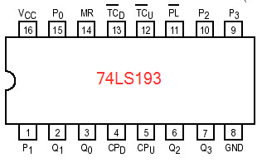

|  |  |  |
| --- | --- | --- |
| 1 | P1 | data input |
| 2 | Q1 | counter output |
| 3 | Q0 | counter output |
| 4 | CPD | count down clock input (low-to-high, edge-triggered) |
| 5 | CPU | count up clock input (low-to-high, edge-triggered) |
| 6 | Q2 | counter output |
| 7 | Q3 | counter output |
| 8 | GND | ground |
| 9 | P3 | data input |
| 10 | P2 | data input |
| 11 | PL | parallel load input (active low) |
| 12 | TCU | terminal count up (carry) output (active low) |
| 13 | TCD | terminal count down (borrow) output (active low) |
| 14 | MR | asynchronous master reset (active high) |
| 15 | P0 | data input |
| 16 | Vcc | supply voltage |

* **74173:**

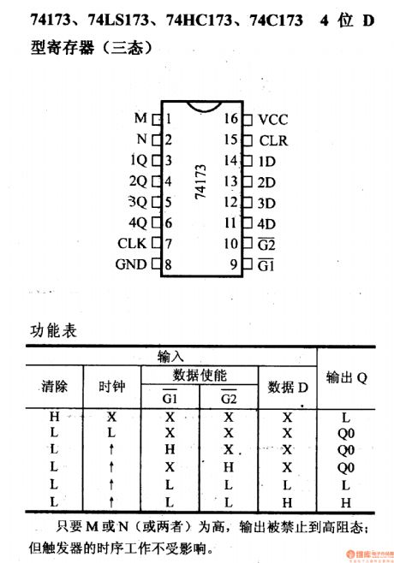

|  |  |  |
| --- | --- | --- |
| **Pin** | **Symbol** | **Description** |
| 1 | M | output enable input (active low) |
| 2 | N | output enable input (active low) |
| 3 | 1Q | 3-state flip-flop output |
| 4 | 2Q | 3-state flip-flop output |
| 5 | 3Q | 3-state flip-flop output |
| 6 | 4Q | 3-state flip-flop output |
| 7 | CLK | clock input (low-to-high, edge-triggered) |
| 8 | GND | ground |
| 9 | G1 | data enable input (active low) |
| 10 | G2 | data enable input (active low) |
| 11 | 4D | data input |
| 12 | 3D | data input |
| 13 | 2D | data input |
| 14 | 1D | data input |
| 15 | CLR | asynchronous master reset (active high) |
| 16 | Vcc | supply voltage |

* **74157:**

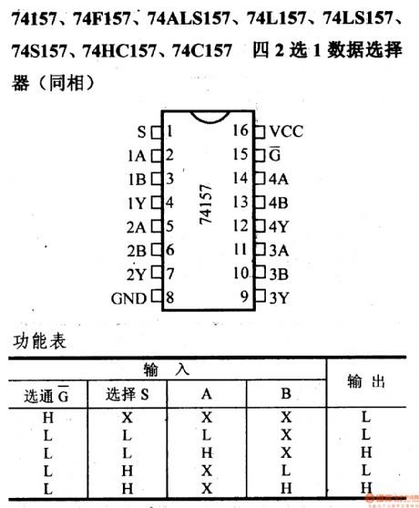

|  |  |  |
| --- | --- | --- |
| **Pin** | **Symbol** | **Description** |
| 1 | S | common data select input |
| 2 | 1A | data input from source 0 |
| 3 | 1B | data input from source 1 |
| 4 | 1Y | multiplexer output |
| 5 | 2A | data input from source 0 |
| 6 | 2B | data input from source 1 |
| 7 | 2Y | multiplexer output |
| 8 | GND | ground |
| 9 | 3Y | multiplexer output |
| 10 | 3B | data input from source 1 |
| 11 | 3A | data input from source 0 |
| 12 | 4Y | multiplexer output |
| 13 | 4B | data input from source 1 |
| 14 | 4A | data input from source 0 |
| 15 | G | enable input (active low) |
| 16 | Vcc | supply voltage |

* **74125:**

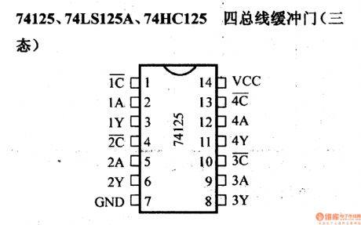

|  |  |  |
| --- | --- | --- |
| **Pin** | **Symbol** | **Description** |
| 1 | 1C | output enable (active low) |
| 2 | 1A | data input |
| 3 | 1Y | data output |
| 4 | 2C | output enable (active low) |
| 5 | 2A | data input |
| 6 | 2Y | data output |
| 7 | GND | ground |
| 8 | 3Y | data output |
| 9 | 3A | data input |
| 10 | 3C | output enable (active low) |
| 11 | 4Y | data output |
| 12 | 4A | data input |
| 13 | 4C | output enable (active low) |
| 14 | Vcc | supply voltage |

* **6116 -2k RAM:**

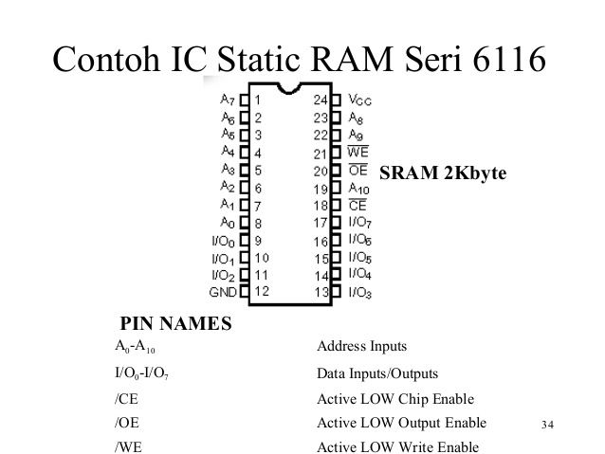

|  |  |  |
| --- | --- | --- |
| **Pin** | **Symbol** | **Description** |
| 1 | A7 | Address inputs |
| 2 | A6 | Address inputs |
| 3 | A5 | Address inputs |
| 4 | A4 | Address inputs |
| 5 | A3 | Address inputs |
| 6 | A2 | Address inputs |
| 7 | A1 | Address inputs |
| 8 | A0 | Address inputs |
| 9 | I/O0 | Data Input/output |
| 10 | I/O1 | Data Input/output |
| 11 | I/O2 | Data Input/output |
| 12 | GND | Ground |
| 13 | I/O3 | Data Input/output |
| 14 | I/O4 | Data Input/output |
| 15 | I/O5 | Data Input/output |
| 16 | I/O6 | Data Input/output |
| 17 | I/O7 | Data Input/output |
| 18 | CE | Chip Enable (active low) |
| 19 | A10 | Address inputs |
| 20 | OE | Output Enable (active low) |
| 21 | WE | Write Enable (active low) |
| 22 | A9 | Address inputs |
| 23 | A8 | Address inputs |
| 24 | Vcc | Supply voltage |

* **74164:**

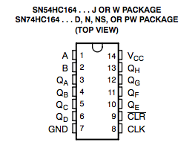

|  |  |  |
| --- | --- | --- |
| **Pin** | **Symbol** | **Description** |
| 1 | A | data input |
| 2 | B | data input |
| 3 | QA | output |
| 4 | QB | output |
| 5 | QC | output |
| 6 | QD | output |
| 7 | GND | ground |
| 8 | CP | clock input (low-to-high, edge-triggered) |
| 9 | CLR | master reset input (active low) |
| 10 | QE | output |
| 11 | QF | output |
| 12 | QG | output |
| 13 | QH | output |
| 14 | Vcc | supply voltage |

* **74181:**

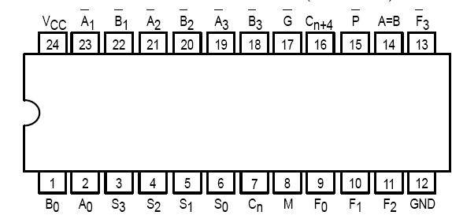

|  |  |  |
| --- | --- | --- |
| **Pin** | **Symbol** | **Description** |
| 1 | B0 | Operand (Active LOW) Inputs |
| 2 | A0 | Operand (Active LOW) Inputs |
| 3 | S3 | Function — Select Inputs |
| 4 | S2 | Function — Select Inputs |
| 5 | S1 | Function — Select Inputs |
| 6 | S0 | Function — Select Inputs |
| 7 | Cn | Carry Input |
| 8 | M | Mode Control Input |
| 9 | F0 | Function (Active LOW) Outputs |
| 10 | F1 | Function (Active LOW) Outputs |
| 11 | F2 | Function (Active LOW) Outputs |
| 12 | GND | Ground |
| 13 | F3 | Function (Active LOW) Outputs |
| 14 | A=B | Comparator Output |
| 15 | P | Carry Propagate (Active LOW) Output |
| 16 | Cn+4 | Carry Output |
| 17 | G | Carry Generator (Active LOW) Output |
| 18 | B3 | Operand (Active LOW) Inputs |
| 19 | A3 | Operand (Active LOW) Inputs |
| 20 | B2 | Operand (Active LOW) Inputs |
| 21 | A2 | Operand (Active LOW) Inputs |
| 22 | B1 | Operand (Active LOW) Inputs |
| 23 | A1 | Operand (Active LOW) Inputs |
| 24 | Vcc | Supply voltage |

* **74154:**

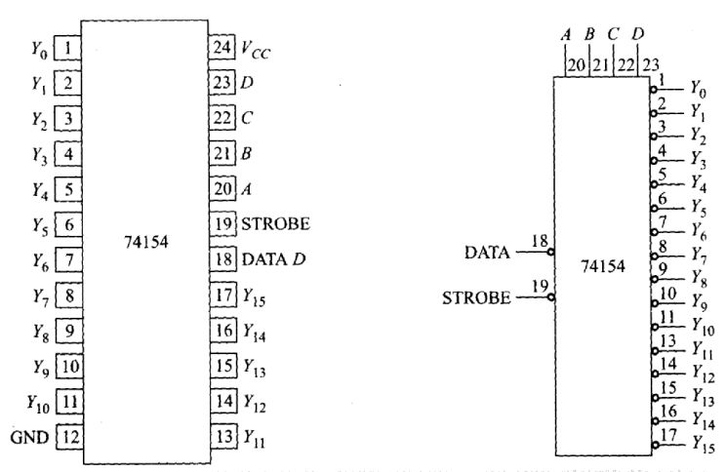

|  |  |  |
| --- | --- | --- |
| **Pin** | **Symbol** | **Description** |
| 1 | Y0 | data output (active low) |
| 2 | Y1 | data output (active low) |
| 3 | Y2 | data output (active low) |
| 4 | Y3 | data output (active low) |
| 5 | Y4 | data output (active low) |
| 6 | Y5 | data output (active low) |
| 7 | Y6 | data output (active low) |
| 8 | Y7 | data output (active low) |
| 9 | Y8 | data output (active low) |
| 10 | Y9 | data output (active low) |
| 11 | Y10 | data output (active low) |
| 12 | GND | ground |
| 13 | Y11 | data output (active low) |
| 14 | Y12 | data output (active low) |
| 15 | Y13 | data output (active low) |
| 16 | Y14 | data output (active low) |
| 17 | Y15 | data output (active low) |
| 18 | DATA D | enable input (active low) |
| 19 | STROBE | enable input (active low) |
| 20 | A | address input |
| 21 | B | address input |
| 22 | C | address input |
| 23 | D | address input |
| 24 | Vcc | supply voltage |

1. **DISCUSSION:**

The discussion is based on the problems we critically faced with some major recommendations.

* We tried to minimize the T states to save clock periods so that operations run faster. The lesser the T states, the faster the microprocessor.
* We also minimized some ICs.
* It is wise to use ROM rather than RAM because the RAM is volatile and we have to write instructions every time after we switch off the power. It takes a lot of time.
* It was hard to find out a mistake after implementing the whole big circuitry and we had to rebuild the whole circuitry for several times. It should be done that the instructions are implemented one by one.
* The circuit must not be powered on for much time and kept in rest after testing for some times to avoid damage of ICs.
* Jumper wires are preferable as there is less voltage drop in jumpers.
* If LEDs are used it is wise to connect it via resistor or capacitor.
* Any part of the circuit may get shorted. So the contents of BUS should be checked for a regular interval.
* All the components of the trainer board are to be checked before starting the hardware implementation.
* We tried to make control matrix simpler.

SAP-1 is a 4-bit microprocessor which is the first stage in the evolution towards modern computers. The instruction sets of SAP-1 are very limited and simple. To make a 8-bit microprocessor, further extension of this project is needed to make. For example, there would have more instruction sets and the circuitry would be more complex than our project. That means it will take more time and energy to design and implement the hardware.