***Algorithms Design and Analysis Lab***

***ETMA 351***

Faculty: **Dr. Deepak Gupta** Name: **Syeda Reeha Quasar**

Roll No.: **14114802719**

Semester: **4**

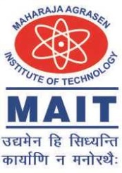

Maharaja Agrasen Institute of Technology, PSP Area,

Sector – 22, Rohini, New Delhi – 110085

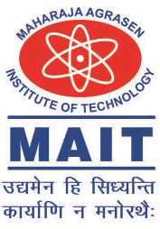

**MAHARAJA AGRASEN INSTITUTE OF TECHNOLOGY**

**COMPUTER SCIENCE & ENGINEERING DEPARTMENT**

**VISION**

To Produce “Critical thinkers of Innovative Technology”

**MISSION**

To provide an excellent learning environment across the computer science discipline to inculcate professional behavior, strong ethical values, innovative research capabilities and leadership abilities which enable them to become successful entrepreneurs in this globalized world.

1. To nurture an **excellent learning environment** that helps students to enhance their problem solving skills and to prepare students to be lifelong learners by offering a solid theoretical foundation with applied computing experiences and educating them about their **professional, and ethical responsibilities**.
2. To establish **Industry-Institute Interaction**, making students ready for the industrial environment and be successful in their professional lives.
3. To promote **research activities** in the emerging areas of technology convergence.
4. To build engineers who can look into technical aspects of an engineering solution thereby setting a ground for producing successful **entrepreneur.**

#### VISION

To nurture young minds in a learning environment of high academic value and im- bibe spiritual and ethical values with technological and management competence.

#### MISSION

The Institute shall endeavor to incorporate the following basic missions in the teaching methodology:

#### Engineering Hardware - Software Symbiosis

Practical exercises in all Engineering and Management disciplines shall be carried out by Hardware equipment as well as the related software enabling deeper un- derstanding of basic concepts and encouraging inquisitive nature.

#### Life - Long Learning

The Institute strives to match technological advancements and encourage students to keep updating their knowledge for enhancing their skills and inculcating their habit of continuous learning.

#### Liberalization and Globalization

The Institute endeavors to enhance technical and management skills of students so that they are intellectually capable and competent professionals with Industrial Aptitude to face the challenges of globalization.

#### Diversification

The Engineering, Technology and Management disciplines have diverse fields of studies with different attributes. The aim is to create a synergy of the above at- tributes by encouraging analytical thinking.

#### Digitization of Learning Processes

The Institute provides seamless opportunities for innovative learning in all En- gineering and Management disciplines through digitization of learning processes using analysis, synthesis, simulation, graphics, tutorials and related tools to create a platform for multi-disciplinary approach.