**EXPERIMENT - 1**

**Aim:** a) Study and prepare list of Graphic functions.

b) Write a C program to make a hut and car using built-in graphic function.

**Theory:**

The graphics. h header file provides access to a simple graphics library that makes it possible to draw lines, rectangles, ovals, arcs, polygons, images, and strings on a graphical window.

**Functions:**

[**initGraphics()**](https://web.stanford.edu/class/archive/cs/cs106b/cs106b.1126/materials/cppdoc/graphics.html#Function:initGraphics) **or initwindow():** Creates the graphics window on the screen. Syntax - [initGraphics(width, height)](https://web.stanford.edu/class/archive/cs/cs106b/cs106b.1126/materials/cppdoc/graphics.html#Function:initGraphics), [initwindow(width, height)](https://web.stanford.edu/class/archive/cs/cs106b/cs106b.1126/materials/cppdoc/graphics.html#Function:initGraphics)

1. **Putpixel**

Purpose:-Putpixel function is to draw the pixel on the screen.  Pixel is small dot on the screen.

Syntax:-putpixel(x co-orinate, y co-ordinate,COLOR);

Example: – putpixel(100,100,BLUE);

1. **SetbkColor**

Purpose:-Setbkcolor function is used to set background color of the screen.

Syntax:-setbkcolor(COLOR);

Example:-setbkcolor(RED);

1. **Setlinestyle**

Purpose:-setlinestyle function is used to set the current line style, width and pattern

Syntax:-setlinestyle(linestyle, pattern, thickness);

Example:-setlinestyle(SOLID_LINE,1,2);

1. **Setcolor**

Purpose:-setcolor is to set color of the objects which is to be drawn after this setcolor line.

Syntax:-setcolor(COLOR);

Example:-setcolor(RED);

1. **Rectange:-**

Purpose:- Rectangle function is used to draw the rectangle on the screen.  X1,y1 are the lower left co-ordinates of the rectangle and the x2,y2 are the upper right co-ordinates of the rectangle.

Syntax:– rectangle(x1,,y1,x2,y2);

Example:– rectangle(100,100,200,200);

1. **Textheight**

Purpose:-textheight returns the height of a string in pixels.

Syntax:-textheight(STRING);

Example:-i=textheight(“HELLO”);

1. **Textwidth**

Purpose:-textwidth returns the width of a string in pixels

Syntax:-textwidth(STRING);

Example:-i=textwidth(“HELLO”);

1. **Getx**

Purpose:-getx returns the current position’s of x o-ordinate

Syntax:-getx();

Example:-x=getx();

1. **Gety**

Purpose:-gety returns the current position’s of y co-ordinate

Syntax:-gety();

Example:-y=gety();

1. **Getmaxx**

Purpose:-getmaxxreturns the maximum x co-ordinate on the screen

Syntax:-getmaxx();

Example:-maxx=getmaxx();

1. **Getmaxy**

Purpose:-getmaxy returns the maximum y co-ordinate on the screen

Syntax:-getmaxy();

Example:-maxy=getmaxy();

1. **Line**

Purpose:-Line function is used to draw the line on the screen.

Syntax: line(x1,y1,x2,y2);

Example:-line(100,100,200,100);

1. **Closegraph**

Purpose:-closegraph function shut down the graphic system

Syntax:-closegraph();

Example:-closegraph();

1. **Moveto**

Purpose:-moveto function moves current cursor position on the screen

Syntax:-moveto(x co-ordinate, y co-ordinate);

Example:-moveto(getmaxx/2, getmaxy/2);

1. **Settextstyle**

Purpose:-settextstyle sets the current text characteristics like font, direction and size

Syntax:-settextstyle(font, direction size);

Example:-settextstyle(1,1,10);

1. **Circle**

Purpose: Circle function is used to draw the circle on the screen

Syntax:– circle(x,y,radius);

Example:circle(100,100,50);

1. **Cleardevice**

Purpose: cleardevice function is used to clear the contents or graphic images on the screen in graphics mode.

Syntax:cleardevice();

Example:cleardevice();

1. **Outtextxy**

Purpose: outtextxy function is used to print the text on the screen in graphics mode.

Syntax:outtext(x,y,text);

Example:-outtextxy(100,100,”HELLO”);

1. **Sector**

Purpose:sector function draws and fills an elliptical pie slice.

Syntax:sector(x, y, starting angle, ending angle, xradius, yradius);

Example:sector(100,100,45 135 100 50);

1. **Arc**

Purpose:arc draws the arc on the screen, arc is  a part of the circle

Syntax:arc(x, y, starting angle, ending angle, radius);

Example:arc( 100,100,90,180,50);

1. **Setfillstyle**

Purpose: setfillstyle is used to set the color and style to be filled in the object using the flood fill method.

Syntax:stefillstyle(STYLE, COLOR);

Example:setfillstyle(1,RED)

1. **Floodfill**

Purpose:floodfill function is used to fill the color in the object, object may be circle, rectangle or any other closed image.

Syntax:floodfill(x,y,boundary color);

Example:floodfill(100,100,BLUE);

1. **Ellipse**

Purpose:ellipse function is used to draw the ellipse on the screen.

Syntax:ellipse(x, y, starting angle, ending angle, xradius, yradius);

Example:ellipse(100,100,90,200,20,20);

1. **Outtext**

Purpose:outtext function is used to display the text on the screen, using this function text is display in the current position.

Syntax:outtext(STRING);

Example:outtex(“HELLO”);

1. **Getcolor**

Purpose:getcolor returns the current drawing color.

Syntax:getcolor();

Example:intclr = getcolor();

1. **Getpixel**

Purpose:getpixel gets the color of a specified pixel.

Syntax:getpixel(x,y);

Example: color=getpixel(100,100);

**Drawing Functions**

**For drawing arc:**

void arc( int x, int y, int stangle, int endangle, int radius );

**for drawing bar:**

void bar( int left, int top, int right, int bottom );

**for drawing 3d bar:**

void bar3d( int left, int top, int right, int bottom, int depth, int topflag );

**for drawing a circle:**

void circle( int x, int y, int radius );

**for clearing:**

void cleardevice( );

void clearviewport( );

**for drawing polygon:**

void drawpoly(int n_points, int* points);

void fillpoly(int n_points, int* points);

**for drawing ellipse:**

void ellipse( int x, int y, int stangle, int endangle, int xradius, int yradius );

void fillellipse( int x, int y, int xradius, int yradius );

**for filling:**

void floodfill( int x, int y, int border );

**for making line:**

void line( int x1, int y1, int x2, int y2 );

void linerel( int dx, int dy );

void lineto( int x, int y );

void pieslice( int x, int y, int stangle, int endangle, int radius );

void putpixel( int x, int y, int color );

**for drawing rectangle:**

void rectangle( int left, int top, int right, int bottom );

**for drawing sector:**

void sector( int x, int y, int stangle, int endangle, int xradius, int yradius );

**Source Code:**

**CAR**

#include <stdio.h>

#include <conio.h>

#include <graphics.h>

main()

{

initwindow(800, 800);

rectangle(50,275,150,400);

rectangle(150,350,200,400);

circle(75,410,10);

circle(175,410,10);

getch();

}

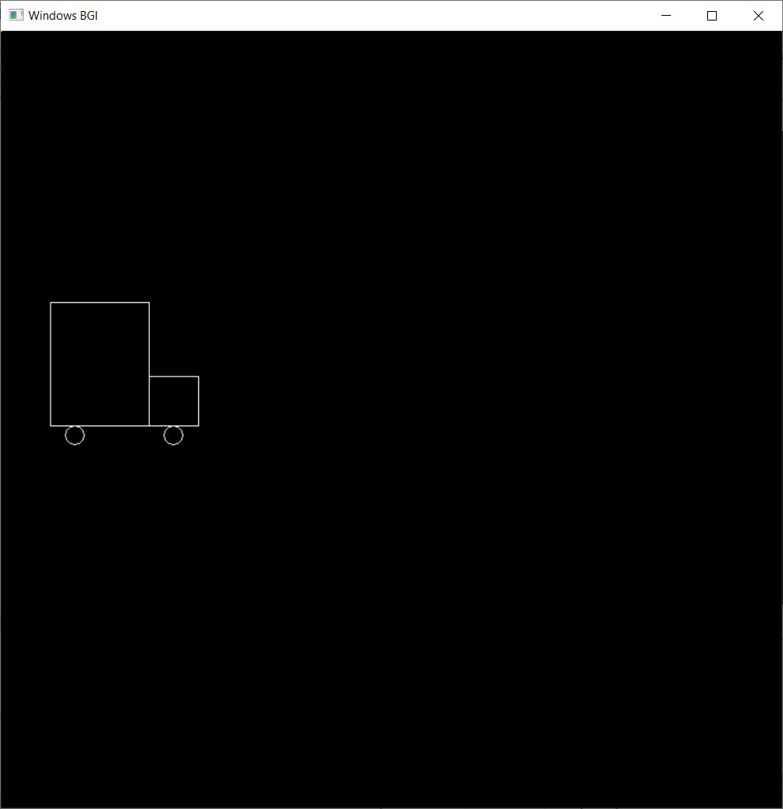

**HUT**

#include <stdio.h>

#include <conio.h>

#include <graphics.h>

main()

{

initwindow(800, 800);

rectangle(150,180,250,300);

rectangle(250,180,420,300);

rectangle(180,250,220,300);

line(200,100,150,180);

line(200,100,250,180);

line(200,100,370,100);

line(370,100,420,180);

getch();

}

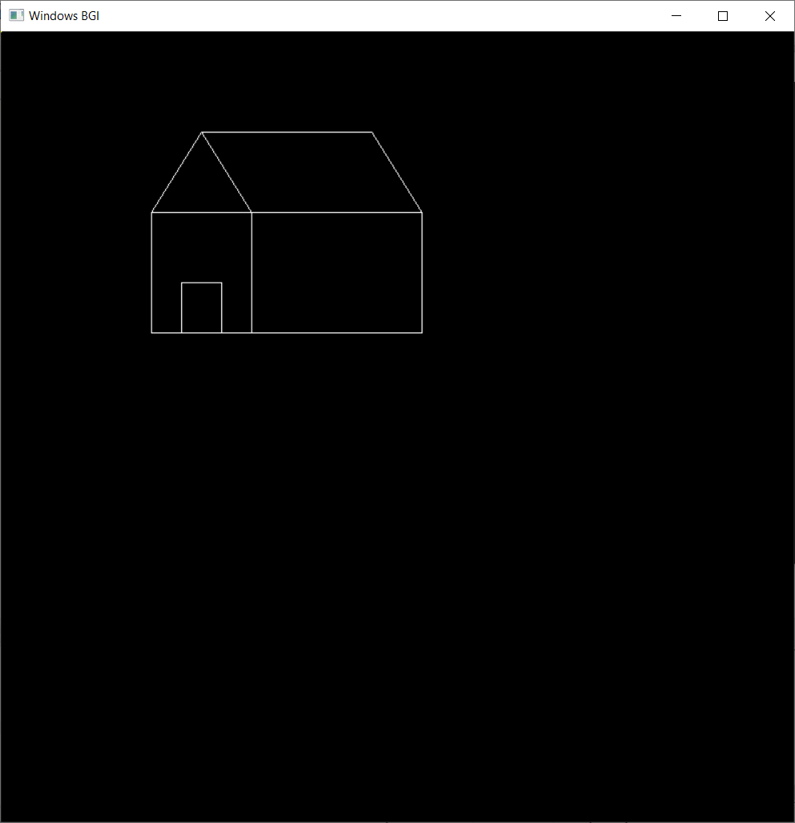

**Concentric circle and lines:**

#include <stdio.h>

#include <conio.h>

#include <graphics.h>

main()

{

initwindow(800, 800);

line(100, 100, 500, 500);

circle(100, 100, 100);

int x = 320, y = 240, radius;

for ( radius = 25; radius <= 125 ; radius = radius + 20)

circle(x, y, radius);

getch();

}

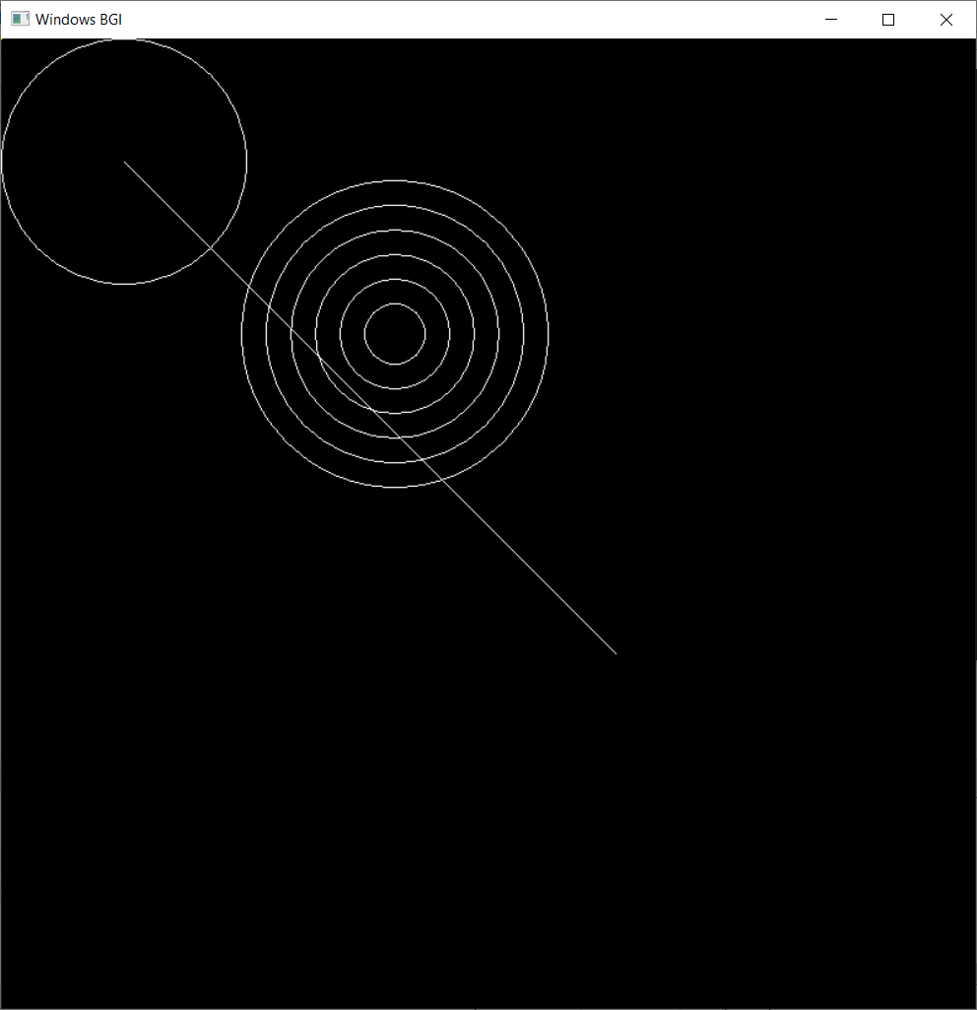

**VIVA QUESTIONS:**

1. **What is the use of initgraph() and closegraph() function?**

**ANS. initgraph() function is used to enter in the graphics mode and closegraph() function is used to exit from the graphics mode and also enter in the text mode** .

1. **Why do we need to use closegraph() function after getch() ?**

**ANS.** Getch() helps us to wait until a key is pressed, closegraph() function closes the graphics mode, and finally return statement returns a value 0 to main indicating successful execution of the program. Getch is used to hold the output sceen and wait until user gives any type of input(i.e. Until user press any key ) so that they can read the character and due to this we able to see the output on the screen.

1. **Which parameters are used to find the resolution of the screen?**

**ANS.** Pixels are the parameter for measuring the resolution.

1. **How is putpixel() different from getpixel()?**

**ANS.** Function getpixel returns the color of pixel present at point(x, y).  
Function putpixel plots a pixel at a point(x, y) of the specified color.

1. **Explain various other graphic functions.**

**ANS.**

1. Putpixel

Purpose:-Putpixel function is to draw the pixel on the screen.  Pixel is small dot on the screen.

Syntax:-putpixel(x co-orinate, y co-ordinate,COLOR);

Example: – putpixel(100,100,BLUE);

1. SetbkColor

Purpose:-Setbkcolor function is used to set background color of the screen.

Syntax:-setbkcolor(COLOR);

Example:-setbkcolor(RED);

1. Setlinestyle

Purpose:-setlinestyle function is used to set the current line style, width and pattern

Syntax:-setlinestyle(linestyle, pattern, thickness);

Example:-setlinestyle(SOLID_LINE,1,2);

1. Setcolor

Purpose:-setcolor is to set color of the objects which is to be drawn after this setcolor line.

Syntax:-setcolor(COLOR);

Example:-setcolor(RED);

1. Rectange:-

Purpose:- Rectangle function is used to draw the rectangle on the screen.  X1,y1 are the lower left co-ordinates of the rectangle and the x2,y2 are the upper right co-ordinates of the rectangle.

Syntax:– rectangle(x1,,y1,x2,y2);

Example:– rectangle(100,100,200,200);

1. Textheight

Purpose:-textheight returns the height of a string in pixels.

Syntax:-textheight(STRING);

Example:-i=textheight(“HELLO”);

1. Textwidth

Purpose:-textwidth returns the width of a string in pixels

Syntax:-textwidth(STRING);

Example:-i=textwidth(“HELLO”);

1. Getx

Purpose:-getx returns the current position’s of x o-ordinate

Syntax:-getx();

Example:-x=getx();

1. Gety

Purpose:-gety returns the current position’s of y co-ordinate

Syntax:-gety();

Example:-y=gety();

1. Getmaxx

Purpose:-getmaxxreturns the maximum x co-ordinate on the screen

Syntax:-getmaxx();

Example:-maxx=getmaxx();

1. Getmaxy

Purpose:-getmaxy returns the maximum y co-ordinate on the screen

Syntax:-getmaxy();

Example:-maxy=getmaxy();

1. Line

Purpose:-Line function is used to draw the line on the screen.

Syntax: line(x1,y1,x2,y2);

Example:-line(100,100,200,100);

1. Closegraph

Purpose:-closegraph function shut down the graphic system

Syntax:-closegraph();

Example:-closegraph();

1. Moveto

Purpose:-moveto function moves current cursor position on the screen

Syntax:-moveto(x co-ordinate, y co-ordinate);

Example:-moveto(getmaxx/2, getmaxy/2);

1. Settextstyle

Purpose:-settextstyle sets the current text characteristics like font, direction and size

Syntax:-settextstyle(font, direction size);

Example:-settextstyle(1,1,10);

1. Circle

Purpose: Circle function is used to draw the circle on the screen

Syntax:– circle(x,y,radius);

Example:circle(100,100,50);

1. Cleardevice

Purpose: cleardevice function is used to clear the contents or graphic images on the screen in graphics mode.

Syntax:cleardevice();

Example:cleardevice();

1. Outtextxy

Purpose: outtextxy function is used to print the text on the screen in graphics mode.

Syntax:outtext(x,y,text);

Example:-outtextxy(100,100,”HELLO”);

1. Sector

Purpose:sector function draws and fills an elliptical pie slice.

Syntax:sector(x, y, starting angle, ending angle, xradius, yradius);

Example:sector(100,100,45 135 100 50);

1. Arc

Purpose:arc draws the arc on the screen, arc is  a part of the circle

Syntax:arc(x, y, starting angle, ending angle, radius);

Example:arc( 100,100,90,180,50);

1. Setfillstyle

Purpose: setfillstyle is used to set the color and style to be filled in the object using the flood fill method.

Syntax:stefillstyle(STYLE, COLOR);

Example:setfillstyle(1,RED)

1. Floodfill

Purpose:floodfill function is used to fill the color in the object, object may be circle, rectangle or any other closed image.

Syntax:floodfill(x,y,boundary color);

Example:floodfill(100,100,BLUE);

1. Ellipse

Purpose:ellipse function is used to draw the ellipse on the screen.

Syntax:ellipse(x, y, starting angle, ending angle, xradius, yradius);

Example:ellipse(100,100,90,200,20,20);

1. Outtext

Purpose:outtext function is used to display the text on the screen, using this function text is display in the current position.

Syntax:outtext(STRING);

Example:outtex(“HELLO”);

1. Getcolor

Purpose:getcolor returns the current drawing color.

Syntax:getcolor();

Example:intclr = getcolor();

1. Getpixel

Purpose:getpixel gets the color of a specified pixel.

Syntax:getpixel(x,y);

Example: color=getpixel(100,100);