# Aim

Write C Programs for the implementation of 2D transformations.

experiment 6

COMPUTER GRAPICS AND MULTIMEDIA

**Syeda Reeha Quasar**

**14114802719**

**3C7**

# **EXPERIMENT 6**

**AIM:**

Write C Programs for the implementation of 2D transformations.

# **THEORY:**

Transformation means changing some graphics into something else by applying rules. We can have various types of transformations such as translation, scaling up or down, rotation, shearing, etc. When a transformation takes place on a 2D plane, it is called 2D transformation.

Transformations play an important role in computer graphics to reposition the graphics on the screen and change their size or orientation.

In computer graphics, various transformation techniques are-

1. [Translation](https://www.gatevidyalay.com/2d-transformation-in-computer-graphics-translation-examples/)
2. [Rotation](https://www.gatevidyalay.com/2d-rotation-in-computer-graphics-definition-examples/)
3. [Scaling](https://www.gatevidyalay.com/scaling-in-computer-graphics-definition-examples/)
4. [Reflection](https://www.gatevidyalay.com/2d-reflection-in-computer-graphics-definition-examples/)
5. [Shear](https://www.gatevidyalay.com/2d-shearing-in-computer-graphics-definition-examples/)

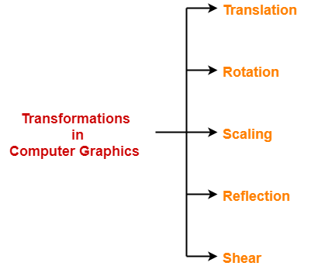

**In this experiment, we will discuss about 2D Translation, Rotation and Scaling in Computer Graphics.**

## 2D Translation in Computer Graphics-

|  |
| --- |
| In Computer graphics,  2D Translation is a process of moving an object from one position to another in a 2-dimensional plane. |

Consider a point object O has to be moved from one position to another in a 2D plane.

Let-

* Initial coordinates of the object O = (Xold, Yold)
* New coordinates of the object O after translation = (Xnew, Ynew)
* Translation vector or Shift vector = (Tx, Ty)

Given a Translation vector (Tx, Ty)-

* Tx defines the distance the Xold coordinate has to be moved.
* Ty defines the distance the Yold coordinate has to be moved.

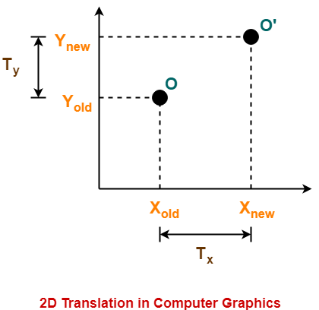

This translation is achieved by adding the translation coordinates to the old coordinates of the object as-

* Xnew = Xold + Tx     (This denotes translation towards X axis)
* Ynew = Yold + Ty     (This denotes translation towards Y axis)

In Matrix form, the above translation equations may be represented as-

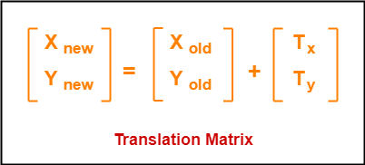

* The homogeneous coordinates representation of (X, Y) is (X, Y, 1).
* Through this representation, all the transformations can be performed using matrix / vector multiplications.

The above translation matrix may be represented as a 3 x 3 matrix as-

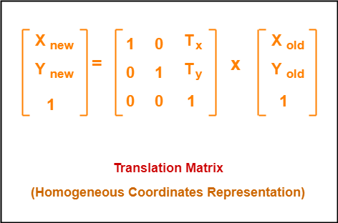

## 2D Rotation in Computer Graphics-

|  |
| --- |
| In Computer graphics,  2D Rotation is a process of rotating an object with respect to an angle in a two dimensional plane. |

Consider a point object O has to be rotated from one angle to another in a 2D plane.

Let-

* Initial coordinates of the object O = (Xold, Yold)
* Initial angle of the object O with respect to origin = Φ
* Rotation angle = θ
* New coordinates of the object O after rotation = (Xnew, Ynew)

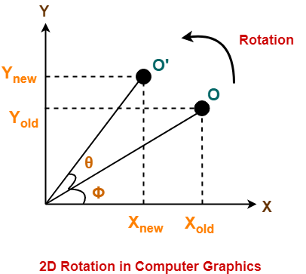

This rotation is achieved by using the following rotation equations-

* Xnew = Xold x cosθ – Yold x sinθ
* Ynew = Xold x sinθ + Yold x cosθ

In Matrix form, the above rotation equations may be represented as-

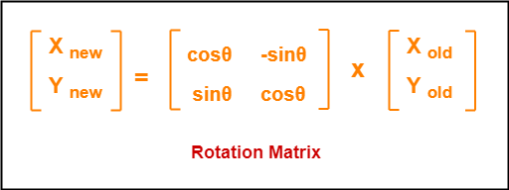

For homogeneous coordinates, the above rotation matrix may be represented as a 3 x 3 matrix as-

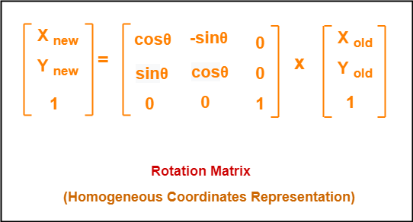

## 2D Scaling in Computer Graphics-

|  |
| --- |
| In computer graphics, scaling is a process of modifying or altering the size of objects. |

* Scaling may be used to increase or reduce the size of object.
* Scaling subjects the coordinate points of the original object to change.
* Scaling factor determines whether the object size is to be increased or reduced.
* If scaling factor > 1, then the object size is increased.
* If scaling factor < 1, then the object size is reduced.

Consider a point object O has to be scaled in a 2D plane.

Let-

* Initial coordinates of the object O = (Xold, Yold)
* Scaling factor for X-axis = Sx
* Scaling factor for Y-axis = Sy
* New coordinates of the object O after scaling = (Xnew, Ynew)

This scaling is achieved by using the following scaling equations-

* Xnew = Xold x Sx
* Ynew = Yold x Sy

In Matrix form, the above scaling equations may be represented as-

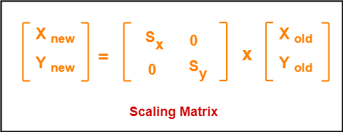

For homogeneous coordinates, the above scaling matrix may be represented as a 3 x 3 matrix as-

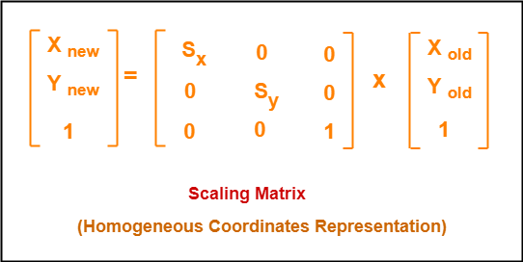

# **SOURCE CODE:**

# #include <stdio.h>

# #include <graphics.h>

# #include <conio.h>

# #include <math.h>

# void smiley(int x, int y, int r)

# {

# setcolor(YELLOW);

# 

# // creating circle and fill it with

# // yellow color using floodfill.

# circle(x, y, r);

# setfillstyle(SOLID_FILL, YELLOW);

# floodfill(x, y, YELLOW);

# 

# // Set color of background to black

# setcolor(BLACK);

# setfillstyle(SOLID_FILL, BLACK);

# 

# // Use fill ellipse for creating eyes

# fillellipse(x + 10, y - 15, 2, 6);

# fillellipse(x - 10, y - 15, 2, 6);

# 

# // Use ellipse for creating mouth

# ellipse(x, y, y + 105, x + 35, r - 20, r - 31);

# ellipse(x, y, y + 105, x + 35, r - 20, r - 30);

# ellipse(x, y, y + 105, x + 35, r - 20, r - 29);

# }

# int rotation(int x, int y, int r, int flag)

# {

# int p, q;

# p = abs(x * cos(r) - y * sin(r));

# q = abs(y * cos(r) + x * sin(r));

# if (flag == 1)

# return p;

# return q;

# }

# void rotate(float angle){

# int x1,x2,x3,x4;

# int y1,y2,y3,y4;

# int refx,refy;

# int ax1,ax2,ax3,ax4,ay1,ay2,ay3,ay4;

# angle=angle*(3.14/180);

# refx=100;

# refy=100;

# x1=100;

# y1=100;

# x2=150;

# y2=100;

# x3=150;

# y3=150;

# x4=100;

# y4=150;

# ax1=refy+(x1-refx)*cos(angle)-(y1-refy)*sin(angle);

# ay1=refy+(x1-refx)*sin(angle)+(y1-refy)*cos(angle);

# ax2=refy+(x2-refx)*cos(angle)-(y2-refy)*sin(angle);

# ay2=refy+(x2-refx)*sin(angle)+(y2-refy)*cos(angle);

# ax3=refy+(x3-refx)*cos(angle)-(y3-refy)*sin(angle);

# ay3=refy+(x3-refx)*sin(angle)+(y3-refy)*cos(angle);

# ax4=refy+(x4-refx)*cos(angle)-(y4-refy)*sin(angle);

# ay4=refy+(x4-refx)*sin(angle)+(y4-refy)*cos(angle);

# setcolor(4);

# rectangle(100,150,150,100);

# line(ax1,ay1,ax2,ay2);

# line(ax2,ay2,ax3,ay3);

# line(ax3,ay3,ax4,ay4);

# line(ax4,ay4,ax1,ay1);

# }

# main()

# { initwindow(800, 800);

# rectangle(150, 200, 300, 400);

# circle(200, 200, 100);

# smiley(300, 100, 100);

# 

# // translation

# printf("\n TRANSLATION \n\n");

# printf("Enter the value you want the x-coordinate to: \n");

# int x, y;

# scanf("%d", &x);

# printf("Enter the value you want the y-coordinate to: \n");

# scanf("%d", &y);

# rectangle(150 + x, 200 + y, 300 + x, 400 + y);

# circle(200 + x, 200 + y, 100);

# smiley(300 + x, 100 + y, 100);

# 

# // scaling

# printf("\n\n scaling \n\n");

# printf("Enter the scaling factor\n");

# int d;

# scanf("%d", &d);

# rectangle(150 * d , 200 * d, 300 * d, 400 * d);

# circle(200, 200 , 100 * d);

# // rotation

# printf("\n\n ROTATION \n\n");

# printf("Enter the angle\n");

# int r;

# scanf("%d", &r);

# // 2 ways to print:

# // rectangle(rotation(15, 20, r, 1), rotation(15, 20, r, 0), rotation(30, 40, r, 1), rotation(30, 40, r, 0));

# rotate(r);

# getch();

# closegraph();

# }

# **OUTPUT:**

#### SHAPES GOING TO USE:

* Square
* Circle

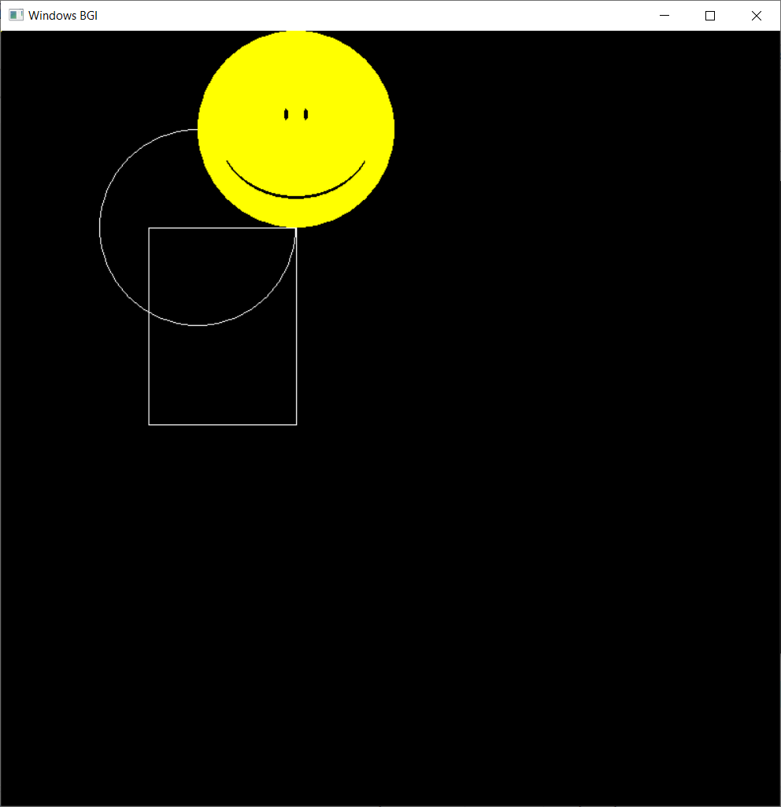

## **All transformations on circle:**

## 

## 

## 

translation

Original circle

Scaling

## **ALL TRANSFORMATIONS ON SQUARE:**

## 

## 

translation

scaling

Square

Rotation

# **VIVA-VOCE:**

#### **Q1. Given a circle C with radius 10 and center coordinates (1, 4). Apply the translation with distance 5 towards X axis and 1 towards Y axis. Obtain the new coordinates of C without changing its radius?**

Ans.

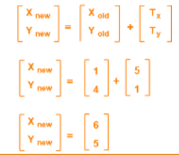Old center coordinates of C = (Xold, Yold) = (1, 4)

Translation vector = (Tx, Ty) = (5, 1)

Applying the translation equations, we have-

•Xnew = Xold + Tx = 1 + 5 = 6

•Ynew = Yold + Ty = 4 + 1 = 5

New center coordinates of C = (6, 5).

#### **Q2. Given a line segment with starting point as (0, 0) and ending point as (4, 4). Apply 30 degree rotation anticlockwise direction on the line segment and find out the new coordinates of the line.**

Ans.

Old ending coordinates of the line = (Xold, Yold) = (4, 4)

Rotation angle = θ = 30º

new ending coordinates of the line after rotation = (Xnew, Ynew).

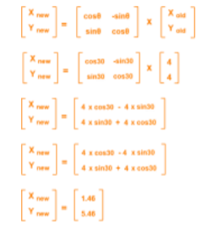Xnew

= Xold x cosθ – Yold x sinθ

= 4 x cos30º – 4 x sin30º

= 4 x (√3 / 2) – 4 x (1 / 2)

= 2√3 – 2

= 2(√3 – 1)

= 2(1.73 – 1)

= 1.46

Ynew

= Xold x sinθ + Yold x cosθ

= 4 x sin30º + 4 x cos30º

= 4 x (1 / 2) + 4 x (√3 / 2)

= 2 + 2√3

= 2(1 + √3)

= 2(1 + 1.73)

= 5.46

New ending coordinates of the line after

rotation = (1.46, 5.46).

#### **Q3. Given a square object with coordinate points A(0, 3), B(3, 3), C(3, 0), D(0, 0). Apply**

#### **the scaling parameter 2 towards X axis and 3 towards Y axis and obtain the new**

#### **coordinates of the object.**

Ans.

Old corner coordinates of the square = A (0, 3), B(3, 3), C(3, 0), D(0, 0)

Scaling factor along X axis = 2

Scaling factor along Y axis = 3

For Coordinates A(0, 3)

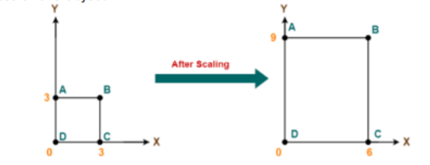•Xnew = Xold x Sx = 0 x 2 = 0

•Ynew = Yold x Sy = 3 x 3 = 9

For Coordinates B(3, 3)

•Xnew = Xold x Sx = 3 x 2 = 6

•Ynew = Yold x Sy = 3 x 3 = 9

For Coordinates C(3, 0)

•Xnew = Xold x Sx = 3 x 2 = 6

•Ynew = Yold x Sy = 0 x 3 = 0

For Coordinates D(0, 0)

•Xnew = Xold x Sx = 0 x 2 = 0

•Ynew = Yold x Sy = 0 x 3 = 0

#### **Q4. Given a triangle with coordinate points A(3, 4), B(6, 4), C(5, 6). Apply the reflection on**

#### **the X axis and obtain the new coordinates of the object.**

Ans.

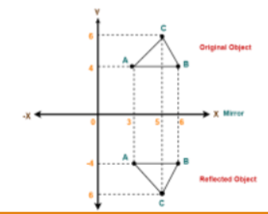For Coordinates A(3, 4)

•Xnew = Xold = 3

•Ynew = -Yold = -4

For Coordinates B(6, 4)

•Xnew = Xold = 6

•Ynew = -Yold = -4

For Coordinates C(5, 6)

•Xnew = Xold = 5

•Ynew = -Yold = -6

#### **Q5. Given a triangle with points (1, 1), (0, 0) and (1, 0). Apply shear parameter 2 on X axis and 2 on Y axis and find out the new coordinates of the object.**

Ans.

* Old corner coordinates of the triangle = A (1, 1), B(0, 0), C(1, 0)
* Shearing parameter towards X direction (Shx) = 2
* Shearing parameter towards Y direction (Shy) = 2

Shearing in X AxisFor Coordinates A(1, 1)

Xnew = Xold + Shx x

Yold = 1 + 2 x 1 = 3

Ynew = Yold = 1

For Coordinates B(0, 0)

Xnew = Xold + Shx x Yold = 0 + 2 x 0 = 0

Ynew = Yold = 0

Shearing in X AxisFor Coordinates C(1, 0)

•Xnew = Xold + Shx x Yold = 1 + 2 x 0 = 1

•Ynew = Yold = 0

New coordinates of the triangle after shearing in X axis = A (3, 1), B(0, 0), C(1, 0)