experiment 8

COMPUTER GRAPICS AND MULTIMEDIA

# Aim

Write a C program to draw 4 point Bezier Curve.

**Syeda Reeha Quasar**

**14114802719**

**3C7**

# **EXPERIMENT - 8**

**AIM:**

Write a C program to draw 4-point Bezier Curve.

# **THEORY:**

Bezier curve is discovered by the French engineer **Pierre Bézier**. These curves can be generated under the control of other points. Approximate tangents by using control points are used to generate curve. The Bezier curve can be represented mathematically as −

∑k=0nPiBni(t)∑k=0nPiBin(t)

Where pipi is the set of points and Bni(t)Bin(t) represents the Bernstein polynomials which are given by −

Bni(t)=(ni)(1−t)n−itiBin(t)=(ni)(1−t)n−iti

Where **n** is the polynomial degree, **i** is the index, and **t** is the variable.

The simplest Bézier curve is the straight line from the point P0P0 to P1P1. A quadratic Bezier curve is determined by three control points. A cubic Bezier curve is determined by four control points.

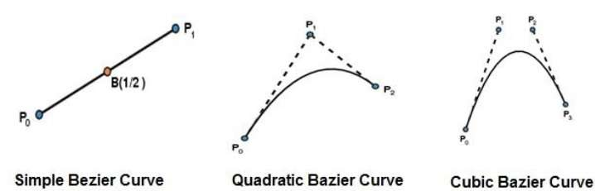

### Properties of Bezier Curves

Bezier curves have the following properties −

* They generally follow the shape of the control polygon, which consists of the segments joining the control points.
* They always pass through the first and last control points.
* They are contained in the convex hull of their defining control points.
* The degree of the polynomial defining the curve segment is one less that the number of defining polygon point. Therefore, for 4 control points, the degree of the polynomial is 3, i.e. cubic polynomial.
* A Bezier curve generally follows the shape of the defining polygon.
* The direction of the tangent vector at the end points is same as that of the vector determined by first and last segments.
* The convex hull property for a Bezier curve ensures that the polynomial smoothly follows the control points.
* No straight line intersects a Bezier curve more times than it intersects its control polygon.
* They are invariant under an affine transformation.
* Bezier curves exhibit global control means moving a control point alters the shape of the whole curve.
* A given Bezier curve can be subdivided at a point t=t0 into two Bezier segments which join together at the point corresponding to the parameter value t=t0.

# **SOURCE CODE:**

#include <stdio.h>

#include <graphics.h>

#include <math.h>

int x[4]={20,200,40,300};

int y[4]={80,30,50,400};

void bezier () {

int i;

double t,xt,yt;

for (t = 0.0; t < 1.0; t += 0.0005) {

xt = pow(1-t,3)x[0]+3*t*pow(1-t,2)*x[1]+3*pow(t,2)(1-t)*x[2]+pow(t,3)*x[3];

yt = pow(1-t,3)y[0]+3*t*pow(1-t,2)*y[1]+3*pow(t,2)(1-t)*y[2]+pow(t,3)*y[3];

putpixel (xt, yt,WHITE);

}

for (i=0; i<4; i++)

putpixel (x[i], y[i], YELLOW);

getch();

}

main() {

initwindow(1920,1080);

bezier ();

getch();

closegraph();

}

# **OUTPUT:**

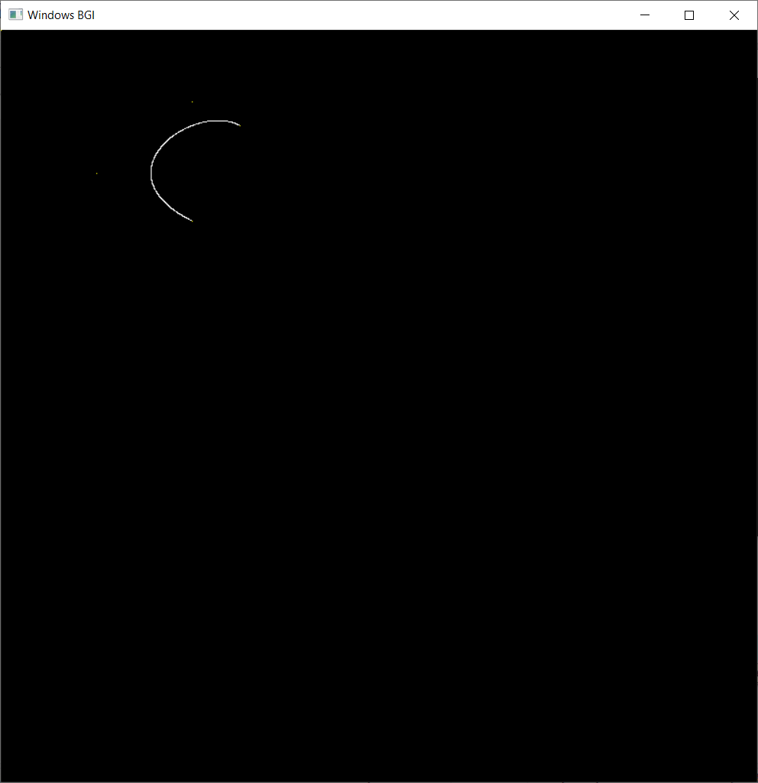

**VIVA Voice**

**Q1. what are control points?**

Ans.

A control point is work which is aimed at checking of the compliance of the results of certain work in a business process with formulated requirements to its results. In case of non-conformity, a feed-back is arranged and the result should be corrected.

**Q2. What are the applications of bezier curves?**Ans.

A Bezier curve is a parametric curve frequently used in computer graphics, animation, modeling, CAD, CAGD, and many other related fields. Bezier curves are also used in the time domain, particularly in animation and interface design, e.g., a Bezier curve can be used to specify the velocity over time of an object such as an icon moving from A to B, rather than simply moving at a fixed number of pixels per step. When animators or interface designers talk about the "physics" or "feel" of an operation, they may be referring to the particular Bezier curve used to control the velocity over time of the move in question.

**Q3. what are the properties of bezier curves?**

Ans.

Bezier curves have the following properties −

* They generally follow the shape of the control polygon, which consists of the segments joining the control points.
* They always pass through the first and last control points.
* They are contained in the convex hull of their defining control points.
* The degree of the polynomial defining the curve segment is one less that the number of defining polygon point. Therefore, for 4 control points, the degree of the polynomial is 3, i.e. cubic polynomial.
* A Bezier curve generally follows the shape of the defining polygon.
* The direction of the tangent vector at the end points is same as that of the vector determined by first and last segments.
* The convex hull property for a Bezier curve ensures that the polynomial smoothly follows the control points.
* No straight line intersects a Bezier curve more times than it intersects its control polygon.
* They are invariant under an affine transformation.
* Bezier curves exhibit global control means moving a control point alters the shape of the whole curve.
* A given Bezier curve can be subdivided at a point t=t0 into two Bezier segments which join together at the point corresponding to the parameter value t=t0.

**Q4. what do you mean by approximation and interpolation points?**

Ans.

Interpolation is a common way to approximate functions. Given a function with a set of points one can form a function such that for (that is that interpolates at these points). In general, an interpolant need not be a good approximation, but there are well known and often reasonable conditions where it will.

interpolation - all points of the basic figure are located on the created figure called interpolation curve segment

approximation - all points of the basic figure need not be located on the created figure called approximation curve segment.

**Q5. A cubic curve is defined by points (1,1) (2,3) (4,4) (6,1). Calculate the coordinates of parametric midpoint of this curve.**

Ans.

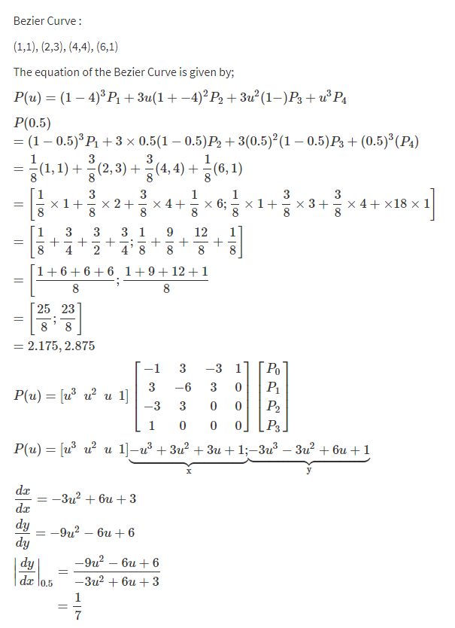

**Q6. what is the difference between Bezier curves and B Spline curves?**

Ans.

Bezier curves are parametric curves used frequently in modeling smooth surfaces in computer graphics and many other related fields. These curves can be scaled indefinitely. Linked Bezier curves contain paths that are combinations that are intuitive and can be modified. This tool is also made use of in controlling motions in animation videos. When programmers of these animations talk about the physics involved, they are in essence talking about these Bezier curves. Bezier curves were first developed by Paul de Castlejau using Castlejau’s algorithm, which is considered a stable method to develop such curves. However, these curves became famous in 1962 when French designer Pierre Bezier used them to design automobiles.

B-Spline curves are considered as a generalization of Bezier curves and as such share many similarities with it. However, they have more desired properties than Bezier curves. B-Spline curves require more information such as a degree of the curve and a knot vector, and in general, involve a more complex theory than Bezier curves. They, however, possess many advantages that offset this shortcoming. Firstly, a B-Spline curve can be a Bezier curve whenever the programmer so desires. Further B-Spline curve offers more control and flexibility than a Bezier curve. It is possible to use lower degree curves and still maintain a large number of control points. B-Spline, despite being more useful are still polynomial curves and cannot represent simple curves like circles and ellipses. For these shapes, a further generalization of B-Spline curves known as NURBS is used.

* Both Bezier and B-Spline curves are used for drawing and evaluating smooth curves, especially in computer graphics and animations.
* B-Spline are considered a special case of Bezier curves
* B-Spline offer more control and flexibility than Bezier curves