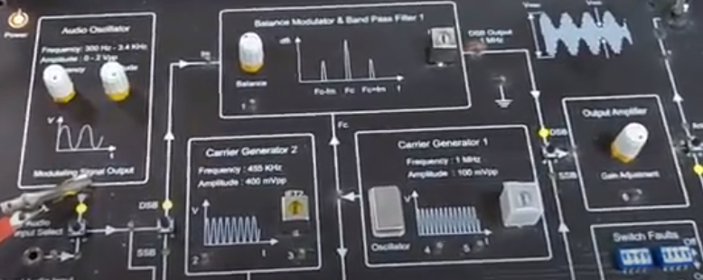

**Fig. 1 - AM Transmitter for DSB-FC (AM) wave generation**

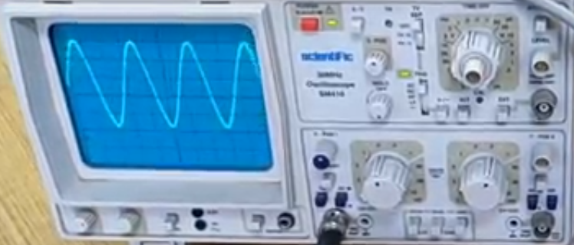

**Fig. 2 – Modulating signal**

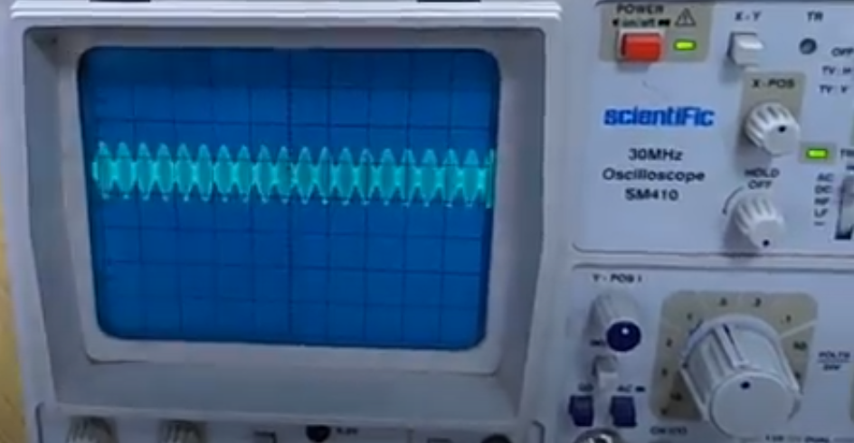

**Fig. 3 – Amplitude Modulated signal (modulation index, m < 1)**

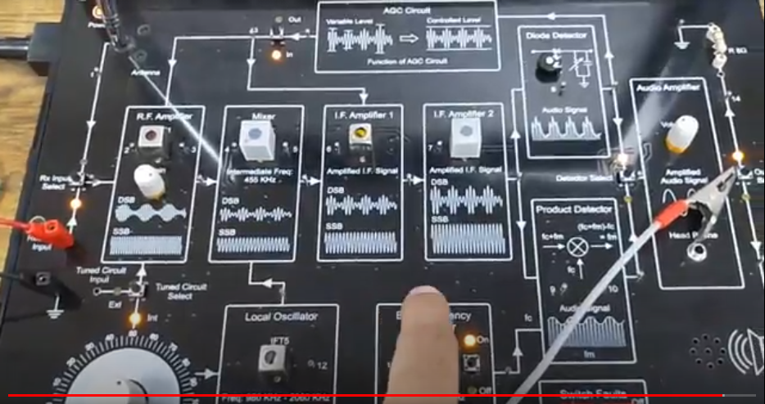

**Fig. 4 – AM Receiver**

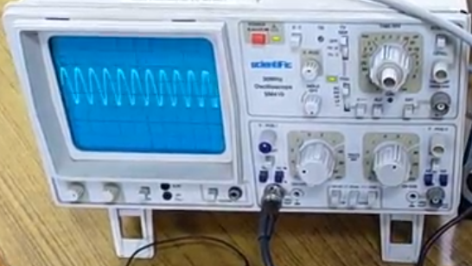

**Fig. 5 – AM signal demodulation (Information signal recovery)**